**CHAPTER ONE**

**1.1 BACKGROUND INFORMATION**

A first step in postulating a theory of mobile knowledge sharing system is to differentiate what is special about E-knowledge sharing system compared to other types of knowledge sharing systems. An obvious yet essential difference is it starts from assumption that organizations that encourage or practice knowledge sharing are continuously on the move. Effective knowledge sharing is of great importance as a foundation for knowledge management in organizations (chumg et al., 2016). Through effective E-knowledge sharing among employees in an organization, organizations can improve their profile and gain market opportunities, enhance performance and increase their competitive advantage in an uncertain environment.

In today’s business world, E-sharing systems are very much essential in other to store and preserve knowledge within the organizations and make decision and problem-solving processes faster and easier. The truth about E-knowledge sharing system is that every organization aimed at rapid development needs an E-sharing system. An organization in which knowledge sharing is not practiced is prone to slow development, knowledge hoarding and slow response to problems and decision-making processes. To prevent this, we use technology. This has resulted in what we know today as E-knowledge sharing system.

Knowledge sharing is nothing new, for hundreds of years owners of businesses and experienced employee have passed their commercial wisdom unto their families or other employees using traditional methods of knowledge sharing. But it wasn’t until the 1990’s that researches started talking about E- knowledge sharing. The traditional methods of E- knowledge sharing was questioned by asking what happens when an employee refuses to share knowledge. They concluded that the invention of E-knowledge sharing system will help answer these questions.

The traditional method of using passing knowledge through interactions is still very good, but that cannot keep up with our world today where information is traveling at the speed of light and things change at the speed of thought.

**1.2 STATEMENT OF THE PROBLEM**

In view of the importance of the E-knowledge sharing systems, one of the major problems that organizations face today is getting employees to share both their tacit and explicit knowledge. This is a major concern because without getting employees to share their knowledge there would be no reason to have a knowledge sharing system.

The day to day activities of employees in an organization is also quite tasking. There are a lot of problems to be solved, important projects to be completed and things in which they need to remember as it relates to the organization. It would be better and more profitable if the organizations where able to develop a system in which employees can quickly log on to and find related answers to their problems as well as finding pervious work done by other employees in other to increase problem solving speed. Employees can also post their solutions to problems in form of reports or reviews on these systems for other people to gain knowledge from.

**1.3 AIM AND OBJECTIVES OF STUDY**

The aim of this project is to design and implement an E-knowledge sharing system that organizations can use to store and share knowledge

Objectives of this project includes:

1. To carry out study of existing knowledge sharing system.

2. Design search engine for searching users and documents.

3. Design status reporting platform.

4. Design employee ranking.

5. Design notification board for meeting and scheduling.

6. Design and model an E-knowledge sharing system

7. Implement the E-knowledge sharing platform.

**1.4 RESEARCH METHODOLOGY**

Research methodology of this project goes further to explain the best methods intended to achieve the stated objectives.

**Objective 1: Carry out study of existing E-knowledge sharing system**

In order to carry out a research on existing systems, a thorough study of such applications will be carried out relating to what they did, how they did it, their flaws and their merits. This would be used as a base to develop more functionalities for the system.

**Objective 2: Design search engine for document and user searching**

The search engine would be implemented using development tool Ruby on Rails, the programming language to be used is ruby.

**Objective 3: Design status reporting platform**

The status reporting platform would be implemented using development tool Ruby on Rails, the programming language to be used is ruby.

**Objective 4: Design employee ranking**

The status reporting platform would be implemented using development tool Ruby on Rails, the programming language to be used is ruby.

**Objective 5**: **Design notification board for meeting and scheduling.**

The notification board for meeting and scheduling would be implemented using development tool Ruby on Rails, the programming language to be used is ruby.

**Objective 6: Design and model an E-knowledge sharing system**

To design and model the system, UML was used for the system modelling and design. Diagrams such as sequence, activity and use case was used to model the system. A use case model is used view of system that emphasizes the behavior of a system as it appears to outside users. the sequence diagram is used to flow of messages, events, and actions between objects.

**Objective 7: Implement the E-knowledge sharing system**

This will be achieved by the implementation of a web application; the user interface design was guided by using JavaScript, HTML and CSS. The system is intended to run on as a web application, therefore web browsers like chrome, safari, Mozilla, internet explorer. The development tool used is Ruby on Rails which is very popular integrated development environment for developing web applications. The programming language to be used is Ruby. The database of the system will be created using PostgreSQL relational database.

**1.5 SIGNIFICANCE OF STUDY**

The role technology has played in enhancing learning and knowledge sharing in organizations cannot be over emphasized, little contributions of knowledge from various employees over time can form a very large repository of knowledge base over time. An organization using an E-knowledge sharing system would be generally more productive than an organization that doesn’t use it, this therefore implies that every organization seeking to grow fast should have an E-knowledge sharing system.

**1.6 LIMITATIONS OF STUDY**

* At first release, the web application may not have all the features desired by the organization.
* Due to time constraint, the first release of the web application may not have all the intended functionalities, though the future updates will have.

**1.7 PROJECT OUTLINE**

Chapter one of the project contains the introduction, statement of the problem, aim and objectives of the study, the significance of the study and the methodology used.

Chapter Two is a summary of literature review which consists of researches, journals, articles attempt and projects related to E-knowledge sharing system.

Chapter Three presents the E-knowledge sharing system and its system design, which includes the physical and logical design, it presents the system architecture and conceptual design of the application

Chapter Four contains the system implementation, the tools used, the development methodology, program modules, interfaces and system development process.

Chapter Five contains the general overview of the project, findings from the existing works in relation to the new system. It also includes the result and significance of the work and finally suggestions to the research community or system users.

**CHAPTER 2**

**2.1 INTRODUCTION**

Whether it's a large or small organization, knowledge is considered to be one of the most important aspect of present-day business organizations. Almost all types of organizations are now keeping trust on knowledge-based resources to gain competitive advantage over similar organizations (Kuruppuge and Gregar, 2018). It is worth to add that it is in the interest of an organization that the employees do not keep their knowledge to themselves but that they share it to other members of the organization (Matoskova and smesna, 2017). Knowledge sharing plays a very important role in organizations today, as these organizations devote mass resources into building and promoting knowledge sharing in their organizations. Therefore, it is necessary to know the importance of knowledge sharing, forms of knowledge sharing in organizations, methods to improve knowledge sharing among employees, factors affecting knowledge sharing and the effects of knowledge sharing in organizations.

**2.2 HISTORY OF KNOWLEDGE SHARING IN ORGANIZATIONS**

One of the earliest forms of knowledge sharing started in the early 1500BC and it took place in form of cave drawings. After this period, documentation became more advanced and this evolved from using imagery to alphabets, and from writing on walls to using scrolls. Academics and monks took up the responsibility of interpreting books and organizing encyclopedias, and stored these knowledges acquired in exclusive libraries. In 1440s the invention of printing was developed and that was the first time knowledge was able to be shared among businesses and individuals easily via print material.

Rapid changes in knowledge sharing started with real-time audio broadcasting in the 1990s. then, the invention of the internet in 1980s was also introduced. As relevant information became more and more accessible, it became difficult for organizations to function without these technologies enabling this new level of connectivity among employees in the organization. It became clear to organizations that a means for managing the excess and incredibly useful information was greatly needed.

Research in recent time shows that organizational consultants were among the first set of professionals to seriously explore and consider the best means for knowledge sharing with the organization. Consultants found out that some organizations use person to person interactions (tacit) methods to share knowledge whereas others used computers to codify and store knowledge. The use of computers not only allowed them to share knowledge electronically but to communicate, store and preserve knowledge acquired over time. As organizations grew and technology improved immensely, one lesson learnt by organizations is that “the death of knowledge is to isolate it” (alexander, 2018).

The concept of knowledge sharing isn’t new, but how we convey information is what is changing drastically. Though we once focused on simply sharing knowledge, leaving it up to predecessors and academics to record, organize, and interpret such materials, we now understand the importance of businesses and organizations to remain competitive in the global marketplace while using E-knowledge sharing systems.

As networked computers made it possible to store and share knowledge more easily than any other period in history, business pioneers have begun to recognize the value of knowledge and how capturing and sharing it could impact their business positively. The incentives for companies and organizations is vast, from increasing efficiency to eliminating redundancy, but the benefits and applications are still being realized as technologies improve.

**2.3 KNOWLEDGE SHARING**

knowledge sharing is defined “the process of transferring knowledge from a person to another in organization. It is a process to accumulate shared knowledge among members” (Park and Im, 2003). It can also be defined as a kind of social interaction among people (Bock and Kim, 2002). Knowledge, unlike information and is locked in the human mind and part of human identity. (Frappaolo,2006) claimed that knowledge sharing is about "how people share and use what they know". In addition, (Tasminand Woods, 2007) asserted that knowledge sharing as a social system that supports collaboration and integration which is normally facilitated by technology.

(Dalkir 2005) also supported the defined notion that knowledge sharing is to be associated with “appropriate mix” of technological channels for optimizing knowledge exchanges. Creating and exchanging knowledge are intangible activities that can neither be supervised nor imposed.

**2.4 REVIEW OF EXISTING SYSTEMS**

Today, knowledge sharing systems go from the simple to the complex. Knowledge sharing systems in organizations today are widely used by individuals for personal improvement rather in organizations where employees are reluctant to share their knowledge. As technology keeps changing and advancing today, there is an important need for. knowledge to be shared in organizations and soon every organization would need an effective knowledge sharing to share knowledge acquired by employees.

There are existing knowledge sharing systems available today on the internet. The internet is a global computer network providing a variety of information and communication facilities, consisting of interconnected networks using standardized communication. Some applications can either be web applications or mobile applications. Users can download or login to the systems of their choice to download or upload information.

**2.4.1 QUORA**

Quora is one of the best knowledge sharing systems we have today, Quora works both as a web and mobile application. It is a question and answer website where questions are asked, answered, edited, and organized by its community of users in the form of opinions. Users can work together by editing questions and proposing edits to answers that have been submitted by other users. Figure 2.1 shows the display interface for Quora.

 **Figure 2.3 Image displaying Quora**

(source: buffer.com)

Some features of the application that helps increase its productivity are:

* Quora inbox which shows the list of activities from individuals who are following your progress.
* Adding answers to questions this gives users the ability to add an answer to the question asked and improves the development of the specific content.
* Sharing questions and answers among a social media community.
* Quora profile which allows users to access everything Quora on the user's personal profile.
* Quora home gives users the ability to see updates top answered questions and ranked questions as users browse the site.

**2.4.2 BOOST HQ**

BoostHQ is a standout popular web application and mobile application for users to create content, share links, files and thoughts on various topics. It also enables exchange of information among team members and also allows for real time discussions. What is great about BoostHQ is that everything team members share is automatically indexed in topic specific channels and they can access it exactly when they want it. Figure 2.1 shows the display interface for BoostHQ.

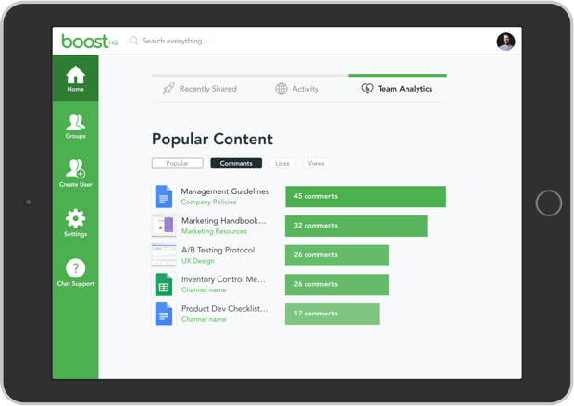  **Figure 2.1 Image displaying BoostHQ**

(Source: chanty.com)

BoostHQ Features

* File sharing: BoostHQ allows users to easily share content whether its links, videos, documents or other useful materials. Users can easily share learning contents such as job aids, procedural guidelines or tutorials.
* Smart search: smart search feature ensures users have access to whatever information they need.
* Social engagement: allows employees to contribute feedbacks, ideas and questions. It also increases employee engagements with the content being shared.
* Push notifications
* Gamification: up voting feature encourages employees to participate and improve their involvement.

**2.4.3 ZOHO**

Zoho is a very easy and simple way to put all your information available to be shared into one searchable portal. It is mostly efficient for organizations with employees scattered across different geographical areas as they find it very useful and it takes less technical knowledge to operate. figure 2.3 Shows the display interface for zoho

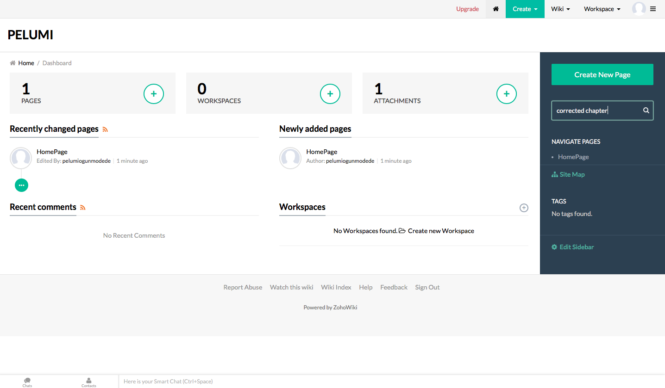

Figure 2.3 image displaying zoho

(source: pelumi.wiki.zoho.com)

Features of Zoho

* Content management: Zoho allows users to organize their workspace by creating pages and subpages for different topics. It also has an effective mechanism that allows users to search content within Zoho. The searches are conducted based on page and file names.
* Workspace: allows users to create their own workspaces in which they can share knowledge.
* User administration: this feature allows users to give access permissions to other users to view their contents. Users can also decide which content they want to be shared.
* Notifications: this feature allows users to get updates and notify users when changes are made or comments are added to the user’s page.

**2.4.4 SCOPUS**

Scopus is one of the largest online repositories for sharing knowledge. It is also the largest abstract and citation database used to share knowledge through publishing of research literatures. Scopus has billions of tools to track, analyze and visualize research. It is very easy for new users to navigate on Scopus due to the ease. Figure 2.4 shows the display interface for Scopus.

 figure 2.4 image displaying Scopus in operation

(source: blog.scopus.com )

Features of Scopus

* Smart search: this feature allows the users to search content within Scopus.
* Large knowledge repository that stores all information.
* Search query that limits the search to specific content.
* Notifications which allows the user to be notified when changes are made.

**2.5 FEATURES OF AN ONLINE KNOWLEDGE SHARING SYSTEM**

There are some common features of a knowledge sharing system, these features should be present in all others, and they are discussed below. These features may not be available in every single knowledge sharing system but they are features for a standard system for knowledge sharing.

**2.5.1 Search Engine**

One of the most important features of any knowledge sharing system is the search engine. A knowledge base is a separate entity with a separate engine similar to those of web browsers. The reason for this is because the knowledge base is usually large. It has been noticed that they only get bigger and bigger over time because companies update them with important new information to keep their customers informed. Finding the right item in a knowledge repository is not easy and can be difficult. This is why it is important to have a search engine. With a good search engine, keywords and tags, the user of the knowledge base will be able to search what they are looking for and find it quickly and easily.

**2.5.2 Ease of use**

Except for the amount of valuable information it holds, a knowledge-sharing software must be simple in every way possible. Implementation, set-up and access should be easy. A company must update its knowledge base and regularly add new information to keep it fresh and relevant. This means that simple operations should allow users to do so without any complications and, most importantly, very quickly.

**2.5.3 Accessibility**

The system of knowledge sharing cannot be restricted in any way. Any user wishing to access it should be able to do so. The biggest problem companies faced in the past was that their knowledge bases were simply built and only optimized for some web browsers, which caused a lot of damage.

**2.5.4 Option to comment**

In addition to many articles and other forms of documents that can help users, the system also requires the ability to share feedback and discuss important issues. A well-written good knowledge sharing system that provides users with relevant data can actually help them find solutions to problems and can create a whole community around them.

**2.5.5 Notification**

There was no notification with the old paper method, but with digital power, a lot can be done, one of which is notification A notification can be a simple pop - up and beep that notifies the user when changes are made, which helps the user to keep track of how the system is activated.

**2.6 ISSUES WITH ONLINE KNOWLEDGE SHARING SYSTEMS**

As with most systems there are shortcomings, knowledge sharing systems are no exception.

**2.6.1 Security**

Adjusting the right level of knowledge management security is essential. Conscious information should be protected from most users while providing easy access to people with the right credentials.

**2.6.2 Getting People Motivated**

Overpowering organizational culture challenges and developing a culture that embraces learning, sharing, changing, improving can’t be done with technology.

**2.6.3 Keeping Up with Technology**

It is an enormous challenge to regulate how knowledge should be distributed, transferred quickly and effectively. Constantly changing structures mean learning how to be intelligent, fast, agile and responsive - a KM tool must be able to complete everything.

**2.6.4 Measuring Knowledge**

Knowledge is not easily quantifiable and much more complex because it is copied from human relationships and experience. Instead of results or efforts, the focus should be on distributed purposes.