Ice, Ice Maybe: The Arctic Set to Melt Each Summer by 2100
Projections show the Arctic becoming seasonally ice-free by the end of the 21st century
In the coming decades, the Arctic may become unrecognizable. According to projections from the most recent Coupled Model Intercomparison Project Phase 6 (CMIP6), the Arctic Ocean is set to be ice-free during the summer months by the end of this century. This will impact global climate, sea levels and ecosystems around the globe and much more. (ADD ANOTHER SENTENCE- maybe introduce CMIP in this paragraph
The Projections
Warning: climate science acronyms are coming your way, but I promise it will be quick and painless!
These projections come from Coupled Model Intercomparison Project, Phase 6 (CMIP6). CMIP data is a collection of climate models designed to improve knowledge of climate change with CMIP6 being the most recent available dataset. These models combine sets and projections to create the most accurate depiction of what variables around the globe could look like in the future. CMIP6 uses Shared Socioeconomic Pathways (SSP) to model different potential future outcomes. SSPs are projected climate change scenarios in line with certain potential socioeconomic global changes.
In the case of these Arctic Sea ice projections, the plotted data is the percentage of sea ice in the long term (from 2081-2100) during June through August (Fig. 1). This shows what, according to the most extreme SSP, SSP5-8.5, is projected to happen to Arctic Sea ice each summer by the end of the century.
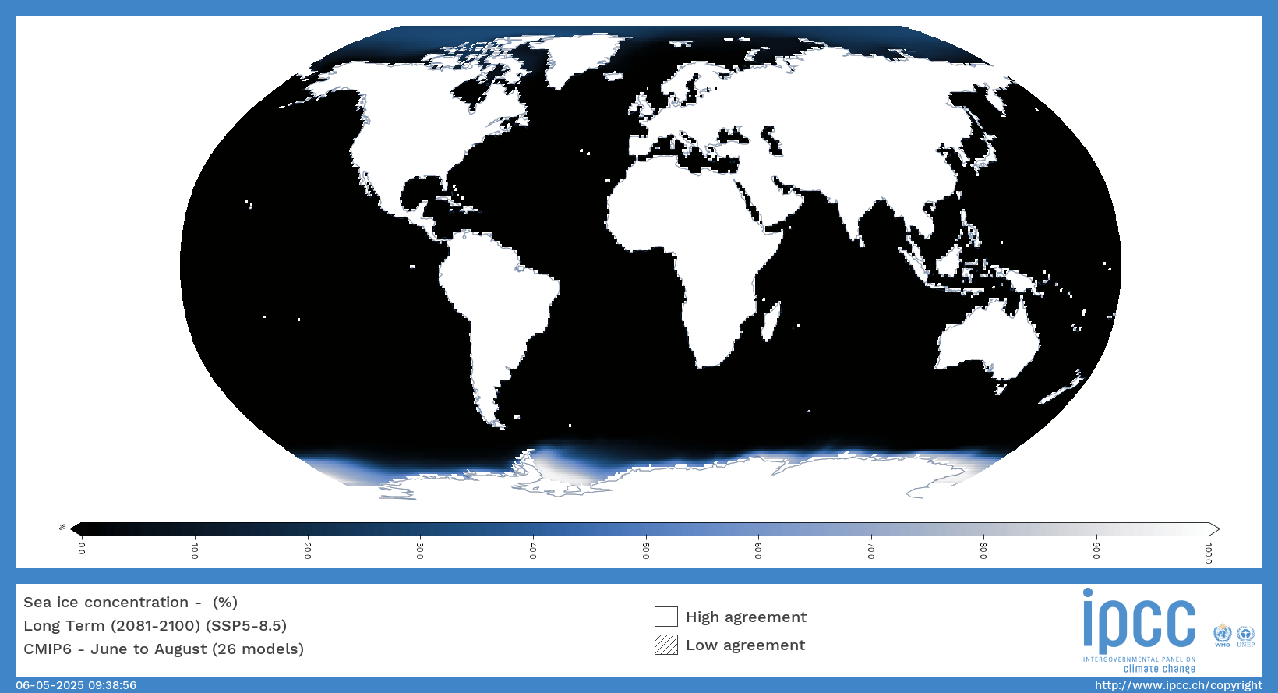
Figure 1: Projection of percent sea ice concentration in the long term (2081-2100) from June-August using SSP5-8.5. Black is 0% sea ice and white is 100% sea ice. Land masses are plotted but not analyzed here. Created using the IPCC Interactive Atlas, IPCC WGI Interactive Atlas.
This figure shows Arctic Sea ice concentrations at near zero percent during the summer months which is…You guessed it! Detrimental for the planet.
Buzzwords: Tipping Points, Feedback Loops, and Sea Level Rise
A concern with melting sea ice is its connecting feedback loops. As I’m sure you were taught in science class when you were 11, there is a chain of effects when it comes to the environment; remove or change one variable, and a cascade of impacts will follow. As sea ice melts, the surface becomes darker, reducing the amount of sunlight reflected off the surface (albedo), increasing heat absorption into the system, increasing global temperature, melting more ice, and so on.
If we surpass a tipping point in this cycle, we reach a point of no return where, as sea ice continues to melt, sea level continues to rise. Currently, we are at an observed 0.20-0.30-meter global average sea level rise. This increase alone is leading to coastal cities struggling to cope with yearly tidal flooding, inundating roads and homes (Givetash, 2024). This will only grow worse; under SSP5-8.5, sea levels could rise to 0.77 meters, over double the current levels (Fig 2.). If we are already seeing impacts with a 0.30-meter increase, imagine how much worse it could get at 0.77-meters. 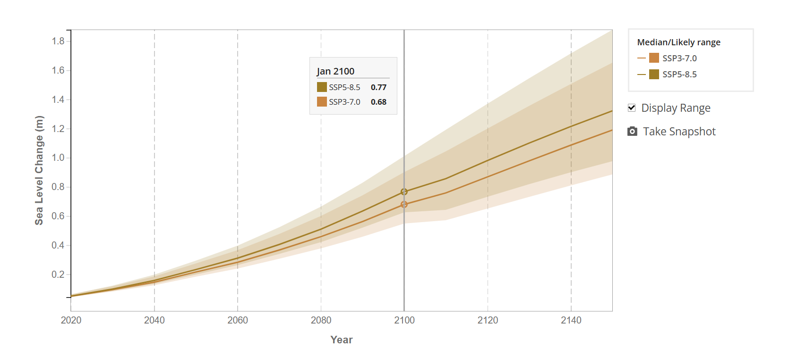
Figure 2: Projected Sea Level Change under SSP5-8.5 in the year 2100. Taken from NASA’s Global Sea Level Projection Tool (https://sealevel.nasa.gov/ipcc-ar6-sea-level-projection-tool?type=global).
Well, That Was a Bit of a Bummer. What Now?
Much of the required change is in the hands of policymakers and politicians, two groups of people that are sometimes not who I want to rely on to save the planet. A little goes a long way, though. Reducing your carbon footprint on a personal level is do-able. Shop local if you can, avoid fast fashion, plant more trees, have one night a week where you eat vegetarian. Compromise where you can.
It’s hard to know how much hope is naive and how much makes all the difference in the world. If you ask me, I might tell you that hope feels futile, that we are too far gone, that there’s no way we can rally the entire globe to come together and make a change. But does that mean we shouldn’t try?

References
Sea Level Projection Tool – NASA Sea Level Change Portal
New Antarctic Ice Tipping Point Discovered as Study Says We've Underestimated Melting : ScienceAlert
An Arctic ‘beyond recognition’ by 2100 | National Snow and Ice Data Center
Arctic Warming: Cascading Climate Impacts and Global Consequences
By 2100: An Arctic we’ll hardly recognize : CLICCS : Climate, Climatic Change, and Society : University of Hamburg
Climate Feedback Loops and Tipping Points | Center for Science Education

