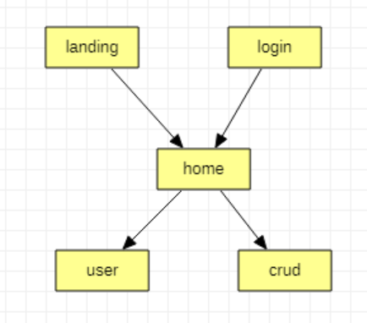

API/React/Flutter

1. Landing page
2. Home/dashboard (route navigation)
3. Login (authentication)
4. CRUD transaction {customer code, transaction type, date, amount, approved}
5. User management

Little of everything

AWS/Jobs/ API /React/Flutter/Leetcode/