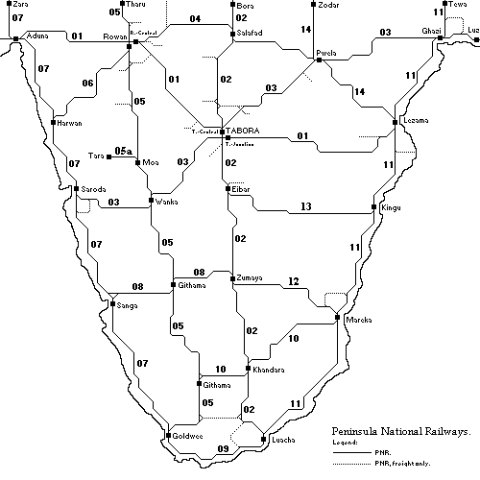

PENINSULA 2, version 1:
Welcome to Peninsula! The Goverment has invited your company to build and run a railway system over a 40 year period.
Geografy: From the tropical coastland, Peninsula slopes towards the highland. Along the mainly agricultural coasts the crops are grain, produce, sugar, cotton and coffee and some cattle. The northern part of the highland is heavy industrialized. The southern highland is mainly agricultural with some logging industry and rubber plantations. In this scenario, a some events will have influence on the outcrop (“Record grain/sugar/fruit/cotton harvest”, “Locusts destroys 50% of this years outcrop”, “Cattle plague or “Wood fires”) . This “build and have fun” scenario is single player only,
Note: Space is reserved for quadouble track and/or bypasses around most of the big population centres in an attempt
to avoid congestion. The train turnaround time is improved by 50%, traction +40% and acceleration +10%. Average distance between stations are 5-10 km.
PORTS: IMPORT: EXPORT: OTHER DATA: RRT2, The second Century with
Food (fish) 1 unit pr. dock. Start year 1865-1875,
Goods Logs Alternative engine avaibility *).
Goods p Rubber Start economy: 100%. Growth: 0,6% per year.
Food Coffee
*) First diesel in 1954, first electrics in 1918 with speed +25% from 1950, no TGV or other high speed trains.
Win conditions: BRONZE: 200 mill., SILVER: 300 mill., GOLD: 500 mill. of company book value within 40 years.

This map has been created by Anders Robert Pilgaard – Århus – Denmark. (bx03638@post7.teledk).
Last update: 2001-01-14.

