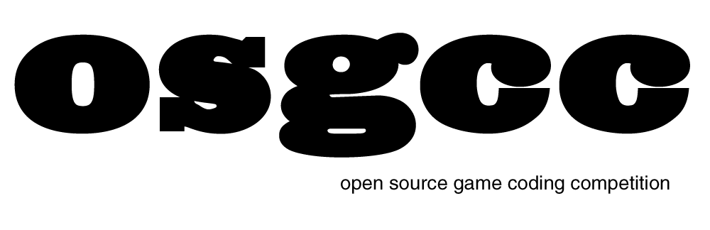
Open Source Game Coding Competition VI
November 17th-18th 2012
Judging Form

ORGANIZATION

Team Name: ________________________________________________________________

Name of Game: ________________________________________________________________

Themes: _______________________________ _______________________________

Team Members:

__________________________________________________________________________________

__________________________________________________________________________________

__________________________________________________________________________________

JUDGING

ORIGINALITY 1 2 3 4 5 6 7 8 9 10
How original is the game idea?

FUN 1 2 3 4 5 6 7 8 9 10
How much fun is the game to play? Replay?

TECHNICAL 1 2 3 4 5 6 7 8 9 10
How much effort or skill is expressed in the code? Clarity? Engineering?

INNOVATION 1 2 3 4 5 6 7 8 9 10
How original is the usage of development tools, libraries, graphics tools, audio tools, or languages?

INCORPORATION 1 2 3 4 5 6 7 8 9 10
How well are the spontaneous themes visible? How creative are their incorporation?

Total _____
Comments:

