
RFP 177 - IoT Protocols
Draft
8 Pages

Abstract
In the IoT domain there is a widespread of communication protocols available for letting devices interact with eachother. Protocols for energy efficient wireless communication, protocols for remote device management, protocols for application development. This RFP focuses on the latter, describing ways to integrate protocols such as MQTT and CoAP with OSGi. The goal is twofold. First, allow low-end devices that are unable to run a complete OSGi stack communicate with an OSGi framework using these protocols. Second, allow OSGi frameworks to leverage these IoT protocols to be used in Distribution Providers and for distributed eventing.

Document Information

License
DISTRIBUTION AND FEEDBACK LICENSE, Version 2.0
The OSGi Alliance hereby grants you a limited copyright license to copy and display this document (the “Distribution”) in any medium without fee or royalty. This Distribution license is exclusively for the purpose of reviewing and providing feedback to the OSGi Alliance. You agree not to modify the Distribution in any way and further agree to not participate in any way in the making of derivative works thereof, other than as a necessary result of reviewing and providing feedback to the Distribution. You also agree to cause this notice, along with the accompanying consent, to be included on all copies (or portions thereof) of the Distribution. The OSGi Alliance also grants you a perpetual, non-exclusive, worldwide, fully paid-up, royalty free, limited license (without the right to sublicense) under any applicable copyrights, to create and/or distribute an implementation of the Distribution that: (i) fully implements the Distribution including all its required interfaces and functionality; (ii) does not modify, subset, superset or otherwise extend the OSGi Name Space, or include any public or protected packages, classes, Java interfaces, fields or methods within the OSGi Name Space other than those required and authorized by the Distribution. An implementation that does not satisfy limitations (i)-(ii) is not considered an implementation of the Distribution, does not receive the benefits of this license, and must not be described as an implementation of the Distribution. "OSGi Name Space" shall mean the public class or interface declarations whose names begin with "org.osgi" or any recognized successors or replacements thereof. The OSGi Alliance expressly reserves all rights not granted pursuant to these limited copyright licenses including termination of the license at will at any time.

EXCEPT FOR THE LIMITED COPYRIGHT LICENSES GRANTED ABOVE, THE OSGi ALLIANCE DOES NOT GRANT, EITHER EXPRESSLY OR IMPLIEDLY, A LICENSE TO ANY INTELLECTUAL PROPERTY IT, OR ANY THIRD PARTIES, OWN OR CONTROL. Title to the copyright in the Distribution will at all times remain with the OSGi Alliance. The example companies, organizations, products, domain names, e-mail addresses, logos, people, places, and events depicted therein are fictitious. No association with any real company, organization, product, domain name, email address, logo, person, place, or event is intended or should be inferred.

THE DISTRIBUTION IS PROVIDED "AS IS," AND THE OSGi ALLIANCE (INCLUDING ANY THIRD PARTIES THAT HAVE CONTRIBUTED TO THE DISTRIBUTION) MAKES NO REPRESENTATIONS OR WARRANTIES, EXPRESS OR IMPLIED, INCLUDING, BUT NOT LIMITED TO, WARRANTIES OF MERCHANTABILITY, FITNESS FOR A PARTICULAR PURPOSE, NON-INFRINGEMENT, OR TITLE; THAT THE CONTENTS OF THE DISTRIBUTION ARE SUITABLE FOR ANY PURPOSE; NOR THAT THE IMPLEMENTATION OF SUCH CONTENTS WILL NOT INFRINGE ANY THIRD PARTY PATENTS, COPYRIGHTS, TRADEMARKS OR OTHER RIGHTS.
NEITHER THE OSGi ALLIANCE NOR ANY THIRD PARTY WILL BE LIABLE FOR ANY DIRECT, INDIRECT, SPECIAL, INCIDENTAL OR CONSEQUENTIAL DAMAGES ARISING OUT OF OR RELATING TO ANY USE OR DISTRIBUTION OF THE DISTRIBUTION.

Implementation of certain elements of this Distribution may be subject to third party intellectual property rights, including without limitation, patent rights (such a third party may or may not be a member of the OSGi Alliance). The OSGi Alliance is not responsible and shall not be held responsible in any manner for identifying or failing to identify any or all such third party intellectual property rights.

The Distribution is a draft. As a result, the final product may change substantially by the time of final publication, and you are cautioned against relying on the content of this Distribution. You are encouraged to update any implementation of the Distribution if and when such Distribution becomes a final specification.

The OSGi Alliance is willing to receive input, suggestions and other feedback (“Feedback”) on the Distribution. By providing such Feedback to the OSGi Alliance, you grant to the OSGi Alliance and all its Members a non-exclusive, non-transferable, worldwide, perpetual, irrevocable, royalty-free copyright license to copy, publish, license, modify, sublicense or otherwise distribute and exploit your Feedback for any purpose. Likewise, if incorporation of your Feedback would cause an implementation of the Distribution, including as it may be modified, amended, or published at any point in the future (“Future Specification”), to necessarily infringe a patent or patent application that you own or control, you hereby commit to grant to all implementers of such Distribution or Future Specification an irrevocable, worldwide, sublicenseable, royalty free license under such patent or patent application to make, have made, use, sell, offer for sale, import and export products or services that implement such Distribution or Future Specification. You warrant that (a) to the best of your knowledge you have the right to provide this Feedback, and if you are providing Feedback on behalf of a company, you have the rights to provide Feedback on behalf of your company; (b) the Feedback is not confidential to you and does not violate the copyright or trade secret interests of another; and (c) to the best of your knowledge, use of the Feedback would not cause an implementation of the Distribution or a Future Specification to necessarily infringe any third-party patent or patent application known to you. You also acknowledge that the OSGi Alliance is not required to incorporate your Feedback into any version of the Distribution or a Future Specification.

I HEREBY ACKNOWLEDGE AND AGREE TO THE TERMS AND CONDITIONS DELINEATED ABOVE.

Trademarks
OSGi™ is a trademark, registered trademark, or service mark of the OSGi Alliance in the US and other countries. Java is a trademark, registered trademark, or service mark of Oracle Corporation in the US and other countries. All other trademarks, registered trademarks, or service marks used in this document are the property of their respective owners and are hereby recognized.

Feedback
This document can be downloaded from the OSGi Alliance design repository at https://github.com/osgi/design The public can provide feedback about this document by opening a bug at https://www.osgi.org/bugzilla/.

Table of Contents
0 Document Information 2
0.1 License 2
0.2 Trademarks 3
0.3 Feedback 3
0.4 Table of Contents 3
0.5 Terminology and Document Conventions 4
0.6 Revision History 4
1 Introduction 4
2 Application Domain 4
2.1 Terminology + Abbreviations 5
3 Problem Description 5
4 Use Cases 5
5 Requirements 6
6 Document Support 6
6.1 References 6
6.2 Author’s Address 6
6.3 End of Document 6

Terminology and Document Conventions
The key words "MUST", "MUST NOT", "REQUIRED", "SHALL", "SHALL NOT", "SHOULD", "SHOULD NOT", "RECOMMENDED", "NOT RECOMMENDED", "MAY" and "OPTIONAL" in this document are to be interpreted as described in 6.1.
Source code is shown in this typeface.

Revision History
The last named individual in this history is currently responsible for this document.

Revision | Date | Comments
Initial | October 9 2015 | Initial contribution  Tim Verbelen, iMinds – Ghent University, tim.verbelen@intec.ugent.be

Introduction
Internet of Things (IoT) is becoming an important application domain of OSGi. The ability to run an OSGi framework on a gateway device as well as a Cloud server, together with the ability of transparently calling remote services using distributed OSGi makes it perfect base for an IoT platform. However, the proliferation of IoT protocols makes it difficult to integrate the many technologies available. This RFP seeks a proposal to hide away a lot of the IoT protocols, leveraging the clean and simple OSGi APIs while still being able to interface with external systems.

Application Domain
In the current IoT domain we see a proliferation of different protocols for device access, remote management and IoT applications.
Various device access protocols are defined to interface with small (wireless) sensor devices, such as enOcean, ZigBee, Z-Wave, etc. Also for device management different protocols exist such as OMA DM, TR-69, etc. While these protocols are already being handled in the OSGi specification (103 – Device Access, 117 – Dmt Admin, 141- Device Abstraction layer, and specific protocol adapters for enOcean, TR069, …), there are also many IoT protocols that are widely used on an application level.
Two of the more popular application-level IoT protocols nowadays are the service-based CoAP and the event based MQTT.

CoAP
Constrained Application Protocol (CoAP) is standardized by the IETF and is intended to provide a lightweight protocol for machine to machine communication. It is a RESTful protocol that was designed to provide transparent mapping to HTTP. Devices (also called “Resources” in CoAP) are made available through URLs, and clients access these using GET, PUT, POST and DELETE methods. It uses UDP as transport layer in order to limit bandwidth and overhead.

MQTT
MQTT is a lightweight publish/subscribe messaging protocol on top of TCP/IP standardized by OASIS. MQTT uses a central broker where all clients send their messages to and where clients can subscribe on certain topics.

Problem Description
Although there are already solutions for using MQTT and/or CoAP within an OSGi application, these still leave it up to the developer to use the specific APIs of the MQTT/CoAP library used, which is currently not standardized in OSGi. Also, this could leverage the existing OSGi specifications regarding RemoteServiceAdmin and (distributed) EventAdmin.
Concretely, this RFP seeks a solution to:
- allow to import CoAP resources as OSGi services in an OSGi framework and to export OSGi services in an OSGi framework as CoAP resources
- use the (distributed) EventAdmin API to communicate via MQTT events with external devices

Use Cases

Integrate with small, embedded devices unable to run OSGi
Many devices are powered with a small microcontroller (e.g. Arduino-like) that is unable to run a full OSGi stack, but often does support communicating over IoT protocols such as CoAP or MQTT. By providing a nice integration with these protocols, we can seamlessly integrate such small devices in an OSGi application. For example, CoAP resources could be exposed as OSGi services, and MQTT messages could be made available as OSGi Events.
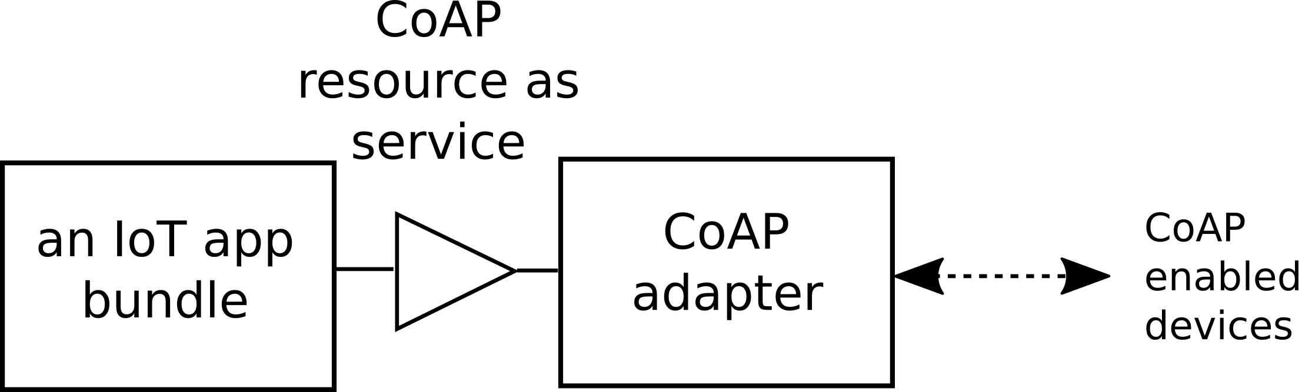
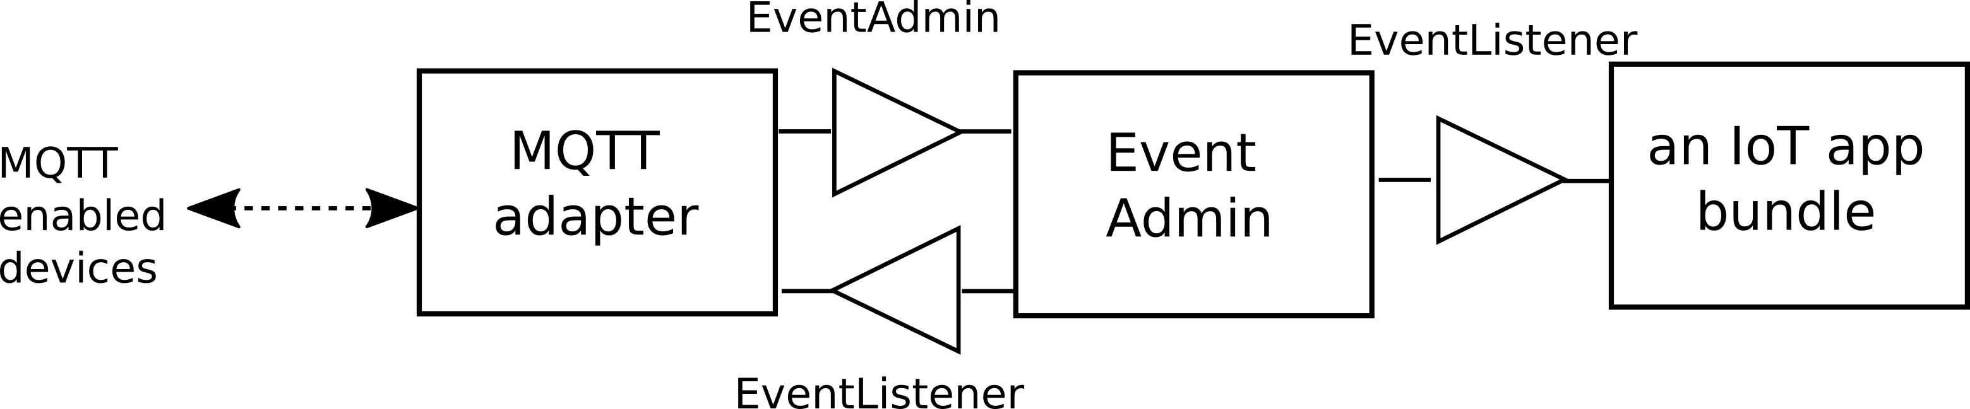

MQTT as distributed eventing mechanism between OSGi frameworks
An adapter that translates MQTT events to OSGi events through EventAdmin and vice versa could provide a mechanism for distributed eventing in OSGi.
TODO: relation with RFP 158

Use CoAP as Distribution Provider for OSGi
The RESTful design of CoAP could also allow it to be used as Distribution Provider for a RemoteServiceAdmin allowing to execute remote service calls via the CoAP protocol.

Requirements

CoAP
- C0010 – The solution MUST provide a Distributed OSGi configuration type name
- C0020 – The solution MUST define a mapping from a Java interface to a CoAP resource and vice versa.
- C0030 – The solution MUST provide a type safe way for parameters on the CoAP POST/GET methods to be made available to implementation methods.
- C0040 – The solution MAY provide a mechanism to discover CoAP endpoints and their metadata

MQTT
- M0010 – The solution MUST define a mapping from an MQTT topic to an EventAdmin topic
- M0020 – The solution MUST define a mapping from an MQTT message to an OSGi Event
- M0030 – The solution SHOULD provide a mechanism to define which OSGi Events should be sent to the MQTT broker

Document Support

References
- Bradner, S., Key words for use in RFCs to Indicate Requirement Levels, RFC2119, March 1997.
- Software Requirements & Specifications. Michael Jackson. ISBN 0-201-87712-0

Author’s Address

Name | Tim Verbelen
Company | iMinds, Ghent University
Address | Gaston Crommenlaan 8 box 201, 9050 Ghent, Belgium
Voice
e-mail | tim.verbelen@intec.ugent.be

End of Document

