
RFP 187 - oneM2M Service Layer API
Final
11 Pages

Abstract
oneM2M is standard organization and specifies middleware for IoT, called Common Services Entities (CSE). Application can access functionality in CSE with RESTful operations, which are Create, Retrieve, Update, Delete and Notify. oneM2M allows variety of communication methods, 4 protocol bindings (HTTP, MQTT, CoAP, Websocket) and 3 serializations (XML, JSON, CBOR). This RFP discuss the way to provide high level API for oneM2M RESTful operations hiding the difference of variety of communication methods.

Document Information

License
DISTRIBUTION AND FEEDBACK LICENSE, Version 2.0
The OSGi Alliance hereby grants you a limited copyright license to copy and display this document (the “Distribution”) in any medium without fee or royalty. This Distribution license is exclusively for the purpose of reviewing and providing feedback to the OSGi Alliance. You agree not to modify the Distribution in any way and further agree to not participate in any way in the making of derivative works thereof, other than as a necessary result of reviewing and providing feedback to the Distribution. You also agree to cause this notice, along with the accompanying consent, to be included on all copies (or portions thereof) of the Distribution. The OSGi Alliance also grants you a perpetual, non-exclusive, worldwide, fully paid-up, royalty free, limited license (without the right to sublicense) under any applicable copyrights, to create and/or distribute an implementation of the Distribution that: (i) fully implements the Distribution including all its required interfaces and functionality; (ii) does not modify, subset, superset or otherwise extend the OSGi Name Space, or include any public or protected packages, classes, Java interfaces, fields or methods within the OSGi Name Space other than those required and authorized by the Distribution. An implementation that does not satisfy limitations (i)-(ii) is not considered an implementation of the Distribution, does not receive the benefits of this license, and must not be described as an implementation of the Distribution. "OSGi Name Space" shall mean the public class or interface declarations whose names begin with "org.osgi" or any recognized successors or replacements thereof. The OSGi Alliance expressly reserves all rights not granted pursuant to these limited copyright licenses including termination of the license at will at any time.

EXCEPT FOR THE LIMITED COPYRIGHT LICENSES GRANTED ABOVE, THE OSGi ALLIANCE DOES NOT GRANT, EITHER EXPRESSLY OR IMPLIEDLY, A LICENSE TO ANY INTELLECTUAL PROPERTY IT, OR ANY THIRD PARTIES, OWN OR CONTROL. Title to the copyright in the Distribution will at all times remain with the OSGi Alliance. The example companies, organizations, products, domain names, e-mail addresses, logos, people, places, and events depicted therein are fictitious. No association with any real company, organization, product, domain name, email address, logo, person, place, or event is intended or should be inferred.

THE DISTRIBUTION IS PROVIDED "AS IS," AND THE OSGi ALLIANCE (INCLUDING ANY THIRD PARTIES THAT HAVE CONTRIBUTED TO THE DISTRIBUTION) MAKES NO REPRESENTATIONS OR WARRANTIES, EXPRESS OR IMPLIED, INCLUDING, BUT NOT LIMITED TO, WARRANTIES OF MERCHANTABILITY, FITNESS FOR A PARTICULAR PURPOSE, NON-INFRINGEMENT, OR TITLE; THAT THE CONTENTS OF THE DISTRIBUTION ARE SUITABLE FOR ANY PURPOSE; NOR THAT THE IMPLEMENTATION OF SUCH CONTENTS WILL NOT INFRINGE ANY THIRD PARTY PATENTS, COPYRIGHTS, TRADEMARKS OR OTHER RIGHTS.
NEITHER THE OSGi ALLIANCE NOR ANY THIRD PARTY WILL BE LIABLE FOR ANY DIRECT, INDIRECT, SPECIAL, INCIDENTAL OR CONSEQUENTIAL DAMAGES ARISING OUT OF OR RELATING TO ANY USE OR DISTRIBUTION OF THE DISTRIBUTION.

Implementation of certain elements of this Distribution may be subject to third party intellectual property rights, including without limitation, patent rights (such a third party may or may not be a member of the OSGi Alliance). The OSGi Alliance is not responsible and shall not be held responsible in any manner for identifying or failing to identify any or all such third party intellectual property rights.

The Distribution is a draft. As a result, the final product may change substantially by the time of final publication, and you are cautioned against relying on the content of this Distribution. You are encouraged to update any implementation of the Distribution if and when such Distribution becomes a final specification.

The OSGi Alliance is willing to receive input, suggestions and other feedback (“Feedback”) on the Distribution. By providing such Feedback to the OSGi Alliance, you grant to the OSGi Alliance and all its Members a non-exclusive, non-transferable, worldwide, perpetual, irrevocable, royalty-free copyright license to copy, publish, license, modify, sublicense or otherwise distribute and exploit your Feedback for any purpose. Likewise, if incorporation of your Feedback would cause an implementation of the Distribution, including as it may be modified, amended, or published at any point in the future (“Future Specification”), to necessarily infringe a patent or patent application that you own or control, you hereby commit to grant to all implementers of such Distribution or Future Specification an irrevocable, worldwide, sublicenseable, royalty free license under such patent or patent application to make, have made, use, sell, offer for sale, import and export products or services that implement such Distribution or Future Specification. You warrant that (a) to the best of your knowledge you have the right to provide this Feedback, and if you are providing Feedback on behalf of a company, you have the rights to provide Feedback on behalf of your company; (b) the Feedback is not confidential to you and does not violate the copyright or trade secret interests of another; and (c) to the best of your knowledge, use of the Feedback would not cause an implementation of the Distribution or a Future Specification to necessarily infringe any third-party patent or patent application known to you. You also acknowledge that the OSGi Alliance is not required to incorporate your Feedback into any version of the Distribution or a Future Specification.

I HEREBY ACKNOWLEDGE AND AGREE TO THE TERMS AND CONDITIONS DELINEATED ABOVE.

Trademarks
OSGi™ is a trademark, registered trademark, or service mark of the OSGi Alliance in the US and other countries. Java is a trademark, registered trademark, or service mark of Oracle Corporation in the US and other countries. All other trademarks, registered trademarks, or service marks used in this document are the property of their respective owners and are hereby recognized.

Feedback
This document can be downloaded from the OSGi Alliance design repository at https://github.com/osgi/design The public can provide feedback about this document by opening a bug at https://www.osgi.org/bugzilla/.

Table of Contents
0 Document Information 2
0.1 License 2
0.2 Trademarks 3
0.3 Feedback 3
0.4 Table of Contents 3
0.5 Terminology and Document Conventions 4
0.6 Revision History 4
1 Introduction 4
2 Application Domain 4
2.1 Terminology + Abbreviations 5
3 Problem Description 5
4 Use Cases 5
5 Requirements 6
6 Document Support 6
6.1 References 6
6.2 Author’s Address 6
6.3 End of Document 6

Terminology and Document Conventions
The key words "MUST", "MUST NOT", "REQUIRED", "SHALL", "SHALL NOT", "SHOULD", "SHOULD NOT", "RECOMMENDED", "NOT RECOMMENDED", "MAY" and "OPTIONAL" in this document are to be interpreted as described in 6.1.
Source code is shown in this typeface.

Revision History
The last named individual in this history is currently responsible for this document.

Revision | Date | Comments
Initial | June 24 2017 | Initial contribution  Hiroyuki Maeomichi, NTT, maeomichi.hiroyuki@lab.ntt.co.jp

Introduction
oneM2M is standard organization and specifies middleware for Internet of Things (IoT), called Common Services Entities (CSE). Applications can access CSE’s functionality with RESTful operations, which are Create, Retrieve, Update, Delete and Notify. TS-0001 [2] defines more than 40 resource types to expose CSE’s functionalities. oneM2M allows variety of communication methods, combination of 4 protocol bindings (HTTP, MQTT, CoAP, Websocket) and 3 serializations (XML, JSON, CBOR).
This RFP discuss the way to provide high level API (namely service layer API) for oneM2M RESTful operations hiding the difference of variety of communication methods.

Application Domain

IoT Application configuration using oneM2M
oneM2M’s middleware, called CSE can be deployed in different locations and they are connected each other forming tree topology. Depending on deployed location, CSEs are categorized to 3 types, IN-CSE, MN-CSE and ASN-CSE. IN-CSE is located top of tree, ASN-CSE is located at leaf and MN-CSE is located and MN-CSE is located on middle.

IN-CSE
MN-CSE
MN-CSE
ASN-CSE
ASN-CSE
AE
AE
AE

oneM2M’s application, called Application Entity (AE) connects to one of CSEs. After AE connecting to the CSE, AE can access to all of CSEs, by retargeting function of CSE.
AE accesses to CSE’s functionality through RESTful API, which consists of Create, Retrieve, Update, Delete and Notify in targeting more than 40 types of resources. For examples, typical resources are contentInstance that expresses IoT data and Container that holds set of contentInstances. AE can create or retrieve the contentInstance on any CSE by the retargeting functionality, if permission is allowed.
It is possible to develop variety types of distributed applications. For example for IoT data aggregation applications, it is possible to develop gradual aggregation type or direct aggregation type. In gradual aggregation type, AE connected to ASN-CSE creates conentInstances in ASN-CSE, and intermediate applications calculate statistics and put the result on IN-CSE as a contentInstance, while, in direct aggregation type, AE connected to ASN-CSE creates contentInstances in IN-CSE directly.
IN-CSE

MN-CSE
ASN-CSE
AE
AE
Sensor
IN-CSE

MN-CSE
ASN-CSE
AE
Sensor

Communication methods used in oneM2M
oneM2M allows variety of communication methods, combination of 4 protocol bindings (HTTP, MQTT, CoAP, Websocket) and 3 serializations (XML, JSON, CBOR). It might be added in future. oneM2M specifies specification in different level.
Firstly TS-0001[2] specifies high level resource definitions, it defines more than 40 resource types, such as contentInstance for storing IoT data, timeSeriesInstance for periodic sensor measurement with leap detection mechanism.
Secondly TS-0004[3] specifies procedures and serializations in independent manner from protocol bindings. Resource type and protocol data unit are defined using XSD for XML serialization. Mapping between XML and other serializations are also specified.
Thirdly TS-0008, TS-0009, TS-0010, TS-0020 specify protocol specific details for CoAP, HTTP, MQTT and Web Socket respectively.

Long name and short name
oneM2M introduced two types of notation, called long name and short name for resource types, attribute and so on. Long name is human friendly string and specifications mainly use this notation, while short name is short string consist of 2 – 4 characters and communication protocol use this notation. For examples, ct for CreationTime and at for AnnounceTo. Even if short name is defined by trying to use initial characters, it is not straight forward to translate them in head.

Problem Description
oneM2M specifies protocol based interface, but doesn’t specify programing level API. As previously mentioned oneM2M allows variety of communication methods which are the combinations of 4 protocol bindings (HTTP, MQTT, CoAP, Websocket) and 3 serializations (XML, JSON, CBOR).
First problem is application portability. Without standardized API, application program tends to depend on the communication method initially intend to use and it will became hard to run another environment in which uses another communication method. (E.g. an application designed for XML/HTTP, tend to run on environment use JSON/Websocket)
Second problem is the latency of the communication between CSE and application. Even if CSE and application is located in the same box, current oneM2M specifications define methods through protocols which requires serialization/deserialization of data, context-switch of applications, validation of incoming data and resulted in large latency compared to the situation both CSE and Application resides in the same Java VM and communicate with Java interfaces. Large latency reduces applicable area of oneM2M based solution.
Third problem is the complexity of handling of long name and short name.

Use Cases

Application uses oneM2M communication services to communicate outer CSE
First use case is the application using oneM2M communication service to connect CSE out side of the OSGI framework.
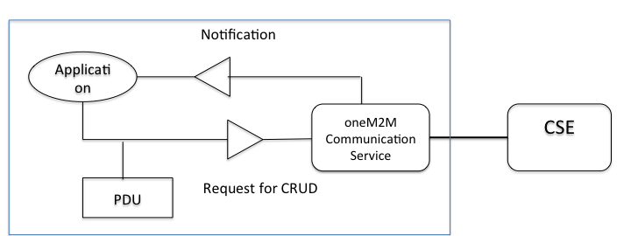

CSE uses oneM2M communication services to communicate upper CSE
Second use case is that a lower CSE uses oneM2M communication service to communicate upper CSE. Here CSE is acting like client side.

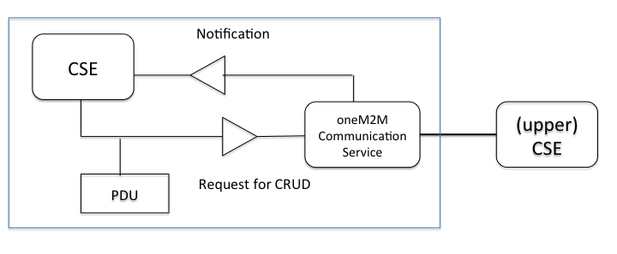
Outer AE accesses to CSE
Outer application entity accesses to CSE. oneM2M server-side communication service handles connection with AE and invoke CSE through the interface.
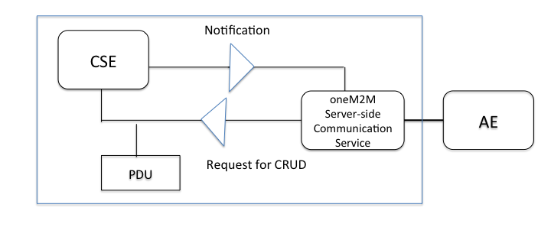

Communication inside of OSGi framework
Fourth use case is that application access to CSE inside of OSGi framework through Java Interface.
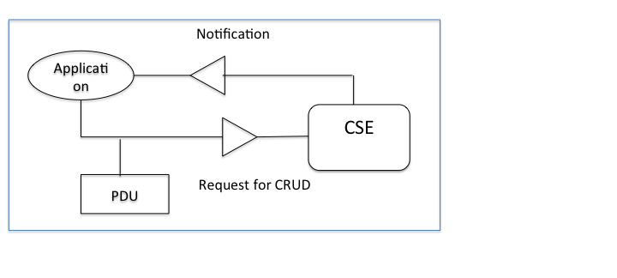

Requirements

- R0010 – The solution MUST provide means to access outer CSE from application and client CSE.
- R0011 – The solution MUST provide means to select a communication method to use for application and client CSE.
- R0020 – The solution MUST provide means for CSE to accept requests form outer CSE or application.
- R0030 – The solution MUST provide means to communicate through Java interface between CSE and application that are located in the same OSGi framework.
- R0040 – The solution SHOULD hide differences of communication methods, which are combinations of 4 protocol bindings and 3 serializations (XML, JSON, CBOR).
- R0050 – The solution SHOULD provide developer friendly way for handling short names.

Document Support

References
- Bradner, S., Key words for use in RFCs to Indicate Requirement Levels, RFC2119, March 1997.
- oneM2M TS-0001 Functional Architecture, http://onem2m.org/images/files/deliverables/Release2/TS-0001-%20Functional_Architecture-V2_10_0.pdf
- oneM2M TS-0004 Service Layer Core Protocol, http://onem2m.org/images/files/deliverables/Release2/TS-0004_Service_Layer_Core_Protocol_V2_7_1.zip
- RFC 7049 Concise Binary Object Representation, http://cbor.io

Author’s Address

Name | Hiroyuki Maeomichi
Company | NTT
Address | Midorimachi 3-9-11, Musashino, Tokyo, Japan
Voice
e-mail | maeomichi.hiroyuki@lab.ntt.co.jp

End of Document

