
Resource Management
Draft
75 Pages
Abstract
OSGi applications need hardware and software resources to perform their features. As these resources are limited, they have to be fairly shared between applications in order to preserve the global quality of service. Up to now, OSGi platforms delegate the resource management features to the Java Virtual Machines themselves or took advantage of some external Java Resource Management solution like JVM TI or JMX. Unfortunately, all of these resource management solutions provide features at the Object or Class level. This granularity is too low level to easily monitor resources consumed by OSGi applications.
This specification proposes a Resource Management solution fitting with OSGi model and constraints. Resources (CPU, memory, disk storage space, I/O) are monitored per bundle and can be enabled and disabled at runtime. When a bundle consumes too many resources, the Resource Management solution notifies interested applications and limits resource allocations.

Document Information

License
DISTRIBUTION AND FEEDBACK LICENSE, Version 2.0
The OSGi Alliance hereby grants you a limited copyright license to copy and display this document (the “Distribution”) in any medium without fee or royalty. This Distribution license is exclusively for the purpose of reviewing and providing feedback to the OSGi Alliance. You agree not to modify the Distribution in any way and further agree to not participate in any way in the making of derivative works thereof, other than as a necessary result of reviewing and providing feedback to the Distribution. You also agree to cause this notice, along with the accompanying consent, to be included on all copies (or portions thereof) of the Distribution. The OSGi Alliance also grants you a perpetual, non-exclusive, worldwide, fully paid-up, royalty free, limited license (without the right to sublicense) under any applicable copyrights, to create and/or distribute an implementation of the Distribution that: (i) fully implements the Distribution including all its required interfaces and functionality; (ii) does not modify, subset, superset or otherwise extend the OSGi Name Space, or include any public or protected packages, classes, Java interfaces, fields or methods within the OSGi Name Space other than those required and authorized by the Distribution. An implementation that does not satisfy limitations (i)-(ii) is not considered an implementation of the Distribution, does not receive the benefits of this license, and must not be described as an implementation of the Distribution. "OSGi Name Space" shall mean the public class or interface declarations whose names begin with "org.osgi" or any recognized successors or replacements thereof. The OSGi Alliance expressly reserves all rights not granted pursuant to these limited copyright licenses including termination of the license at will at any time.

EXCEPT FOR THE LIMITED COPYRIGHT LICENSES GRANTED ABOVE, THE OSGi ALLIANCE DOES NOT GRANT, EITHER EXPRESSLY OR IMPLIEDLY, A LICENSE TO ANY INTELLECTUAL PROPERTY IT, OR ANY THIRD PARTIES, OWN OR CONTROL. Title to the copyright in the Distribution will at all times remain with the OSGi Alliance. The example companies, organizations, products, domain names, e-mail addresses, logos, people, places, and events depicted therein are fictitious. No association with any real company, organization, product, domain name, email address, logo, person, place, or event is intended or should be inferred.

THE DISTRIBUTION IS PROVIDED "AS IS," AND THE OSGi ALLIANCE (INCLUDING ANY THIRD PARTIES THAT HAVE CONTRIBUTED TO THE DISTRIBUTION) MAKES NO REPRESENTATIONS OR WARRANTIES, EXPRESS OR IMPLIED, INCLUDING, BUT NOT LIMITED TO, WARRANTIES OF MERCHANTABILITY, FITNESS FOR A PARTICULAR PURPOSE, NON-INFRINGEMENT, OR TITLE; THAT THE CONTENTS OF THE DISTRIBUTION ARE SUITABLE FOR ANY PURPOSE; NOR THAT THE IMPLEMENTATION OF SUCH CONTENTS WILL NOT INFRINGE ANY THIRD PARTY PATENTS, COPYRIGHTS, TRADEMARKS OR OTHER RIGHTS.
NEITHER THE OSGi ALLIANCE NOR ANY THIRD PARTY WILL BE LIABLE FOR ANY DIRECT, INDIRECT, SPECIAL, INCIDENTAL OR CONSEQUENTIAL DAMAGES ARISING OUT OF OR RELATING TO ANY USE OR DISTRIBUTION OF THE DISTRIBUTION.

Implementation of certain elements of this Distribution may be subject to third party intellectual property rights, including without limitation, patent rights (such a third party may or may not be a member of the OSGi Alliance). The OSGi Alliance is not responsible and shall not be held responsible in any manner for identifying or failing to identify any or all such third party intellectual property rights.

The Distribution is a draft. As a result, the final product may change substantially by the time of final publication, and you are cautioned against relying on the content of this Distribution. You are encouraged to update any implementation of the Distribution if and when such Distribution becomes a final specification.

The OSGi Alliance is willing to receive input, suggestions and other feedback (“Feedback”) on the Distribution. By providing such Feedback to the OSGi Alliance, you grant to the OSGi Alliance and all its Members a non-exclusive, non-transferable, worldwide, perpetual, irrevocable, royalty-free copyright license to copy, publish, license, modify, sublicense or otherwise distribute and exploit your Feedback for any purpose. Likewise, if incorporation of your Feedback would cause an implementation of the Distribution, including as it may be modified, amended, or published at any point in the future (“Future Specification”), to necessarily infringe a patent or patent application that you own or control, you hereby commit to grant to all implementers of such Distribution or Future Specification an irrevocable, worldwide, sublicenseable, royalty free license under such patent or patent application to make, have made, use, sell, offer for sale, import and export products or services that implement such Distribution or Future Specification. You warrant that (a) to the best of your knowledge you have the right to provide this Feedback, and if you are providing Feedback on behalf of a company, you have the rights to provide Feedback on behalf of your company; (b) the Feedback is not confidential to you and does not violate the copyright or trade secret interests of another; and (c) to the best of your knowledge, use of the Feedback would not cause an implementation of the Distribution or a Future Specification to necessarily infringe any third-party patent or patent application known to you. You also acknowledge that the OSGi Alliance is not required to incorporate your Feedback into any version of the Distribution or a Future Specification.

I HEREBY ACKNOWLEDGE AND AGREE TO THE TERMS AND CONDITIONS DELINEATED ABOVE.

Trademarks
OSGi™ is a trademark, registered trademark, or service mark of the OSGi Alliance in the US and other countries. Java is a trademark, registered trademark, or service mark of Oracle Corporation in the US and other countries. All other trademarks, registered trademarks, or service marks used in this document are the property of their respective owners and are hereby recognized.

Feedback
This document can be downloaded from the OSGi Alliance design repository at https://github.com/osgi/design The public can provide feedback about this document by opening a bug at https://www.osgi.org/bugzilla/.

Table of Contents
0 Document Information 2
License 2
Trademarks 3
Feedback 3
Table of Contents 3
Terminology and Document Conventions 4
Revision History 5
1 Introduction 9
2 Application Domain 10
What are resources? 10
Most common and crucial resources 11
What is Healthiness? 12
Terminology and abbreviations 12
3 Problem Description 13
Cooperative applications 13
Less cooperative or legacy applications 14
4 Requirements 14
5 Initial Specification Chapter 15
Essentials 15
Entities 16
Operation summary 17
Resource Context 18
System Resource Context 18
Framework Resource Context 18
Resource Monitor 18
Resource Monitor Factory 19
CPU Monitor 20
Memory Monitor 20
Socket Monitor 20
Disk Storage Monitor 20
Thread Monitor 20
Resource Listener 21
Resource Event 24
Resource Context Listener 24
Resource Context Event 25
Resource Manager 25
Resource Management Authority 26
6 Javadoc 26
7 Considered Alternatives 66
Resource Manager inside the Core framework or in a bundle? 66
Adapt pattern or OSGi service? 66
Eventing paradigms 66
Resource event classes 66
CPU Monitor 67
Resource Threshold algorithm and eventing 67
Resource Monitor Factory 68
Resource accounting and context switching 68
Compatibility between bundles capabilities 72
Implementation of resource management aware bundles 72
Example 1 73
Example 2 73
Event Admin use-case 74
Http Service use-case 75
8 Security Considerations 76
9 Document Support 76
References 76
Author’s Address 77
Acronyms and Abbreviations 78
End of Document 78

Terminology and Document Conventions
The key words "MUST", "MUST NOT", "REQUIRED", "SHALL", "SHALL NOT", "SHOULD", "SHOULD NOT", "RECOMMENDED", "NOT RECOMMENDED", "MAY" and "OPTIONAL" in this document are to be interpreted as described in 1.
Source code is shown in this typeface.

Revision History
The last named individual in this history is currently responsible for this document.

Revision | Date | Comments
Initial | 03 06 2013 | Initial draft.  RINQUIN Arnaud, Orange, arnaud.rinquin@orange.com  BOTTARO André, Orange, andre.bottaro@orange.com  BONNARDEL Grégory, Orange, gbonnardel.ext@orange.com
v01 | 04 16 2013 | Some modifications after the Cologne meeting:  - Global Resource Context is now named as Platform Resource Context  - Bandwidth Monitor → Socket Monitor  - Resource Context persistence  - Add a table indicating the type of Java object the ResourceMonitor.getUsage() method returns for each type of resource.  - New paragraph about the use of the context switching operation (chapter 6.15 Resource Manager)
V02 | 04 30 2013 | Fixes:  - Rewritings  - Operation Summary  - CPU Monitor  - Socket Monitor  - Framework Resource Context  - Actions are taken by authorities  Added:  - Resource Thresholds  - Resource Event Types  - Back To Normal  - Back To Warning
V03 | 05 14 2013 | Fixes:  - Rewritings  - Memory Monitor (OutOfMemoryException)  - Implementation of all types of Resource Monitor is optional  - Socket Monitor (existing sockets)  - BACK_TO_NORMAL Resource Event → NORMAL Resource Event  - BACK_TO_WARNING Resource Event → WARNING Resource Event  Added:  - A new paragraph about algorithms reducing the number of Resource Event into the Considered Alternatives chapter.  - Socket Monitor scope in Considered Alternatives
V04 | 05 22 2013 | Fixes:  - Socket Monitor  - only tracks bound or connected socket  - throw a SocketException when an error threshold is reached  - Rewritings  - Disk Storage Monitor (exception)  - Thread Monitor (exception)
V05 | 05 28 2013 | Modifications:  - Add Resource Monitor Factory (new paragraph + entity diagram)  - Change resource monitor threshold list to maximum and minimum threshold attributes
V06 | 06 04 2013 | Modifications:  - Add ResourceContext.addMonitor() and ResourceContext.removeMonitor() methods.  - Clarify the Resource Monitor state when a new instance is created by a ResourceMonitorFactory.  - ResourceEvent.getResourceThreshold() returns a SNAPSHOT of the Resource Threshold instance at the moment when the event was generated.  - Resource Thresholds:  - A Resource Monitor holds an upper Resource Threshold instance and a lower Resource Threshold.  - Add a diagram showing Resource Threshold state transitions. This diagram also shows what kind of Resource Event is generated.  - Clarify which threads are monitored by a ThreadMonitor (alive thread = all threads which are in the RUNNABLE, BLOCKED, WAITING, TIMED_WAITING java state).
V07 | 06 12 2013 | Modifications:  - Refactoring of the Resource Event interface:  - Add getResourceType() method  - Add getValue() method  - Add getThresholdValue() method  - Add isUppperThreshold() method  - Remove getMonitor() method  - Remove getThreshold() method  - Remove getMonitor() method
V08 | 06 19 2013 | Updates:  - Replace ResourceMonitor.setMonitored(boolean) by ResourceMonitor.enable()/disable()  - Replace ResourceMonitor.isMonitored() by ResourceMonitor.isEnabled()  - Threshold diagram (new colors + state)
V09 | 06 26 2013 | Updates:  - Resource Monitor Factory chapter  - the newly created Resource Monitor instance is disabled by default because it should be configured before activation.  - Resource Monitor instance MUST be created only by Resource Monitor Factory instance.  - Add ResourceMonitor,isDeleted() method.  - Considered Alternatives  - ResourceMonitor instantiations without ResourceMonitorFactory.
V10 | 07 04 2013 | Updates:  - Add a new diagram for upper threshold (cpu example)  - The upper and lower threshold diagram has been adapted to the socket resource
V11 | 07 10 2013 | - Replaced arrows by circles into diagrams related to Resource Thresholds. Removed the text on arrows/circle. Update diagram titles.
V12 | 07 18 2013 | - Remove old references to connected socket → in-use state sockets  - Remove old references to active/started threads → alive threads  - Remove old reference to Bandwidth Monitor → Socket Monitor  - Update Extensibility clause of the Essentials chapter (5 types of resources instead of 4).  - New use case for the context switching operation (Event Handler use case)
V13 | 07 23 2013 | - A Socket Monitor tracks native socket file descriptors.  - Update UML Schema:  - add Resource Listener Implementer entity  - add Resource Monitor Factory Implementer entity  - Update Operation Summary  - Add new section in Considered Alternatives about compatibility implementation between bundles which handles ResourceManagement api and the other ones.
V14 | 07 30 2013 | - Add EventAdmin and HttpService use cases into compatibility section  - Describe how a bundle can manage Resource Management features (direct implementation, weaving, service proxy)
V15 | 08 06 2013 | - ResourceManager entity registered as a service and accessible through the adapt method.
V16 | 08 14 2013 | - Introduce Resource Context Listener and Resource Context Event  - All Resource Context are retrieved through the Resource Manager service (Bundle.adapt() approach is deprecated)  - Thresholds are now hosted by Resource Listener  - Resource Threshold entities have been removed.
V17 | 09 26 2013 | - Exceptions thrown when a threshold is reached are now optional.  - Use of MemoryException instead of OutOfMemoryException
V18 | 11 06 2013 | - Introduce new methods in ResourceMonitor reporting resource context operations.
V19 | July 24, 2014 | Antonin CHAZALET, Orange  - Fix typos.  - Add several comments.
v20 | July 25th, 2014 | André Bottaro, Orange  - Removed context switching feature in the specification chapter part. Put the main context switching feature descriptions into 'considered alternatives' section.  - Partially removed the link between resource context and threads. To be continued.
V21 | July 30th, 2014 | Antonin CHAZALET, Orange  - Add javadoc.
V22 | August 1st, 2014 | Antonin CHAZALET, Orange  André BOTTARO, Orange  - Remove “links” amongst Resource Context, and Thread.
V23 | September 8th, 2014 | Antonin CHAZALET, Orange  André BOTTARO, Orange  - Remove MemoryException.  - Update Javadoc.

Introduction
Applications, executed on an OSGi platform, need hardware resources (CPU, memory, disk, storage space) and software resources (sockets, threads). As these resources are limited, applications have to share them in order to preserve system quality of service. This is a general fact in the Entreprise and Residential markets.
Providing fair resource management features is crucial for the Smart Home to emerge as Residential players are opening their gateway (or box) execution environment to third party apllications. In this perspective, the framework administrator has to fairly offer the same guarantees to every actor sharing the platform.
Resource Monitoring is also vital to Cloud Computing scenarios where a management agent needs to ensure that SLAs agreed around the cloud offering are met. When a cloud node gets overloaded or fails this can affect the pre-agreed SLA and action needs to be taken. In a Cloud Computing scenario this may imply starting additional nodes, adjusting the provisioning state of the system by moving or adding deployments or indeed shutting down some nodes if the system become quiet. To be able to handle such scenarios the management agent will need to have visibility of the resource utilization of the cloud system as a whole, which encompasses a multiplicity of nodes and runtimes.
For the moment, existing OSGi specifications do not provide monitoring resource mechanism ensuring a fair resource sharing between bundles and applications. The underlying JVM provides only some standard mechanisms at a level that is too fine-grained, e.g., classes, objects, methods. The bundle being the smallest deployment unit of interest for platform administrator and application provides, this RFC defines an API compliant with the RFP [3].
Introduce the RFC. Discuss the origins and status of the RFC and list any open items to do.

Application Domain
Resources of environments are always limited and entities that share such environments should be aware of that. This is not different in OSGi environments. Each bundle consumes resources of different types. Some of them are required for the very basic operations, some others are nice to have, but all of them can run out and lead to situations where the bundle, a set of bundles that form an application, or even the framework as a whole is not operational anymore.
Problematic situations arise when a software unit binds a lot of resources but does not release them after normal operation. This can be caused by wrong implementations, wrong error handling or by intention in case of malware. Especially in environments with very limited resources and/or with a huge number of bundles/vendors it is crucial to monitor the state of bundles and their resource consumption and also to provide mechanisms to react on detected failures.

What are resources?
There are some obvious, basic resources like CPU, memory, disk-space, bandwidth. But new applications might introduce the need for new, different types of resources that are required for their normal operation (e.g., the presence of certain external services and devices, room temperature etc.). Because of that it is impossible to provide a complete list of potential resources here. The following figure tries to illustrate that:
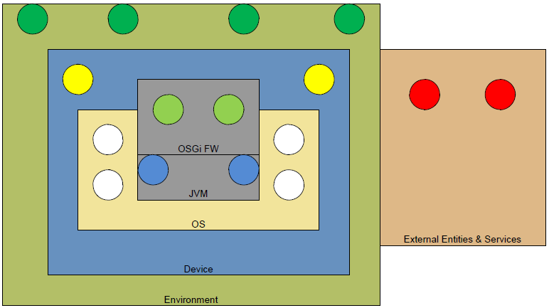Figure 1: Origins of resources
Every circle in this picture stands for a certain resource. As illustrated these resources can
come from:
- the same OSGi Framework (e.g., service instances, exported packages …),
- the same Java VM (e.g., threads, memory …),
- the device (e.g., USB-Ports,, network interfaces/ports …),
- the local environment (e.g., room temperature, power consumption of the device, geo-location…),
- or from completely external locations (e.g., special external services like maps, dictionary …).

Most common and crucial resources
Applications use hardware and operating system resources. Targeted resources are:
- CPU
- Memory
- Disk storage space
- Bandwidth on connected networks
JVMs allocate these resources when applications call Java standard APIs. They may provide resource monitoring mechanisms such as:
- Java Management Extension (JMX), now provided by all J2SE-v5-compliant JVM
- JVM Tool Interface Interface(JVMTI) and JVM Profiler Interface (JVMPI)
- Proprietary resource management API (e.g., IBM J9, Oracle Java Embedded Client, /K/ Embedded Mika Max, Myriad Jbed)
The latter provide strict algorithms that charge bundles with consumed resources. There are
two known algorithms [4].:
- Direct accounting: the resources consumed during bundle interaction are accounted to the code provider. In other words, the CPU used by a code that belongs to bundle A will be accounted to A, even if it is the bundle B that called this code through a public interface.
- Indirect accounting: all the resources consumed by the threads belonging to a bundle are accounted to this same bundle. Therefore in service interaction there is no resource consumption accounted to service providers.
Java and OSGi enables CPU management per bundle on any VM (without any VM customization) [4].[5].
However, memory management require that standard VMs either implement JVMTI Java standard [8]. or implement custom APIs. [6].[7]. These features are not available on standard VMs, with the following definition: a standard Java platform implements the JVM Specification [9]., Java Language Specification [10]. and base class libraries (http://docs.oracle.com/javase/7/docs/api). It does not include tools like javac, javadoc, JVMTI, tools.jar which are outside the Java platform specification.

What is Healthiness?
Healthiness of an entity (service, bundle, set of bundles, or the whole framework) is meant as the state where the entity is operational as it was specified and will be for the foreseeable future. The correct operation of such an entity is often strongly related to the availability, and perhaps a certain quality, of resources that the entity needs to work. That means an entity that doesn’t have or get the required resources is not healthy. There might also be intermediate states where mandatory resources are there, but some optional ones are not available.
Other reasons for non-healthy entities are potential failure situations either inside the entity itself or in their environment. Sometimes such conditions cause shortage of other resources, which at the end affects other entities as well.
So, in order to ensure the healthiness of entities the first step that should be done is to ask themselves, “how do you feel?”, and the second step is to know the entities resources requirements, and to monitor their availability.

Terminology and abbreviations

Application
A set of bundles needed to render a full application to the user.

Observable
An entity that is subject of Health monitoring. In the scope of this document this can be a framework, a bundle or a set of bundles.

Health
The state of an observable that describes its ability to work as specified.

Resource
A limited source or supply of physical or virtual goods that are used by bundles in order to provide their service(s).

Fault
The term fault is usually used to name a defect at the lowest level of abstraction, e.g., a memory cell that always returns the value 0.

Error
A fault may cause an error, which is a category of the system state.

Failure
An error, in effect, may lead to a failure, meaning that the system deviates from its correctness specification.

This section should be copied from the appropriate RFP(s). It is repeated here so it can be extended while the RFC authors learn more subtle details.

Problem Description
OSGi platforms host several applications which are executed concurrently. These applications have to share limited resources between them.

Cooperative applications
These mechanisms should also allow to estimate the severity of the situation and to decide for required actions to recover the intended state. Ideally, this should be done in cooperation with the bundle that causes the failure. If a failure situation is detected and can be assigned to a certain bundle, then first this bundle should have the chance to take actions to come back to a healthy state. If this is not successful, then appropriate actions must be taken by another entity.
Due to the wide range of potential failures and the definition of resources as very generic and application specific, this can not be achieved by a fixed and inflexible mechanism that handles a fixed set of predefined problems.
What is needed is a flexible framework that allows dynamic provisioning of modules to:
- collect information about resource requirements, and further, the normal, intended states of the monitored entities,
- monitor those resources (as defined above) and ask services for their health status,
- warn interested and legitimate applications when monitored consumptions are above thresholds,
- evaluate the severity of deviations of the currently monitored state from the intended state,
- take decisions and perform actions to recover the intended state,
- control/monitor the success of the actions taken.

Less cooperative or legacy applications
In case of an application consumes too much resources, it may affect the quality of service of the other applications installed on the platform. Those situations have to be prevented by OSGi platforms.
As described in the previous chapter, JVMs may provide resource management mechanisms. However, all these solutions are designed to monitor low granularity elements: e.g., threads, classes, objects or methods.
As such, these data are of limited interest and there is a need to raise the abstraction to the primitive deployment unit in OSGi, bundles and applications (or sets of bundles). This encourages the specification of a standard unified OSGi-level API managing resources of bundles and sets of bundles installed on the platform.

This section should be copied from the appropriate RFP(s). It is repeated here so it can be extended while the RFC authors learn more subtle details.

Requirements
R1: The solution MUST provide at least one resource accounting algorithm (e.g., direct accounting algorithm).
R2: The solution MUST monitor resources per bundle or per bundle set.
R3: The resource monitoring solution MUST be configurable, enabled and disabled at runtime per bundle or per bundle set.
R4: The solution MUST monitor the following resources, if relevant on the underlying (hardware and software) platform:
- CPU
- Memory
- Disk storage space
- Bandwidth on any connected network
R5: The solution MUST provide a mechanism to list the resource types that can be monitored on the underlying (hardware and software) platform.
R6: The solution MUST allow the setting of a warning threshold and an error threshold per bundle or set of bundles.
R7: The solution MUST send events while a bundle or a bundle set is exceeding one of the two thresholds defined by R6.
R8: The solution MUST define CPU thresholds as a percentage of use over a configurable period.
R9: The solution MUST define memory thresholds as bytes.
R10: The solution MUST define disk storage space thresholds as bytes.
R11: The solution MUST define thread thresholds as a number of threads.
R12: The solution MUST define socket thresholds as a number of opened sockets.
R13: The solution MUST be able to lower bundle thread priorities while CPU error threshold is reached.
R14: The solution MUST raise an error (e.g., OutOfMemoryError) and MUST prevent further memory allocation while memory error threshold is reached.
R15: The solution MUST raise an error (e.g., IOException) and MUST prevent further disk storage space allocation while disk storage space error threshold is reached.
R16: The solution MUST raise an error (e.g., InternalError) and MUST prevent further thread activation while thread error threshold is reached.
R17: The solution MUST raise an error (e.g., IOException) and MUST prevent further connected-state socket while socket error threshold is reached.
R18: The solution MUST define means for bundles to define their intend resource usage.
R19: The solution MUST allow OSGi applications to monitor bundles, evaluate their states and take decisions to react gracefully.
R20: The solution MAY define optional means for a bundle to resolve its own conflicts based on the decisions of the entity introduced in R19.
R21: Thanks to notification from R6, an application able to monitor the success of R20 MAY take actions, if the conflicts are not resolved after a period of time. Default action MAY be that the framework mechanism resolve this conflict.
R22: The solution MUST provide a mechanism that allows to plug application specific components to evaluate application specific resources.
R23: Special (non standard, see standard Java Runtime definition in section 2) Java platform implementations MAY be necessary to support management of certain resource types.

Initial Specification Chapter

Essentials
Monitoring – Bundle execution resource usage is monitored.

Granular activation – The resource manager can be activated and deactivated per bundle or per bundle set.
Extensibility – five resource types are specified (CPU, memory, disk storage, alive thread and in-use sockets). The list of monitored resource types is extensible and query-able.

Eventing – the resource manager notifies interested entities of exceeded limits.

Entities
Resource Context – A logical entity for resource accounting. A context may be related to a single bundle or a set of bundles.
System Resource Context – Resource context of the core framework.
Platform Resource Context – A Resource context monitoring the resource usage of the platform as a whole.
Resource Monitor – Monitors the usage of a specific resource type for a specific Resource Context. Resource Monitors track resource usage. They hold Resource Thresholds instances. Resource Monitor object implementation may depend on standard or proprietary JVM APIs, and on operating system features.
Resource Monitor Factory – a factory creating Resource Monitor instances for every Resource Context.
CPU Monitor – Resource Monitor used to monitor CPU.
Memory Monitor – Resource Monitor used to monitor memory.
Socket Monitor – Resource Monitor used to monitor socket resource.
Disk Storage Monitor – Resource Monitor for disk storage usage.
Thread Monitor – Resource Monitor used to monitor alive Java Thread objects.
Resource Listener – A Resource Listener receives resource threshold notifications.
Resource Event – A Resource Event defines a notification to be sent to Resource Listener instances.
Resource Context Listener – A Resource Context Listener receives notifications about resource context creation and configuration.
Resource Context Event – A Resource Context Event defines a notification to be sent to Resource Context Listeners instances.
Resource Manager – This is a singleton entity which manages Resource Context instances. It is used to create new Resource Context instances and to enumerate existing contexts.
Resource Management Authority – Makes any decision to ensure the quality of the service of the system. They use the Resource Manager to create Resource Context instances. It configures them by adding bundles and Resource Monitors.

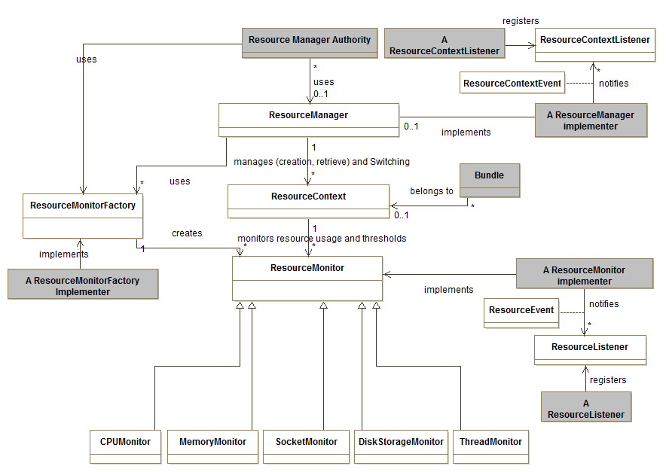Figure 2: Resource management class diagram specification

Operation summary
Resource Management Authorities use the Resource Manager service to create Resource Contexts. These authorities set bundles or group of bundles to Resource Contexts. They also request every Resource Monitor Factory to create Resource Monitors for a resource type. These Resource Monitors are associated to a single Resource Context.
When activated, Resource Monitors provide the current resource usage per Resource Context. Then, they check whether the current resource usage is compatible with the thresholds held by their associated Resource Listeners. When one of these thresholds is violated, the related Resource Monitor notifies the Resource Listener holding this threshold.
The Resource Manager manages the set of Resource Contexts. Resource Contexts are persistent between platform restarts. Resource Context Listeners are notified when a Resource Context is created or deleted or when a Resource Context configuration (i.e., adding or removing of bundle) is updated.

Resource Context
A Resource Context instance is a logical entity used to account resource usage. Every Resource Context defines a bundle scope which can be either a single bundle or a set of bundles. Once the bundle scope is defined, resources used by those bundles are monitored through a set of per-resource-type Resource Monitor instances.
Resource Context instances are persistent. The persistence of those instances is directly managed by the Resource Manager instance.
Each Resource Context is uniquely identified by a name. It can be retrieved through the getName() method. It can not be changed, i.e. it is definitively set when the Resource Context instance is created.
The Resource Context bundle scope is retrieved through the getBundles() method. This bundle scope can be extended through the addBundle(Bundle) method. Bundles can also be removed from a Resource Context through the removeBundle(Bundle, ResourceContext) method. For this last method, a Resource Context instance MAY be specified in order to associate the removed bundle to another Resource Context instance.
Resource Monitor instances are retrieved through getResourceMonitor(String resourceType) method or the getMonitors() method. The list of available resource types is retrieved through the Resource Manager singleton instance.
Resource Monitor instances are added to and removed from a Resource Context instance by calling either addMonitor() method or removeMonitor() method. Both methods SHOULD only be called by ResourceMonitorFactory instances (see ResourceMonitorFactory.createMonitor() method).
A Resource Context is retrieved through the Resource Manager service.
A Resource Context instance can be deleted through removeContext(ResourceContext) method. The Resource Context input argument then defines a destination Resource Context instance for the bundles belonging to the to-be-removed Resource Context instance.

System Resource Context
The System Resource Context is the Resource Context of the core framework. It is retrieved through the Resource Manager service.
The name of this context is “system”.

Framework Resource Context
The Framework Resource Context is a Resource Context monitoring resources of the platform as a whole. It is retrieved through the Resource Manager service. This Resource Context holds all hosted bundles allowing access to the whole platform resource consumption.
The name of this context is “framework”.

Resource Monitor
A Resource Monitor instance monitors a resource type consumed by the bundles of a specific Resource Context instance.
A Resource Context instance holds at most one Resource Monitor instance per monitor-able resource type. Resource Monitor instances are retrieved through their related Resource Context instance. Resource Monitor instances give access to their related Resource Context instance through a call to getContext() method.
The monitored resource type is retrieved through getType() method.
The current usage of a resource consumed by a Resource Context instance is given through getUsage() method. This method returns a Java Object to be casted to the appropriate Java object type depending on the Resource type. The next table provides the expected Java Object type for each specified resource type:
Type of Resource | Expected Java Object type | Value description
CPU | Long | Cumulative CPU time in ns
Memory | Long | Allocated memory in bytes
Threads | Long | Number of alive thread.
Socket | Long | Number of in-use socket.
Disk storage space | Long | Bytes on the bundle persistent storage area
For example, for a Memory Monitor instance, a call to MemoryMonitor.getUsage() returns a Long java object indicating the amount of memory the related Resource Context instance is consuming.
A Resource Monitor instance is enabled and disabled through enable() and disable() methods. The state (enabled or disabled) of a Resource Monitor is retrieved through a call to isEnabled() method.
A Resource Monitor instance can also be deleted (delete() method). isDeleted() method returns true if the ResourceMonitor instance has been deleted.

Five types of Resource Monitor are specified:
- CPU Monitor
- Memory Monitor
- Socket Monitor
- Disk Storage Monitor
- Thread Monitor
The support of any Resource Monitor is optional. This list MAY be extended by the solution vendor. The list of the types that are supported on the OSGi platform can be computed by querying ResourceMonitorFactory services.

Resource Monitor Factory
A Resource Monitor Factory is a service that provides Resource Monitor instances of a specific resource type (e.g., CPUMonitor, MemoryMonitor...) for every Resource Context.
Every Resource Monitor Factory service is registered with the org.osgi.resourcemanagement.ResourceType mandatory property. This property indicates which type of Resource Monitor a Resource Monitor Factory is able to create. The type can also be retrieved through a call to ResourceMonitorFactory.getType(). The type MUST be unique (two Resource Monitor Factory instances MUST not have the same type).
New Resource Monitor instances are created by a call to createResourceMonitor(ResourceContext). This method returns a new Resource Monitor instance associated to the provided Resource Context instance (the ResourceMonitorFactory MUST call ResourceContext.addMonitor() to associate the newly created ResourceMonitor with the provided ResourceContext instance). The newly created Resource Monitor is disabled, i.e., it is initially not monitoring the Resource Context resource consumption. It can be activated through a call to ResourceMonitor.enable().
Resource Monitor instances are deleted by calling ResourceMonitor.delete() method.
A Resource Monitor instance MUST only be created through its ResourceMonitorFactory.
Resource Monitor Factory instances should be only used by the Resource Manager singleton instance. The Resource Manager singleton instance performs a service lookup on all existing Resource Monitor Factories. It uses a Resource Monitor Factory instance when it has to create a new Resource Context instance and their associated Resource Monitor instances.

CPU Monitor
A CPU Monitor instance is a Resource Monitor used to monitor the CPU usage of the bundles belonging to a Resource Context.
CPU usage and thresholds are expressed as a cumulative number of nanoseconds (Long). The encapsulated value can be retrieved with the CPUMonitor.getCPUUsage() method.
In case where a threshold is reached, the CPU Monitor instance generates an event triggering Resource Authorities defined corrective actions (e.g., decrease thread priority).

Memory Monitor
A Memory Monitor instance monitors and limits the memory used by the bundles of a Resource Context instance.
Memory is accounted as bytes. Memory usage and thresholds are Long java objects. The encapsulated value can be retrieved through the getMemoryUsage() method.
When an error threshold is reached, the next memory allocation MAY be prevented by the system and MAY throw a specific Exception in the associated context.

Socket Monitor
A Socket Monitor instance monitors and limits the number of existing sockets (e.g., TCP, UDP) which are considered to be in use (e.g., listening for incoming packet, bound, or sending outgoing packets).
A Socket is considered to be in-use state when a native socket file descriptor is created. It leaves this state when this socket file descriptor is deleted.
The number of in-use sockets is a Long. The encapsulated value can be retrieved using SocketMonitor.getSocketUsage() method.
When an ERROR threshold is reached, the next socket file descriptor creation in the associated context MAY throw a SocketException.

Disk Storage Monitor
A Disk Storage Monitor instance monitors and limits the use of persistent storage within Bundle Persistent Storage Area a Resource Context (the bundles actually belonging to it) consumes.
Disk Storage is expressed as a number of bytes of type Long. The encapsulated value can be retrieved using DiskStorageMonitor.getUsedDiskStorage() method.
A IOException MAY be thrown in the associated context when an error threshold is reached.

Thread Monitor
A Thread Monitor instance monitors and limits the number of alive Java Thread objects for a Resource Context instance. A Thread is considered to be alive when it is in the RUNNABLE, BLOCKED, WAITING or TIMED_WAITING java state.
Usage and thresholds are Java Long objects. The encapsulated value can be retrieved using ThreadMonitor.getAliveThreads() method.
When an error threshold is reached, any further thread activation will be prevented in the associated context. An InternalError exception MAY also be thrown in the associated context.

Resource Listener
A Resource Listener receives notifications about resource usage for a specific Resource Context and a specific type of resource. A notification will be sent to a Resource Listener when one of its thresholds is violated.
A Resource Listener holds two types of threshold:
- A lower threshold type. This kind of threshold is reached when the monitored resource usage decreases below the threshold.
- An upper threshold type. An upper threshold is reached when the monitored resource usage exceeds this threshold.
Each of them have two levels:
- a WARNING level
- an ERROR level.
A threshold has the following state diagram, which transitions are associated to events:
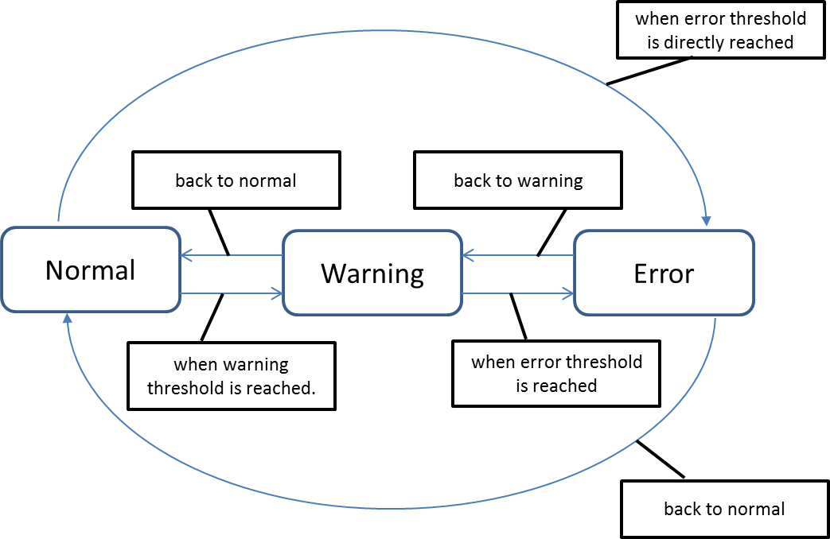Figure 3: Threshold state diagram
A threshold state depends on the current consumption of resource and the type of threshold (upper or lower threshold).
A Resource Listener is registered as an OSGi service. The implementer must provide the two following mandatory properties:
- RESOURCE_CONTEXT property – a String defining the name of Resource Context for which the Listener want to receive threshold notifications.
- RESOURCE_TYPE property – a String defining which type of resource the listener wants to monitor.
It also has to provide at least one of these four properties when registered as an OSGi service:
- UPPER_WARNING_THRESHOLD
- UPPER_ERROR_THRESHOLD
- LOWER_WARNING_THRESHOLD
- LOWER_ERROR_THRESHOLD
These properties are mapped to the four types of threshold values a Resource Listener may support. The service properties are used to notify the associated Resource Monitor when one of these threshold values is modified.
Threshold values can also be retrieved through a set of getter methods. All of these methods returns a Comparable object used by the associated Resource Monitor in order to determine the current state of the current usage.
RESOURCE_CONTEXT and RESOURCE_TYPE properties are used by Resource Monitors to identify their associated Resource Listeners. Once associated, a Resource Monitor retrieves the threshold settings using service properties. When one of its thresholds is reached, the Resource Monitor calls ResourceListener.notify(ResourceEvent).
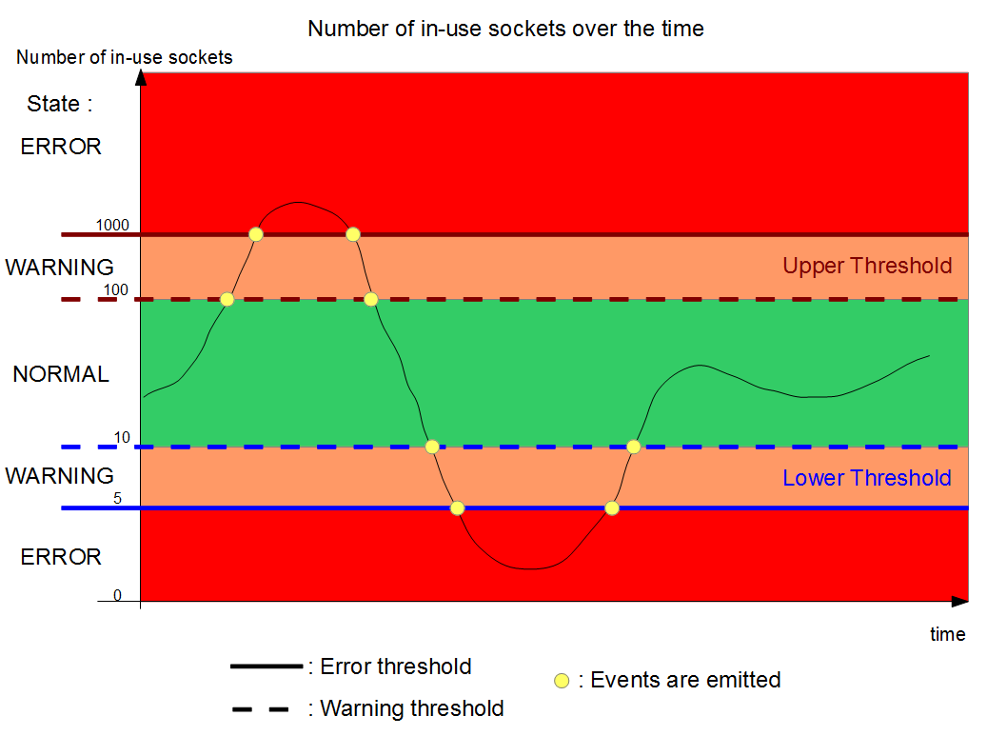
Two examples of resource consumption are explained below, first with in-use sockets monitoring, second with CPU monitoring. The next picture shows the state diagram of the number of in-use state socket over the time.
In our example, the lower warning threshold and the lower error threshold of the Resource Listener are respectively set to 10 and 5. When the number of in-use sockets decreases under 10, the usage goes from the NORMAL state to the WARNING state and the Resource Listener receives a WARNING event. If the number of in-use state sockets decreases again and goes down to 5, the usage goes from the WARNING state to the ERROR state and the Resource Listener receives a ERROR Resource Event.
The upper threshold is also set. The upper warning threshold and the upper error threshold are respectively set to 100 and 1000 in-use state sockets. When the number of sockets reaches 100, the usage goes from the NORMAL state to the WARNING state and the Resource Listener receives a WARNING Resource Event. If this number is still increasing and exceeds 1000, then the usage goes from the WARNING state to the ERROR state and the Resource Listener receives an ERROR Resource Event.
This is a typical use case for a Java Web server. Indeed, one of the most important quality of service indicator is the number of in-use state sockets a java web server is handling. A low number of in-use state sockets may indicate the java web server encounters network problems. On the contrary, a high number of in-use state socket may be the result of an external network attack or it could also indicates the java web server is overused and its administrator should take actions to load-balance the charge to another java web server instance.
For other resource types, only upper thresholds may be useful. The next diagram shows the CPU consumption a Resource Context is using over the time:
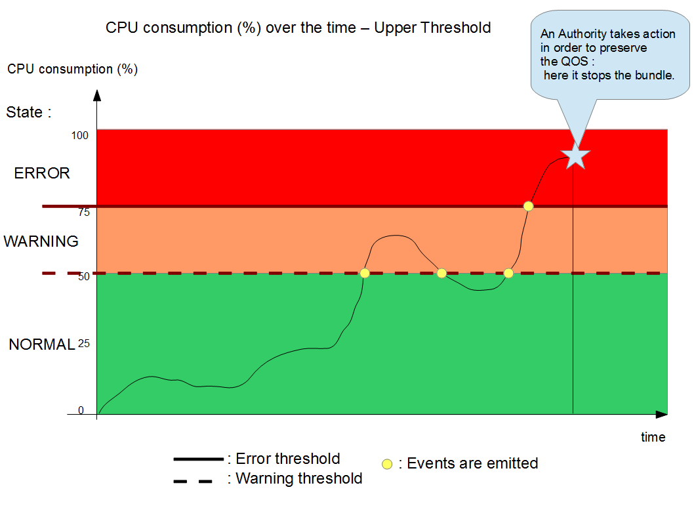
In this example, only the upper threshold is set. The upper warning threshold is set to 50%, the error one is set to 75%. CPU consumption fluctuates between 0 and 50%, the usage is in the NORMAL state. Then it increases and reaches 50%. The usage then goes from the NORMAL state to the WARNING state and the Resource Listener holding the threshold receives a WARNING Resource Event.
Afterwards, CPU consumption decreases under 50%; the usage goes from the WARNING state to the NORMAL state. The related Resource listener receives a NORMAL Resource Event.
It then increases again and exceeds 50%. The usage goes to the WARNING state. CPU consumption is still increasing and exceeds 75%. At this moment, the usage goes from the WARNING state to the ERROR state and the related Resource Listener receives an ERROR Resource Event.
After some seconds in the ERROR state, the Resource Listener implementation stops the bundle in order to preserve the quality of service.
The choice of the type of threshold (lower or upper, or both of them) depends on the type of resource and the needs of the Resource Management Authorities providing the Resource Listener. Other resources like the free memory may take advantage of a lower threshold.

Resource Event
A Resource Event instance is an event sent to a Resource Listener when one of its thresholds is reached. This event is notified to a Resource Listener through a call to ResourceListener.notify(ResourceEvent).
A Resource Event has a type among the following ones:
- ERROR – The resource consumption reaches either the upper or the lower error threshold of the Resource Listener receiving this event,
- WARNING – The resource consumption reaches either the upper or the lower warning threshold of the Resource Listener receiving this event.
- NORMAL – The resource consumption is back from warning or error state to normal state.
The Resource Listener instance analyzes this event by calling the following methods:
- getValue() method returns the resource consumption at the time when the Resource Event instance was generated.
- isUpperThreshold() method returns true if the reached threshold is an upper threshold type. If this method returns false, this is a lower threshold.
- getType() method indicates the state (WARNING, ERROR, or NORMAL) of the resource usage.
- getContext() method returns the Resource Context instance related to this event. The Resource Listener can use it to retrieve the Resource Monitor instance (e.g., event.getContext().getMonitor(event.getResourceType()).

Resource Context Listener
A Resource Listener instance receives notifications about Resource Context lifecycle and configuration.
A notification will be sent when:
- A Resource Context is created.
- A Resource Context is updated, i.e., a bundle has been added or removed from a Resource Context instance.
- A Resource Context is deleted.
An application which is interested in notifications has to register a Resource Context Listener instance as an OSGi service. The application may provide a set of properties at registration time to reduce the number of notifications a Resource Listener instance will receive. The available properties are:
- RESOURCE_CONTEXT property – An array of String defining the name of Resource Context instances. If defined, a Resource Listener instance will only receive notifications related to these specified Resource Context instances.
- RESOURCE_TYPE property – an array of integers defining the type of notifications a Resource Context Listener instance will receive (see types defined in section Resource Context Event).
A Resource Context Listener instance is notified through a call to notify(ResourceContextEvent) method.

Resource Context Event
A Resource Context Event instance is an event sent to Resource Context Listener instances through a call to ResourceContextListener.notify(ResourceContextEvent) method.
A Resource Context Event has a type among the four following ones:
- RESOURCE_CONTEXT_CREATED – A new Resource Context instance has been created.
- RESOURCE_CONTEXT_REMOVED – A Resource Context instance has been deleted.
- BUNDLE_ADDED – A bundle has been added in the scope of a Resource Context instance
- BUNDLE_REMOVED – A bundle has been removed from the scope of a Resource Context instance.
In the case of a RESOURCE_CONTEXT_ADDED event or a RESOURCE_CONTEXT_REMOVED event, a call to getContext() returns the targeted Resource Context instance.
In the case of a BUNDLE_ADDED type or BUNDLE_REMOVED type, getBundle() returns the Bundle object to be added to or removed from. The related Resource Context instance is given by a call to getContext().

Resource Manager
The Resource Manager service manages the Resource Context instances. The Resource Manager service is available through the OSGi service registry.
This service holds the existing Resource Context instances. Resource Context instances are created by calling the createContext(String, ResourceContext) method. The caller provides a context name as a string and optionally a template as a ResourceContext object.
The list of existing Resource Context instances can be retrieved through the following methods:
- getContext(String) – retrieve a Resource Context instance by name.

- listContexts() - retrieve all existing Resource Context instances as an array.
The Resource Manager singleton manages the persistence of the Resource Context instances. The following properties are stored:
- name of the Resource Context.
- list of the bundles belonging to the Resource Context.
- list of the Resource Monitor instances. For each one:
  - sampling period.
  - monitoring period.
The way the Resource Manager persists the Resource Context instances is implementation specific. The implementer is free to use any file format and file location it wants. At startup, the Resource Manager will load the persisted Resource Context instances to restore shutdown state.

Resource Management Authority
A Resource Management Authority uses the Resource Manager singleton instance to apply Resource Management policies. These entities MAY:
- create and configure Resource Context instances (resource thresholds, bundle scope)
- take any decisions (stop a bundle, uninstall a bundle) if a Resource Context exceeds resource limit.
These policies are out of the scope of this specification.

Javadoc
OSGi Javadoc
09/09/14 09:53
Package Summary |  | Page
org.osgi.service.resourcemanagement |  | 28
org.osgi.service.resourcemanagement.monito  r |  | 57

Package org.osgi.service.resourcemanagement
Interface Summary |  | Page
ResourceContext | Logical entity for resource accounting. | 29
ResourceContextListener | A ResourceContextListener is notified whenever:  - a ResourceContext is created or deleted. | 37
ResourceListener | A ResourceListener is an OSGi service which is notified when a Resource Context violates one of the threshold defined by the listener. | 42
ResourceManager | The Resource Manager service manages the Resource Context instances. | 46
ResourceMonitor | Representation of the state of a resource for a resource context. | 50
ResourceMonitorFactory | A Resource Monitor Factory is a service that provides Resource Monitor instances of a specific resource type (e.g., CPUMonitor, MemoryMonitor...) | 55

Class Summary |  | Page
ResourceContextEvent | A Resource Context Event instance is an event sent to Resource Context Listener instances through a call to ResourceContextListener.notify(ResourceContextEvent) method. | 33
ResourceEvent | An event is sent to a ResourceListener when resource usage violates one of their thresholds. | 39

Exception Summary |  | Page
ResourceMonitorException | Resource Monitor Exception reports an invalid usage of a monitor. | 54

Interface ResourceContext
org.osgi.service.resourcemanagement

public interface ResourceContext
Logical entity for resource accounting. A resource context has a group of member bundles, and a bundle can be a member of 0 or 1 resource context.
Management agents can use the ResourceManager.createContext(String, ResourceContext) method to create ResourceContext instances.
Management agents can use the getMonitor(String) method to get ResourceMonitor instances for the supported resource types. These instances can then be used to monitor the usage of the resources, or the set usage limits.
ResourceContexts are retrieved through the ResourceManager OSGi service.
ThreadSafe

Method Summary |  | Page
void | addBundle(long bundleId)  Adds a bundle to the resource context. | 30
void | addResourceMonitor(ResourceMonitor resourceMonitor)  Adds a new ResourceMonitor instance monitoring resource for this resource context. | 31
boolean | equals(Object resourceContext)  A ResourceContext rc1 is equals to ResourceContext rc2 if rc1.getName() is equals to rc2.getName(). | 32
long[] | getBundleIds()  Returns the bundle identfiers belonging to this Resource Context. | 30
ResourceMonitor | getMonitor(String resourceType)  Returns a ResourceMonitor instance for the specified resource type. | 31
ResourceMonitor[] | getMonitors()  Retrieves all the existing ResourceMonitor belonging to this context. | 31
String | getName()  Returns the name of the resource context. | 30
int | hashCode()  Retrieves the hashCode value of a ResourceContext. | 32
void | removeBundle(long bundleId)  Removes the bundle identified by bundleId from the Resource Context. | 30
void | removeBundle(long bundleId, ResourceContext destination)  Removes the bundle from this resource context. | 30
void | removeContext(ResourceContext destination)  Removes a resource context. | 32
void | removeResourceMonitor(ResourceMonitor resourceMonitor)  Removes a ResourceMonitor instance from the context. | 31
Method Detail
getName
String getName()
Returns the name of the resource context. Resource context names are unique within a framework instance.
Returns:
The resource context name

getBundleIds
long[] getBundleIds()
Returns the bundle identfiers belonging to this Resource Context.
Returns:
An array of org.osgi.framework.Bundle objects, or an empty array if no bundles are currently members of this context

addBundle
void addBundle(long bundleId)
Adds a bundle to the resource context. The bundle will be a member of the context until it is uninstalled, or explicitly removed from the context with removeBundle(long) method or removeBundle(long, ResourceContext) method.
Resources previously allocated by this bundle (in another resource context) will not be moved to this resource context. The change applies only for future allocations.
A ResourceContextEvent with type ResourceContextEvent.BUNDLE_ADDED will be sent.
Parameters:
bundleId - The bundle to add to this resource context

removeBundle
void removeBundle(long bundleId)
Removes the bundle identified by bundleId from the Resource Context. The bundle is no longer to this Resource Context.
Parameters:
bundleId - bundle identifier

removeBundle
void removeBundle(long bundleId,
ResourceContext destination)
Removes the bundle from this resource context. If a destination context is specified, the bundle will be added in it.
Resources previously allocated by this bundle will not be removed from the resource context. The change applies only for future allocations.
A ResourceContextEvent with type ResourceContextEvent.BUNDLE_REMOVED will be sent.
Parameters:
bundleId - the identifier of the bundle to be removed from the Resource Context
destination - A resource context in which to add the bundle, after removing it from this context. If no destination is provided (i.e. null), the bundle is not associated to a new Resource Context.

getMonitor
ResourceMonitor getMonitor(String resourceType)
Returns a ResourceMonitor instance for the specified resource type. If the ResourceManager implementation does not support this resource type, null is returned
Parameters:
resourceType - The resource type, for which a resource monitor is requested
Returns:
A ResourceMonitor instance, or null, if this resource type is not supported

getMonitors
ResourceMonitor[] getMonitors()
Retrieves all the existing ResourceMonitor belonging to this context.
Returns:
an array of ResourceMonitor. May be empty if no ResourceMonitor

addResourceMonitor
void addResourceMonitor(ResourceMonitor resourceMonitor)
throws ResourceMonitorException
Adds a new ResourceMonitor instance monitoring resource for this resource context. This method should be called only by ResourceMonitorFactory instance.
Parameters:
resourceMonitor - resourceMonitor instance to be added
Throws:
ResourceMonitorException - if resourceMonitor is associated to another context or resourceMonitor has been deleted.

removeResourceMonitor
void removeResourceMonitor(ResourceMonitor resourceMonitor)
Removes a ResourceMonitor instance from the context.
Parameters:
resourceMonitor - resource monitor instance to be removed

removeContext
void removeContext(ResourceContext destination)
Removes a resource context. All resources allocated in this resource context will be moved to the destination context. If destination is null, these resources will no longer be monitored.
A ResourceContextEvent with type ResourceContextEvent.RESOURCE_CONTEXT_REMOVED will be sent.
Parameters:
destination - The ResourceContext where the resources currently allocated by this resource context will be moved.

equals
boolean equals(Object resourceContext)
A ResourceContext rc1 is equals to ResourceContext rc2 if rc1.getName() is equals to rc2.getName().
Overrides:
equals in class Object
Parameters:
resourceContext - resource context
Returns:
true if getName().equals(resourceContext.getName()

hashCode
int hashCode()
Retrieves the hashCode value of a ResourceContext. The hashCode value of a ResourceContext is only based on the hashcode value of the name of the context.
Overrides:
hashCode in class Object
Returns:
hashcode
Class ResourceContextEvent
org.osgi.service.resourcemanagement
java.lang.Object
org.osgi.service.resourcemanagement.ResourceContextEvent

public class ResourceContextEvent
extends Object
A Resource Context Event instance is an event sent to Resource Context Listener instances through a call to ResourceContextListener.notify(ResourceContextEvent) method. A Resource Context Event has a type among the four following ones:
- RESOURCE_CONTEXT_CREATED â€“ A new Resource Context instance has been created.
- RESOURCE_CONTEXT_REMOVED â€“ A Resource Context instance has been deleted.
- BUNDLE_ADDED â€“ A bundle has been added in the scope of a Resource Context instance.
- BUNDLE_REMOVED â€“ A bundle has been removed from the scope of a Resource Context instance.
Immutable

Field Summary |  | Page
static int | BUNDLE_ADDED  A bundle has been added to e ResourceContext  The ResourceContext.addBundle(long) method has been invoked | 34
static int | BUNDLE_REMOVED  A bundle has been removed from a ResourceContext  ResourceContext.removeBundle(long) method or ResourceContext.removeBundle(long, ResourceContext) method have been invoked, or the bundle has been uninstalled | 34
static int | RESOURCE_CONTEXT_CREATED  A new ResourceContext has been created. | 34
static int | RESOURCE_CONTEXT_REMOVED  A ResourceContext has been removed  The ResourceContext.removeContext(ResourceContext) method has been invoked | 34

Constructor Summary | Page
ResourceContextEvent(int pType, ResourceContext pResourceContext)  Create a new ResourceContextEvent. | 34
ResourceContextEvent(int pType, ResourceContext pResourceContext, long pBundleId)  Create a new ResourceContextEvent. | 35

Method Summary |  | Page
boolean | equals(Object var0) | 36
long | getBundleId()  Retrieves the identifier of the bundle being added to or removed from the Resource Context. | 35
ResourceContext | getContext()  Retrieves the Resource Context associated to this event | 35
int | getType()  Retrieves the type of this Resource Context Event. | 35
int | hashCode() | 36
String | toString() | 36
Field Detail
RESOURCE_CONTEXT_CREATED
public static final int RESOURCE_CONTEXT_CREATED = 0
A new ResourceContext has been created.
The ResourceManager.createContext(String, ResourceContext) method has been invoked.

RESOURCE_CONTEXT_REMOVED
public static final int RESOURCE_CONTEXT_REMOVED = 1
A ResourceContext has been removed
The ResourceContext.removeContext(ResourceContext) method has been invoked

BUNDLE_ADDED
public static final int BUNDLE_ADDED = 2
A bundle has been added to e ResourceContext
The ResourceContext.addBundle(long) method has been invoked

BUNDLE_REMOVED
public static final int BUNDLE_REMOVED = 3
A bundle has been removed from a ResourceContext
ResourceContext.removeBundle(long) method or ResourceContext.removeBundle(long, ResourceContext) method have been invoked, or the bundle has been uninstalled
Constructor Detail
ResourceContextEvent
public ResourceContextEvent(int pType,
ResourceContext pResourceContext)
Create a new ResourceContextEvent. This constructor should be used when the type of the event is either RESOURCE_CONTEXT_CREATED or RESOURCE_CONTEXT_REMOVED.
Parameters:
pType - event type
pResourceContext - context

ResourceContextEvent
public ResourceContextEvent(int pType,
ResourceContext pResourceContext,
long pBundleId)
Create a new ResourceContextEvent. This constructor should be used when the type of the event is either BUNDLE_ADDED or BUNDLE_REMOVED.
Parameters:
pType - event type
pResourceContext - context
pBundleId - bundle
Method Detail
getType
public int getType()
Retrieves the type of this Resource Context Event.
Returns:
the type of the event. One of:
- RESOURCE_CONTEXT_CREATED
- RESOURCE_CONTEXT_REMOVED
- BUNDLE_ADDED
- BUNDLE_REMOVED

getContext
public ResourceContext getContext()
Retrieves the Resource Context associated to this event
Returns:
Resource Context.

getBundleId
public long getBundleId()
Retrieves the identifier of the bundle being added to or removed from the Resource Context.
This method returns a valid value only when getType() returns:
- BUNDLE_ADDED
- BUNDLE_REMOVED
Returns:
the bundle id or -1 (invalid value) .

toString
public String toString()
Overrides:
toString in class Object

hashCode
public int hashCode()
Overrides:
hashCode in class Object

equals
public boolean equals(Object var0)
Overrides:
equals in class Object
Interface ResourceContextListener
org.osgi.service.resourcemanagement

public interface ResourceContextListener
A ResourceContextListener is notified whenever:
- a ResourceContext is created or deleted.
- a bundle is added or removed from a ResourceContext.
A ResourceContextListener is registered as an OSGi service. At registration time, the following properties may be provided:
- the RESOURCE_CONTEXT property which limits the Resource Context for which notifications will be received. This property can be either a String value or an array of String. If this property is not set, the Resource Context Listener receives events from all the Resource Context.
- the EVENT_TYPE property. If set, this property filters the type of event this listener will receive. The value of this property can either a String (then, the Listener receives notifications about a single type) or an array of String (several types). The expected values for this property are the types defined by a ResourceContextEvent:
- ResourceContextEvent.RESOURCE_CONTEXT_CREATED
- ResourceContextEvent.RESOURCE_CONTEXT_REMOVED
- ResourceContextEvent.BUNDLE_ADDED
- ResourceContextEvent.BUNDLE_REMOVED

Field Summary |  | Page
String | EVENT_TYPE  Property specifying the type of events this listener will receive. | 37
String | RESOURCE_CONTEXT  Property specifying the ResourceContext(s) for which a notification will be received by this listener. | 37

Method Summary |  | Page
void | notify(ResourceContextEvent event)  Notify this listener about a ResourceContext events. | 38
Field Detail
RESOURCE_CONTEXT
public static final String RESOURCE_CONTEXT = "resource.context"
Property specifying the ResourceContext(s) for which a notification will be received by this listener.
The property value is either a string (i.e the name of the ResourceContext) and an array of string (several ResourceContext).

EVENT_TYPE
public static final String EVENT_TYPE = "event.type"
Property specifying the type of events this listener will receive. The expected values are the ResourceContextEvent types. It can be a String or an array of String.
Method Detail
notify
void notify(ResourceContextEvent event)
Notify this listener about a ResourceContext events.
Parameters:
event - event.
Class ResourceEvent
org.osgi.service.resourcemanagement
java.lang.Object
org.osgi.service.resourcemanagement.ResourceEvent

public class ResourceEvent
extends Object
An event is sent to a ResourceListener when resource usage violates one of their thresholds.
ResourceEvent objects are delivered synchronously to all matching ResourceListener services. A typed code is used to identify the event.
See Also:
ResourceListener
Immutable

Field Summary |  | Page
static int | ERROR  Type of ResourceEvent indicating a threshold goes to the ERROR state. | 40
static int | NORMAL  Type of ResourceEvent indicating a threshold goes to the NORMAL state. | 40
static int | WARNING  Type of ResourceEvent indicating a threshold goes to the WARNING state. | 40

Constructor Summary | Page
ResourceEvent(int pType, ResourceContext pContext, boolean pIsUpperThreshold, Object pValue)  Creates a new ResourceEvent. | 40

Method Summary |  | Page
boolean | equals(Object var0) | 41
ResourceContext | getContext()  Returns the resource context that caused the event. | 41
int | getType()  Returns the event type. | 40
Object | getValue()  Returns the resource consumption value. | 41
int | hashCode() | 41
boolean | isUpperThreshold()  Returns true if the threshold triggering this event is an upper threshold. | 41
String | toString() | 41
Field Detail
NORMAL
public static final int NORMAL = 0
Type of ResourceEvent indicating a threshold goes to the NORMAL state.

WARNING
public static final int WARNING = 1
Type of ResourceEvent indicating a threshold goes to the WARNING state.

ERROR
public static final int ERROR = 2
Type of ResourceEvent indicating a threshold goes to the ERROR state.
Constructor Detail
ResourceEvent
public ResourceEvent(int pType,
ResourceContext pContext,
boolean pIsUpperThreshold,
Object pValue)
Creates a new ResourceEvent.
Parameters:
pType - the event type
pContext - the resource context
pIsUpperThreshold - whether it is an upper threshold
pValue - the value
Method Detail
getType
public int getType()
Returns the event type. The type values are:
- NORMAL
- WARNING
- ERROR
Returns:
The event type

getValue
public Object getValue()
Returns the resource consumption value. Relevant only for event types NORMAL, WARNING and ERROR.
Returns:
the resource consumption value, or null if a resource monitor is not relevant.

getContext
public ResourceContext getContext()
Returns the resource context that caused the event.
Returns:
The resource context that caused the event.

isUpperThreshold
public boolean isUpperThreshold()
Returns true if the threshold triggering this event is an upper threshold. This method is only used when getType() returns NORMAL, WARNING or ERROR.
Returns:
true if it is an upper threshold.

hashCode
public int hashCode()
Overrides:
hashCode in class Object

equals
public boolean equals(Object var0)
Overrides:
equals in class Object

toString
public String toString()
Overrides:
toString in class Object
Interface ResourceListener
org.osgi.service.resourcemanagement

public interface ResourceListener
A ResourceListener is an OSGi service which is notified when a Resource Context violates one of the threshold defined by the listener.
Every ResourceListener is associated to a specific Resource Context and a specific Resource type. It defines two types of thresholds: a lower and a upper. A lower threshold is reached when the resource usage decreases below the threshold. On the contrary, an upper threshold is reached when the resource usage exceeds the threshold.
Both lower or upper threshold are two levels : a warning level and error level. The warning level indicates the resource usage becomes to be critical but are still acceptable. The error level indicates the resource usage is now critical for the overall system and actions should be taken.
A Resource Listener is registered with these two mandatory properties:
- RESOURCE_CONTEXT which defines the ResourceContext associated to this Listener
- RESOURCE_TYPE which the type of resource
The next optional properties are used to specify threshold values. A ResourceListener must at least provides one of them:
- UPPER_WARNING_THRESHOLD
- UPPER_ERROR_THRESHOLD
- LOWER_WARNING_THRESHOLD
- LOWER_ERROR_THRESHOLD
These threshold values can also be retrieved through methods.
Resource Listeners are associated to a Resource Context and a Resource Monitor based on the RESOURCE_CONTEXT property and the RESOURCE_TYPE property (both of them are mandatory at registration time).
Once associated, the ResourceMonitor gets the threshold values through the service properties (i.e UPPER_WARNING_THRESHOLD, UPPER_ERROR_THRESHOLD, LOWER_WARNING_THRESHOLD and LOWER_WARNING_THRESHOLD) and store them. Once it detects a new resource consumption, it compares the new resource usage value with the thresholds provided by the Resource Listener. If the resource usage violates one of these thresholds, the Resource Monitor notifies the ResourceListener through a call to notify(ResourceEvent).
A ResourceMonitor tracks threshold value modification by using a org.osgi.framework.ServiceListener.

Field Summary |  | Page
String | LOWER_ERROR_THRESHOLD  Optional property defining the value of the lower error threshold. | 44
String | LOWER_WARNING_THRESHOLD  Optional property defining the value of the lower warning threshold. | 43
String | RESOURCE_CONTEXT  Mandatory property specifying the Resource Context associated with the listener. | 43
String | RESOURCE_TYPE  Mandatory property defining the type of Resource (i.e the ResourceMonitor) associated to this Listener. | 43
String | UPPER_ERROR_THRESHOLD  Optional property defining the value of the upper error threshold. | 43
String | UPPER_WARNING_THRESHOLD  Optional property defining the value of the upper warning threshold. | 43

Method Summary |  | Page
Comparable | getLowerErrorThreshold()  Retrieves the lower error threshold value set by the listener. | 44
Comparable | getLowerWarningThreshold()  Retrieves the lower warning threshold value set by the listener. | 44
Comparable | getUpperErrorThreshold()  Retrieves the upper error threshold value set by this listener. | 45
Comparable | getUpperWarningThreshold()  Retrieves the upper warning threshold value set by this listener. | 44
void | notify(ResourceEvent event)  Receives a resource management notification | 44
Field Detail
RESOURCE_CONTEXT
public static final String RESOURCE_CONTEXT = "resource.context"
Mandatory property specifying the Resource Context associated with the listener.

RESOURCE_TYPE
public static final String RESOURCE_TYPE = "resource.type"
Mandatory property defining the type of Resource (i.e the ResourceMonitor) associated to this Listener.

UPPER_WARNING_THRESHOLD
public static final String UPPER_WARNING_THRESHOLD = "upper.warning.threshold"
Optional property defining the value of the upper warning threshold.

UPPER_ERROR_THRESHOLD
public static final String UPPER_ERROR_THRESHOLD = "upper.error.threshold"
Optional property defining the value of the upper error threshold.

LOWER_WARNING_THRESHOLD
public static final String LOWER_WARNING_THRESHOLD = "lower.warning.threshold"
Optional property defining the value of the lower warning threshold.

LOWER_ERROR_THRESHOLD
public static final String LOWER_ERROR_THRESHOLD = "lower.error.threshold"
Optional property defining the value of the lower error threshold.
Method Detail
notify
void notify(ResourceEvent event)
Receives a resource management notification
Parameters:
event - The ResourceEvent object

getLowerWarningThreshold
Comparable getLowerWarningThreshold()
Retrieves the lower warning threshold value set by the listener. If the resource usage decreases under this threshold value, the notify(ResourceEvent) will be called. The provided ResourceEvent then indicates the WARNING state is reached.
Returns:
a comparable object or null if no threshold is set.

getLowerErrorThreshold
Comparable getLowerErrorThreshold()
Retrieves the lower error threshold value set by the listener. If the resource usage decreases under this threshold, the notify(ResourceEvent) will be called. The provided ResourceEvent then indicates the ERROR state is reached.
Returns:
a comparable object or null if no threshold is set.

getUpperWarningThreshold
Comparable getUpperWarningThreshold()
Retrieves the upper warning threshold value set by this listener. If the resource usage exceeds this threshold, the notify(ResourceEvent) method will be called. The provided ResourceEvent then indicates the WARNING state is reached.
Returns:
a comparable object or null if no threshold is reached.

getUpperErrorThreshold
Comparable getUpperErrorThreshold()
Retrieves the upper error threshold value set by this listener. If the resource usage exceeds this threshold, the notify(ResourceEvent) will be called. The provided ResourceEvent then indicates the ERROR state is reached.
Returns:
a comparable object or null if no threshold is reached.
Interface ResourceManager
org.osgi.service.resourcemanagement

public interface ResourceManager
The Resource Manager service manages the Resource Context instances. The Resource Manager service is available through the OSGi service registry. This service holds the existing Resource Context instances. Resource Context instances are created by calling the createContext(String, ResourceContext) method.
ThreadSafe

Field Summary |  | Page
String | FRAMEWORK_CONTEXT_NAME  The name of the special, optional resource context, representing the whole OSGi framework. | 47
String | RES_TYPE_CPU  The name of the CPU resource type, used to monitor and control the CPU time used by a resource context. | 47
String | RES_TYPE_DISK_STORAGE  The name of the disk storage resource type, used to monitor and control the size of the persistent storage used by a resource context. | 47
String | RES_TYPE_MEMORY  The name of the memory resource type, used to monitor and control the size of the java heap used by a resource context. | 47
String | RES_TYPE_SOCKET  The name of the socket resource type, used to monitor and control the number of existing sockets used by a resource context. | 47
String | RES_TYPE_THREADS  The name of the threads resource type, used to monitor and control the number of threads created by a resource context. | 47
String | SYSTEM_CONTEXT_NAME  The name of the Resource Context associated with System bundle (bundle 0). | 47

Method Summary |  | Page
ResourceContext | createContext(String name, ResourceContext template)  Creates a new ResourceContext. | 48
ResourceContext | getContext(String name)  Returns the context with the specified name | 48
ResourceContext | getContext(long bundleId)  Returns the ResourceContext associated to the provided bundle | 48
String[] | getSupportedTypes()  Returns a list with the supported resource type names. | 49
ResourceContext[] | listContext()  Lists all available resource contexts. | 48
Field Detail
RES_TYPE_THREADS
public static final String RES_TYPE_THREADS = "resource.type.threads"
The name of the threads resource type, used to monitor and control the number of threads created by a resource context. ResourceManager implementations must create ThreadMonitor instances for this resource type.

RES_TYPE_CPU
public static final String RES_TYPE_CPU = "resource.type.cpu"
The name of the CPU resource type, used to monitor and control the CPU time used by a resource context. ResourceManager implementations must create CPUMonitor instances for this resource type.

RES_TYPE_DISK_STORAGE
public static final String RES_TYPE_DISK_STORAGE = "resource.type.disk.storage"
The name of the disk storage resource type, used to monitor and control the size of the persistent storage used by a resource context. ResourceManager implementations must create DiskStorageMonitor instances for this resource type.

RES_TYPE_MEMORY
public static final String RES_TYPE_MEMORY = "resource.type.memory"
The name of the memory resource type, used to monitor and control the size of the java heap used by a resource context. ResourceManager implementations must create MemoryMonitor instances for this resource type.

RES_TYPE_SOCKET
public static final String RES_TYPE_SOCKET = "resource.type.socket"
The name of the socket resource type, used to monitor and control the number of existing sockets used by a resource context. ResourceManager implementations must create SocketMonitor instances for this resource type.

FRAMEWORK_CONTEXT_NAME
public static final String FRAMEWORK_CONTEXT_NAME = "framework"
The name of the special, optional resource context, representing the whole OSGi framework.

SYSTEM_CONTEXT_NAME
public static final String SYSTEM_CONTEXT_NAME = "system"
The name of the Resource Context associated with System bundle (bundle 0).
Method Detail
listContext
ResourceContext[] listContext()
Lists all available resource contexts. The list will contain the special FRAMEWORK_CONTEXT_NAME context and the SYSTEM_CONTEXT_NAME context, if it is supported.
Returns:
An array of ResourceContext objects, or an empty array, if no contexts have been created.

createContext
ResourceContext createContext(String name,
ResourceContext template)
Creates a new ResourceContext.
A ResourceContextEvent with type ResourceContextEvent.RESOURCE_CONTEXT_CREATED will be sent.
Parameters:
name - The name identifying the context. Names must be unique within the framework instance.
template - If a template is provided, the new resource context will inherit all resource monitoring settings (enabled monitors, thresholds) from the template.
Returns:
A new ResourceContext instance.

getContext
ResourceContext getContext(String name)
Returns the context with the specified name
Parameters:
name - The resource context name
Returns:
An existing ResourceContext with the specified name, or null if such a context doesn't exist

getContext
ResourceContext getContext(long bundleId)
Returns the ResourceContext associated to the provided bundle
Parameters:
bundleId - bundle identifier
Returns:
the ResourceContext associated to bundle b or null if the bundle b does not belong to a Resource Context.

getSupportedTypes
String[] getSupportedTypes()
Returns a list with the supported resource type names.
Returns:
An array containing the names of all resource types that this ResourceManager implementation supports.
Interface ResourceMonitor
org.osgi.service.resourcemanagement
All Known Subinterfaces:
CPUMonitor, DiskStorageMonitor, MemoryMonitor, SocketMonitor, ThreadMonitor

public interface ResourceMonitor
Representation of the state of a resource for a resource context.
ResourceMonitor objects are returned by the ResourceContext.getMonitor(String) method.
The ResourceMonitor object may be used to:
- Enable/Disable the monitoring of the corresponding resource type for the corresponding resource context
- View the current usage of the resource by this resource context
A resource monitor can have a sampling period, a monitored period, or both. For example, for CPU monitoring, the resource management implementation can get the CPU usage of the running threads once per minute, and calculate the CPU usage per context in percentages based on the last ten such measurements. This could make a 60 000 milliseconds sampling period, and a 600 000 milliseconds monitored period.
ThreadSafe

Method Summary |  | Page
void | delete()  Disable and delete this instance of Resource Monitor. | 51
void | disable()  Disable the monitoring of this resource type for the resource context associated with this monitor instance. | 52
void | enable()  Enable the monitoring of this resource type for the resource context associated with this monitor instance. | 52
boolean | equals(Object resourceMonitor)  Checks if resourceMonitor is equals to the current instance. | 53
ResourceContext | getContext()  Returns the resource context that this monitor belongs to | 51
long | getMonitoredPeriod()  Returns the time period for which the usage of this resource type is monitored. | 53
String | getResourceType()  The name of the resource type that this monitor represents | 51
long | getSamplingPeriod()  Returns the sampling period for this resource type. | 52
Comparable | getUsage()  Returns an object representing the current usage of this resource type by this resource context. | 52
int | hashCode()  Retrieves the hashCode value of this ResourceMonitor. | 53
boolean | isDeleted()  Returns true if the ResourceMonitor instance has been deleted, i.e. the delete() method has been called previously. | 51
boolean | isEnabled()  Checks if the monitoring for this resource type is enabled for this resource context | 51
Method Detail
getContext
ResourceContext getContext()
Returns the resource context that this monitor belongs to
Returns:
The associated ResourceContext

getResourceType
String getResourceType()
The name of the resource type that this monitor represents
Returns:
The name of the monitored resource type

delete
void delete()
Disable and delete this instance of Resource Monitor. This method MUST update the list of ResourceMonitor instances hold by the Resource Context (getContext().removeMonitor(this)).

isEnabled
boolean isEnabled()
Checks if the monitoring for this resource type is enabled for this resource context
Returns:
true if monitoring for this resource type is enabled for this context, false otherwise

isDeleted
boolean isDeleted()
Returns true if the ResourceMonitor instance has been deleted, i.e. the delete() method has been called previously.
Returns:
true if deleted.

enable
void enable()
throws ResourceMonitorException,
IllegalStateException
Enable the monitoring of this resource type for the resource context associated with this monitor instance. This method SHOULD also update the current resource consumption value (to take into account all previous resource allocations and releases occurred during the time the monitor was disabled).
Throws:
ResourceMonitorException - if the ResourceMonitor instance can not be enabled (for example some MemoryMonitor implementations evaluate the memory consumption by tracking memory allocation operation at runtime. This kind of Monitor can not get instantaneous memory value. Such Monitor instances need to be enabled at starting time.)
IllegalStateException - if the ResourceMonitor instance has been previously deleted

disable
void disable()
throws IllegalStateException
Disable the monitoring of this resource type for the resource context associated with this monitor instance. The resource usage is not available until it is enabled again.
Throws:
IllegalStateException - if the ResourceMonitor instance has been previously deleted

getUsage
Comparable getUsage()
throws IllegalStateException
Returns an object representing the current usage of this resource type by this resource context.
Returns:
The current usage of this resource type.
Throws:
IllegalStateException - if the ResourceMonitor instance is not enabled.

getSamplingPeriod
long getSamplingPeriod()
Returns the sampling period for this resource type.
Returns:
The sampling period in milliseconds, or -1 if a sampling period is not relevant for this resource type.

getMonitoredPeriod
long getMonitoredPeriod()
Returns the time period for which the usage of this resource type is monitored.
Returns:
The monitored period in milliseconds, or -1 if a monitored period is not relevant for this resource type.

equals
boolean equals(Object resourceMonitor)
Checks if resourceMonitor is equals to the current instance. A ResourceMonitor rm1 is equals to a ResourceMonitor rm2 if rm1.getContext().equals(rm2.getContext()) and r1.getType().equals(rm2.getType()).
Overrides:
equals in class Object
Returns:
true if the current instance is equals to the provided resourceMonitor

hashCode
int hashCode()
Retrieves the hashCode value of this ResourceMonitor. The hashCode value is based on the hashCode value of the associated ResourceContext and the hashCode value of the type.
Overrides:
hashCode in class Object
Returns:
hashcode
Class ResourceMonitorException
org.osgi.service.resourcemanagement
java.lang.Object
java.lang.Throwable
java.lang.Exception
org.osgi.service.resourcemanagement.ResourceMonitorException
All Implemented Interfaces:
Serializable

public class ResourceMonitorException
extends Exception
Resource Monitor Exception reports an invalid usage of a monitor.

Constructor Summary | Page
ResourceMonitorException(String msg)  Create a new ResourceMonitorException | 54
Constructor Detail
ResourceMonitorException
public ResourceMonitorException(String msg)
Create a new ResourceMonitorException
Parameters:
msg - message
Interface ResourceMonitorFactory
org.osgi.service.resourcemanagement

public interface ResourceMonitorFactory
A Resource Monitor Factory is a service that provides Resource Monitor instances of a specific resource type (e.g., CPUMonitor, MemoryMonitor...) for every Resource Context. Every Resource Monitor Factory service is registered with the RESOURCE_TYPE_PROPERTY mandatory property. This property indicates which type of Resource Monitor a Resource Monitor Factory is able to create. The type can also be retrieved through a call to getType(). The type MUST be unique (two Resource Monitor Factory instances MUST not have the same type).

Field Summary |  | Page
String | RESOURCE_TYPE_PROPERTY  Resource type property. | 55

Method Summary |  | Page
ResourceMonitor | createResourceMonitor(ResourceContext resourceContext)  Creates a new ResourceMonitor instance. | 55
String | getType()  Returns the type of ResourceMonitor instance this factory is able to create. | 55
Field Detail
RESOURCE_TYPE_PROPERTY
public static final String RESOURCE_TYPE_PROPERTY = "org.osgi.resourcemanagement.ResourceType"
Resource type property. The value is of type String, e.g., ResourceManager.RES_TYPE_CPU
Method Detail
getType
String getType()
Returns the type of ResourceMonitor instance this factory is able to create.
Returns:
factory type

createResourceMonitor
ResourceMonitor createResourceMonitor(ResourceContext resourceContext)
throws ResourceMonitorException
Creates a new ResourceMonitor instance. This instance is associated with the ResourceContext instance provided as argument ( ResourceContext.addResourceMonitor(ResourceMonitor) is called by the factory). The newly ResourceMonitor instance is disabled. It can be enabled by calling ResourceMonitor.enable().
Parameters:
resourceContext - ResourceContext instance associated with the newly created ResourceMonitor instance
Returns:
a ResourceMonitor instance
Throws:
ResourceMonitorException
Package org.osgi.service.resourcemanagement.monitor
Interface Summary |  | Page
CPUMonitor | A ResourceMonitor for the ResourceManager.RES_TYPE_CPU resource type. | 58
DiskStorageMonitor | A ResourceMonitor for the ResourceManager.RES_TYPE_DISK_STORAGE resource type. | 59
MemoryMonitor | A ResourceMonitor for the ResourceManager.RES_TYPE_MEMORY resource type. | 60
SocketMonitor | A ResourceMonitor for the ResourceManager.RES_TYPE_SOCKET resource type. | 61
ThreadMonitor | A ResourceMonitor for the ResourceManager.RES_TYPE_THREADS resource type. | 62

Interface CPUMonitor
org.osgi.service.resourcemanagement.monitor
All Superinterfaces:
ResourceMonitor

public interface CPUMonitor
extends ResourceMonitor
A ResourceMonitor for the ResourceManager.RES_TYPE_CPU resource type. CPUMonitor instance monitors the CPU consumed by a ResourceContext instance.

Method Summary |  | Page
int | getCPUUsage()  Returns the CPU usage as a cumulative number of nanoseconds  The ResourceMonitor.getUsage() method returns the same value, wrapped in a Long | 58

Methods inherited from interface org.osgi.service.resourcemanagement.ResourceMonitor
delete, disable, enable, equals, getContext, getMonitoredPeriod, getResourceType, getSamplingPeriod, getUsage, hashCode, isDeleted, isEnabled
Method Detail
getCPUUsage
int getCPUUsage()
Returns the CPU usage as a cumulative number of nanoseconds
The ResourceMonitor.getUsage() method returns the same value, wrapped in a Long
Returns:
the CPU usage in nanoseconds
Interface DiskStorageMonitor
org.osgi.service.resourcemanagement.monitor
All Superinterfaces:
ResourceMonitor

public interface DiskStorageMonitor
extends ResourceMonitor
A ResourceMonitor for the ResourceManager.RES_TYPE_DISK_STORAGE resource type. A DiskStorageMonitor instance monitors and limits the persistent storage of the bundle belonging to the ResourceContext

Method Summary |  | Page
long | getUsedDiskStorage()  Returns the sum of the size of the persistent storage areas of the bundles in this resource context. | 59

Methods inherited from interface org.osgi.service.resourcemanagement.ResourceMonitor
delete, disable, enable, equals, getContext, getMonitoredPeriod, getResourceType, getSamplingPeriod, getUsage, hashCode, isDeleted, isEnabled
Method Detail
getUsedDiskStorage
long getUsedDiskStorage()
Returns the sum of the size of the persistent storage areas of the bundles in this resource context.
The ResourceMonitor.getUsage() method returns the same value, wrapped in a Long
Returns:
the sum of the sizes of the persistent storage areas in bytes
Interface MemoryMonitor
org.osgi.service.resourcemanagement.monitor
All Superinterfaces:
ResourceMonitor

public interface MemoryMonitor
extends ResourceMonitor
A ResourceMonitor for the ResourceManager.RES_TYPE_MEMORY resource type. A MemoryMonitor instance monitors and limits the memory used by a ResourceContext instance.

Method Summary |  | Page
long | getUsedMemory()  Returns the size of the java heap used by the bundles in this resource context. | 60

Methods inherited from interface org.osgi.service.resourcemanagement.ResourceMonitor
delete, disable, enable, equals, getContext, getMonitoredPeriod, getResourceType, getSamplingPeriod, getUsage, hashCode, isDeleted, isEnabled
Method Detail
getUsedMemory
long getUsedMemory()
Returns the size of the java heap used by the bundles in this resource context.
The ResourceMonitor.getUsage() method returns the same value, wrapped in a Long
Returns:
the size of the used java heap in bytes
Interface SocketMonitor
org.osgi.service.resourcemanagement.monitor
All Superinterfaces:
ResourceMonitor

public interface SocketMonitor
extends ResourceMonitor
A ResourceMonitor for the ResourceManager.RES_TYPE_SOCKET resource type. SocketMonitor instance are used to monitor and limit the number of in-use sockets per ResourceContext instance. SocketMonitor instance handle all types of sockets (TCP, UDP, ...).
A TCP socket is considered to be in-use when it is bound ( Socket.bind(java.net.SocketAddress)) or when it is connected ( Socket.connect(java.net.SocketAddress)). It leaves the in-use state when the socket is closed (Socket.close()).
A UDP socket is in-use when it is bound ( DatagramSocket.bind(java.net.SocketAddress)) or connected ( DatagramSocket.connect(java.net.SocketAddress)). A UDP Socket leaves the in-use state when it is closed (DatagramSocket.close()).

Method Summary |  | Page
long | getSocketUsage()  Returns the number of existing socket created by a ResourceContext. | 61

Methods inherited from interface org.osgi.service.resourcemanagement.ResourceMonitor
delete, disable, enable, equals, getContext, getMonitoredPeriod, getResourceType, getSamplingPeriod, getUsage, hashCode, isDeleted, isEnabled
Method Detail
getSocketUsage
long getSocketUsage()
Returns the number of existing socket created by a ResourceContext.
The ResourceMonitor.getUsage() method returns the same value, wrapped in a Long
Returns:
the number of existing socket.
Interface ThreadMonitor
org.osgi.service.resourcemanagement.monitor
All Superinterfaces:
ResourceMonitor

public interface ThreadMonitor
extends ResourceMonitor
A ResourceMonitor for the ResourceManager.RES_TYPE_THREADS resource type. A ThreadMonitor instance monitors and limits the thread created by a ResourceContext instance.

Method Summary |  | Page
int | getAliveThreads()  Returns the number of alive threads created by the bundles in this resource context. | 62

Methods inherited from interface org.osgi.service.resourcemanagement.ResourceMonitor
delete, disable, enable, equals, getContext, getMonitoredPeriod, getResourceType, getSamplingPeriod, getUsage, hashCode, isDeleted, isEnabled
Method Detail
getAliveThreads
int getAliveThreads()
Returns the number of alive threads created by the bundles in this resource context. A Thread is considered to be alive when its java state is one of the following:
- RUNNABLE
- BLOCKED
- WAITING
- TIMED_WAITING
The ResourceMonitor.getUsage() method returns the same value, wrapped in a Integer
Returns:
the number of alive threads created by this resource context
Java API documentation generated with DocFlex/Doclet v1.5.6
DocFlex/Doclet is both a multi-format Javadoc doclet and a free edition of DocFlex/Javadoc. If you need to customize your Javadoc without writing a full-blown doclet from scratch, DocFlex/Javadoc may be the only tool able to help you! Find out more at www.docflex.com

Considered Alternatives

Resource Manager inside the Core framework or in a bundle?
Some framework operations like Bundle.start() or Bundle.stop() requires a context switching to account resource usage in the context of the related bundle (instead of using the context of the caller of the method). These context switching have to be done automatically by the framework. As a consequence, the Resource Manager solution must be implemented inside the core framework. However, the Resource Manager may take advantage of the extension bundle mechanism.

Adapt pattern or OSGi service?
Each bundle is belonging to one specific resource context. So, the Bundle.adapt() method is an easy to use way to get access to its related ResourceContext object. It also avoid service management code necessary to require and release a service reference.
Moreover, as the Core framework has to be modified in order to perform automatic context switching on specific framework methods, the adapt pattern is definitely the best approach.
03/22/2013: Evgeni (Prosyst) seems not to be 100% sure of the adapt pattern. He indicates that the service approach could be better. Then the discussion moves the reasons why the Start Level Service uses the adapt pattern.
08/20/2013: David Bosschaert proposes to remove the adapt pattern for retrieving Resource Manager and Resource Contexts. From the Enterprise Expert Group point of view, the Resource Manager capability may be implemented outside the OSGi core framework. Introducing the adapt pattern supposes to be a part of the OSGi core framework and implies a high coupling between the Resource Management solution and the core framework. David proposes to use the service mechanism to make available the Resource Manager instance. Then from this Resource Manager service, Resource Context can easily be retrieved.

Eventing paradigms
03/22/2013: Several eventing mechanism have been discussed:
- The Event Admin service. This is the logical service to send notifications on OSGi platform. However, this service is optional and may not be accessible all the time. What to do in these cases?
- Use of the core eventing system:
  - Notifications through BundleEvent objects. Notifications MUST be sent when a Resource Context instance exceeds one of its resource usage thresholds. As a Resource Context is not limited to a single bundle (it could be a set of bundle), the BundleEvent approach seems not to be a good approach.
  - Notifications through FrameworkEvent objects. Those events have been designed to notify about general events of the OSGi environment (e.g., The framework has started,...). FrameworkEvent instances contains a few fields like the bundle associated to the event, the exception causing this event and a type. Moreover, it is not possible to define filters when registering the FrameworkListener.
  - Notifications through a new ResourceEvent object. To be defined.
- Whiteboard pattern approach. Some ResourceListener instance (to be defined) may be registered as an OSGi service or any other pattern. Each time a ResourceMonitor instance detects a resource usage exceeding, it requests for the list of existing ResourceListener instances and notify them. Some filters may be applied in order to reduce the number of ResourceListener to be notified.

Resource event classes
04/03/2013: Resource Event instances notify applications about threshold exceeding as well as Resource Management configuration updates (e.g., adding/removing Resource Context instance, adding/removing bundles from Resource Context instance). A Resource Listener instance receiving a notification then has to identify which kind of notification it receives (through a call to ResourceEvent.getType()) and treat it accordingly.
So it could be interesting to separate concerns by creating two different Event/Listener interfaces. Resource Event and Resource Listener can still deal with threshold exceeding while Resource Context Event and Resource Context Listener will manage any events about Resource Context configuration updates (adding or removing Resource Context, adding or removing bundles).

CPU Monitor
CPU Monitor instances monitor the CPU usage of Resource Context. The CPU usage is expressed as a percentage of usage over the monitoring period.
This percentage may be evaluated using the raw cpu data like the number of nanoseconds a Resource Context uses CPU. CPU Monitor instance evaluates the percentage by making a difference between cumulative values periodically retrieved (sampling period).
It could be interested to leave access to the CPU cumulative values. A getCumulativeUsage() method may be added to the CPU Monitor interface.

Resource Threshold algorithm and eventing
When the resource consumption exceeds the WARNING threshold, the Resource Threshold instance goes from the NORMAL state to the WARNING state and generates WARNING Resource Event. When the resource consumption decreases below the WARNING threshold, the Resource Threshold instance goes back to the NORMAL state and generates a NORMAL Resource Event notification. In some cases, the resource consumption may fluctuate around the threshold generating several WARNING or NORMAL Resource Event notification. The next chart summarizes the situation:
Warning threshold
time
resource consumption value
WARNING event
WARNING event
WARNING event
BACK_TO_NORMAL
notification
BACK_TO_NORMAL
notification

NTT proposes the Resource Threshold instances are not a fixed straight value but rather a floating value with a lower warning threshold and a higher warning threshold (some kind of range). The NTT's solution is summarized below:
Lower warning threshold
Higher warning threshold
time
resource consumption value
WARNING event
BACK_TO_NORMAL
notification
WARNING event
(no event)

WARNING Resource event are generated only when higher warning threshold is exceeded. The same for NORMAL Resource Event when the resource consumption decreases under the lower warning threshold.
This kind of algorithms decreases the number of Resource Event notifications but increases the implementation complexity.
The RFC does not take any strong position on that particular question. Resource Management solution providers are free to implement such algorithms.

Resource Monitor Factory
ResourceMonitor instances are created by ResourceMonitorFactory. Some ResourceMonitor implementation (e.g., those provided by the framework itself) might not have ResourceMonitorFactory. This is strongly encouraged to provide Resource Monitor Factory instance for all kind of Resource Monitor.

Resource accounting and context switching
In a previous version, the Resource Manager service also allowed to perform Resource Context switching. The switching feature relied on a specific design for resource monitoring and accounting. For generality, it was decided to remove this feature (after CPEG review).
This feature relies on the association of Java threads with a Resource Context instance. In that case, every Java thread is associated with a single Resource Context instance. A Resource Context switching operation then reallocates a Java thread to another Resource Context instance. Therefore, all further resource allocation made during the execution of the Java thread are accounted to the new Resource Context instance.
This switching feature is executed by a call to the switchContext(Thread, ResourceContext) or switchCurrentContext(ResourceContext). Resource Monitors are notified when a context switching operation occurs. When a thread joins a ResourceContext, all ResourceMonitors of the incoming ResourceContext are notified through a call to ResourceMonitor.notifyIncomingThread(thread). On the opposite, when a thread leaves a ResourceContext, all ResourceMonitors of the outgoing ResourceContext are notified through a call to ResourceMonitor.notifyOutgoingThread(thread).
Below are described three use cases showing an appropriate usage of the context switching feature.
When the platform is starting, the core framework may start automatically bundles. The next sequence diagram describes the actions performed to start a bundle:
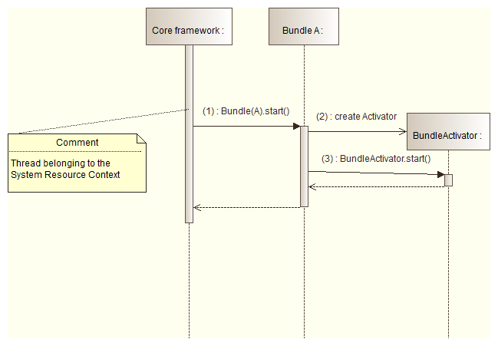
For every bundle instance to be started, the core framework calls Bundle.start() method (1). Bundle.start() method then creates a new instance of the BundleActivator implementation class of the Bundle (2) and calls BundleActivator.start() method (3). BundleActivator.start() method is generally used to allocate all resources a bundle needs, start threads and get and/or register services.
The object starting the bundle (actually the thread calling Bundle.start() method) belongs to the System Resource Context. As a consequence, resources consumed during start() call, including the resources used for the activation of the bundle, are accounted by the System Resource Context.
This situation may not be suitable. In usual situations, these resources may be accounted by the Resource Context instance of the bundle. A context switching operation has thus to be performed to switch to the Resource context instance of the bundle. The next diagram summarizes the actions to perform:
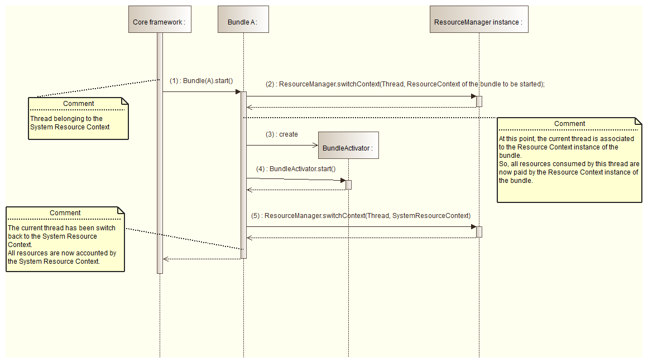
The ResourceManager.switchContext() operation (action 2) switches to the Resource Context of the bundle. At this point, all resources consumed by the current thread are accounted by the Resource Context instance of the bundle. Then, a new BundleActivator instance is created (action 3) and the BundleActivator.start() method is called (action 4). BundleActivator.start() method allocates all resources needed by the bundle. Before the completion of the Bundle.start() method, a context operation is again executed to switch back to the System Resource Context (action 5).
It is important to note that a context switching operation must be executed twice. The first context switching sets the context to which resources must be accounted. The second switches back to the initial context. The developer MUST ensure that these two operations are correctly achieved in order to avoid resource miscellaneous accounting.
This use case clearly shows that a context switching operation is needed at bundle startup to account resource in the appropriate Resource Context instance. Other framework operations requires a context switching execution:
- BundleActivator.start() - switch to the to-be-activated bundle Resource Context instance.
- BundleActivator.stop() - switch to the to-be-stopped bundle Resource Context instance.
- ServiceListener.serviceChanged() - switch to the Resource Context instance of the bundle hosting the ServiceListener instance.
- BundleListener.bundleChanged() - switch to the Resource Context instance of the bundle hosting the BundleListener instance.
- FrameworkListener.frameworkEvent() - switch to the Resource Context instance of the bundle hosting the FrameworkListener instance.
- ServiceFactory.getService() - switch to the Resource Context instance of the bundle requesting the OSGi service.
- ServiceFactory.ungetService() - switch to the Resource Context instance of the bundle calling ungetService.
Some other Compendium OSGi service like Http Service or Event Admin service should also take advantage of the context switching operation. The next diagram shows the use case for the Event Admin service:
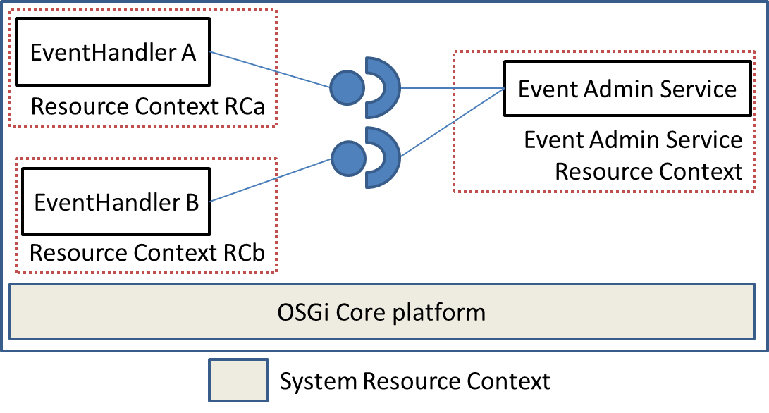
The EventAdmin Service should execute a context switching operation before and after calling EventHandler.handleEvent(event). This operation switches the current context to the context of the bundle providing the Event handler. Then, the resources consumed by the EventHandler,handleEvent() method are accounted by the Resource Context associated to the bundle providing the Event Handler and are not paid by the Event Admin service.
Now, the LogService case is considered. Any bundle about to log requires the LogService instance and calls LogService.log() method. The next schema shows two bundles A and B belonging respectively to Resource Context RCa and RCb. These two bundles requires the LogService (which belongs to Resource Context Log Service):
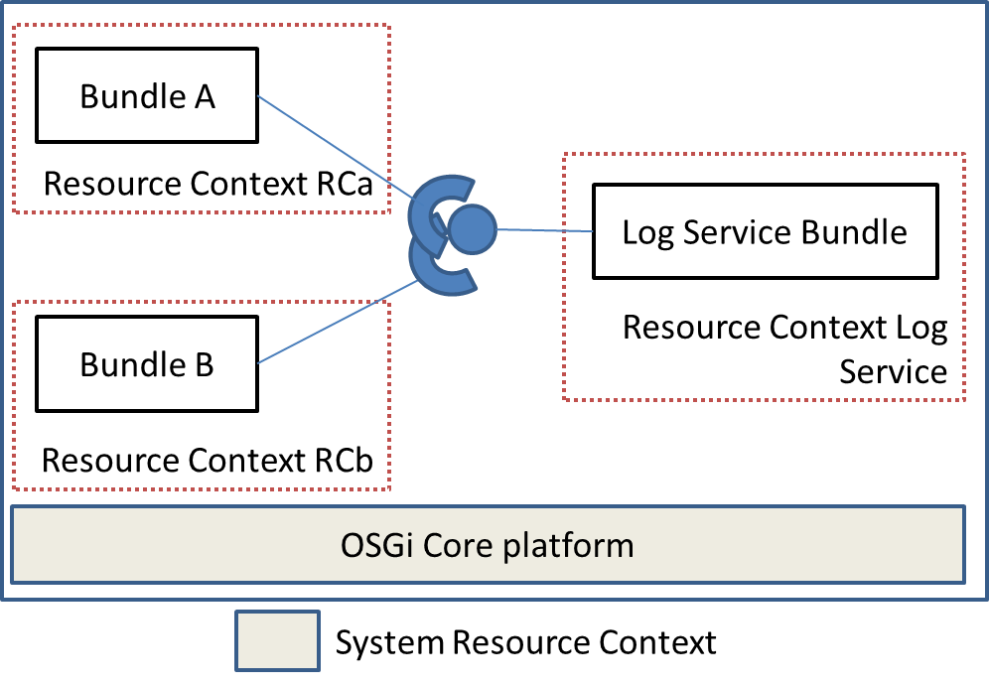
In such situation, the resources used by the LogService.log() method due to the bundle A are paid by RCa (the Resource Context of A). So, if bundle A overuses the LogService, it may exceeds the resource quotas of RCa which may lead to stop the bundle A (for example). Bundle B is not impacted and can still use the LogService.
Now, the following example is considered:
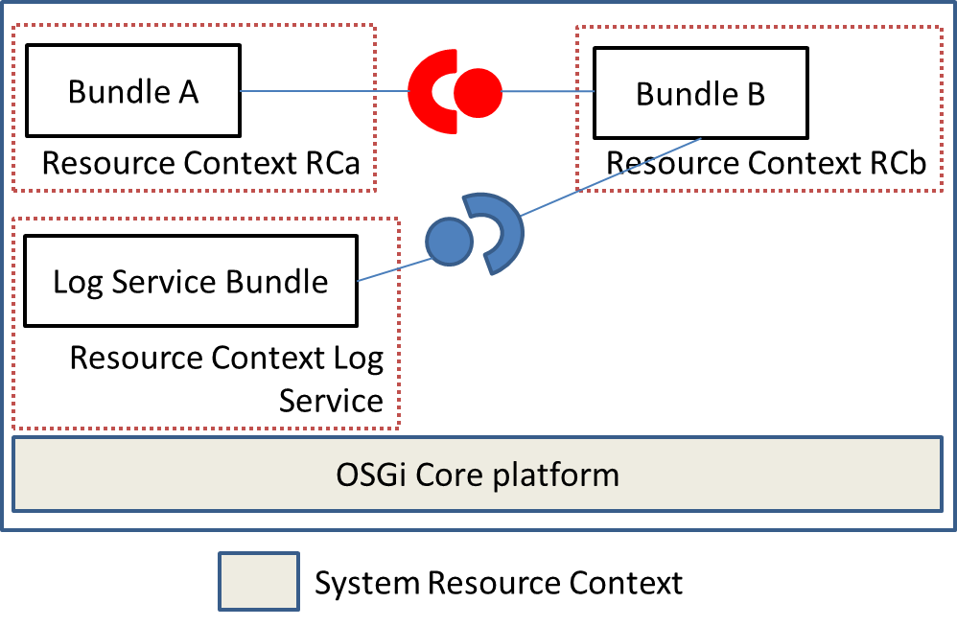
Bundle A belongs to the Resource Context named RCa. It requires the Red service provided by Bundle B. The Red service provides a single public method called m(). Red.m() method uses the LogService to log useful data. Bundle B belongs to Resource Context RCb, LogService bundle belongs to Resource Context Log Service.
When bundle A calls Red.m() method, all the resources consumed by Red.m() method are paid by Rca (if, for instance, the owner is defined as the owner of the current thread). As Red.m() calls also the LogService.log() method, the resource consumed by LogService.log() method are also paid by RCa.
Now, if the Red.m() method executes a context switching operation to switch to RCb (resource context instance of bundle B), then all resources used by Red.m() method are paid by RCb including the resources used by the call to the LogService.log() method. In this case, a call to Red.m() method costs nothing to RCa. However, Red.m() method MUST switches back to RCa at the end of its execution. If it is not the case, all resources consumed afterwards could be still paid by RCb. One more time, it is very important for a method that need to execute a switch context operation to switch back to the initial context at the end of its execution.
The three use cases described above show that context switching operation are not suitable in all cases. The most important thing is finally to determine which is the context executing the code. In all cases, a switching context operation notify all ResourceMonitor instances of both the outgoing ResourceContext and the incoming ResourceContext. The ResourceMonitor instances of the leaving ResourceContext are notified through ResourceMonitor.notifyOutgoingThread(thread) where the ones of the incoming ResourceContext are notified through ResourceMonitor.notifyIncomingThread(thread).

Compatibility between bundles capabilities
Some bundle implementation should naturally use the Resource Management features and in particular the switching context operation in order to account resource properly. For example, the Http Service implementation switch to the Context of the bundle providing the servlet before executing any service methods when receiving an HTTP request.
An open issue is the deployment of resource management non-aware bundles into a resource management aware context. In that particular case, some Resource Context may not be charged correctly.
The present specification gives all the features necessary to implement bundles and framework resource management aware. As a consequence, the platform operator is free to deploy suitable bundles depending on its needs (i.e., in a resource management aware context or not).

Implementation of resource management aware bundles
There are different ways to implement a resource management aware bundle.
The first approach is the direct implementation into the bundle. The bundle implementer is free to execute context switching operation when it is required. The bundle implementer is fully responsible to choose the appropriate Resource Context to charge and it is also responsible to switch back to the initial Resource Context. This approach has some drawbacks. First, it implies to handle Resource Management features into a business features which is sometimes not suitable. Moreover, the platform operator must be confident in the way the bundle implementer uses context switching operations (i.e., permissions). Finally, as the context switching operations are made by the bundle itself, the chosen accounting policy is statically defined. This accounting policy may not be convenient in all situations.
The second approach is to take advantage of the weaving feature. The weaving feature allows to inject some byte-code into existing bundles. In this case, the injected byte-code deals with the context switching features. The byte-code injection can be done at runtime or at the compilation time. The advantage of this approach is that the bundle implementer does not need to handle any context switching feature. Moreover, the accounting policy can be changed with a new byte-code injection. The main drawback of this approach is the complexity and acceptability of the use of bytecode injection.
Finally, the last approach is to implement service proxies. This kind of service proxyfies a service which is not resource management aware. The service proxy implements the same interface as the one of the to-be-proxified service and handles all the resource management stuff. This approach is very similar to the weaving approach.

Example 1
Operators involved into the Residential market plan to provide a Resource Management aware OSGi platform on which Third Party Players will deploy bundles:
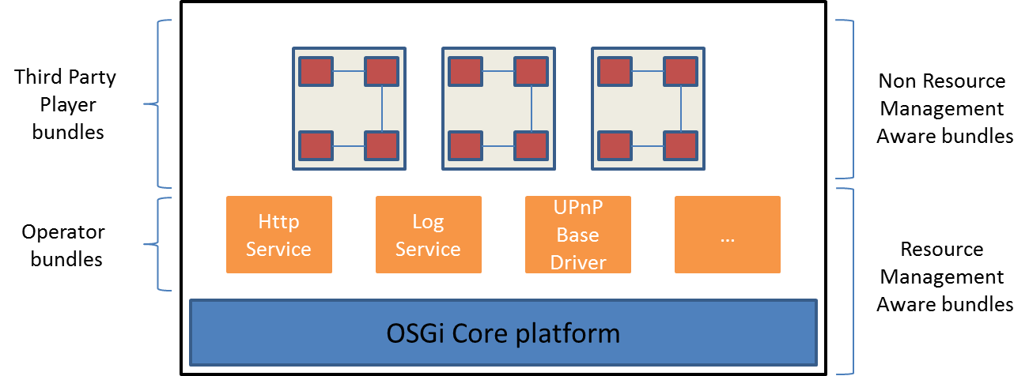
The OSGi platform hosts some operator bundles like HttpService or LogService. All of them are resource management aware, i.e., they automatically execute switch context operation in order to charge resource to the appropriate Resource Context.
All these operator services are used by Third Party Player bundles. Each Third Party Player is isolated from another (they do not share services between them) and the platform operator creates a Resource Context per Third Party Player. Moreover, as Third Party Players may not be trusted, their bundles do not have access to the Resource Management API. This does not prevent the resources to be accounted to the Resource Context belonging to the Third Party Player.
In such situations, Resource Management is transparent for the Third Party Player. Authorities and operator bundles handle resource context switching at the appropriate moment.

Example 2
In the Enterprise context, bundles are deployed using the OBR service. The OBR allows to deploy bundles and all their dependencies computed based on package and service dependencies of to be-installed bundle:
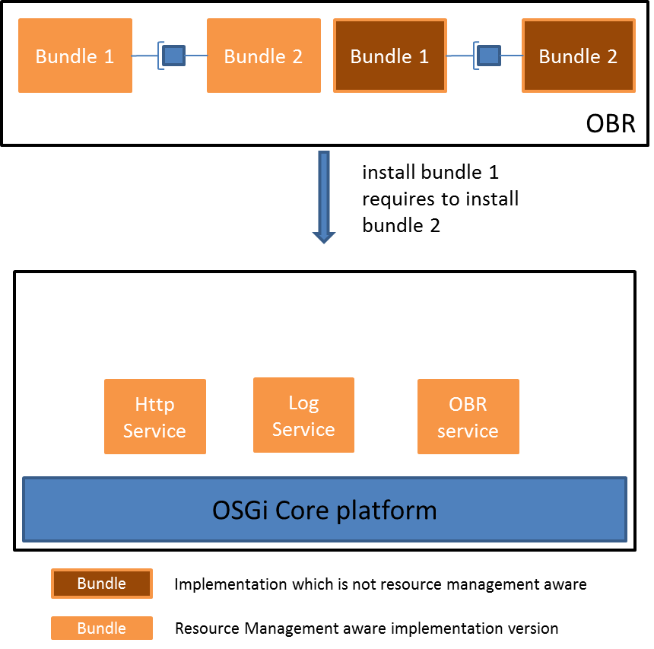
Here, the OBR service is requested to install the bundle 1 which depends on a package provided by bundle 2 (which is not installed on the platform). The OBR then installs the bundle 1 as well as the bundle 2 in order to satisfy the missing dependency.
In the case where the OSGi Core platform is resource management aware, the operator may have to deploy bundles which should be resource management aware. So the OBR service should take care between a bundle implementation which is resource management aware (light orange box on the schema) and a one which is not (dark orange box).
In such cases, either the OBR service is smart to deploy the appropriate version or the operator should do it itself.

Event Admin use-case
The next sequence diagram shows the use-case of the Event Admin:
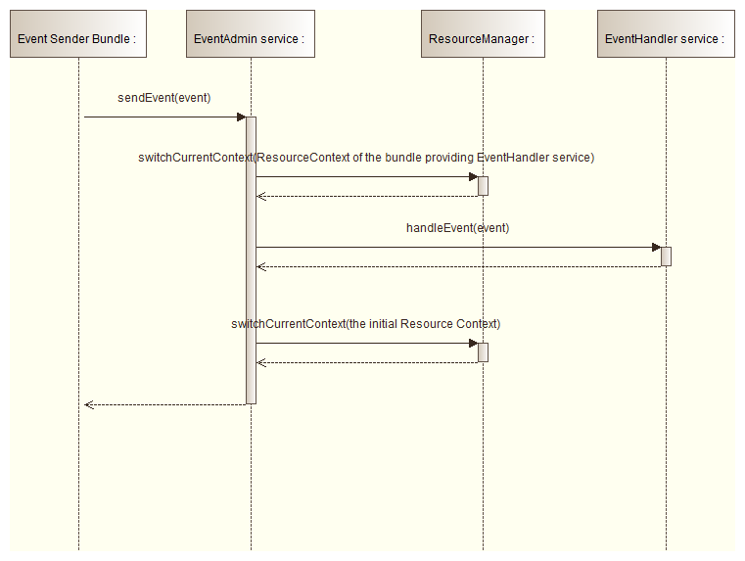

A bundle uses the EventAdmin.sendEvent() method to emit an event. The EventAdmin service then performs a lookup into the OSGi service registry to find out all the available EventHandler services. For every to-be-notified EventHandler, the EventAdmin performs a switching context operation to be in the Resource Context of the bundle providing the EventHandler service. Then it calls the EventHandler.handleEvent() method and switches back to the initial Resource Context (the one of the bundle sending the event).
The context switching operation made here allows to charge the bundle receiving the event instead of the bundle sending the event.

Http Service use-case
The Http Service use-case is shown below:
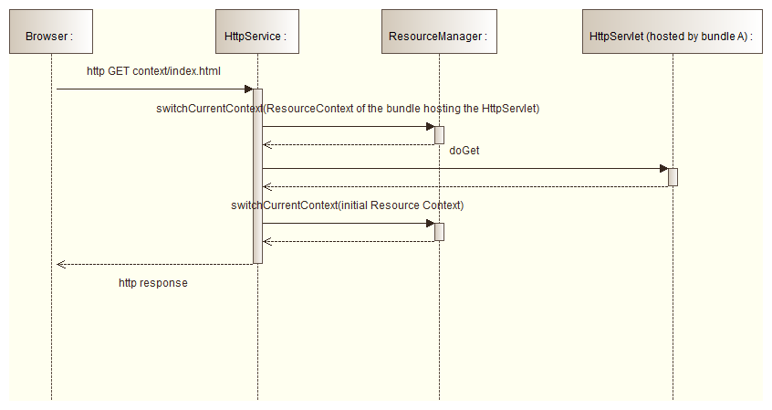
A browser requests an HTTP GET on context/index.html. The HttpService identifies the HttpServlet to be-invoked based on the context of the request. Once identified, the HttpService executes a switch context operation to the Resource Context of the bundle provided the HttpServlet. Then, the HttpService calls the HttpServlet.doGet() method and switches back to the initial context.
The switching context operation allows to charge the bundle providing the HttpServlet instead the bundle exposing the HttpService.

Security Considerations

Document Support

References
- Bradner, S., Key words for use in RFCs to Indicate Requirement Levels, RFC2119, March 1997.
- Software Requirements & Specifications. Michael Jackson. ISBN 0-201-87712-0
- RFP 153 – Resource Management for OSGi Platform, OSGi Alliance
- T. Miettinen, D. Pakkala, and M. Hongisto. A method for the resource monitoring of osgi-based software components. In Software Engineering and Advanced Applications, 2008. SEAA '08. 34th Euromicro Conference, pages 100 {107, 3-5 2008.
- Y. Maurel, A. Bottaro, R. Kopetz, K. Attouchi. Adaptive Monitoring of End-user OSGi based Home Boxes. In Component Base Software Engineering, 15th ACM SigSoft International Symposium on Component-Based Software Engineering (CBSE 2012), Bertinoro, Italy, June 2012.
- C. Larsson and C. Gray. Challenges of resource management in an OSGi environment. In OSGi Community Event 2011, Darmstadt, Germany, September 2011.
- N. Geofray, G. Thomas, G. Muller, P. Parrend, S. Frénot, and B. Folliot. I-JVM: a java virtual machine for component isolation in osgi. In Proceedings of the 2009 IEEE/IFIP International Conference on Dependable Systems and Networks, DSN, pages 544{553. IEEE, 2009.
- Java Community Process, Java Specification Request 163, Java Platform Profiling Architecture, final release, September 2004.
- The Java Virtual Machine Specification, Second Edition by Tim Lindholm and Frank Yellin. Addison-Wesley, 1999, ISBN 0-201-43294-3.
- The Java Language Specification, Third Edition, May 2005, ISBN 0-321-24678-0.
Add references simply by adding new items. You can then cross-refer to them by chosing <Insert><Cross Reference><Numbered Item> and then selecting the paragraph. STATIC REFERENCES (I.E. BODGED) ARE NOT ACCEPTABLE, SOMEONE WILL HAVE TO UPDATE THEM LATER, SO DO IT PROPERLY NOW.

Author’s Address

Name | BONNARDEL Gregory
Company | France Telecom Orange
Address | 28 Chemin du Vieux Chêne, 38240 Meylan, France
Voice | +33 4 76 76 44 49
E-mail | gbonnardel.ext@orange.com

Name | BOTTARO Andre
Company | France Telecom Orange
Address | 28 Chemin du Vieux Chêne, 38240 Meylan, France
Voice | +33 4 76 76 41 03
e-mail | andre.bottaro@orange.com

Name | DIMOV Svetozar
Company | Prosyst
Address
Voice
e-mail | s.dimov@prosyst.com

Name | GRIGOROV Evgeni
Company | Prosyst
Address
Voice
e-mail | e.grigorov@prosyst.com

Name | RINQUIN Arnaud
Company | France Telecom Orange
Address | 28 Chemin du Vieux Chêne, 38240 Meylan, France
Voice | +33 4 76 76 45 59
e-mail | arnaud.rinquin@orange.com

Name | CHAZALET Antonin
Company | France Telecom Orange
Address | 28 Chemin du Vieux Chêne, 38240 Meylan, France
Voice | +33 4 76 76 41 03
e-mail | antonin.chazalet@orange.com

Acronyms and Abbreviations

End of Document

