Template version: proc-RFC_template-1_01_011016.dot

RFC 14 Accounting Service
Members Only, Draft
cpeg-rfc_14_accounting_service-1_00C
43 Pages

Abstract
The Accounting Service allows a service to charge a customer for service consumption. This RFC describes a common interface to collect charging units from service bundles. The Accounting Service also defines a common interface between the OSGi framework and any underlying Accounting System..

Document Information

Table of Contents
0 Document Information 2
0.1 Table of Contents 2
0.2 Status 4
0.3 Acknowledgement 4
0.4 Terminology and Document Conventions 4
0.5 Revision History 5
1 Introduction 5
1.1 Trust model 5
1.2 Efficiency 6
1.3 Authentication and authorization issues 6
2 Motivation and Rationale 7
2.1 Use cases 8
2.1.1 Payment based on service consumption 8
2.1.2 Secure events 8
3 Technical Discussion 8
3.1 Overview 8
3.1.1 Charge events and Transactions 8
3.1.2 System overview 9
3.2 Preparing the charge event 9
3.3 Charge event descriptor 10
3.3.1 Template Factory 11
3.3.2 CED Template 11
3.3.3 CED Instance 11
3.3.4 Attributes 11
3.3.5 CED Metadata 11
3.4 Sending charge events 12
3.4.1 PaymentSession 13
3.5 Monitoring the charge event 16
3.5.1 Message Exchange – Transaction 17
3.5.2 API comments 18
3.5.3 Reliability of delivery 19
3.6 Obtaining a receipt of delivery for charge event 20
3.7 Message format 20
3.7.1 Accounting service generated messages 20
3.7.2 User bundle generated messages 21
3.8 Performance 22
3.9 Full example 22
4 Current practice 22
4.1 Micropayment schemes 22
4.2 Hash-chains 22
4.3 Security 22
5 Security Considerations 23
5.1 Threats 23
5.2 Known vulnerabilities 24
5.2.1 Trust Establishment 24
5.2.2 Latency in the message authentication process 24
5.3 Open issues 24
5.3.1 Choice of Hash-algorithms 24
5.3.2 Key-lengths 24
5.3.3 How good is the solution anyway? 25
6 Javadoc (API) 25
6.1 org.osgi.service.accounting Interface AccountingService 25
6.1.1 newSession 25
6.1.2 initiateCharge 26
6.1.3 chargeAndCommit 26
6.2 org.osgi.service.accounting Class ChargeException 27
6.2.1 ChargeException 28
6.2.2 ChargeException 28
6.3 org.osgi.service.accounting Interface ChargeState 28
6.3.1 WAITING 29
6.3.2 OPEN 29
6.3.3 ACCEPTED 30
6.3.4 DENIED 30
6.3.5 COMMITTED 30
6.3.6 CANCELLED 30
6.3.7 ERROR 30
6.3.8 BROKEN 30
6.3.9 addChargeStateListener 30
6.3.10 removeChargeStateListener 31
6.3.11 cancel 31
6.3.12 commit 31
6.3.13 getStatus 31
6.3.14 session 31
6.3.15 getTicket 31
6.3.16 getIdentity 32
6.4 org.osgi.service.accounting Class ChargeStateEvent 32
6.4.1 newstate 33
6.4.2 ChargeStateEvent 33
6.4.3 getState 33
6.5 org.osgi.service.accounting Interface ChargeStateListener 34
6.5.1 stateChanged 34
6.6 org.osgi.service.accounting Interface ChargeTicket 34
6.6.1 getTemplateSignature 35
6.6.2 getInstanceSignature 35
6.6.3 getIdentity 35
6.6.4 getStatus 35
6.6.5 getProvider 35
6.7 org.osgi.service.accounting Interface PaymentSession 36
6.7.1 getProvider 36
6.7.2 getDetails 37
6.7.3 signature 37
6.7.4 expire 37
6.7.5 currentToken 37
6.7.6 setToken 37
6.8 org.osgi.service.accounting Interface SessionToken 38
6.8.1 currentToken 38
6.8.2 messageDigest 38
6.8.3 session 38
6.9 org.osgi.service.accounting.ced Interface CEDInstance 38
6.9.1 getMetadata 39
6.9.2 validate 39
6.10 org.osgi.service.accounting.ced Interface CEDTemplate 40
6.10.1 getMetadata 41
6.10.2 validate 41
6.10.3 newInstance 41
6.11 org.osgi.service.accounting.ced Interface CEDTemplateFactory 41
6.11.1 createTemplate 42
7 Document Support 42
7.1 References 42
7.2 Author’s Address 43
7.3 Acronyms and Abbreviations 43
7.4 End of Document 43

Status
This document specifies a proposal for a standardized payment mechanism for the Open Services Gateway Initiative, and requests discussion and suggestions for improvements. Distribution of this document is unlimited within OSGi.

Acknowledgement

Terminology and Document Conventions
The key words “MUST”, “MUST NOT”, “REQUIRED”, “SHALL”, “SHALL NOT”, “SHOULD”, “SHOULD NOT”, “RECOMMENDED”, “NOT RECOMMENDED”, “MAY” and “OPTIONAL” in this document are to be interpreted as described in [1].

Source code is shown in this typeface..

Revision History
The last named individual in this history is currently responsible for this document.

Revision | Date | Comments
First draft. | January 11, 2001 | First draft. Lars Eriksson, Telia AB, lars.q.eriksson@telia.se,  Tommy Bohlin, Gatespace AB, tommy@gatespace.com
Draft B |  | Transactions introduced, a improved API description  Lars Eriksson, Telia AB
Draft C | April 9, 2002 | CED, charge event descriptors introduced, a security mechanism proposed, changes to API. Entity model adapted to the terminology described in RFC28.  Lars Eriksson, Telia AB

Introduction
Essentially, charging mechanisms are based on the collection of charge events. The mechanism can be designed differently depending on the trust model between the entities and the equation of security-efficiency contra the cost of handling a transaction. To handle low-cost transaction the charging mechanism in telecommunication systems are based on the generation and collection of charge detail records, CDRs. By protecting the boundaries of the system the degree of security is limited inside the system. In open environments like Internet, many protocol to handle low-cost transaction or micropayments have been developed.
OSGi does not prescribe any particular business model for deployment and therefore it is not obvious which model will fit.
This proposal suggests a model based on generation of charge events. The service generates a charge event and is collected and processed by an accounting operator. The accounting operator will be apparent in the platform as an accounting application. As the trust model suggests the charging mechanism will have some of the characteristics of micropayment schemes

Trust model
The OSGi framework can be executed on different platforms and a bundle cannot normally tell on which one it runs on currently. It means that the service application must consider the environment as hostile.
The mechanism relies on the following trust relationships:
- the service provider trust certain accounting operators. The service application will only trust on information that originates from a trusted accounting operator. The security mechanism will not authenticate the accounting application itself.
- the provider of the service application will assume that the accounting operator will check the credentials of the service user to use the service. If the service user does not have the correct credentials to use the service, the accounting operator will notify the service. This means the service user has a relationship with the accounting operator directly or indirectly.
- the accounting operator will trust on information that originates from an application managed by a certain service provider.
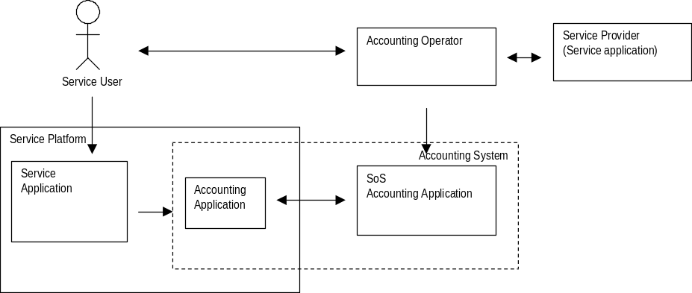
The trust model does not involve the platform operator directly but the proposed mechanism will use certain certificates and/or secret keys and these keys is probably only available on platforms belonging to trusted platform operators.

Efficiency
The transaction or charge event will occur frequently and if many services are running it is of major importance that a charging mechanism will cause as small overhead as possible. Security will cost in performance and it is important that the degree of security can be adapted both between applications and platforms.

Authentication and authorization issues
Authentication and authorization is two concepts that are tightly related to payments. As the trust model propose, the accounting operator is responsible for the authentication and authorization of the user.
[TBA]

If we consider the following example:
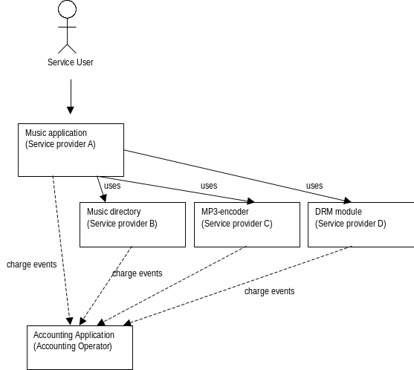
Figure 1 Example - Authentication/Authorization
A service provider has developed a fancy music application. The application takes advantage of three modules that is supplied by three different providers: a music directory that let the user connect to a (commercial) music site, an MP3-encoder engine and a DRM module. Each of these modules generates charge events.
As the trust model implies, there is a relationship between the service providers and the accounting operators. It is not necessary an agreement will exist between the different service providers. When the first charge event reaches the accounting application, the charge event is scrutinized and finds out that the user is not (yet) authenticated. The accounting application takes care of the authentication when it probably knows 1) in which environment it is deployed and knows the available authentication methods 2) the required strength of authentication, if any 3) if the user has been authenticated recently and therefore spare the user from filling in user-name and password twice. The alternative is to put these decisions on the individual components and it will require that the service providers agree upon one solution that makes the approach very application-specific and inflexible.

Motivation and Rationale
Payment is an essential incentive to develop useful services. A charging mechanism will enable a service to generate events that is adapted to a specific application and is bound to the actual service consumption. Further, a bundle is supposed to work in any OSGi platform and therefore it is important a bundle may work with any available payment mechanism. Some use case are presented below:

Use cases

Payment based on service consumption
In some area of application we usually pay in proportion to our consumption of a certain service, for instance water, energy and telephony. A charge mechanism will give an opportunity to implement business models that is based on the consumption of a service that is customized to the specific application.
For instance, a possible business model for road fees could be based on how many miles you actually have driven on the highway.

Secure events
In some applications, it is important that a notification will reach a endpoint and the endpoint can trust that the event really originates from that location.

Technical Discussion

Overview
The proposal is based on a two-phase transaction mechanism. The charge event is sent to the accounting operator and waits that the application commits the transaction before it completes. A transaction can be pending by several reasons. Firstly, before the application will deliver any service at all, it will check if the service user has the correct credentials to use it. Secondly, the service delivery is often based on best effort basis. An unreliable network connection or server may reduce the quality of service to a degree that makes it worthless for the user and therefore the provider will not charge the user.

A charge event differs from an event in Java [8] because each event must be seen as a transaction both in respect for the reliability of delivery and the security regarding destination and origin. Both issues will be described in more detail later in the chapter. This chapter will cover:

- Event description
- State model for the transaction
- Message exchange mechanism
- Reliability of delivery
- Proof of transaction

Charge events and Transactions
This document distinguishes between the charge events and (charge) transactions. A charge event will refer to the action that the application describes for the accounting operator. A transaction will refer to the hand-over procedure of a charge event to the accounting operator.

System overview

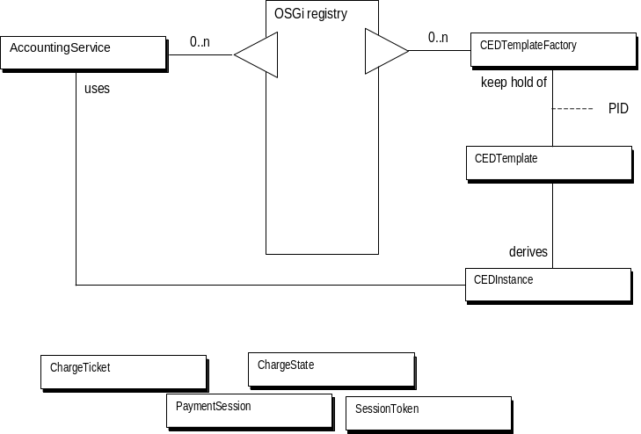
Figure 2 System Overview

The charge flow will include the following steps:
- Preparing the charge event
- Charge Event Descriptor
- Sending the charge event
- Monitor the state of the charge event
- Obtaining a receipt of delivery for the charge event

These steps will be covered in this chapter.

Preparing the charge event
[TBA]
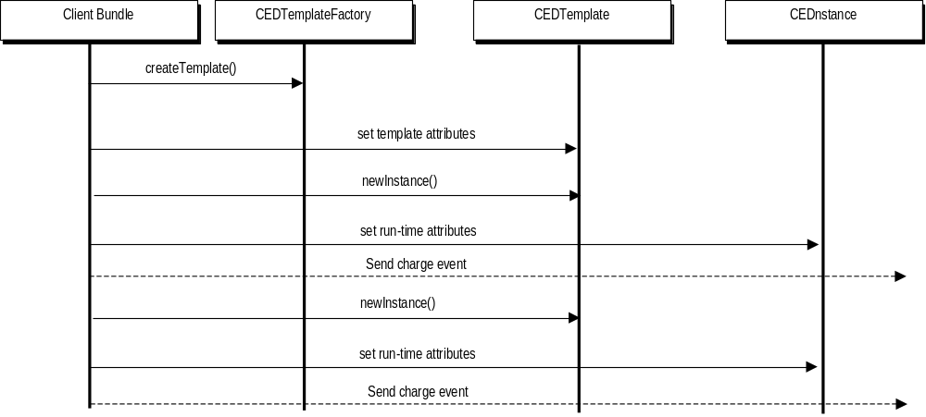
Figure 3. Overview of Charge Event preparation

Charge event descriptor
An event is described in terms of a Charge Event Descriptor, CED. A CED describes a charge event in the system and can be seen as a pre-defined key-value list with one or more attributes. The collection of attributes may differ from different kind of applications. In telecommunication applications the number of attributes is often quite large. A CED should capture an image of the current state of the system. However, most of the values in a CED will remain unchanged between a numbers of consecutive charge events. A bundle should not be able to modify some of the attributes in a CED to prevent mistakes and/or tampering. In addition a CED should not contain any objects only information.
The attributes is divided into three categories:
- system attributes
- session attributes
- run-time attributes
The categories reflect when the attributes are set. System attributes are set before the bundle receives the CDR template and cannot be changed by the bundle and is supposed to be common for all charge events.
Session attributes will be set by the bundle but will be valid for a number of consecutive calls. These attributes are set in the CED template and when the first instance is created from the CED template, the bundle cannot change the values without obtaining a new CED template.
Run-time attributes are supposed to change between two consecutive charge events and therefore can be redefined at any time.
A motivation of differentiating attributes is to provide a simple protection mechanism for attributes. System attributes often reflects vital system information and access to this information is often restricted to components with administrator privileges. A session may indicate some logical connection between numbers of consecutive charge events. By protecting session attributes a bundle can prevent unauthorized modification of certain attributes from any point of time.

Template Factory
A CDR template is acquired from a CEDTemplateFactory. A CEDTemplateFactory creates the CEDTemplate, sets the system attributes and return the template to the bundle. In general a template is not connected to the bundle even though the system attributes can be set in respect to the bundle that acquires the template.
A template is acquired with is persistent identity or PID. It is recommended that the PID should be defined as a URI [2] to give a globally uniqueness for the CEDTemplate. For instance, www.ietf.org/radius should be suitable as a PID for a RADIUS charge detail record [3]. The CEDTemplateFactory must return null if a CEDTemplate with a specific PID cannot be returned.

CED Template
A CED template is basically a pre-defined attribute list of key-value pairs and a meta-data description specified in RFC16 [4]. A CED template could be acquired from a CEDTemplateFactory.
System attributes describes system properties that cannot be changed by the bundle and must be set before the bundle receives the template from the CEDTemplateFactory. Session attributes is set by the bundle but is expected not to change during a number of consecutive numbers of calls. When the first CDR is instantiated from the CEDTemplate using newInstance() method, these attributes cannot be changed. A bundle may set any run-time attribute in the CEDTemplate and the values should be propagated to the CEDInstance that is created from the CEDTemplate and could be seen as a default value. The bundle should be able to redefine the value of for any run-time attribute.

CED Instance
The CEDInstance is the constructed charge event. The very same instance could be used in more than one transaction although it is recommended to obtain a new instance from the CEDTemplate when some run-time attributes can be set automatically.

Attributes
An attribute contains of a key-value pair. The key must be of type java.lang.String and must be unique and case insensitive. The value must of a type or an array of:
- BigDecimal
- BigInteger
- Boolean
- Byte
- Character
- Double
- Float
- Integer
- Long
- Short
- String

The bundle cannot redefine any platform-specific attributes. The bundle can redefine template-specific attributes until the first CEDInstance are created. The bundle must not be able to create new attributes nor to redefine the type of an attribute

CED Metadata
If metadata is available CEDTemplate and CEDInstance must check that the bundle sets the attribute value to the expected type; otherwise it must throw a java.lang.IllegalArgumentException. If the metadata for a certain attribute is missing, a java.lang.IllegalStateException must be thrown. The following exception from this rule will apply:
- A bundle may use a java.util.Vector instead of an array construct as long as the vector entirely consists of elements of the expected type.
- A bundle may use an atomic instance of the expected type instead of an array or java.util.Vector structure as long as the atomic instance is of correct type.

Example: If an attribute name-list expects an array of java.lang.String the following structure should be acceptable:

put( “name-list”, “Charlie”) // OK
java.lang.Vector list = new java.lang.Vector();
list.addElement(“Charlie”);
put(“name-list”, list); // OK
put( “name-list”, new java.lang.String[] { “Charlie” } ); //Expected structure

System attributes must be converted to the expected type when the CEDTemplate is returned to the bundle. Any session attributes must be converted to the expected type when the first CEDInstance is created. The accounting service must convert any run-time attribute. The accounting service must check that other metadata requirements are met. Otherwise, the accounting service should put the current transaction into ERROR state. If the metadata is inconsistent with the attribute list it should put the current transaction into ERROR state.

The validate methods in CEDInstance will check all constraints as well, i.e. cardinality, maximum, minimum value. If no metadata is provided a java.lang.NullPointerException must be thrown. An exception must also be thrown if the included metadata is not consistent with the set of attributes. The metadata is consistent if and only if the metadata contains all attributes in the CED.

Sending charge events
A bundle interacts with the accounting operator through the AccountingService interface. An event can only be submitted in the context of a PaymentSession. A PaymentSession is the core of the security mechanism and is the result of a handshake between the service provider and the accounting provider. The PaymentSession will be described in more detail later in this chapter.
A charge event is a two-phase transaction that gives the provider to obtain a preliminary response before the provider commits the transaction. When the accounting operator receives the charge event, it should check the authenticity of the charge event and check the user’s credential and send back a preliminary response to the client bundle whether the client bundle should proceed with the action.
The client bundle performs the action, check if the desired action was successful and thereafter, decide whether to commit the charge event or discard it. The accounting operator may process the charge event and notify the bundle about the final outcome.
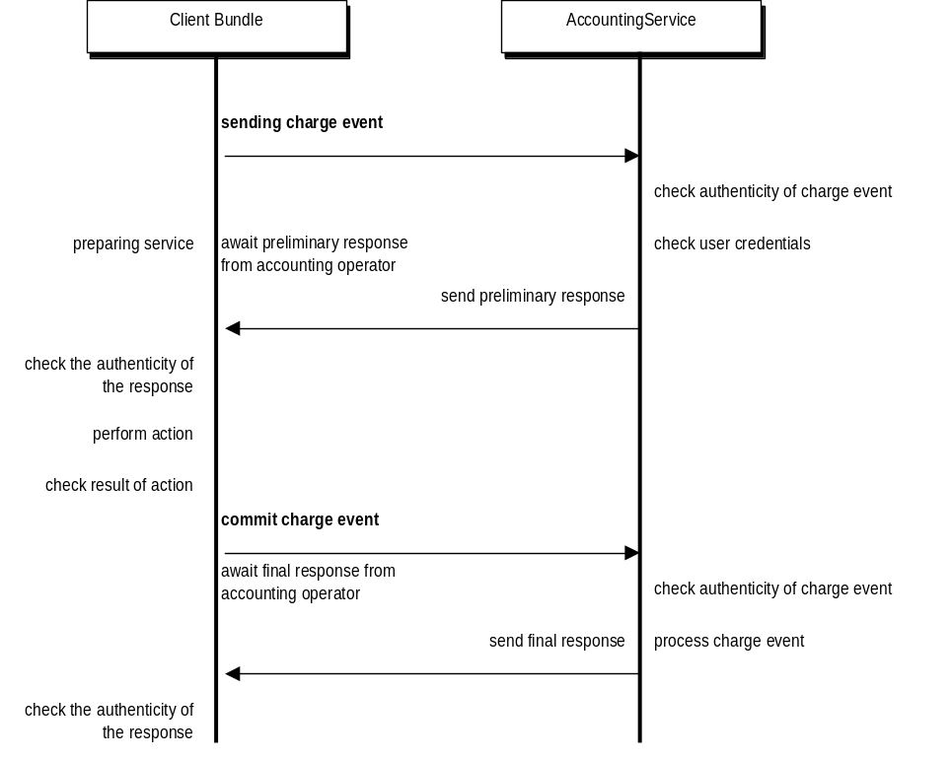
Figure 4. Conceptual flow - sequence chart
The preliminary and the final response from the accounting service could differ depending on circumstances that are difficult to foresee in advance. For instance, the connection between the accounting application in the service platform and the SOS (Service Operations Support) before the bundle can commit the transaction.

PaymentSession
A PaymentSession defines the security framework for the accounting service. The mechanism for authenticate the message exchange is based on hash chains [9] that is commonly practiced in micropayment schemes. Chapter 5 will describe the theory behind hash chain more detailed.
A hash chain is an ordered list of tokens that has a specific relationship to each other. Beginning with a seed value, a token is calculated as the hash-sum of the following token. Suppose a hash-chain { x, y, z }. Token z is calculated as H(seed) where H is a hash-algorithm and seed is a random number. Token y is calculated as H(z) and token x is calculated as H(y) = H (H (z)). If the tokens are used in order {x, y, z}, it should be very difficult (impossible in the ideal case) to forecast token y, given that you know token x. On the contrary, it is very simple to check that token y is followed by token x.
In many schemes, this hash-chain is shared between the two entities to protect against man-in-the-middle attacks but shared secrets are not a comfortable approach. A badly written bundle will contaminate both the bundle and the accounting service and therefore I suggest a model using two distinct hash chains.
Let s_{n} denotes the n^{th} value of a hash-chain s, t_{n} denotes the n^{th} value of a hash-chain t, H denotes a strong hash-algorithm like MD5 [5] or SHA [6], HMAC denotes a HMAC algorithm using a strong hash-algorithm [7].
Initialisation
- The service provider and the accounting operator obtain or generate a pre-generated hash-chain. It is important that the parties keep the chain secret for exposure. The security relies entirely on the fact that the next token is a well-kept secret.
Trust establishment
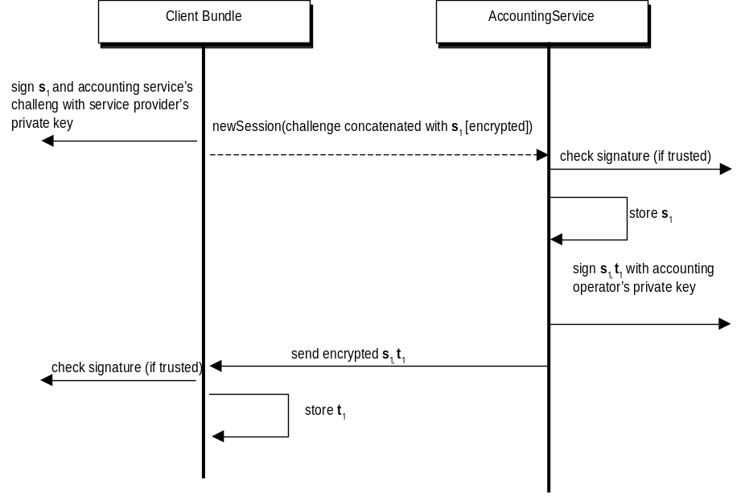
Figure 5 Trust Establishment - Sequence Chart
- The trust establishment occurs when the client bundle creates a new PaymentSession. The trust is established with a challenge-response. The client signs the first token s₁ concatenated with a known challenge from the accounting service with its private key. The client bundle sends the encrypted message and expects that the accounting service respond with the concatenation of the token s₁ and the accounting service first token t₁ that is encrypted with its private key.
When a token is exposed for the other party it is not considered as a secret anymore.
Implementation note: The implementation may support a shared secret key solution if the service platform or the client bundle does not support certificates. By omitting the certificate parameter in the method newSession(nounce, cert) method the accounting service should assume that the nounce is encrypted with a known secret key
Message Exchange
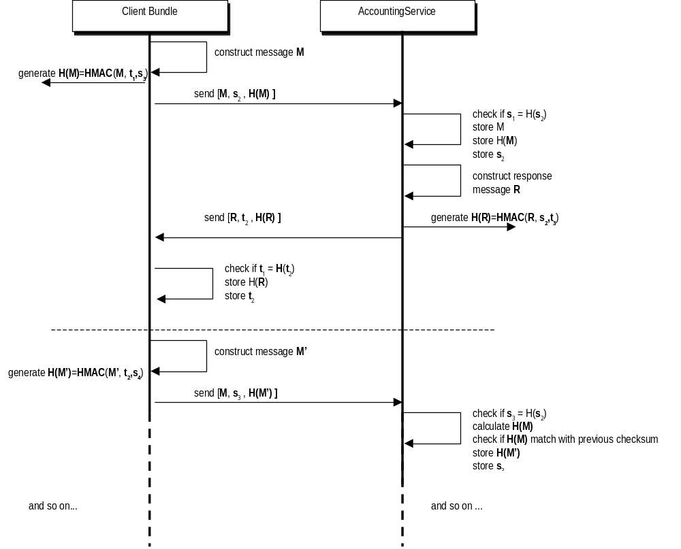
Figure 6 Message Exchange - Sequence Chart
- The message M is constructed.
- Client bundle let create a checksum H(M)=HMAC(M, t₁, s₃). Please observe the checksum does not contain the following token s₂ that will be sent in clear-text that is used in the checksum. It is important that s₃ is not revealed at this moment. The t₁ is used to prevent replay-attacks.
- The client bundle transmits the message M concatenated with token s₂ and the checksum H(M).
- The accounting service starts to check the chain is not broken, in other words if s₁=H(s₂). It stores message M, the checksum H(M) and token s₂. At this stage, the accounting service is unable to check the integrity of message M.
- The accounting service constructs its response message in similar way and generates a checksum value H(R)=HMAC(R, s₂, t₃) and return the response to the client bundle.
- The client bundle starts to check the chain is not broken, in other words if t₁=H(t₂). It stores message R, the checksum H(R) and the token t₂.
In the next message M’ that is sent to the accounting service, the client bundle reveals token s₃ for the accounting service and H(M) can now be reconstructed by the accounting service.
A more extensive security analysis is given in chapter 4.

Monitoring the charge event
A service bundle may monitor and to a certain degree control the flow of the charge event from the moment when the charge event is submitted until the accounting service returns its final response. The major decision a bundle must take is whether the charge event should be confirmed or discarded.
The figure below shows the state chart of a transaction. The initial state of transaction is WAITING. It means that the charge event is unconfirmed by the accounting operator. As soon as the accounting operator acknowledges it has received the transaction, the transaction becomes OPEN.
At this point, the accounting operator must make a decision to either reject the charge event or approve it. If the charge event is rejected the transaction is set into DENIED state otherwise it set the charge event into ACCEPTED state.
The client bundle must make the next decision. If the client bundle wants to proceed with the transaction it commits the charge event, otherwise it cancels the transaction.
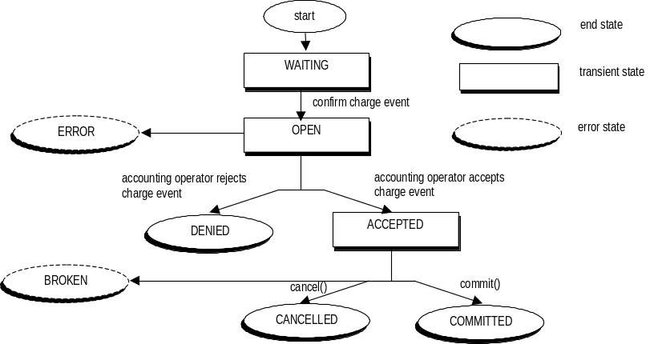
Figure 7 Transaction State Chart
There are two error states of a transaction. The ERROR state indicates that the accounting service cannot tell which decision the accounting operator has made regarding the charge event. The BROKEN state indicates that the accounting service cannot find the current transaction (that has been accepted) and therefore cannot complete the task by canceling or committing the transaction. This state may indicate that the client bundle has waited too long with its decision so the accounting operator has considered the transaction uncompleted.
The bundle may commit or cancel the transaction when it has reached ACCEPTED state. A ChargeException is thrown otherwise. It is undefined what happens in WAITING state.
A transaction will wait forever in WAITING state if the client bundle does not receive any acknowledgement from the accounting service.

Message Exchange – Transaction
The proposed message exchange mechanism has a built-in latency that implies that the last message can be modified and the scam will not be discovered until the next message. However, the hash-chain guarantees that every message must reach the other to receive the next token. However, it is extremely important that not doing anything before it has received the token.
The state chart gives less flexibility for the client bundle. A transaction cannot be committed or cancelled in any state but ACCEPTED and the accounting service should consider any attempt by breaking this as a potential security breach. Further, the accounting service should take this security weakness of the protocol into consideration.
The potential risks are:
- A WAITING transaction becomes OPEN state and the client bundle may believe that the charge event is “secured”. A bogus accounting service cannot set the transaction into ACCEPTED/DENIED/ERROR state without breaking the hash-chain. If the service bundle must wait ACCEPTED to commit the bundle anyway.
- An OPEN transaction waits for a decision. A malicious bundle may turn the transaction into ACCEPTED state. If the client bundle commits the transaction and continues without awaiting the response from the accounting operator the attack was successful.
- A CANCELLED transaction was turned into COMMITTED (a malicious bundle may cancel a transaction that was committed by the client bundle and pretend the transaction was COMMITTED anyway). This scam is not revealed before the next transaction is initialized (using the same hash-chain).
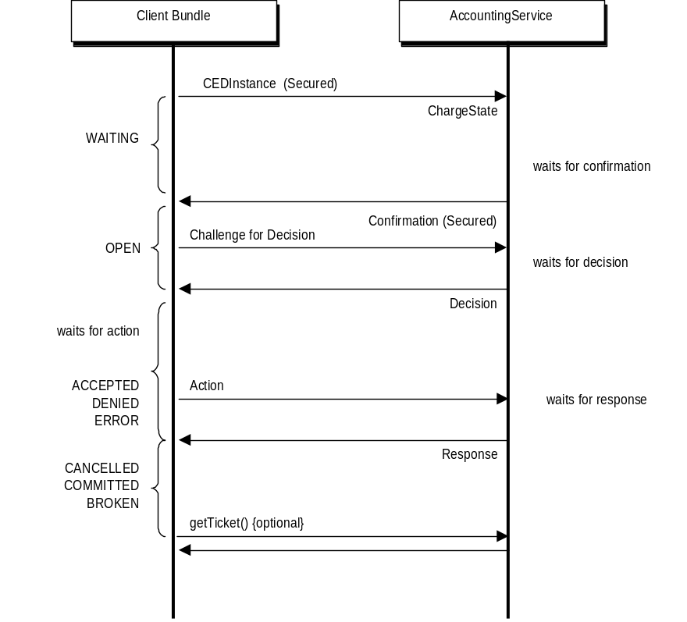
Figure 8. Message exchange in the scope of a transaction.
There are many more potential risks but these risks shows that the bundle must take management of charge event with great care.

API comments
There are two classes the controls the message exchange flow:
- PaymentSession
- SessionToken
A PaymentSession manifest the trust establishment mechanism and encapsulate two tokens: the one that is sent from the accounting service to the client bundle and the token that will be sent to the accounting operator in order to authenticate the sent message.
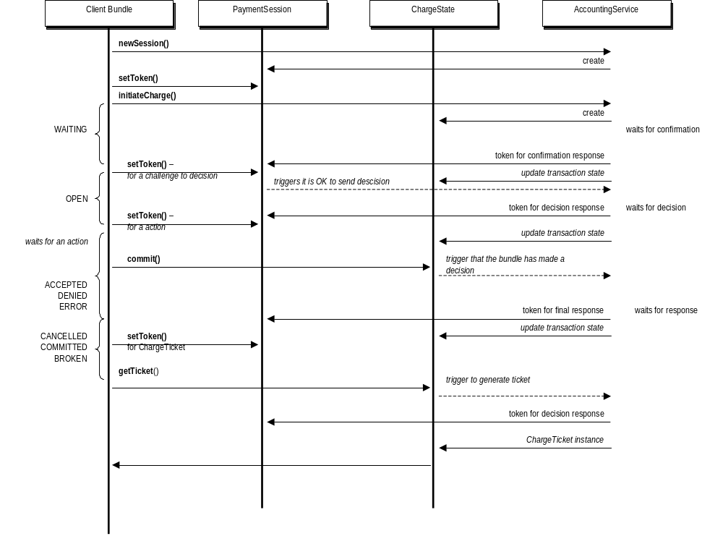
Figure 9. Sequence Chart - Payment Flow
The sequence chart the method a client bundle has to invoke to complete the transaction. For each action, the bundle place a new token in the PaymentSession instance using the setToken() method. When the token reaches the accounting service, it should remove the client bundle’s old token from the PaymentSession instance and update its own token.
Method like AccountingService.initiateCharge, AccountingService.chargeAndCommit, ChargeState.commit and ChargeState.cancel requires a token to do something. If the PaymentSession does not contain any client token, these methods will do nothing. Additionally, the PaymentSession must be loaded with a token to move from WAITING into OPEN state. In this case PaymentSession.setToken method must trigger the accounting service to proceed.
The AccountingService.chargeAndCommit is a shortcut that will block the current thread until the transaction completes (reaches an end-state). The whole process is done in the background and for the accounting service will be considered as a transaction with two possible states: WAITING, or one of the end-states. One token will suffice and another one to obtain the ChargeTicket for the transaction.

Reliability of delivery
No explicit requirements of reliability exist.

Obtaining a receipt of delivery for charge event
The service bundle may obtain a ChargeTicket that confirms the transaction. The ticket can be used to trace transactions that the service provider claims to have occurred.
The ChargeTicket have another purpose as well. It finalize the transaction and as any message. It consists the last piece of evidence that confirms the end-state of the transaction’s end-state. A charge ticket could only be obtained in an end state.

Message format
The security mechanism required that message format of the exchanged messages are standardized or at least that the HMAC-sums are generated in exactly the same way.
Each transaction must be assigned a unique identity and will be available for the client bundle as soon as the transaction reaches OPEN state. The client bundle can retrieve the identity using the ChargeState.getIdentity method.
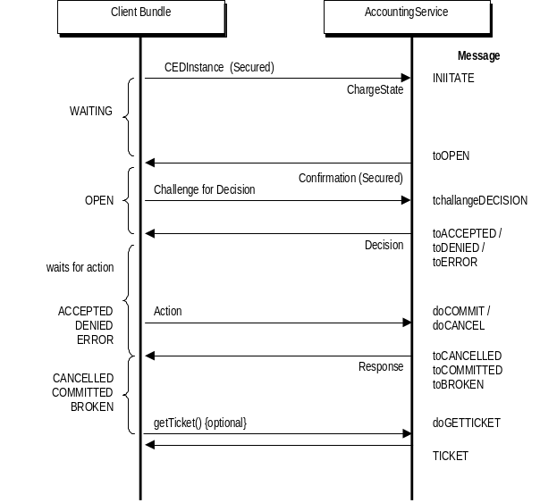

Accounting service generated messages
The table below should be interpreted that the bundle constructs the message by concatenating the identity string with the postfix (UTF-8 encoded) except for the TICKET message that has its own format.
Message | Postfix
toOPEN | :WAITING:OPEN
toACCEPTED | :OPEN:ACCEPTED
toDENIED | :OPEN:DENIED
toERROR | :OPEN:ERROR
toCANCELLED | :ACCEPTED:CANCELLED
toCOMITTED | :ACCEPTED:COMMITTED
toBROKEN | :ACCEPTED:BROKEN
TICKET | special

User bundle generated messages
The table below should be interpreted that the bundle constructs the message by concatenating the identity string with the postfix (UTF-8 encoded) except for the INITIATE message that has its own format.
Message | Postfix
INITIATE | special
challengeDECISION | [identity]:OPEN:
doCOMMIT | [identity]:COMMIT
doCANCEL | [identity]:CANCEL
doGETTICKET | [identity]:TICKET

Initiate message
A CED consists of key-value pairs and when the number of attributes can be a rather large number it must be possible to work with increment hash-sum. The following message format is proposed. The message is a UTF-8 encoded representation of four hash-sums encoded with a hash-algorithm. Use the textual representation of the attribute values:
- HMAC-encoding of all attributes names
- HMAC-encoding of the values of the system-attributes
- HMAC-encoding of the values of the session-attributes
- HMAC-encoding of the values of the runtime-attributes
The elements are encoded in the order that they appear in the CEDInstance. Concatenates the four hash-sum’s UTF-8 encoded representation. Three hash-sum can be generated once and after the bundle only have to calculate the forth hash-sum to generate the new message.
Ticket
to be added

Performance
To be added

Full example
To be added – [Music app]

Current practice

Micropayment schemes
To be added -- NetBill, Jalda, SET, categorization of micropayment schemes

Hash-chains
To be added – brief presentation

Security
To be added – what is known

Security Considerations

Threats
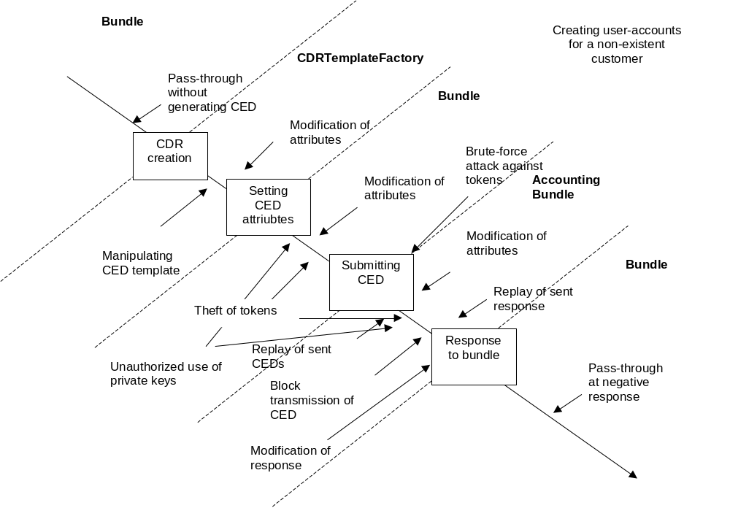
Figure 10. Threats against the charging mechanisms
As the figure shows, there are many possible attacks and there are many more. I will comment some scenarios.

Pass-through
A pass-through attack will manipulate classes or the virtual machine so the bundle skips the charging process and works any way.

Modification of CED
The attack tries to change attribute values in the CEDInstance or CEDTemplate. A malicious bundle obtains a reference to the instance and can set attributes without the other bundle’s knowledge.

Unauthorized use of private keys
A bundle can be fooled to sign a message that was generated by the malicious bundle.

Theft of tokens
The “secure” token repository can be contaminated. However, when the rightful owner tries to use the same tokens an inconsistency will occur. It is important that both the bundle and the accounting service will not tolerate any discrepancy in the hash-chain or the message format.

Attacks against hash-chains
[tba]

Attacks against certificates
[tba]

Attacks against HMAC-sum
[tba] clear-text attack, birthday-attack

Known vulnerabilities

Trust Establishment
The first message sent from the service bundle to the accounting service contains, in the view of the accounting service, a random-generated message. Essentially, a malicious bundle may establish a session by pretending to be someone. The weakness is that a malicious can be tempted to break the hash-chain computationally and if so it can 1) pretend to be someone else 2) having a hash-chain that seems to be encrypted with correct certificate. Therefore the accounting service must publish a challenge as a service attribute that must be used in the trust establishment phase.

Latency in the message authentication process
A nice feature in the mechanism is the fact that the mechanism does not rely on shared secrets. A well-written accounting service will not suffer when it communicates with badly written service bundle. However, the price is the exchange mechanism protects a message by signing the message with a token from the past (the counterpart’s last token) and a token from the future (the token that follows) and the current token in clear-text.
It means it cannot authenticate the message immediately but waiting to the next message and this implies that the last message can be modified and this fact must be taken into consideration when using the accounting mechanism.

Open issues

Choice of Hash-algorithms
Performance, Strength, known vulnerabilities, any license cost
[to be added]

Key-lengths
Security vs Performance
[to be added]

How good is the solution anyway?

Javadoc (API)
Class
Tree | Deprecated | Index | Help

PREV CLASS NEXT CLASS | FRAMES NO FRAMES
SUMMARY: INNER | FIELD | CONSTR | METHOD | DETAIL: FIELD | CONSTR | METHOD

org.osgi.service.accounting
Interface AccountingService

public interface AccountingService
AccountingService provides an interface toward a charging mechanism to collect and process charge events. The charge event is submitted in the context of a PaymentSession. The AccountingService must publish a challenge that is used by the service bundle in the trust establishment phase. The challenge must be available as a service attribute org.osgi.service.accounting.challenge. The challenge should be published as a java.lang.String. The challenge can be change during time

Method Summary
ChargeState | chargeAndCommit(CEDInstance ev, long timeout, PaymentSession session)  Submits a charge event and blocks until the transaction is completed.
ChargeState | initiateCharge(CEDInstance ev, PaymentSession session)  Submits a charge event to the accounting service.
PaymentSession | newSession(byte[] nounce, java.lang.Object cert)  Creates a new PaymentSession.

Method Detail

newSession

public PaymentSession newSession(byte[] nounce,
java.lang.Object cert)
throws java.lang.SecurityException,
java.lang.UnsupportedOperationException,
java.lang.IllegalArgumentException
Creates a new PaymentSession. The PaymentSession establish trust between accounting operator and the service provider by exchanging a nounce that should be a token in a generated and secret Hashchain.
Parameters:
nounce - is an encrypted nounce. A nounce could be encrypted with the private key of the service provider or be exchanged using a shared secret key.
cert - hints the accounting service that the nounce is exchanged using certificates. If the value is set to null the service provider preferes to use shared secret keys for trust establishment. The nounce is encrypted using the shared secret key. The type must be of java.security.Certificate, otherwise an exception is thrown
Returns:
an encrypted token from accounting operator. The accounting operator uses the same method for trust establishment as the service provider choosed.
Throws:
java.lang.UnsupportedOperationException - is thrown if the accounting operator does not support the prefered mechansim of trust establishment.
java.lang.IllegalArgumentException - is thrown if cert is not of type java.security.Cerficate or null

initiateCharge

public ChargeState initiateCharge(CEDInstance ev,
PaymentSession session)
throws java.lang.SecurityException,
ChargeException
Submits a charge event to the accounting service. The method returns immediately and the state of the charge event can be traced using the ChargeState instance.
Parameters:
ev - the submitted event. If the value is null an exception will be thrown
session - the security context of the submitted event. If the value is null or the session is invalid, an exception will be thrown
Returns:
a monitoring instance for the charge event
Throws:
java.lang.SecurityException - is thrown if the session is invalid or set to null
java.lang.ChargeException - is thrown if the charge event is set to null the accounting service detects that the charge event does not match the metadata description of the charge event
See Also:
CEDInstance

chargeAndCommit

public ChargeState chargeAndCommit(CEDInstance ev,
long timeout,
PaymentSession session)
throws java.lang.SecurityException,
ChargeException
Submits a charge event and blocks until the transaction is completed. When the charge event is ready to be committed, the accounting service autmatically commits the transaction and waits for the transaction to complete.
Parameters:
ev - the charge event that is submitted to the accounting service. If the value is null an exception will be thrown
timeout - specifies the number of milliseconds the method waits to let the transaction complete. If the transaction has not completed within specified time an exception will be thrown and the transaction is cancelled (if possible).
session - the security context of the submitted event. If the value is null or the session is invalid, an exception will be thrown
Returns:
a monitor instance for the charge event if the transaction completed.
Throws:
java.lang.SecurityException - is thrown if the session is invalid or set to null
ChargeException - is thrown if the transaction was unable to complete within specified time.

Class
Tree | Deprecated | Index | Help

PREV CLASS NEXT CLASS | FRAMES NO FRAMES
SUMMARY: INNER | FIELD | CONSTR | METHOD | DETAIL: FIELD | CONSTR | METHOD

Class
Tree | Deprecated | Index | Help

PREV CLASS NEXT CLASS | FRAMES NO FRAMES
SUMMARY: INNER | FIELD | CONSTR | METHOD | DETAIL: FIELD | CONSTR | METHOD

org.osgi.service.accounting
Class ChargeException

java.lang.Object
|
+-java.lang.Throwable
|
+-java.lang.Exception
|
+-org.osgi.service.accounting.ChargeException
All Implemented Interfaces:
java.io.Serializable

public class ChargeException
extends java.lang.Exception
See Also:
Serialized Form

Constructor Summary
ChargeException()
ChargeException(java.lang.String msg)

Methods inherited from class java.lang.Throwable
fillInStackTrace, getLocalizedMessage, getMessage, printStackTrace, printStackTrace, printStackTrace, toString

Methods inherited from class java.lang.Object
clone, equals, finalize, getClass, hashCode, notify, notifyAll, wait, wait, wait

Constructor Detail

ChargeException

public ChargeException()

ChargeException

public ChargeException(java.lang.String msg)

Class
Tree | Deprecated | Index | Help

PREV CLASS NEXT CLASS | FRAMES NO FRAMES
SUMMARY: INNER | FIELD | CONSTR | METHOD | DETAIL: FIELD | CONSTR | METHOD

Class
Tree | Deprecated | Index | Help

PREV CLASS NEXT CLASS | FRAMES NO FRAMES
SUMMARY: INNER | FIELD | CONSTR | METHOD | DETAIL: FIELD | CONSTR | METHOD

org.osgi.service.accounting
Interface ChargeState

public interface ChargeState
Monitors the state of a charge event. A service bundle uses this instance to monitor and control the flow of a charge event.

Field Summary
static int | ACCEPTED  ACCEPTED state indicates that the accounting operator has accepted the charge event.
static int | BROKEN  BROKEN state indicates that the service bundle cannot commit or cancel the charge event when an inconsistency has occurred in the accounting service
static int | CANCELLED  CANCELLED state acknowleges that the accounting operator has registered that the service bundle has withdrawn the charge event.
static int | COMMITTED  COMMITTED state acknowledges that accounting operator has registered and finally approved the charge event.
static int | DENIED  DENIED state indicates that the accounting operator has rejected the charge event.
static int | ERROR  ERROR state indicates that an error occured before the accounting operator has made a decision to either accept or reject.
static int | OPEN  OPEN state indicates that the accounting operator has acknowledged that the charge event has been registered in the system.
static int | WAITING  WAITING state indicates that the transaction has not been confirmed by the accounting operator.

Method Summary
void | addChargeStateListener(ChargeStateListener l)  Adds a listener that receives notification when a charge event changes its state
void | cancel()  Withdraws the charge event that is ready to be committed.
void | commit()  Commits the charge event that is read to be committed.
java.lang.String | getIdentity()  Returns the transaction identity.
int | getStatus()  Returns the current state of the charge event
ChargeTicket | getTicket()  Return a ticket of a completed transaction.
void | removeChargeStateListener(ChargeStateListener l)  Removes a listener that is currently receives notification about state changes
PaymentSession | session()  Returns the current session of the chargestate

Field Detail

WAITING

public static final int WAITING
WAITING state indicates that the transaction has not been confirmed by the accounting operator. This state is insecure when it indicates that the charge event may not have been registered in the system

OPEN

public static final int OPEN
OPEN state indicates that the accounting operator has acknowledged that the charge event has been registered in the system. The accounting service waits for a decision if the system accepts or rejects the charge event

ACCEPTED

public static final int ACCEPTED
ACCEPTED state indicates that the accounting operator has accepted the charge event. The accounting service waits for the service bundle to either commit or cancel the service event

DENIED

public static final int DENIED
DENIED state indicates that the accounting operator has rejected the charge event. No further information is given by the system. This is an end state

COMMITTED

public static final int COMMITTED
COMMITTED state acknowledges that accounting operator has registered and finally approved the charge event. This is an end state

CANCELLED

public static final int CANCELLED
CANCELLED state acknowleges that the accounting operator has registered that the service bundle has withdrawn the charge event. This is an end state

ERROR

public static final int ERROR
ERROR state indicates that an error occured before the accounting operator has made a decision to either accept or reject. For instance the network connection has been lost to the back-end server

BROKEN

public static final int BROKEN
BROKEN state indicates that the service bundle cannot commit or cancel the charge event when an inconsistency has occurred in the accounting service
Method Detail

addChargeStateListener

public void addChargeStateListener(ChargeStateListener l)
Adds a listener that receives notification when a charge event changes its state
Parameters:
l - is the listener that receives notification for state changes. If the listener is already registered as a listener or the value is null this method will do nothing

removeChargeStateListener

public void removeChargeStateListener(ChargeStateListener l)
Removes a listener that is currently receives notification about state changes
Parameters:
l - is the instance that is removed to receive notification from the current charge event. If the instance is not registered as a listener or the value is null, this method will do nothing

cancel

public void cancel()
throws java.lang.IllegalStateException
Withdraws the charge event that is ready to be committed. A charge event can be cancelled when the transaction is in ACCEPTED state. If the transaction is in WAITING state nothing will happen and in any other state than WAITING and ACCEPTED, an exception will be thrown. This is a secured action and that means the PaymentSession must be loaded with a new token before the action can be performed. If no new token exists in the current PaymentSession, nothing will happen.
See Also:
PaymentSession.setToken(org.osgi.service.accounting.SessionToken)

commit

public void commit()
throws java.lang.IllegalStateException
Commits the charge event that is read to be committed. A charge event can be committed when the transaction is in ACCEPTED state. If the transaction is in WAITING state nothing will happen. If the state is any other than WAITING or ACCEPTED, an exception will be thrown. This is a seucred action and that means the PaymentSession must be loaded with a new token before the action can be performed. If no new token exists in the current PaymentSession, nothing will happen.
See Also:
PaymentSession.setToken(org.osgi.service.accounting.SessionToken)

getStatus

public int getStatus()
Returns the current state of the charge event

session

public PaymentSession session()
Returns the current session of the chargestate

getTicket

public ChargeTicket getTicket()
throws java.lang.IllegalStateException
Return a ticket of a completed transaction. This is a secure action and the current session must be loaded with a new token before the action can be performed. If no new token exists in the current PaymentSession, nothing will happen. The transaction must be in an end state, otherwise an exception will be thrown
Returns:
a ticket of the charge event.

getIdentity

public java.lang.String getIdentity()
Returns the transaction identity. The transaction identity is unique in the scope of the accounting operator and is used to identity the transaction

Class
Tree | Deprecated | Index | Help

PREV CLASS NEXT CLASS | FRAMES NO FRAMES
SUMMARY: INNER | FIELD | CONSTR | METHOD | DETAIL: FIELD | CONSTR | METHOD

Class
Tree | Deprecated | Index | Help

PREV CLASS NEXT CLASS | FRAMES NO FRAMES
SUMMARY: INNER | FIELD | CONSTR | METHOD | DETAIL: FIELD | CONSTR | METHOD

org.osgi.service.accounting
Class ChargeStateEvent

java.lang.Object
|
+-java.util.EventObject
|
+-org.osgi.service.accounting.ChargeStateEvent
All Implemented Interfaces:
java.io.Serializable

public class ChargeStateEvent
extends java.util.EventObject
See Also:
Serialized Form

Field Summary
protected int | newstate

Fields inherited from class java.util.EventObject
source

Constructor Summary
ChargeStateEvent(ChargeState transaction, int newstate)
Common constructor that sets the source and new state of the transaction.

Method Summary
int | getState()  Return the reached state of the transaction

Methods inherited from class java.util.EventObject
getSource, toString

Methods inherited from class java.lang.Object
clone, equals, finalize, getClass, hashCode, notify, notifyAll, wait, wait, wait

Field Detail

newstate

protected int newstate
Constructor Detail

ChargeStateEvent

public ChargeStateEvent(ChargeState transaction,
int newstate)
Common constructor that sets the source and new state of the transaction. The source of the transaction is set to the ChargeState instance that registered the listener
Parameters:
transaction - defines the source of the event
newstate - defines the new state of the transaction
See Also:
ChargeState
Method Detail

getState

public int getState()
Return the reached state of the transaction

Class
Tree | Deprecated | Index | Help

PREV CLASS NEXT CLASS | FRAMES NO FRAMES
SUMMARY: INNER | FIELD | CONSTR | METHOD | DETAIL: FIELD | CONSTR | METHOD

Class
Tree | Deprecated | Index | Help

PREV CLASS NEXT CLASS | FRAMES NO FRAMES
SUMMARY: INNER | FIELD | CONSTR | METHOD | DETAIL: FIELD | CONSTR | METHOD

org.osgi.service.accounting
Interface ChargeStateListener

public interface ChargeStateListener
Receives notification when a transaction's state changes
See Also:
ChargeState.addChargeStateListener(org.osgi.service.accounting.ChargeStateListener), ChargeState.removeChargeStateListener(org.osgi.service.accounting.ChargeStateListener)

Method Summary
void | stateChanged(ChargeStateEvent ev)  Receives notifications about a transaction's state changes

Method Detail

stateChanged

public void stateChanged(ChargeStateEvent ev)
Receives notifications about a transaction's state changes
Parameters:
the - generated event that describes the state change

Class
Tree | Deprecated | Index | Help

PREV CLASS NEXT CLASS | FRAMES NO FRAMES
SUMMARY: INNER | FIELD | CONSTR | METHOD | DETAIL: FIELD | CONSTR | METHOD

Class
Tree | Deprecated | Index | Help

PREV CLASS NEXT CLASS | FRAMES NO FRAMES
SUMMARY: INNER | FIELD | CONSTR | METHOD | DETAIL: FIELD | CONSTR | METHOD

org.osgi.service.accounting
Interface ChargeTicket

public interface ChargeTicket
ChargeTicket is a receipt of a completed transaction. Only a completed transaction can obtain a ticket

Method Summary
java.lang.String | getIdentity()  Returns the transaction identity
byte[] | getInstanceSignature()  Return the hash-sum of the attribute values.
java.lang.String | getProvider()  Returns the name of the accounting operator
int | getStatus()  Return the end state of the transaction
byte[] | getTemplateSignature()  Return the hash-sum of the template.

Method Detail

getTemplateSignature

public byte[] getTemplateSignature()
Return the hash-sum of the template. The hash-sum includes the attributes name (in the same order they occur in CEDInstance) where each of the attribute names' byte representation are iteratively added to the hash-sum
Returns:
hash-sum as a byte array

getInstanceSignature

public byte[] getInstanceSignature()
Return the hash-sum of the attribute values. The hash-sum is generated by a HMAC-algorithm where the byte representation (UTF-8 encoded) of the attribute value's textual representation
Returns:
hash-sum as a byte array

getIdentity

public java.lang.String getIdentity()
Returns the transaction identity
See Also:
ChargeState.getIdentity()

getStatus

public int getStatus()
Return the end state of the transaction
See Also:
ChargeState

getProvider

public java.lang.String getProvider()
Returns the name of the accounting operator

Class
Tree | Deprecated | Index | Help

PREV CLASS NEXT CLASS | FRAMES NO FRAMES
SUMMARY: INNER | FIELD | CONSTR | METHOD | DETAIL: FIELD | CONSTR | METHOD

Class
Tree | Deprecated | Index | Help

PREV CLASS NEXT CLASS | FRAMES NO FRAMES
SUMMARY: INNER | FIELD | CONSTR | METHOD | DETAIL: FIELD | CONSTR | METHOD

org.osgi.service.accounting
Interface PaymentSession

public interface PaymentSession
A PaymentSession defines a security context for the transaction. A session starts with a trust establishment between the service provider and the accounting operator. The session is created by invoking the newSession method in AccountingService interface. The PaymentSession instance acts as a holder for tokens in the message exchange mechansim and the token must be explicitly set before the submission of a charge event, descision challenge, before the invocation of commit or cancel and before a ChargeTicket is returned.
See Also:
AccountingService#newSession

Method Summary
SessionToken | currentToken()  Return the current token that was sent by the accounting service.
void | expire()  Notfies that the serivce provider does not count the PaymentSession as valid anymore.
java.lang.String | getDetails()  Gives addtional cryptographic information regarding algorithm, keylength etc
java.lang.Object | getProvider()  Return the accounting operator that this session belongs to
void | setToken(SessionToken token)  Sets the token.
byte[] | signature()  Returns an encrypted token that is the first token in the hash-chain that the accounting operator uses to exchange information

Method Detail

getProvider

public java.lang.Object getProvider()
Return the accounting operator that this session belongs to
Returns:
a certificate of the accounting provider as a java.security.Certifcate instance. If null is returned the trust establishment has been performed by shared secret algorithm

getDetails

public java.lang.String getDetails()
Gives addtional cryptographic information regarding algorithm, keylength etc

signature

public byte[] signature()
Returns an encrypted token that is the first token in the hash-chain that the accounting operator uses to exchange information
Returns:
an encrypted token

expire

public void expire()
Notfies that the serivce provider does not count the PaymentSession as valid anymore. If the session has already expired, nothing will happen

currentToken

public SessionToken currentToken()
Return the current token that was sent by the accounting service. Returns null if the session does not contain any tokens.

setToken

public void setToken(SessionToken token)
throws java.lang.IllegalArgumentException
Sets the token. Each time the message reaches the accounting service, the token is cleared. The instance will trigger an insertion action (except when the transaction reaches ACCEPTED state) and sends the message to the accounting service. If the transaction has reached the ACCEPTED state the message is sent as soon as a commit or cancel action has been performed as long as a new token has been set.
Parameters:
token - is the token that authenticates the message that will be sent. If the value is null an exception will be thrown.
Throws:
java.lang.IllegalArgumentException - is thrown is the token is set to null

Class
Tree | Deprecated | Index | Help

PREV CLASS NEXT CLASS |  |  | FRAMES NO FRAMES
SUMMARY: INNER | FIELD | CONSTR | METHOD |  |  | DETAIL: FIELD | CONSTR | METHOD
Class | Tree | Deprecated | Index | Help

PREV CLASS NEXT CLASS | FRAMES NO FRAMES
SUMMARY: INNER | FIELD | CONSTR | METHOD | DETAIL: FIELD | CONSTR | METHOD

org.osgi.service.accounting
Interface SessionToken

public interface SessionToken

Method Summary
byte[] | currentToken()
byte[] | messageDigest()
PaymentSession | session()

Method Detail

currentToken

public byte[] currentToken()

messageDigest

public byte[] messageDigest()

session

public PaymentSession session()

Class
Tree | Deprecated | Index | Help

PREV CLASS NEXT CLASS | FRAMES NO FRAMES
SUMMARY: INNER | FIELD | CONSTR | METHOD | DETAIL: FIELD | CONSTR | METHOD

Class
Tree | Deprecated | Index | Help

PREV CLASS NEXT CLASS | FRAMES NO FRAMES
SUMMARY: INNER | FIELD | CONSTR | METHOD | DETAIL: FIELD | CONSTR | METHOD

org.osgi.service.accounting.ced
Interface CEDInstance
All Superinterfaces:
java.util.Map

public interface CEDInstance
extends java.util.Map
CEDInstance represents a single instance of a Charge Event Descriptor. A CEDInstance is derived from a CEDTemplate. A CEDInstance extends the java.util.Map interface and includes all system and session-specific attributes that is defined in CEDTemplate. These attributes cannot be changed.

Inner classes inherited from class java.util.Map
java.util.Map.Entry

Method Summary
java.lang.Object | getMetadata()  Return metadata that describes the structure of the CEDInstance.
boolean | validate()  Validates the structure against the metadata, if available.

Methods inherited from interface java.util.Map
clear, containsKey, containsValue, entrySet, equals, get, hashCode, isEmpty, keySet, put, putAll, remove, size, values

Method Detail

getMetadata

public java.lang.Object getMetadata()
Return metadata that describes the structure of the CEDInstance. If metadata is provided it must be of type org.osgi.service.ObjectClassDefinition
Returns:
a org.osgi.service.ObjectClassDefinition instance that describes the structure including any system and session-specific attributes. If null is retured, there is no metadata associated to the the charge event.

validate

public boolean validate()
throws java.lang.NullPointerException
Validates the structure against the metadata, if available.
Returns:
whether the attribute data match against the metadata. If there is no metadata associated to this object, an exception is thrown
Throws:
java.lang.NullPointerExcpetion - is thrown if there is no metadata connected to this object

Class
Tree | Deprecated | Index | Help

PREV CLASS NEXT CLASS | FRAMES NO FRAMES
SUMMARY: INNER | FIELD | CONSTR | METHOD | DETAIL: FIELD | CONSTR | METHOD

Class
Tree | Deprecated | Index | Help

PREV CLASS NEXT CLASS | FRAMES NO FRAMES
SUMMARY: INNER | FIELD | CONSTR | METHOD | DETAIL: FIELD | CONSTR | METHOD

org.osgi.service.accounting.ced
Interface CEDTemplate
All Superinterfaces:
java.util.Map

public interface CEDTemplate
extends java.util.Map
CEDTemplate represents a template instance of a Charge Event Descriptor. A CEDTemplate extends the java.util.Map interface and includes all system attributes that is set in CEDTemplateFactory. These attributes cannot be changed. Any run-time attributes can be set and the value will be propagated to each instance that is derived from this template instance.

Inner classes inherited from class java.util.Map
java.util.Map.Entry

Method Summary
java.lang.Object | getMetadata()  Return metadata that describes the structure of the Charge Event Descriptor.
CEDInstance | newInstance()  Creates a new instance of the Charge Event Descriptor.
boolean | validate()  Validates the structure against the metadata, if available.

Methods inherited from interface java.util.Map
clear, containsKey, containsValue, entrySet, equals, get, hashCode, isEmpty, keySet, put, putAll, remove, size, values

Method Detail

getMetadata

public java.lang.Object getMetadata()
Return metadata that describes the structure of the Charge Event Descriptor. If metadata is provided it must be of type org.osgi.service.ObjectClassDefinition
Returns:
a org.osgi.service.ObjectClassDefinition instance that describes the structure including any system and session-specific attributes. If null is retured, there is no metadata associated to the the charge event.

validate

public boolean validate()
throws java.lang.NullPointerException
Validates the structure against the metadata, if available.
Returns:
whether the attribute data match against the metadata. If there is no metadata associated to this object, an exception is thrown
Throws:
java.lang.NullPointerExcpetion - is thrown if there is no metadata connected to this object

newInstance

public CEDInstance newInstance()
Creates a new instance of the Charge Event Descriptor. When the first instance is created, the session specific attributes cannot be altered anymore. Any values of set run-time specific attibutes will be propagated to the CEDInstance
Returns:
a charge event descriptor

Class
Tree | Deprecated | Index | Help

PREV CLASS NEXT CLASS | FRAMES NO FRAMES
SUMMARY: INNER | FIELD | CONSTR | METHOD | DETAIL: FIELD | CONSTR | METHOD

Class
Tree | Deprecated | Index | Help

PREV CLASS NEXT CLASS | FRAMES NO FRAMES
SUMMARY: INNER | FIELD | CONSTR | METHOD | DETAIL: FIELD | CONSTR | METHOD

org.osgi.service.accounting.ced
Interface CEDTemplateFactory

public interface CEDTemplateFactory
A factory class that creates template instances.

Method Summary
CEDTemplate | createTemplate(java.lang.String PID)  Create a template instance given a persistent identity

Method Detail

createTemplate

public CEDTemplate createTemplate(java.lang.String PID)
Create a template instance given a persistent identity
Parameters:
PID - is a persistent identity that uniquely refers to a Charge Event Descriptor template in the service platform.
Returns:
the template if the template are accessible from this template factory, otherwise null is returned.

Class
Tree | Deprecated | Index | Help

PREV CLASS NEXT CLASS | FRAMES NO FRAMES
SUMMARY: INNER | FIELD | CONSTR | METHOD | DETAIL: FIELD | CONSTR | METHOD

Document Support

References
- Bradner, S., Key words for use in RFCs to Indicate Requirement Levels, RFC2119, March 1997.
- Barners-Lee, T., Fielding, L., Uniform Resource Identifiers (URI): Generic Syntax, RFC2396 August 1998
- RFC 2139 IETF RADIUS RFC
- OSGi, Meta typing API, RFC0016
- Rivest, R., The MD5 Message-Digest Algorithm, RFC1321, April 1992
- FIPS, Secure Hash Standard, FIPS PUB 180-1, April 1995
http://www.itl.nist.gov/fipspubs/fip180-1.htm
- Krawczyk, H., Bellare, M., Canetti, R., HMAC: Keyed-Hashing for Message Authentication RFC2104, February 1997
- http://java.sun.com/docs/books/tutorial/uiswing/overview/event.html
- Micali, S., Rivest, R.L. Proceedings of the Cryptographer's Track at the RSA Conference 2002, Bart Preneel (ed.), Springer Verlag CT-RSA 2002
http://theory.lcs.mit.edu/~rivest/MicaliRivest-MicropaymentsRevisited.pdf

Author’s Address

Name | Lars Eriksson
Company | Telia Research AB
Address | Bryggargatan 6, S14980 Nynashamn
Voice | +46 8 520 67132
e-mail | lars.q.eriksson@telia.se

Name | Tommy Bohlin
Company | Gatespace AB
Address
Voice
e-mail | tommy@gatespace.com

Acronyms and Abbreviations

End of Document

Even known as Call Detail Record or Call Descriptor Record depending of the application.
Digital Rights Management

