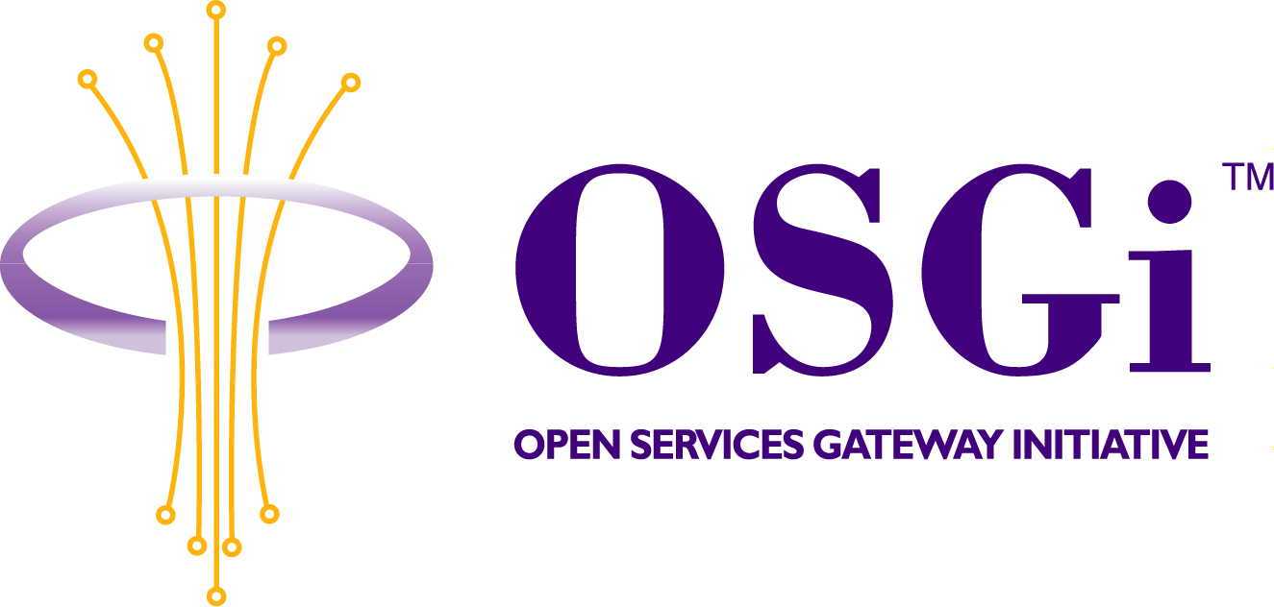
Discovery and control of Jini services within an OSGi framework
Confidential, Draft
RFC-0031
16 Pages

Abstract
The Jini network architecture is to become widely used. For OSGi-compliant gateways to be ready to meet future customer needs in that direction, there is a need for a standardized API, which enables OSGi services to interact with Jini networks using Jini services or being able to act as such.
This RFC presents an API that allows discovery and control of Jini services within an OSGi framework, and export OSGi Services as Jini services.

Document Information

Table of Contents
0 Document Information 2
0.1 Table of Contents 2
0.2 Status 3
0.3 Acknowledgement 3
0.4 Terminology and Document Conventions 3
0.5 Revision History 3
1 Introduction 5
2 Motivation and Rationale 5
3 Technical Discussion 6
3.1 Jini Driver Bundle 6
3.1.1 Jini-to-OSGi Transformation 6
3.1.2 OSGi-to-Jini Transformation 7
3.1.3 Components 8
3.2 Package Dependencies 9
3.2.1 Java RMI package 9
3.2.2 Jini packages 10
3.3 Example Usage 10
4 API Specification 12
4.1 org.osgi.service.jini Interface JiniDriver 12
4.1.1 DEVICE_CATEGORY 13
4.1.2 EXPORT 13
4.1.3 LUS_EXPORT_GROUPS 13
4.1.4 SERVICE_ID 14
4.1.5 ENTRIES 14
4.1.6 CM_LUS_IMPORT_GROUPS 14
4.1.7 CM_LUS_EXPORT_GROUPS 14
4.1.8 setServiceTemplates 14
4.1.9 getServiceTemplates 15
5 Security Considerations 15
6 Implementation issues 15
6.1 Dynamic import of statically exported packages 15
6.2 Java Serialization 15
7 Document Support 16
7.1 References 16
7.2 Author’s Address 16
7.3 Acronyms and Abbreviations 16
7.4 End of Document 16

Status
This document specifies an API for discovery and control of Jini services within an OSGi framework for the Open Services Gateway Initiative, and welcomes discussion and suggestions for improvements. Distribution of this document is unlimited within OSGi.

Acknowledgement
I want to thank Iliana Kostova and the technical writer team in ProSyst that helped me to write this RFC.

Terminology and Document Conventions
The key words "MUST", "MUST NOT", "REQUIRED", "SHALL", "SHALL NOT", "SHOULD", "SHOULD NOT", "RECOMMENDED", "NOT RECOMMENDED", "MAY" and "OPTIONAL" in this document are to be interpreted as described in [1].
Source code is shown in this typeface.

Revision History
The last named individual in this history is currently responsible for this document.

Revision | Date | Comments
Initial | Sep 05 2001 | First draft based on RFP 24 Jini Driver API.  Pavlin Dobrev, ProSyst Software AG  p.dobrev@prosyst.com  Krasimira Velikova, ProSyst Software AG  k_velikova@prosyst.bg
Second | Nov 29 2001 | Updates from October OSGi member meeting in San Francisco.  Pavlin Dobrev, ProSyst Software AG  p.dobrev@prosyst.com
Third | Dec 21 2001 | Updates from DEG conference call at 20th of December 2001.  Pavlin Dobrev, ProSyst Software AG  p.dobrev@prosyst.com
Fourth | Feb 20 2002 | Updates from January OSGi member meeting in Las Vegas. Updates from DEG conference call at 14th of February 2001.  Pavlin Dobrev, Svetozar Dimov, ProSyst Software AG  p.dobrev@prosyst.com, s_dimov@prosyst.bg
Fifth | May 17 2002 | Updates according to joint CPEG/DEG Meeting April 16, 2002, Fairfax, VA.  - Minor editing changes  - Added “jini” prefix to LUS_EXPORT_GROUPS, CM_LUS_EXPORT_GROUPS and CM_LUS_IMPORT_GROUPS  - Removed CM_PID from interface  - Added, “The Jini Driver is defined as a Service Factory. For every bundle a different set of Service Templates is maintained. Jini Driver registers all Jini Services that match at least one Service Template.”  - Added, “The kind of services that can be exported to the jini network is defined in point [3.1.2.1].”  - Added point “3.2.1 Java RMI package” that explains RMI requirement.”  - Added point “6 Implementation issues” that discuss dynamic importing and Java Serialization.”  Pavlin Dobrev, ProSyst Software AG  p.dobrev@prosyst.com

Introduction
The goal of this RFC is to specify an API that can be used to develop OSGi bundles that interoperate with Jini services in a Jini network.
The Jini network technology provides simple mechanisms that enable devices to form impromptu communities, which can be assembled without any planning, installation or human intervention. Each device provides services that other devices in the community may use. These devices offer their own interfaces, ensuring reliability and compatibility.
The Jini technology uses a Jini lookup service (LUS), where devices and services register themselves. When a device is attached to a network, it uses an add-in protocol, called discovery and join. The device first locates the lookup service (discovery), and then uploads an object that implements all of its service interfaces (join).
To leverage the Jini architecture from within an OSGi framework, this RFC defining an API that can:

- Enable access to Jini services from within an OSGi framework; and
- Provide OSGi services to members of a Jini community.

This API acts as a bridge between a Jini network (community) and an OSGi framework. Using this API, OSGi services from the framework can be exported easily to the Jini network, and Jini services from the Jini network can be imported into the OSGi framework. This results in two possible transformations: Jini-to-OSGi and OSGi-to-Jini. The Jini Driver module in the OSGi framework is responsible for these transformations.

Motivation and Rationale
The Jini network architecture is to become widely used. For OSGi-compliant gateways to be ready to meet future customer needs in that direction there is a need for a standardized API, which enables OSGi services to interact with Jini networks using Jini services or being able to act as such.

Technical Discussion

Jini Driver Bundle
The Jini Driver module is an OSGi bundle that operates according to the driver-like model of the OSGi Device Access Service and deals with Jini lookup services and OSGi services. The Jini driver discovers particular types of Jini services in the Jini lookup services and registers them as services in the OSGi framework. Similarly, the Jini Driver transforms to OSGi services any Jini lookup services that are discovered in the network, along with the Jini services that they currently hold (importing services). Conversely, the Jini Driver can discover services that are registered in the OSGi framework as compliant with the Jini technology and place them in the discovered Jini lookup services (exporting services).

By using the Jini Driver bundle, developers do not need to call the standard discovery and join mechanisms, because the bundle does this for them. From a developer’s point of view, there is no difference between Jini services and conventional OSGi services; any operation defined in OSGi can be performed on these services.

The Jini Driver bundle provides two transformations: Jini-to-OSGi, where discovered Jini services are converted to OSGi services, and OSGi-to-Jini, where OSGi services are registered as Jini services in the discovered Jini lookup services. These two transformations are detailed next.

Jini-to-OSGi Transformation
The Jini-to-OSGi transformation enables applications in an OSGi framework to interact with Jini services quickly and easily by using the API defined by the OSGi framework specification. Thus, OSGi bundles need not include extra components to use Jini services.

On starting the Jini Driver Bundle registers as a listener for events fired when Jini Lookup Services are discovered using the standard Jini discovery utilities. The CM_LUS_IMPORT_GROUPS configuration property of the Jini Driver Bundle defines groups of LUS that the driver is interested in.
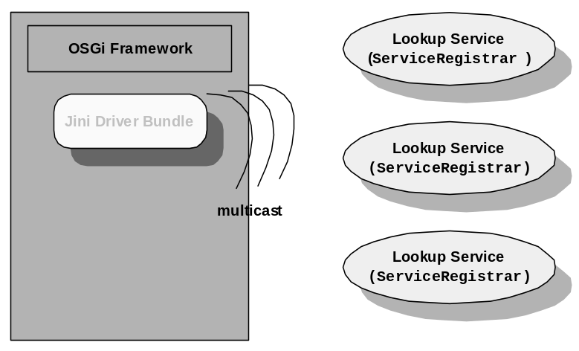
Figure 1: The Jini Driver multicasts discovery message about Jini Lookup Services.
When a Jini Lookup Service is discovered, the Jini Driver Bundle retrieves its proxy object and registers it as a net.jini.core.lookup.ServiceRegistrar service in the OSGi framework. Next, the Jini Driver finds that Jini service registered in the Jini Lookup Services that matches a given template and registers it in the OSGi framework. This template is set by the method setServiceTemplates of the Jini Driver. This registration is possible only if the Jini service packages are exported in the framework. Jini Driver performs dynamic import of statically exported packages.
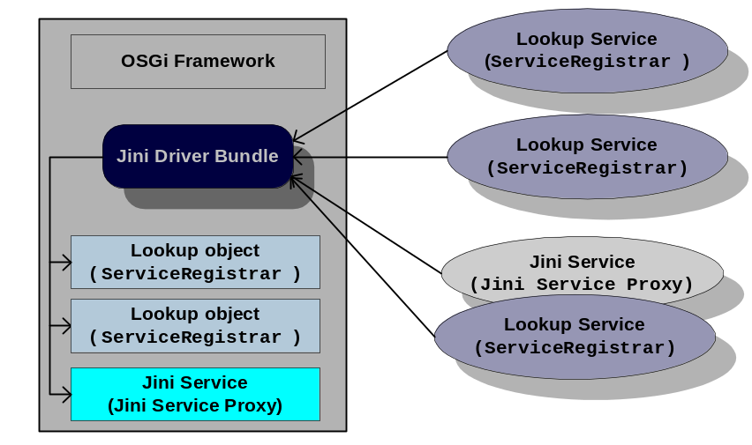
Figure 2: Registering the objects of found Jini Lookup Services as services and importing Jini services.

OSGi-to-Jini Transformation

The OSGi-to-Jini transformation in the Jini Driver offers convenience to services running in the OSGi framework: these services need not register Jini services; instead, the Jini Driver can do so. This significantly reduces the complexity in definition and registration of Jini services. The kind of services that can be exported to the jini network is defined in point [3.1.2.1].
OSGi defines a service property that specifies a service as Jini-compliant. When a service is registered in the framework, the Jini Driver inspects this property. If it is a Jini-compliant service, the driver registers it in the discovered Jini lookup services. This property has a value that defines a possibility for a service to be registered into the Jini network. The Jini Driver Bundle is responsible for managing the life cycle of the Jini service in compliance with its state in the framework. In particular, when the service is registered in the framework, the Jini Driver must automatically register it in the Jini Lookup Services. When the service bundle is stopped or uninstalled, the Jini Driver removes it from the Jini Lookup Services.
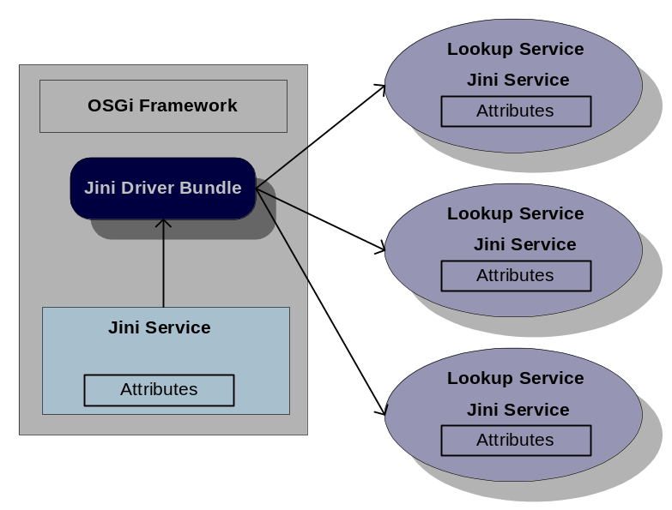
Figure 3: Automatic registration of OSGi services as a Jini services.

Jini-Export requirements for OSGi services
A Jini service is a conventional OSGi service having additional requirements. These requirements come from the Jini specification. The same service object of OSGi service is used as a service object of the Jini service that will be registered in LUS. This object will be serialized by LUS proxy and sent to the LUS implementation for storage. Later when a client requests the service, this is the object that will be given. To avoid confusion between the original service and the object that is sent to the Jini Lookup Service, I shall use the term exported service object. There are several things to note about the exported service object:
- The object must be serializable. Some objects, such as Swing's JtextArea, are currently not serializable and therefore cannot be used.
- The object is created in the service's VM. However, when it runs it will do so in the client's VM. It may need to be a proxy for the actual service that already exists in the OSGi framework.

Components

Jini Driver Service
The Jini Driver service represents the device driver functionality of the Jini Driver Bundle. The interface of this service is org.osgi.services.jini.JiniDriver. Using this service allows you to specify the Jini Lookup Services to register services in, as well as which Jini Lookup Service and Jini Services will be registered in the framework. The criterion to filter Jini Lookup Services is based on their group names. The criterion to filter other Jini Services is based on their service templates.
The Jini Driver is defined as a Service Factory. For every bundle a different set of Service Templates is maintained. Jini Driver registers all Jini Services that match at least one Service Template.

Service Registrar
As it was described above, when a Jini Lookup Service is discovered in the network, the Jini Driver registers it as a Service Registrar in the framework. The interface of the service is net.jini.core.lookup. ServiceRegistrar. You can perform any of the familiar Jini operations on these registrars, retrieving the available Jini services and so on.
The Service Registrar for a Jini Lookup Service owns the EXPORT, SERVICE_ID and ENTRY properties with values the attributes defined in the Jini network.

Jini Services
When a Jini service is imported into the framework, it is register as an OSGi service with the following set of properties:
- DEVICE_CATEGORY which has value a string array with the "jini" element.
- SERVICE_ID that contains the Jini service ID that is used in the LUS.
- ENTRIES which has value net.jini.core.entry.Entry[] holding the attribute entries that is stored in Jini Lookup Service.
The values of the properties are the same as an attributes of the Jini Service which is defined in the Jini network.
A Jini service that represent exported service object as defined in 3.1.2.1 should be registered as an OSGi service with the following properties:
- DEVICE_CATEGORY which would have value a string array with the "jini" element.
- EXPORT that marks that this OSGi service must be exported by the Jini Driver as a Jini service to the Jini network.
- LUS_EXPORT_GROUPS which should contain a string array of the LUS groups, which are of interest to the OSGi service.
- SERVICE_ID that should contain the Jini service ID to use in the LUS.
- ENTRIES which has value net.jini.core.entry.Entry[] holding the attribute entries to store in found Jini Lookup Services.

Package Dependencies

Java RMI package
The dependence on Java RMI is determined by the particular Jini implementation. If the Jini implementation is not RMI based the only requirement is to have some part of RMI because these classes and interfaces are used by the Jini Interfaces defined in [4].
Note that the Sun Jini Reference Implementation requires full RMI Support and a Java 2 compatible VM. Here is a minimal list of RMI that is required for non-RMI based Jini implementations:
- java.rmi.MarshalException
- java.rmi.MarshalledObject
- java.rmi.NoSuchObjectExceptionRemote
- java.rmi.RemoteException
- java.rmi.UnmarshalException

Jini packages
The Jini specifications define many Java APIs that are needed to implement a Jini Driver into the OSGi framework. The bundle programmer may define a Jini Library bundle providing the main Jini-related packages to requesting bundles. This bundle may export:
- net.jini.core.entry - contains the components of the Jini Entry Specification.
- net.jini.core.lookup - contains the components of the Jini Lookup Service Specification.
- net.jini.core.event - contains the ingredients of the Jini Distributed Event Specification.
- net.jini.core.lease - contains the API of the Jini Distributed Leasing Specification.
- net.jini.core.discovery - contains the unicast discovery part of the Jini Discovery and Join Specification.
- net.jini.admin - contains the interface that an administrable Jini service should implement.
- net.jini.discovery - contains the Jini Discovery Utilities Specification.
- net.jini.lookup - contains utilities for managing the communication with Jini Lookup Services.
- net.jini.lookup.entry - contains an utility to implement in order to specify a modification of an attribute entry

Example Usage
The following example demonstrates how to interact with the Jini services found in the framework.
import net.jini.core.lookup.*;
import net.jini.core.entry.*;

import org.osgi.framework.*;

import java.rmi.RemoteException;

class Example {

interface SearchedInterface {
void doesnothing();
}

public class SearchedEntry implements Entry {
public String value;

public SearchedEntry() {
value = "";
}

public SearchedEntry(String value) {
this.value = value;
}
}

// This method demonstrates how Jini Service can be found in LUS
// registered in framework

Object SearchInJini(ServiceRegistrar lus) {
Class[] classes = {SearchedInterface.class};
Entry[] entries = {new SearchedEntry("Some info")};

ServiceTemplate template = new ServiceTemplate(null, classes, entries);

try {
return lus.lookup(template);
} catch (RemoteException ex) {
}

return null;
}

// This method demonstrates how the Jini service can be found in
// framework using an LDAP search filter

ServiceReference SearchInFramework(BundleContext bc) {

String filter = "(objectClass=" + SearchedInterface.class.getName() + ")";
Entry entry = new SearchedEntry("Some info");

try {
ServiceReference[] ref = bc.getServiceReferences(null, filter);

if (ref == null) {
return null;
}

for (int i = 0; i < ref.length; i++) {
if (entry.equals(ref[i].getProperty("ENTRY"))) {
return ref[i];
}
}
} catch (InvalidSyntaxException ex) {
}

return null;
}
}

API Specification

org.osgi.service.jini
Interface JiniDriver

public interface JiniDriver
A basic interface for a Jini Driver.
This Driver acts as a bridge between a Jini network (community) and an OSGi framework. Using it OSGi services from the framework can be exported to the Jini network, and Jini services from the Jini network can be imported into the OSGi framework. This results in two possible transformations: Jini-to-OSGi and OSGi-to-Jini. The Jini Driver is responsible for these transformations.
An OSGi service is a Jini service if it is registered in the framework with the specified properties.
In OSGi-to-Jini transofmation the driver registers OSGi services as a Jini services in the discovered LUS.
In Jini-to-OSGi transformation it registers with the framework all discovered LUS and services in the LUS matching the given template.
The Jini Driver can be configured through a set of properties to export/import Jini Services.
The properties DEVICE_CATEGORY, EXPORT, LUS_EXPORT_GROUPS, SERVICE_ID, SERVICE_TYPES and ENTRIES are service register properties for particular Jini Service (imported or exported).
The properties CM_LUS_IMPORT_GROUPS and CM_LUS_EXPORT_GROUPS are for configuration of the Jini Driver. These properties are kept in the Configuration Management Service defined by OSGi.

Field Summary
static java.lang.String | CM_LUS_EXPORT_GROUPS  Optional property, which should be a string array, containing the LUS groups that the driver is interested in, when exporting framework services to the Jini network.
static java.lang.String | CM_LUS_IMPORT_GROUPS  Optional property, which should be a string array, containing the groups of LUS, that the driver is interested in, when importing Jini services.
static java.lang.String | DEVICE_CATEGORY  Constant for the value of the service property DEVICE_CATEGORY used by all Jini services.
static java.lang.String | ENTRIES  Optional property, which should be an Entry array, holding the attributes set of the framework service that represents Jini proxy in the registration with a LUS.
static java.lang.String | EXPORT  The Export service property is a hint that marks an OSGi service to be picked up and exported by the Jini Driver in the Jini network.
static java.lang.String | LUS_EXPORT_GROUPS  Optional property, which should contain a string array of the LUS groups that are of interest to the OSGi service.
static java.lang.String | SERVICE_ID  Optional property, which should contain a string representation of the Jini service ID.

Method Summary
net.jini.core.lookup.ServiceTemplate[] | getServiceTemplates()  Gets the current set of templates that is used for searching and registering services registered in discovered LUS.
void | setServiceTemplates(net.jini.core.lookup.ServiceTemplate[] template)  The Jini Driver is defined as a Service Factory.

Field Detail

DEVICE_CATEGORY

public static final java.lang.String DEVICE_CATEGORY
Constant for the value of the service property DEVICE_CATEGORY used by all Jini services.
Value: jini
See Also:
org.osgi.service.device.Constants.DEVICE_CATEGORY

EXPORT

public static final java.lang.String EXPORT
The Export service property is a hint that marks an OSGi service to be picked up and exported by the Jini Driver in the Jini network. Imported services do not have this property set.
The property has no value. The name of the property is jini.export;

LUS_EXPORT_GROUPS

public static final java.lang.String LUS_EXPORT_GROUPS
Optional property, which should contain a string array of the LUS groups that are of interest to the OSGi service. This overrides the property CM_LUS_EXPORT_GROUPS of the Jini Driver. If the value of this property is not defined, CM_LUS_EXPORT_GROUPS will be used. The name of the property is jini.lus.export.groups.

SERVICE_ID

public static final java.lang.String SERVICE_ID
Optional property, which should contain a string representation of the Jini service ID. It is used by the Jini Driver when exporting framework service. The driver automatically fills the values of this property when importing the Jini service. The name of the property is jini.service.id.

ENTRIES

public static final java.lang.String ENTRIES
Optional property, which should be an Entry array, holding the attributes set of the framework service that represents Jini proxy in the registration with a LUS. The name of the property is jini.entries.
See Also:
Entry

CM_LUS_IMPORT_GROUPS

public static final java.lang.String CM_LUS_IMPORT_GROUPS
Optional property, which should be a string array, containing the groups of LUS, that the driver is interested in, when importing Jini services. The driver discovers only the LUS members of at least one of these groups. It discovers all if the property is null or the property is not defined, and does not perform discovery if the length of the array is 0. If LUS are discovered, which after changing the value of this property are not members of the groups, all registered services from them are unregistered. The name of the property is jini.lus.import.groups.

CM_LUS_EXPORT_GROUPS

public static final java.lang.String CM_LUS_EXPORT_GROUPS
Optional property, which should be a string array, containing the LUS groups that the driver is interested in, when exporting framework services to the Jini network. The driver discovers only the LUS, which are members of at least one of these groups. It discovers all if the property is null or the property is not defined, and does not perform discovery if the length of the array is 0. If Jini Lookup Services are discovered, which after changing the value of this property are not members of the groups, the registration of all Jini services from the framework, which are registered with them, is cancelled. The name of the property is jini.lus.export.groups.
Method Detail

setServiceTemplates

public void setServiceTemplates(net.jini.core.lookup.ServiceTemplate[] template)
The Jini Driver is defined as a Service Factory. For every bundle a different set of Service Templates is maintained. This method sets a new set of ServiceTemplates (net.jini.core.lookup.ServiceTemplates) that are used for searching and registering services in the discovered LUS. A service registered in a LUS will be registered in framework if it matches at least one of the templates in one of the sets.
The ServiceTemplate(null, null, null) matches all services.
Parameters:
template - template to be added.

getServiceTemplates

public net.jini.core.lookup.ServiceTemplate[] getServiceTemplates()
Gets the current set of templates that is used for searching and registering services registered in discovered LUS. A service, registered in a LUS, will be registered in the framework if it matches at least one of the templates in this set
Returns:
an array containing templates or null if the set of templates is empty.

Security Considerations
Security in inherited from Jini.

Implementation issues

Dynamic import of statically exported packages
Because Jini dynamically imports code into the OSGi framework there is a requirement Framework to support dynamic import of statically exported packages.

Java Serialization
Note that the serialization protocol for java 1 and java 2 virtual machines is different. Jini uses java serialization as a protocol for exchanging java objects. They are two possible solutions that go round the problem. First is all JVM to be from the same class (Java 1 or Java 2 compatible). Second is implementation of Java serialization protocol of Java 2 under Java 1 compatible virtual machines.

Document Support

References
- Bradner, S., Key words for use in RFCs to Indicate Requirement Levels, RFC2119, March 1997.
- http://www.jini.org
- RFP 24 Jini Driver API
- Jini Specifications, http://www.sun.com/jini/specs/
- ProSyst mBedded Server documentation, http://www.mBeddedServer.com

Author’s Address

Name | Pavlin Dobrev
Company | ProSyst Software AG
Address | Gustav-Heinemann-Ufer 54, 50968 Cologne, Germany
Voice | +359 2 963 10 04
e-mail | p.dobrev@prosyst.com

Name | Krasimira Velikova
Company | ProSyst Software AG
Address | Gustav-Heinemann-Ufer 54, 50968 Cologne, Germany
Voice | +359 2 963 10 04
e-mail | k_velikova@prosyst.bg

Acronyms and Abbreviations
OSGi Open Service Gateway Initiative
LUS Jini Lookup Service

End of Document

