
RFC 49 Customer Entity Description
Confidential, Draft
rfc0049-customer_entity_desc
13 Pages

Abstract
This RFC specifies a standardized way of referring a customer. A reference should unambiguously refer to a unique customer entity belonging to a service provider to make it easier to share this information between bundles.

Document Information

Table of Contents
0 Document Information 2
0.1 Table of Contents 2
0.2 Status 3
0.3 Acknowledgement 3
0.4 Terminology and Document Conventions 3
0.5 Revision History 3
1 Introduction 3
2 Motivation and Rationale 4
2.1 Scenario and requirements 4
2.1.1 Requirements on customer reference 4
2.1.2 Scenario – payment solution 4
2.1.3 Scenario – Open Distributed environment 6
3 Technical Discussion 7
3.1 API 7
3.2 Customer Representation 7
3.2.1 Service Provider Identity and naming schemes 8
3.2.2 Customer identity 8
3.2.3 Reference Issuer 8
3.2.4 Timestamp 8
3.3 Credentials 9
3.3.1 Credential and Credential type 9
3.3.2 Credential Issuer 9
3.3.3 Credential Timestamp 9
3.3.4 Setting credentials 9
3.4 API discussion 10
3.4.1 Textual representation 10
3.4.2 Equality method 10
3.4.3 Reference signature 10
3.4.4 Credential signature 10
3.5 Connections to other RFCs 11
3.5.1 Accounting API 11
3.5.2 User Management API 11
4 Security Considerations 11
4.1 Repudiation 11
4.2 Disclosure of business-sensitive information 12
5 Document Support 12
5.1 References 12
5.2 Author’s Address 12
5.3 Acronyms and Abbreviations 13
5.4 End of Document 13

Status
This document specifies … for the Open Services Gateway Initiative, and requests discussion and suggestions for improvements. Distribution of this document is unlimited within OSGi.

Acknowledgement

Terminology and Document Conventions
The key words "MUST", "MUST NOT", "REQUIRED", "SHALL", "SHALL NOT", "SHOULD", "SHOULD NOT", "RECOMMENDED", "NOT RECOMMENDED", "MAY" and "OPTIONAL" in this document are to be interpreted as described in [1].
Source code is shown in this typeface.

Revision History
The last named individual in this history is currently responsible for this document.

Revision | Date | Comments
Initial | April 12 2002 | First draft  Lars Eriksson, Telia.  lars.q.eriksson@telia.se

Introduction
This RFC is based on RFP 29. If bundles from different service providers should interact with each other, it must be possible to pass information and ‘talking about the same thing’. The notation of a user is non-trivial in a multi-vendor environment. It is not enough to provide the platform with a mapping between a physical user and a user for a service. First, each service provider has its own idea of a user and how to represent one. Second, the mapping between a ‘user’ and a physical user is often different between different kinds of application, especially if we look how to deal payments.
Instead of speaking in terms of users, this RFC uses the concept of a ‘customer’ to avoid the direct association to the physical user of the service and to state one business relationship to a specific service provider. The customer concept is very complex and this RFC gives a definition that is practical for its purpose. A ‘customer’ refers to one business relationship between a physical or legal user and the service provider. This service provider is hereafter referred as the customer owner. A physical or legal user may have multiple relationships to the same provider but for a third-party provider, hereafter called a vendor, each of these relationships is seen as a unique customer entity.
The scope of this RFC will define a common way of referencing a customer for a service provider unambiguously so two service provider should be able, so to say ‘speak about the same customer’.

Motivation and Rationale
In the OSGi framework, functionality is packed together into bundle, where each bundle implements a small piece of the supply chain of a service. In applications that spans over a number of different providers, it is essential that the customer can be referenced independently who owns the customer relationship.
A common way of referring a customer will make it easier to develop generic components and components that will work in open environments without a defined or bounded set of users.

Scenario and requirements

Requirements on customer reference
- A reference must point out a service provider’s customer unambiguously in a framework.
- The framework should be able to handle different namespaces of provider identities.
- A reference must be able to keep a credential associated to the customer

Scenario – payment solution
This scenario shows how a customer reference can be a part of payment transaction using a third party payment module. An authentication module is also involved in the scenario. However, the way the authentication of the user is done is not important in this scenario. The color of the bundle indicates the ownership of the bundle. Different service providers manage the white, yellow and green bundles and it assumes there exists an agreement between the parties.
The fictitious service MyService wants to use the third party payment service. In order to do that, it must reference the user in the context of a customer of the payment service in use. The first step in the scenario the fetch the customer reference.
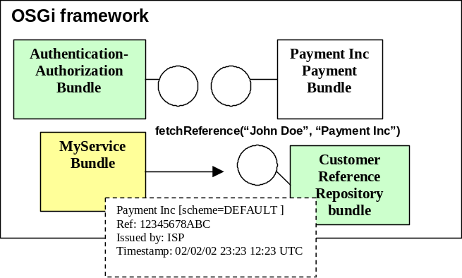
This RFC does not target how a customer reference is fetched initially. The customer reference instances can be installed statically or can be retrieved from a service and is resolved from a certificate, user-name etc.
The customer reference contains information about
- the service provider
- a reference to the customer that only makes sense for the service provider that owns the customer relationship
- the issuer of the customer reference
- any credential associated to the customer
Before MyService proceeds to perform the action it wants to authenticate the user and let the user authorize the payment. However a module provided by the operator performs the authentication and authorization of the user. Even though the MyService cannot validate the credential, it trust the ISP that the customer having the necessary credential by checking the certificate of credential part of the reference.
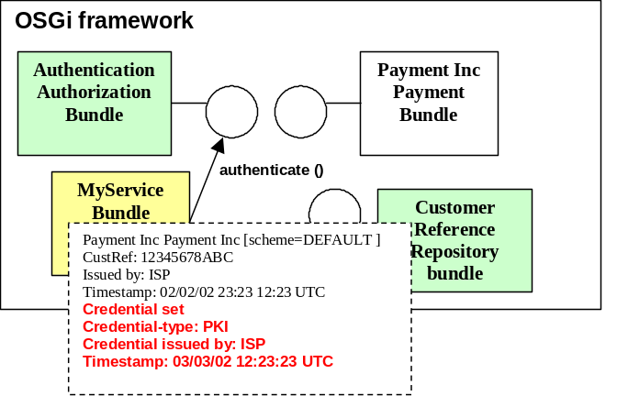
In the final step, the charge request is sent to the payment bundle. In the charge request is the customer referred. The payment system can examine the reference and choose to trust the reference and check the attached credential. This scenario assumes that MyService knows what type of credential the payment bundle requires. This information could be available as attributes for the service. However, this is outside the scope of this RFC.
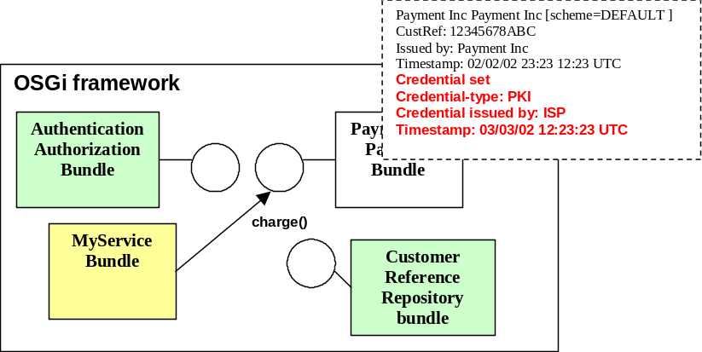

Scenario – Open Distributed environment
This scenario involves to OSGi platform. A car garage offers a Parking Fee Service that let the user pay the parking fee with from a mobile device. In this scenario both the Parking Fee device and the mobile device is OSGi-enabled and the mobile device is also equipped with a Javacard reader
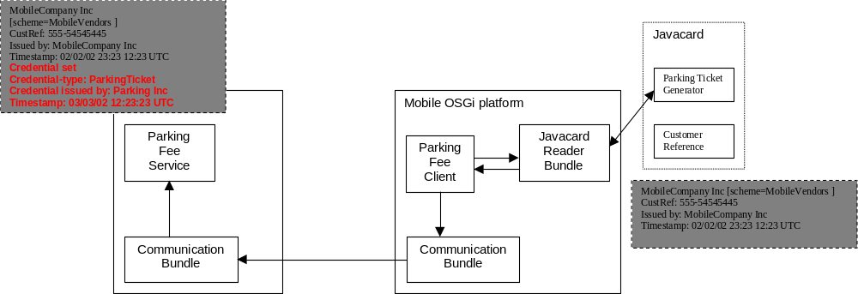
None of the platforms have an Internet Connection (This garage is assumed be located deep under the ground and these places often have very poor mobile coverage).
The user communicates with the Parking Fee device from the Parking Fee Client bundle. The parking fee ticket is valid 24 hours and associates a parking ticket with the car’s license number that is stored securely in the Parking Fee device. An operator downloads the information manually once a day.
The fictitious company Parking Lot company have agreements with several mobile operators that let their customers to pay the parking fee with its mobile devices. This scenario assumes there is an agreement between Parking Lot company and the fictitious mobile operator MobileCompany Inc. The parking ticket is generated in the mobile device (on the javacard). When the user decides to pay the parking ticket, the Parking Fee Client call an applet on the javacard. The user may enter a PIN-code that unlocks the javacard and gives access to the Parking Ticket Generator. A new customer reference is instantiated and signed by the Parking Ticket Generator.
Before the Parking Fee Service accepts the Ticket it checks the issuers of both the reference (to make certain it can trust customer information) and the credential (to make certain it can trust the credential). Finally, it validates the credential itself. The MobileCompany Inc can use the same reference to make certain that the tickets are authentic (they are issued by MobileCompany Inc) before they charge the customer for the parking.

Technical Discussion
There are several issues to target:
- API
- Representation of a customer
- Trust
- Connections to other RFCs

API
The customer reference is represented as an Interface:
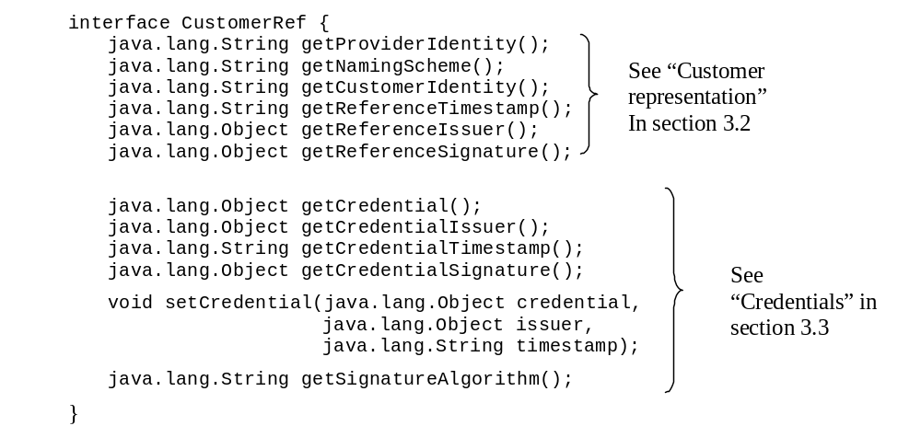

Customer Representation
The customer must be represented somehow. For increasing the possibility of storing and transfer information using common text-based protocols such as http and using XML as a description language, it must exist a unique textual representation of the customer. The representation consists of two parts:
- service provider identity
- customer identity
- reference issuer
- expiration time
- credential

Service Provider Identity and naming schemes
Preferably, the service provider identification should be unique globally. However, different applications may apply different naming convention of referring a service provider. Some will refer a company xyz as xyz, some will use xyz inc and some application will refer the service provider as xyz incorporated. In some cases the reference is still clear but what happened when it exist both an American company xyz inc and a British company xyz Ltd when a bundle refer for a service provider xyz? By providing a naming scheme for the reference the identity will be fixed and the abbreviation xyz can have different meanings in different schemes but a bundle will still be able to handle them in both contexts. For instance, application related to credit card may use the naming convention specified in ISO 7812-1 [2] and or in ITU-T E.118 recommendation Error: Reference source not found that makes it possible to look at the SIM card number and determine which a card belongs to (it is easier to look at the logotype that is on the card though)
A scheme is expressed in a form as a URI [4] or the keyword default if the reference refers to the default scheme. The URI has no meaning but to distinguish the scheme from others. Two service provider identities must refer unambiguously to the same service provider if the schemes are the same. The OSGi platform should support a default scheme. This approach is currently used in XML schemas for defining different namespaces [5]. If a naming scheme is omitted, it means the naming convention follows the naming scheme in the platform that is set as default in the OSGi platform. The default scheme should be available as a system property org.osgi.util.customref.defaultscheme.
The service provider identity must not be omitted in a customer reference instance.

Customer identity
In this meaning, the customer entity is not associated to the physical person that has a relationship with the service provider as a customer. In this context it means rather one business relationship with the service provider. For instance, a basic representation of a business relationship is some kind of account. A physical person may have multiple accounts at the same service provider for different purposes.
The customer identity is only known to the service provider and can be expressed in an arbitrary fashion. However, the customer identity must be unique for each customer. The customer identity should be expressed independent of naming scheme. It means, independently of the naming scheme the customer identity should be the same to make it easier for a bundle to compare for equality.
The customer identity must not be omitted in a customer reference instance.

Reference Issuer
This field should identify the issuer of the customer reference. It must contain a java.security.Certificate if any. This value must not be omitted.

Timestamp
This field takes a time that must be parseable into UTC format. This field hints the bundle when the reference was generated. A reference does not give any guarantees that the customer does exist but a bundle must rely that a trusted issuer (see section 3.2.3) does not generate bogus references. A timestamp may hint valuable information if the reference is cached or persistently stored when it is time to retrieve a new one. This value should not be omitted.

Credentials
The instance may embed information from an authentication service of a kind. As in the scenario described in section 2.1.1. The authentication service performs an authentication regarding:
- credential token (if applicable)
- credential type
- issuer of the credential
- time when the authentication took place

Credential and Credential type
A credential does provide meaningful information for the entities that can interpret it and even though a bundle cannot validate the credential it may trust the issuer of the credential and therefore may trust that the customer is correctly authenticated in the system.
A bundle should only use credentials to ensure that the customer is properly authenticated. In other words, the meaning of the credential should ensure the credibility of the reference only and not pass information for other purposes.
The credential type is set as a hint for bundle the kind of credential. For instance the type may hint if the credential is a KerberosV5 ticket or is of a type MD5-hashed password. This information is proprietary but can be used to pass information regarding key-size, the cryptography algorithms, the location of the Kerberos server etc.

Credential Issuer
If a bundle cannot interpret the credential, it may trust some issuers to generating ‘fair’ credentials and can assume that the customer has the correct credentials in the system.
This value can be omitted.

Credential Timestamp
This field takes a time that must be parseable into UTC format. This field hints the bundle when the credential was generated.
This value should not be omitted if a credential is set.

Setting credentials
A bundle may set credentials by using setCredential() method. The method must generate a credential signature accordingly to the description in section 3.4.3. If a credential is already set it will be replaced with the new one if the call was successful. If the credential is set to null, the method must set credential, credential issuer and credential timestamp to null.

API discussion

Textual representation
As stated before, the information should have a meaningful textual representation when a reference is often transmitted using text-based protocols like HTTP or embedded into XML data sheets. A textual representation should be unique for each customer to supply enough with information to retrieve a new reference for the same customer.

Equality method
Two references should be considered equal if:
- the service providers’ identities are equal
- the naming schemes in both references are equal
- the customer identities are equal
- the reference issuer in both references are equal

Reference signature
The reference signature must include (in the following order):
- service provider identity
- naming scheme
- customer identity
- reference timestamp
The signature must be done with algorithm that is given with getSignatureAlgorithm() and the format should follow the conventions specfied in [6]. The signature is then encrypted with the reference issuer’s private key. The certificate that contains the reference issuer’s public key should be available with the getReferenceIssuer() method.

Credential signature
The credential signature must include (in the following order):
- credential
- credential issuer
- credential timestamp
The signature must be done with algorithm that is given with getSignatureAlgorithm() and the format should follow the conventions specfied in [6]. The signature is then encrypted with the reference issuer’s private key. The certificate that contains the reference issuer’s public key should be available with the getCredentialIssuer() method. No signature should be generated if the credential or the credential issuer field is set to null.

Connections to other RFCs

Accounting API
RFC 14 [7] defines a standardized accounting service. The customer reference is used in the accounting service to refer which customer that will be charge for the event. Often, payment solutions are based on accounts and in this case a customer reference may point out for the accounting system which account is debit for a particular event.
A payment service should use the credential to check whether the user has been authenticated. However, the strength of the authentication may differ dependent of the application and there is an underlying assumption in this RFC that the bundle knows these requirements, otherwise the payment service will deny the transaction.

User Management API
[8] defines a module of managing users. The distinction between a user and a customer is complex. A customer can be represented as an abstract user. In this section does not distinguish a User in User Management API from the customer concept this RFC.
- The Customer Reference is a pointer to an abstract user that may exist. The identity of the user can be established with a credential and can be added by any bundle. It gives a flexibility to choose any available authentication method (if any) and each bundle can decide whether the authentication is trustworthy.
- The Customer Reference approach distributes the customer management to each provider instead to put the management into a centralized function in the system.
- The purpose with Customer Reference is not to handle a user’s different privileges in the system but helping bundle to act in a large-scale open environment.

Security Considerations

Repudiation
A reference with an attached credential can be an attractive to forge or re-use. The degree of security depends mainly on:
- the time the credential is valid
- the generated credential
It is up to every bundle to decide how long time the credential is trustworthy. Some application may trust the same credential a longer time than others. A credential is a ticket that is generated that gives privileges to the system. It is possible to embed restriction that ties these privileges to a specific host, IP-address etc. However it is beyond the scope of this RFC how to generate credentials securely.

Disclosure of business-sensitive information
If the service provider chooses a simple way to identify the customer, for instance a phone-number or the social security number, this information can disclose the customer for other provider. A service provider should choose a non-trivial representation.

Document Support

References
- Bradner, S., Key words for use in RFCs to Indicate Requirement Levels, RFC2119, March 1997.
- Identification card - Identification of Issuers, ISO/IEC 7812-1, Sept 2000
- ITU-T recommendation E.118 The Internation Telecommunication Charge Card,
- Berners-Lee, T., Uniform Resource Identifiers (URI): Generic Syntax, RFC 2396, August 1998
- Namespaces in XML, W3C, January 1999
- Java crypto specifications, Sun Microsystems, http://java.sun.com/j2se/1.4/docs/guide/security/
- RFC 0014, Accounting Service API, OSGi
- RFC 0010, User Management API, OSGi

Author’s Address

Name | Lars Eriksson
Company | Telia Research AB
Address | Bryggargatan 6, S14980 Nynashamn
Voice | +46 70 6501333
e-mail | Lars.q.eriksson@telia.se

Acronyms and Abbreviations

End of Document

