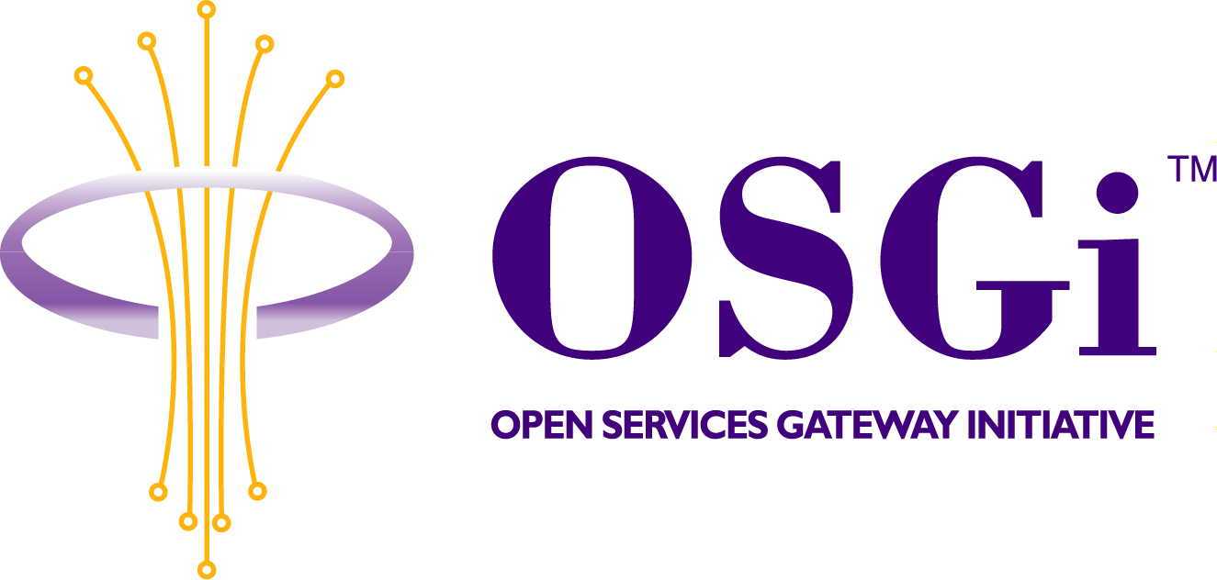
RFC 65: Vehicle Architecture Survey
Confidential, Draft
30 Pages
Abstract
The OSGi standard has seen increased interest among developers of embedded vehicle systems. This RFC examines vehicle systems and how OSGi gateways may be employed. The purpose is to examine potential reference architectures to guide future work within the OSGi Vehicle Expert Group.

Document Information

Table of Contents
0 Document Information 2
0.1 Table of Contents 2
0.2 Status 3
0.3 Acknowledgement 3
0.4 Terminology and Document Conventions 3
0.5 Revision History 3
1 Introduction 3
2 Application Domain 4
3 Problem Description 4
4 Technical Discussion 4
4.1 Automotive Applications 5
4.1.1 Improving the Driver Interface 5
4.1.2 Navigation 5
4.1.3 Telematics 5
4.2 Automotive Systems Technologies and Issues 6
4.2.1 In-Vehicle Networking 6
4.2.2 HMI 6
4.2.3 System Integration 7
5 Examples of OSGi usage in the Automobile 8
5.1 AMI-C General architecture 8
5.1.1 Architectural views 8
5.2 BMW 22
5.3 IBM PVC Telematics Client Stack 22
Java and OSGi Base 23
5.3.1 Vehicle Bus Access 23
5.3.2 ML Kit 23
5.3.3 Application Frameworks 25
5.4 ProSyst Telematics System Architecture 25
5.4.2 Siemens/VDO TLA 27
5.5 Others? 30
6 Document Support 30
6.1 References 30
6.2 Author’s Address 30
6.3 Acronyms and Abbreviations 30
6.4 End of Document 30

Status
This document specifies … for the Open Services Gateway Initiative, and requests discussion and suggestions for improvements. Distribution of this document is unlimited within OSGi.

Acknowledgement
Any acknowledgments the authors feel are necessary.

Terminology and Document Conventions
The key words "MUST", "MUST NOT", "REQUIRED", "SHALL", "SHALL NOT", "SHOULD", "SHOULD NOT", "RECOMMENDED", "NOT RECOMMENDED", "MAY" and "OPTIONAL" in this document are to be interpreted as described in [1].
Source code is shown in this typeface.

Revision History
The last named individual in this history is currently responsible for this document.

Revision | Date | Comments
Initial | 15 Jan 2003 | Initial draft as RFP by Rick DeNatale denatale@us.ibm.com
 | 18 Mar 2003 | Updated by Rick DeNatale
 | 19 Mar 2003 | Updated to change RFP Number
 | 30 Apr 2003 | Converted to RFC by Rick DeNatale

Introduction
Vehicle Applications represent a valuable opportunity to apply OSGi gateway technology. The OSGi Vehicle Expert Group is charged with defining requirements in the vehicle area, and participating with the Core Platform Expert Group in defining OSGi specifications useful to that end.
The purpose of this RFC is to discuss the various ways in which OSGi gateways might interact with the architecture of the embedded systems network in a vehicle, and which interfaces are candidates for standards consideration.
The focus is on automotive applications, although the considerations apply, with concomitant increase in architectural variability, to other vehicle types.

Application Domain
The OSGi Vehicle Expert Group has worked since late 2000 to develop vehicle related standards in the context of the OSGi framework. As the result of that work, Release 3 of the OSGi framework specification contains several API specifications relevant to vehicles. These specifications provide low-level function. In order to facilitate progress, this RFP is offered as a vehicle to discuss the larger issues of how OSGi has been used in vehicle applications, in order to provide a common view of usage.

Problem Description
The OSGi Vehicle Expert Group has worked since late 2000 to develop vehicle related standards in the context of the OSGi framework. As the result of that work, Release 3 of the OSGi framework specification contains several API specifications relevant to vehicles. These specifications provide low-level function. In order to facilitate progress, this RFC is offered as a vehicle to discuss the larger issues of how OSGi has been used in vehicle applications, in order to provide a common view of usage.
Various organizations have used or are planning to use OSGi as a component in vehicles. This document attempts to describe these usages as architectural use cases.

Technical Discussion
Automobiles have evolved from simple machines, in which simple ignition coils, distributors, and spark plugs controlled the engine, to sophisticated computer controlled machines comprising multiple embedded computer systems connected by one or more vehicle networks. The nodes on these networks typically control not only the engine, but also other performance and safety systems such as anti-lock braking and traction control, as well as passenger amenities such as doors, lights, seats, climate control etc.
This increase in sophistication invites increased functionality. Potential applications are discussed below. This increases the complexity of the overall system and demands better control over the lifecycle of the overall system. Modular maintenance and enhancement of the system over the lifecycle of the vehicle becomes more important.

Automotive Applications
This section discusses some of the ways in which OSGi technology is being applied in vehicular projects.

Improving the Driver Interface
The driver interface has evolved to using devices such as computer displays, touch-screens voice input/output and haptic controls, in addition to or replacing traditional instruments knobs and switches. The set of input and output devices and their relationships will vary from vehicle to vehicle, which will likely not be standardized in the foreseeable future.
Vehicle manufacturers have an interest in integrating the look and feel of the driver and passenger interfaces into the overall look and feel of the vehicle. At the same time, experience gained in making interfaces that minimize driver distraction, and maximize usability will drive changes in the interface.
It is probably premature to attempt to standardize the overall HMI for the vehicle, or even how different HMI devices are connected. However, there is probably value in the near term in developing standard interfaces to HMI components such as displays and individual input devices.

Navigation
An obvious extension of the driver interface is the addition of a computerized navigation system. Typically such a system utilizes GPS positioning, perhaps with additional dead-reckoning calculations based on dynamics data obtained from the vehicle in order to improve accuracy.
Variations in the implementation of the navigation will arise. The navigation system might be a wholly or partially self-contained system, or it might share hardware used for other vehicle functions. Map data may be stored in a variety of volatile and or non-volatile forms. In a vehicle equipped for telematics, server connectivity opens further variations, allowing distributed navigation system design.

Telematics
Telematics introduces the ability to connect the vehicle to a server. This enables a variety of extended services. As just discussed, a navigation system that utilizes a server can provide more up to date maps and location data than one that relies on periodically updated data within the vehicle.
Need more here, other applications from our use cases, variations….

Automotive Systems Technologies and Issues

In-Vehicle Networking
As mentioned above, today’s automobiles typically contain multiple networked embedded systems. For example, the engine management, Antilock braking/traction control, and dashboard systems are typically separate systems. The necessary communication between these systems is via some form of device control network.
Need examples of how vehicles have partitioned subsystems, engine-control, body electronics, dashboard, “radio” heads…

Vehicle Control Systems

Most current automobiles use networks to control the basic vehicle function. CAN is commonly used for the physical and data link layers, however newer alternatives are on the horizon. The higher protocol layers vary by vehicle type and usage. (SAE/DIN other standards lists?)

Often, two different speed networks are used in the same vehicle, a higher speed network for performance and safety critical functions such as engine and braking controls, and a lower speed network for functions such as control over the vehicle body and interior parts.

Entertainment Systems
While some vehicle entertainment components incorporate CAN or other vehicle network interfaces increasingly higher speed media networks are being used to carry digital media data. These media networks may use different physical infrastructure such as the plastic optical fiber used by MOST. Media networks must provide high speed, and deal with isochronous data transport concurrently with control data. Other consumer electronics standards such as Firewire and USB may begin to play a larger part in automotive applications as well in order to allow then increasing number of devices supporting these standards to be interfaced to the vehicle.

Access to other networks
Bridges to devices that are not directly or permanently connected to the vehicle will likely become important as these devices proliferate.

Bluetooth

IEEE 802.11x

FireWire?

USB?

Convergence and bridging
Need words about the relationship between all this. MOST vehicle function block is an example…

HMI
The Human Machine Interface in a vehicle involves many inputs and outputs, which must be integrated. How to integrate these devices in order to provide an interface that provides maximum benefit is still a subject of research and development. As such totally standardizing vehicle HMI is premature. However, standardized programming interfaces to components and subsystems of the overall vehicle HMI would be useful. Furthermore many of these HMI component interfaces would be useable in other OSGi applications.
The implementation of the Human Machine Interface in an automobile presents some interesting issues and opportunities. Multiple input and output devices are typically integrated, and may or may not appear in any particular vehicle. Although graphic displays, with or without touch-screen interfaces may be present in high-end vehicles, simpler displays may be used, either for cost reduction or due to a desire to avoid driver distraction.
Many of the user interface devices in the vehicle may take to form of the buttons, switches, lights and dedicated displays typically found in vehicles. In a telematics enabled vehicle, these need to be integrated into the overall vehicle HMI.
The implementation of the Human Machine Interface within a vehicle may comprise multiple components. Although the code which implements the HMI may be resident in the same box which contains an OSGi gateway, it may instead be in an entirely separate box, or be distributed.
Another aspect of HMI is who controls the overall look, feel, and policies of the vehicle’s interface to its occupants. This is primarily, if not solely, the domain of the vehicle manufacturer. Besides wanting to design the overall vehicle design, which includes the HMI, the OEM is ultimately responsible for ensuring the function and safety of the vehicle. The look, feel, and policies will vary not only between different OEMs but also between different lines and models of vehicle from the same OEM. This means that bundles which bind their functionality to a particular HMI will not be widely reusable. It is desirable to have a vehicle architecture which carefully factors HMI and function so that functional bundles can be reused with little regard to the actual HMI.

System Integration
Most modern automobiles contain a plethora of networked functional modules. Manufacturers are trying to reduce the number in order to reduce costs, however there will likely still be multiple modules for the foreseeable future. These modules will perform multiple functions, with partitioning of functions between modules being determined by factors such as function grouping (e.g. navigation), optional function grouping, or other considerations.
The drive to reduce the number of modules by introducing more powerful multi-function modules is one of the factors which lead to adoption of OSGi in vehicle modules in order to allow for upgrading and maintenance of the module’s software. Different vehicles will likely partition function differently, and some vehicle might well have multiple OSGi gateway modules.

Examples of OSGi usage in the Automobile

AMI-C General architecture
The AMI-C architecture is the framework upon which the AMI-C system is formulated and configured. This framework defines how the various components of an AMI-C system are interconnected, how the system logically operates, and how the system meets the AMI-C system requirements.

Architectural views
An architectural view is a representation of the AMI-C system from the perspective of a related set of concerns. The views used in this document are structural, functional and application views. Each of these architectural views responds to different types of inquiries about the architectural description. The views and related inquiry types are as follows:

Structural view: What are the logical elements and how do they inter-relate?

Functional view: What does the system do and what are the basic behavioral aspects?

Application view: How does it enable applications and implementations to access services?

Structural view
The logical elements of the AMI-C architecture are:
- Vehicle interface – An interface to other vehicle systems, information, and signals
- Network(s) – Standard network and message set to provide data interchange and control between components.
- Network protocols and services
- Network nodes: devices, controllers and gateways
- Host – Computer used to execute cross-platform, downloadable application code
- System services
- Applications

An actual implementation of the AMI-C architecture shall have a vehicle interface, and may have one or more networks and/or one or more hosts.

AMI-C Vehicle interface
The AMI-C Vehicle Interface (VI) is the only required component of the AMI-C architecture. The VI is the interface between the manufacturer’s proprietary systems and the AMI-C System. While the VI performs functions traditionally ascribed to a gateway, it does so in a way that does not reveal any of the protocols, addressing mechanisms, physical devices or functional partitioning of the manufacturer’s proprietary systems.

The VI creates for AMI-C devices a standard interface to information and services from the manufacturer specific portions of the vehicle. To other devices on the AMI-C network, the VI appears as a black box. This approach enables the VI to provide a measure of security to the proprietary side of the vehicle. Since the services of the vehicle are exposed through the VI’s standard interface, AMI-C devices never have direct communication with manufacturer specific devices. The VI receives request for information or services, translates them into appropriate messages and/or protocols, and then forwards the requests to the proprietary network. Additionally, the VI provides information regarding the required power status of the AMI-C network. This includes the control of specific hardware to control the power mode of AMI-C networks and devices, if required by individual networks. The VI functions are also made available to applications running on hosts through an appropriate API.

Vehicle services provide AMI-C devices and applications with three main mechanisms for retrieving information or performing command functions:

- Request/command: The request/command mechanism consists of a single command to a service target, or request for information from a device on the proprietary side of the vehicle. The command may be answered by a confirmation message. The request for information must always be answered with the requested data.
- Subscription: The subscription mechanism consists of a single request for Subscription to a piece of vehicle interface information, followed by periodic updates of the information at a fixed rate specified by AMI-C.
- Notification: The notification mechanism consists of a single request for notification of the change of a particular piece of vehicle interface information, followed by messages generated by the vehicle services’ detection of a change in the parameter.

An individual service always supports the request/command mechanism, and may support either of the subscription or notification mechanisms.

AMI-C network
AMI-C supports a set of wired and/or wireless networks that meet a set of AMI-C defined requirements. The network system requirements are found in the AMI-C 1002, AMI-C System Requirements. Based on these requirements, AMI-C adopts existing network specifications that meet the requirements or AMI-C, extends existing specifications with AMI-C developed specification statements, or develops a specific specification where none exists.

An AMI-C network transmits both control data and content data, between the devices on the network.

A network consists of two types of elements: devices and a protocol.

A gateway connects two networks, while the vehicle interface connects one or more networks to a manufacturer’s proprietary services, some or all of which may be provided across the manufacturer’s proprietary network. A network may have one or more gateways to other networks, but the resulting inter-network topology shall not contain a loop.

The system may be upgraded by the addition of new gateways, networks, devices and hosts. An AMI-C System must support upgrades through implementation of a discovery protocol on each local network that supports the addition of AMI-C devices to the network up to its capacity.

Communication on an AMI-C network
Figure 1 shows one of the typical applications of an AMI-C system in a vehicle from the viewpoint of the network architecture. The diagram depicts two major domains:

- The AMI-C domain: The AMI-C domain is completely open to any AMI-C devices and these AMI-C devices are connected with one or more AMI-C networks.
- The automaker’s domain: The automaker’s domain is proprietary to a vehicle manufacturer’s specific design and controls all the services available to the AMI-C domain (e.g. amplifier and speaker, or vehicle-related information like vehicle speed). Access to these services is managed through the AMI-C vehicle interface.
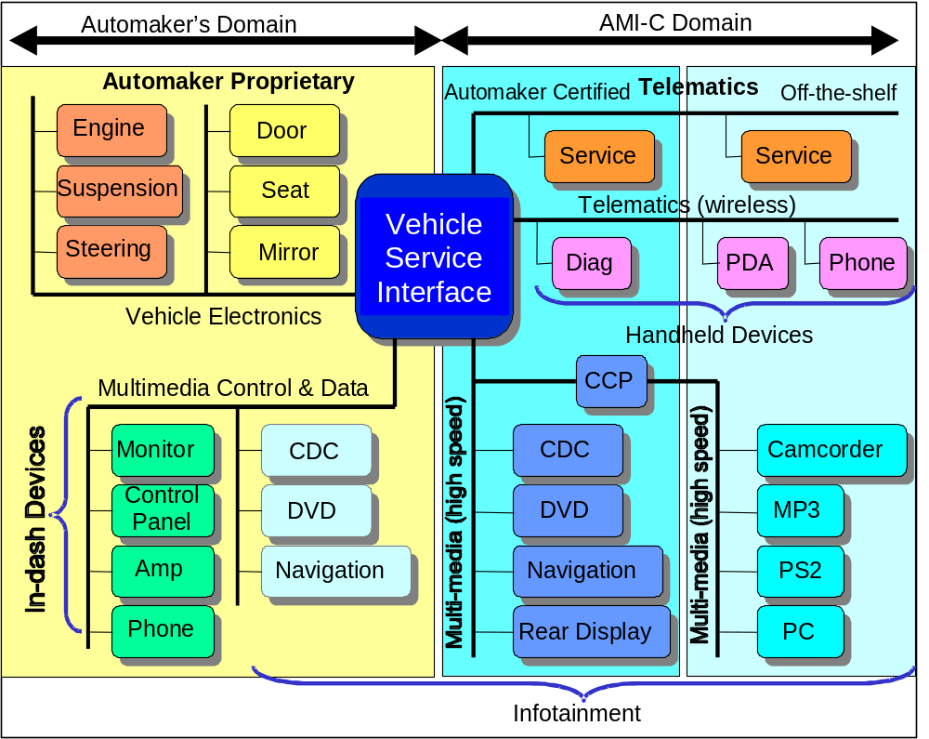
Figure 1 — Domains in AMI-C network configuration
A basic network concept is described in AMI-C 2001, AMI-C network communication model and AMI-C 2002, AMI-C Common Message Set. The AMI-C network communication model provides a framework for implementation of vehicle services on an AMI-C endorsed network. The AMI-C Common Message Set describes those services.

A functional module is an abstraction within the AMI-C network architecture that represents a group of related functions associated with a component. As an example, a network component could be a door control unit that would consist of several functional modules such as window and door control panels, air conditioning control and display, etc. There can be multiple instances of same functional modules in one vehicle. For example there can be four window-related functional modules in one vehicle.

See Figure 2 for a functional module, which can also access and use resources in the automaker’s domain. This domain includes powertrain functions, body functions, diagnostics, etc. Although Figure 1 depicts the audio and display resources in the automaker’s domain, they can also be in the AMI-C domain.

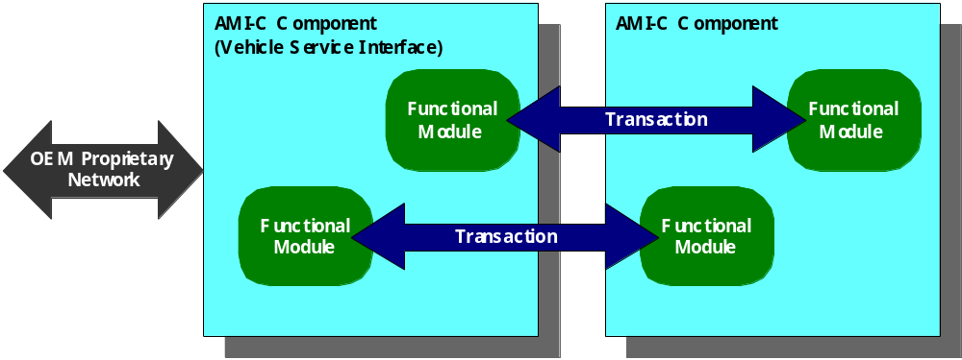
Figure 2 — Logical communication between functional modules

There are two specific functional modules that must be implemented by each AMI-C vehicle. These modules, “core” and “common,” must be implemented in order to discover the configuration of the vehicle and its functional modules.

A functional module type and instance number identify each functional module. In order to identify each functional module uniquely, an instance number is assigned to it. This identification may be used directly in some messages or it may be converted to another format. The network adaptation layer is the software that handles this conversion if required.

Whereas the AMI-C Network Communication Model commonizes the addressing formats, the AMI-C Common Message Set provides for common messages among the various AMI-C networks. Any AMI-C network must support the vehicle-related elements of the AMI-C Common Message Set that will be produced or consumed by its attached devices or gateways. A gateway is required between two heterogeneous AMI-C networks. The gateway may run on the same platform as a host, but is logically distinct from it. The AMI-C architecture permits multiple gateways in various configurations. Vehicle manufacturers and after-market suppliers may choose to integrate several logical gateways into a single physical package.

Network power management
All AMI-C networks shall support three distinct power modes:

- ON: supports all device functions on the network.
- OFF: implies that all device functions have been shut down.
- SLEEP: results in low power consumption by all devices, with no data communications.

Transitions between power modes can be carried out by either messages on the bus or a hardwired signal. The message or hardwired signal notifies AMI-C components to change to a specific state, based on requests initiated from sources such as the ignition switch, an active system timer, external signal, or the waking of other modules. The detailed behavior of those components is network and implementation dependent.

AMI-C host
AMI-C defines a host as a computing platform that can execute software other than embedded software that was provided with the device. An AMI-C host is a host that contains a specific software architecture that enables it to execute generic AMI-C application software. The software architecture provides a common execution environment that allows applications to be written to run on the host platforms of any AMI-C vehicle.

The AMI-C software architecture is based on the capability of Java to provide a platform independent program execution environment. The AMI-C software interfaces are defined in Java. Any AMI-C host must have a Java virtual machine and implement the AMI-C software interfaces. In addition to using Java, AMI-C has chosen to specify the OSGi framework as part of the execution environment, so an AMI-C host must provide an implementation of this framework. AMI-C designates a set of services, each of which has an interface to the applications. The collection of these interfaces constitutes the AMI-C application programming interfaces or APIs. Applications can use these interfaces to access services running on the host in a consistent, platform-independent manner.

shows an example of an AMI-C host connected to an AMI-C network.

Vehicle controller networks, sensors, actuators.
Proprietary to the automaker
From the point of view of the multimedia network devices, a black box.
AMI-C APIs
Vehicle Interface
(presenting a standard set of vehicle services).
XML Parser
AMI-C Network
Other multimedia devices
HOST
API implementation
Figure 3 — Example of an AMI-C host connected to an AMI-C network

There are two points worth noting. First, the implementations of the APIs are specific to the network(s) connected to the host. The APIs themselves are network independent except for those functions dealing with the network, such as network management. Second, some aspects of the host platform, such as the processor and operating system used, are not specified by AMI-C.

Figure 4 shows the host software structure. The basic platform consists of an operating system and low level drivers for the network(s) to which the host is attached. At the next level there is a Java runtime environment as well as application level network drivers for the AMI-C Common Message Set. The Java virtual machine supports platform independence for the software above it. The choice of operating system and Java implementation is not mandated by AMI-C.

Figure 4 — Host software structure
AMI-C APIs
Operating System
Low-level Network Drivers
Common Message Set Drivers
Java Runtime Environment
OSGi Framework
SW exe-cution
Persist Storage
VSI
Service Dis-covery
…
Navi
…
Address Book
Core Software Services
Optional Services
Applications
The host platform must have an implementation of the framework defined by the Open Services Gateway Initiative (OSGi). The framework provides an execution environment for services that provides lifecycle management, storage management, security and service discovery. The set of services managed by the OSGi framework includes a set of AMI-C core services that must be present on each AMI-C host and a set of AMI-C optional services. It may also include additional services not defined by AMI-C. The core services cover the areas of software execution, software lifecycle, security, persistent storage, Internationalization, vehicle services, resource management, service discovery and human machine interface. Some of these areas, such as software lifecycle, are covered by OSGi defined service interfaces. Some, such as vehicle services, are defined by AMI-C, and others are covered by a combination of OSGi defined services and AMI-C defined services. The AMI-C optional services include user profile services, address book service and off-board navigation services.

One of the major functions of OSGi specification is to define a standard format for packaging services and applications. This allows new applications/services to be added in a consistent manner across all platforms. The standard OSGi package for a service is called a bundle. A bundle has two aspects. First, it is a Java archive (jar) file that contains the code and data to implement a set of services. It may include such items as Java class files, text/HTML/XML files, and graphics files. It also contains a manifest file that contains information needed to install the bundle, as well as information about dependencies on other resources. Second, a bundle is a functional module that may exist in different states during its lifetime. , which is taken from the OSGi specification [OSGI2001], shows the bundle states and their transitions.

Automatic Transition
INSTALLED
UNINSTALLED
RESOLVED
STARTING
STOPPING
ACTIVE
Explicit Transition
uninstall
install
update
resolve
uninstall
start
stop
Figure 5 — Bundle states and their transitions

Each application or service on the AMI-C platform must be written as an OSGi bundle. This requires writing a bundle activator that registers the services in the bundle with the OSGi framework.

Functional view
A functional view of an architecture customarily describes what a system does. It identifies, defines, and organizes the functions, processes, activities, and behavior of a system. The AMI-C functional view of the architecture describes the system functions and behavior that have been chosen to meet the AMI-C system requirements.

The AMI-C architecture is agnostic to the functionality of the applications and implementations that it supports. Therefore, in the context of AMI-C, the subjects of a functional architecture are systems services provided by an AMI-C system. The primary functions are: service discovery, security, system management and HMI services.

Service discovery
AMI-C’s service discovery provides a mechanism to query for particular services and determine service information or other characteristics.

Four AMI-C architectural elements provide service discovery: Bluetooth, OSGi, MOST, and AMI-C Network Communication Model (on 1394 Automotive). Any two of these elements shall have a bridge between them.

For an AMI-C system with a host, service discovery will be provided by the OSGi framework. For an AMI-C system with a host and a Bluetooth interface, the network service discovery protocol will be bridged to the OSGi service discovery protocol. For an AMI-C system with a host and 1394 Automotive network, the service discovery protocol described in the AMI-C Network Communication Model/AMI-C Common Message Set will be bridged to the OSGi framework. For an AMI-C system with a host and MOST network, the MOST service discovery protocol will be bridged to the OSGi framework.

For a networked AMI-C system without a host, the native service discovery protocol, if any, shall be used. If a native service discovery protocol does not exist, the AMI-C Common Message Set and AMI-C Network Communication Model define the service discovery protocol. In this protocol, devices connected to the AMI-C network are grouped into service categories based on their characteristics.

The discovery of services available to application software includes the ability to inquire about the current set of available services and the ability to track that set for changes, such as the appearance of a new service.

Devices on the network must be discovered before the services provided by those devices can be discovered. Device discovery uses protocols specific to a given network, but service discovery should be network independent.

Security
The purpose of AMI-C system security is to protect the devices, applications, data, and operation of the AMI-C system and the vehicle from theft, unauthorized installations, unauthorized information transfer, and corruptions.

The mechanisms used to accomplish security include authentication, authorization, and encryption. Both devices and applications may use one or more of these mechanisms to satisfy their security requirements.

Authentication verifies identity. Authorization limits what actions are allowed based on the assumed identity. Encryption hides information from unwanted discovery.

The following contents in this section are applicable to network security:

- Network categorization based on connection type
The AMI-C architecture addresses three types of network connectivity: wired (e.g. MOST), short-range wireless (e.g. Bluetooth), and long-range wireless (e.g. GPRS). Each connection type has different requirement regarding network security.

- Vehicle safety
In the AMI-C architecture, all vehicle safety systems (such as anti-lock breaking system, or airbag supplemental restraint system) are isolated from the telematics and/or multimedia systems and networks by the vehicle service interface. The vehicle service interface ensures that AMI-C systems cannot interfere with vehicle safety systems. AMI-C does not specify how the vehicle service interface will be designed because the design is dependent on the attributes of the specific vehicle platform.

3. Integrity of network transactions
A network technology has transaction integrity if the network protocol ensures that the intended recipient of a message receives the content of a message unchanged from what was sent by the sender and the recipient is provided with a means to verify that there had been no change to the content. Transaction integrity may not be required for all transactions.

4. Access authorization
A network technology provides access authorization if the network protocol ensures that the owner of a network object (such as a service, or data element, or device) can designate which network elements (such as nodes, devices or services) can access the object (e.g. invoke a service, change the state of a parameter, or read a data object). In general, authorization is not possible without authentication.

5. System Authentication
A network technology provides authentication if the network protocol provides a means to designate devices and services that can be on the network and denies network access to devices and services that are not so designated.

The short-range wireless technology of AMI-C for Release 2 is Bluetooth. The Bluetooth core specification includes device authentication through pairing and service authentication through encryption.

Authentication over long-range wireless (packet data cellular such as GPRS or CDMA2000 1X) is carrier and application dependant.

6. Privacy
A network technology provides privacy of network transactions if the network protocol ensures that only the sender designated recipient of a network message can read it.

The Bluetooth core specification contains encryption of content transferred over-the-air. Likewise, long-range wireless (commercial digital cellular) provides over-the-air encryption.

For a wired network, third party access to content of a private transaction can be prevented by implementation specific application level encryption and/or by the security inherent in a closed, installed network.

Some types of content may be subject to external requirements for content protection. An example is the Digital Transmission Content Protection (DTCP) requirement for copyrighted video media. Both 1394 Automotive (Wanli) and MOST have a DTCP approved content transfer specification.

Table 1 summarizes network security capabilities for AMI-C Release 2.

Table 1 — Network security capabilities for AMI-C Release 2
Connection type |  | Wired network | Short-range wireless | Long-range wireless
Bus |  | 1394 Automotive  MOST | Bluetooth | Cellular network
Vehicle  Safety |  | An AMI-C device is not a part of vehicle safety components. Any data transmission between AMI-C system and vehicle safety system is done through the vehicle interface.
Integrity of network transactions |  | CRC (Cyclic redundancy check) | CRC | Yes (1)
AMI-C system authorization | Mechanism to provide authorization | IMP | No | N/A
AMI-C system authentication | Mechanism to authenticate  devices | No | Yes  Bluetooth paring | N/A
AMI-C system authentication | Mechanism to authenticate  services | No | Yes  BT layer 2 security | Yes (1)
Privacy  (prevention of interception) | Data sources | IMP | IMP | IMP
Privacy  (prevention of interception) | Data flows | YES for DTCP for DVD stream data (2) | Yes  Bluetooth layer 2 encryption | Yes (1)
Privacy  (prevention of interception) | Contents  protection | Based on each contents/media restriction
YES means that the feature is present in either an AMI-C specification, a normative reference in an AMI-C specification, or is present in existing commercial implementations.
NO means that network technology is incompatible with this feature.
IMP means that the network technology provides the capability for the feature to be added by the implementer.
(1) Dependant on the individual network or service provider
(2) Both 1394 and MOST have accepted DTCP specifications. Although DTCP is intended to protect content on an isochronous stream, it can be implemented to provide asynchronous channel protection.

System management
System management is the function controlling the availability and capabilities of structural components. AMI-C specifies these interfaces and APIs. AMI-C does not provide system management policies, applications or tools.

Release 2 includes
- System power management
- Start up and shutdown
- Device and service discovery

Release 2 does not include
- Service parameter control
- System resource management (e.g. network bandwidth)
- Fault management
- Tacking and logging
- Performance monitoring
- Diagnostics

AMI-C Release 2 provides the following system management functions:
- Power control from the vehicle-side, as part of the vehicle interface. This is coordinated with three generic network states:
- ON
- OFF
- SLEEP
- A set of activity states and messages at the vehicle interface level.
- Boot state
- Shutdown state
- Sleep state
- Active state
- Diagnostic state

HMI services
Based upon the requirement to provide with automakers the ability to maintain control over how the vehicle user interface (UI) is implemented, AMI-C specifies a content-based approach to HMI. For a content-based HMI, a device or application communicates HMI content information in predefined data structure. Only content is communicated, not presentation format. The specific characteristics of the vehicle’s UI devices including the method for user input and display characteristics are unknown to the application. The AMI-C content-based approach has the added benefit of making applications or embedded devices portable.

The AMI-C HMI specification assumes that a central entity (i.e., the HMI manager) will be used to manage access and use of UI resources. The HMI manager has full knowledge and control of the presentation and input of the vehicle UI devices. The HMI manager is vehicle specific. AMI-C does not place explicit requirements on the HMI manager, thereby allowing the automakers to scale the level of complexity for their AMI-C implementation.

Figure 6 shows the HMI manager as the intermediary between the vehicle UI devices and the AMI-C network or host application. The communication language between applications and the HMI manager is via the AMI-C specified XML called Vehicle User Interface Markup Language (VUIML). The HMI manager uses rules specified by automakers for how to present that information on that vehicle’s UI devices. Conversely, when the user makes an UI device input, the HMI manager provides a VUIML message to the respective application.

Figure 6 — Block diagram of an HMI manager
XML Generator
XML Parser
Visual
Display
HMI Manager
Content to OEM UI
Audio
Arbitration
Text
-
to
-
Speech
OEM UI to Content
Visual
Display
Voice Recognition
Button
Inputs
Network or Host Applications
List of Applications
needing HMI
Service discovery
XML Parser
XML Generator
Vehicle devices
Visual
Display
HMI manager
Content to automaker’s UI
Audio
arbitratio
Text-to-speech
Automaker’s UI to content
Visual display
Voice recognition
Button inputs
List of applications needing HMI
VUIML
XML Parser
XML Generator
XML Generator
XML Parser

Application view of the AMI-C architecture
The application view of the AMI-C architecture focuses on the relationship of the AMI-C use cases to the AMI-C interfaces. An application view of architecture customarily identifies the relationship between the uses cases and the applications that meet the requirements implicit in the use cases. An application view also defines the applications and the relationships among the applications. It is important to note that AMI-C does not specify the applications.

A use case describes the provision of user perceptible utility by a system or an element of a system. Within the AMI-C domain, the provision of utility is by a network implementation or by an application on a host computing platform (or possibly both).

AMI-C provides common interface specifications between implementations or applications and the services of the vehicle, multi-media network or the computing system. Therefore, the AMI-C interface specifications enable the use cases.
- For a multi-media network implementation, the interface is an element of the network protocol, customarily one or more application level messages.
- For a software application, the interface is customarily an application programming interface (API).

Figure 7 shows the application view of AMI-C use cases.

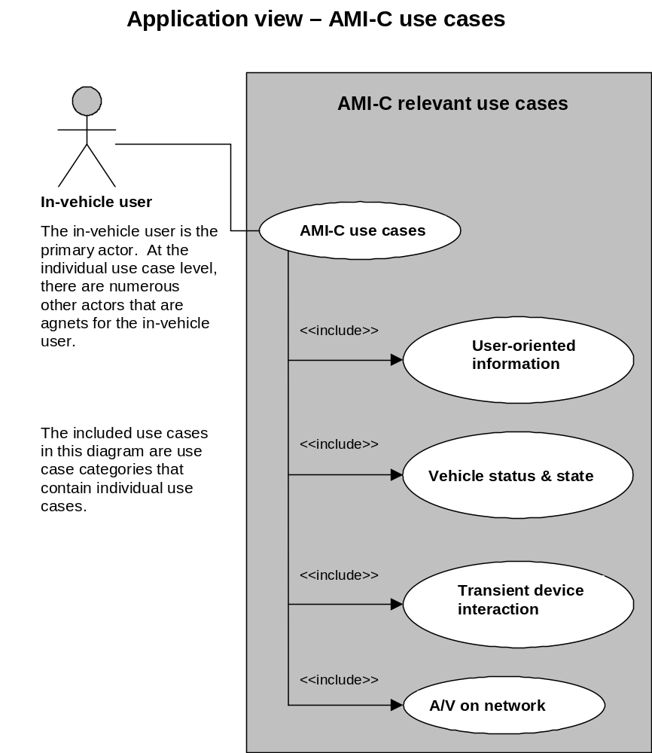
Figure 7 — Application view of AMI-C use cases

Driver information applications
Use cases in this category address the provision of real-time and/or location specific information to driver. (Note: This section and the following few sections will use the abbreviated use case names as in AMI-C 1001, AMI-C use cases.)

Examples of AMI-C use cases:
- GUID 1 On-board navigation system
- GUID 2 Off-board navigation system
- GUID 3 Navigation with communication system
- GUID 4 Traffic information using multiplex broadcasting
- ITS 1 Obtaining traffic information from vehicle service provider
- GUID 6 Obtaining roadside information

Vehicle status applications
Use cases in this category address the real-time, event driven vehicle status message to or transaction with a service center. Examples of such AMI-C use cases include
- CUST 1 Acquisition of customer data
- EMER 1 Automatic vehicle accident notification
- EMER 2 Emergency call with vehicle diagnostics
- EMER 3 User-initiated emergency call
- FLEE 1 Submitting vehicle transit data
- FLEE 2 Installing fleet management software
- SERV 3 Diagnose system fault

Transient device interaction
Use cases in this category address the interaction between or among vehicle services, vehicle HMI and one or more personal devices. Examples of such use cases:
- MOBI 2 Mobile phone voice call
- MOBI 3 Mobile phone data call
- MOBI 6 Synchronizing personal data between vehicle and a personal mobile device

Network Audio/Video applications
Use cases in this category address the audio and video entertainment, primarily on a wired network. Examples of such use cases include
- ENTE 4 Receiving broadcast analog/digital audio
- ENTE 5 Audio media player (cassette, DVD, CD)
- ENTE 6 Receiving broadcast analog/digital video
- ENTE 7 Video media player (DVD, VCR)
- ENTE 8 Video game player

BMW
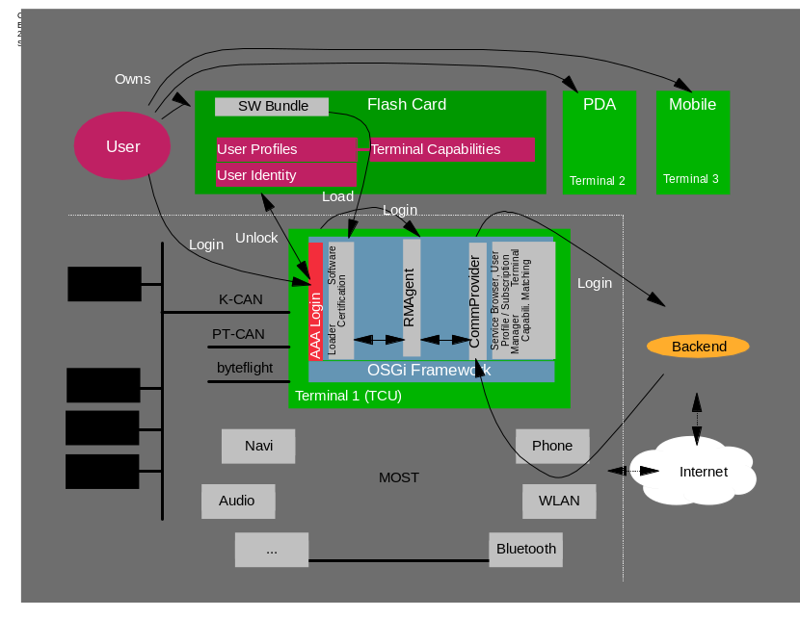
OSGi-Platform is the head unit – every application is running on Java (all car functionality) (Other solution: Head unit is seperated from OSGi platform which is a device in a veh.icle-network, e.g. MOST)
User owns several terminals with which he can log in to the car terminal or the backend server
Log in can be done „local“ (local security context) or „remote“ (remote security context).
There is an „security token“ (e.g. Digital Card, USB Token, Flashcard) which holds private key, and a „storage token“ (also Flashcard,..) which holds bundles and user information.
The flashcard is a server proxy (sync with server).
User profile is a number of (abstract) user software profiles like „home“, „work“, .. .Each profil is linked to a set of applications (bundles, this is user specific). Depending on the terminal capabilities different user software profiles are instantiated and are linked to a special variant of an application which meets the terminal requirements.
There is a sync mechanism to sync data between server, terminal and flash card (terminal capabilities, user profiles, bundles)

IBM PVC Telematics Client Stack
The IBM embedded Java enablement team has been developing an OSGi based telematics client stack in the course of a series of customer engagements with most North American automotive OEMs and tier 1 suppliers.
The stack consists of both Java run-time code in the form of OSGi bundles, and tools for developing and maintaining embedded systems.

Java and OSGi Base
IBM’s customers have been attracted to Java for productivity benefits in developing embedded systems and applications, and for the platform portability it provides when properly applied. The OSGi platform provides lifecycle management of the embedded software by allowing modular replacement, maintenance, and enhancement of functions comprised of bundles.

Vehicle Bus Access
To facilitate interfacing to the wide variety of bus protocols found in vehicles, the IBM stack includes the Device Kit. The Device kit provides an XML-based language for modeling bus protocols in terms of syntax, measurements (data), commands and events, tools for generating Java classes, structured as OSGi bundles and implementing OSGi services, from the XML model which implement the application model interface.
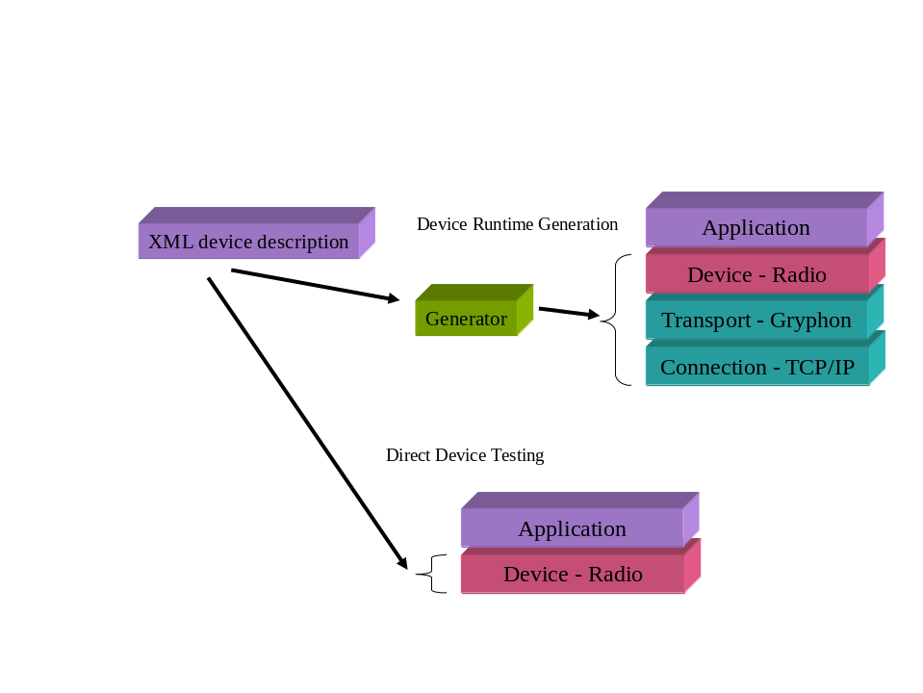
Figure 8 Device Kit Bundle Generation
The device kit also provides flexibility by separating concerns of hardware access and transport layer dependencies from the application level modeling. This allows hardware changes both for the development life cycle and for variation in products. For example the development life cycle support allows hardware and software development to proceed in parallel by using protocol converters which are replaced as development proceeds by evaluation board hardware and finally by production hardware.

ML Kit
The ML kit provides a framework for markup language description of UI interfaces. This provides application independence over the physical UI devices. Applications respond to and generate events defined in the ML. This approach incorporates support for display, text display, touch, physical buttons, voice, and other HMI devices.
For graphical user interfaces, the ML kit provides application isolation from the underlying graphics layers. User interfaces expressed in a markup language may be rendered on a variety of graphics implementations. This is valuable because it allows cost reductions in production hardware, while allowing development systems to emulate future or current production hardware using readily available standard graphics APIs.
ML Kit supports multiple markup languages by using optional renderers. HTML cHTML, and WML have all be used. In addition, for the highly “designed” graphical interfaces often required in automotive and consumer electronics applications, ML Kit provides P3ML.

P3ML
P3ML (Portable Positional Paint Markup Language) provides support for a variety of graphical displays and touchscreen devices. It uses an XML markup language for describing the user interface presentations and to provide an interface to the application, which is isolated from the actual user interface. P3ML was designed to allow highly customized designer user interfaces. The separation between the look of the interface and the application allows the user presentation to be designed by graphical artists, such as designers in an auto manufacturer’s design studio. P3ML also allows other markup languages to be nested.
P3ML provides a high level graphical HMI description which can be rendered on several different underlying graphic and UI levels. Our observation is that the kind of rich customized UI presentations which are demanded in vehicle and consumer electronics products make use of a small percentage of the function typically provided in a widget-oriented service such as AWT. While such services can support customized interfaces, they bring a high cost in the footprint of the services which are not used. Since automotive and consumer electronics products tend to have tight hardware budgets this cost cannot always be justified.

Application Frameworks

ProSyst Telematics System Architecture
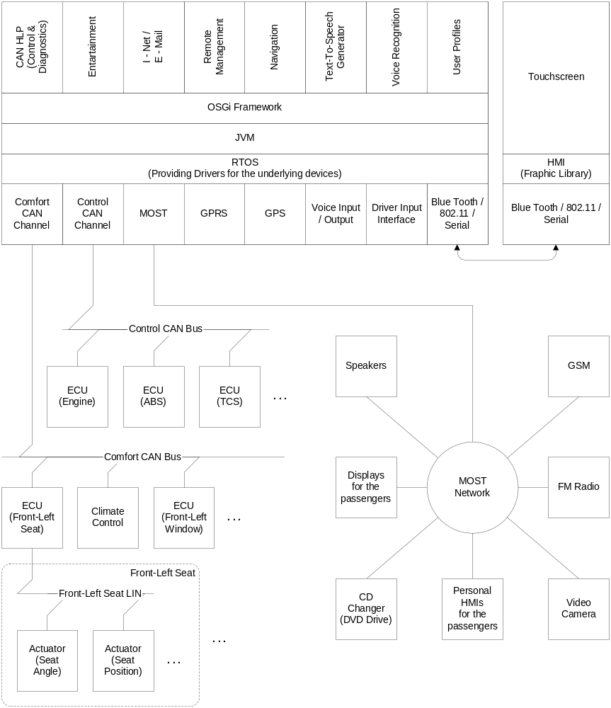
Figure 9 ProSyst System Architecture

Comfort CAN Channel (Low speed CAN)
There are many possibilities for implementation of this CAN channel. Here is no requirement for fast and very reliable transfer of data. The “Comfort CAN” is build over some kind of device-control protocol, such as CANopen, DeviceNet or CANKingdom. There is one Master ECU (the Board on which runs the OSGi server) and numerous Slave ECUs. The Slave ECUs are located in the individual parts of the interior: Doors, Seats etc. and actually every one of the Slave ECUs is CAN-LIN gateway. The LIN (Local Interconnection Network) is used for the physical connection to the actuators: lifter for windows, central lock device etc.

Control CAN Channel (High speed CAN)
Here is used some kind of already standardized CAN HLP (High Layer Protocol): J1939, ISO15765 etc. The main function of this network is communication between ECUs of the automobile: Engine ECU, ABS, Traction Control System, Emissions Related ECUs, and Car Diagnostic Devices etc. The OSGi Telematics system has to be able to monitor this communication, but not to make any intervention. However, there is two possible applications:
- One of the possible device-implementation is for example J1939-Virtual Terminal ECU. A Virtual Terminal is an ECU, consisting of a graphical display and input functions, connected to a J1939 network that provides the capability for a Working Set of ECUs in the car (automobile, truck, agriculture machinery etc.) to interact with an operator. The VT provides the capability to display information and to retrieve data from an operator.
- Another one is Diagnostic and Test Tool. Gathers and stores information for the working process of the whole automobile.

MOST (Media Oriented System Transport)
Provides interconnection between Multi Media devices, such as: CD Changer, DVD drive, Displays, HiFi speakers, FM Radio Tuner etc. The basic function of the OSGi platform is to provide HMI for control over devices, attached in the MOST networks.

HMI
There is three possible ways for implementation of the Telematics system, depending on the location of the HMI:
- Docked - The touch screen with the HMI and the OSGi platform are on one board. This is applicable only for personal car and is not very handy.
- Undocked – The OSGi platform with all Telematics services is running on the board and the HMI is running on mobile device (e.g. PDA). This situation is more comfortable. The connection between both is over some kind of wireless network (Blue Tooth, 802.11 etc.), wired serial connection (USB etc.) or combination from both.
- Distributed – Very similar to the previous, but in this case all OSGi services are running on the mobile device and the board is handing only the communication functions.

Navigation
Navigation module facilitates the driver to reach a desired destination on the basis of a multitude of factors such as distance, traffic, quality of the road, etc. Provides to the driver turn by turn direction notifications, provided by the text to speech module and display representation.

Remote management
It provides ability for dynamic configuration, installation, and update of components, supervision of service Framework runtime states, and configuration of security for the network and the end users. The backend handles the communication with service frameworks, monitors changes in their configuration state, manages user access, schedules management jobs for execution and keeps track of job result replied by service frameworks.

Text-To-Speech Generator
Minimizes eyes-off-the-road and hands-off-the-wheel time. Combined with the voice recognition provides alternative user interface to the system, which is more comfortable for use in a vehicle than the conventional one.

Voice Recognition
Minimizes the number of steps required to perform a task

User profile
In these days users has already accustomed with desktop personalization. But in the vehicle they are able not only to control the services they use, as e-mail or the desktop view, but they are able to customize their seat angle and position, mirrors tilt, etc. every user has a different profile which customizes the in vehicle environment by his/hers preferences.

Siemens/VDO TLA

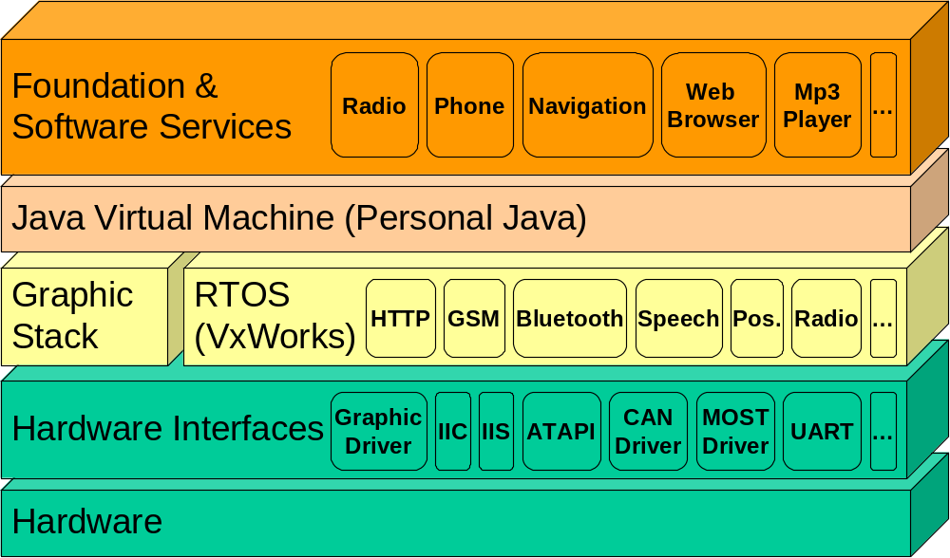
Figure 10 TLA System Architecture diagram

The architecture is split into multiple components, which can be grouped into four general levels.
▪ Level 1: Foundation and Software Services
▪ Level 2: Software Level (Java Runtime)
▪ Level 3: Operating System & Native Drivers
▪ Level 4: Hardware

TLA Foundation & Software Services
Applications and services are the final products to be sold to the end user. They are developed on top of the underlying TLA Platform. Based on the underlying Java classes layer, the graphics parts of all applications and services should be implemented. The use of deeper native calls, which would lead to unnecessary platform dependencies, should be avoided.

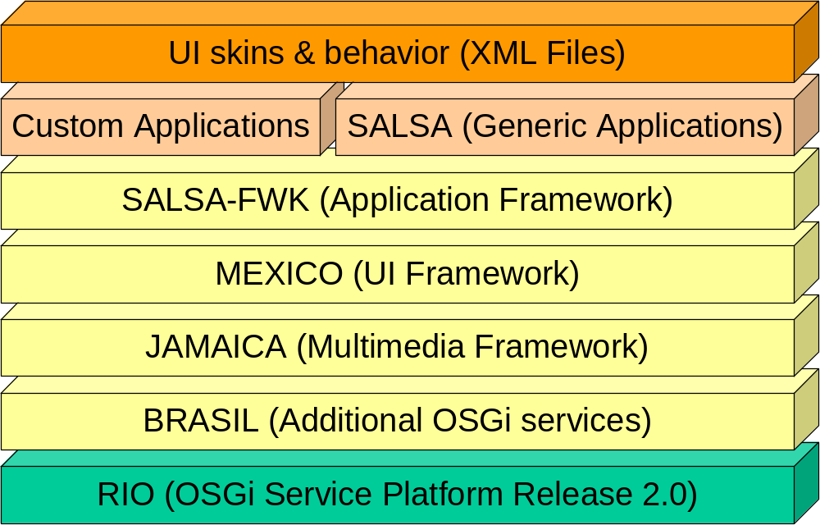
Figure 11 TLA Foundation & Software Services diagram
The diagram above describes all layers defined in the “Foundation & Software Services” level. From the top to the bottom we have.

UI Skins & Behaviors
UI skins & behaviors are defined by using XML files according to the MEXICO concept.

Custom & SALSA Generic Applications
Contains all applications without any UI.
There are two kinds of applications:
- Generic Applications provided by SALSA (Software Application LineS for Automotive).
These applications are: phone, radio, MP3 Player, CD Player, e-mail, @Book, Web Browser, Launcher, …
- Custom Applications that are specific to a customer and need to be developed in a specific context

SALSA FWK
SALSA (Software Application LineS for Automotive) defines as well a framework for applications based on MEXICO.

MEXICO
MEXICO(Multimedia EXtensible Interface COmponents) is the HMI part of the TLA reference platform that provides application developers with an environment in which to design and build User Interfaces with a flexible, replaceable Look and Feel in accordance with the overall platform development strategy.
MEXICO can be seen as three subsystems:
- An interface to allow applications to access the basic services MEXICO offers
- A system that manages the various input devices that can be plugged into the system
- A system that manages the different output devices that can be present in the system, and provide these if the form of an abstract set of devices.

JAMAICA
Multimedia is handled by JAMAICA (Java based Advanced Multimedia Architecture In Car Applications).

BRASIL
BRASIL (Base Reusable Automotive Services Integration Layer) provides additional OSGi services used by above layers:
- Diagnostic Service
- Internationalization (i18n) Service
- Persistence Service
- Power Live-Cycle Model
- Resource Sharing Service
- Session Manager
- State Machine Utility
- Units Utility

RIO
RIO (RIO Implements OSGi) is strictly the implementation of the OSGi Service Platform Release 2.0.

Level 2: Software Level (Java Runtime)
Java offers a platform independent and object oriented API for application developers. All the functionality of the operation system and the native graphics driver is wrapped into Java classes.

Level 3: Operating System & Native Drivers
A Realtime Operating System with all necessary native drivers.

Level 4: Hardware
The hardware includes the main processor unit (CPU) where the TLA system runs, and an I/O-Gateway that handles the input/output from/to devices such as LCD-display, rotary, and network.

Others?

Document Support

References
- Bradner, S., Key words for use in RFCs to Indicate Requirement Levels, RFC2119, March 1997.
- Software Requirements & Specifications. Michael Jackson. ISBN 0-201-87712-0

Add references simply by adding new items. You can then cross-refer to them by chosing <Insert><Cross Reference><Numbered Item> and then selecting the paragraph. STATIC REFERENCES (I.E. BODGED) ARE NOT ACCEPTABLE, SOMEONE WILL HAVE TO UPDATE THEM LATER, SO DO IT PROPERLY NOW.

Author’s Address

Name | Rick DeNatale
Company | IBM
Address | 1604 Barnes House Court, Wake Forest, NC 27587 USA
Voice | +1 919 453-0039
e-mail | denatale@us.ibm.com

Acronyms and Abbreviations

End of Document

This section is a major excerpt from the AMI-C Release 2 Architectural Overview version 0.87 dated 11 February, 2003

