

RFC xx - <Better-Name-than-AAA>-Service
Confidential, Draft
16 Pages
Text in Red is here to help you. Delete it when you have followed the instructions.
The <Document Title> and <Company Name> can be set from the File=>Properties menu. To update it onscreen, press F9. To update all of the fields in the document Select All (CTRL-A), then hit F9. Set the confidentiality and release level by selecting one from each list; Confidential, Members Only or Open Distribution and Draft, Final Draft, Release. The date is set automagically when the document is saved. Note that FINAL DRAFT and RELEASE documents should only be released as PDF, NOT AS WORD DOCUMENTS
Abstract
The Terminal Session Service supports applications and other services in a mobile device OSGi environment with three functions: (1) Authentication of the device user due to login, (2) authorization of the current user by providing an Authorization object and (3) access of a user specific encryption key of the current user that can be used for encryption/decryption of persistent data.

Document Information

Table of Contents
0 Document Information 2
0.1 Table of Contents 2
0.2 Terminology and Document Conventions 3
0.3 Revision History 3
1 Introduction 4
2 Application Domain 4
3 Problem Description 5
3.1 Authentication and Authorization Support 5
3.2 Management of User Individual Encryption/Decryption Keys 6
4 Requirements 6
4.1 User 6
4.2 Signature 7
4.3 Permissions 7
4.4 Data 7
4.5 Compatibility 7
4.6 Performance 7
5 Technical Solution 8
5.1 Current Status of User/Role/UserAdmin/Authorization to Build on 8
5.2 Overview of New Terminal Session Service 8
5.2.1 Authentication and Authorization 9
5.2.2 Management of a User Individual Encryption/Decryption Key 10
5.3 Class TerminalSession 11
5.3.1 getUser 11
5.3.2 getAuthorization 11
5.3.3 login 12
5.3.4 userLogin 12
5.3.5 roleLogin 12
5.3.6 reLogin 12
5.3.7 logOut 12
5.3.8 getEncryptionKey 12
5.4 Sample Code 13
6 Considered Alternatives 14
7 Security Considerations 14
8 Document Support 14
8.1 References 14
8.2 Author’s Address 14
8.3 Acronyms and Abbreviations 15
8.4 End of Document 15

Terminology and Document Conventions
The key words "MUST", "MUST NOT", "REQUIRED", "SHALL", "SHALL NOT", "SHOULD", "SHOULD NOT", "RECOMMENDED", "NOT RECOMMENDED", "MAY" and "OPTIONAL" in this document are to be interpreted as described in [1].
Source code is shown in this typeface.

Revision History
The last named individual in this history is currently responsible for this document.

Revision | Date | Comments
Initial | Apr 24, 2004 | Chapter 4 Requirements created  by Olli Immonen, Nokia, Olli.Immonen@Nokia.com
0.1 | Apr 28, 2004 | Abstract and Chapter 1 through 3 created  by Frank Seliger, IBM, Seliger@de.ibm.com
0.2 | Apr 29, 2004 | Chapter 5 overview sections created (5.1 and 5.2)  by Frank Seliger, IBM, Seliger@de.ibm.com
0.3 | May 14, 2004 | Added TerminalSession javadoc (5.3) and sample code (5.4).  by Olli Immonen, Nokia, Olli.Immonen@Nokia.com
0.4 | May 14, 2004 | Minor editorial changes. Addition of open issues (see <….>), more info on Authentication and Authorization, and the description of the Authentication Plug-In interface  by Frank Seliger, IBM, Seliger@de.ibm.com
0.5 | Jun 25, 2004 | Made TerminalSession into an interface so that it can be used as a service.  By Benjamin Reed, IBM, breed@almaden.ibm.com
0.6 | Jun 29, 2004 | Minor editorial changes (like correct RFC number, copyright on companies instead of persons, and other important stuff ☺)  by Frank Seliger, IBM, Seliger@de.ibm.com

Introduction
Supporting handheld mobile devices (in contrast to vehicles) with OSGi brings new use cases and requirements. The Mobile Expert Group in OSGi is focusing on these new use cases and requirements. The security relevant new use cases and requirements are captured in the RFP 56 [2].
One new area of use cases is the notion that there is a single current user or device user, who logs into the device before using it or before using the first function requiring authorization. Access to application functions and resources in the device is dependent on this current user and on the roles granted to this current user. When several applications require authorization, the user should login just once (usually referred to as “single sign-on”).
Applications, especially those for the enterprise market, will often have a need to identify a user or otherwise have the user authenticated for the purpose of customization and authorization. This can be a key issue while data is accessed both locally and remotely. Not being able to properly authenticate the user may result in allowing access to an improper set of data.
This RFC describes a new service that supports applications with function that makes the authentication and authorization handling convenient for application developers and that offers a “single sign-on” experience to the users. This function bases on a simple user model that is sufficient for the mobile device. The model is aimed at managed devices that are having at the most one physical local user at a time. The model offers the concept of roles as they are already used in OSGi.
The new service described here is an extension to the OSGi framework. It uses itself heavily the existing UserAdmin Service. This new service deals with all aspects of the security context of the current device user. This service stacks neatly on top of UserAdmin without requiring any change (I hope we will not discover later that we can not keep this promise).

Application Domain
The Mobile Expert Group brings OSGi solutions to the world of mobile devices. The nature of the mobile domain differs in several places from what has been usually considered to be the scope of OSGi. This unique nature creates significant new challenges regarding the security. Following is the list of most important differences from the security perspective.
- Small form factor. The mobile device is usually designed to be hand-held, with limited memory, processing capabilities and battery life.
- Personal usage. The mobile device is carried, used and operated by the single person in a variety of environments. The different, personal, usage pattern of the device may allow for the simple user model. At the same time the usability of security is of enormous importance.
- Smart cards. SIM cards are ubiquitous in GSM-compliant devices while higher-end devices allows for memory cards.
- MIDP. There is the existing solution for Java applications with its own security intrinsic.
The second item, personal usage, is the major new aspect that this RFC tries to address.

Problem Description
This RFC tries to support two tasks for mobile devices operated by a single current user:
(1) Authentication and Authorization and (2) Management of a user individual encryption/decryption key

Authentication and Authorization Support
Currently, without the new service described in this RFC, the work that application developers need to do for authorization enforcement is complex and makes it very hard to provide a “single sign-on” experience. If for example, an application needs to make a certain access dependent on the authorization of the current user, it currently needs to perform the following steps:
- Present a login prompt to the user. If the user was already authenticated before by another application and if that other application did not explicitly pass on this information to this application, then the user is annoyed by the repeated login.
- get the user’s credentials from UserAdmin. This makes it necessary that all applications needing user authorization are holding the permission to read the user’s credentials. This is violating the principle of least privilege.
- Compare the user’s credentials from UserAdmin with the user input during login,
- get an Authorization object for this user from UserAdmin.
- invoke Authorization.hasRole(…) on it and enforce the authorization decision according to the result.
This RFC describes an extension to the OSGi framework, which is a single service using itself heavily the existing UserAdmin Service. Based on this new service, the application would need to perform the following steps for authorization enforcement:
- Call getUser() to determine if anybody is logged in already. If not, call login() to have the user logged in,
- call getAuthorization() to get the current user’s Authorization object,
- invoke Authorization.hasRole(…) on it and enforce the authorization decision according to the result.
The major difference is that without the new service:
  - the application needs to provide all user prompting and credential gathering,
  - the application needs to understand and implement the authentication protocol,
  - the application needs to have more permissions than are secure to distribute,
  - Single Sign-on is not supported.

Management of User Individual Encryption/Decryption Keys
Another problem that the new service solves for applications and services is the management of a user individual encryption/decryption key for sensitive user data. How and where to store such a key is a problem for which there is no easy solution. Keep the key to the safe inside a safe! To keep such an encryption key persistent, it would need to be encrypted itself or to be kept in security hardware. To then keep such an encryption key or the credential to access the security hardware persistent it would need to be encrypted itself or to be kept in security hardware. But then to keep …
The only chance to break this recursion is to have the user provide the key or some data from which the key can be derived dynamically.
The new service is trying to exploit the user secret entered for the purpose of login, derive a key from that secret and keep the key in transient storage until the user logs out or a timeout occurs. Applications and services with the necessary permission can access this key but not the user authentication secret.

Requirements
This RFC addresses following requirements captured in the RFP 56 [2]:

User
REQ-SEC-01-01. MEG MUST provide support for the concept of the user authentication/authorisation for the personal use of the device.
REQ-SEC-01-02. MEG MUST provide the lock-out mechanism where the user is locked out from the device after the certain period of inactivity or at the user's request. Such lock-out is equivalent to changing the user to the anonymous one.
REQ-SEC-01-03. The application is responsible to verify user's rights before proceeding. MEG MUST provide services for applications to decide whether to proceed depending on the user authentication.
REQ-SEC-01-04. MEG MUST be able to use the notion of the user in several contexts without frequently asking the user for additional authentication (single log-in).
REQ-SEC-01-06. MEG SHOULD provide a simple method that allows the user to gain access to sensitive functions of applications that require another log-in.
REQ-SEC-01-07. The device MUST be configurable so that certain functions can be accessible to unauthenticated (anonymous) user.

Signature
REQ-SEC-02-02. MEG SHOULD provide means to support trusted dialogue to prevent PIN/password interception. The user SHOULD be able to distinguish between trusted dialogue and regular interaction. Note: This requirement is not fulfilled by this RFC (i.e. API). It is listed here since the requirement may be related with the implementation of this RFC.

Permissions
REQ-SEC-03-03. MEG SHOULD provide the mechanism where the changes in policy or in conditions propagate to actual permissions (e.g. SIM change). [This might be related]

Data
REQ-SEC-04-01. MEG SHOULD provide means for applications to securely keep selected confidential information in the device.
REQ-SEC-04-02. MEG SHOULD provide support for secure device upgrade. [This is a reason why the first one is needed]
REQ-SEC-04-03. MEG SHOULD provide support for secure backup and restore. . [This is a reason why the first one is needed]
REQ-SEC-04-04. MEG SHOULD provide support for secure disposal of the device. . [This is a reason why the first one is needed]
REQ-SEC-04-05. MEG SHOULD provide means for applications so that data stored in the removable storage is protected (e.g. encrypted) while it is usable at least on the original mobile device. . [This is a reason why the first one is needed]

Compatibility

Performance

Technical Solution
To better understand how the new service will integrate with the current UserAdmin Service, we briefly look at the current status.

Current Status of User/Role/UserAdmin/Authorization to Build on
UserAdmin owns user specific information, most notably here the roles a user has been granted and the credentials for user authentication. Roles are the basis of all user authorization decisions.
Role is an OSGi interface, interface User extends it, and interface Group extends interface User. It seems an enormous stretch to model a user as a specialization of a role and a group as a specialization of a user (instead of an aggregation of user references). But this is an established fact in OSGi that we do not even think of correcting.
Roles and users have properties. For users, the properties can contain authentication credentials, which are very sensitive information. UserAdminPermission is needed to access these properties, to set them for roles, to set and get them for users.
There is a special user object defined, User.Anyone, the roles of which are applied whenever a specific user was not (yet) authenticated, that is when we are dealing with an anonymous user.
For authorization the class Authorization encapsulates all evaluation of group membership and associated roles. For the user an authorization object can be requested from UserAdmin by calling UserAdmin.getAuthorization(User). It is left to the applications to communicate this authorization object. The application can then use the method Authorization.getRoles() to have the evaluation and thus the access control decision logic executed.

Overview of New Terminal Session Service
The new service is based on the UserAdmin Service:
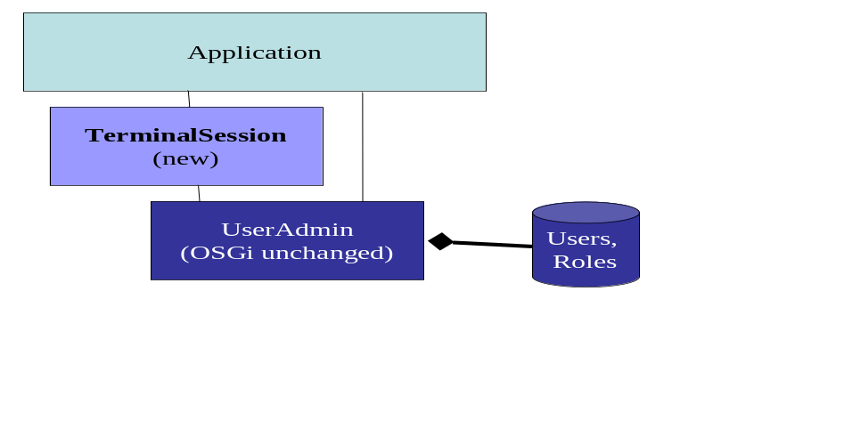
Applications can use both, the Terminal Session Service to authenticate or authorize the current user or to work with the individual user encryption key. They also can use, if granted the required permission, use the UserAdmin Service to work with users other than the single user currently logged into the device.
The Terminal Session Service focuses on the current user of the device who is defined for the entire platform at this time. If binds to the person last authenticated on the device and assumed to currently use it (as long as not explicitly logged out or timed out).

Authentication
The Terminal Session Service uses the same logic that currently applications and bundles need to perform for authentication and offers this as a reusable function and with built-in support for “single sign-on” to applications and other services.
The login methods …
- Present a login prompt to the user (assuming password-based authentication here).
- Get the user’s credentials from UserAdmin. TerminalSession needs the required UserAdminPermission.
- Compare the user’s credentials from UserAdmin with the user input during login,
- Compute the encryption key for user specific data and store it in transient storage.
- Get an Authorization object for this user from UserAdmin.

Plug-in for different Authentication methods
To not restrict this TerminalSession service to password-based authentication only, we propose a plug-point for different authentication approaches. Such plug-in will need to provide the steps 1. to 4. listed in the previous section on the login. The interface between the TerminalSession service and the plug-in needs to pass the following information:
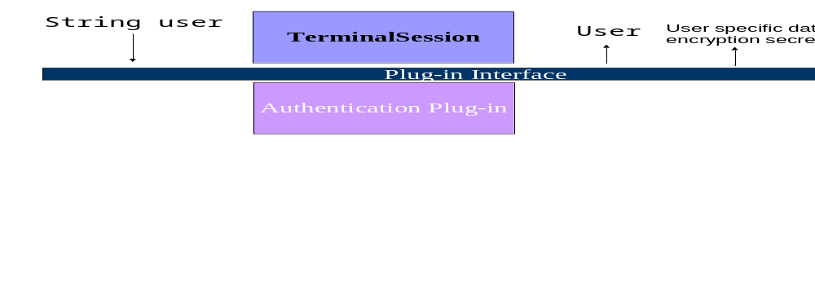
The plug-in interface is not yet specified in this version of the document. These plug-ins correspond one-to-one to the LoginModule in JAAS. However, we could only get close to JAAS here but not fit the JAAS API completely, because JAAS LoginModules update the JAAS Subject with relevant Principals, all of which are not yet defined in OSGi as long as JAAS is not included.
It is important to note that the plug-ins will all need UserAdminPermission to retrieve the user authentication credentials.

Authorization
The login methods have (this part would be outside of the plug-ins) retrieved an Authorization object from the UserAdmin service. This authorization object can be retrieved from the TerminalSession using getAuthorization() and then used to determine authorization to specified roles with hasRole().

Management of a User Individual Encryption/Decryption Key
We suggest using a key management according to the scheme used in several databases: All bulk data encryption is done using a symmetrical data encryption key. This key is created using a random key generation process like for the session key in SSL for example. The symmetrical data encryption key itself is persistently stored in encrypted form. It is encrypted and decrypted using the user specific secret that can at any time be recreated from the user secret (password, pass phrase), or that is derived or retrieved in any other form during the user authentication.
The advantage of this approach seems that it is a widely established pattern.
- Initial state: At user enrolment the data encryption key is generated. The user specific key is derived (based on the first user chosen secret or however the plug-in derives it for this method of authentication).
- Password change (or change in key derived during authentication plug-in): The data encryption key is decrypted using the old key and encrypted using the new key. It is stored again.

Interface TerminalSession
java.lang.Object
|
+--TerminalSession

public interface TerminalSession
This TerminalSession interface provides applications the functionality to authenticate and authorize the user and to obtain the encryption key for this user.

Method Summary
Authorization | getAuthorization()  Returns an Authorization object for the current user or null.
Key | getEncryptionKey()  Returns the symmetric key for encryption and decryption of data that should be protected on a per user base.
User | getUser()  Returns the current user or null if no user/anonymous.
User | login()  Allows to log-in as any user.
void | logOut()  Logs-out and becomes the anonymous user.
boolean | reLogin()  Requests the login to be repeated for the current user.
User | roleLogin(java.lang.String role)  Requests to log in as one of users that are able to carry on the specific role.
User | userLogin(java.lang.String name)  Requests to log in as a specified user.

Method Detail

getUser
public User getUser()
Returns the current user or null if no user/anonymous.
Returns:
the current user or null if no user/anonymous

getAuthorization
public Authorization getAuthorization()
Returns an Authorization object for the current user or null. This Authorization object can be used for access control decisions through its method Authorization.hasRole().
Returns:
an Authorization object for the current user or null

login
public User login()
Allows to log-in as any user. Uses functions of the User Interface to acquire user ID and credentials. Possibly presents the list of available users to select from. If already logged in and if the credential check for the new login was successful, then the current user is logged out and the new logged in.
Returns:
a User object if logged in as any user, null otherwise.

userLogin
public User userLogin(java.lang.String name)
throws TerminalSessionException
Requests to log in as a specified user. The user name does not need to be entered on the UI (it can be filled in already or shown as string that can not be changed). If already logged in and if the credential check for the new login was successful, then the current user is logged out and the new logged in.
Parameters:
name - the name of the specified user
Returns:
a User object if logged in as the specified user, null otherwise
TerminalSessionException

roleLogin
public User roleLogin(java.lang.String role)
throws TerminalSessionException
Requests to log in as one of users that are able to carry on the specific role. If more than one user can carry the role then the selection will be provided. If already logged in and if the credential check for the new login was successful, then the current user is logged out and the new logged in.
Returns:
a User object if logged in as the specified user, null otherwise
TerminalSessionException

reLogin
public boolean reLogin()
Requests the login to be repeated for the current user. If failed, the current user becomes the anonymous user.
Returns:
true if login was succesful

logOut
public void logOut()
Logs-out and becomes the anonymous user. The same happens after a time-out.

getEncryptionKey
public Key getEncryptionKey()
Returns the symmetric key for encryption and decryption of data that should be protected on a per user base.
Returns:
a Key object or null

Sample Code
// Determine if anybody is logged in already
TerminalSession termSess;
... get a TerminalSession object from the service registry and assign to termSess …
User u = termSess.getUser();
// If not logged in, call login()
if (u == null)
u = termSess.login();
// If login was unsuccessful terminate the operation
if (u == null)
return;
// Get the current user’s Authorization object
Authorization a = termSess.getAuthorization();
// Check if the user has the required role and enforce the authorization decision according to the result
if (a.hasRole(…)) {
// do something
}
// Decrypt some user data
Key k = termSess.getEncryptionKey()
if (k != null) {
...
}
// logout
// Well, we will have to think about this one some more. If we explicitly log out // in the application then we will not have the Single Sign-On user experience.
termSess.logout();

Considered Alternatives
For posterity, record the design alternatives that were considered but rejected along with the reason for rejection. This is especially important for external/earlier solutions that were deemed not applicable.

Security Considerations
The TerminalSession service is protected by the ServicePermission. If a service has permission to get the TerminalSession it will be able to indirectly access much of the UserAdmin service through the Terminal Service. More importantly, care must be taken granting ServicePermission to bundles to allow them to register TerminalSessions. A malicious bundle that can register a TerminalSession service can trick other bundles into authorizing access to users who have not sufficiently authenticated themselves.

Document Support

References
- Bradner, S., Key words for use in RFCs to Indicate Requirement Levels, RFC2119, March 1997.
- OSGi RFP 56 - MEG Security Use Cases and Requirements
- Software Requirements & Specifications. Michael Jackson. ISBN 0-201-87712-0

Add references simply by adding new items. You can then cross-refer to them by chosing <Insert><Cross Reference><Numbered Item> and then selecting the paragraph. STATIC REFERENCES (I.E. BODGED) ARE NOT ACCEPTABLE, SOMEONE WILL HAVE TO UPDATE THEM LATER, SO DO IT PROPERLY NOW.

Author’s Address

Name | Olli Immonen | Frank Seliger
Company | Nokia | IBM
Address | Helsinki, Finnland | Boeblingen, Germany
Voice | +35 85 04 83 63 04 | +49 7031 16 3142
e-mail | Olli.Immonen@nokia.com | Seliger@de.ibm.com

Acronyms and Abbreviations

End of Document

This is a plug-in that will be called by the login methods of the TerminalSession class.

