

RFC90 - Navigation Domain Model
Confidential, Draft
86 Pages

Abstract
This document specifies the navigation domain model: the key navigation entities.

Document Information

Table of Contents
0 Document Information 2
0.1 Table of Contents 2
0.2 Status 4
0.3 Acknowledgement 4
0.4 Terminology and Document Conventions 4
0.5 Revision History 4
1 Introduction 7
2 Application Domain 7
2.1 Navigation domain 7
2.2 Entities 8
Address 8
Advice 8
Destination 8
Itinerary 8
Journey 8
Location 8
Maneuver 8
Map 8
Point of Interest (POI) 9
Position 9
Route 9
Via-Point 9
Waypoint 9
2.3 Standard References 10
3 Problem Description 10
3.1 Use Cases 12
3.1.1 Download POIs (Points Of Interest) 12
3.1.2 Download a route 13
3.1.3 Transfer a map 15
3.1.4 Scenic Guide 16
3.1.5 Plan a route 17
3.1.5 Provide Guidance Information 20
3.1.6 Provide Facility Information 21
4 Requirements 22
ReqNDM#1 - Download destination 22
ReqNDM#2 - Download journey 22
ReqNDM#3 - Download route 22
ReqNDM#4 - Download POI 22
ReqNDM#5 - Transfer map 22
ReqNDM#6 - Scenic Guide 22
ReqNDM#7 - Plan a route 23
ReqNDM#8 - Provide Guidance Information 23
ReqNDM#9 - Provide Facility Information 23
ReqNDM#10 - Multimodal travel 23
ReqNDM#11 - Tank stop 23
ReqNDM#12 - Fleet management 23
ReqNDM#13 - Breakdown Call 23
ReqNDM#14 - Emergency Call 23
ReqNDM#15 - Off-board navigation 23
4.1 Future requirements 24
ReqNDM#16 - Import external information 24
ReqNDM#17 - Provide GPS information 24
ReqNDM#18 - Provide Traffic information 24
ReqNDM#19 - Provide ADAS information 24
5 Technical Solution 25
5.1 Overview 25
5.2 Use case realizations 26
5.3 Plan a route 26
5.4 Resolve an address 27
5.5 Get POI information 27
5.6 Class Diagrams 28
5.6.1 Navigation Service 28
5.6.2 Address 29
5.6.3 Geometry 32
5.6.4 Location 34
5.6.5 Maneuver 35
5.6.6 POI 37
5.6.7 Route 38
6 API Specification 40
6.1 Navigation packages 40
6.2 Package org.osgi.nursery.service.navigation 40
6.2.1 Interface NavigationService 40
6.3 Package org.osgi.nursery.util.address 43
6.3.1 Interface Address 43
6.3.2 Interface AddressKeys 44
6.4 Package org.osgi.nursery.util.geo 47
6.4.1 Interface Zone 47
6.4.2 Class CircularZone 48
6.4.3 Class Coordinate 50
6.4.4 Class RectangularZone 51
6.5 Package org.osgi.nursery.util.location 54
6.5.1 Interface Location 54
6.5.2 ADDRESS_FIRST 54
6.5.3 COORDINATE_FIRST 54
6.5.4 ZONE_FIRST 55
6.5.5 getAddress 55
6.5.6 getCoordinate 55
6.5.7 getType 55
6.5.8 getZone 55
6.6 Package org.osgi.nursery.util.maneuver 56
6.6.1 Interface ActionType 56
6.6.2 Interface JunctionGeometry 57
6.6.3 Interface JunctionSegment 58
6.6.4 Interface JunctionType 60
6.6.5 Interface Maneuver 62
6.7 Package org.osgi.nursery.util.poi 65
6.7.1 Interface PointOfInterest 65
6.8 Package org.osgi.nursery.util.route 67
6.8.1 Interface FormOfWay 67
6.8.2 Interface RoadClass 69
6.8.3 Interface Route 72
6.8.4 Class FeaturePreference 73
6.8.5 Class RouteElement 74
6.8.6 Class RoutePlan 77
7 Considered Alternatives 80
7.1 Address [Siemens VDO Automotive] 80
7.2 Address [BOSCH] 81
7.3 Maneuver [BOSCH] 82
8 Security Considerations 84
9 Document Support 84
9.1 References 84
9.2 Author’s Address 84
9.3 Acronyms and Abbreviations 85
9.4 End of Document 85

Status
This document specifies the navigation domain model for the Open Services Gateway Initiative, and requests discussion and suggestions for improvements. Distribution of this document is unlimited within OSGi.

Acknowledgement

Terminology and Document Conventions
The key words "MUST", "MUST NOT", "REQUIRED", "SHALL", "SHALL NOT", "SHOULD", "SHOULD NOT", "RECOMMENDED", "NOT RECOMMENDED", "MAY" and "OPTIONAL" in this document are to be interpreted as described in [1].
Source code is shown in this typeface.

Revision History
The last named individual in this history is currently responsible for this document.

Revision | Date | Comments
0.1 | June 24, 2004 | Document creation
0.2 | August 18, 2004 | Updates after Schaumburg meeting.  - Add a new proposal for Address, Coordinate, Geometry, Location and Map definitions in Considered Alternatives section;  - Add Siemens VDO Automotive technical solution for Route and Maneuver class in Considered Alternatives section
0.3 | Sept 24, 2004 | Updates after Amsterdam meeting:  - Move alternative definition of Coordinate to section 5;  - Move alternative definition of Map, POI and Position to section 5 and remove of alternatives;  - Change the alternative definition of an Address.
0.4 | November 24, 2004 | Updates after Sophia Antipolis meeting:  - Move Address, Geometry, Location to section 5.  - Add Javadoc
0.5 | June 3, 2005 | Add some open issues  Reorganize the document
0.6 | Jan 4, 2006 | Updates after Boeblingen meeting:  - Add MOST definition for address keys;  - Remove Polygon definition and rename Shape to Zone.
1.0 | March 6, 2006 | Updates after Sophia Antipolis Meeting:  - Move Route and Maneuver classes to section 5;  - Route, Location updates
1.1 | April 3, 2006 | Updates after Eindhoven Meeting:  - Remove constructors from Location and integrate this to a Navigation Service interface;  - ManeuverGeometry and ManeuverSegment changed to JunctionGeometry and JunctionSegment;  - RouteElement link removed;  - DirectionOfTurn removed and add turn angle added;  - NO_ACTION and CONTINUE values added to ActionType;  - Map entity is removed from the model for the moment;  - Introduction of Navigation Service interface;  - Use Map instead of Dictionary in the RFC;  - POI category should use '/' format to express hierarchy in categories.
1.2 | April 14, 2006 | - Add locale to POI search;  - Remove getHints() from Route interface;  - Add ZONE_FIRST constant to Location interface

Introduction
This document is a very first draft of the navigation domain model. The goal is to describe the key entities of the domain model.

It is an API proposal for entities defined in the "RFP 37 – Navigation Domain Model".

Later these entities can be used to define some higher level API like Navigation Service.

Application Domain

Navigation domain

In order to explain the navigation domain we must define some terms.

The navigation domain concerned all information and services used in the vehicle to guide, to inform or to go with the driver.

The navigation domain model is the set of entities that defined all exchangeable data within the navigation domain.

As explained previously some navigation entities can be exchanged between different applications developed by different vendors that is why we have to come to a standard definition of this key entities.

Actors that will use the NDM are:

- Car OEM
Car OEM can select or develop appropriate services for in-vehicle use.

- Car supplier
Car supplier can easily integrate third party service or content provider in order to offer broader services.

- Service provider
Services developed can be used and integrated by various car OEM and/or car supplier.

By defining such a model actors can:
- Reduce R&D costs
- Allow re-use or use of existing services
- Reduce development time frame
- Facilitate integration phase

Entities

Address
An Address is a human-understandable symbolic reference of a location. Several different kinds of address reference systems exist, even in the same area (e.g., postal addresses). An address consists of a street address (or intersection), an ordered tree of place names (e.g. country, municipality, etc), postal code and house number. Address referencing systems tend to be unambiguous only in local areas. Multiple addresses can be associated with the same location.

Advice
An Advice is a message presented to the driver. An advice may be visual (e.g. icons representing the next turn), textual (e.g. next road name) or acoustical (e.g. speech messages). It must be presented at a well-defined point of time. An advice can be a decision advice related to a maneuver or a non-decision advice (e.g. traffic information). In the first case it represents the next action the driver has to perform in order to stay on the planned route.

Destination
A Destination is a location where the user wants to go and stop. Intermediate destinations are called via-points.

Itinerary
An Itinerary is a planned route containing at least the list of maneuvers to reach the destinations.

Journey
A Journey is a set of route that shares the same destination, list of via-points and list of way-points.

Location
A Location is a reference to a point on the surface of the earth (geographic reference: latitude, longitude and altitude).

Maneuver
A Maneuver is the action that the driver has to perform at a location (e.g. junctions). Several advices can be presented for the same maneuver.

Map
A Map is a topographical representation of an area (e.g. parts of a country) defined by roads, land use (e.g. forests, lakes …) and locations (e.g. POI).
A set of data that allows the generation of a graphical representation of a geographical area (e.g. roads, land use, locations …)

Point of Interest (POI)
A Point of Interest represents a special location, like a hospital, a gas station, a theatre, a hotel, etc. It consists of a name, a category, a location and a variety of attributes that can be attached to it (e.g. importance, brand, opening hours …).

Position
A Position is the representation of the current location typically based on the WGS84 system.

Route
A Route is the description of the travel that the user wants to do. A route has different representations. Initially the route contains a destination, a list of via-points, a list of way-points with associated route preferences. When a route calculation is performed the route contains, in addition, the route geometry (the full list of intermediate locations) that leads to destinations.

Via-Point
A Via-Point is an intermediate destination.

Waypoint
A Waypoint is a location where the user wants to go nearby or avoid on his route.

Standard References

The RFC should take advantage of already existing standards such as:

- AMI-C
AMI-C is a worldwide organization of motor vehicle manufacturers created to facilitate the development, promotion and standardization of automotive multimedia interfaces to motor vehicle communication networks.
Additional information can be found in AMI-C Website

- OpenLS
The Open Location Services Initiative (OpenLS) is devoted to the development of interface specifications that facilitate the use of location and other forms of spatial information in the wireless Internet environment. The purpose of the Initiative is to produce open specifications for interoperable location application services that will integrate spatial data and processing resources into telecommunications and Internet services infrastructure.
Additional information can be found in OGC Website

- MOST
The MOST Cooperation is based on a partnership of carmakers, set makers, system architects and key component suppliers. Together they define and adopt a common multimedia network protocol and application object model.
Additional information can be found in MOST Cooperation Website

- ADASIS
Advance Driver Assistance Systems (ADAS) need to access and use map data, vehicle position, speed, as well as other sensors' data in order to improve the performance of these applications or apply them to new functionalities.
The purpose of the ADASIS Forum is to:
Define an open standardized data model and structure to represent map data in the vicinity of the vehicle position (i.e. the electronic horizon), in which map data are delivered by navigation and/or by a general map data server.
Define open standardized API(s) to enable ADAS applications to access the electronic horizon and position-related data of the vehicle.
ADASIS is an European Forum, coordinated by ERTICO.
Additional information can be found in ADASIS / ERTICO Website

Problem Description
By defining a NDM, all exchangeable data between systems are clearly described and allow an easy integration of navigation features from various vendors.

All actors already identified in the previous paragraph will benefit from this definition. The NDM needs to be defined in the OSGi context because more and more systems are or will use an OSGi Service Platform in the automotive industry.

Use Cases

Download POIs (Points Of Interest)

Actors | Driver | In-car User | External user | Other Systems
Actors |  | X
Description | Transfer of POIs from a web site to the in-car system.
Flow of events | - The use case starts when Emma enters in the car  She is on holidays in Bretagne (Brittany) and she would like to find a hotel for tonight  - She starts the web browser and downloads some POI of her favourite hotel brands around her current car location  - The system displays the POIs on the map  - She selects one of these on the map and asks for some more information  - The system downloads and displays an HTML page with a nice hotel picture  - On the web page, she selects the “Phone to” link to make a reservation by phone.  - She adds the hotel address as a further destination  - The use case ends
Must have devices | An in-car system with an OSGi Service Platform installed and connected to Internet (e.g. using GSM)
May have devices | N/A
Prior conditions | The in-car system and the external service provider must have the same definition of:  - A Point Of Interest (POI)  - An address  - A destination
Post conditions | The system stored the hotel address as next destination.
Alternative flow 1 | - …  - She starts the web browser and requests POI around a nice location not too far from her car  - …
Extension points | None
Notes | None
Date of creation | 10/28/02
Last modification | 02/02/04
Status | Final

Download a route

Actors | Driver | In-car User | External user | Other Systems
Actors |  | X
Description | Download a route from an external service provider to the in-car system.
Flow of events | - The use case starts when Emma enters in the car  She is on holidays in Bourgogne (Burgundy) and she would like to visit some famous “domaine”  - Within her in-car system she starts the web browser and enters Michelin URL  - She selects and download the route of the famous “Route des vins en Bourgogne”  - She enters as destination the address of the house she has rent for holidays  - A message is displayed asking her if she would like to be guided along this route  - The use case ends when the guidance starts
Must have devices | An in-car system with an OSGi Service Platform installed and connected to Internet (e.g. GSM)
May have devices | N/A
Prior conditions | The in-car system and the external service provider must have the same definition of:  - A route  - An address  - A destination  Route downloaded must be validated according to embedded map data (stored on a CD, DVD or else).
Post conditions | - A full itinerary is valid from the current car position to the final destination.  - The guidance is started.
Alternative flow 1 | Off-board Navigation  - …  - She selects domaine’s addresses as new stages.  - These stages are transferred to a remote system where the best itinerary is calculated. The final result is transferred back to the in-car system.  - …
Alternative flow 2 | Itinerary with a ferry connection  - …  - She is living in Corsica and she would like to visit some famous domain in Bourgogne  - ….  - The in-car system has automatically calculated the itinerary to reach the first part of the itinerary in Bourgogne. It has to take care of the ferry connection  - …
Alternative flow 3 | Itinerary with an off-road part  - …  - Emma is off-road (not on a digitized map). The in-car system guides her to proceed to the itinerary.  - The use case ends
Extension points | None
Notes | The in-car system will guide the driver to the nearest entry point of the route and not the first point.
Date of creation | 10/23/02
Last modification | 03/15/04
Status | Final

Transfer a map

Actors | Driver | In-car User | External user | Other Systems
Actors |  | X
Description | Transfer a map from the in-car system to an external device (e.g. PDA).
Flow of events | - The use case starts when Emma enters in the car.  She is on holidays and she is visiting Paris for the first time.  - She would like to have the Paris map on her PDA.  - She selects the Paris map on her in-car system and downloads it into her PDA.  - The map is automatically centered on the current car location.  - She can perform a scroll; zoom in and out on the complete area of Paris.  - The use case ends when Emma leaves the car.
Must have devices | - An in-car system with an OSGi Service Platform installed  - An external device (e.g. PDA) with a rendering application installed
May have devices | N/A
Prior conditions | The in-car system and the external device must have the same definition of:  - A map.
Post conditions | The external device stored the map of Paris.
Alternative flow 1
Extension points | None
Notes | Some geographical concepts must be known in order to draw properly the road network, land uses and facilities.
Date of creation | 10/23/02
Last modification | 12/02/02
Status | Final

Scenic Guide

Actors | Driver | In car user | External user | Other Sub-Systems
Actors |  | X
Description | Use of a third party scenic route with audible and visual messages in the car.
Flow of events | - The use case starts when Emma enters in the car  - She is on holidays and she would like to visit the beautiful “châteaux de la Loire”  - She inserts the DVD offered by the tourist office  - An HTLM page appears in her in-car system proposing to select on of the scenic route along castles (Point Of Interest)  - She selects one route  - The in-car system guides her along this route  - While approaching the Chenonceau castle a visual advice (e.g. HTLM page) is displayed and an acoustical advice is rendered: “On your left you can discover the beautiful Chateau de Chenonceau...”  - The use case ends
Must have devices | An in-car system with an OSGi Service Platform installed
May have devices | N/A
Prior conditions | The in-car system and the external service provider must have the same definition of:  - A Point Of Interest  - A route  - A visual advice  - An acoustical advice
Post conditions | - The system uses the downloaded itinerary as current one  - The audible and visual advices are presented
Alternative flow 1
Extension points | None
Notes | The advice must be presented on a well-defined point of time.
Date of creation | 10/28/02
Last modification | 03/15/04
Status | Final

3.1.5 Plan a route

Actors | Driver | In-car User | External user | Other Systems
Actors |  | X |  | X
Description | Plan a route with the in-car system.
Flow of events | - The use case starts when Emma enters in the car.  She is living in Nice; she would like to visit a friend in Lyon and Paris.  Last night she has prepared her trip. She has selected in her PDA's address book her friend’s address in Lyon as an intermediate destination and her friend’s address in Paris as final destination of her trip  - She transfers her selection into the in-car system  - The system displays a message asking her if she would like to be guided to the address in Lyon first and finally to the address in Paris. By default the route preference is shortest for both destinations  - She validates the selection and the system calculates the route  - She reviews the detailed information about the route. The system provides the list of maneuvers where each maneuver may include the distance from the previous maneuver, the name of the road onto which the vehicle turns and an icon indicating the type of maneuver and turn angle.  - The system provides the route summary information (e.g. total distance of route and estimated time of arrival)  - She validates the route.  - The use case ends when the guidance starts.
Must have devices | - An in-car system with an OSGi Service Platform installed
May have devices | - An external device (e.g. PDA) that contains destinations  - An address book application on the in-car system
Prior conditions | The in-car system and external devices must have the same definition of:  - Address  - Destination (intermediate and final)  Addresses must be “navigable”. It means that addresses must be validated using embedded map data (stored on CD, DVD or else).
Post conditions | - The destinations have been validated as "navigable".  - Driver receives the first advice
Alternative flow 1 | Destination entered by using an Intelligent Speller  - …  - She enters her friends addresses by means of an intelligent speller: it uses a database of addresses to suggest letters when typing and/or list of matching address parts (country, city, street names)  - …
Alternative flow 2 | Destination entered by using an address book  - …  - She selects her friends addresses from the in-car's address book where she has stored them  - …
Alternative flow 3 | Destination entered by history list  - …  - She selects her friends addresses from the history list because she has recently used these addresses. The number of destination stored in the history list is customizable.  - …
Alternative flow 4 | Destination entered by using a POI (Point Of Interest)  - …  - Before arriving in Lyon she wants to have lunch, so she looks up available restaurants in Lyon, and decided to have lunch at the Leon de Lyon before going top her friend. She selects this restaurant as her 1st destination on her journey.  - …
Alternative flow 5 | Destination entered by using geographic coordinates  - …  - She enters the destination by using the geographic coordinate, which she stored from a last visit.  - …
Alternative flow 6 | Destination entered via map  - …  - She does not remember where her friends leave exactly and she selects a point on a map  - She selects a location from a list of relevant locations proposed by the system (near the selected point on the map)  - …
Alternative flow 7 | Destination entered via voice input  - …  - She speaks the name of the location  - She selects a location from a list of relevant locations proposed by the system  - …
Alternative flow 8 | Destination entered via free text  - …  - She enters her friends address in free text.  - She selects a location from a list of relevant locations proposed by the system.  - …
Alternative flow 9 | Add of a way point  - …  - Next to her destinations, Emma decided to enter a way-point that will guide the route planning: i.e. she will enter Grenoble as way-point, to make sure that she will be guided to the east of the "Autoroute du Soleil".  - Note: the route will not necessarily go through Grenoble.  - …
Alternative flow 10 | Change route preferences  - …  - She decides to change the default route preferences. She has the choice of the following route preferences:  - Shortest  - Fastest  - Avoid highway  - Avoid toll  - Avoid ferry  …
Alternative flow 11 | Make a detour  - …  - She would like to avoid the first part of the route and indicates to the system to avoid the 20 first kilometers.  - The system calculates a new route and mark as a "black spot" the entered distance for the route calculation  - She validates the route\  - …
Alternative flow 12 | Avoid a road  - …  - She selects several road to avoid from the maneuver list.  - The system calculates a new route and mark as a "black spot" the road selected  - She validates the route  - …
Extension points | None
Notes | None
Date of creation | 10/23/02
Last modification | 02/02/04
Status | Final

Provide Guidance Information

Actors | Driver | In-car User | External user | Other Systems
Actors |  | X
Description | Provide information about the upcoming maneuver
Flow of events | - System provides the detailed information for the current/upcoming maneuver, landmark, or waypoint  - System provides the name of the road on which the vehicle is currently located  - System provides the name of the city in which the vehicle is located  - System provides the distance to next maneuver/landmark/waypoint, and the next road name  - System provides the destination direction  - System provides the distance to the destination  - System provides the estimated time to destination  - Periodically (about once per second), the system provides updated information
Must have devices | N/A
May have devices | N/A
Prior conditions | User is driving on route
Post conditions | Guidance information is provided and periodically updated
Alternative flow 1
Extension points | None
Notes | None
Date of creation | 10/10/03
Last modification | 10/10/03
Status | Final

Provide Facility Information

Actors | Driver | In-car User | External user | Other Systems
Actors |  | X
Description | Provide information about facilities alongside the route
Flow of events | - The system maintains a list of facilities (e.g. exit, parking area, service area, …) along the planned route, ordered according to their appearance  - The list is made available to other applications or presented to the user together with the distance to each facility  - If a facility is passed by the vehicle, the list is updated
Must have devices
May have devices | N/A
Prior conditions | User is driving on route
Post conditions
Alternative flow 1
Extension points | None
Notes | None
Date of creation | 10/10/03
Last modification | 10/10/03
Status | Final

Requirements
The NDM must be in line with some general requirements:

- The model should be limited to the key entities.
We must identify and define the key entities of the model. It cannot be too broad.

- The model must not be linked to any map database references
The abstraction level of the NDM must be high enough to avoid any link to map databases.

- The model entities must have a limited size
Devices which will import or export entities from the model can have limited resources. By defining heavyweight entities we will automatically limit the device scope.

- The model should take advantage of already existing standards
These standards are already mentioned in Application Domain / Look at section.

This RFP is covering the following requirements.

ReqNDM#1 - Download destination
Download an address as a final destination from an external device (e.g. PDA) to the in-vehicle system. This address can be picked up from an address book (e.g. friend’s address) or can be retrieved from e-mail (e.g. an appointment for an important meeting).

ReqNDM#2 - Download journey
Download a journey from an external device (e.g. PDA) to the in-vehicle system. A prepared journey is downloaded in the in-vehicle system and used as input for route calculation and then guidance.

ReqNDM#3 - Download route
Download a route from a content provider to the in-vehicle system. The driver can download from a web site a predefined route and use it as an input for guidance given by the in-vehicle system.

ReqNDM#4 - Download POI
Download of POIs from a web site to the in-vehicle system. POIs can be displayed on the in-vehicle map. The POI phone number can be used to make a phone call and the POI address can be used to be a destination.

ReqNDM#5 - Transfer map
Transfer a map from the in-vehicle system to an external device (e.g. PDA). This transferred map can be used for a pedestrian walk within a city.

ReqNDM#6 - Scenic Guide
A third party provider can distribute scenic route containing POIs with advice (audible and/or visual). These advice are rendered as soon as the driver is entering a well-defined zone around POI.

ReqNDM#7 - Plan a route
The system must provide an ordered list of locations (route) including maneuvers to be able to guide the driver to a destination.

ReqNDM#8 - Provide Guidance Information
The system must provide all advice information to follow the planned route.

ReqNDM#9 - Provide Facility Information
The system must provide all relevant information pertaining to facilities.

ReqNDM#10 - Multimodal travel
Travelers can use a complete itinerary while using available modes of transportation such as bicycles, automobiles, walking, ferries, trains and commercial aircraft flights.

ReqNDM#11 - Tank stop
By using a list of gas station offered by a third party provider (POI) the driver can select one of them and add it as an intermediate destination.

ReqNDM#12 - Fleet management
Retrieve navigation information about a fleet such as current destination, current itinerary, and current position.

ReqNDM#13 - Breakdown Call
When a driver is unable to continue his journey because some necessary component has failed a call is sent with the current car position.

ReqNDM#14 - Emergency Call
Send a call with the current car position to an emergency phone number.

ReqNDM#15 - Off-board navigation
Download of a corridor and an itinerary from a remote server into the in-vehicle system in order to be guided along this itinerary. Until the driver stays in this corridor the in-vehicle system does not access anymore the remote server.

Future requirements
ReqNDM#16 - Import external information
The system should be able to import and use external information. The information could be travel-related information (traffic jams, weather conditions, road work areas) that is broadcast / received in any number of ways (dedicated short-range communication, mobile phone)
ReqNDM#17 - Provide GPS information
The system should be able to provide GPS information such as number of satellites.
ReqNDM#18 - Provide Traffic information
The system should be able to provide Traffic Information independent from the source it comes from (TMC, TPEG, GATS, ….).
ReqNDM#19 - Provide ADAS information
The system should be able to provide ADAS (Advance Driver Assistance System) information to any services that require them. ADAS information is mainly road network in front of the car and the position of the car on this road network.

Technical Solution

Overview
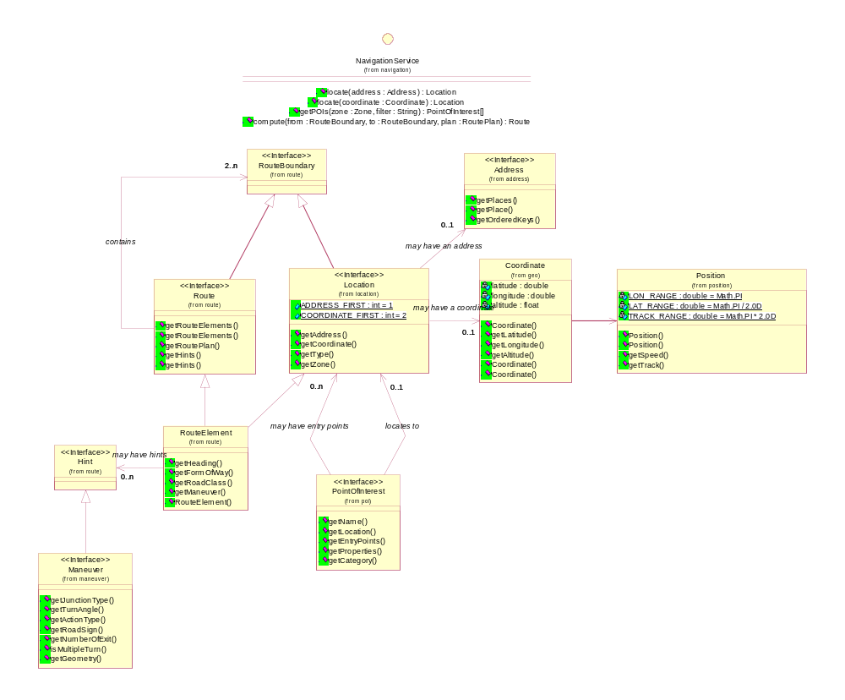
The class diagram below presents the main classes of the Navigation Domain Model and their relationships.
Several important concepts must be highlighted from this diagram:
- Most of the navigation classes are linked to the notion of Location. The Location is the central notion within the model
- A Location is composed by a Coordinate and/or an Address
All these concepts will be developed in the following sections.

Use case realizations

Plan a route
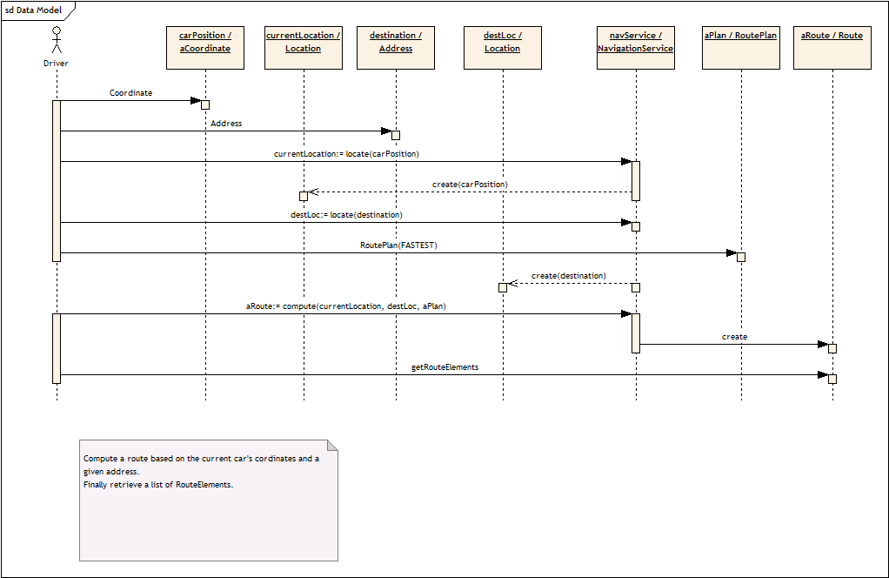

Resolve an address
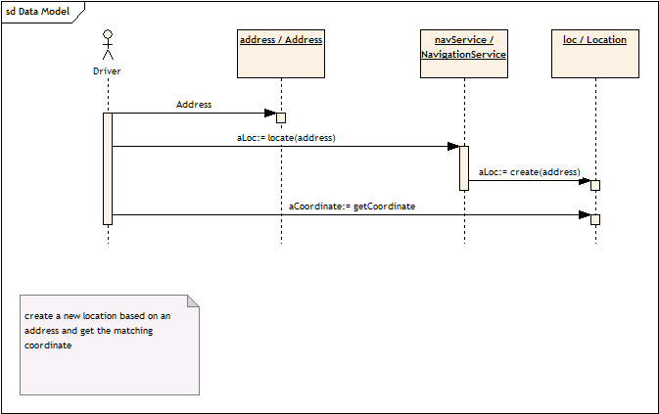

Get POI information

Class Diagrams

Navigation Service
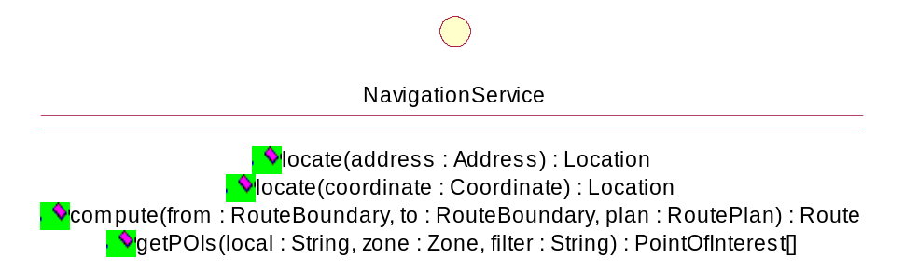

Address
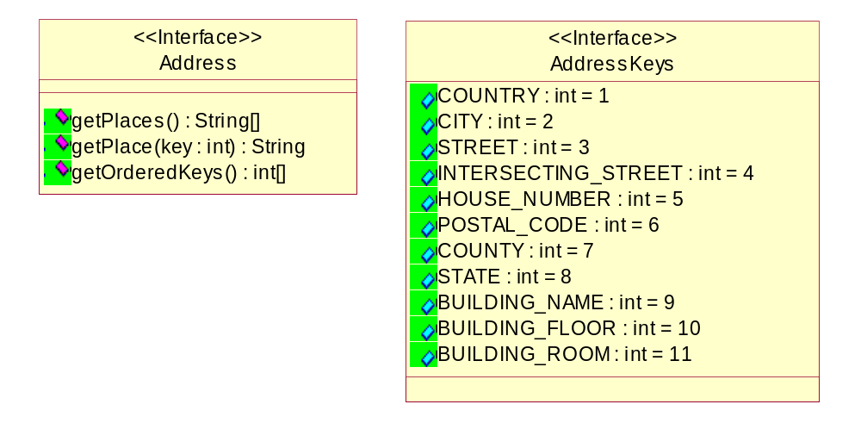

The Address class is made of a list of places. Each place is represented by a key (one of the integer values contained in AddressKeys interface) and a value (a String object) which is the place name.

The address format can be retrieved by using the getOrdreredKeys() method that returns you an ordered list of keys.
A place name can be retrieved by using:
- getPlace(int key) with the key as parameter
- getPlaces(), in this case all values are returned at once
The AddressKeys interface contains all possible values for address place keys.
For a specific Country (or even within the same country) an ordered list of keys is defined and helps the user to read the address received.

Conversion to VCard format
The address part of the VCard format is a concatenation of 7 fields:
- Post Office Address (first field)
- Extended Address (second field)
- Street (third field)
- Locality (fourth field)
- Region (fifth field)
- Postal Code (six field)
- Country (seventh field)
We can identify the following conversion
VCard Field | Address Key
Post Office Address | Not used
Extended Address | Not used
Street | STREET
Locality | CITY
Region | STATE? COUNTY?
Postal Code | POSTAL_CODE
Country | COUNTRY

MOST Address Definition

Value | Value Definitions
1 | Country
2 | Town
3 | Street
4 | Junction
5 | Housenumber
6 | ZIP Code
7 | Building
8 | Telephone Number
9 | Province
10 | District

References
- JSR 179 Location API
- VCard Specification V2.1
- MOST Navigation API

Geometry
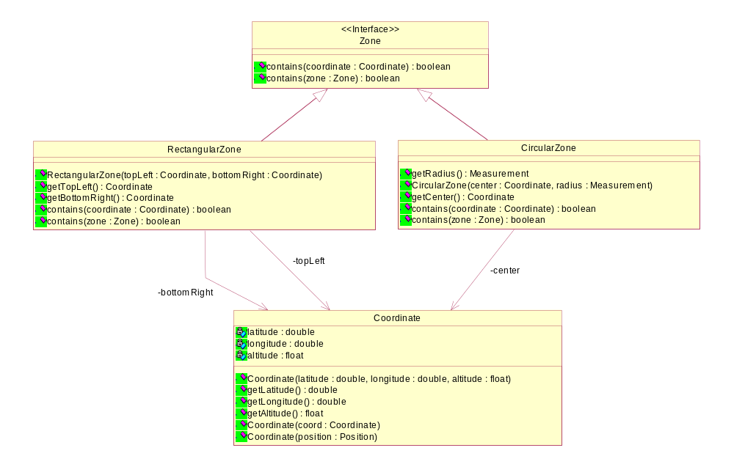

The Geometry package defines an important entity of the Navigation which is the Coordinate and a set of predefined zones based on this coordinate definition. It is easier to manipulate such objects and perform some operations between different zones and/or coordinates
We have identified two types of useful zones to use:
- RectangularZone defined by two coordinates: the top left and bottom right.
- CircularZone defined by a center and a radius.

The Coordinate class defines a WGS84 coordinate, it contains:
- the latitude value in radians
- the longitude value in radians
- the altitude value in meters

To save memory space the Coordinate definition is not based on org.osgi.util.measurement package.
A coordinate can be created:
- by using another coordinate object
- by using a Position object
- by using a set of values (latitude, longitude, altitude)

Relationship with org.osgi.util.position.Position
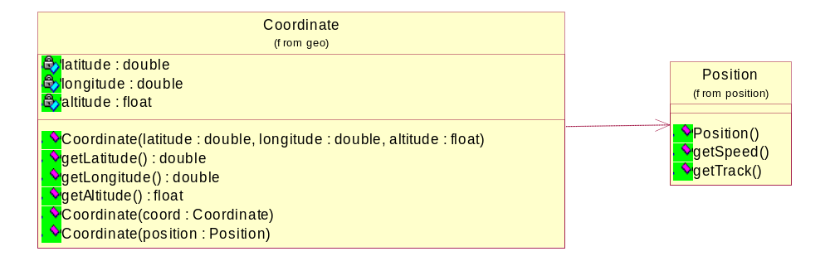
The Position class from the org.osgi.util.position package is unchanged but there is a dependency between Coordinate and Position because we should be able to create a Coordinate object from a Position object.

Location
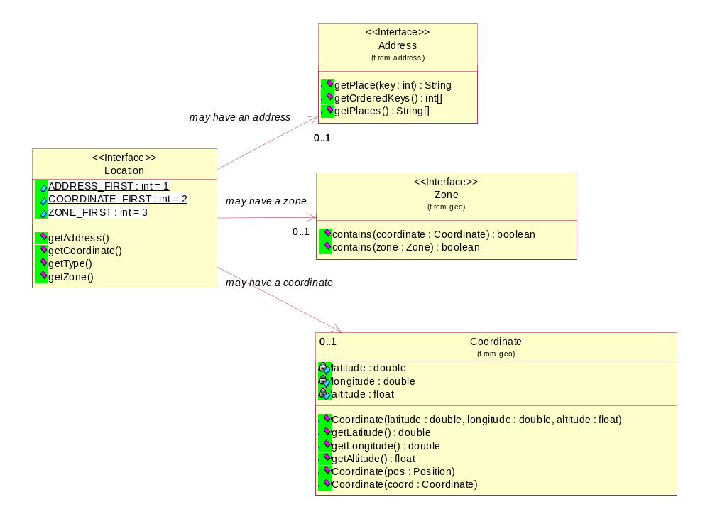
The Location class as mentioned earlier is a central class in the Navigation Domain Model because most of the classes are location based.

The Location object may contain:
  - A Coordinate object
  - An Address object
  - A Zone object

A Location must contain at least one of the following values: an address, a coordinate or a shape.

There is as well an additional attribute called Type that indicates if the location has been created by entering an address (ADDRESS_FIRST) or the coordinate (COORDINATE_FIRST). This information is important when the address has to be validated against an internal address database in order to be used as a destination.

Maneuver
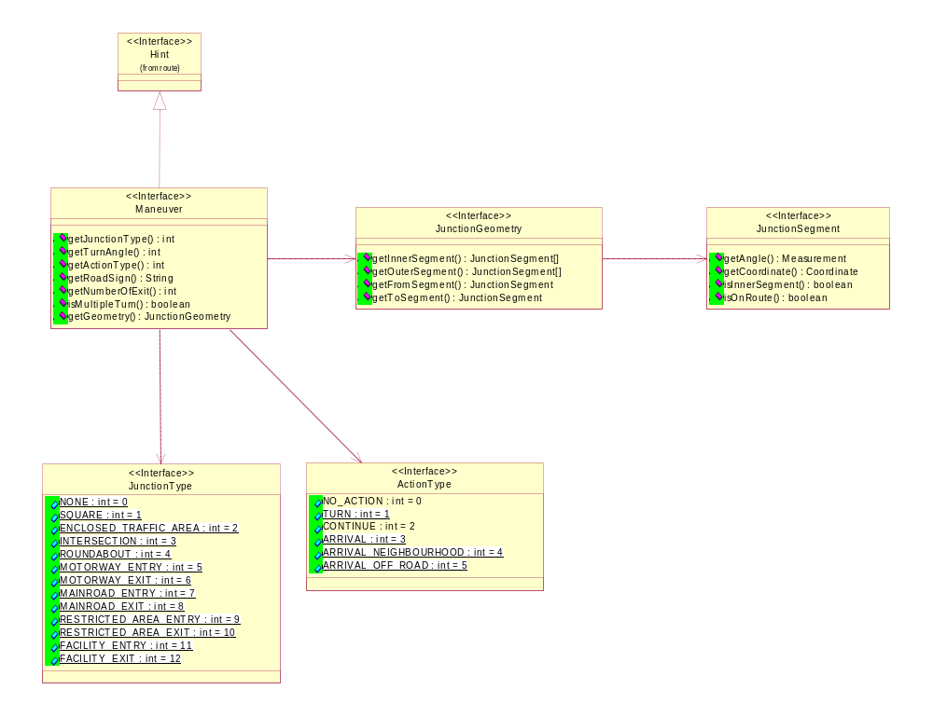
A Maneuver object describes the action that the traveler has to perform at a junction.
The important points in this package are to clearly define:
- A set of action performed;
- A set of junction type;
- A JunctionGeometry.
The JunctionGeometry object is define by a list of JunctionSegment of four types:
- getToSegment() returns the segment where the traveler is leaving the junction
- getFromSegment() returns the segment from where the traveler is entering the junction
- getInnerSegment() defines the inside geometry of the junction. The inner segments are the segments that are connected at both ends with another segment. If all outer segments of a junction are connected to each other in one point, there are no inner segments.
- getOuterSegment() defines the outside geometry of the junction. The outer segments are the segments by which the junction can be entered or left.

POI
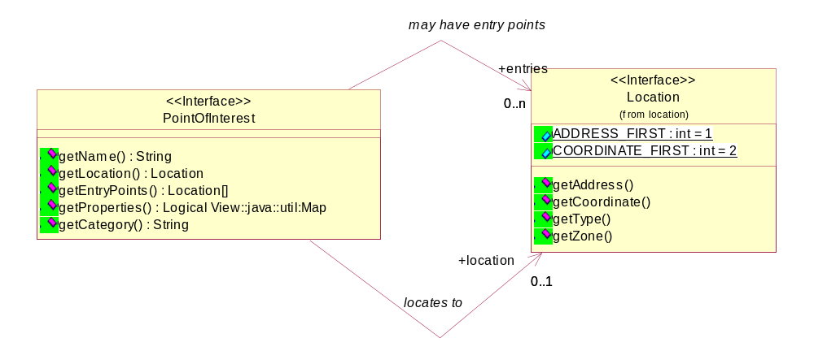
A PointOfInterest object contains the following information:
- A name
- A location. The exact location of the POI as delivered by the POI provider.
- A list of entry points. They are locations of all possible entry points to the POI.
A Point of Interest can contain other specific information that is delivered in a dictionary. This information can be stored in a XML file.

Route
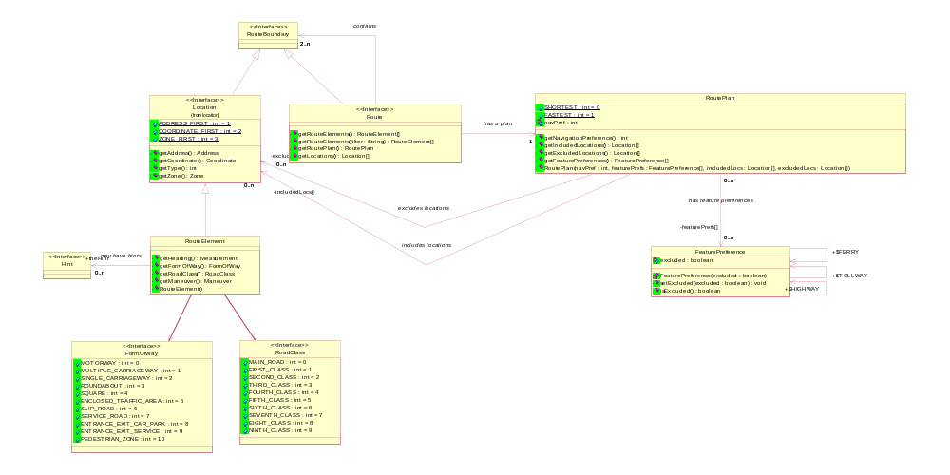
The Route can be represented by two Location objects (e.g. the current car position and the destination) or by a list of RouteElement objects that formed the complete description of the route after computation. The concept is the same it is the same route in different states (before computation and after).
This concept allow to an easily compute a route:
- From one location to another (normal case)
- From one location to a predefined route (e.g. join a scenic route)
- From one predefined route to another (e.g. join two scenic routes)
- From our car to another car (moving destination)
A set of preferences can be set to influence the route computation.
These preferences are contained in a RoutePlan object. There are three kinds of preferences:
- Directly contained in the RoutePlan
- A FeaturePreference that defines feature that the traveler would like to include or exclude
- An AreaPreference that defines areas that the traveler would like to include or exclude
A RoutePlan object is linked to a route.
As soon as the driver leaves the route computed, the route is not valid anymore and another route must be computed.

API Specification

Navigation packages

Packages
org.osgi.nursery.service.navigation | Contains the interface to the Navigation Service.
org.osgi.nursery.util.address | Contains the address definition.
org.osgi.nursery.util.geo | Contains geodetic utility classes.
org.osgi.nursery.util.location | Contains the location definition.
org.osgi.nursery.util.maneuver | Contains the Maneuver definition.
org.osgi.nursery.util.poi | Contains the Point of Interest definition.
org.osgi.nursery.util.route | Contains the Route definition.

Package org.osgi.nursery.service.navigation

Interface NavigationService

Method Summary
Route | compute(RouteBoundary from, RouteBoundary to, RoutePlan plan)  Computes a route between two Route boundaries (from and to) with the given route plan.
PointOfInterest[] | getPOIs(java.lang.String local, Zone zone, java.lang.String filter)  Returns a list of POI (Point Of Interest) in a certain zone.
Location | locate(Address address)  Returns a Location object relative to the Address given as parameter.
Location | locate(Coordinate coordinate)  Returns a Location object relative to the coordinate given as parameter.

Method Detail
locate
public Location locate(Address address)
Returns a Location object relative to the Address given as parameter.
Parameters:
address - The textual address where the user wants to go.
Returns:
org.osgi.nursery.util.location.Location

locate
public Location locate(Coordinate coordinate)
Returns a Location object relative to the coordinate given as parameter.
Parameters:
coordinate - The WGS84 coordinate where the user wants to go.
Returns:
org.osgi.nursery.util.location.Location

getPOIs
public PointOfInterest[] getPOIs(java.lang.String local,
Zone zone,
java.lang.String filter)
Returns a list of POI (Point Of Interest) in a certain zone. The user can filter the number of POIs by using their categories.
Parameters:
local - The locale used to retreive POI information
zone - The zone of the search.
filter - The filter to apply to the search.
Returns:
org.osgi.nursery.util.poi.PointOfInterest[]

compute
public Route compute(RouteBoundary from,
RouteBoundary to,
RoutePlan plan)
Computes a route between two Route boundaries (from and to) with the given route plan.
Parameters:
from - The source.
to - The destination.
plan - The route plan that contains criteria for route computation.
Returns:
org.osgi.nursery.util.route.Route

Package org.osgi.nursery.util.address

Interface Summary
Address | The Address is made of a list of places.
AddressKeys | AddressKeys interface defines all possible values used as key for a place level.

Interface Address

public interface Address
The Address is made of a list of places. Each place is represented by a key (one of the integer values contained in AddressKeys interface) and a value (a String object) which is the place name. The address format can be retrieved by using the getOrdreredKeys() method that returns you an ordered list of keys. A place name can be retrieved by using: • getPlace(int key) with the place key as parameter • getPlaces(), in this case all values are returned at once The AddressKeys interface contains all possible values for address place keys. For a specific Country (or even within the same country) an ordered list of keys is defined and helps the user to read the address received.

Method Summary
int[] | getOrderedKeys()  Returns the ordered list of keys used to define the address.
java.lang.String | getPlace(int key)  Returns the place name of a specified place level.
java.lang.String[] | getPlaces()  Returns the list of place names that define the address.

Method Detail
getPlaces
public java.lang.String[] getPlaces()
Returns the list of place names that define the address.
Returns:
List of place names

getPlace
public java.lang.String getPlace(int key)
Returns the place name of a specified place level. The key must be one the values contained in AddressKey interface.
Parameters:
key - The key of the requested place name
Returns:
String

getOrderedKeys
public int[] getOrderedKeys()
Returns the ordered list of keys used to define the address. Each key represents a place level.
Returns:
The ordered list of keys

Interface AddressKeys

public interface AddressKeys
AddressKeys interface defines all possible values used as key for a place level. All these must allow the definition of any type of postal address. The address format is defined by a list of ordered keys made of these predefined values.

Field Summary
static int | BUILDING_FLOOR  Address key referencing the building floor.
static int | BUILDING_NAME  Address key referencing the building name.
static int | BUILDING_ROOM  Address key referencing the building room.
static int | CITY  Address key referencing the city name.
static int | COUNTRY  Address key referencing the country name.
static int | COUNTY  Address key referencing the county.
static int | HOUSE_NUMBER  Address key referencing the house number.
static int | INTERSECTING_STREET  Address key referencing the name of an intersecting street.
static int | POSTAL_CODE  Address key referencing the postal code.
static int | STATE  Address key referencing the state.
static int | STREET  Address key referencing the street name.

Field Detail
COUNTRY
public static final int COUNTRY
Address key referencing the country name.
See Also:
Constant Field Values

CITY
public static final int CITY
Address key referencing the city name.
See Also:
Constant Field Values

STREET
public static final int STREET
Address key referencing the street name.
See Also:
Constant Field Values

INTERSECTING_STREET
public static final int INTERSECTING_STREET
Address key referencing the name of an intersecting street.
See Also:
Constant Field Values

HOUSE_NUMBER
public static final int HOUSE_NUMBER
Address key referencing the house number.
See Also:
Constant Field Values

POSTAL_CODE
public static final int POSTAL_CODE
Address key referencing the postal code.
See Also:
Constant Field Values

COUNTY
public static final int COUNTY
Address key referencing the county.
See Also:
Constant Field Values

STATE
public static final int STATE
Address key referencing the state.
See Also:
Constant Field Values

BUILDING_NAME
public static final int BUILDING_NAME
Address key referencing the building name.
See Also:
Constant Field Values

BUILDING_FLOOR
public static final int BUILDING_FLOOR
Address key referencing the building floor.
See Also:
Constant Field Values

BUILDING_ROOM
public static final int BUILDING_ROOM
Address key referencing the building room.
See Also:
Constant Field Values

Package org.osgi.nursery.util.geo

Interface Summary
Zone | Defines a geographical area.

Class Summary
CircularZone | A circle is defined by a center expressed by a coordinate and a radius expressed in meter.
Coordinate | Defines a WGS84 coordinate with latitude, longitude and altitude.
RectangularZone | A Box is a rectangular area defined by two coordinates: the top left coordinate and the bottom right coordinate.

Interface Zone
All Known Implementing Classes:
CircularZone, RectangularZone

public interface Zone
Defines a geographical area.

Method Summary
boolean | contains(Coordinate coordinate)  Indicates if the coordinate is contained in the this object.
boolean | contains(Zone zone)  Indicates if the Shape object given as parameter is in this object.

Method Detail
contains
public boolean contains(Coordinate coordinate)
Indicates if the coordinate is contained in the this object.
Parameters:
coordinate - The coordinate that need to be checked
Returns:
true if the coordinate is inside the object, otherwise false

contains
public boolean contains(Zone zone)
Indicates if the Shape object given as parameter is in this object.
Parameters:
zone -
Returns:
true if the shape is completely inside the object, otherwise false

Class CircularZone

public class CircularZone
extends java.lang.Object
implements Zone
A circle is defined by a center expressed by a coordinate and a radius expressed in meter.

Constructor Summary
CircularZone(Coordinate center, org.osgi.util.measurement.Measurement radius)
Create a new Circle object.

Method Summary
boolean | contains(Coordinate coordinate)  Indicates if the coordinate is contained in the this object.
boolean | contains(Zone zone)  Indicates if the area is contained in this object.
Coordinate | getCenter()  Returns the center of the circle expressed by a Coordinate object.
org.osgi.util.measurement.Measurement | getRadius()  Returns the radius of the circle expressed in meter.

Methods inherited from class java.lang.Object
equals, getClass, hashCode, notify, notifyAll, toString, wait, wait, wait

Constructor Detail
CircularZone
public CircularZone(Coordinate center,
org.osgi.util.measurement.Measurement radius)
Create a new Circle object.
Parameters:
center - The center of the circle.
radius - The radius of the circle expressed in meter.

Method Detail
getRadius
public org.osgi.util.measurement.Measurement getRadius()
Returns the radius of the circle expressed in meter.
Returns:
Measurement

getCenter
public Coordinate getCenter()
Returns the center of the circle expressed by a Coordinate object.
Returns:
org.osgi.nursery.util.geo.Coordinate

contains
public boolean contains(Coordinate coordinate)
Indicates if the coordinate is contained in the this object.
Specified by:
contains in interface Zone
Parameters:
coordinate - The coordinate that need to be checked
Returns:
boolean

contains
public boolean contains(Zone zone)
Indicates if the area is contained in this object.
Specified by:
contains in interface Zone
Parameters:
zone -
Returns:
boolean

Class Coordinate

public class Coordinate
extends java.lang.Object
Defines a WGS84 coordinate with latitude, longitude and altitude.

Constructor Summary
Coordinate(Coordinate coord)
Create a new Coordinate object from another Coordinate object.
Coordinate(double latitude, double longitude, float altitude)
Create a new Coordinate object.
Coordinate(org.osgi.util.position.Position pos)
Create a new Coordinate object from a Position object.

Method Summary
float | getAltitude()  Returns the altitude of this coordinate in meters.
double | getLatitude()  Returns the latitude of this coordinate in radians.
double | getLongitude()  Returns the longitude of this coordinate in radians.

Methods inherited from class java.lang.Object
equals, getClass, hashCode, notify, notifyAll, toString, wait, wait, wait

Constructor Detail
Coordinate
public Coordinate(org.osgi.util.position.Position pos)
Create a new Coordinate object from a Position object.

Coordinate
public Coordinate(Coordinate coord)
Create a new Coordinate object from another Coordinate object.
Parameters:
coord - a Coordinate object where values are copied from.

Coordinate
public Coordinate(double latitude,
double longitude,
float altitude)
Create a new Coordinate object.
Parameters:
latitude - a double value specifying the latitude in radians
longitude - a double value specifying the longitude in radians
altitude - a float value specifying the altitude in meters

Method Detail
getLatitude
public double getLatitude()
Returns the latitude of this coordinate in radians.
Returns:
double

getLongitude
public double getLongitude()
Returns the longitude of this coordinate in radians.
Returns:
double

getAltitude
public float getAltitude()
Returns the altitude of this coordinate in meters.
Returns:
float

Class RectangularZone

public class RectangularZone
extends java.lang.Object
implements Zone
A Box is a rectangular area defined by two coordinates: the top left coordinate and the bottom right coordinate.

Constructor Summary
RectangularZone(Coordinate topLeft, Coordinate bottomRight)
Create a new Box object.

Method Summary
boolean | contains(Coordinate coordinate)  Indicates if the coordinate is in the box.
boolean | contains(Zone zone)  Indicates if the Shape is in the box.
Coordinate | getBottomRight()  Returns the bottom right coordinate of the box.
Coordinate | getTopLeft()  Returns the top left coordinate of the box.

Methods inherited from class java.lang.Object
equals, getClass, hashCode, notify, notifyAll, toString, wait, wait, wait

Constructor Detail
RectangularZone
public RectangularZone(Coordinate topLeft,
Coordinate bottomRight)
Create a new Box object.
Parameters:
topLeft - The top left coordinate of the box.
bottomRight - The bottom right coordinate of the box.

Method Detail
getTopLeft
public Coordinate getTopLeft()
Returns the top left coordinate of the box.
Returns:
org.osgi.nursery.util.geo.Coordinate

getBottomRight
public Coordinate getBottomRight()
Returns the bottom right coordinate of the box.
Returns:
org.osgi.nursery.util.geo.Coordinate

contains
public boolean contains(Coordinate coordinate)
Indicates if the coordinate is in the box.
Specified by:
contains in interface Zone
Parameters:
coordinate - The coordinate that need to be checked
Returns:
boolean

contains
public boolean contains(Zone zone)
Indicates if the Shape is in the box.
Specified by:
contains in interface Zone
Parameters:
zone -
Returns:
boolean

Package org.osgi.nursery.util.location

Interface Location
Interface to a location entity. A location can contain: a coordinate, an address and an area.

Field Summary
static int | ADDRESS_FIRST  Indicates that the address has been entered first and it is the relevant part of the location.
static int | COORDINATE_FIRST  Indicates that the coordinate has been entered first and it is the relevant part of the location
static int | ZONE_FIRST  Indicates that the zone has been entered first and it is the relevant part of the location

Method Summary
Address | getAddress()  Returns the address of this location or null if the address is not found.
Coordinate | getCoordinate()  Returns the WGS84 coordinate of this location or null if the coordinate is not known.
int | getType()  Indicates the most relevant part of the address: ADDRESS_FIRST or COORDINATE_FIRST.
Zone | getZone()  Returns the shape of this location or null if the shape is not known.

Field Detail

ADDRESS_FIRST
public static final int ADDRESS_FIRST
Indicates that the address has been entered first and it is the relevant part of the location.
See Also:
Constant Field Values

COORDINATE_FIRST
public static final int COORDINATE_FIRST
Indicates that the coordinate has been entered first and it is the relevant part of the location
See Also:
Constant Field Values

ZONE_FIRST
public static final int ZONE_FIRST
Indicates that the zone has been entered first and it is the relevant part of the location
See Also:
Constant Field Values

Method Detail

getAddress
public Address getAddress()
Returns the address of this location or null if the address is not found.
Returns:
The address at this location, null if the address is not found

getCoordinate
public Coordinate getCoordinate()
Returns the WGS84 coordinate of this location or null if the coordinate is not known.
Returns:
The WGS84 coordinate of this location, null if the coordinate is not known.

getType
public int getType()
Indicates the most relevant part of the address: ADDRESS_FIRST or COORDINATE_FIRST. This information is important to resolve the address against the map database.
Returns:
int The address type.

getZone
public Zone getZone()
Returns the shape of this location or null if the shape is not known.
Returns:
The shape of this location, null if it is not known.

Package org.osgi.nursery.util.maneuver

Interface Summary
ActionType | Contains all possible values for an action type in a maneuver.
JunctionGeometry | A JunctionGeometry is the physical description of the junction that the driver is about to pass by performing the maneuver.
JunctionSegment | A JunctionSegment is a part of the JunctionGeometry.
JunctionType | Contains all possible junction type.
Maneuver | A maneuver is the action that the driver has to perform at a junction.

Interface ActionType

public interface ActionType
Contains all possible values for an action type in a maneuver.

Field Summary
static int | ARRIVAL  Indicates that the driver will arrive exaclty at the destination at the next maneuver.
static int | ARRIVAL_NEIGHBOURHOOD  Indicates that the driver will arrive near the destination the next maneuver.
static int | ARRIVAL_OFF_ROAD  Indicates that the driver will arrive near the destination at the next maneuver but the destination is off-road.
static int | CONTINUE  Indicates that the driver has to continue on the same direction.
static int | NO_ACTION  Indicates that there is no action at this maneuver.
static int | TURN  Indicates that the action is a turn.

Field Detail
NO_ACTION
public static final int NO_ACTION
Indicates that there is no action at this maneuver.
See Also:
Constant Field Values

TURN
public static final int TURN
Indicates that the action is a turn. The direction of turn is indicated by the turn angle. It is up to the client to decide the right advice.
See Also:
Constant Field Values

CONTINUE
public static final int CONTINUE
Indicates that the driver has to continue on the same direction.
See Also:
Constant Field Values

ARRIVAL
public static final int ARRIVAL
Indicates that the driver will arrive exaclty at the destination at the next maneuver.
See Also:
Constant Field Values

ARRIVAL_NEIGHBOURHOOD
public static final int ARRIVAL_NEIGHBOURHOOD
Indicates that the driver will arrive near the destination the next maneuver.
See Also:
Constant Field Values

ARRIVAL_OFF_ROAD
public static final int ARRIVAL_OFF_ROAD
Indicates that the driver will arrive near the destination at the next maneuver but the destination is off-road.
See Also:
Constant Field Values

Interface JunctionGeometry

public interface JunctionGeometry
A JunctionGeometry is the physical description of the junction that the driver is about to pass by performing the maneuver.

Method Summary
JunctionSegment | getFromSegment()  Returns the segment from where the traveler is entering the maneuver
JunctionSegment[] | getInnerSegment()  Returns the list of segments that are inside the maneuver geometry.
JunctionSegment[] | getOuterSegment()  Returns the list of segments that are outside the maneuver geometry.
JunctionSegment | getToSegment()  Returns the segment where the traveler is leaving the maneuver.

Method Detail
getInnerSegment
public JunctionSegment[] getInnerSegment()
Returns the list of segments that are inside the maneuver geometry.
Returns:
org.osgi.nursery.util.maneuver.JunctionSegment[]

getOuterSegment
public JunctionSegment[] getOuterSegment()
Returns the list of segments that are outside the maneuver geometry.
Returns:
org.osgi.nursery.util.maneuver.JunctionSegment[]

getFromSegment
public JunctionSegment getFromSegment()
Returns the segment from where the traveler is entering the maneuver
Returns:
org.osgi.nursery.util.maneuver.JunctionSegment

getToSegment
public JunctionSegment getToSegment()
Returns the segment where the traveler is leaving the maneuver.
Returns:
org.osgi.nursery.util.maneuver.JunctionSegment

Interface JunctionSegment

public interface JunctionSegment
A JunctionSegment is a part of the JunctionGeometry.

Method Summary
org.osgi.util.measurement.Measurement | getAngle()  Returns the angle of this segment with the North in degrees.
Coordinate | getCoordinate()  Returns the coordinate where this segment is attached to the maneuver.
boolean | isInnerSegment()  Returns true if this JunctionSegment object is part of the inner segments otherwise false.
boolean | isOnRoute()  Returns true if this JunctionSegment object is in the itinerary otherwise false.

Method Detail
getAngle
public org.osgi.util.measurement.Measurement getAngle()
Returns the angle of this segment with the North in degrees.
Returns:
Measurement

getCoordinate
public Coordinate getCoordinate()
Returns the coordinate where this segment is attached to the maneuver.
Returns:
org.osgi.nursery.util.geo.Coordinate

isInnerSegment
public boolean isInnerSegment()
Returns true if this JunctionSegment object is part of the inner segments otherwise false.
Returns:
boolean

isOnRoute
public boolean isOnRoute()
Returns true if this JunctionSegment object is in the itinerary otherwise false.
Returns:
Boolean

Interface JunctionType

public interface JunctionType
Contains all possible junction type.

Field Summary
static int | ENCLOSED_TRAFFIC_AREA  Indicates that there is a enclosed traffic area at the maneuver.
static int | FACILITY_ENTRY  Indicates that the driver will access a facility at the next maneuver.
static int | FACILITY_EXIT  Indicates that the driver will exit from a facility at the next maneuver.
static int | INTERSECTION  Indicates that there is normal intersection at the maneuver.
static int | MAINROAD_ENTRY  Indicates that the driver will access a main road at the next maneuver.
static int | MAINROAD_EXIT  Indicates that the driver will exit from a main road at the next maneuver.
static int | MOTORWAY_ENTRY  Indicates that the driver will access a motorway at the next maneuver.
static int | MOTORWAY_EXIT  Indicates that the driver will xit from a motorway at the next maneuver.
static int | NONE  Indicates that there is no junction at the maneuver.
static int | RESTRICTED_AREA_ENTRY  Indicates that the driver will access a restricted area at the next maneuver.
static int | RESTRICTED_AREA_EXIT  Indicates that the driver will exit a restricted area at the next maneuver.
static int | ROUNDABOUT  Indicates that there is a roundabout at the maneuver.
static int | SQUARE  Indicates that there is a square at the maneuver.

Field Detail
NONE
public static final int NONE
Indicates that there is no junction at the maneuver.
See Also:
Constant Field Values

SQUARE
public static final int SQUARE
Indicates that there is a square at the maneuver.
See Also:
Constant Field Values

ENCLOSED_TRAFFIC_AREA
public static final int ENCLOSED_TRAFFIC_AREA
Indicates that there is a enclosed traffic area at the maneuver. An enclosed traffic area is a confined area within which unstructured traffic movements are allowed.
See Also:
Constant Field Values

INTERSECTION
public static final int INTERSECTION
Indicates that there is normal intersection at the maneuver.
See Also:
Constant Field Values

ROUNDABOUT
public static final int ROUNDABOUT
Indicates that there is a roundabout at the maneuver.
See Also:
Constant Field Values

MOTORWAY_ENTRY
public static final int MOTORWAY_ENTRY
Indicates that the driver will access a motorway at the next maneuver.
See Also:
Constant Field Values

MOTORWAY_EXIT
public static final int MOTORWAY_EXIT
Indicates that the driver will xit from a motorway at the next maneuver.
See Also:
Constant Field Values

MAINROAD_ENTRY
public static final int MAINROAD_ENTRY
Indicates that the driver will access a main road at the next maneuver.
See Also:
Constant Field Values

MAINROAD_EXIT
public static final int MAINROAD_EXIT
Indicates that the driver will exit from a main road at the next maneuver.
See Also:
Constant Field Values

RESTRICTED_AREA_ENTRY
public static final int RESTRICTED_AREA_ENTRY
Indicates that the driver will access a restricted area at the next maneuver.
See Also:
Constant Field Values

RESTRICTED_AREA_EXIT
public static final int RESTRICTED_AREA_EXIT
Indicates that the driver will exit a restricted area at the next maneuver.
See Also:
Constant Field Values

FACILITY_ENTRY
public static final int FACILITY_ENTRY
Indicates that the driver will access a facility at the next maneuver.
See Also:
Constant Field Values

FACILITY_EXIT
public static final int FACILITY_EXIT
Indicates that the driver will exit from a facility at the next maneuver.
See Also:
Constant Field Values

Interface Maneuver

public interface Maneuver
extends Hint
A maneuver is the action that the driver has to perform at a junction. Several advices can be rendered at a maneuver.

Method Summary
int | getActionType()  Returns the action performed at the maneuver.
JunctionGeometry | getGeometry()  Returns the junction geometry defined by the JunctionGeometry class.
int | getJunctionType()  Returns the junction type where the maneuver will be performed.
int | getNumberOfExit()  Returns the number of the segment by which the planned route is leaving the junction.
java.lang.String | getRoadSign()  Returns the road sign information towards the itinerary.
int | getTurnAngle()  Returns the direction of turn if the action of the maneuver is a turn.
boolean | isMultipleTurn()  In case of turn action at a maneuver, this flag indicates if there several possibility (roads) to turn.

Method Detail
getJunctionType
public int getJunctionType()
Returns the junction type where the maneuver will be performed. The value must be one of the value defined in JunctionType interface.
Returns:
int

getTurnAngle
public int getTurnAngle()
Returns the direction of turn if the action of the maneuver is a turn. The value must be one of the value defined by DirectionOfTurn interface.
Returns:
int

getActionType
public int getActionType()
Returns the action performed at the maneuver. The value must be one of the value defined by ActionType interface.
Returns:
int

getRoadSign
public java.lang.String getRoadSign()
Returns the road sign information towards the itinerary. It is usuallly a city / municipality names.
Returns:
String

getNumberOfExit
public int getNumberOfExit()
Returns the number of the segment by which the planned route is leaving the junction. The numbering starts at the from-segment (number 0). For right-turning possibilities, numbering proceeds in counter-clockwise order. For left-turning possibilities, numbering proceeds in clockwise order.
Returns:
int

isMultipleTurn
public boolean isMultipleTurn()
In case of turn action at a maneuver, this flag indicates if there several possibility (roads) to turn. This information is important to render advice like "At the next junction take the xxth on the left/right".
Returns:
boolean

getGeometry
public JunctionGeometry getGeometry()
Returns the junction geometry defined by the JunctionGeometry class. This geometry is used to render one or several detailed advices.
Returns:
org.osgi.nursery.util.maneuver.JunctionGeometry

Package org.osgi.nursery.util.poi

Interface Summary
PointOfInterest | A point of interest represents external service provider, like a hospital, a gas station, a theatre, a hotel, etc

Interface PointOfInterest

public interface PointOfInterest
A point of interest represents external service provider, like a hospital, a gas station, a theatre, a hotel, etc. It consists of a name, a brand, an address, a type, and a location. Optionally a point of interest contains an advice: a visual representation (e.g. HTML page) and an audible representation (e.g. mpeg file). It can contain as well a phone number, an influence zone where the advice can be rendered. Points of interest are further separated in national and local POI. National (or country specific) POI means of "national" importance such as international airports, Disney Land, London Tower, etc.

Method Summary
java.lang.String | getCategory()  Returns the POI Category.
Location[] | getEntryPoints()  Returns the location (WGS84 coordinates) of possible entries to the POI.
Location | getLocation()  Returns the location of the POI.
java.lang.String | getName()  Returns the POI name.
java.util.Dictionary | getProperties()  Returns additional properties of the POI.

Method Detail
getName
public java.lang.String getName()
Returns the POI name.
Returns:
The name of the POI

getLocation
public Location getLocation()
Returns the location of the POI.
Returns:
The location of the POI

getEntryPoints
public Location[] getEntryPoints()
Returns the location (WGS84 coordinates) of possible entries to the POI. These location can be used to determine a route.
Returns:
The list of entry points to the POI

getProperties
public java.util.Dictionary getProperties()
Returns additional properties of the POI.
Returns:
The list of specific properties of the POI, null if properties are not provided

getCategory
public java.lang.String getCategory()
Returns the POI Category. There is no recommended classification. The third party provider has to deliver the categories it can handled.
Returns:
String

Package org.osgi.nursery.util.route

Interface Summary
FormOfWay | Defines form of way values according to GDF standard.
Hint
RoadClass | Defines road class values according to GDF standard.
Route | Interface to the route definition.
RouteBoundary

Class Summary
FeaturePreference | Defines a feature that the user would like to include or exclude.
RouteElement
RoutePlan | Defines the complete route plan that the user would like to realise.

Interface FormOfWay

public interface FormOfWay
Defines form of way values according to GDF standard.

Field Summary
static int | ENCLOSED_TRAFFIC_AREA  Indicates that the road segment is part of an Enclosed Traffic Area.
static int | ENTRANCE_EXIT_CAR_PARK  Indicates that the road segment is an entrance to or an exit of Car Park.
static int | ENTRANCE_EXIT_SERVICE  Indicates that the road segment is an entrance to or an exit to Service.
static int | MOTORWAY  Indicates that the road segment is part of a Motorway.
static int | MULTIPLE_CARRIAGEWAY  Indicates that the road segment is part of a Multiple Carriageway which is not a motorway.
static int | PEDESTRIAN_ZONE  Indicates that the road segment is part of a Pedestrian Zone.
static int | ROUNDABOUT  Indicates that the road segment is part of a Roundabout.
static int | SERVICE_ROAD  Indicates that the road segment is part of a Service Road.
static int | SINGLE_CARRIAGEWAY  Indicates that the road segment is part of a Single Carriageway.
static int | SLIP_ROAD  Indicates that the road segment is part of a Slip Road.
static int | SQUARE  Indicates that the road segment is part of a Traffic Square.

Field Detail
MOTORWAY
public static final int MOTORWAY
Indicates that the road segment is part of a Motorway.
See Also:
Constant Field Values

MULTIPLE_CARRIAGEWAY
public static final int MULTIPLE_CARRIAGEWAY
Indicates that the road segment is part of a Multiple Carriageway which is not a motorway.
See Also:
Constant Field Values

SINGLE_CARRIAGEWAY
public static final int SINGLE_CARRIAGEWAY
Indicates that the road segment is part of a Single Carriageway.
See Also:
Constant Field Values

ROUNDABOUT
public static final int ROUNDABOUT
Indicates that the road segment is part of a Roundabout.
See Also:
Constant Field Values

SQUARE
public static final int SQUARE
Indicates that the road segment is part of a Traffic Square.
See Also:
Constant Field Values

ENCLOSED_TRAFFIC_AREA
public static final int ENCLOSED_TRAFFIC_AREA
Indicates that the road segment is part of an Enclosed Traffic Area.
See Also:
Constant Field Values

SLIP_ROAD
public static final int SLIP_ROAD
Indicates that the road segment is part of a Slip Road.
See Also:
Constant Field Values

SERVICE_ROAD
public static final int SERVICE_ROAD
Indicates that the road segment is part of a Service Road.
See Also:
Constant Field Values

ENTRANCE_EXIT_CAR_PARK
public static final int ENTRANCE_EXIT_CAR_PARK
Indicates that the road segment is an entrance to or an exit of Car Park.
See Also:
Constant Field Values

ENTRANCE_EXIT_SERVICE
public static final int ENTRANCE_EXIT_SERVICE
Indicates that the road segment is an entrance to or an exit to Service.
See Also:
Constant Field Values

PEDESTRIAN_ZONE
public static final int PEDESTRIAN_ZONE
Indicates that the road segment is part of a Pedestrian Zone.
See Also:
Constant Field Values

Interface RoadClass

public interface RoadClass
Defines road class values according to GDF standard.

Field Summary
static int | EIGHT_CLASS  Indicates that the road segment is a eight class road.
static int | FIFTH_CLASS  Indicates that the road segment is a fitfh class road.
static int | FIRST_CLASS  Indicates that the road segment is a first class road.
static int | FOURTH_CLASS  Indicates that the road segment is a fourth class road.
static int | MAIN_ROAD  Indicates that the road segment is a main road.
static int | NINTH_CLASS  Indicates that the road segment is a ninth class road.
static int | SECOND_CLASS  Indicates that the road segment is a second class road.
static int | SEVENTH_CLASS  Indicates that the road segment is a seventh class road.
static int | SIXTH_CLASS  Indicates that the road segment is a sixth class road.
static int | THIRD_CLASS  Indicates that the road segment is a third class road.

Field Detail
MAIN_ROAD
public static final int MAIN_ROAD
Indicates that the road segment is a main road.
See Also:
Constant Field Values

FIRST_CLASS
public static final int FIRST_CLASS
Indicates that the road segment is a first class road.
See Also:
Constant Field Values

SECOND_CLASS
public static final int SECOND_CLASS
Indicates that the road segment is a second class road.
See Also:
Constant Field Values

THIRD_CLASS
public static final int THIRD_CLASS
Indicates that the road segment is a third class road.
See Also:
Constant Field Values

FOURTH_CLASS
public static final int FOURTH_CLASS
Indicates that the road segment is a fourth class road.
See Also:
Constant Field Values

FIFTH_CLASS
public static final int FIFTH_CLASS
Indicates that the road segment is a fitfh class road.
See Also:
Constant Field Values

SIXTH_CLASS
public static final int SIXTH_CLASS
Indicates that the road segment is a sixth class road.
See Also:
Constant Field Values

SEVENTH_CLASS
public static final int SEVENTH_CLASS
Indicates that the road segment is a seventh class road.
See Also:
Constant Field Values

EIGHT_CLASS
public static final int EIGHT_CLASS
Indicates that the road segment is a eight class road.
See Also:
Constant Field Values

NINTH_CLASS
public static final int NINTH_CLASS
Indicates that the road segment is a ninth class road.
See Also:
Constant Field Values

Interface Route
Interface to the route definition. The route has several states:

Method Summary
Location[] | getLocations()
RouteElement[] | getRouteElements()
RouteElement[] | getRouteElements(java.lang.String filter)  Returns the list of Route Elements that match to the filter.
RoutePlan | getRoutePlan()

Method Detail
getRouteElements
public RouteElement[] getRouteElements()
Returns:
org.osgi.nursery.util.route.RouteElement[]

getRouteElements
public RouteElement[] getRouteElements(java.lang.String filter)
Returns the list of Route Elements that match to the filter.
Parameters:
filter -
Returns:
org.osgi.nursery.util.route.RouteElement[]

getRoutePlan
public RoutePlan getRoutePlan()
Returns:
org.osgi.nursery.util.route.RoutePlan

getLocations
public Location[] getLocations()
Returns:
org.osgi.nursery.util.location.Location[]

Class FeaturePreference

public class FeaturePreference
extends java.lang.Object
Defines a feature that the user would like to include or exclude. A feature can be set only once. If a user exclude Highway then we must not include them afterwards.

Field Summary
static FeaturePreference | FERRY  FeaturePreference object to set FERRY preference.
static FeaturePreference | HIGHWAY  FeaturePreference object to set HIGHWAY preference.
static FeaturePreference | TOLLWAY  FeaturePreference object to set TOLLWAY preference.

Method Summary
boolean | isExcluded()  Returns true if this FeaturePreference object is excluded otherwise false.
void | setExcluded(boolean excluded)  Exclude this FeaturePreference object.

Methods inherited from class java.lang.Object
equals, getClass, hashCode, notify, notifyAll, toString, wait, wait, wait

Field Detail
HIGHWAY
public static final FeaturePreference HIGHWAY
FeaturePreference object to set HIGHWAY preference.

TOLLWAY
public static final FeaturePreference TOLLWAY
FeaturePreference object to set TOLLWAY preference.

FERRY
public static final FeaturePreference FERRY
FeaturePreference object to set FERRY preference.

Method Detail
setExcluded
public void setExcluded(boolean excluded)
Exclude this FeaturePreference object.
Parameters:
excluded -

isExcluded
public boolean isExcluded()
Returns true if this FeaturePreference object is excluded otherwise false.
Returns:
boolean

Class RouteElement

public class RouteElement
extends java.lang.Object
implements Location

Field Summary

Fields inherited from interface org.osgi.nursery.util.location.Location
ADDRESS_FIRST, COORDINATE_FIRST

Constructor Summary
RouteElement(Coordinate coord)

Method Summary
Address | getAddress()  Returns the address of this location or null if the address is not found.
Coordinate | getCoordinate()  Returns the WGS84 coordinate of this location or null if the coordinate is not known.
FormOfWay | getFormOfWay()
org.osgi.util.measurement.Measurement | getHeading()
Maneuver | getManeuver()
RoadClass | getRoadClass()
int | getType()  Indicates the most relevant part of the address: ADDRESS_FIRST or COORDINATE_FIRST.
Zone | getZone()  Returns the shape of this location or null if the shape is not known.

Methods inherited from class java.lang.Object
equals, getClass, hashCode, notify, notifyAll, toString, wait, wait, wait

Constructor Detail
RouteElement
public RouteElement(Coordinate coord)

Method Detail
getHeading
public org.osgi.util.measurement.Measurement getHeading()
Returns:
Measurement

getFormOfWay
public FormOfWay getFormOfWay()
Returns:
org.osgi.nursery.util.route.FormOfWay

getRoadClass
public RoadClass getRoadClass()
Returns:
org.osgi.nursery.util.route.RoadClass

getManeuver
public Maneuver getManeuver()
Returns:
org.osgi.nursery.util.maneuver.Maneuver

getAddress
public Address getAddress()
Description copied from interface: Location
Returns the address of this location or null if the address is not found.
Specified by:
getAddress in interface Location
Returns:
See Also:
Location.getAddress()

getCoordinate
public Coordinate getCoordinate()
Description copied from interface: Location
Returns the WGS84 coordinate of this location or null if the coordinate is not known.
Specified by:
getCoordinate in interface Location
Returns:
See Also:
Location.getCoordinate()

getType
public int getType()
Description copied from interface: Location
Indicates the most relevant part of the address: ADDRESS_FIRST or COORDINATE_FIRST. This information is important to resolve the address against the map database.
Specified by:
getType in interface Location
Returns:
See Also:
Location.getType()

getZone
public Zone getZone()
Description copied from interface: Location
Returns the shape of this location or null if the shape is not known.
Specified by:
getZone in interface Location
Returns:
See Also:
Location.getZone()

Class RoutePlan

public class RoutePlan
extends java.lang.Object
Defines the complete route plan that the user would like to realise. This plan can be associated to the complete Journey or to a specific via-point. If so then it overrides global navigation plan (if any).

Field Summary
static int | FASTEST  Indicates that the fastest way must be found.
static int | SHORTEST  Indicates that the shortest way must be found.

Constructor Summary
RoutePlan(int navPref, FeaturePreference[] featurePrefs, Location[] includedLocs, Location[] excludedLocs)

Method Summary
Location[] | getExcludedLocations()  Returns the list of LocationPreference objects.
FeaturePreference[] | getFeaturePreferences()  Returns the list of FeaturePreference objects.
Location[] | getIncludedLocations()  Returns the list of LocationPreference objects.
int | getNavigationPreference()  Returns the navigation preference set for this NavigationPlan object.

Methods inherited from class java.lang.Object
equals, getClass, hashCode, notify, notifyAll, toString, wait, wait, wait

Field Detail
SHORTEST
public static final int SHORTEST
Indicates that the shortest way must be found.
See Also:
Constant Field Values

FASTEST
public static final int FASTEST
Indicates that the fastest way must be found.
See Also:
Constant Field Values

Constructor Detail
RoutePlan
public RoutePlan(int navPref,
FeaturePreference[] featurePrefs,
Location[] includedLocs,
Location[] excludedLocs)
Parameters:
navPref -
featurePrefs -
includedLocs -
excludedLocs –

Method Detail
getNavigationPreference
public int getNavigationPreference()
Returns the navigation preference set for this NavigationPlan object. The value is one of the value defined by this class.
Returns:
int

getIncludedLocations
public Location[] getIncludedLocations()
Returns the list of LocationPreference objects.
Returns:
org.osgi.nursery.util.location.Location[]

getExcludedLocations
public Location[] getExcludedLocations()
Returns the list of LocationPreference objects.
Returns:
org.osgi.nursery.util.location.Location[]

getFeaturePreferences
public FeaturePreference[] getFeaturePreferences()
Returns the list of FeaturePreference objects.
Returns:
org.osgi.nursery.util.route.FeaturePreference[]

Considered Alternatives

Address [Siemens VDO Automotive]
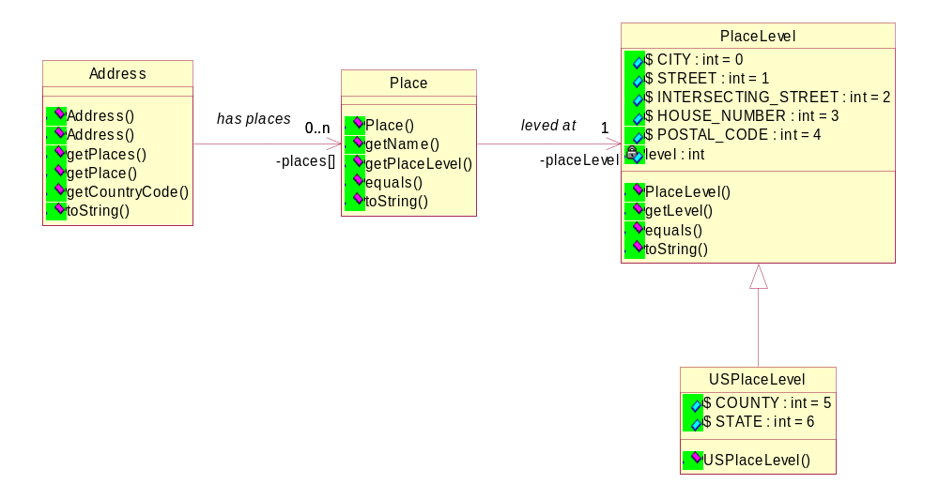
The definition of an address varies from one country to another. These differences of format do not allow having a well-defined model.
To allow this flexibility we have defined each part of the address as a place. A hierarchy of places can be defined for each Country. This model provides a basic hierarchy the PlaceLevel class but this list can be extended (e.g. for US).
The Country (defined by the country code) is the key that determines the place hierarchy.

Address [BOSCH]
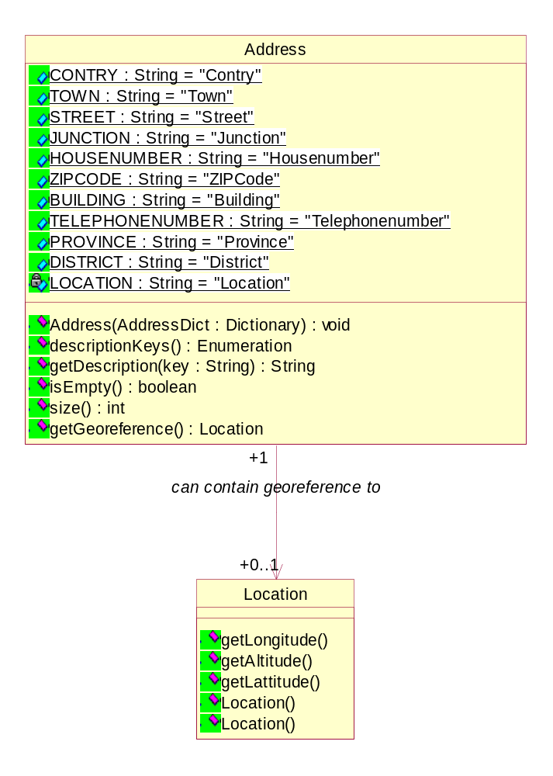
The Address is made of a list of description items. This list is in fact a dictionary with Key/Value pairs. A basic set of keys are defined as constants in the Address interface. This list can be extended by am implementation.

The Address is created with a Dictionary filled with the address description key-value pairs. The Address interface has for reading the same methods as the Dictionary interface but to be immutable all writing and modifying methods are left away. It also provides a method to ask for a geo reference of the address. This method returns the navigation system interpretation of the address if available.

Maneuver [BOSCH]
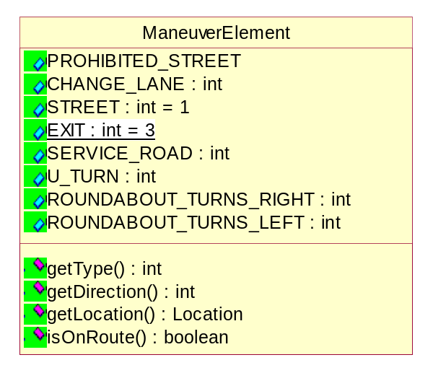
A Maneuver is described by an array of ManeuverElements. Each ManeuverElement class describes one element of the complete maneuver information which can be visualized as an arrow. For example a crossing where the driver should turn right would consist from the following elements:
ID | Direction | isOnRoute | Symbol
STREET | 0 | true
STREET | 90 | false
STREET | 0 | false
STREET | 270 | true

The complete arrow would look like this:


Security Considerations
TO BE DEFINED

Document Support

References
- Bradner, S., Key words for use in RFCs to Indicate Requirement Levels, RFC2119, March 1997.
- Software Requirements & Specifications. Michael Jackson. ISBN 0-201-87712-0
- RFP Navigation Domain Model, Olivier Pavé, March 2003

Author’s Address

Name | Pavé Olivier
Company | Siemens VDO Automotive
Address | Batiment Alpha  80, route des lucioles – BP 305  06906 Sophia-Antipolis Cedex, France
Voice | +33 (0)4-9238-1129
e-mail | olivier.pave@siemens.com

Name | Rob van den Berg
Company | Siemens VDO Automotive
Address | Luchthavenweg 48  5657 EB Eindhoven, Netherlands
Voice | +31 (40) 844-4859
e-mail | rob.vandenberg@siemens.com

Name | Wolfgang Kopmann
Company | Robert Bosch GmbH
Address | Postfach 777777  31134 Hildesheim  Germany
Voice | *49 (5121) 49 4023
e-mail | wolfgang.kopmann@de.bosch.com

Acronyms and Abbreviations

End of Document

