

RFC 91 MEG Application Model
Final
1 Pages

Abstract
The purpose of this document is to explain application model design, API and samples that address the requirements specified in RFP-052.

Document Information

Table of Contents
0 Document Information 2
0.1 Table of Contents 2
0.2 Terminology and Document Conventions 4
0.3 Revision History 4
1 Introduction 7
2 Application Domain 7
2.1 Terminology 7
3 Problem Description 8
4 Requirements 9
5 Technical Solution 9
5.1 Application Descriptor 9
5.2 Application Handle 11
5.3 Application Management Framework Functions 13
5.3.1 Application Locking 13
5.3.2 Launching an Application 13
5.3.3 Stopping an Application Instance 14
5.3.4 Scheduling an Application 14
5.4 Scheduled Application 15
5.5 Permissions for Handling Applications 15
5.6 JSR 211 Content Handling 16
5.6.1 Content Handler API 16
5.6.2 Content Handler Identification 17
5.6.3 Content Handler Access Control 17
5.6.4 Method Descriptions 17
5.7 Internal Interactions 18
5.7.1 Application Installation 18
5.7.2 Launching an Application 19
5.7.3 Destroying an Application Instance 20
5.8 Timer Event 21
5.8.1 Timer Event Examples 22
6 API Specification 22
6.1 org.osgi.service.application Class ApplicationDescriptor 23
6.1.1 APPLICATION_NAME 24
6.1.2 APPLICATION_ICON 24
6.1.3 APPLICATION_PID 24
6.1.4 APPLICATION_VERSION 25
6.1.5 APPLICATION_VENDOR 25
6.1.6 APPLICATION_CONTAINER 25
6.1.7 APPLICATION_PACKAGE 25
6.1.8 APPLICATION_VISIBLE 25
6.1.9 APPLICATION_LAUNCHABLE 25
6.1.10 APPLICATION_LOCKED 25
6.1.11 ApplicationDescriptor 25
6.1.12 getPID 25
6.1.13 getProperties 25
6.1.14 launch 26
6.1.15 launchSpecific 26
6.1.16 schedule 27
6.1.17 lock 27
6.1.18 unlock 27
6.1.19 isLocked 27
6.1.20 getBundleContext 28
6.2 org.osgi.service.application Class ApplicationHandle 28
6.2.1 STOPPING 29
6.2.2 RUNNING 29
6.2.3 ApplicationHandle 29
6.2.4 getState 29
6.2.5 getInstanceID 30
6.2.6 getApplicationDescriptor 30
6.2.7 destroy 30
6.2.8 destroySpecific 30
6.3 org.osgi.service.application Interface ScheduledApplication 31
6.3.1 getTopic 31
6.3.2 getEventFilter 32
6.3.3 isRecurring 32
6.3.4 getApplicationDescriptor 32
6.3.5 getArguments 32
6.3.6 remove 32
6.4 org.osgi.service.application Class SingletonException 33
6.4.1 SingletonException 33
6.4.2 SingletonException 33
6.5 org.osgi.service.application Class ApplicationAdminPermission 34
6.5.1 LAUNCH 35
6.5.2 SCHEDULE 35
6.5.3 MANIPULATE 35
6.5.4 LOCK 35
6.5.5 ApplicationAdminPermission 36
6.5.6 ApplicationAdminPermission 36
7 Considered Alternatives 36
8 Security Considerations 37
9 Document Support 37
9.1 References 37
9.2 Author’s Address 38
9.3 Acronyms and Abbreviations 38
9.4 End of Document 38

Terminology and Document Conventions
The key words "MUST", "MUST NOT", "REQUIRED", "SHALL", "SHALL NOT", "SHOULD", "SHOULD NOT", "RECOMMENDED", "NOT RECOMMENDED", "MAY" and "OPTIONAL" in this document are to be interpreted as described in [1].
Source code is shown in this typeface.

Revision History
The last named individual in this history is currently responsible for this document.
Revision | Date | Comments
Initial | Jun 23, 2004 | MEG application model conceptual architecture described.  Venkat Amirisetty, Motorola, Inc. vamirisetty@motorola.com
Second Draft | Jun 30, 2004 | Merged concepts from Nokia proposal.  Venkat Amirisetty, Motorola, Inc vamirisetty@motorola.com
Third Draft | July 12, 2004 | API specification initial cut added, some comments from Peter Kriens addressed  Venkat Amirisetty, Motorola, Inc vamirisetty@motorola.com
Fourth Draft | August 12, 2004 | Description of application related stuff, container and application manager based on the API  Robert Fajta, Nokia, robert.fajta@nokia.com
Fifth Draft | August 18, 2004 | API specification revised. Minor edits made throughout.  Venkat Amirisetty, Motorola, Inc vamirisetty@motorola.com
Sixth Draft | September 2, 2004 | DMT definition added  Robert Fajta, Nokia, robert.fajta@nokia.com
Seventh Draft | September 20, 2004 | Model description changed to reflect the concept of generic and convenience layers in Technical Solution chapter. Event section removed and reference to rfc-97 added. DMT definition refined according to the conf call comments.  Robert Fajta, Nokia, robert.fajta@nokia.com
8th Draft | September 22, 2004 | DMT refined.  Robert Fajta, Nokia, robert.fajta@nokia.com
9th Draft | October 1, 2004 | Editorial changes in the model description. DMT definition moved to the rfc-87.  Robert Fajta, Nokia, robert.fajta@nokia.com
10th Draft – version 0.5 | November 15, 2004 | Document cleanup. Synchronizing the document contents with other MEG RFCs. Deep edits  Venkat Amirisetty, Motorola, vamirisetty@motorola.com
11th Draft – version 0.6 | November 25, 2004 | Incorporated feedback on version 0.5 from Peter Kriens and Robert Fajta. Added first cut of content handler development model.  Venkat Amirisetty, Motorola, vamirisetty@motorola.com
version 0.7 | December 17, 2004 | Accommodated comments and decisions from the Boca Raton meeting.  Robert Fajta, Nokia, robert.fajta@nokia.com
version 7.1 | January 7, 2005 | Minor, mostly editorial corrections.  Robert Fajta, Nokia, robert.fajta@nokia.com
Version 7.2 | January 31, 2005 | Comments and decisions from the Norwalk, CA meeting  Rick DeNatale, IBM denatale@us.ibm.com
Version 0.8 | February 11, 2005, | Added suspending to Meglets. Changed scheduling to event based. Added content handling related chapter. Described lifecycle states of Meglets. Updated the considered alternatives chapter.  Robert Fajta, Nokia, robert.fajta@nokia.com
Version 0.81 | February 15, 2005 | Document review and minor comments  Venkat Amirisetty, Motorola, vamirisetty@motorola.com
Version 0.82 | February 21, 2005 | Timer event examples corrected. Comments accommodated. Diagrams added. API documentation added. Minor editorial changes.  Robert Fajta, Nokia, robert.fajta@nokia.com
Version 0.83 | February 21, 2005 | Change formatting in 5.5.  Robert Fajta, Nokia, robert.fajta@nokia.com
Version 0.84 | April 1, 2005 | Text modified to reflect most of Munich agreements. Content handling chapter updated. The API chapter has not been updated, it is out of sync.  Robert Fajta, Nokia, robert.fajta@nokia.com
Version 0.85 | April 11, 2005 | STOPPING state removed. Text refinement. API update and syncing.  Robert Fajta, Nokia, robert.fajta@nokia.com
Version 0.86 | July 19, 2005 | Removing all Meglet-related text. The application management framework is preserved only.  Gábor Pécsy, Nokia, gabor.pecsy@nokia.com
Version 0.87 | August 11, 2005 | Two minor editorial corrections. API definition updated (without track changes) to reflect current state.  Robert Fajta, Nokia, robert.fajta@nokia.com
1.0 | Sept 13th 2005 | No changes. Final. Severi Eerola.

Introduction
The OSGi service platform is a generic, service centric execution environment. It specifies a framework and a core set of service interfaces that enable delivery of multiple value added service implementations, potentially from different vendors.
The Application model WS is part of the overall Mobile Expert Group (MEG) effort, tasked to define the architecture, API, samples that specify an execution environment for new type of OSGi runtime artifacts, called Applications. Applications are usually UI centric, designed for user interaction, but this RFC does not address the UI aspects.
MEG defined how OSGi-aware application can be created using any application model in Operational Access Technology [5]. This specification defines, how the lifecycle of applications – OSGi-aware or not – created using any application model can be managed from OSGi.

Application Domain
In the mobile phone domain Java is very attractive and emerging technology. A well-defined Java application model for such devices is MIDP, a very important but limited platform, specifically designed to make Java available for small application development.
The Mobile Information Device Profile (MIDP) applications have gained significant popularity in the mobile world. Support for Java/MIDP has become a standard feature of modern mobile phones, and downloadable games and applications, provided by service operators, are generating more and more revenue.
Originally OSGi was designed as a very generic and horizontal service framework, with its design focused on flexibility of service deployment and consumption. Aiming at a wide variety of application domains, it could not (and should not) have addressed in detail the question of how to make application development more straightforward and convenient in the OSGi environment. Operational Access Technology (OAT) in [5] defines how applications developed in different application models can take advantage of the OSGi platform. This document specifies how the lifecycle of these applications can be managed from OSGi.

Terminology
Terminology is defined in RFP-62. Key concepts defined in this document are:
- Application: A software component, which has well-defined entry and exit criteria. Applications can be started and stopped, and usually are designed for user interaction. Applications may be of various types which are defined by application type specifications. Most of these application type specifications are external to the OSGi specification. A particular application is implemented by a class referred to in this specification as the application implementation. The application implementation is not directly visible outside of the implementation of its run-time environment. Applications and application instances are visible through the their application descriptors and application handles.
- Application Descriptor: A service that represents an installed application and provides application launching, scheduling and locking features. An application descriptor is registered for each application as long as the application is installed. The application descriptor keeps information about the represented application. The application descriptor services can be obtained from the OSGi service registry. Service properties can be used to select application descriptors by a certain point of view. Application descriptor is an abstract class, and it implements the rules of the framework in a non-overridable fashion.
- Application Handle: A service that represents an instance of an application, available in the OSGi service registry as long as the application instance exists. The application handle abstract class implements methods to enforce generic rules for manipulating the represented application. Thus performing security checks on life cycle operations as well as doing resource management actions in a non-overridable fashion.
- Application Container: is an entity that consists of a set of objects, which implements a runtime environment for one or more application types within an MEG framework. It must provide a specialized application descriptor and application handle that corresponds to the supported application type. The design of a particular application container is constrained by specifications, which are usually outside of the scope of OSGi and MEG. For example an application container, which implements MIDlets must follow the appropriate JSR specifications for MIDP. Application containers typically provide isolation, security, scope/visibility for the nested applications, and other features required by the specifications they implement but the details of how this is done is irrelevant to the OSGi/MEG specification, and will not be addressed here. The mechanisms by which an application container installs one of its applications are also outside of the scope of this specification. From the point of view of the OSGi/MEG specification, the primary responsibility of a container developer is to provide one or more specialized application descriptor and application handle extensions to support the applications of the specific type.

Problem Description

TBD

Requirements
Requirements can be found in RFP-052 [4].

Technical Solution

Application management framework defines how to represent applications and their instances and how to administer them in an application type agnostic manner.
Different types of applications can be accommodated in the application management framework. The implementation of an application type typically follows an external specification such as the MIDP specification. The implementer of such a specification can allow such applications to participate in the Application Management Framework by registering a specialized application descriptor for each installed application of the supported type, and a specialized application handle implementation for each instance of such an application. The application management framework provides generic manipulation of the applications lifecycle with control over resource and security policies via application descriptor and application handle base implementations.
The application management framework has the following important artifacts available as services: application descriptor, application handle and scheduled application. They will be introduced in the subsequent chapters.

Application Descriptor
Applications appear to the user as executable entities, usually associated with an icon, name, etc. Each application in the OSGi environment is represented by an application descriptor service. When an application is installed then a new application descriptor will be created and registered into the OSGi service registry. When the application is being uninstalled then the corresponding application descriptor will be unregistered. An application descriptor provides information about the represented application and specialized application descriptors may offer additional methods to perform operations related to the application model of the represented application.
An application descriptor has methods and service properties to provide information about the represented application. Each application has its own String PID, which is a unique identifier within the OSGi environment. It is available as the service.pid service property of the application descriptor.
The getProperties(String locale) method [ref] of the application descriptor service provides access to localized and non-localized information about the application in a java.util.Map. If no locale specific value of an application property is available then the default one must be returned. It is possible to obtain raw (non-localized) data by specifying an empty String (””) as the local. Non-localized data is returned also if the corresponding application model doesn’t support the localization of some application data. The following case sensitive key names are treated as standard for locale specific values in the Map. Additional elements may also be stored in the Map but these names must not be used for any other purposes.
Key name | Value type | Value Restriction | Mandatory | Description
application.name | String |  | yes | Contains the localized name of the application according to the locale string passed to the getProperties(String locale) method [ref].
application.icon | URL |  | yes | Specifies the path of the icon’s image file that contains the localized image within the bundle’s jar file according to the locale string passed to the getProperties(String locale) method [ref]. The framework may support any kind of image format but supporting the PNG image format is mandatory.

Most of the service properties returned by the getProperties(String locale) method are locale independent, they are listed below. The names below are treated as standard service properties of the application descriptor service. OSGi environment should not allow modification of the values of these properties by applications. Additional service properties may also be stored but these names must not be used for any other purposes.

Key name | Value type | Value Restriction | Mandatory | Description
service.pid | String | Unique on the device | yes | Unique identifier of the application. It is recommended to set a value generated from the vendor’s reverse domain name, e.g. com.acme.application.chess. The service.pid service property is defined by the OSGi.
application.version | String |  | no | Specifies the version of the application. The default value is an empty string.
service.vendor | String |  | no | Specifies the vendor of the application. The default value is an empty string.
application.container | String |  | yes | This is the identifier of the container implementation that registered this application descriptor.
application.package | String |  | yes | This value is the identifier of package that contains the application corresponding to this descriptor.
application.visible | Boolean | true or false | yes | Specifies whether the application should be visible for the user. For example, some applications may provide features to other applications but nothing directly to the user. In this case the application should not be revealed to the user to start it individually. The default value is true.
application.launchable | Boolean | true or false | yes | Specifies whether the application is ready to be launched. If the value is true, it means that all the requirements of the application are fulfilled. The default value is false.
application.locked | Boolean | true or false | yes | Specifies whether the represented application is locked to prevent launching it. The default value is false.
The returned Map will contain the standard OSGi service properties as well (e.g. service.id, service.vendor etc.) and specialized application descriptors may offer further service properties. The returned Map contains a snapshot of the properties. It will not reflect further changes in the property values nor will the update of the Map change the corresponding service property.

Application Handle
An application handle is an OSGi service that represents an instance of an Application. The application handle is registered by the application descriptor after successfully launching a new application instance.
Each application instance has a unique identifier within the framework called Instance ID. This identifier can be queried by the getInstanceID() method of the application handle and it is available in the service.pid service property. Depending on the application model and the container implementation, it is possible that the lifecycle of an application instance spreads through multiple restarts of the framework. The Instance ID of such application instances must be preserved through the restarts. Once the application instance is destroyed, its Instance ID must not be reused (at least in reasonable timeframe).
An application handle can be used to query the application instance lifecycle state and manipulate the application instance. It is the responsibility of the application handle to maintain the application instance lifecycle state by interacting with the application’s implementation object. This is possible because the application handle implementation is provided as part of the application container, which understands the details of the application type.
The application handle also includes a method to query the application descriptor, which was used to launch the application instance.
The application handle service maintains the following service properties. Specialized application handles may offer further service properties, but the key names specified in the table below must not be used for other purposes.
Key name | Value type | Value Restriction | Mandatory | Description
service.pid | String | Must be unique | Yes | Contains the unique instance of the service that can also be queried by the getInstanceID() method of the application handle.
application.state | String | Must be a valid state | Yes | Contains the current state of the application instance represented by this application handle. These states can be application model specific. Therefore, the value of the states must be qualified names; non-qualified names are reserved.
application.descriptor | String | Must refer to an existing descriptor’s service.pid property | Yes | Specifies the path of the icon’s image file that contains the localized image within the bundle’s jar file according to the locale string passed to the getProperties(String locale) method [ref]. The framework may support any kind of image format but supporting the PNG image format is mandatory.

Lifecycle States
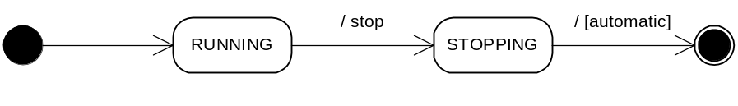
The application handle service maintains the service property called application.state to reflect the current lifecycle state of the represented application instance. Its value is one of RUNNING and STOPPING. When the application handle is registered the value of this property is RUNNING. Upon calling the application handle’s destroy() method it will be set to STOPPING. When the application instance has stopped the application handle will be unregistered. According to the above, the application lifecycle state transitions must be compliant with the following state diagram.
Specialized application handles may offer further application states. The value of the states must be qualified names; non-qualified names are reserved.
Lifecycle state transitions of an application instance can be observed as changes on its application handle service. These changes are advertised through OSGi ServiceEvents, described in [ref to 5.6.2.3. ServiceEvent of RFC 97], thus a client interested in lifecycle state changes can subscribe for these ServiceEvents.
When an application is started successfully the corresponding application handle service will be registered, and an ”org.osgi.framework.ServiceEvent.REGISTERED” event will be fired. So clients interested in application starting have to subscribe to this event. The registered service can be found by searching for an application handle service by matching the value of the event’s service.id property and the service’s service.id property.
If an application instance is stopping, then its application handle’s state property will be changed to STOPPING and an ”org.osgi.framework.ServiceEvent.MODIFIED” event will be fired. An interested client can listen to this event. The related application handle can be found by searching for an application handle service by matching the value of the event’s service.id property and the service’s service.id property.
An interested client may want to know that an application completed its stopping process. In this case it can listen to ”org.osgi.framework.ServiceEvent.UNREGISTERED” events.
A particular application model may have additional states that are represented on the application.state property. State transitions to or from those states can also be observed by listening to ”org.osgi.framework.ServiceEvent.MODIFIED” events.

Application Management Framework Functions
The application management framework must:
- Provide methods for locking, managing application’s lifecycle and scheduling of applications. The framework uses application descriptors, and application handles to provide these features.
- Implement execution policies in a way that they cannot be circumvented.

Application Locking
Applications represented by the application descriptors can be locked. If an application is locked then no new instance of the represented application can be started until it is unlocked. The locking state of the application has no effect on the already launched instance(s). The Application Descriptor provides methods lock() [ref] and unlock() [ref] to set and unset the locking state. Locking and unlocking an application represented by an application descriptor requires the proper permission as described in [ref]. The methods to lock and unlock the locked status of an application are implemented as final methods of the abstract application descriptor class to ensure that an application container implementation will not be able to circumvent this security policy.

Launching an Application
The Application Admin provides launch(ApplicationDescriptor appDesc, Map args) method [ref] to launch an application and create an application handle which is registered as a service and returned to the caller. The method in the application descriptor abstract class, which is used to launch the application is declared final to prevent application containers from circumventing the framework policies. This implementation must check if the caller can launch the application represented by the application descriptor. If all the conditions are met then it has to create a new application instance and start it according to the application container's specification. Once it is successfully started the new application handle is registered to represent the newly launched instance and returned. The state exposed on the application handle representing an application instance gets into RUNNING state right after the application instance successfully created and started. In this RUNNING state, the application instance can operate normally and it can use the functionality of the runtime environment. The detailed steps can be found in [ref]. The application handle is described in [ref].
The Map argument of the launch method contains startup arguments for the application. The keys used in the Map can be standard or application specific. MEG defines the “org.osgi.triggeringevent” key to be used to pass the triggering event to a scheduled application (see [ref]), however in the future it is possible that other well-known keys will be defined. To avoid unwanted clashes of keys, the following rules should be applied:
- The keys starting with the dash (“-“) character are application specific, no well-known meaning should be associated with them.
- Well-known keys should follow the reverse domain name based naming. In particular, the keys standardized in OSGi should start with “org.osgi.”.

Stopping an Application Instance
An application instance can be stopped by calling the destroy() method [ref] of the corresponding application handle service with the proper (ApplicationAdminPermission “manipulate”) permission [ref]. At this point the state exposed by the application handle of the application instance turns to STOPPING. The application instance may save its persistent data before termination and it must release all the resources and must stop its threads. The application instance’s artifacts should not be reused any more. The framework should assure (even forcefully) that all allocated resources are cleaned up and the corresponding threads are terminated.
If the application instance completes its stopping process then its application handle will be unregistered.
The application instances supported by a container must be stopped when the container is stopped.

Scheduling an Application
The intention of this feature is to launch a new application instance when the specified event of any kind occurs. Launching a new instance may fail in some circumstances as described below. The application may schedule itself, as well as, it can be scheduled by an external application.
The application descriptor enables scheduling an application at the occurrence of the specified event with the schedule(Map args, String topic, String eventFilter, boolean recurring) method (described in [ref]) that returns the scheduled application service. The first parameter defines the startup arguments for the scheduled application. The topic parameter is a filter for the topic of the specified event. The next parameter is an LDAP filter for the event. If the last recurring parameter is false then the application will be launched only once, when the event firstly occurs. If the parameter is true then launching will take place for every event occurrence; i.e. it is a recurring schedule. An example is schedule(messengerStartupArgs, ”com.acme.MessageReceived”, ”(sender=Joe)”, true) schedules the messenger application to be launched when a message is received from Joe.
Applications can assume that application management framework makes reasonable effort to launch scheduled applications in a timely manner. However, launching is not guaranteed, implementations may drop events if it is necessary in order to preserve the stability and integrity of the device.
If an event would launch multiple applications then the order of launching is not defined, it is implementation specific.
If scheduling event occurs and the target application is not installed the scheduling must not be removed automatically, even if the event is non-recurring. If a schedule is non-recurring and the specified event has not occurred yet, or the scheduling is recurring then event subscription should not be removed automatically even if the application is uninstalled. Once it is installed again with the same unique identifier the system will be able to launch the reinstalled application based on the previous scheduling. If the application is not reinstalled for a while then e.g. the user may permit the system to cancel the scheduling.
Launching a scheduled application is constrained by the same rules as in case of usual application launch. Thus, attempting to launch a locked scheduled application on the specified event will fail until the application gets unlocked. If the scheduling is non-recurring and launching a new instance fails then when the specified event occurs again launching the application must be attempted again. A non-recurring scheduling on a timer event (timer event is described in this document in 5.8) should be removed automatically after the first successful launching of the specified application, even if the event filter defines more than one point of time.
The triggering event will be delivered to the starting application instance as an additional item identified by the ”org.osgi.triggeringevent” key among its startup parameters. This key must not be used for other purposes in the startup parameters. To ensure that no events are leaked to applications without the apropriate permission, the event is delivered in a GuardedObject, where the guarding permission is the TopicPermission for the topic to which the event was posted.
Scheduling and unscheduling an application or retrieving information about scheduled applications requires the (ApplicationAdminPermission ”schedule” <target>) on the target application to be scheduled. If the target is the unique identifier of the scheduling application itself then it can schedule itself. In addition, the scheduling entity must have TopicPermission for the specified topic.

Scheduled Application
The ScheduledApplication, returned by the schedule(Map args, String topic, String eventFilter, boolean recurring) method, is a service and represents a scheduled application. The scheduled applications can be obtained from the service registry. The ScheduledApplication provides methods to retrieve information about the represented scheduled application, its startup parameters, the event topic, the event filter and the recurring mode of the scheduling. It provides the remove() method to discard the scheduling.

Permissions for Handling Applications
The application management framework uses ApplicationAdminPermission to control access to application manipulation APIs. ApplicationAdminPermission is a subclass of BasicPermission. This permission is granted to an application (maybe through its bundle) and allows the application to do certain actions on other applications or application instances. The ApplicationAdminPermission permission has two parameters. The first parameter describes the target on which the action is performed. The second one describes the action.
The following table lists the actions that can be controlled with ApplicationAdminPermission and when to check if the action is granted.
Action | Meaning | Check in
launch | The application is allowed to launch another application. The target for this permission is the PID of an application descriptor, or nothing if it is allowed to launch all the other applications. | ApplicationDescriptor.launch()
schedule | The application is allowed to schedule another application. The target for this permission is the PID of an application descriptor, or nothing if it is allowed to schedule all the other applications. It implies the launch permission for the same target. | ApplicationDescriptor.schedule()
manipulate | The application is allowed to manipulate the lifecycle state of an application instance. The target for this permission is the PID of an application descriptor of which instances are manipulated, or nothing if all the other applications’ instances are allowed to be manipulated. This permission is not necessary for manipulate itself. It implies the launch permission for the same target. | ApplicationHandle.destroy()
lock | The application is allowed to set/unset the locking state of other applications. The target for this permission is the PID of an application descriptor, or nothing if it is allowed to lock/unlock all the other applications. This permission is not necessary to set/unset its own application’s locking state. | ApplicationDescriptor.lock()  ApplicationDescriptor.unlock()
The caller must be able to retrieve the application descriptor and application handle service objects from the service registry to access their methods.

JSR 211 Content Handling
The JSR 211 Content Handler API (CHAPI) [6] allows applications and other similar entities with a lifecycle to act as content handlers. In the context of OSGi, these entities are OSGi bundles. The following subsections define in more detail how JSR 211 Content Handler API can be implemented on OSGi and how bundles can act as content handlers.

Content Handler API
The Content Handler API is an optional package for the J2ME platform. It allows applications and other entities to register themselves as content handlers and to invoke other content handlers. A content handler is an entity with a lifecycle (typically an application) that has registered itself to be invoked through the API. The registered entities typically handle some content, but this is not required. A lifecycle entity can register itself just to be invoked by other entities and applications without needing to handle any content. Invocations can be based on content URL, content type or content handler ID. Arguments may also be passed to a content handler and the content handler can return results and a status.
The CHAPI specification consists of a generic part and a platform specific part. The generic part of the specification applies to all CHAPI implementations, whereas the platform specific part needs to be specified for each Java platform that has its own concepts for application packaging and life cycle primitives. The CHAPI defines the platform specific part of the specification for Mobile Information Device Profile (MIDP), but leaves it undefined for other platforms. Consequently, a specification for the platform specific parts of CHAPI on the OSGi platform is needed.
The following subsections briefly define the platform specific parts of a CHAPI implementation on the OSGi platform. The reader is assumed to be familiar with the Content Handler API specification. The specification here only lists the additional requirements and clarifications that are needed to implement the API in an interoperable way on the OSGi Service Platform.

Content Handler Identification
A Content Handler API implementation in the OSGi Service Platform must allow bundles to be registered as content handlers. This registration can be done either statically or dynamically as defined by the Content Handler API.
Static registration manifest headers are the same as defined in the package description of the Content Handler API. The dynamic registration parameters are as defined for method Registry.register(). However, the semantics of the classname parameter in both static and dynamic registrations must be defined for the OSGi Service Platform to be as follows:
- When an OSGi bundle is registered as a content handler, it must define a service that has a service.pid service property and use the value of this PID as the classname parameter in the context of the Content Handler API.
Static registration of a service as a content handler must fail if the service.pid service property is undefined. Dynamic registration of a service as a content handler must fail if the service.pid service property passed in as a parameter does not represent a service that has been registered into the system.
This definition for the class name parameter semantics also applies to methods: Registry.getRegistry(), Registry.getServer() and Registry.unregister().
The static registration attributes are placed into the manifest file of the bundle.

Content Handler Access Control
The Content Handler API includes a mechanism allowing content handlers to optionally limit their accessibility to a predefined list of invokers. This mechanism requires that the invokers can define a unique identifier for themselves. CHAPI defines that MIDlets can define this identifier using the attribute MIDlet-<n>-ID, where <n> refers to a specific MIDlet within the MIDlet suite JAR. Since this attribute is MIDP specific, we need a corresponding way to identify OSGi bundles. Fortunately OSGi already includes a way to identify bundles. This can be done using the service.pid service property.
Bundles that act as content handlers must define the service.pid service property to and use its value in the attribute MicroEdition-Handler-<n>-ID to identify themselves as defined in the Content Handler API. Bundles that are not content handlers, must also define the service.pid service property to identify themselves for the access control purposes in the Content Handler API.
(Question: Can any bundle define the property without exposing a service?)

Method Descriptions
Definitions of some Content Handler API methods also need to be further clarified in an OSGi based Content Handler API implementation. Below a list of these methods and clarifications:

ContentHandler.getAppName()
A bundle acting as a content handler should define a service.name property that will contain the service name. This will be used as the return value from this method. If service.name is not defined but service.pid is defined, the value of service.pid will be returned. In case the bundle does not define the ID using either of these means, the value of the Bundle-SymbolicName attribute must be returned.
(Question: Do we need these fallback rules? Or should we simply require that only service.name is used?)

ContentHandler.getAuthority()
The return value must be the subject of the signing certificate in case the bundle has been signed and the signature verification has been successful. Otherwise null must be returned.

ContentHandler.getID()
See section titled “Content Handler Access Control”.

ContentHandler.getVersion()
A bundle acting as a content handler should define a service.version property that will contain the implementation version of the service. This will be used as the return value from this method. If service.version is not defined, the implementation must return null.

Invocation.getID() and Invocation.getInvokingID()
See section titled “Content Handler Access Control”.

Invocation.getInvokingAppName()
Return value is obtained in the same way as for ContentHandler.getAppName().

Invocation.getInvokingAuthority()
Return value is obtained in the same way as for ContentHandler.getAuthority().

Registry.getID() and Registry.getIDs()
See section titled “Content Handler Access Control”.

Registry.getRegistry(), Registry.getServer(), Registry.register(), Registry.unregister()
See section titled “Content Handler Identification”.

Internal Interactions
The content of this chapter is informal. It introduces a possible way of operation to help understand the overall system. On the figures there is a Lifecycle Manager that is a conceptual entity who initiates the illustrated operations. For example, it can be human user acting via an application, a management application or a local agent of a remote management server.

Application Installation
On the figure below an entity of the device notifies the proper application container about the installation of a new application. The actual installation may be done prior to the notification or may be done by the application container. At the end of the successful installation the container must register a specialized application descriptor which properly represents the installed application. If the installed application’s dependencies are fulfilled (if any) then the application descriptor’s application.visible and application.launchable properties should be set to true.
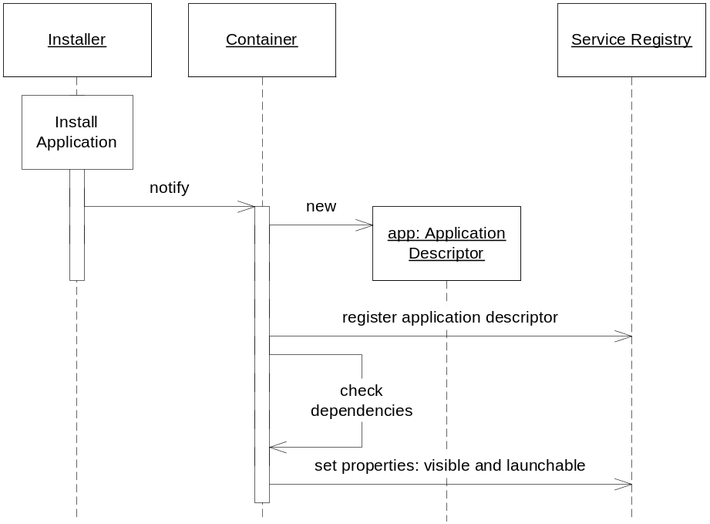

Launching an Application
Firstly the appropriate application descriptor is fetched from the service registry on which the operation will be made. Its launch() method is called and startup arguments are passed to the application instance that will be launched. The application instance may not receive the startup arguments if its application model does not support it. The launch() method checks if the a new application instance can be launched, e.g. necessary rights are granted and the application is not locked.
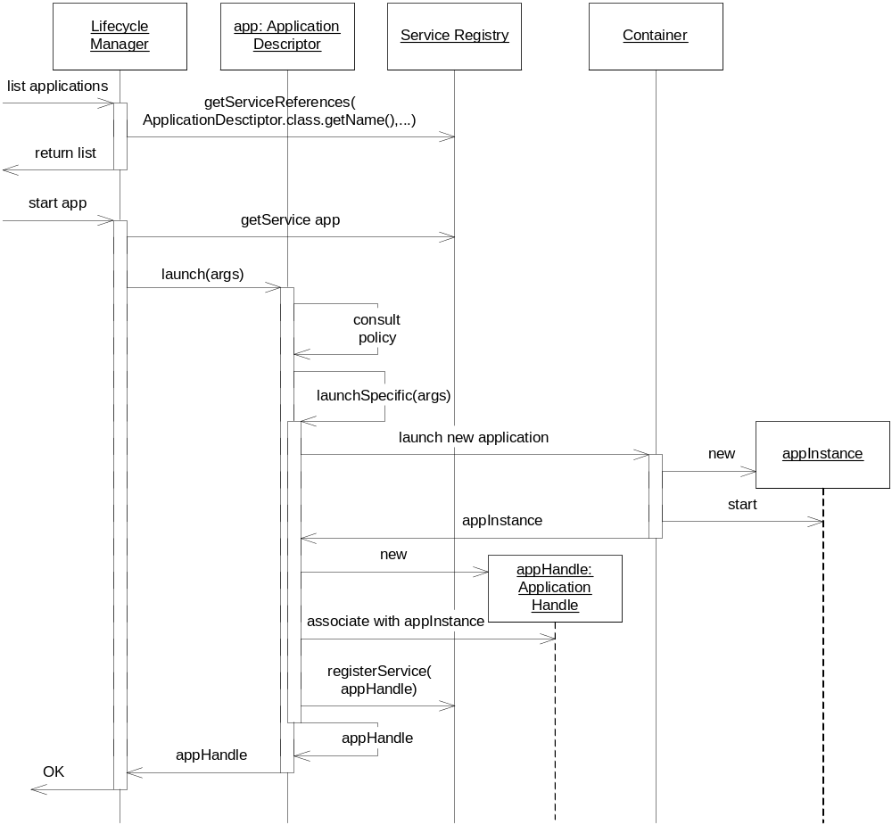
If the application can be launched then the launchSpecific() method will create and start a new application instance according to its application model. It will create a specific application handle and associate the newly created application instance to it. It will register the application handle with proper service properties. The value of application.state service property must be RUNNING. The call chain returns the service object to the application handle.

Destroying an Application Instance
To destroy an application the proper application handle has to be fetched from the service registry to call its destroy() method. It checks if the instance can be destroyed, e.g. necessary permissions are granted, it calls the destroySpecific() method to let its implementation to destroy the instance in application model specific way. Firstly it sets the application.state service property to STOPPING then stops the application instance. Finally it unregisters the application handle.
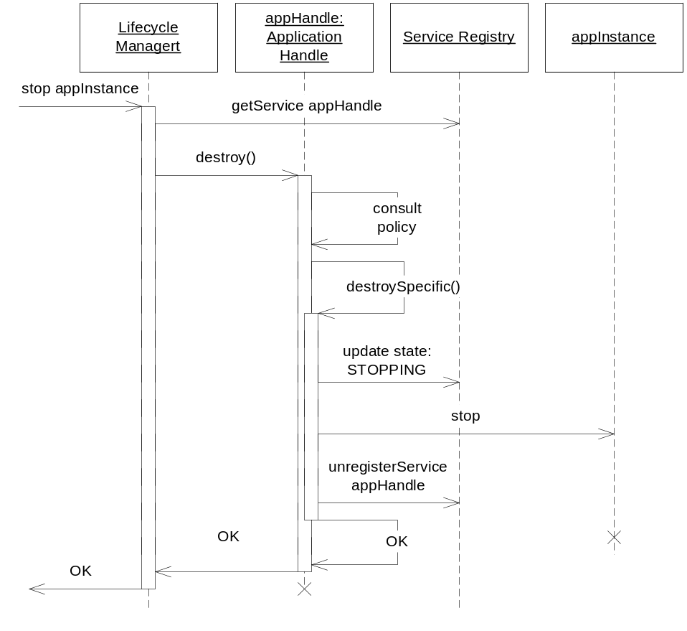

Timer Event
Timer events are not real events in the Event Admin, they are not available for bundles use. They simply reuse the syntax (topic name, event properties and filters) defined in Generic Event Mechanism [3] to allow the consistent usage of the ApplicationDescriptor.schedule method for both timer and event based scheduling. Still, Timer events are delivered to the scheduled application when it is launched. Timer events can be considered as events that are only visible for the scheduler and the scheduled application. Timer event is sent when the date and time it describes reached. This event must represent a valid date and time. The specified date and time is interpreted in the device’s local time. The topic of the event is always ”org/osgi/application/timer”. This topic name is reserved and it must not be used as topic name in Event Admin. The following properties are specific to timer event to describe the date and time it represents.
Name | Type | Notes
year | Integer | The year of the specified date.
month | Byte | The month of the year. Must be within range of 1 to 12. 1 is January.
day | Byte | The day of the month. Must be a valid day of the specified month of the specified year. Value of 1 is the first day of the month.
day_of_week | Byte | The day of the week. Must be within range of 0 to 6. 0 is Sunday.
hour | Byte | The hour of the day. Must be within the range of 0 to 23.
minute | Byte | The minute of the specified hour. Must be within the range of 0 to 59.
It can be assumed that the framework makes reasonable effort to fire the specified timer event in time. However, firing the event is not guaranteed, implementations may drop events if it is necessary in order to preserve the stability and integrity of the device.

Timer Event Examples
The following examples are LDAP filters for the timer event to specify certain time in the device local time. The topic is always ”org/osgi/application/timer”.
- ”(&(hour=12)(minute=0))” means noon in every day
- ”(&(day_of_week=0)(month=1)(minute=0))” means every hour in every Sunday in January of every year
- ”(&(minute=0))” means every whole hour
- ”(&(|(minute=0)(minute=30)))” means every half an hour
- ”(millisecond=0)” means every second
- ”(&(day_of_week=6)(day<=7)(hour=12)(minute=0))” noon of first Saturday of every month
It is important to note that filters on timer event must be constructed carefully. If a filter contains a particular time unit then all of the smaller units should be added to the expression with “&” operator. If a unit is missing from a filter then it will match with any value. It may have the timer event be fired more frequently than intended and may cause system overload.

API Specification

org.osgi.service.application
Class ApplicationDescriptor
java.lang.Object
|
+--org.osgi.service.application.ApplicationDescriptor

public abstract class ApplicationDescriptor
extends java.lang.Object
An OSGi service that represents an installed application and stores information about it. The application descriptor can be used for instance creation.

Field Summary
static java.lang.String | APPLICATION_CONTAINER  The property key for the application container of the application.
static java.lang.String | APPLICATION_COPYRIGHT  The property key for the localized copyright notice of the application.
static java.lang.String | APPLICATION_DESCRIPTION  The property key for the localized description of the application.
static java.lang.String | APPLICATION_DOCUMENTATION  The property key for the localized documentation of the application.
static java.lang.String | APPLICATION_ICON  The property key for the localized icon of the application.
static java.lang.String | APPLICATION_LAUNCHABLE  The property key for the launchable property of the application.
static java.lang.String | APPLICATION_LICENSE  The property key for the localized license of the application.
static java.lang.String | APPLICATION_LOCKED  The property key for the locked property of the application.
static java.lang.String | APPLICATION_NAME  The property key for the localized name of the application.
static java.lang.String | APPLICATION_PACKAGE  The property key for thepackage of the application.
static java.lang.String | APPLICATION_PID  The property key for the unique identifier (PID) of the application.
static java.lang.String | APPLICATION_VENDOR  The property key for the name of the application vendor.
static java.lang.String | APPLICATION_VERSION  The property key for the version of the application.
static java.lang.String | APPLICATION_VISIBLE  The property key for the visibility property of the application.

Constructor Summary
protected | ApplicationDescriptor(java.lang.String pid)  Constructs the ApplicationDescriptor.

Method Summary
protected java.lang.String | getApplicationId()  Returns the identifier of the represented application.
java.util.Map | getProperties(java.lang.String locale)  Returns the properties of the application descriptor as key-value pairs.
protected abstract java.util.Map | getPropertiesSpecific(java.lang.String locale)  Container implementations can provide application model specific and/or container implementation specific properties via this method.
ApplicationHandle | launch(java.util.Map arguments)  Launches a new instance of an application.
protected abstract ApplicationHandle | launchSpecific(java.util.Map arguments)  Called by launch() to create and start a new instance in an application model specific way.
void | lock()  Sets the lock state of the application.
protected abstract void | lockSpecific()  This method is used to notify the container implementation that the corresponding application has been locked and it should update the application.locked service property accordingly.
ScheduledApplication | schedule(java.util.Map arguments, java.lang.String topic, java.lang.String eventFilter, boolean recurring)  Schedules the application at a specified event.
void | unlock()  Unsets the lock state of the application.
protected abstract void | unlockSpecific()  This method is used to notify the container implementation that the corresponding application has been unlocked and it should update the application.locked service property accordingly.

Methods inherited from class java.lang.Object
clone, equals, finalize, getClass, hashCode, notify, notifyAll, toString, wait, wait, wait

Field Detail

APPLICATION_NAME
public static final java.lang.String APPLICATION_NAME
The property key for the localized name of the application.

APPLICATION_ICON
public static final java.lang.String APPLICATION_ICON
The property key for the localized icon of the application.

APPLICATION_PID
public static final java.lang.String APPLICATION_PID
The property key for the unique identifier (PID) of the application.

APPLICATION_VERSION
public static final java.lang.String APPLICATION_VERSION
The property key for the version of the application.

APPLICATION_VENDOR
public static final java.lang.String APPLICATION_VENDOR
The property key for the name of the application vendor.

APPLICATION_VISIBLE
public static final java.lang.String APPLICATION_VISIBLE
The property key for the visibility property of the application.

APPLICATION_LAUNCHABLE
public static final java.lang.String APPLICATION_LAUNCHABLE
The property key for the launchable property of the application.

APPLICATION_LOCKED
public static final java.lang.String APPLICATION_LOCKED
The property key for the locked property of the application.

APPLICATION_DESCRIPTION
public static final java.lang.String APPLICATION_DESCRIPTION
The property key for the localized description of the application.

APPLICATION_DOCUMENTATION
public static final java.lang.String APPLICATION_DOCUMENTATION
The property key for the localized documentation of the application.

APPLICATION_COPYRIGHT
public static final java.lang.String APPLICATION_COPYRIGHT
The property key for the localized copyright notice of the application.

APPLICATION_LICENSE
public static final java.lang.String APPLICATION_LICENSE
The property key for the localized license of the application.

APPLICATION_CONTAINER
public static final java.lang.String APPLICATION_CONTAINER
The property key for the application container of the application.

APPLICATION_PACKAGE
public static final java.lang.String APPLICATION_PACKAGE
The property key for thepackage of the application.
Constructor Detail

ApplicationDescriptor
protected ApplicationDescriptor(java.lang.String pid)
Constructs the ApplicationDescriptor.
Parameters:
applicationId - The identifier of the application. Its value is also available as the service.pid service property of this ApplicationDescriptor service.
Method Detail

getApplicationId
protected final java.lang.String getApplicationId()
Returns the identifier of the represented application.
Returns:
the identifier of the represented application

getProperties
public final java.util.Map getProperties(java.lang.String locale)
Returns the properties of the application descriptor as key-value pairs. The return value contains the locale aware and unaware properties as well. Some of the properties can be retrieved directly with methods in this interface. The returned Map will include the service properties of this ApplicationDescriptor as well. This method will call the getPropertiesSpecific method to enable the container implementation to insert application model and/or container implementation specific properties.
Parameters:
locale - the locale string, it may be null, the value null means the default locale. If the provided locale is the empty String ("")then raw (non-localized) values are returned.
Returns:
service properties of this application descriptor service, according to the specified locale. If locale is null then the default locale's properties will be returned. (Since service properties are always exist it cannot return null.)
Throws:
IllegalStateException - if the application descriptor is unregistered

getPropertiesSpecific
protected abstract java.util.Map getPropertiesSpecific(java.lang.String locale)
Container implementations can provide application model specific and/or container implementation specific properties via this method. Localizable properties must be returned localized if the provided locale argument is not the empty String. The value null indicates to use the default locale, for other values the specified locale should be used.
Parameters:
locale - the locale to be used for localizing the properties. If null the default locale should be used. If it is the empty String ("") then raw (non-localized) values should be returned.
Returns:
the application model specific and/or container implementation specific properties of this application descriptor.

launch
public final ApplicationHandle launch(java.util.Map arguments)
throws java.lang.Exception
Launches a new instance of an application. The args parameter specifies the startup parameters for the instance to be launched, it may be null.
The following steps are made:
- Check for the appropriate permission.
- Check the locking state of the application. If locked then return null otherwise continue.
- Calls the launchSpecific() method to create and start an application instance.
- Returns the ApplicationHandle returned by the launchSpecific()
The caller has to have ApplicationAdminPermission(applicationPID, "launch") in order to be able to perform this operation. The Map argument of the launch method contains startup arguments for the application. The keys used in the Map can be standard or application specific. MEG defines the #### .osgi.triggeringevent (contained funny character) key to be used to pass the triggering event to a scheduled application (see [ref]), however in the future it is possible that other well-known keys will be defined. To avoid unwanted clashes of keys, the following rules should be applied:
- The keys starting with the dash (-) character are application specific, no well-known meaning should be associated with them.
- Well-known keys should follow the reverse domain name based naming. In particular, the keys standardized in OSGi should start with org.osgi..
Parameters:
arguments - Arguments for the newly launched application, may be null
Returns:
the registered ApplicationHandle, which represents the newly launched application instance
Throws:
java.lang.SecurityException - if the caller doesn't have "launch" ApplicationAdminPermission for the application.
java.lang.Exception - if starting the application(s) failed
IllegalStateException - if the application descriptor is unregistered

launchSpecific
protected abstract ApplicationHandle launchSpecific(java.util.Map arguments)
throws java.lang.Exception
Called by launch() to create and start a new instance in an application model specific way. It also creates and registeres the application handle to represent the newly created and started instance and registeres it.
Parameters:
arguments - the startup parameters of the new application instance, may be null
Returns:
the registered application model specific application handle for the newly created and started instance.
Throws:
java.lang.Exception - if any problem occures.

schedule
public final ScheduledApplication schedule(java.util.Map arguments,
java.lang.String topic,
java.lang.String eventFilter,
boolean recurring)
throws java.io.IOException
Schedules the application at a specified event. Schedule information should not get lost even if the framework or the device restarts so it should be stored in a persistent storage. It has to register the returned service.
Parameters:
arguments - the startup arguments for the scheduled application, may be null
topic - specifies the topic of the triggering event, it may contain a trailing asterisk as wildcard, the empty string is treated as "*", must not be null
eventFilter - specifies and LDAP filter to filter on the properties of the triggering event, may be null
recurring - if the recurring parameter is false then the application will be launched only once, when the event firstly occurs. If the parameter is true then scheduling will take place for every event occurrence; i.e. it is a recurring schedule
Returns:
the registered scheduled application service
Throws:
NullPointerException - if the topic is null
java.io.IOException - may be thrown if writing the information about the scheduled application requires operation on the permanent storage and I/O problem occurred.
java.lang.SecurityException - if the caller doesn't have "schedule" ApplicationAdminPermission for the application.
IllegalStateException - if the application descriptor is unregistered

lock
public final void lock()
Sets the lock state of the application. If an application is locked then launching a new instance is not possible. It does not affect the already launched instances.
Throws:
java.lang.SecurityException - if the caller doesn't have "lock" ApplicationAdminPermission for the application.
IllegalStateException - if the application descriptor is unregistered

lockSpecific
protected abstract void lockSpecific()
This method is used to notify the container implementation that the corresponding application has been locked and it should update the application.locked service property accordingly.

unlock
public final void unlock()
Unsets the lock state of the application.
Throws:
java.lang.SecurityException - if the caller doesn't have "lock" ApplicationAdminPermission for the application.
IllegalStateException - if the application descriptor is unregistered

unlockSpecific
protected abstract void unlockSpecific()
This method is used to notify the container implementation that the corresponding application has been unlocked and it should update the application.locked service property accordingly.

org.osgi.service.application
Class ApplicationHandle
java.lang.Object
|
+--org.osgi.service.application.ApplicationHandle

public abstract class ApplicationHandle
extends java.lang.Object
ApplicationHandle is an OSGi service interface which represents an instance of an application. It provides the functionality to query and manipulate the lifecycle state of the represented application instance. It defines constants for the lifecycle states.

Field Summary
static java.lang.String | APPLICATION_DESCRIPTOR  The property key for the pid of the corresponding application descriptor.
static java.lang.String | APPLICATION_PID  The property key for the unique identifier (PID) of the application instance.
static java.lang.String | APPLICATION_STATE  The property key for the state of this appliction instance.
static java.lang.String | RUNNING  The application instance is running.

Constructor Summary
protected | ApplicationHandle(java.lang.String instanceId, ApplicationDescriptor descriptor)  Application instance identifier is specified by the container when the instance is created.

Method Summary
void | destroy()  The application instance's lifecycle state can be influenced by this method.
protected abstract void | destroySpecific()  Called by the destroy() method to perform application model specific steps to stop and destroy an application instance safely.
ApplicationDescriptor | getApplicationDescriptor()  Retrieves the ApplicationDescriptor to which this ApplicationHandle belongs.
java.lang.String | getInstanceID()  Returns the unique identifier of this instance.
abstract java.lang.String | getState()  Get the state of the application instance.

Methods inherited from class java.lang.Object
clone, equals, finalize, getClass, hashCode, notify, notifyAll, toString, wait, wait, wait

Field Detail

APPLICATION_PID
public static final java.lang.String APPLICATION_PID
The property key for the unique identifier (PID) of the application instance.

APPLICATION_DESCRIPTOR
public static final java.lang.String APPLICATION_DESCRIPTOR
The property key for the pid of the corresponding application descriptor.

APPLICATION_STATE
public static final java.lang.String APPLICATION_STATE
The property key for the state of this appliction instance.

RUNNING
public static final java.lang.String RUNNING
The application instance is running. This is the initial state of a newly created application instance.
Constructor Detail

ApplicationHandle
protected ApplicationHandle(java.lang.String instanceId,
ApplicationDescriptor descriptor)
Application instance identifier is specified by the container when the instance is created. The instance identifier must remain static for the lifetime of the instance, it must remain the same even across framework restarts for the same application instance. This value must be the same as the service.pid service property of this application handle. The instance identifier should follow the following scheme: <application descriptor PID>.<index> where <application descriptor PID> is the PID of the corresponding ApplicationDescriptor and <index> is a unique integer index assigned by the application container. Even after destroying the application index the same index value should not be reused in a reasonably long timeframe.
Parameters:
instanceId - the instance identifier of the represented application instance.
descriptor - the ApplicationDescriptor of the represented application instance.
Method Detail

getApplicationDescriptor
public final ApplicationDescriptor getApplicationDescriptor()
Retrieves the ApplicationDescriptor to which this ApplicationHandle belongs.
Returns:
The corresponding ApplicationDescriptor

getState
public abstract java.lang.String getState()
Get the state of the application instance.
Returns:
the state of the application.
Throws:
IllegalStateException - if the application handle is unregistered

getInstanceID
public final java.lang.String getInstanceID()
Returns the unique identifier of this instance. This value is also available as a service property of this application handle's service.pid.
Returns:
the unique identifier of the instance
Throws:
IllegalStateException - if the application handle is unregistered

destroy
public final void destroy()
throws java.lang.Exception
The application instance's lifecycle state can be influenced by this method. It lets the application instance to perform operations to stop the application safely, e.g. saving its state to a permanent storage.
The method must check if the lifecycle transition is valid; a STOPPING application cannot be stopped. If it is invalid then the method must exit. Otherwise the lifecycle state of the application instance must be set to STOPPING. Then the destroySpecific() method must be called to perform any application model specific steps for safe stopping of the represented application instance.
At the end the ApplicationHandle must be unregistered. This method should free all the resources related to this ApplicationHandle.
When this method is completed the application instance has already made its operations for safe stopping, the ApplicationHandle has been unregistered and its related resources has been freed. Further calls on this application should not be made because they may have unexpected results.
Throws:
java.lang.SecurityException - if the caller doesn't have "manipulate" ApplicationAdminPermission for the corresponding application.
java.lang.Exception - is thrown if an exception or an error occurred during the method execution.
IllegalStateException - if the application handle is unregistered

destroySpecific
protected abstract void destroySpecific()
throws java.lang.Exception
Called by the destroy() method to perform application model specific steps to stop and destroy an application instance safely.
Throws:
java.lang.Exception - is thrown if an exception or an error occurred during the method execution.

org.osgi.service.application
Interface ScheduledApplication

public interface ScheduledApplication
It is allowed to schedule an application based on a specific event. ScheduledApplication service keeps the scheduling information. When the specified event is fired a new instance must be launched. Note that launching operation may fail because e.g. the application is locked.

Method Summary
ApplicationDescriptor | getApplicationDescriptor()  Retrieves the ApplicationDescriptor which represents the application and necessary for launching.
java.util.Map | getArguments()  Queries the startup arguments specified when the application was scheduled.
java.lang.String | getEventFilter()  Queries the event filter for the triggering event.
java.lang.String | getTopic()  Queries the topic of the triggering event.
boolean | isRecurring()  Queries if the scheduling is recurring.
void | remove()  Cancels this schedule of the application.

Method Detail

getTopic
public java.lang.String getTopic()
Queries the topic of the triggering event. The topic may contain a trailing asterisk as wildcard.
Returns:
the topic of the triggering event
Throws:
IllegalStateException - if the scheduled application service is unregistered

getEventFilter
public java.lang.String getEventFilter()
Queries the event filter for the triggering event.
Returns:
the event filter for triggering event
Throws:
IllegalStateException - if the scheduled application service is unregistered

isRecurring
public boolean isRecurring()
Queries if the scheduling is recurring.
Returns:
true if the scheduling is recurring, otherwise returns false
Throws:
IllegalStateException - if the scheduled application service is unregistered

getApplicationDescriptor
public ApplicationDescriptor getApplicationDescriptor()
Retrieves the ApplicationDescriptor which represents the application and necessary for launching.
Returns:
the application descriptor that represents the scheduled application
Throws:
IllegalStateException - if the scheduled application service is unregistered

getArguments
public java.util.Map getArguments()
Queries the startup arguments specified when the application was scheduled. The method returns a copy of the arguments, it is not possible to modify the arguments after scheduling.
Returns:
the startup arguments of the scheduled application. It may be null if null argument was specified.
Throws:
IllegalStateException - if the scheduled application service is unregistered

remove
public void remove()
Cancels this schedule of the application.
Throws:
java.lang.SecurityException - if the caller doesn't have "schedule" ApplicationAdminPermission for the scheduled application.
IllegalStateException - if the scheduled application service is unregistered

org.osgi.service.application
Class ApplicationAdminPermission
java.lang.Object
|
+--java.security.Permission
|
+--java.security.BasicPermission
|
+--org.osgi.service.application.ApplicationAdminPermission
All Implemented Interfaces:
java.security.Guard, java.io.Serializable

public class ApplicationAdminPermission
extends java.security.BasicPermission
This class implements permissions for manipulating applications and their instances.
ApplicationAdminPermission can be targeted to applications that matches the specified filter.
ApplicationAdminPermission may be granted for different actions: lifecycle, schedule and lock. The permission schedule implies the permission lifecycle.
See Also:
Serialized Form

Field Summary
static java.lang.String | LIFECYCLE  Allows the lifecycle management of the target applications.
static java.lang.String | LOCK  Allows setting/unsetting the locking state of the target applications.
static java.lang.String | SCHEDULE  Allows scheduling of the target applications.

Constructor Summary
ApplicationAdminPermission(java.lang.String filter, java.lang.String actions)
Constructs an ApplicationAdminPermission.

Method Summary
boolean | implies(java.security.Permission p)

Methods inherited from class java.security.BasicPermission
equals, getActions, hashCode, newPermissionCollection

Methods inherited from class java.security.Permission
checkGuard, getName, toString

Methods inherited from class java.lang.Object
clone, finalize, getClass, notify, notifyAll, wait, wait, wait

Field Detail

LIFECYCLE
public static final java.lang.String LIFECYCLE
Allows the lifecycle management of the target applications.

SCHEDULE
public static final java.lang.String SCHEDULE
Allows scheduling of the target applications. The permission to schedule an application implies that the scheduler can also manage the lifecycle of that application i.e. schedule implies lifecycle

LOCK
public static final java.lang.String LOCK
Allows setting/unsetting the locking state of the target applications.
Constructor Detail

ApplicationAdminPermission
public ApplicationAdminPermission(java.lang.String filter,
java.lang.String actions)
Constructs an ApplicationAdminPermission. The filter specifies the target application. If the filter is null then it matches "*". If actions is "*" then it identifies all the possible actions.
Parameters:
filter - filter to identify application. The value null indicates "all application".
actions - comma-separated list of the desired actions granted on the applications or "*" means all the actions. It must not be null. The order of the actions in the list is not significant.
Throws:
NullPointerException - is thrown if the actions parameter is null
Method Detail

implies
public boolean implies(java.security.Permission p)
Overrides:
implies in class java.security.BasicPermission

Considered Alternatives
At the Newark meeting it was suggested that application descriptor might take over then entire function of ApplicationAdmin. While I was editing the document to reflect the decisions made at the meeting I realized that it was still needed as a target for scheduling applications. The name might better be changed to ApplicationScheduler since this is the only remaining function. (Added by Rick DeNatale.)
Then the scheduling functionality was also moved to the application descriptor and ScheduledApplication became a service. The rationale behind moving ApplicationAdmin’s functionality to the application descriptor is that an extra interface could be eliminated. All of the methods of application admin had the application descriptor parameter to define on which application to perform the selected operation.
The application descriptor and AppplicationHandle became an abstract class instead of being an interface. They have final methods, which are intended to be implemented by the implementer of the application management framework. In these final methods the generic policies of the framework can be ensured in a way that cannot be circumvented by specialized implementations provided to support various application models, like the Meglet model. They contain some protected methods, which cannot be invoked from outside of the object but can be overridden by the implementer of the specialized classes to provide a behavior specific to the supported application model.

Security Considerations
When an application (A) launches another application (B), application B will be constrained by application A’s permission. In other words, launching an application is not surronded with a doPrivileged() call of in the application management framework. This mechanism is used to make sure that application A cannot obtain higher privileges unnoticed by launching a more trusted application. If B wouldn’t be constrained by A’s permissions, then it would be possible for A to use B – by specifying the appripriate startup parameters – to perform some action for which A has no permission. If B wants to perform some action independently from its launcher, the it should surround that action with a doPrivileged() call. To ensure that applications launched by the user can execute properly, AllPermission should be granted to Desktop Manager. When launch of an application is triggered by some event for which it was scheduled, the application management framework launches the application in doPrivileged() call, with all permission. As startup parameters can be specified for the scheduling, a mallicious application with schedule privilege can perform the attack described above. This implies that the right to schedule an application is much stronger and therefore, it should be granted to applications carefully.

Document Support

References
- Bradner, S., Key words for use in RFCs to Indicate Requirement Levels, RFC2119, March 1997.
- RFC 80 – Declarative Services
http://membercvs.osgi.org/rfcs/rfc0080/
- RFC 97 – Generic Event Mechanism
http://membercvs.osgi.org/rfcs/rfc0097/
- RFP 52 – Application Model Requirements
http://membercvs.osgi.org/rfps/rfp-0052_MEG_WS_Application_Model.doc
- RFC XXX – Operational Access Techonology
http://membercvs.osgi.org/rfcs/rfcxxxx/
- JSR 211 Content Handler API
http://www.jcp.org/en/jsr/detail?id=211

Author’s Address

Name | Venkat Amirisetty
Company | Motorola, Inc
Address | 805, E. Middlefield Road, Mountain View, CA 94043, USA
Voice | +1-650-318-3362
e-mail | vamirisetty@motorola.com

Acronyms and Abbreviations

End of Document

