

RFC-106 MEG Deployment Management Object
Final
36 Pages
Abstract

Document Information

Table of Contents
0 Document Information 2
0.1 Table of Contents 2
0.2 Terminology and Document Conventions 3
0.3 Revision History 3
1 Introduction 4
2 Application Domain 4
3 Problem Description 4
4 Requirements 5
5 Technical Solution 5
5.1 Deployment Component State on the device 5
5.1.1 Operations Primitives 6
5.1.2 Download related primitive 6
5.1.3 Deployment Management Object scope 6
5.2 Deployment Management Object 7
5.2.1 Deployment Management Object internal structure 8
5.2.2 Deployment Management Object Parameters 8
5.3 Agent Behaviour associated with the Deployment Management Object 26
5.3.1 …/Operations/Remove Exec command semantic 27
5.3.2 Operations/InstallAndActivate Exec command semantic 27
5.3.3 DownloadAndInstallAndActivate Exec command semantic 28
5.3.4 Use of the Generic Alert 28
5.3.5 Tree management 31
5.4 Device Management Server initiated download of a DP – message flow chart - informative 31
5.4.1 Description 31
5.4.2 Normal flow 33
6 Considered Alternatives 34
7 Security Considerations 35
8 Document Support 35
8.1 References 35
8.2 Author’s Address 35
8.3 Acronyms and Abbreviations 36
8.4 End of Document 36

Terminology and Document Conventions
The key words "MUST", "MUST NOT", "REQUIRED", "SHALL", "SHALL NOT", "SHOULD", "SHOULD NOT", "RECOMMENDED", "NOT RECOMMENDED", "MAY" and "OPTIONAL" in this document are to be interpreted as described in [1].
Source code is shown in this typeface.

Revision History
The last named individual in this history is currently responsible for this document.

Revision | Date | Comments
Initial | 03. 16. 2005 | Initial proposal.  Magdolna Gerendai, Nokia, magdolna.gerendai@nokia.com
0.2 | 03.18.2005 | Added dynamic node under Download node, Generic Alert syntax and semantic, clarifications in the Exec commands semantic, some editorial changes  Magdolna Gerendai, Nokia, magdolna.gerendai@nokia.com
0.21 | 03.23. 2005 | Corrections based on telcon discussion.  Andre Kruetzfeldt, Sun, Andre.Kruetzfeldt@Sun.COM
0.3 | 04.05.2005 | MO tree and parameter change, status codes.  Magdolna Gerendai, Nokia, magdolna.gerendai@nokia.com
0.4 | 04.08.2005 | Execution status update, Generic alert parameters update, editorial changes.  Magdolna Gerendai, Nokia, magdolna.gerendai@nokia.com
0.45 | 04.20.2005 | Resource Processors and Processors management nodes related update and some editorial changes.  Magdolna Gerendai, Nokia, magdolna.gerendai@nokia.com
0.46 | 04.21.2005 | Generic Alert modification and editorial changes.  Magdolna Gerendai, Nokia, magdolna.gerendai@nokia.com
0.5 | 05.18.2005 | Standalone bundle download, package, application type and signers of the bundle inserted.  Magdolna Gerendai, Nokia, magdolna.gerendai@nokia.com
0.6 | 05.20.2005 | Envtype value definition change.  Magdolna Gerendai, Nokia, magdolna.gerendai@nokia.com
Final | 8th June 2005 | No changes, Severi Eerola

Introduction
This document describes management object used in a Deployment Package management process that is based on the OMA DM v 1.2 protocol. It defines the Deployment Management Object and the protocol between the client and server to manage the download and deployment of DPs.

Application Domain
This section should be copied from the appropriate RFP(s). It is repeated here so it can be extended while the RFC authors learn more subtle details.

Problem Description
This section should be copied from the appropriate RFP(s). It is repeated here so it can be extended while the RFC authors learn more subtle details.

Requirements
This section should be copied from the appropriate RFP(s)

Technical Solution

Deployment Component State on the device

There are two possible States of a Deployment Component, i.e Deployment Package or standalone bundle on the device known by the DM framework: Delivered and Deployed-Active:
- In Delivered State the Deployment Component has been delivered into the device, but not deployed and it is stored in a storage accessible by DM Framework. Likely it’s delivered via another technology than OMA DM to the device (e.g. Bluetooth, MMS, e-mail, etc.) and a Local Management Entity inserted it into the tree via the DMT API
- In Deployed-Active state the Deployment Component has been installed into the OSGi runtime system and services or resources it embodies are accessible to other entities or resources (incl. end-user).

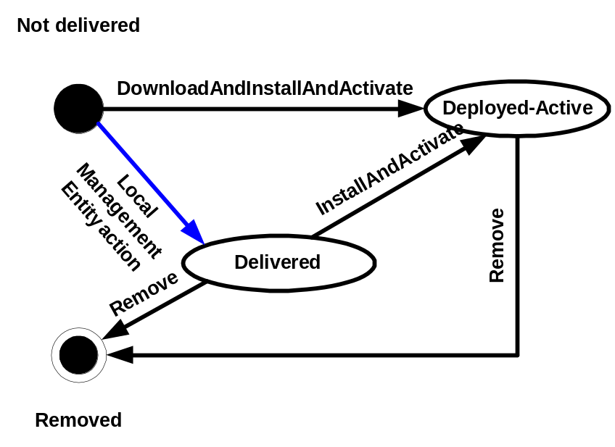

Operations Primitives

Operation primitives are used to transfer Deployment Components between different states:

Primitive | Description
Remove | This primitive is used to remove Deployment Component from any state.
InstallAndActivate | This primitive is used to move Deployment Component from Delivered state to Deployed-Active state.

Download related primitive

Download primitive is used to enable the client to download the Deployment Component into Deployed-Active state directly with one command to enable streaming like installation of a package.

Primitive | Description
DownloadAndInstallAndActivate | This primitive is used to download Deployment Component into Deployed-Active state.

Deployment Management Object scope

This Management Object covers the delivery and management of Deployment Components in the client.
This specification doesn’t take stance on how possible dependency management between deployment components is done. Mapping to the DM tree and displaying of Deployment Components that are delivered to the device outside of this management framework are not handled in this specification.
Also timeouts and other triggers for operation commands are implementation specific decisions.

Deployment Management Object

The management object is statically created under the OSGi node in the DM tree.
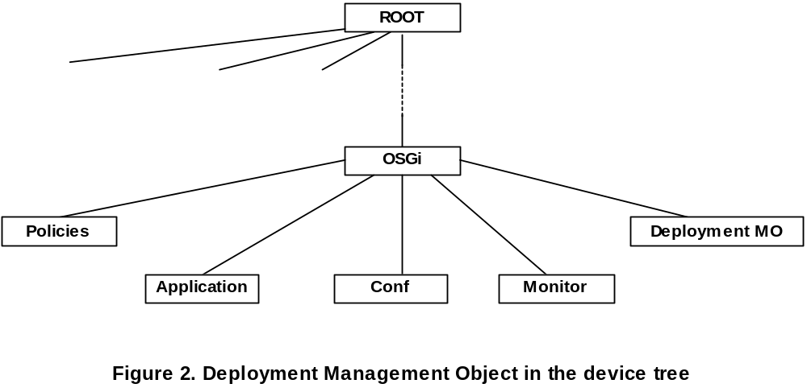
Management Object identifier: org.osgi./1.0/DeploymentManagementObject
Protocol Compatibility: This object is compatible with OMA Device Management protocol specifications, version 1.2 and upward.

Deployment Management Object internal structure
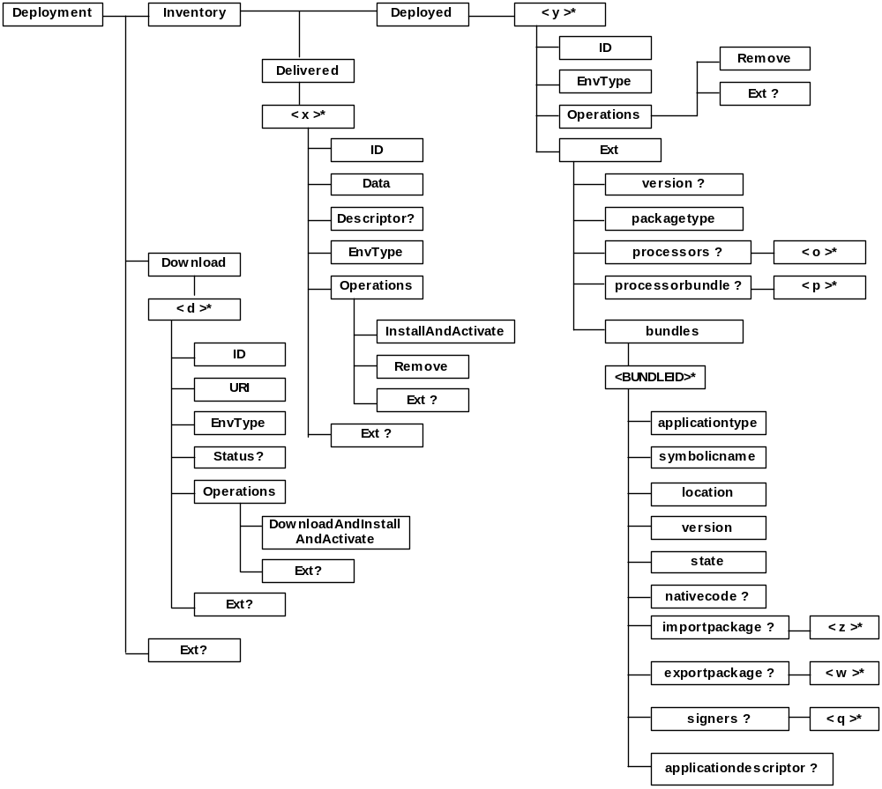

Deployment Management Object Parameters

The [OSGi-root] notation represents the location of the OSGi interior node in the DM tree. The manufacturers or vendors define its actual path from the DM tree root on the device.

Node [OSGi-root]/Deployment

Parameters of the Deployment Management Object are assembled under this interior node.
AccessType: Get
Format: node
Occurrence: One
Scope: Permanent

Node [OSGi-root]/Deployment/Download

This is the parent node for the Download operations.
AccessType: Get
Format: node
Occurrence: One
Scope: Permanent

Node [OSGi-root]/Deployment/Download/<d>

This dynamically created node is the parent node of Download parameters for a Deployment Component.
AccessType: Get, Add, Delete
Format: node
Occurrence: ZeroOrMore
Scope: Dynamic

Node [OSGi-root]/Deployment/Download/<d>/URI

This leaf node contains the URL of the Deployment Component to be downloaded. The URL points to the DLOTA Download Descriptor of the package which is either a Deployment Package or a standalone bundle.
AccessType: Get, Add
Format: chr
Occurrence: One
Scope: Dynamic

Node [OSGi-root]/Deployment/Download/<d>/ID

This leaf node carries the unique ID of the Deployment Component. This value is set by the DMS server or the Local Management Entity. If the Deployment Component is a Deployment Package, this node must have the value of the DeploymentPackage-Name manifest header of the DP see [6]. If the Deployment Component is a standalone bundle, this leaf node must have the value of the Bundle-SymbolicName manifest header.
AccessType: Get, Add
Format: chr
Occurrence: One
Scope: Dynamic

Node [OSGi-root]/Deployment/Download/<d>/Operations

This is the parent node for download operations to be invoked on the Deployment Component identified by the ID parameter under the same <d> dynamic node.
AccessType: Get, Add
Format: node
Occurrence: One
Scope: Dynamic

Node [OSGi-root]/Deployment/Download/<d>/Operations/DownloadAndInstallAndActivate

It’s used with Exec command to initiate the download and immediate installation of a Deployment Component. The Deployment Package or standalone bundle is downloaded via OMA DLOTA 1.0 protocol with the OSGi specific Download Descriptor extension. When the command is executed, a dynamic node (sub-tree) is created under the [OSGi-root]/Deployment/Inventory/Deployed node with the appropriate parameters (including the same ID) of the installed DP. If the sub-tree for the DP already exists - the ID is the same as of the Deployment Component to be downloaded - the sub-tree parameters are updated.
AccessType: Exec, Get, Add
Format: node
Occurrence: One
Scope: Dynamic

Node [OSGi-root]/Deployment/Download/<d>/Operations/Ext

This optional interior node designates a branch of the Operations sub-tree into which vendor specific extensions MAY be added, permanently or dynamically.
AccessType:
Format: node
Occurrence: ZeroOrOne

Node [OSGi-root]/Deployment/Download/<d>/Status

This leaf node holds the execution state of the device after an attempt to execute the download and deployment operations. This value indicates the execution state(s) following the invocation of the Exec command.
AccessType: Get, Add, Replace
Format: int
Occurrence: ZeroOrOne
Scope: Dynamic

The possible execution states are one of:
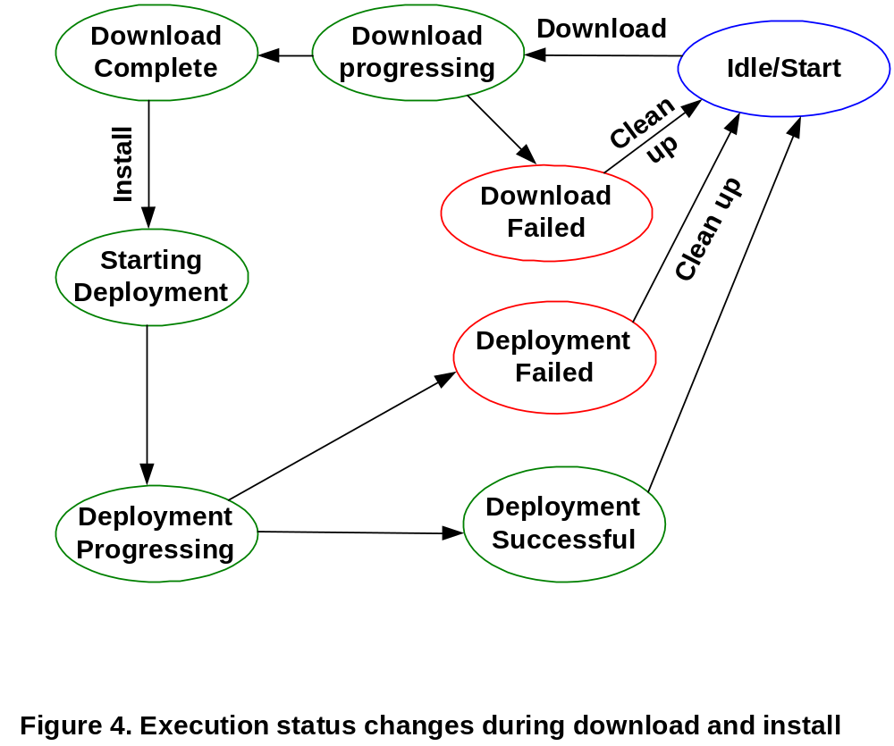

The client sets the Status value with one of the possible values:
Status | Description | Integer Value
Idle / Start | There is no data available and download is about to start | 10
Download Failed | Download failed and there is No data received | 20
Download Progressing | Denotes that a download has started and that 0 or more bytes of data have been downloaded | 30
Download Complete | Have data after Download has been completed successfully | 40
Starting Deployment | Have data and about to start Deployment | 50
Deployment Progressing | Denotes that the Deployment is currently running, but has not yet completed | 60
Deployment Failed | Deployment failed | 70
Deployment Successful | Deployment complete. | 80

Node [OSGi-root]/Deployment/Download/<d>/EnvType

This leaf node holds the value that indicates the environment for the Deployment Component to be downloaded. Definition of the leaf node value is: OSGi.<version>. For this specification the value of <version> is “R4”., i.e. the node value is “OSGi.R4”.
AccessType: Get, Add
Format: chr
Occurrence: One
Scope: Dynamic

Node [OSGi-root]/Deployment/Download/<d>/Ext

This optional interior node designates a branch of the Download parameters sub-tree into which vendor specific extensions MAY be added, permanently or dynamically.
AccessType:
Format: node
Occurrence: ZeroOrOne

Node [OSGi-root]/Deployment/Inventory

This interior node is the parent node of the Deployed branch that populates the meta-data of the Deployment Components actually deployed in the runtime environment.
AccessType: Get
Format: node
Occurrence: One
Scope: Permanent

Node [OSGi-root]/Deployment/Inventory/Delivered

This interior node is the parent node of the placeholder branches containing the parameters of the delivered Deployment Components.
AccessType: Get
Format: node
Occurrence: One
Scope: Permanent

Node [OSGi-root]/Deployment/Inventory/Delivered<x>

This interior node is the placeholder node for a Deployment Component.
AccessType: Get, Add, Delete
Format: node
Occurrence: ZeroOrMore
Scope: Dynamic

Node [OSGi-root]/Deployment/Inventory/Delivered/<x>/ID

This leaf node contains the unique ID of the Deployment Component. This value is set by the originator of the package (either DMS or a Local Entity for DPs delivered to the device via different technology, than OMA DM). If it’s a Deployment Package, this node must have the value of the DeploymentPackage-Name Manifest header of the DP see [6]. If the Deployment Component is a standalone bundle, this leaf node must have the value of the Bundle-SymbolicName manifest header.
AccessType: Get
Format: chr
Occurrence: One
Scope: Dynamic

Node [OSGi-root]/Deployment/Inventory/Delivered/<x>/Data

This leaf node value refers to the Deployment Component stored on the device.
AccessType: Get
Format: bin
Occurrence: One
Scope: Dynamic

Node [OSGi-root]/Deployment/Inventory/Delivered/<x>/Descriptor

This leaf node includes the DLOTA Download Descriptor of the Deployment Component if exists.
AccessType: Get
Format: xml
Occurrence: ZeroOrOne
Scope: Dynamic

Node [OSGi-root]/Deployment/Inventory/Delivered/<x>/EnvType

This leaf node value indicates for which run-time environment the Deployment Component is targeted. Definition of the leaf node value is: OSGi.<version>. For this specification the value of <version> is “R4”., i.e. the node value is “OSGi.R4”.
It must have the value:”OSGi.R4”.
AccessType: Get
Format: chr
Occurrence: One
Scope: Dynamic

Node [OSGi-root]/Deployment/Inventory/Delivered/<x>/Operations/Remove

This node with Exec command is used to start the removal (uninstall) of the Deployment Component identified by the ID parameter of the same <x> branch.
AccessType: Exec
Format: Boolean
Occurrence: One
Scope: Dynamic

Node [OSGi-root]/Deployment/Inventory/Delivered/<x>/Operations/InstallAndActivate

This node with Exec command is used to start the installation of a Deployment Component, which is in Delivered state and identified by the ID of the same <x> branch. After the command is executed successfully the <x> sub-tree is deleted. If a sub-tree under the [OSGi-root]/Deployment/Inventory/Deployed node with the same ID doesn’t exist, it’s created, otherwise the existing sub-tree is updated.
AccessType: Exec
Format: Boolean
Occurrence: One
Scope: Dynamic

Node [OSGi-root]/Deployment/Inventory/Delivered/<x>/Operations/Ext

This optional interior node designates a branch of the Operations sub-tree into which vendor extensions MAY be added, permanently or dynamically.
AccessType:
Format: node
Occurrence: ZeroOrOne

Node [OSGi-root]/Deployment/Inventory/Delivered/<x>/Ext

This placeholder node is the parent node of the OSGi environment extension branch and may be the placeholder of any vendor specific extension.
AccessType: Get
Format: node
Occurrence: ZeroOrOne
Scope: Dynamic

Node [OSGi-root]/Deployment/Inventory/Deployed

This interior node is the parent node of the placeholder branches containing the parameters of the deployed Deployment Components.
AccessType: Get
Format: node
Occurrence: One
Scope: Permanent

Node [OSGi-root]/Deployment/Inventory/Deployed/<y>

This interior node is the placeholder node for a deployed Deployment Component.
AccessType: Get, Add, Delete
Format: node
Occurrence: ZeroOrMore
Scope: Dynamic

Node [OSGi-root]/Deployment/Inventory/Deployed/<y>/ID

This leaf node contains the unique ID of the Deployment Component. This value is set by the originator of the package (either DMS or a Local Entity for DPs delivered to the device via different technology, than OMA DM). If it’s a Deployment Package, this node must have the value of the DeploymentPackage-Name Manifest header of the DP see [6]. If the Deployment Component is a standalone bundle, this leaf node must have the value of the Bundle-SymbolicName manifest header.

AccessType: Get
Format: chr
Occurrence: One
Scope: Dynamic

Node [OSGi-root]/Deployment/Inventory/Deployed/<y>/EnvType

This leaf node indicates that the Deployment Component is targeted for the OSGi environment. Definition of the leaf node value is: OSGi.<version>. For this specification the value of <version> is “R4”., i.e. the node value is “OSGi.R4”.

AccessType: Get
Format: chr
Occurrence: One
Scope: Dynamic

Node [OSGi-root]/Deployment/Inventory/Deployed/<y>/Operations/Remove

This node with Exec command is used to start the removal of the Deployment component identified by the ID parameter of the same <y> branch.
AccessType: Exec
Format: Boolean
Occurrence: One
Scope: Dynamic

Node [OSGi-root]/Deployment/Inventory/Deployed/<y>/Operations/Ext

This optional interior node designates a branch of the Operations sub-tree into which vendor extensions MAY be added, permanently or dynamically.
AccessType:
Format: node
Occurrence: ZeroOrOne

Node [OSGi-root]/Deployment/Inventory/Deployed/<y>/Ext

This placeholder node is the parent node of the OSGi environment extension branch and may be the placeholder of any vendor specific extension.
AccessType: Get
Format: node
Occurrence: ZeroOrOne
Scope: Dynamic

Node [OSGi-root]/Deployment/Inventory/Deployed/<y>/Ext/version

This node allows querying of the Deployment Package version declared by the DeploymentPackage-Version manifest header of the DP. This shares the format as the Deployment Package header see [6]. If the Deployment Component is a standalone bundle, this leaf node is optional and contains the value of the Bundle-Version manifest header.
AccessType: Get
Format: chr
Occurrence: ZeroOrOne
Scope: Dynamic

Node [OSGi-root]/Deployment/Inventory/Deployed/<y>/Ext/packagetype

This node allows querying of the package type, possible values are:
OSGi.DP = 1
OSGi.bundle = 2

AccessType: Get
Format: chr
Occurrence: One
Scope: Dynamic

Node [OSGi-root]/Deployment/Inventory/Deployed/<y>/Ext/processorbundle

This node exists only if the Deployment Package declared that it contains resource processor(s). If present, this node is the parent of the underlying <p> nodes that contain the symbolic name of the customizer bundle(s), i.e. the symbolic name of bundles that include in their Name section the “DeploymentPackage-Customizer: true” header in the DP manifest see [6].
AccessType: Get
Format: chr
Occurrence: ZeroOrOne
Scope: Dynamic

Node [OSGi-root]/Deployment/Inventory/Deployed/<y>/Ext/processorbundle/<p>

This leaf node contains the symbolic name of a bundle that declared to be customizer with the “DeploymentPackage-Customizer: true” header in its Name section of the DP manifest see [6].
AccessType: Get
Format: chr
Occurrence: OneOrMore
Scope: Dynamic

Node [OSGi-root]/Deployment/Inventory/Deployed/<y>/Ext/processors

This node exists only if the Deployment Package declared resource processor(s) required with Resource-Processor manifest headers in the Name sections of the DP manifest and their values share the same format as the Deployment Package header see [6].
AccessType: Get
Format: chr
Occurrence: ZeroOrOne
Scope: Dynamic

Node [OSGi-root]/Deployment/Inventory/Deployed/<y>/Ext/processors/<o>

This leaf node contains the value of a Resource-Processor header in a Name section of the DP manifest and shares the same format as the Deployment Package header see [6].

AccessType: Get
Format: chr
Occurrence: OneOrMore
Scope: Dynamic

Node [OSGi-root]/Deployment/Inventory/Deployed/<y>/Ext/bundles

This node is the parent node of information nodes of bundles-. If the Deployment Component is a DP, these information node(s) describe the bundles belonging to the DP.
AccessType: Get
Format: node
Occurrence: One
Scope: Dynamic

Node [OSGi-root]/Deployment/Inventory/Deployed/<y>/Ext/bundles/<BUNDLEID>

BUNDLEID represents the ID of the bundles belonging to the deployment package. The <BUNDLEID> is equal to the ID of the bundle.
AccessType: Get
Format: node
Occurrence: ZeroOrMore
Scope: Dynamic

Node [OSGi-root]/Deployment/Inventory/Deployed/<y>/Ext/bundles/<BUNDLEID>applicationtype

This leaf node allows the query of the type of the application included in the bundle. The possible values are:
NONE = 0
SERVICE = 1
APPLICATION = 2
MIDLET = 3
XLET= 4

AccessType: Get
Format: chr
Occurrence: One
Scope: Dynamic

Node [OSGi-root]/Deployment/Inventory/Deployed/<y>/Ext/bundles/<BUNDLEID>symbolicname

This leaf node contains the symbolic name of the bundle.
AccessType: Get
Format: chr
Occurrence: One
Scope: Dynamic

Node [OSGi-root]/Deployment/Inventory/Deployed/<y>/Ext/bundles/<BUNDLEID>location

This leaf node contains the location identifier of the bundle.
AccessType: Get
Format: chr
Occurrence: One
Scope: Dynamic

Node [OSGi-root]/Deployment/Inventory/Deployed/<y>/Ext/bundles/<BUNDLEID>version

This leaf node contains the version of the bundle.
AccessType: Get
Format: chr
Occurrence: One
Scope: Dynamic

Node [OSGi-root]/Deployment/Inventory/Deployed/<y>/Ext/Bundles/<BUNDLEID>state

This leaf node contains the lifecycle state of the bundle. The value of this node must be one of the followings:
NOTAVAILABLE is represented by a value of 0
INSTALLED is represented by a value of 2
RESOLVED is represented by a value of 4
STARTING is represented by a value of 8
STOPPING is represented by a value of 16
ACTIVE is represented by a value of 32
AccessType: Get
Format: int
Occurrence: One
Scope: Dynamic

Node [OSGi-root]/Deployment/Inventory/Deployed/<y>/Ext/bundles/<BUNDLEID>importpackage

This node is the parent of the underlying <z> nodes that contain the name and version of the import packages required by the bundle.
AccessType: Get
Format: node
Occurrence: ZeroOrOne
Scope: Dynamic

Node [OSGi-root]/Deployment/Inventory/Deployed/<y>/Ext/bundles/<BUNDLEID>importpackage/<z>

This leaf node contains an imported package name, specification version and other attributes included in the manifest header of the bundlewith the same format. In case of Dynamic-Import the value is *.

AccessType: Get
Format: chr
Occurrence: OneOrMore
Scope: Dynamic

Node [OSGi-root]/Deployment/Inventory/Deployed/<y>/Ext/bundles/<BUNDLEID>exportpackage

This node is the parent of the underlying <w> nodes that describe export packages provided by the bundle.
AccessType: Get
Format: node
Occurrence: ZeroOrOne
Scope: Dynamic

Node [OSGi-root]/Deployment/Inventory/Deployed/<y>/Ext/bundles/<BUNDLEID>exportpackage/<w>

This leaf node contains an exported package name, specification version and other attributes included in the bundle manifest header with the same format.
AccessType: Get
Format: chr
Occurrence: OneOrMore
Scope: Dynamic

Node [OSGi-root]/Deployment/Inventory/Deployed/<y>/Ext/bundles/<BUNDLEID>nativecode

This leaf node contains the value of the Bundle-NativeCode manifest header of the bundle.
AccessType: Get
Format: chr
Occurrence: ZeroOrOne
Scope: Dynamic

Node [OSGi-root]/Deployment/Inventory/Deployed/<y>/Ext/bundles/<BUNDLEID>signers

This node is the parent of the underlying <q> nodes that contain the signers of the bundle.

AccessType: Get
Format: chr
Occurrence: ZeroOrOne
Scope: Dynamic

Node [OSGi-root]/Deployment/Inventory/Deployed/<y>/Ext/bundles/<BUNDLEID>signers/<q>

This leaf node contains a signer of the bundle. The node value is the Subject (Distinguised Name) of the X.509 Certificate.

AccessType: Get
Format: chr
Occurrence: OneOrMore
Scope: Dynamic

Node [OSGi-root]/Deployment/Inventory/Deployed/<y>/Ext/bundles/<BUNDLEID>applicationdescriptor

This leaf node contains the content of the application descriptor file of the bundle.
AccessType: Get
Format: xml
Occurrence: ZeroOrOne
Scope: Dynamic

Node [OSGi-root]/Deployment/Ext

This optional interior node designates a branch of the Deployment sub-tree into which vendor specific extensions MAY be added, permanently or dynamically.
AccessType:
Format: node
Occurrence: ZeroOrOne

Agent Behaviour associated with the Deployment Management Object

…/Operations/Remove Exec command semantic

The Exec command for …/Operations/Remove node starts the execution of the removal operation. The Exec command is targeted to the Deployment Component represented by the branch including the Operations/Remove node.

<Exec>
<CmdID>3</CmdID>
<Item>
<Target>
<LocURI>[OSGi-root]/Deployment/Inventory/Deployed/ServerA/Operations/Remove</LocURI>
</Target>
</Item>
</Exec>

or

<Exec>
<CmdID>3</CmdID>
<Item>
<Target>
<LocURI>[OSGi-root]/Deployment/Inventory/Delivered/ServerB/Operations/Remove</LocURI>
</Target>
</Item>
</Exec>

When the Exec command is sent to the …/Operations/Remove node, the Client sends a status command for the Exec command back to the server. If the Exec command is successful than client begins the removal operation. To this operation the client sends the response back to the DMS by using the Generic Alert [3] after the operation is finished. If the operation was successful, client removes the sub-tree under the [OSGi-root]/Deployment/Inventory/Deployed/<y> or [OSGi-root]/Deployment/Inventory/Delivered/<x> on which the Exec command was invoked otherwise the state of the Deployment Component must not change, i.e. the sub-tree must not be deleted.

Operations/InstallAndActivate Exec command semantic

The Exec command for this node starts the deployment of a Deployment Component which is in Delivered state and is on the Delivered sub-tree, identified by the same ID value that is included in the Exec command Data element:

<Exec>
<CmdID>3</CmdID>
<Item>
<Target>
<LocURI>[OSGi-root]/Deployment/Inventory/Delivered/ServerA/Operations/InstallAndActivate</LocURI>
</Target>
</Item>
</Exec>

When the Exec command is sent to this node, the Client sends a status command for the Exec command back to the server. If the Exec command is successful than client begins the deployment operation. To this operation the client must the response back to the DMS by using the Generic Alert [3] after the operation is finished. If the operation was successful, client removes the [OSGi-root]/Deployment/Inventory/Delivered/<x> sub-tree If there is no sub-tree with the same ID under the [OSGi-root]/Deployment/Inventory/Deployed node, a new one is created containing the same ID and with the parameters of the installed Deployment Component. If a sub-tree including the same ID already exists under the [OSGi-root]/Deployment/Inventory/Deployed node, the parameters of the Deployment Component is updated in this sub-tree. If the operation is unsuccessful, the Deployment Component must keep its previous state, i.e. the sub-tree must not be deleted.

DownloadAndInstallAndActivate Exec command semantic

When DM Exec command is sent to the [OSGi-root]/Deployment/Download/<d>/Operations/DownloadAndInstallAndActivate node, the Client sends a status command for the Exec command back to the server. If the Exec command is successful than client starts the download and immediate deployment of the downloaded package. After the operations are finished, the client must send the response back to the DMS by using the Generic Alert [3] to indicate the URI of the dynamic node describing the deployed Deployment Component.

The Deployment Component identified by the [OSGi-root]/Deployment/Download/<d>/URI item is downloaded via the OMA OTA Download v1.0 [DLOTA] protocol [4] with the OSGi specific extension [5]. It’s is the responsibility of the Download Manager to download only OSGi Deployment Component. The deployment operation is immediately launched via the Deployment API appropriate method for DP and OSGi framework API for standalone bundle.

Pre-Condition:

- [OSGi-root]/Deployment/Download/<d> dynamic node creation
The following objects need to be set with an appropriate value:
- [OSGi-root]/Deployment/Download/<d>URI
- [OSGi-root]/Deployment/Download/<d>/ID
- [OSGi-root]/Deployment/Download/<d>/EnvType.

<Exec>
<CmdID>3</CmdID>
<Item>
<Target>
<LocURI>[OSGi-root]/Deployment/Download/ServerA/Operations/DownloadAndInstallAndActivate</LocURI>
</Target>
</Item>
</Exec>

After the successful command execution a sub-tree under the [OSGi-root]/Deployment/Inventory/Deployed node is created for the Deployment Component including the ID parameter in the download branch. If such a sub-tree already exists, the parameters of the Deployment Component are updated.

Use of the Generic Alert

After the requested operation finished the DM server is notified about the outcome of the operation employing a Generic Alert message.

The alert message includes the following data:
- An integer result code – Used to report status of the operation.
- The URI of the dynamic node created, updated or removed under [OSGi-root]/Deployment/Inventory/Deployed node – Used to identify the result.
- An alert type – Used to identify the operation
- Correlator – Used by the server and passed as part of the Exec command
Alerts that are reporting an error or failure condition SHOULD report a severity other than Informational in the Mark field of the Meta information. If the server needs to retrieve additional information, such as Status, then the server MAY query the device for those specific nodes.

Result Code

The result code of the operation MUST be sent as an integer value in the Data element of the GenericAlert [DMPRO] message. The ResultCode MUST be one of the values defined below:

Result Code | Error Message | Informative Description of Status Code Usage
200 | Successful | Successful - The Request has Succeeded.
401 | User Cancelled | User chose not to accept the request when prompted.
402 | Corrupted Deployment Component | Corrupted Deployment Component, did not store correctly. Detected, for example, by mismatched CRC’s between actual and expected.
403 | Package Mismatch | Wrong Deployment Component delivered to device based on current device characteristics.
404 | Not Acceptable | Delivered Content is Not Acceptable.
405 | Authentication Failure | Authentication was Required but Authentication Failure was encountered.
406 | Request Time-Out | Client has encountered a time-out.
407 | Undefined Error | Indicates failure not defined by any other error code.
408 | Malformed or Bad URL | The URL provided for DLOTA download did not provide access to the package. This may represent for example errors of type server down, incorrect URL and service errors.
409 | The Download Server Temporarily Unavailable | The Download Server is Unavailable or Does not Respond.
410 | Download Descriptor error | Indicates that the device could not interpret the DLOTA Download Descriptor. This typically means a syntactic error or the package does not match the attributes defined in the Download Descriptor. The device therefore rejects the package.
450 | Deployment error: ordering | The manifest is not the first file in the stream or bundles don't precede resource files.
451 | Deployment error: missing header | Missing mandatory manifest header.
452 | Deployment error: bad header | Syntax error in any manifest header.
453 | Deployment error: missing fixpack target | Fix pack version range doesn't fit to the version of the target deployment package or the target deployment package of the fix pack doesn't exist.
454 | Deployment error: missing bundle | A bundle in the deployment package is marked as MissingResource-Bundle but there is no such bundle in the target deployment package.
455 | Deployment error: missing resource | A resource in the deployment package is marked as MissingResource-Resource  but there is no such resource in the target deployment package.
456 | Failed Signature Authentication | Failure to positively validate digital signature of Deployment Package
457 | Deployment error: bundle name error | Bundle symbolic name is not the same as defined by the deployment package  manifest.
458 | Deployment error: foreign customizer | Matched resource processor service is a customizer from another deployment package.
459 | Deployment error: no such resource | A resource was passed to a matched resource processor but the resource processor doesn't manage this resource.
460 | Deployment error: bundle sharing violation | Bundle with the same symbolic name already exists.
461 | Deployment error: resource sharing violation | A side effect of any resource already exists.
462 | Deployment error: commit error | A resource processor is not able to commit the operations.
463 | Deployment error: undefined | Undefined error during deployment.
464 | Removal error | The Deployment Component was not removed.
470 -499 | Client Error – Vendor Specified | Client Error encountered for Operation with Vendor Specified ResultCode
500 | Download Server Error | Download Server Error Encountered
501-549 | Reserved for Future Use
550 -599 | Download Server Error – Vendor Specified | Download Server Error encountered for Operation with Vendor Specified ResultCode

URI of the dynamic node

The URI of the dynamic node created, updated or removed under [OSGi-root]/Deployment/Inventory/Deployed node MUST be sent as the source of the Generic Alert [DMPRO] message. This allows the Management Server to identify the resulted node in the alert.

Alert Types for the Deployment Management Object

One of the following alert types MUST be used in a Generic Alert [DMPRO] message originating from a Deployment Management Object. The alert types are used to identify the operation that was performed on the device.
org.osgi.deployment.downloadandinstallandactivate
org.osgi.deployment.delivered.remove
org.osgi.deployment.deployed.remove
org.osgi.deployment.installandactivate

Correlator

If the server passes a correlator to the client in the Exec command for an operation, the client MUST return the same value to the server in the correlator field of the Generic Alert [DMPRO] message.
If the server does not pass a correlator to the client in the Exec command for an operation, the client MUST NOT send a correlator to the server in the correlator field of the Generic Alert [DMPRO] message.

Tree management

After an Exec command to …/Operations/Remove or Download/<d>/Operations/DownloadAndInstallAndActivate node it is the client responsibility to reflect the changes in the Inventory sub-tree. After the Deployment Component is delivered to and deployed on the device, it is tracked with the ID. If it’s a Deployment Package, the ID is created from the DeploymentPackage-Name manifest header value of the DP see [6]. Deployment Admin maintains the meta-data of the DPs. If the package is a standalone bundle, the ID value is the symbolic name of the bundle, i.e. the value of the Bundle-SymbolicName manifest header.

Device Management Server initiated download of a DP – message flow chart - informative

Description

Device Management Server sends a Notification for Session Initiation (Alert) to the device. If the device has an OMA DM session already, this step is not needed. User Interaction is controlled by the push message. If User Interaction is needed, DM framework prompts the user about the initiation of a DM session. Device Management Server adds a dynamic node under the Download node and sets the DLOTA Download Descriptor URI of the Deployment Package, the ID and EnvType via Add management commands and requests an Exec command on the Download/<d>/Operations/DownloadAndInstallAndActivate node.

DM framework passes the URL of the DLOTA DD to the Download Manager. The DD or the actual DP (that happens to be a JAR) is on separate server called Content storage. Download Manager gets the DLOTA DD and with the User is able to make informed decisions before initiating the download (e.g. Do I have enough storage space for this content? Do I want to pay for this content?) The device shows a dialog to the user for accepting the download of the DP. The dialog contains e.g. name, vendor and size of the application. If User accepts it the download starts. The downloaded DP is installed via the appropriate MEG Deployment API method invocation. Content Server has optionally received an installation notification indicating the download was a success or failure via an InstallNotify message sent.

At the completion of the installation process DM framework notifies the DMS server of the resulting status through a subsequent client or server initiated OMA DM session to assure that the management server is informed of the execution result.

DMS maintains the state of the individual devices and may request the actual state of the device via Inventory query before (and/or after) the download and installation of a DP.

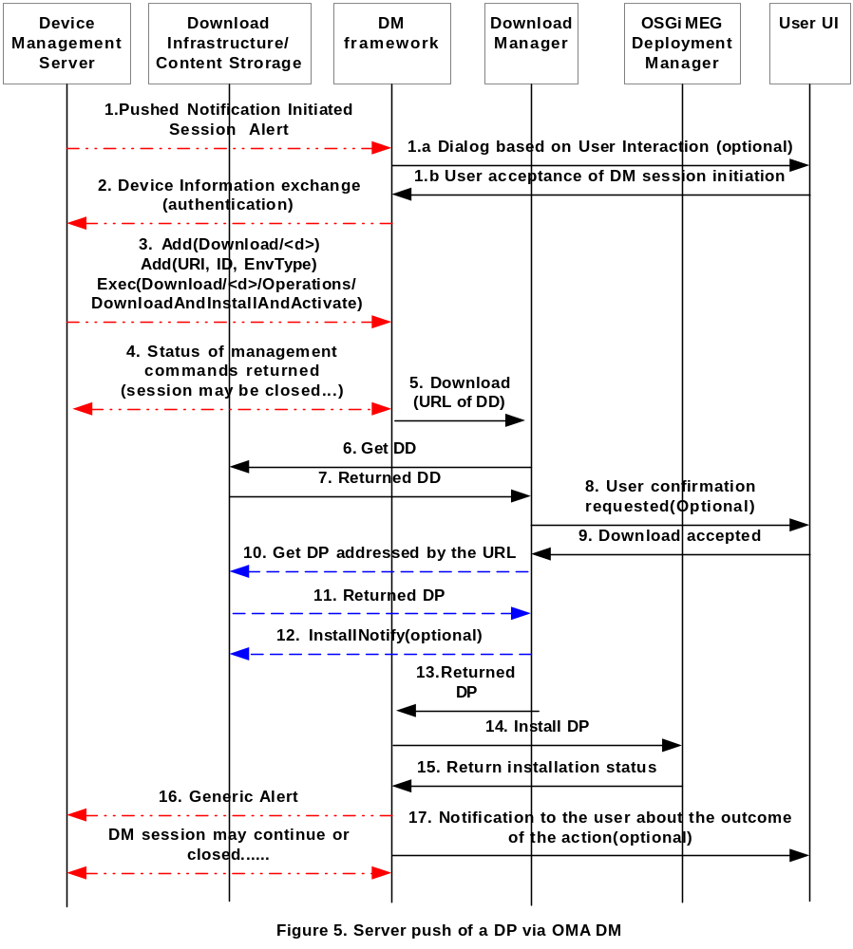

Notation:
Shows OMA DLOTA protocol interactions.
Indicates OMA DM protocol interactions.

Normal flow

1. Notification Initiated Session Alert OMA DM command is pushed to the device. The Push message may be delivered via a Push Proxy Gateway or DMS may directly communicate with the device if it’s able to operate as a PPG. If there is a DM session already between the device and DMS, the session initiation steps (1) aren’t needed.
1a,b. The <ui-mode> field of the pushed message indicates the User Interaction Mode requested. This user action may be informative only or may require the user confirmation of the DM session initiation.
2-4. Device DM framework initiates an OMA DM session with the DMS. As a minimum set of selection criteria, DevInfo parameters are sent to the server. This is mandatory for each OMA DM management session. The server sends the DM session management commands to create a dynamic node under the Download node and deliver the URI of the DLOTA DD of the OSGi DP, the ID and EnvType values and the execution request for the download and installation. Parties may close the DM session at this point.
5. Device DM framework calls Download Manager to download the OSGi DP. The URL of the DLOTA DD is passed.
6-9. After downloading the DLOTA DD some checks (e.g. capability) are performed. User confirmation may be requested and the size of the package investigated. If the outcome of any of the investigation is negative, further steps for download will be aborted and the reason returned to the DM framework.
10-11. The OSGi content is downloaded.
12. If the installNotifyURI attribute in the Download Descriptor has been explicitly used, the Download Manager informs the status of the download to the server indicated in the installNotifyURI field of the descriptor. This only implies that the OSGi DP has been successfully downloaded. It does not imply that it has been processed.
13. Download Manager returns the downloaded DP.
14-15. Device DM framework installs the DP via OSGi MEG Deployment API and gets back the status of the installation operation.
16. Device DM framework notifies the DMS server of the resulting status through a (subsequent client or server initiated) OMA DM session. The result is provided to the DMS server via a Generic Alert notification. This DM session can continue to carry other DM related management commands from any side or closed if no other actions needed.
17. User is notified about the outcome of the action (optional).

Considered Alternatives
For posterity, record the design alternatives that were considered but rejected along with the reason for rejection. This is especially important for external/earlier solutions that were deemed not applicable.

Security Considerations
Description of all known vulnerabilities this may either introduce or address as well as scenarios of how the weaknesses could be circumvented.

Document Support

References
- Bradner, S., Key words for use in RFCs to Indicate Requirement Levels, RFC2119, March 1997.
- Software Requirements & Specifications. Michael Jackson. ISBN 0-201-87712-0
- “OMA Device Management Protocol, Version 1.2”. Open Mobile Alliance™. OMA-TS-DM-Protocol-V1_2_0, URL:http://www.openmobilealliance.org
- “Generic Content Download Over The Air Specification Version 1.0”, Open Mobile Alliance™, OMA-Download-OTA-v1_0, URL:http://www.openmobilealliance.org/ [OMA Download v1.0 Enabler Release]
- “MEG Download” OSGi RFC 105.
- “MEG Deployment”, OSGi RFC 88.
Add references simply by adding new items. You can then cross-refer to them by chosing <Insert><Cross Reference><Numbered Item> and then selecting the paragraph. STATIC REFERENCES (I.E. BODGED) ARE NOT ACCEPTABLE, SOMEONE WILL HAVE TO UPDATE THEM LATER, SO DO IT PROPERLY NOW.

Author’s Address

Name
Company
Address
Voice
e-mail

Acronyms and Abbreviations

End of Document

