

RFC 121 Bundle Tracker
Final
18 Pages
Abstract
The BundleTracker class simplifies tracking bundles much like the ServiceTracker simplified tracking services.

Document Information

Table of Contents
0 Document Information 2
0.1 Table of Contents 2
0.2 Terminology and Document Conventions 3
0.3 Revision History 3
1 Introduction 4
2 Application Domain 4
3 Problem Description 4
4 Requirements 4
5 Technical Solution 5
5.1 Design Discussion 5
5.1.1 Overview 5
5.1.2 org.osgi.util.tracker package 6
5.1.3 Tracking Criteria 6
5.1.4 Synchronous Listener 6
5.1.5 Customized object 7
5.2 org.osgi.util.tracker.BundleTracker 7
5.2.1 context 9
5.2.2 BundleTracker 9
5.2.3 addingBundle 10
5.2.4 close 10
5.2.5 getBundles 10
5.2.6 getObject 11
5.2.7 getTrackingCount 11
5.2.8 modifiedBundle 11
5.2.9 open 11
5.2.10 remove 12
5.2.11 removedBundle 12
5.2.12 size 12
5.3 org.osgi.util.tracker.BundleTrackerCustomizer 13
5.3.1 addingBundle 13
5.3.2 modifiedBundle 14
5.3.3 removedBundle 14
6 Considered Alternatives 15
6.1 Using Services to model Bundles 15
6.2 Using asynchronous Bundle Listener 15
7 Security Considerations 17
8 Document Support 17
8.1 References 17
8.2 Author’s Address 17
8.3 Acronyms and Abbreviations 18
8.4 End of Document 18

Terminology and Document Conventions
The key words "MUST", "MUST NOT", "REQUIRED", "SHALL", "SHALL NOT", "SHOULD", "SHOULD NOT", "RECOMMENDED", "NOT RECOMMENDED", "MAY" and "OPTIONAL" in this document are to be interpreted as described in [1].
Source code is shown in this typeface.

Revision History
The last named individual in this history is currently responsible for this document.

Revision | Date | Comments
Initial | 7 August 2007 | Initial Draft.
Draft 2 | 13 September 2007 | Based upon CPEG discussion, I remove support for async BundleListener use by the tracker.
Draft 3 | 3 October 2007 | Based upon CPEG discussion, I modified the customizer signature to pass the BundleEvent, if any, which triggered the action.
Final | 2 December 2008 | No Changes. Going Final for CPEG voting.

Introduction
Service Tracker[4] has long been around (since Release 2) and has long been a very useful tool providing a simple and correct way to track a set of services in the face of dynamism. It is very useful for implementing whiteboard pattern approaches. With the advent of the extender model, it is now important to have a simple and correct way to track a set of bundles in the face of dynamism.

Application Domain
Any bundle, such as an extender bundle, that needs to track a set of bundles in a given range of states will need code to enable this tracking. Currently this is custom code for each such bundle.

Problem Description
Tracking bundles and services in the OSGi environment is challenging to do simply and correctly. Bundles may change state at any time and the bundle which needs to do the tracking will be started after a set of bundles already are present. The same challenges present for tracking services are also present for tracking bundles. Like the Service Tracker class introduced in Release 2, a Bundle Tracker class is needed[3] to define a standard, correct and easy-to-use way to track bundles.

Requirements
The following requirements are met by the proposed solution:
- The Bundle Tracker class must be modeled along the Service Tracker class to provide a familiar pattern to developers.
- The Bundle Tracker class must be in the org.osgi.util.tracker package to share code with Service Tracker reducing size, errors and maintenance.
- The Bundle Tracker class must be correct with respect to the dynamic nature of OSGi.
- The Bundle Tracker class must track all existing bundles which match the specified criteria as well as bundle whose state change to match the specified criteria after the tracker is opened.
- The Bundle Tracker must be thread safe.
- The Bundle Tracker must be able to support early versions of the framework (SynchronousBundleListener support is the minimal requirement.)

Technical Solution

Design Discussion

Overview
The Service Tracker design is based upon tracking service which are registered and match some specified criteria. Service events are used to indicate a state change in the service and are (only) synchronously delivered. During event processing, the event type along with criteria match against the service metadata is used to decide whether the service is to be added or removed from the tracker, or has just been modified.
The state diagram of a service is very simple.
The state diagram of a bundle is much more complex. The Bundle Tracker design is based upon the bundle’s state. Bundles are tracked if they are in a set of states and not tracked otherwise. In this design, the state of the bundle is of primary importance and not the type of the bundle event received by the tracker.
REGISTERED
REGISTERED
MODIFIED
UNREGISTERING

org.osgi.util.tracker package
This design places the new Bundle Tracker into the existing org.osgi.util.tracker package. This is valuable for 2 reasons. First, it enables code sharing with the Service Tracker class. The tracking logic has been refactored from the Service Tracker class into an abstract base class which is then used by the Bundle Tracker. This reduces footprint and (hopefully) errors due to maintenance of duplicated code.
Given the name of the package, which does not include the word “service”, there is no package naming issue. However section 701 of the spec will need to be renamed from Service Tracker Specification to simply Tracker Specification.
Furthermore, with this addition to the package, the version of the package is incremented to 1.4.

Tracking Criteria
The tracking criteria for the Bundle Tracker are supplied as a bit mask in the constructor. This mask is an ORing of a set of bundle states. If a bundle is in one of those states, the Bundle Tracker will track it. Since the tracker must track bundles whose state matches the criteria at the time the tracker is opened as well as bundles whose state changes to match the criteria after the tracker is opened, a consistent test is needed.
During tracker open, the only state to test is the bundle’s state as visible via Bundle.getState. However, while processing bundle events, both the bundle’s state and the event type are available for examination. Bundle event types are not sufficient to describe the resulting state of the bundle. The event type UNRESOLVED can be fired for entry to the INSTALLED and UNINSTALLED state.
In order to provide a simple and consistent test, the Bundle Tracker always examines the bundle’s state during open and bundle event processing. The bundle event type is not use. The delivery of the bundle event is used as a trigger to test the bundle against the tracking criteria to decide of the bundle should be tracked or untracked.

Synchronous Listener
The Bundle Tracker uses a Synchronous Bundle Listener. With synchronous bundle event processing, the bundle’s state is set before the event is synchronously fired and the event is delivered before the state can change again.
The following diagram depicts the bundle states and the event fired upon entry to those states. Note that entry to STARTING and STOPPING states is only signaled to synchronous bundle listeners and would not be reliably observable to asynchronous bundle listeners.
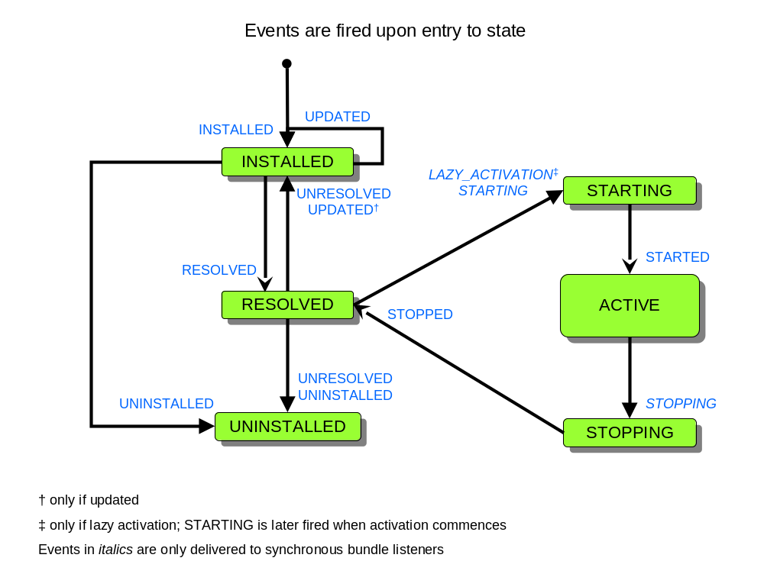

Customized object
Like Service Tracker, the Bundle Tracker also allows the tracking of a customized object (object returned from BundleTrackerCustomized.addingBundle) along with the tracked bundle. For Service Tracker, this customized object is typically the service object. For Bundle Tracker, the default implementation of addingBundle simply returns the bundle.

org.osgi.util.tracker.BundleTracker

java.lang.Object
org.osgi.util.tracker.BundleTracker
All Implemented Interfaces:
BundleTrackerCustomizer

public class BundleTracker
extends java.lang.Object
implements BundleTrackerCustomizer

The BundleTracker class simplifies tracking bundles much like the ServiceTracker simplifies tracking services.
A BundleTracker object is constructed with state criteria and a BundleTrackerCustomizer object. A BundleTracker object can use the BundleTrackerCustomizer object to select which bundles are tracked and to create a customized object to be tracked with the bundle. The BundleTracker object can then be opened to begin tracking all bundles whose state matches the specified state criteria.
The getBundles method can be called to get the Bundle objects of the bundles being tracked. The getCustomizedObject method can be called to get the customized object for a tracked bundle.
The BundleTracker class is thread-safe. It does not call a BundleTrackerCustomizer object while holding any locks. BundleTrackerCustomizer implementations must also be thread-safe.
Since:
1.4

Field Summary
protected org.osgi.framework.BundleContext | context  Bundle context this BundleTracker object is tracking against.

Constructor Summary
BundleTracker(org.osgi.framework.BundleContext context, int stateMask, BundleTrackerCustomizer customizer)
Create a BundleTracker object for bundles whose state is present in the specified state mask.

Method Summary
java.lang.Object | addingBundle(org.osgi.framework.Bundle bundle, org.osgi.framework.BundleEvent event)  Default implementation of the BundleTrackerCustomizer.addingBundle method.
void | close()  Close this BundleTracker object.
org.osgi.framework.Bundle[] | getBundles()  Return an array of Bundle objects for all bundles being tracked by this BundleTracker object.
java.lang.Object | getObject(org.osgi.framework.Bundle bundle)  Returns the customized object for the specified Bundle object if the bundle is being tracked by this BundleTracker object.
int | getTrackingCount()  Returns the tracking count for this BundleTracker object.
void | modifiedBundle(org.osgi.framework.Bundle bundle, org.osgi.framework.BundleEvent event, java.lang.Object object)  Default implementation of the BundleTrackerCustomizer.modifiedBundle method.
void | open()  Open this BundleTracker object and begin tracking bundles.
void | remove(org.osgi.framework.Bundle bundle)  Remove a bundle from this BundleTracker object.
void | removedBundle(org.osgi.framework.Bundle bundle, org.osgi.framework.BundleEvent event, java.lang.Object object)  Default implementation of the BundleTrackerCustomizer.removedBundle method.
int | size()  Return the number of bundles being tracked by this BundleTracker object.

Methods inherited from class java.lang.Object
clone, equals, finalize, getClass, hashCode, notify, notifyAll, toString, wait, wait, wait

Field Detail

context

protected final org.osgi.framework.BundleContext context
Bundle context this BundleTracker object is tracking against.
Constructor Detail

BundleTracker

public BundleTracker(org.osgi.framework.BundleContext context,
int stateMask,
BundleTrackerCustomizer customizer)
Create a BundleTracker object for bundles whose state is present in the specified state mask.
Bundles whose state is present on the specified state mask will be tracked by this BundleTracker object.
Parameters:
context - BundleContext object against which the tracking is done.
stateMask - A bit mask of the ORing of the bundle states to be tracked.
customizer - The customizer object to call when bundles are added, modified, or removed in this BundleTracker object. If customizer is null, then this BundleTracker object will be used as the BundleTrackerCustomizer object and the BundleTracker object will call the BundleTrackerCustomizer methods on itself.
See Also:
Bundle.getState()
Method Detail

addingBundle

public java.lang.Object addingBundle(org.osgi.framework.Bundle bundle,
org.osgi.framework.BundleEvent event)
Default implementation of the BundleTrackerCustomizer.addingBundle method.
This method is only called when this BundleTracker object has been constructed with a null BundleTrackerCustomizer argument. The default implementation returns the specified Bundle object.
This method can be overridden in a subclass to customize the object to be tracked for the bundle being added.
Specified by:
addingBundle in interface BundleTrackerCustomizer
Parameters:
bundle - Bundle being added to this BundleTracker object.
event - The bundle event which caused this customizer method to be called or null if there is no bundle event associated with the call to this method.
Returns:
The customized object to be tracked for the bundle added to this BundleTracker object.
See Also:
BundleTrackerCustomizer

close

public void close()
Close this BundleTracker object.
This method should be called when this BundleTracker object should end the tracking of bundles.

getBundles

public org.osgi.framework.Bundle[] getBundles()
Return an array of Bundle objects for all bundles being tracked by this BundleTracker object.
Returns:
Array of Bundle objects or null if no bundles are being tracked.

getObject

public java.lang.Object getObject(org.osgi.framework.Bundle bundle)
Returns the customized object for the specified Bundle object if the bundle is being tracked by this BundleTracker object.
Parameters:
bundle - Bundle being tracked.
Returns:
Customized object or null if the specified Bundle object is not being tracked.

getTrackingCount

public int getTrackingCount()
Returns the tracking count for this BundleTracker object. The tracking count is initialized to 0 when this BundleTracker object is opened. Every time a bundle is added, modified or removed from this BundleTracker object the tracking count is incremented.
The tracking count can be used to determine if this BundleTracker object has added, modified or removed a bundle by comparing a tracking count value previously collected with the current tracking count value. If the value has not changed, then no bundle has been added, modified or removed from this BundleTracker object since the previous tracking count was collected.
Returns:
The tracking count for this BundleTracker object or -1 if this BundleTracker object is not open.

modifiedBundle

public void modifiedBundle(org.osgi.framework.Bundle bundle,
org.osgi.framework.BundleEvent event,
java.lang.Object object)
Default implementation of the BundleTrackerCustomizer.modifiedBundle method.
This method is only called when this BundleTracker object has been constructed with a null BundleTrackerCustomizer argument. The default implementation does nothing.
Specified by:
modifiedBundle in interface BundleTrackerCustomizer
Parameters:
bundle - Bundle whose state has been modified.
event - The bundle event which caused this customizer method to be called or null if there is no bundle event associated with the call to this method.
object - The customized object for the bundle.
See Also:
BundleTrackerCustomizer

open

public void open()
Open this BundleTracker object and begin tracking bundles.
Bundle which match the state criteria specified when this BundleTracker object was created are now tracked by this BundleTracker object.
Throws:
java.lang.IllegalStateException - if the BundleContext object with which this BundleTracker object was created is no longer valid.
java.lang.SecurityException - If the caller and this class do not have the appropriate AdminPermission[context bundle,LISTENER], and the Java Runtime Environment supports permissions.

remove

public void remove(org.osgi.framework.Bundle bundle)
Remove a bundle from this BundleTracker object. The specified bundle will be removed from this BundleTracker object. If the specified bundle was being tracked then the BundleTrackerCustomizer.removedBundle method will be called for that bundle.
Parameters:
bundle - Bundle to be removed.

removedBundle

public void removedBundle(org.osgi.framework.Bundle bundle,
org.osgi.framework.BundleEvent event,
java.lang.Object object)
Default implementation of the BundleTrackerCustomizer.removedBundle method.
This method is only called when this BundleTracker object has been constructed with a null BundleTrackerCustomizer argument. The default implementation does nothing.
Specified by:
removedBundle in interface BundleTrackerCustomizer
Parameters:
bundle - Bundle being removed.
event - The bundle event which caused this customizer method to be called or null if there is no bundle event associated with the call to this method.
object - The customized object for the bundle.
See Also:
BundleTrackerCustomizer

size

public int size()
Return the number of bundles being tracked by this BundleTracker object.
Returns:
Number of bundles being tracked.

org.osgi.util.tracker.BundleTrackerCustomizer
All Known Implementing Classes:
BundleTracker

public interface BundleTrackerCustomizer

The BundleTrackerCustomizer interface allows a BundleTracker object to customize the bundle objects that are tracked. The BundleTrackerCustomizer object is called when a bundle is being added to the BundleTracker object. The BundleTrackerCustomizer can then return an object for the tracked bundle. The BundleTrackerCustomizer object is also called when a tracked bundle has been removed from the BundleTracker object.
The methods in this interface may be called as the result of a BundleEvent being received by a BundleTracker object. Since BundleEvents are received synchronously by the BundleTracker, it is highly recommended that implementations of these methods do not alter bundle states while being synchronized on any object.
The BundleTracker class is thread-safe. It does not call a BundleTrackerCustomizer object while holding any locks. BundleTrackerCustomizer implementations must also be thread-safe.
Since:
1.4

Method Summary
java.lang.Object | addingBundle(org.osgi.framework.Bundle bundle, org.osgi.framework.BundleEvent event)  A bundle is being added to the BundleTracker object.
void | modifiedBundle(org.osgi.framework.Bundle bundle, org.osgi.framework.BundleEvent event, java.lang.Object object)  A bundle tracked by the BundleTracker object has been modified.
void | removedBundle(org.osgi.framework.Bundle bundle, org.osgi.framework.BundleEvent event, java.lang.Object object)  A bundle tracked by the BundleTracker object has been removed.

Method Detail

addingBundle

java.lang.Object addingBundle(org.osgi.framework.Bundle bundle,
org.osgi.framework.BundleEvent event)
A bundle is being added to the BundleTracker object.
This method is called before a bundle which matched the search parameters of the BundleTracker object is added to it. This method should return the object to be tracked for this Bundle object. The returned object is stored in the BundleTracker object and is available from the getBundles method.
Parameters:
bundle - Bundle being added to the BundleTracker object.
event - The bundle event which caused this customizer method to be called or null if there is no bundle event associated with the call to this method.
Returns:
The object to be tracked for the Bundle object or null if the Bundle object should not be tracked.

modifiedBundle

void modifiedBundle(org.osgi.framework.Bundle bundle,
org.osgi.framework.BundleEvent event,
java.lang.Object object)
A bundle tracked by the BundleTracker object has been modified.
This method is called when a bundle being tracked by the BundleTracker object has had its state modified.
Parameters:
bundle - Bundle whose state has been modified.
event - The bundle event which caused this customizer method to be called or null if there is no bundle event associated with the call to this method.
object - The tracked object for the modified bundle.

removedBundle

void removedBundle(org.osgi.framework.Bundle bundle,
org.osgi.framework.BundleEvent event,
java.lang.Object object)
A bundle tracked by the BundleTracker object has been removed.
This method is called after a bundle is no longer being tracked by the BundleTracker object.
Parameters:
bundle - Bundle that has been removed.
event - The bundle event which caused this customizer method to be called or null if there is no bundle event associated with the call to this method.
object - The tracked object for the removed bundle.

Considered Alternatives

Using Services to model Bundles
See Member Bug 501[3] for some discussion of this design alternative.

Using asynchronous Bundle Listener
The first draft of this RFC suggested allowing BundleTracker to provide the option of using either BundleListener (asynchronous) and SynchronousBundleListener. This was changed to only support SynchronousBundleListsner due to issues with using asynchronous BundleListener. Following is the removed text:
The Bundle Tracker supports user configuration to use either a Synchronous Bundle Listener or the asynchronous Bundle Listener. For synchronous bundle event processing, the bundle’s state is set before the event is synchronously fired and the event is delivered before the state can change again. However, if asynchronous bundle event processing is used, then the behavior of the tracker will be different since entry to some states are not visible to asynchronous bundle listeners and the time between the event firing and event delivery may prevent some bundle state transitions from being observed.
The following diagram depicts the bundle states and the event fired upon entry to those states. Note that entry to STARTING and STOPPING states is only signaled to synchronous bundle listeners and are thus not reliably observable to asynchronous bundle listeners.
There are also cases when several bundle events can be fired before the first event is asynchronously delivered. During processing of the first event by the BundleTracker, the state of the bundle at the time the final event was fired is observed. The can result in the bundle becoming tracked while processing the first event. As the remaining events are then delivered, the bundle’s state does not actually change, but the Bundle Tracker will call the modifiedBundle method of the customizer for each additional event. There are also cases where the bundle should be removed and added back the tracker (e.g. bundle update), but delay in delivery of the STOPPED event, which might result in the bundle being removed from the tracker, until after the bundle has been restarted will result in the tracker never seeing the bundle leave the ACTIVE state and thus never being removed and then added back to the tracker.
Thus the value of supporting asynchronous bundle listeners in Bundle Tracker is dubious and we may want to consider removing it.
To deal with the above issues, two approaches are possible but still may deliver suboptimal results.
- Process the event types in addition to the bundle state to “simulate” the bundle being removed and added if necessary. This logic could be fairly complex as it will have to map event type onto the state map. This would only be necessary for the asynchronous listener.
- Have Bundle Tracker always use a synchronous bundle listener and wrap the addBundleListener call in a doPrivileged method to not require the caller to have the necessary permission. This would make every bundle able to synchronously be notified of bundle events which will provide a form of privilege elevation in secured systems.

Security Considerations
Bundle Tracker runs in the security context of the bundle using it. It doesn't provide or remove any of the security checks that are already in place for bundles.
In order to support tracking bundles synchronously, a SynchronousBundleListener must be used. In order to prevent elevation of privilege, the Bundle Tracker implementation must not use doPrivilege when registering the SynchronousBundleListener object. This means that the code calling the open method (which makes the addBundleListener call) and the Bundle Tracker class itself must both have the AdminPermission[context bundle, LISTENER] permission. In particular, the bundle containing the org.osgi.util.tracker package must have this permission. If the org.osgi.util.tracker package is delivered as part of the framework implementation, then it likely has AllPermission and this requirement is then met.

Document Support

References
- Bradner, S., Key words for use in RFCs to Indicate Requirement Levels, RFC2119, March 1997.
- Software Requirements & Specifications. Michael Jackson. ISBN 0-201-87712-0
- Member Bug 501, https://www2.osgi.org/members/bugzilla/show_bug.cgi?id=501
- Service Tracker Specification, OSGi Core Specification, R4 V4.1, Section 701

Author’s Address

Name | BJ Hargrave
Company | IBM Corporation
Address | 800 N Magnolia Av, Orlando, FL, USA
Voice | +1 386 848 1781
e-mail | hargrave@us.ibm.com

Acronyms and Abbreviations

End of Document

