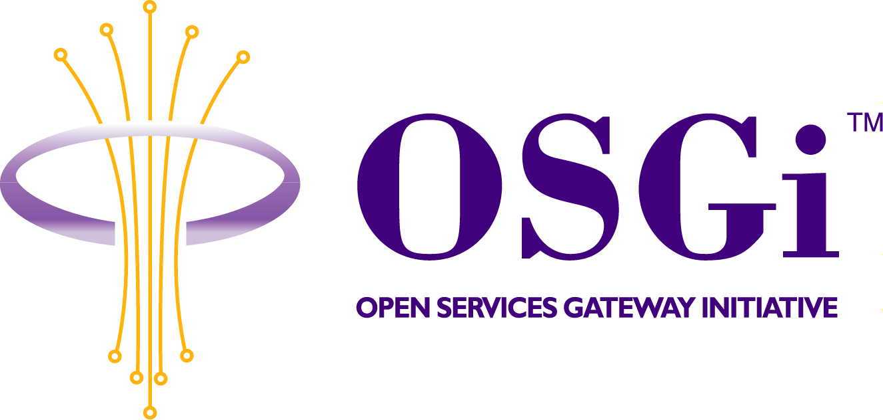
RFP 12 - Accounting Service
Members Only
cpeg-rfp_12_accounting_service-1_00A
5 Pages
Abstract
This RFP provides an interface and some general guidelines for collecting charging data from services residing inside the Open Services Gateway Initiative Services framework.

Document Information

Table of Contents
0 Document Information 2
0.1 Table of Contents 2
0.2 Status 2
0.3 Acknowledgement 2
0.4 Terminology and Document Conventions 2
0.5 Revision History 3
1 Introduction 3
2 Motivation and Rationale 3
3 Technical Discussion 3
4 Security Considerations 4
5 Document Support 5
5.1 References 5
5.2 Author’s Addresses 5
5.3 Acronyms and Abbreviations 5
5.4 End of Document 5

Status
This document suggests the following extension to the OSGi specification. Distribution of this document is unlimited.

Acknowledgement
The author wants to acknowledge Peter Kriens for his help and valuable advice.

Terminology and Document Conventions
The key words "MUST", "MUST NOT", "REQUIRED", "SHALL", "SHALL NOT", "SHOULD", "SHOULD NOT", "RECOMMENDED", "NOT RECOMMENDED", "MAY" and "OPTIONAL" in this document are to be interpreted as described in [1].
Source code is shown in this typeface.

Revision History
The last named individual in this history is currently responsible for this document.

Revision | Date | Comments
1.0 | 2000-11-21 | Lars Eriksson, lars.q.eriksson@telia.se

Introduction
The Accounting API creates a standard interface for a service to record its charging data in the framework. This API should be a core utility within the OSGi framework.

Motivation and Rationale
Today there is little monetary incentive for service providers and operators to develop and use the OSGi framework as a production platform. The Accounting API will provide an added attraction to the OSGi platform as it solves this problem. Firstly, it gives service providers a mechanism to collect charging data for small amounts of money in a safe and reliable way. Secondly, operators have the potential to create a profitable billing service for the OSGi platform. Finally, the end-user benefits from a broader spectrum of Internet services and a convenient way of payment for these services.

Technical Discussion
This Accounting API collects charging data based on service consumption for an underlying billing system.

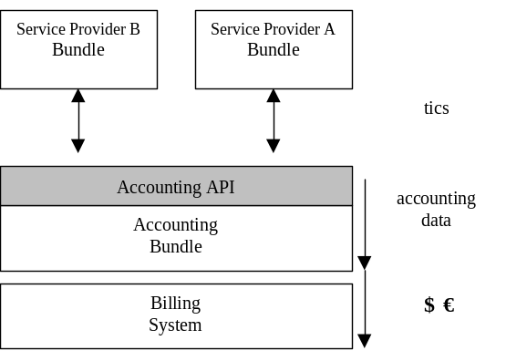

The Accounting API collects charging data, ‘tics’ which is a unit neutral to national currencies and tax regulations etc. The charging can be based on time, service quality or other pre-defined parameters. The Accounting API intermediates ‘tic’ requests and responses between the Service Provider bundle and the accounting mechanism. The value of a ‘tic’ may vary and is based on a pre-defined agreement between the Service Provider and the customer, hence it's beyond the scope of this API. The connection to the billing system is also outside the scope of this RFP.

Confidence, simplicity and integrity are three important issues related to an accounting mechanism:
- The Service Provider wants guarantees that a service will be paid for and its charging data is kept secret to other service providers.
- The end-user is ensured that he only pays for requested services and has the control to refuse a transaction.

The RFP will also cover the installation process and how a bundle can discover the framework’s accounting mechanism.

Security Considerations
The Accounting API necessitates some security considerations:
- How to identify, authenticate, authorize and address the accounting mechanism
- How to identify, authenticate, authorize the services that use the accounting mechanism
- How to identify and authenticate the consumer (a person or a household)
- How to identify and authenticate the provider of the “consumption” service (who provides the bundle and service, e.g. streaming video service).
- How to provide the consumer with both anonymous and non-anonymous access to or purchase of a “consumption” service. Either being anonymous to both the owners of the accounting service and the “consumption” service or only anonymous to the owner of the “consumption” service.
- How to prove to the “consumption” service provider that the accounting service provider is forwarding the correct information of the usage of the “consumption” service to the “consumption” service provider.
- How to ensure the integrity of charging data sent between general service and the accounting mechanism.
- How to define, generate and store audit data in a secure manner.

Document Support

References
- Bradner, S., Key words for use in RFCs to Indicate Requirement Levels, RFC2119, March 1997.

Author’s Addresses

Name | Lars Eriksson
Company | Telia Research AB
Address | Bryggargatan 6  SE14980 Nynashamn  Sweden
Voice | +46 8 520 67132
e-mail | Lars.q.eriksson@telia.se

Acronyms and Abbreviations
OSGi Open Services Gateway Initiative

End of Document

