
RFP 17 - Secure Messaging
Confidential, Draft
rmeg-rfp_17_secmsg-1_00A
8 Pages

Abstract
Services on a Service Gateway must be able to communicate securely with external entities, such as back-end servers, management systems or other peer services. This RFP discusses the need of a standardized secure messaging service and the capabilities such a service should offer.

Document Information

Table of Contents
0 Document Information 2
0.1 Table of Contents 2
0.2 Status 2
0.3 Acknowledgement 2
0.4 Terminology and Document Conventions 3
Revision History 3
1 Introduction 3
2 Motivation and Rationale 3
3 Technical Discussion 4
3.1 Address Space 5
3.2 Routing 5
3.3 Protocol 5
3.4 Summary 6
4 Security Considerations 6
4.1 Introduction 6
4.2 Implementation and Design 7
4.3 Integrity and Authentication 7
4.4 Confidentiality 7
4.5 External Dependencies 7
4.6 Replay 7
4.7 Denial of Service 7
4.8 Unauthorized Use of Resources 7
5 Document Support 8
5.1 References 8
5.2 Author’s Address 8
5.3 Acronyms and Abbreviations 8
5.4 End of Document 8

Status
This document suggests the following extension to the OSGi specification. Distribution of this document is unlimited within OSGi.

Acknowledgement

Terminology and Document Conventions
The key words "MUST", "MUST NOT", "REQUIRED", "SHALL", "SHALL NOT", "SHOULD", "SHOULD NOT", "RECOMMENDED", "NOT RECOMMENDED", "MAY" and "OPTIONAL" in this document are to be interpreted as described in [1].
Source code is shown in this typeface.

Revision History
The last named individual in this history is currently responsible for this document.

Revision | Date | Comments
Initial | January 31 2001

Introduction
Services on a Service Gateway must be able to communicate securely with external entities, such as back-end servers, management systems or other peer services. This document discusses the need of a standardized secure messaging service, defining both a client API and a protocol. Streaming is not covered by this RFP. The messaging service can be used for stream negotiation, but these details are beyond the scope of this document.

Motivation and Rationale
How services communicate will be highly dependent on the software and hardware environment of the Service Gateway, which may even be subject to change over time. The available or preferred communication channels may depend on such factors as:
- Physical location of sender and recipient (mobile applications)
- Urgency of a message (cost vs. speed tradeoff)
- Faults (multiple redundant communication channels)
Service developers may not know at design time the communication capabilities of the target run time environment. A standardized messaging API can abstract the communication and relieve its clients of routing and many other messaging details. The result is:
- Smaller and simpler services
- All services can benefit from advanced messaging features
A common protocol shall be used by the messaging service, creating a standard way for message communication between Service Gateways. A standardized protocol will result in:
- Interoperability between Service Gateways
- Possibility for service developers to design services interacting with non-Java applications.
Services will need to send messages containing sensitive data, which must be authenticated and/or protected from eavesdropping. These security issues are tightly coupled to the protocol used. The messaging service shall be designed with these security issues in mind, providing message integrity and confidentiality for clients using the service.

Technical Discussion
The messaging service is located in the network layer of the OSI model, providing peer-to-peer message communication. The transports used to deliver messages encapsulate the link layer (e.g. TCP/IP or WDP) and the physical layer (e.g. Ethernet, 802.11b).
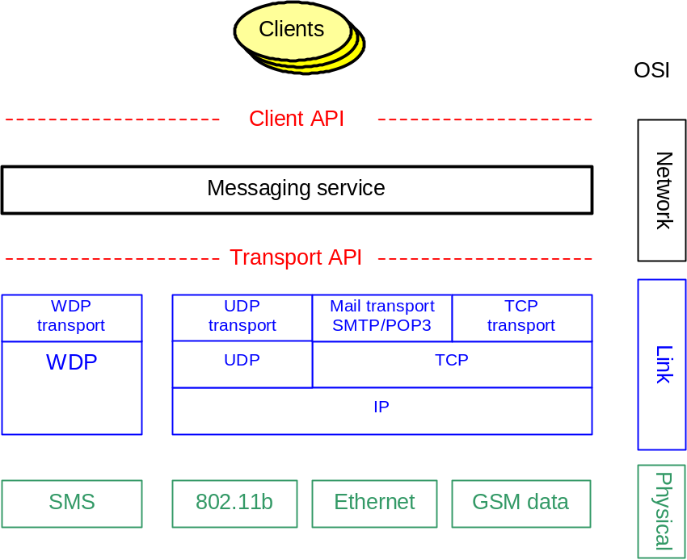
Figure 1:Layers
The messaging service must be able to handle different environments where transport capabilities may vary. In light of this, the messaging service should have a modular architecture, allowing capabilities, such as transports, to be added as plug-ins. The API used by clients, shall hide the actual details of the current transports available.

Address Space
The address space is an important component when designing and deploying a network of Service Gateways. The address space should be hierarchical, supporting routing and providing a flexible and scalable name space. The hierarchy must at least support the addressing of an entity within a Service Gateway. The entity addresses must also be unique within the message system in which they are used, where a message system is a set of interconnected Service Gateways. If communication between several message systems is needed the, entity addresses must be unique within all those message systems. The address space could for example be based on DNS hostnames, providing a collision free hierarchical name space. The address space must be large enough not to pose problems in the future.

Routing
The messaging service shall support routing, not assuming that end-to-end transport connectivity exists. The support for routing enables flexible and scalable messaging solutions. The routing procedure must be able to select the next hop using addresses in the network layer and thereby selecting a transport service and transport address from the link layer. This selection should also be based on privileges of the calling service, message priority etc. The service shall also be able to handle temporarily unreachable destinations, using store and forward.

Protocol
A common protocol shall be used by the messaging service, creating a standard way for message communication between Service Gateways. The protocol must be designed with security in mind, providing a high level of integrity and confidentiality for clients. The security issues are discussed further in section 4, Security Considerations. The protocol must be language independent enabling development of non-Java applications interacting with services. The protocol shall have a reasonable overhead allowing small messages to be sent over costly transports. The protocol shall also support autonomous secure messages; meaning that messages are self-contained with no external references to volatile data such as session keys. Autonomous secure messages enable messages to be stored for later delivery, verification or decryption.

Summary
The discussions in the previous sections can be condensed into the following list of requirements:
- Standardized client API, hiding transport details for clients
- Standardized transport API, allowing transport plug-ins
- Standardized message format, designed for secure messages
- Support peer-to-peer message communication
- Support transport of arbitrary data
- Support secure messages, providing integrity and confidentiality for clients
- Define a uniform address space
- Support message routing

Security Considerations
Security must be considered for each interface published by the messaging service, including API’s as well as protocols used. This section discusses some general security issues that shall be considered when designing a secure messaging service. Public key infrastructure (PKI) and private key handling is beyond the scope of this document. This section assumes that key and certificate management is handled outside the messaging service.

Introduction
Security is a complex art that is often neglected, but it has gained some attention lately in the light of computer viruses. A system is no more secure than its least secure part, including but not limited to cryptographic algorithm, key management, protocol specification, physical security, intermediate storage and user interaction. Security must be considered throughout the development and independent security experts should perform audit. This chapter discusses some important issues to consider when designing a communication protocol and service.

Implementation and Design
The service and the protocol itself shall not be unnecessarily complex. Errors in the implementation of the protocol may be avoided by keeping the protocol as simple as possible. A complex protocol or API makes the design of clients using the service harder, which results not only in increased development time but also in a higher rate of implementation errors. Features that are not necessary shall be avoided and options should be kept to a minimum.
A protocol or a service does not automatically become secure just because it uses cryptography. Security must be considered in every part of the design; it is rarely an efficient approach to add security afterwards. Attempts to add security to a system that was developed without security in mind often result in weak security and an overall development time longer than it would have been if security was considered from the beginning.

Integrity and Authentication
A client shall be able to request that data is cryptographically signed in order for the receiver to be able to verify the authenticity of the data and the sender. The receiver must also be able to determine the integrity of the message. The messaging service must verify the identity of the sending entity and shall not allow a client to disguise as another client when sending messages.

Confidentiality
A client shall be able to request that data is encrypted to stop an eavesdropper from acquiring sensitive information. Encrypted information from two different clients shall be encrypted with separate keys to avoid that a client decrypts the information. It may also be desirable to send encrypted information to one place and the key needed to decrypt the information to another place, this ensures that two parties have to cooperate to decrypt the information.

External Dependencies
The protocol shall by itself be able to guarantee the security. This means that hop-to-hop security should be avoided in favor of end-to-end security. External information should not be trusted; examples are sending IP address that may be spoofed or answers to DNS lookups that can be forged.

Replay
Duplicated transmissions shall not cause any problems. An economic transaction shall for example not be registered twice if data is sent twice because of network delay or replayed by an attacker.

Denial of Service
One client shall not be able to prevent another client from using the messaging service. The messaging service shall for example not allow a client to use all available bandwidth or change the routing table for other clients. The protocol shall be robust enough to withstand deliberate or accidental injection of malformed or volumous data. Important communication shall not be blocked due to e.g. excessive computation intensive cryptographic operations, and it shall not be possible to induce malfunctions such as routing problems.

Unauthorized Use of Resources
The messaging service shall enforce a policy regarding resource usage. Expensive transports such as SMS may for example only be used for important messages while other information may only be sent via other means.

Document Support

References
- Bradner, S., Key words for use in RFCs to Indicate Requirement Levels, RFC2119, March 1997.

Author’s Address

Name | Anders Rimén
Company | Gatespace
Address
Voice
e-mail | ar@gatespace.com

Name | Andreas Gunnarsson
Company | Gatespace
Address
Voice
e-mail | andreas@gatespace.com

Acronyms and Abbreviations

End of Document

