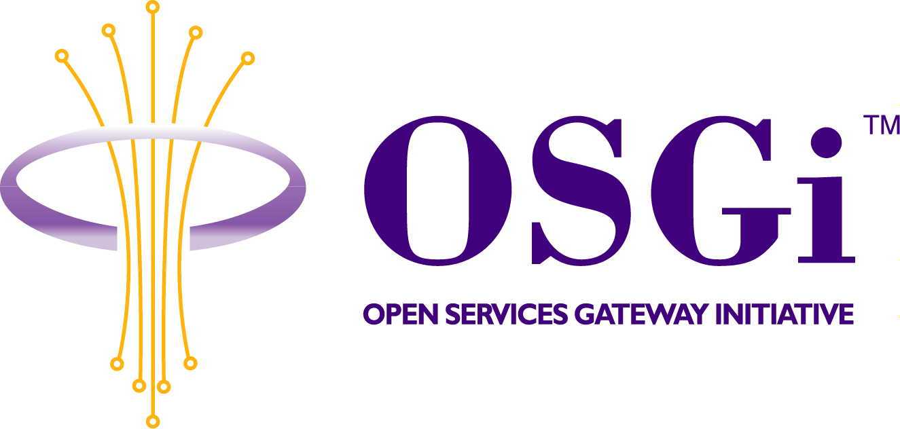
Jini Driver API
Confidential, Draft
RFP 24
8 Pages

Abstract
Discovery and Control of Jini Devices and Service from within OSGi Framework.
Using the OSGi Device Driver model. Export OSGi Services as Jini services.

Document Information

Table of Contents
0 Document Information 2
0.1 Table of Contents 2
0.2 Status 2
0.3 Acknowledgement 2
0.4 Terminology and Document Conventions 2
0.5 Revision History 3
1 Introduction 4
2 Motivation and Rationale 4
3 Technical Discussion 5
3.1 Interaction with Jini network 5
3.1.1 Lookup and discovery 5
3.1.2 Exporting OSGi Services as Jini Services 6
4 Security Considerations 7
5 Document Support 7
5.1 References 7
5.2 Author’s Address 7
5.3 Acronyms and Abbreviations 8
5.4 End of Document 8

Status
This document specifies Jini Driver API for the Open Services Gateway Initiative, and requests discussion and suggestions for improvements. Distribution of this document is unlimited within the OSGi organization.

Acknowledgement

Terminology and Document Conventions
The key words "MUST", "MUST NOT", "REQUIRED", "SHALL", "SHALL NOT", "SHOULD", "SHOULD NOT", "RECOMMENDED", "NOT RECOMMENDED", "MAY" and "OPTIONAL" in this document are to be interpreted as described in [1].
Source code is shown in this typeface.

Revision History
The last named individual in this history is currently responsible for this document.

Revision | Date | Comments
Initial | Jul 09 2001 | Krasimira Velikova, ProSyst Software AG  k_velikova@prosyst.bg  Pavlin Dobrev, ProSyst Software AG  p.dobrev@prosyst.com

Introduction
Jini network technology provides simple mechanisms, which enable devices to plug together to form an impromptu community -- a community put together without any planning, installation, or human intervention. Each device provides services that other devices in the community may use. These devices provide their own interfaces, which ensures reliability and compatibility.
Jini technology uses a lookup service, which devices and services register with. When a device is plugeed in, it goes through an add-in protocol, called discovery and join-in. The device first locates the lookup service (discovery) and then uploads an object that implements all of its services' interfaces (join).
To use a service, a person or a program locates it using the lookup service. The service's object is copied from the lookup service to the requesting device where it is going to be used. The lookup service acts as an intermediary between a client looking for a service and the corresponding service. Once the connection is established, the lookup service is not involved in any of the resulting interactions between the client and the service.
It doesn't matter where a service is implemented -- compatibility is ensured because each service provides everything needed to interact with it. There is no central repository of drivers, or anything else for that matter.
The Java programming language is the key to making Jini technology work. Devices in a network employing Jini technology are tied together using Java Remote Method Invocation (RMI). By using the Java programming language, a Jini network architecture is secure. The discovery and join protocols, as well as the lookup service, depend on the ability to move Java objects, including their code, between Java virtual machines.
Jini technology not only defines a set of protocols for discovery, join, and lookup, but also leasing and transaction mechanisms to provide resilience in a dynamic networked environment. The underlying technology and services architecture is powerful enough to build a fully distributed system on a network of workstations. In addition the Jini network infrastructure is small enough that a community of devices enabled by Jini network software can be built out of the simplest devices. For example, it is entirely feasible to build such a device community out of home entertainment devices or a few cellular telephones with no "computer" in sight.

Motivation and Rationale
Jini network architecture is on the way to becoming widely used. In order OSGi-complaint gateways to be ready to meet future customer needs in that direction, there is a need for a standardized API which enables OSGi Services to interact with Jini Networks either using Jini Devices and Services or being able to act as one.

Technical Discussion

Interaction with Jini network

Lookup and discovery
The specified API must provide interfaces that allow registering of Jini Lookup services as OSGi services. When the LUS are registered with the framework, ather OSGi services must be capable of interacting with them.
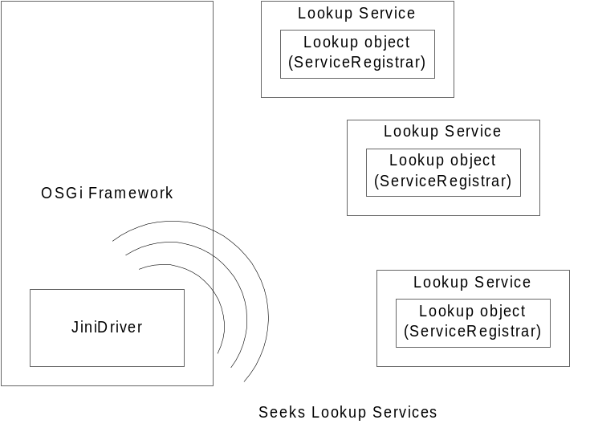
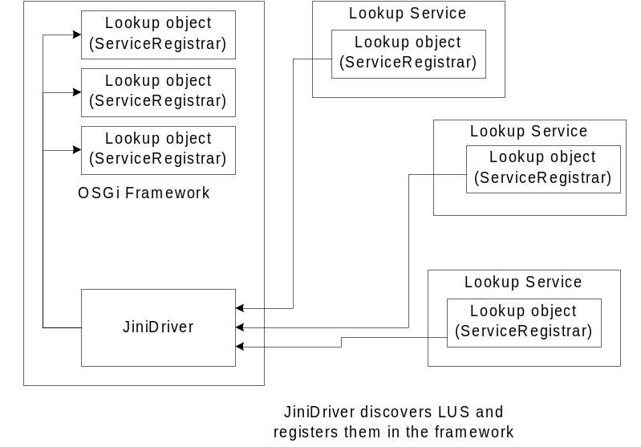

Exporting OSGi Services as Jini Services
All exportable OSGi services must have a property, whose values define the state of this service in the Jini network. The Jini Driver must manage the life cycle of Jini services. When the OSGi service is started the driver must automatically register this service with the LUS. When the service is stopped the driver must automatically unregister it.
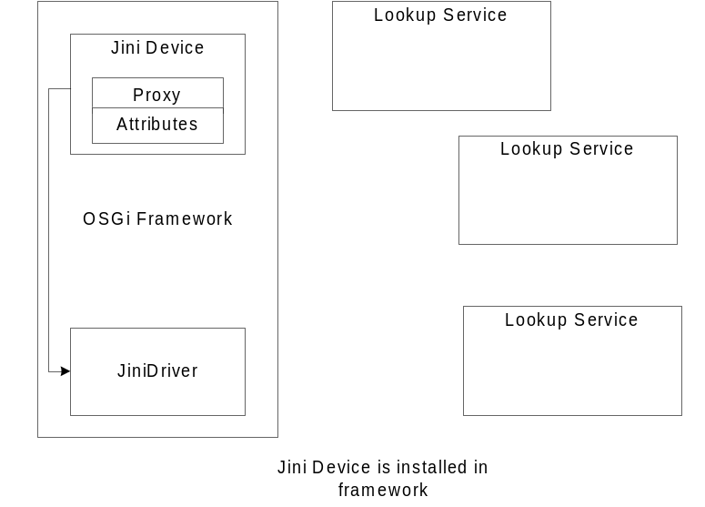
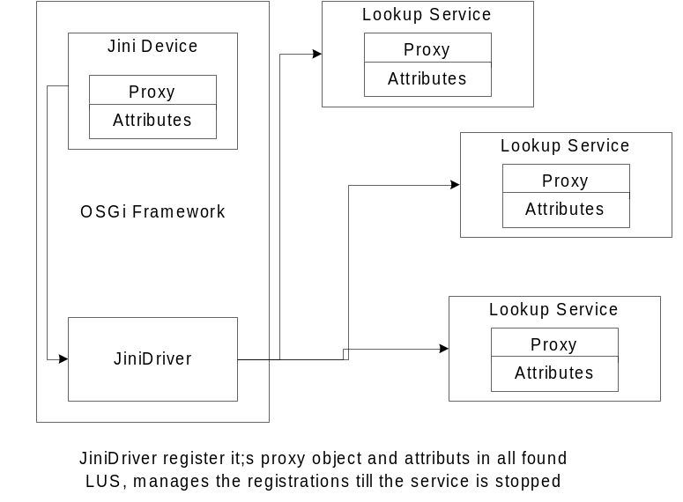

Security Considerations
Security in inherited from Jini.

Document Support

References
- Bradner, S., Key words for use in RFCs to Indicate Requirement Levels, RFC2119, March 1997.
- http://www.jini.org

Author’s Address

Name | Pavlin Dobrev
Company | ProSyst Software AG
Address | Gustav-Heinemann-Ufer 54, 50968 Cologne, Germany
Voice | +359 2 963 10 04
e-mail | p.dobrev@prosyst.com

Name | Krasimira Velikova
Company | ProSyst Software AG
Address | Gustav-Heinemann-Ufer 54, 50968 Cologne, Germany
Voice | +359 2 963 10 04
e-mail | k_velikova@prosyst.bg

Acronyms and Abbreviations
LUS Jini Lookup Service

End of Document

