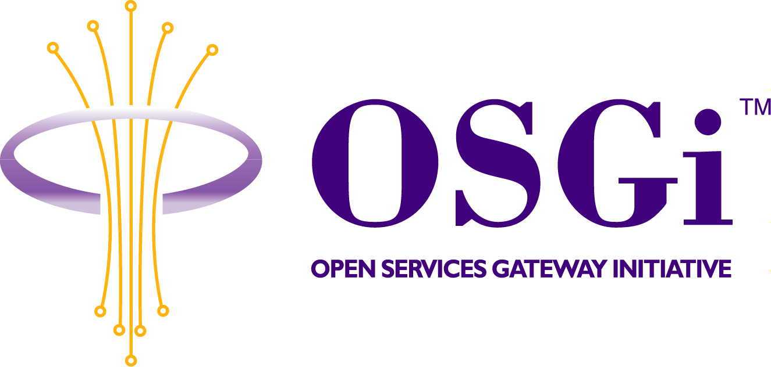
RFP 42 - Diagnostics
Confidential, Draft

Abstract
This document is a proposal on how diagnostics should be handled in an OSGi Service Platform.

Document Information

Table of Contents
0 Document Information 2
0.1 Table of Contents 2
0.2 Status 2
0.3 Acknowledgements 2
0.4 Terminology and Document Conventions 3
0.5 Revision History 3
1 Introduction 4
2 Application Domain 4
2.1 Automotive Context 4
2.2 Entities 5
2.3 Domain 5
2.4 Standard References 6
3 Problem Description 7
3.1 Use Cases 8
Use Case Name 8
Diagnose a device 8
4 Requirements 10
5 Document Support 11
5.1 References 11
5.2 Author’s Address 11
5.3 Acronyms and Abbreviations 11
5.4 End of Document 11

Status
This document proposes a diagnostic framework for the Open Services Gateway Initiative. The contents are not definitive and are open to discussion. Distribution of this document is unlimited within the OSGi membership.

Acknowledgements

Terminology and Document Conventions
The key words "MUST", "MUST NOT", "REQUIRED", "SHALL", "SHALL NOT", "SHOULD", "SHOULD NOT", "RECOMMENDED", "NOT RECOMMENDED", "MAY" and "OPTIONAL" in this document are to be interpreted as described in [1].
Source code is shown in this typeface.

Revision History
The last author in this table is the current owner of the document.
Revision | Author | Date | Comments
0.0 | Olivier Pavé | Mar 17, 2003 | New document.
0.1 | Olivier Pavé | Apr 24, 2003 | Updates according to remarks made in San-Francisco member meeting: clarify Application Domain and Problem Descritpion sections; add use cases.
0.2 | Olivier Pavé | May 20, 2003 | Updates according to remarks made in Cologne EG meeting: change 'resource' is changed to 'service' for better understanding; change service/device definition; add a new requirement on bundle degradation.
0.3 | Olivier Pavé | Jun 14, 2003 | Integration of remarks from Sofia Doncheva and Rick DeNatale
0.4 | Olivier Pavé | Jun 24, 2003 | Updates after EG meeting in Raleigh. Version for final approval.

Introduction
This RFP is a proposal for a diagnostic framework on an OSGi Service Platform.

On an OSGi Service Platform there are a range of different services and some are connected to a device. In such cases it is necessary to perform diagnostic commands in order to configure, monitor and verify the system (e.g. after a crash).

Taking into account that diagnostic commands are specific to the associated service, there must be a standard approach for the use of diagnostic commands, and for the retrieval of the resulting feedback.

Application Domain

Automotive Context

It must be understood that the OSGi Service Platform is a node on the in-vehicle network. Diagnostic commands can be applied on all the services installed in the OSGi Service Platform.

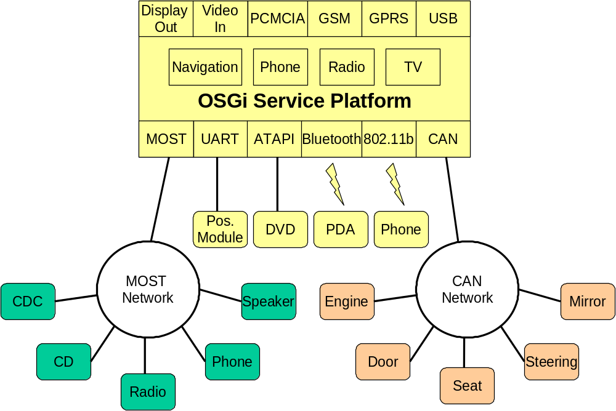
Figure 1 – Typical Vehicle Architecture
The Figure 1 presents a typical Vehicle Architecture where several devices are connected to the MOST network, the CAN network or to the OSGi Service platform directly.

The scope of this RFP is only to diagnose all software services (with maybe a device connected to it) installed on the OSGi Service Platform. All modules concerned are represented in yellow.

The other modules (in green and orange) provide diagnostic capabilities accessible via the network itself.

Entities

The following entities are used in this document:

- Diagnostician - A person who needs to perform a diagnostic check.

- Service - An OSGi service that can be connected to a device.

- Device - An external piece of hardware connected to the system.

Domain

The diagnostic domain is the set of commands that a diagnostician can perform on services installed on the system.

All services have various diagnostic capabilities. We can illustrate these capabilities by using the example of an independent positioning device connected to the in-vehicle system.

The diagnostician would like to:

- Get Device Parameter Values
usually a device has parameters, which may or may not be configurable. These parameters are sometimes stored on the device itself. For example, the diagnostician would like to retrieve the current parameter value and the status of the GPS antenna.

- Change Device Parameter Values
when the device has configurable parameters, the diagnostician may want to change them. For example, change the DPP (Distance Per Pulse) of the Tachometer.

- Execute a Self-test
some devices have a self-test feature. A test can run internally on the device and the resulting status is returned to the caller. For example, the diagnostician may want to run a self-test on the gyroscope.
Some self-tests can run automatically on a device during device start-up or during runtime. If a problem is encountered, an error is logged.

- Monitor Device Data
Some devices provide a continuous flow of data and a diagnostician can monitor this data. For example, a positioning device produces dead reckoning data (latitude, longitude, altitude, heading, speed, and driving direction) that is constantly monitored by a test application.

- Collect Device Data
A diagnostician may want to collect device data over a period of time or at regular intervals, and store the data for future analysis. For example, on a positioning device, a diagnostician may want to know the maximum speed measured in a given period.

Note: Diagnostic command content and methods (e.g. protocols) are outside the scope of this RFP.

Standard References

- OSGi State Management
The State management on an OSGi Service Platform is handled using Wire Admin Service. This provides a standard connection between state providers and consumers.

- Keyword Protocol 2000 (ISO 14230)
ISO 14230 is a protocol that is used mostly on vehicles manufactured and sold in Europe. It is also commonly referred to as "Keyword Protocol 2000". In recent years, there has been increased effort on European standardization (European On Board Diagnostics or EOBD). In addition, there is limited provision in SAE J1979 for the use of certain ISO 14230 modes, so some of these vehicles may start appearing in the US in the near future. It is for the above reasons that solutions for this protocol have been developed.

Problem Description

Taking into account all diagnostic capabilities defined in the application domain, there must be a standard approach for the use of diagnostic commands and for the retrieval of the resulting feedback.

Recently developed services can extend these diagnostic capabilities so the OSGi Service Platform must facilitate their use without any changes to the system.
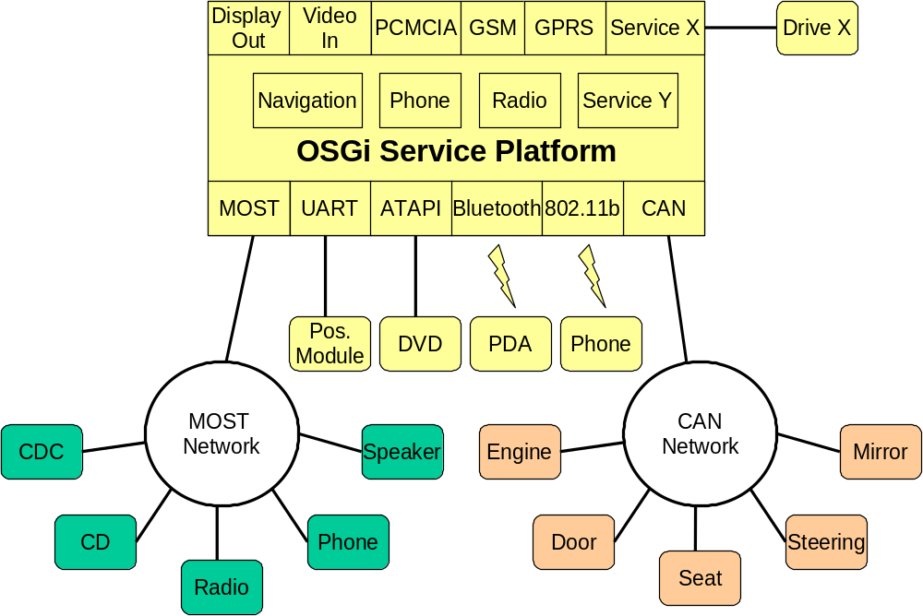

Figure 2 – Installation of two new services

In the Figure 2 two new services is installed: Service X and Service Y. The second one has a device connected to it. These two services provide new diagnostic commands and they must implement these commands in order to be easily called by a client. More, all errors and results must be properly logged in the OSGi Service Platform.

A client that needs to perform diagnostics on a service must know the extent of the diagnostic capabilities and how to use them. The framework must not be impacted.

Use Cases

Use Case Name | Diagnose a device

Feature
Actors | Diagnostician | In car user | Certified System Engineer | Other Sub-Systems
Actors | X |  | X
Description | The intent of the use case is to diagnose a device connected to the system.
Flow of events | Basic flow - Diagnose and adjust device parameters  The diagnostician may adjust device parameters:  - When the type of the car changes.  - For diagnostics purpose.  1. This use case starts when the user requests to view or change device parameters.  2. The system displays device parameter values  3. The user changes the values.  4. The system saves the changes.  5. The use case ends.
Must have devices | A device connected to the system.
May have devices | N/A
Prior conditions | Service is running.
Post conditions | Basic flow:  1. Device parameters are changed.  Alternative flows:  1. Errors are logged and device parameters are stored.
Alternative flow 1 | The system tests the service  - This use case starts when the diagnostician requests a self-test.  - The system starts the self-test on the service  - The system logs errors and warnings.  - The system returns a result from the self-test to the caller  - The use case ends.
Alternative flow 2 | Diagnosis of device input data  1. This use case starts on the diagnostician requests a record.  2. The system starts the collection of device data  3. The system shall be able to provide the following data on a continuous basis on screen.  4. The use case ends.
Alternative flow 3 | The system collects device data for a given period and store them  Specific prior-conditions:  - The system is continuously supplied by electrical power.  - The collection period is customizable.  1. This use case starts when the diagnostician requests to collect information.  2. The user can change the collection period.  3. The system starts the collection of data.  4. The system stores the collected data into persistent memory.  5. The use case ends.
Notes
Future considerations | Data collection  The system provides a facility to output a file with the collected device data.
Lower level Use Cases | N/A
Date | 02/04/03
Status | Draft

Requirements
This RFP covers the following requirements.

Remote and Local Connection
A diagnostician should be able to perform diagnostics locally or remotely. Locally means that a test application is installed on the system and displays/saves the results from the tests locally (e.g. on the car monitor). Remotely means that the diagnostician performs diagnostics through a communication channel (MOST, CAN, TCP/IP, Wireless, …)

Change Device Parameters
A diagnostician must be able to view, change and if necessary store device parameter values.

Start Self-test on a Service
The system must allow starting (and stopping) of a self-test on a service. Self-test results can be stored on a logger and/or sent out to the test application.
Self-tests can be started explicitly by the diagnostician, or can run automatically during device (if any) start-up or during runtime.

Monitor Device Data
The system must allow the setup of a continuous flow of a defined set of data from a device. Data are sent continuously to the test application. The test application can decide whether to display it or record it or send it to be displayed remotely.

Collect Device Data
The system must allow the collection of a defined set of data from a device. The collection period must be configurable and the data stored in persistent memory, and if necessary, displayed on the test application.

Read Logged Information
The system must allow the logged information to be read during a self-test and after a system crash.

Diagnose Newly Installed Service
The system must allow the diagnosis of newly installed services without any changes to the system.

Notify about Bundle Degradation
There is no standardized way of supervising bundles except for checking that the state of the bundle is "ACTIVE". A bundle may be marked as "ACTIVE" even though it is not functioning. In this case the bundle wants to inform client that something is going and that their internal state is not really "ACTIVE". The main goal is to allow client to register to bundle specific internal states.

Separable Diagnostic Commands
Diagnostic commands are usually used on demand. For low memory devices it should possible to avoid a permanent installation of bundles containing diagnostic capabilities. These bundles could be installed when needed.

Document Support

References
- Bradner, S., Key words for use in RFCs to Indicate Requirement Levels, RFC2119, March 1997.

Author’s Address
Name | Olivier Pavé
Company | Siemens VDO Automotive
Address | Batiment Alpha  80, route des Lucioles – BP 305  06906 Sophia Antipolis Cedex
Voice | +33 (0)4 92 38 11 29
e-mail | olivier.pave@siemens.com

Acronyms and Abbreviations

End of Document

