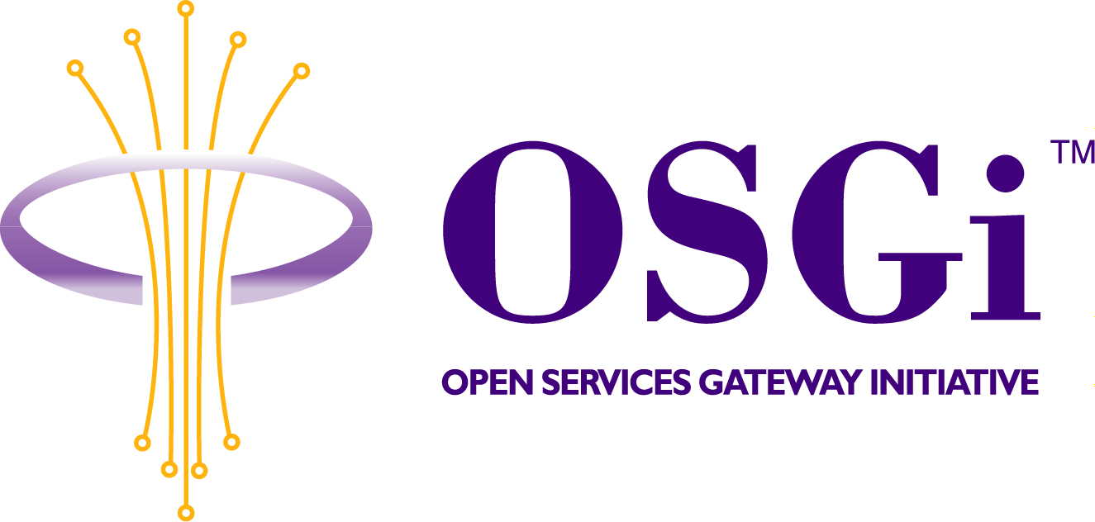
SIP-based Device Communication Service
Confidential, Draft
RFP 43
9 Pages
Abstract
SIP-based Discovery and Control of Mobile Devices and Services from within an OSGi Framework. Using the OSGi Device Driver Model. Exporting OSGi Services as SIP-based Mobile Devices and Services.

Document Information

Table of Contents
0 Document Information 2
0.1 Table of Contents 2
0.2 Status 2
0.3 Acknowledgement 2
0.4 Terminology and Document Conventions 2
0.5 Revision History 3
1 Introduction 4
2 Motivation and Rationale 4
3 Technical Discussion 4
4 Other Considerations 8
5 Document Support 8
5.1 References 8
5.2 Author’s Address 8
5.3 Acronyms and Abbreviations 9
5.4 End of Document 9

Status
This document specifies requirements for APIs that implement OSGi device service mobility support using SIP, and requests discussion and suggestions for improvements. Distribution of this document is unlimited within the OSGi organization.

Acknowledgement

Terminology and Document Conventions
The key words "MUST", "MUST NOT", "REQUIRED", "SHALL", "SHALL NOT", "SHOULD", "SHOULD NOT", "RECOMMENDED", "NOT RECOMMENDED", "MAY" and "OPTIONAL" in this document are to be interpreted as described in [7].
Source code is shown in this typeface.

Revision History
The last named individual in this history is currently responsible for this document.

Revision | Date | Comments
Initial | April 12, 2003 | Dennis Bushmitch, Panasonic Information and Networking Technologies Laboratory  db@research.panasonic.com
Changes after the Cologne EG-Meeting | May 13, 2003 | Dennis Bushmitch, Panasonic Information and Networking Technologies Laboratory  db@research.panasonic.com

Introduction
Originally designed as the protocol for multimedia session creation with intended use in VoIP applications, SIP [1] has become ever more popular in other applications (e.g., device control, instant messaging and presence, capability negotiation, etc.). This enhanced usage of SIP is warranted by SIP’s support service/device portability and location independence [2], wide area service mobility and strengthened security when compared with HTTP.

As OSGi framework evolves toward supporting mobile devices and services, it is important to acknowledge that mobile devices of the future wireless networks (e.g., 3GPP2 [3] standard devices) will support SIP. While other device control frameworks (e.g., UPnP) are considered as “too heavy” for mobile device’s hardware and software profile, SIP protocol usage in mobile is certain.

Because of application level mobility SIP offers, numerous SIP services were proposed and deployed in the past:
Device control using SIP (Telcordia) [4]
Device/service capability negotiation (Fujitsu) [5]
SIP-based Instant messaging and presence (SIMPLE) [6]

SIP protocol (its interaction and methods) provides all the needed tools for device, associated service and its control point mobility, discovery, registration, eventing, control, presentation. Specifically, SIP provides event notification – a critical facility for device control. Existing SIP methods can accommodate all the required functionality of gateway-device interaction, while some additional information can be carried inside new custom MIME types.

Motivation and Rationale
Motivation behind this proposal is to create the specification for an OSGi service, which defines APIs that enable:
- Secure Wide area support of device registration, communication, control, and event handling for next generation of devices (e.g., 4G mobile) utilizing SIP
- OSGi Device Mobility (Application-layer mobility) using SIP
- OSGi Inter-working and Inter-Gateway bridging of heterogeneous local area device communication protocols (e.g., UPnP, Jini) across wide area network.

The following are some application use cases, which are proposed to be supported by the new API:

1) Secure WAN Communication of Diverse Devices, including SIP-based devices (e.g., 3GPP2, 4G mobile clients). In this first use case scenario, SIP protocol enables secure access from the wide area mobile device to local devices and services connected and registered with home gateways as OSGi devices. The proposed OSGi SIP service will translate between SIP devices and other different local devices and services. This use case is shown in Fig. 1. In addition, a new type of SIP-based devices will be supported. The existing SIP-based networking infrastructure will be utilized.

- OSGi Device and Service Mobility using SIP. In this use case, device registered with 1st framework is exported as SIP device and registered with SIP proxy / location service. This device gains mobility feature of SIP, can move and register with another gateway while maintaining its SIP service / device identity. This use case is shown in Fig. 2. This use case utilizes SIP-based logical naming which preserves service portability and can also abstract service definitions from physical devices to capability-based functionality.

- OSGi Inter-gateway Bridging: in this use case, devices registered with one Framework’s service registry are exported as SIP devices and imported into a service registry of another Framework. Thus cross-framework device and service mobility is achieved. This use case is shown in Fig. 3 and can be viewed as extension of the previous use case. One gateway can also gain mobility with respect to another gateway, while maintaining device connectivity.

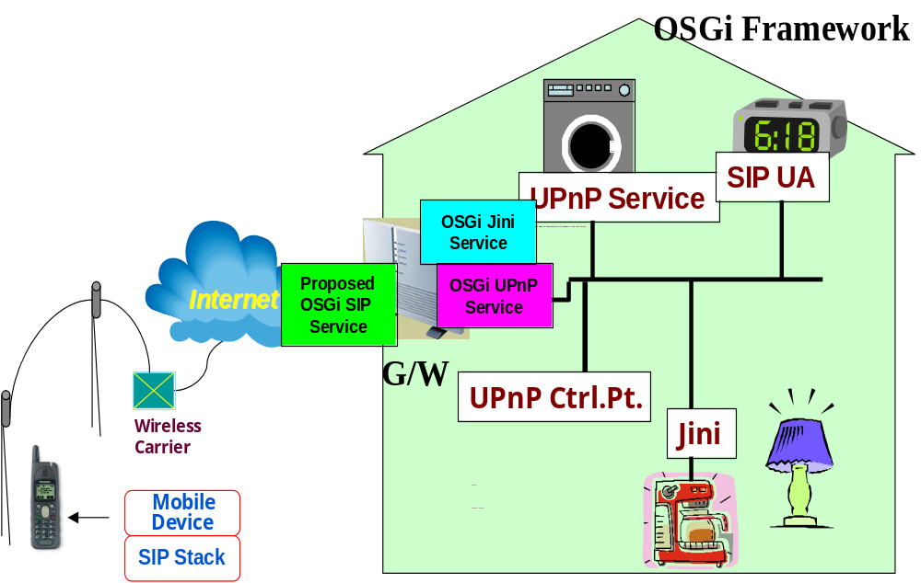

Fig.1 Secure WAN Communication of Diverse Devices

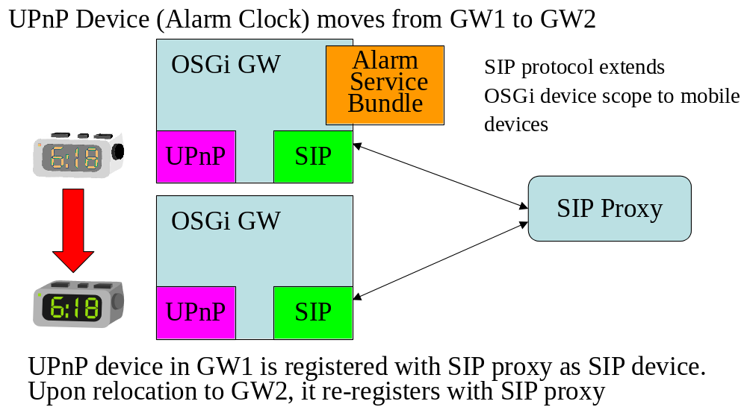

Fig.2 OSGi Device Mobility using SIP

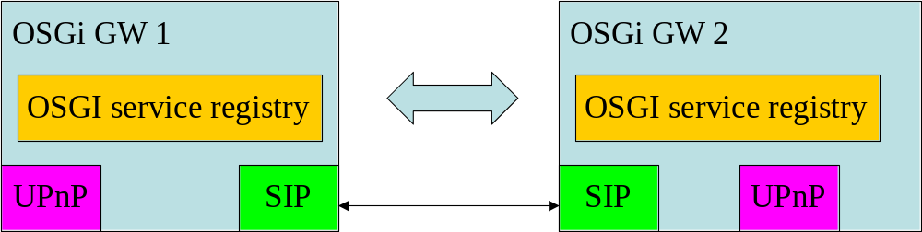

Fig.3 OSGi Inter-Gateway Bridging

Technical Discussion
The following are the high-level requirements for the proposed service

OSGi APIs have to be provided for:
- Export of OSGi services into mobile SIP-based device communication framework
- Import of SIP device functionality into OSGi framework

The proposed service will utilize the OSGi device driver model. SIP Device Service Driver must register all SIP devices with OSGi Framework

SIP devices need to be devices in a context of the OSGi Framework’s Device manager.
Bundles need to discover registered SIP devices. Bundles must be able to listen to SIP-devices’ events.
Bundles must be able to control SIP devices and be controlled by SIP devices. Bundles must be able to discover SIP devices/services capabilities.

The Proposed service is different from SIP protocol bundle:
Provides “high end” SIP device control service to other bundles / end user
Underlying SIP device control issues need to be transparent to application developers
Proposed service is different from API specification to SIP protocol’s general functionality

Examples of similar level OSGi services presently standardized by OSGi: Jini, UPnP

Example level of abstraction in the proposed API are as follows:
SIP device interface via SIPDevice
SIP device registration via SIPDeviceRegister
SIP device eventing via SIPDeviceEvent

The proposed Service would be bridged with other service (e.g., UPnP) by means of IPC provided by bridging bundles. Bridging bundles would utilize both services and would provide proxying relying upon:
OSGi-level device discovery
OSGi-level eventing
OSGi-level control
Etc.

The SIP service Export Manager MUST provide API for OSGi Services to export their functionality as SIP-based Devices and Services.

Other Considerations
Why is UPnP not sufficient for device networking today:

It has limited scalability due to multicasting during discovery, UPnP “Eventing”
Limited device discovery due to a single level search
UPnP has questionable security since UPnP presently lacks security architecture and inherits the HTTPS security drawbacks
It requires carefully provisioned multicast network with communication that cannot exceed home network boundary
UPnP does not support user mobility: device mobility, control point mobility
Finally, UPnP has large footprint for mobile devices

Document Support

References
- Session Initiation Protocol (SIP), RFC 3261, www.ietf.org
- S. Moyer, D. Marples, S. Tsang and A. Ghosh, “Service Portability of Networked Appliances”, IEEE Communications Magazine, January 2002
- 3rd Generation Partnership Project (3GPP) www.3gpp.org
- Device Control using SIP: http://www.argreenhouse.com/iapp
- Capability negotiation using SIP: Fujitsu internet draft
- SIMPLE: http://www.ietf.org/html.charters/simple-charter.html
- Bradner, S., Key words for use in RFCs to Indicate Requirement Levels, RFC2119, March 1997

Author’s Address

Name | Dennis Bushmitch
Company | Panasonic Information and Networking Technologies Laboratory
Address | 2 Research Way, Princetonm NJ 08540
Voice | +1 609 734 7337
e-mail | db@research.panasonic.com

Name | David Famolari
Company | Telcordia
Address | 445 South St, MCC-1B225B, Morristown, NJ 07960
Voice | +1 973 829 4506
e-mail | fam@research.telcordia.com

Acronyms and Abbreviations

End of Document

