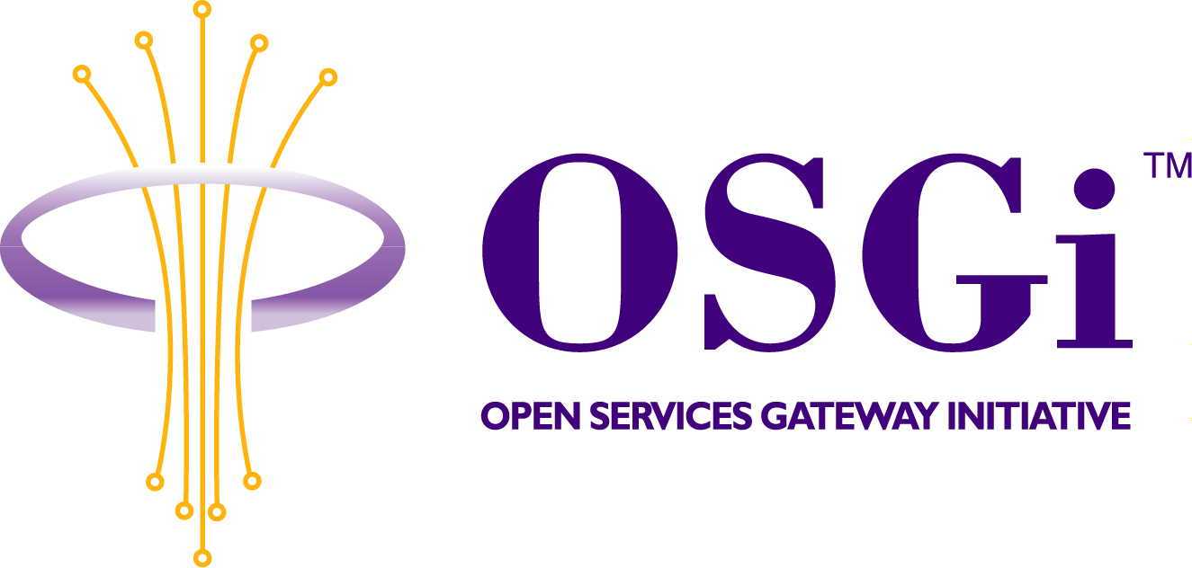
EHS API
Confidential, Draft
RFP 45
8 Pages
Abstract

The European Home Systems (EHS) Specification defines the way electronic and electric devices in and around a home can interact and communicate with each other. Major European white goods, brown goods and telecommunication industries developed (starting in 1987) and validated EHS specification. EHS is further developed by EHSA's Standards Control Committee, involving also major European electrical utilities and semiconductor companies. The possibility to provide platform independent software through java should convince OSGi members of really required need to support that standard.

Document Information
All Page within this Box
All Page Within This Box

Table of Contents

0Document Information 2
0.1Table of Contents 2
0.2Status 2
0.3Acknowledgement 2
0.4Terminology and Document Conventions 2
0.5Revision History 3
1Introduction 3
2Motivation and Rationale 4
3Technical Discussion 4
3.1Application Domain Context 4
3.2Use case for the EHS API 5
3.2.1 Device Search 5
3.2.2 Device Control 6
3.2.3 Device Unenroll 6
3.2.4 Modem Control 6
4Security Considerations 6
5Document Support 6
5.1References 6
5.2Author’s Address 6
5.3Acronyms and Abbreviations 7
5.4End of Document 7

Status
This document suggests EHS API for the Open Services Gateway Initiative, and requests discussion. Distribution of this document is unlimited within OSGi.

Acknowledgement

Terminology and Document Conventions
The key words "MUST", "MUST NOT", "REQUIRED", "SHALL", "SHALL NOT", "SHOULD", "SHOULD NOT", "RECOMMENDED", "NOT RECOMMENDED", "MAY" and "OPTIONAL" in this document are to be interpreted as described in [1].
Source code is shown in this typeface.

Revision History
The last named individual in this history is currently responsible for this document.

Revision | Date | Comments
Initial | Apr 17 2003 | Veselin Petev, ProSyst Software AG  v_petev@prosyst.bg
Update | May 15 2003 | Diagrams added by Veselin Petev
Update | May 16 2003 | Style and format revision by Vesselin Malinovsky
Update | May 26 2003 | Content revision by Sofia Doncheva
Update | July 15 2003 | Small changes by Kai Hackbarth

Introduction
Energy cost savings, security of persons and goods, comfort improvement are some of the benefits of Home Automation. Energy cost savings are achieved thanks to temperature management depending on presence and type of rooms, automatic adaptation of power consumption to tariff rates or lighting management. Security of persons and goods is increased with functions such as detection of fire or gas leakage, teletransmission of alarm or detection of intrusion. Increasing of quality of life brings new facilities for the elderly, in-house distribution of entertainment and services, telecontrol of heating and lighting. To achieve all these new services, home appliances, connected on different communication media, have to communicate to exchange messages in a structured way following a communication standard. This is the purpose of the European Home Systems protocol.
Born in 1992 by the publishing of a comprehensive specification for an open communication protocol dedicated to Home Automation, European Home Systems (EHS) has now entered a mature phase: hardware and software products are existing; major European companies involved in white and brown goods and major European utilities have already decided to include EHS protocol in their products.
As OSGi framework evolves toward supporting home devices and services, it is important to acknowledge that home devices of the future home networks will support EHS.

Motivation and Rationale
The European Home System has gained popularity lately. Just like other popular home-network standarts like X10, UPnP, CeBUS, Jini, etc. it allows full control over the house.
The network is designed to run alone, when configured, without any need of external components. But external components like PC are often used in a new installation when it should be prepared, configured and later – maintained.
Some possible problems that may occur in EHS require complex and slow diagnostics, which can be done only by EHS professional in the house.
OSGi, in other hand, through its device access specification and the capability of efficient enterprise management could allow EHS manufacturers to do remote diagnostics and configuration of their EHS client installations.
With an EHS API it becomes easier to control devices over the EHS Network at home. It should be totally independent on the protocol used by a specific Physical EHS Modems. The EHS API should provide access to the EHS Modem and EHS Device Table. The EHS Device Table holds all devices available in the EHS Network. There should also be a logical representation of the physical EHS Devices, which are registered as OSGI Device services in the framework. The logical service holds all properties of the physical appliance and it allows a complete control of the physical one.

Technical Discussion

Application Domain Context
An EHS API specification should be capable of addressing, accessing and manipulating EHS devices.
The EHS specification has been defined in order that home appliances can communicate and share each other's resources. The EHS protocol is based on a shared communication system and on unambiguous definitions of the device functionality.
The EHS specification describes completely all the communications aspects. The EHS communication model follows the structure of the Open Standard Interconnection (OSI) reference model. EHS specifies the physical layer, the data link layer, the network layer and the application layer. Due to the fact that the message length is limited, the dialogue session is short and the command language is managed by the application layer, the transport, session and presentation layer has been omitted.
The API should provide unique access to the EHS-bus, independent on the physical connection (e.g. RS232, USB). It should also support full network stack, which is based on the OSI model.
The EHS API should be flexible enough to handle various types of communications and should cover only the required subset of bus access, which is common to all different types of EHS communication.
Further information can be retrieved from the EHS Specification Version 3.

A possible EHS implementation could have the following main components:
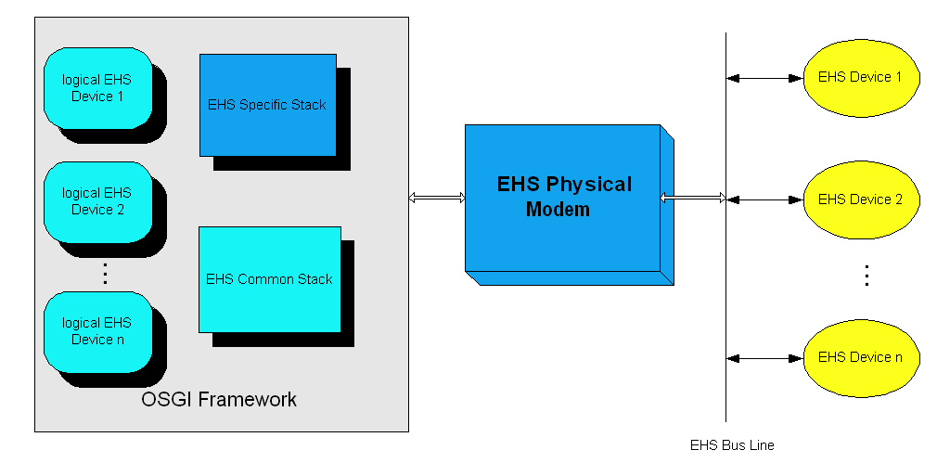
The EHS Common Stack holds EHS modem independent logic. It handles a table with devices similar to the table of the physical modems. The EHS Specific Stack manages the control of this table. For each physical device in the EHS network, the EHS Common Stack registers a service in the OSGI Framework. Through this service the External Application can control the physical appliances. The logical EHS devices represent the link to the physical devices. The connection protocol between the OSGi framework and the EHS Physical modem is totally up to the EHS Specific stack. Different protocols can be used: Serial Port, USB and others. The EHS API does not specify which of them to be used.

Use case for the EHS API
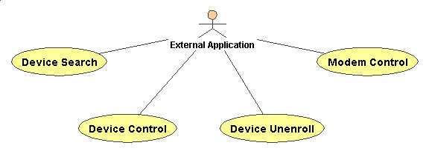

Device Search
Initiates sending of a device search command. If there are physical devices in the EHS Network it initiates their registration as services in the OSGI Framework.

Device Control
With this action the EHS API gives to the External Application access to the physical EHS Device. The External Application is notified for device events through a corresponding listener interface.

Device Unenroll
With this action the External Application can unenroll a device it is not interested in from the physical modem

Modem Control
With this action the External Application can send commands to the physical EHS Modem for maintaining its device table, creating a new house address, reset, etc.

Security Considerations
The EHS protocol does not support authorization or any other security related issues.

Document Support

References
- Bradner, S., Key words for use in RFCs to Indicate Requirement Levels, RFC2119, March 1997.
- EHS Specification from EHSA.

Author’s Address

Name | Veselin Petev
Company | ProSyst Software AG
Address | Dürener Str. 405, 50858 Cologne, Germany
Voice | +359 2 963 10 04
e-mail | v_petev@prosyst.bg

Acronyms and Abbreviations
EHS – European Home Systems
EHSA – European Home System Association
ETS – EIB Tool Software
Falcon – EIB Development Tool
UPnP – Universal Plug and Play
OSI – OSI/ISO Model, ISO 7498

End of Document

