
RFP 0046 - OSGi on Embedded Systems
Confidential, Draft
10 Pages

Abstract
High interest has been shown to put the flexibility of an OSGi framework also on small products and systems with (very) limited hardware resources. This document is basis for a discussion and describes what techniques can be used to down-size the big platform in a dynamic way to still keep both performance and key features.

Document Information

Table of Contents
0 Document Information 2
0.1 Table of Contents 2
0.2 Status 2
0.3 Acknowledgement 2
0.4 Terminology and Document Conventions 2
0.5 Revision History 3
1 Introduction 3
2 Application Domain 3
3 Problem Description 5
4 Requirements 10
5 Document Support 10
5.1 References 10
5.2 Author’s Address 10
5.3 Acronyms and Abbreviations 10
5.4 End of Document 10

Status
This document suggests the following enhancement/extension to the OSGi specification and requests discussion. Distribution of this document is unlimited within OSGi.

Acknowledgement
./.

Terminology and Document Conventions
The key words "MUST", "MUST NOT", "REQUIRED", "SHALL", "SHALL NOT", "SHOULD", "SHOULD NOT", "RECOMMENDED", "NOT RECOMMENDED", "MAY" and "OPTIONAL" in this document are to be interpreted as described in [1].
Source code is shown in this typeface.

Revision History
The last named individual in this history is currently responsible for this document.

Revision | Date | Comments
Initial | July 23 2003 | Initial draft  Roland Berger,beg@iis.fraunhofer.de
Updated | Aug 13 2003,  Sep 18 2003 | Roland Berger

Introduction
OSGi brings a flexible common environment to a broad variety of applications. It is used already in very different areas of business and products. Based on Java, OSGi also defines a standardized platform independently of the underlying hardware.
Embedded microcomputer systems – hidden inside a normal product – are on the other hand designed to be small, cheap, efficient and reliable. Additional unnecessary functionality is skipped and the resulting system is deeply tested for very high reliability, life- and uptime.
To support these particular small platforms and join both worlds – highly standardized OSGi and proprietary small embedded hardware, new approaches should be discussed.

Application Domain
Lots of small embedded systems are used around the world. They comprise programmable microprocessor platforms and flexibility up to a specific degree. They are each designed and build up using their own product requirements, design rules and technology. A lot of different aspects have to be taken into account when these kind of systems should run OSGi.
An embedded system can be seen as a small processor based system that is (very) limited by several main requirements on the final commercial product. Some example figures should be given for understanding:
Costs
Component costs are expected to be in a range below 50 EUR.
Size
The physical size depends, but also SoC solutions must be considered
Purpose and features
Usually very limited to one control functionality. OSGi would help to give the product more features and flexibility.
Power consumption
The system might be supplied by a small wall power supply or even battery, so, typically some Watt. This constrains all main hardware devices like processor, memory and I/O.
Other
Several other restrictions can be derived:
- little RAM (~8 MB)
- little Flash (~2 MB), no harddisk
- small CPU (performance)
- very limited and often non-standard I/O, maybe no UI
- potentially: realtime requirements

For developers and vendors a real benefit for their highly optimized and customized systems must be shown and be available:
- Lifecycle management via network and hardware independence as OSGi key features
- The OSGi specification must respect the particular requirements that are put on embedded systems. As shown, these are very restrictive and not all of the functionality from big platforms could be offered in all cases.

For the future, a high potential for small, flexible, networked, OSGi based systems can be seen in all kinds of markets: industry automation, home, vehicle, communication, etc. However, to put OSGi (and Java) on these systems, efforts have to be taken on both sides – hardware and software.

Problem Description

Down-sizing the System
Several techniques are of particular interest that all aim for a significant reduction in memory usage (both RAM and ROM).

Small Minimum Execution Environment
As described, each black boxed hardware is used for (and restricted to) a very particular purpose. To get small and efficient systems, the functional API platform must be handy and should not be too big and luxury.
Execution Environments as defined in R3 are the main API to standardized Java platform. Looking at the specified Minimum Execution Environment however, which is based on JCP’s Foundation Profile, some inadequate functionality for really small embedded systems can be identified.
Suggestion is made to discuss and define an optimised Execution Environment for small, and innately limited systems.

Class loading from the net
OSGi defines a detailed and highly standardized platform, that is even based on other standards such as Java2 APIs. The whole platform however is very big and provides features that might not be needed and used in every case on embedded systems. To handle this, a dynamic class loading model underneath the OSGi platform is suggested.
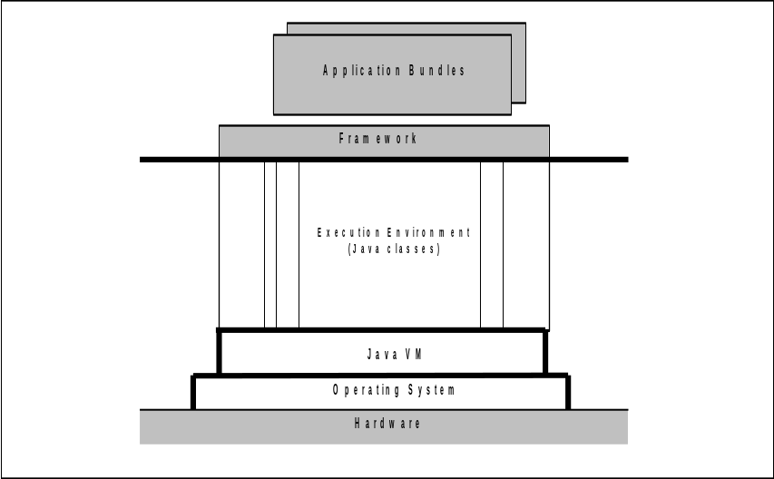
Fig. 1: Full Size Model
Fig. 1 shows the current architecture with the framework API on top. From memory point of view, the VM and the Execution Environments (two of them are standardized in R3) have biggest demands here (usually some MB). The core framework however is relatively small (usually some 100KB).
To keep a standardized API towards the application but still reduce the system to its core, a dynamic platform could be used that connects and disconnects EE Java classes at run-time. Fig. 2.shows the principle.
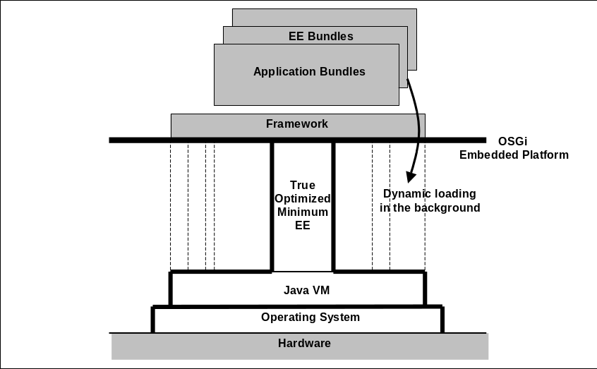
Fig. 2: Embedded Platform Modular Model

Monitored Resources
The OSGi platform is intended to be used in embedded systems around the world. The manufacturer implements control functionality for his product, and the user should be able to download and run his specific user applications provided also by third parties.
Both, system and user applications must not interfere – separation must absolutely be guaranteed. To approach this, an application may be tested, qualified and signed for “good behaviour”. However there are use cases where these efforts for a new application cannot be taken and are also undesirable from all parties. Then, a real secure sandbox environment must be available where all resources are strictly monitored.
Java and OSGi provide standard security mechanisms that apply for data protection and other things. However, they do not apply for limitation on shared system resources. Of particular concern are:
- Object resources like new RandomAccessFile()
- CPU usage in a multitasking environment
- RAM usage, new() operator
- Access to the hardware, e.g. writing only to a limited area in flash file system

A set of monitored functions should be provided to handle these kind of requests in a controlled way and to be able to build a real restricted and safe sandbox (fig. 3.).
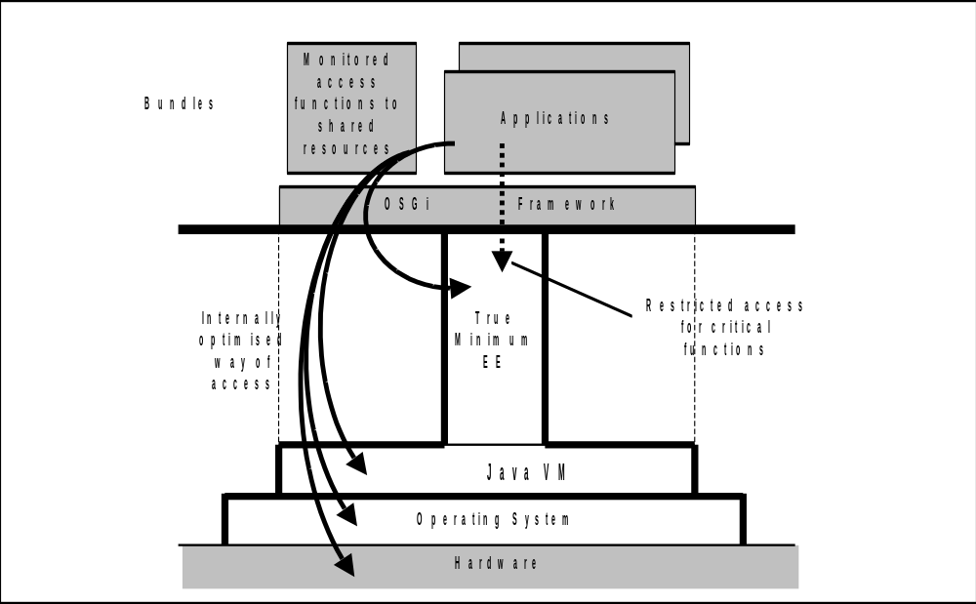
Fig. 3: Monitored access to important shared resources

Requirements are:
- Exclusively provide controlled and limited access to (hardware) resources that are going to be shared.
- A special bundle should hold these functions.
- OSGi and Java functionality should be untouched in general.
- Normal access to Java classes from the Execution Environment can and must be limited. This can be done (transparently) by Java policy mechanism.

Impacts:
- The core OSGi/Java platform is significantly reduced to a required minimum base of functionality.
- It becomes a secure and safe system. Uncertified bundles from third party cannot mutually/accidentally harm a running system.
- Only a small, lean API is provided and recommended for the application developer. Further, higher-level functionality can be provided by Extension-Bundles.
- Access to critical functions is (generally) blocked with normal Java and OSGi security mechanisms.
- Compatibility for Embedded-Platform-Bundles to other enterprise-platforms can be achieved by an adapter bundle.

Platform Limitations
Demanding the use of the monitored resources, we loose direct compatibility to R3 platforms for most bundles. However, it must be seen, that these kind of hardware platforms are anyway heavily limiting their software. Here, also runtime issues have to be considered.
- “Not enough memory”
There might be too less memory to start a big bundle or to load a dependent bundle chain.
- “Hardware Device (temporarily) missing!”
Particular hardware and periphery elements will differ a lot on the systems. Bundles must be prepared for all kind of exception (“Main power switch missing…”).
- “Class library missing!”
A small hardware platform is not going to provide 100% functionality from big systems. A lot of classes will simply be not be implemented or cannot be provided via network. The framework needs to inform the user.
- Performance
The core system (HW, VM, True-Minimum-EE) is built as an optimised core system, but dependence on the network link is there. Loading and access times might have to be considered.

Open issues
- Team work of the different (class) loaders within the OSGi system.
- Controlling multithreaded resources
- Restricting memory usage

Use cases
- Invulnerable embedded platforms are particularly required where critical things are controlled, but end users get in contact with the systems, use them and provide new software. This applies for all kind of areas, particularly automotive and home.
- Secure interface to bundles: very different access permissions and methods can be implemented: from full access for debugging purposes (memory dump) up to an absolutely restricted sandbox.
- High level “luxury” classes and APIs are removed, but can be provided on demand.
- Hardware costs are minimized. The black boxes can be optimised for the particular purpose.
- Compatibility and Cross-Platform-Development:
Bundles still can run in “enterprise environments”, using adapter bundles.
- Updating the hardware: Systems are often based on programmable logic (FPGAs, etc). These devices could be updated, serviced, monitored, and even be debugged from “home”.

Requirements

How can this RFC be tested?
TBD.

Document Support

References
- OSGi Service Platform, Release 3.

Author’s Address

Name | Roland Berger
Company | Fraunhofer Institute for Integrated Circuits
Address | Nordostpark 93  90480 Nuremberg  Germany
Voice | +49 (0) 911 5806 319
e-mail | beg@iis.fraunhofer.de

Acronyms and Abbreviations

End of Document

