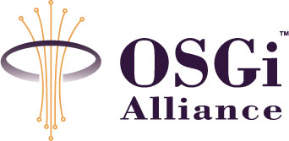
RFP 51
CECED Device Specification
Confidential, Draft
7 Pages
Abstract
The European Committee of Domestic Equipment Manufacturers (CECED, http://www.ceced.org) specifies how sets of products from multiple manufacturers are able to interoperate and be installed with or without the use of a special tool, in the most automatic matter.
In order to achieve this, CECED is creating a “Household Appliances Control and Monitoring Application Interworking Specification (AIS)”. This specification is independent of underlying networks and bus systems. Special “Mapping to Protocol” specifications are responsible for the interoperability of the AIS with existing networks and bus systems. Currently, CECED is specifying this for the “European Home System (EHS)” protocol.

Document Information

Table of Contents
0 Document Information 2
0.1 Table of Contents 2
0.2 Status 2
0.3 Acknowledgements 2
0.4 Terminology and Document Conventions 3
0.5 Revision History 3
1 Introduction 4
2 Application Domain 5
3 Problem Description 6
4 Requirements 6
4.1 Easy Installation of Appliances 7
4.2 Network Independence 7
4.3 Standardized Service Interface for Appliances 8
4.4 Extendable Driver 8
4.5 Security 8
4.6 Branding 8
5 Document Support 10
5.1 References 10
5.2 Author’s Address 10
5.3 Acronyms and Abbreviations 10
5.4 End of Document 10

Status
This document requests discussion to suggested enhancements of the OSGi specification for home appliance integration independent of their connectivity, used networks and protocols,. . Distribution of this document is unlimited within OSGi.

Acknowledgements
- The CECED consortium.
- Prosyst, BSH (Bosch Siemens Hausgeräte) , T-Systems and IBM all of which would like to provide interoperable solutions to their white goods customers.

Terminology and Document Conventions
The key words "MUST", "MUST NOT", "REQUIRED", "SHALL", "SHALL NOT", "SHOULD", "SHOULD NOT", "RECOMMENDED", "NOT RECOMMENDED", "MAY" and "OPTIONAL" in this document are to be interpreted as described in [1].
Source code is shown in this typeface.

Revision History
The last named individual in this history is currently responsible for this document.

Revision | Date | Comments
Initial | 08 August 2003 | K. Hackbarth (Prosyst, k.hackbarth@prosyst.com), M. Ellinger (Siemens, michael.ellinger@siemens.com), S. Fassmann/C. Weiss (IBM PvC/Wireless, fassmann@de.ibm.com, christoph_weiss@de.ibm.com)
2nd draft | 12. Sep. 03 | Extended by Michael Ellinger (based on Information from BSH and CECED)
3rd draft | 05. Nov. 2003 | Extended with Uses Cases and new architecural overview by Joachim Ritter and Kai Hackbarth

Introduction
Appliance manufacturers are starting to equip their products with network capabilities. They are looking at ways of achieving manufacturer independent interoperability between these network-enabled appliances as well as for the integration in application runtime environments such as the OSGi Service Platform.
Interoperability of applications that expose the appliances functions in OSGi is a key issue for them.
The European Committee of Domestic Equipment Manufacturers (CECED, http://www.ceced.org) specifies “how sets of products from multiple manufacturers are able to interoperate and be installed with or without the use of a special tool, in the most automatic matter” ([1]).
In order to achieve this, CECED is creating a “Household Appliances Control and Monitoring Application Interworking Specification (AIS)”. This specification is independent of underlying networks and bus systems.
The specification addresses the following issues :
- Abstract Installation Process for appliances
- Abstract Message Data Structure
- Appliance functions and behavior
Special “Mapping to Protocol” specifications are responsible for the interoperability of the AIS with existing networks and bus systems. Currently, CECED is specifying this for the “European Home System (EHS)” protocol.
Independently from a physical transport medium, this specification defines functions for sending data or commands, reading data or receiving events from a dedicated type of device. Example: The specification defines typical user perceived states of a washing machine, how such states can be read remotely and how the machine can be started.

Application Domain
At the moment, many white good appliance manufacturers are looking at ways to network-enable their home appliances. They make decisions about networks and protocols they are going to support.
Two major use cases in the smart home domain must be supported:
- Remote control of the appliances through centralized graphical user interfaces (e.g. kitchen consoles).
- External communication capabilities in order to perform alerting/messaging (e.g. inform the user about a certain state or alert the service organization in the case of errors) and/or to remotely access the appliance from a service provider (e.g. remote diagnostics).

Actors in this application domain are:

- White good appliance manufacturers
They sell networked appliances in order to increase the customer relationship and revenues.
- Service developers / service providers
Service developer / service provider offer new or additional services.
- Network infrastructure providers
Network infrastructure providers provide network equipment (e.g. EHS chipsets, modems) for CECED-devices.
- Consumers
Consumer take advantage of all new possibilities that networked appliances offer independently from the appliance manufacturer.
- CECED Organization
CECED is creates a “Household Appliances Control and Monitoring Application Interworking Specification (AIS)”, which specifies how sets of products from multiple manufacturers are able to interoperate and be installed with or without the use of a special tool, in the most automatic matter

Problem Description
Appliance manufacturers are in the phase of equipping their new generation of home appliances with network capabilities. This alone does not help to introduce and deploy new services to their customers. The networked appliances must be accessible from other appliances and networks as well as from Service Providers and common control consoles.
At present many home network standards and protocols exist. Appliance manufacturers face the problem that they cannot support all of them. In addition there are different solutions for accessing the same network protocol and there is no common standard for accessing functions of an appliance. As a result the different applications and services for these appliances are not interoperable.

Requirements
According to the OSGi Device Access Specification each appliance in the network should be handled by one or more driver services.
The functions specified by CECED must be encapsulated by a CECED layer which contains base drivers of each type of appliance (in addition, there might be a common set of functions as well). This RFP aims at defining the CECED API through which the base drivers can be addressed.
In the Device Access refinement process another driver can be assigned to the appliance. This optional device specific driver is based on the CECED specified appliance driver (see CECED Layer in Fig. 1) and deals with the functions of the appliance and its behavior and makes them available to other applications and services. The optional device specific driver, in the Driver Layer of Fig. 1, is typically implemented by the device manufacturers and contain the appliance specific features of the manufacturer.
The CECED API must encapsulate both the CECED functions and the underlying network dependencies completely. From the upper layers point of view, the network binding of the CECED drivers are completely transparent.
Each network protocol has to be supported by a network driver (see Network Layer in Fig.1) . This driver enables other services or applications to communicate with appliances connected to this network. It is capable of sending and receiving of messages, identifying appliances and handle network management functions such as installation/deinstallation of devices. It is yet undefined, if a common network data abstraction API might be specified, hence it is not within the scope of this documents.
Example: 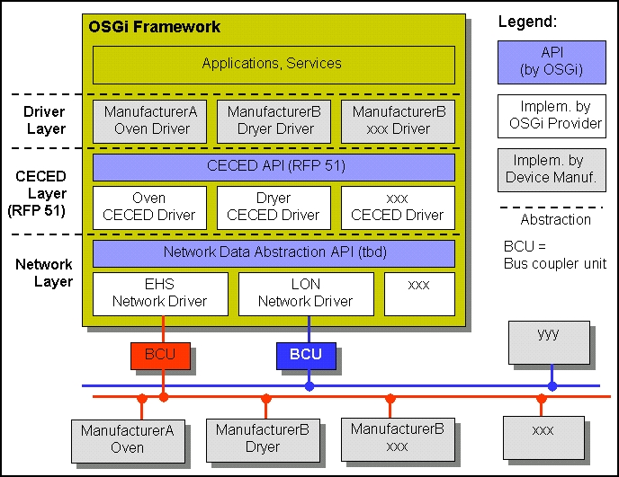
Fig.1 Communication Interfaces
The requirements issued by the appliance manufacturers and third parties which are going to develop services based on network capable appliances are listed below.

Easy Installation of Appliances
To achieve market acceptance, appliances must be easily installable. Otherwise these appliances will not be integrated in other applications.

Network Independence
The drivers that are provided by the manufacturer for a network capable appliance must be independent of the physical connection between the Service Platform and the appliance. Any network dependencies must be within or underneath the CECED Layer.
A standardized application interface must be available in order to achieve interoperability of OSGi services and applications built on top of the appliance drivers (see CECED API in Fig. 1). This Application Interface for appliances hides vendor specific OSGi implementation details of the Communication Interface from the user of the Appliance Driver (e.g. the application and service developer).

Standardized Service Interface for Appliances
Interfaces of all appliance drivers including the most common functions must be standardized. E.g., a generic OSGi washing machine driver must provide access to a washing machine independent of the manufacturer and the model. This is necessary to enable a third party, such as a service provider, to offer a remote control service for appliances. The service provider will use the same CECED appliance specific implementation for accessing different washing machines from different manufacturers.

Extendable Driver
The generic CECED drivers must be extendable with manufacturer and appliance model specific functions, that are provided with a device specific driver (see CECED Layer in Fig 1). These functions can be publicly available or private (see chapter 4.5).

Security
Appliance manufacturers equip their appliances with network capabilities which also enable remote access to these appliances. Remote diagnostics is an important use-case. Measurement of consumption data would be another way of helping the manufacturer to improve their future products.
Some of these manufacturer and appliance specific functions should only be available to either the manufacturer himself and/or a trusted third party. This is necessary to hide critical appliance information from the public and the competition in order to avoid economic disadvantages.

Branding
If an appliance manufacturer ships an extended driver (supporting all the appliance and manufacturer specific functions), the appliance manufacturer wants to ensure a common look and feel of his appliance user interfaces. Since the user interface is a major market differentiator, this must be taken into consideration here as well.

Scenarios / Use Cases
Note that any brand name (such as “Miele”) mentioned below is used as substitute for all other white goods manufactures and applied to present the use cases as realistic as possible .

Scenario / Use Case 1:
  - Miele makes a new version of their dishwasher
  - The dishwasher supports the EHS-bus
  - Miele implements the CECED-layer inside the device
  - The customer “Al Bundle” buys such a dishwasher
  - Al connects the dishwasher to his EHS enabled home network
  - The device is registered in the home network via an OSGi enabled Residential Gateway (manually or automatically)
  - Al is now able to use the CECED generic functions provided by the CECED specified appliance driver over a generic Portal which supports all CeCed Devices
  - A Service Developer creates a tariff management service based on the Ceced OSGI Specification. This allows the Service Developer to access the STOP function for all CECED complient devices dependent on the energy consumption of the
  - The residential gateway checks for a responsible service provider
  - The service provider delivers the optional appliance specific driver(s)
  - Al subscribes to a new service called “tariff management”
  - This service can now be used by all CECED-devices with a CECED specific device drivers for each device

Scenario / Use Case 2:
- Al Bundle has a Siemens Oven, a Miele washing machine and a V-Zug fridge.
- Al has a User-Interface, which is provided by Miele
- all generic CECED-functions for all devices are available from the UI
- For Miele devices device specific functions are available
- The devices can reside on different networks
- Data collection is manufacturer specific service.

Document Support

References
- The CECED AIS: Household Appliance Application Interworking Specification, CECED, http://www.ceced.org, Aug 2003.

Author’s Address

Name | K. Hackbarth (Prosyst), S. Fassmann (IBM), M. Ellinger (BSH)
Company
Address
Voice
e-mail

Acronyms and Abbreviations

End of Document

