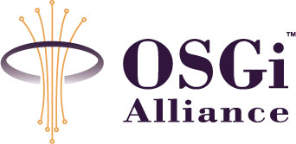
RFP 0069 – Device Management for Vehicle Device
Confidential, Draft
14 Pages

Document Information

Table of Contents
0 Document Information 2
0.1 Table of Contents 2
0.2 Terminology and Document Conventions 3
0.3 Revision History 3
1 Introduction 4
2 Application Domain 4
2.1 Terminology 5
2.2 Standard References 6
3 Problem Description 6
4 Use Cases 7
4.1 Software List Query 7
4.1.1 Description 7
4.1.2 Flow of events 7
4.2 Telematics Device Configuration Management 7
4.2.1 Description 7
4.2.2 Flow of events 7
4.3 Telematics Terminal Status Management 8
4.3.1 Description 8
4.3.2 Flow of events 8
4.4 Vehicle Status Information Monitoring 8
4.4.1 Description 8
4.5 Abnormal Vehicle Status Notification 9
4.6 Firmware Update 9
5 Requirements 10
5.1 High Level Functional Requirements 10
5.1.2 Recording 10
5.2 Overall Systems Requirements 11
5.3 System Elements 11
5.3.1 Telematics Terminal 11
5.3.2 Telematics Server 11
5.3.3 Data Model 12
6 Document Support 13
6.1 References 13
6.2 Author’s Address 13
6.3 Acronyms and Abbreviations 13
6.4 End of Document 14

Terminology and Document Conventions
The key words "MUST", "MUST NOT", "REQUIRED", "SHALL", "SHALL NOT", "SHOULD", "SHOULD NOT", "RECOMMENDED", "NOT RECOMMENDED", "MAY" and "OPTIONAL" in this document are to be interpreted as described in [1].

Revision History
The last named individual in this history is currently responsible for this document.

Revision | Date | Comments
V 0.1  Initial | May 04 2005 | Document creation
V 0.2  Internal revision | May 06 2005 | Acronyms and abbreviations added
V 0.3  Internal revision | May 12 2005 | Polished and supplemented
V 0.4 | June 20 2005 | Revised according to the comments after VEG conf call May 12 2005  Especially, comments of Olivier Pave are reflected  (Application Domain updated, Requirements added, Problem Description updated)
V 0.5 | July 29 2005 | Revised according to the comments of Rob van den Berg issued in July 26 2005.  (Typos are corrected, several sentences are modified to clarify the meaning, and document layout is also modified.)
V 0.6 | August 11 2005 | Use Cases updated
V 0.7 | October 18 2005 | Revised according to the comments of Rob van den Berg issued in October 13  (Application Domain updated, Requirements added)  This may be the final revision after final review(Oct 14) and is ready to be submitted to the Requirement Committee

Introduction
This document describes the operations and use cases, needed to manage a Telematics Terminal as part of OSGi platform.
This RFP lists the standardized data model and related operations for telematics device management.

Application Domain

This section describes the generic view of the data model architecture, which includes a Telematics Terminal and a server for vehicle device management.

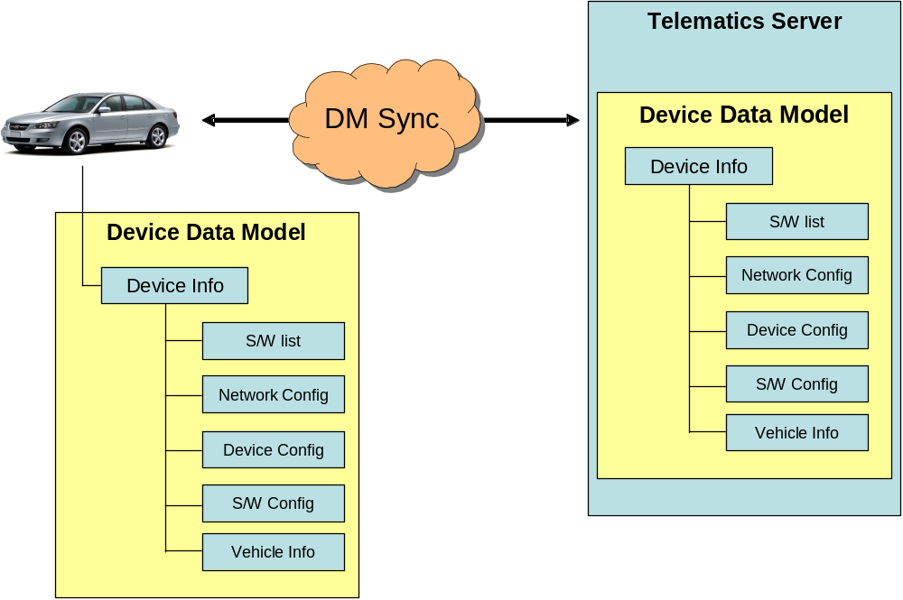

Figure1. Data model architecture of Telematics Terminal device management

The DM specification as defined by OSGi’s MEG forms the basis for the data model and on the operations on this model. This model extends it the DM specification for the vehicle device domain.

The MEG has already proposed the DM domain in RFP 58:

- Device configuration parameters setting/querying
- Application configuration parameters setting/querying
- Device characteristics monitoring
- Software provisioning
- Software repair

This RFP proposes to add vehicle specific data to the existing domain.
This vehicle specific data contains the status of other electronic devices in vehicle as well as vehicle diagnostics.
The AMI-C has defined standard APIs about various vehicle diagnostic statuses, and these APIs can be taken into account.

Terminology

Telematics Terminal
A Telematics Terminal is a terminal device in a vehicle used for the telematics service.
It can be a mobile phone, PDA, etc.
Diagnostic
A Diagnostic is the status of a device connected to the car’s MOST network or CAN network.
Telematics Server
The Telematics Server is a server system which provides various telematics services.
TSP
Telematics Service Provider
User
The User is a driver or a fellow passenger in the vehicle who uses the telematics service.
Administrator
The Administrator is a telematics system administrator on the Telematics Server side.
Terminal Discovery
The Terminal Discovery is the method to push the Telematics Terminal to call or send data to the Telematics Server. E.g. SMS
Vehicle Status Information
Position, speed, moving direction of the vehicle and diagnosis signal of in-vehicle devices, etc
Replay Attack
The Replay Attack is a form of network attack in which a valid data transmission is repeated or delayed intentionally. This is carried out by the intruder who intercepts the data and retransmits it.

Standard References

AMI-C
AMI-C is a worldwide organization of motor vehicle manufacturers created to facilitate the development, promotion and standardization of automotive multimedia interfaces to motor vehicle communication networks.
Additional information can be found in http://www.ami-c.org

MOST
The MOST Cooperation is based on a partnership of carmakers, set makers, system architects and key component suppliers. Together they define and adopt a common multimedia network protocol and application object model.
Additional information can be found in http://www.mostcooperation.com

CAN
The CAN is a serial bus system, which was originally developed for automotive applications in the early 1980's and used as the in-vehicle network for the engine management, the body electronics like door and roof control, air conditioning, etc.
Additional information can be found in http://www.can-cia.org/

RFC 85 Device Management
The RFC 85 defines simple and consistent API providing access method to the device management information.
Additional information can be found in http://membercvs.osgi.org/rfcs/rfc0085.

RFC 87 Device Management Tree Structure
The RFC 87 specifies how information related to configuration, logging, monitoring, deployment, applications and policy is mapped to the Device Management Tree.
Additional information can be found in http://membercvs.osgi.org/rfcs/rfc0087.

Problem Description
Device management for vehicle device is required to provide verified and seamless telematics service for User and to manage problems promptly and appropriately.

Although MEG in OSGi defines the device management for mobile device, more additional functions are needed for the special feature of vehicle device:

- It is hard to change the configuration and environment of vehicle device after initial installation. Therefore the remote managing functions should be provided.
- The devices which are connected to the terminal should be managed through the standardized interface.
- The following vehicle status should be collected and monitored for the drivers’ safety and convenience.
- Current moving speed
- Current moving direction
- Current position
- Air pressure of tires
- Door lock status
- Internal temperature of engine
- Other diagnosis signal of vehicle devices

Use Cases

Software List Query

Description
Query of the list of software available on the Telematics Terminal

Flow of events

- The User or Administrator wants to query the inventory of the installed software on the device.
- The request is sent to the device management system.
- The device management system responds with the name, version and dependency information of software components installed on the device.
- The use case ends.

4.2.3 Notes
None

Telematics Device Configuration Management

Description
Retrieve or update the device configuration parameters of the Telematics Terminal.

Flow of events

- The User or the Administrator wants to retrieve or update the device configuration parameters of the Telematics Terminal.
- The request is transferred to the device management system.
- The device management system receives the request and processes it.
- After the processing, the device management system sends a completion notice to the User.
- The use case ends.

4.2.3 Notes
During the process, the application which uses configuration parameters should be noticed by the device management system whenever the system has updated the parameters.
When the configuration parameters are corrupted by some reason, a reset to the factory state by the device management system might be needed.
4.2.4 Exception
The User or the Administrator has no right to access the device configuration

Telematics Terminal Status Management

Description
Monitor the current status of the Telematics Terminal.

Flow of events

- The User or the Administrator wants to inspect the current status of the Telematics Terminal.
- A request is sent to the device management system with the name of the status information to be queried.
- Then the device management system responds the value of the status information (e.g. available disk space, memory usage, running applications, etc.).
- The use case ends.

4.3.3 Notes
The User or the Administrator may want to stop the running application to get more memory space. The request is then sent to the device management system upon which the device management system will kill the running application.
4.3.4 Exception
The User or the Administrator has no right to manage the application running in the Telematics Terminal.

Vehicle Status Information Monitoring

Description
Monitor the current status of the vehicle.
4.4.2 Flow of events
- The User or the Administrator wants to inspect current status of the vehicle (e.g. location, speed, moving direction, etc.)
- The request is transferred to the device management system.
- The device management system sends the response of the status information that is collected through the internal network in vehicle (e.g. CAN and MOST).
- The use case ends.

4.4.3 Notes
None
4.4.4 Exception
The internal network is disconnected.

Abnormal Vehicle Status Notification

4.5.1 Description
Notify the abnormal or dangerous status of vehicle to the Telematics Server
4.5.2 Flow of events
- The abnormal or dangerous status of vehicle is sensed by the device management system
- The device management system sends the status information to the Telematics Server.
- The Administrator should notify the driver who is in the dangerous or abnormal status of vehicle using an emergency call. (e.g. Engine temperature is too high, Engine oil shortage)
- The use case ends

4.5.3 Notes
None
4.5.4 Exception
The network between the Telematics Terminal and Telematics Server is disconnected. If this occurs, retry to connect repeatedly. But if it still fails, alarm to the driver.

Firmware Update

4.6.1 Description
Update the firmware of the Telematics Terminal.
4.6.2 Flow of events
- When new firmware is updated on the Telematics Server, the Administrator should notify the device management system.
- The device management system requests to the Telematics Server for the new firmware.
- After updating the firmware, the Telematics Terminal may be restarted by the device management system.
- The use case ends

4.6.3 Notes
The firmware update must be performed when the car is not operating (engine is off).

4.6.4 Exception
The User or the Administrator has no right to perform the firmware update.

Requirements

High Level Functional Requirements

5.1.1 Security
  - An Authentication mechanism is needed.
  - The authentication procedure must be strong enough to ensure that is not possible for a third party to masquerade as a Telematics Server by spoofing its identity.
  - The Telematics Terminal and Telematics Server must be capable of detecting replay attacks.
  - If User confirmation is indicated by the Telematics Server, the Terminal will prompt for User confirmation before accepting the changes.
  - The non-repudiation of the session must be ensured.
  - For the driver’s privacy, the position information of the vehicle should be encrypted.

Recording
  - The Telematics Terminal Management System shall provide sufficient information so that queries from the Telematics Server, reports from Terminals, data downloads, and acknowledgements may be billed and tracked accordingly.
  - A session must be uniquely identified.
  - If transactions are logged, the server must log transactions with success indicator.

5.1.3 Administration and Configuration
  - The Telematics Terminal Management System shall provide a standardized mechanism for publishing session/message transactions such as confirmation requests and results.
  - Confirmation request messages shall be uniquely identified and contain at least the subscriber id, data or data summary, and date/time.
  - Confirmation result messages shall be uniquely identified and correlated to the request.
5.1.4 Usability
  - If User confirmation is indicated by the Telematics Server, the Terminal shall ask for User confirmation before incorporation of configuration data (transferred by Telematics Server).
  - The Terminal may have a dedicated connection for the server.
  - For safety reasons the user should only be prompted if his input is required.
  - User may be informed that a process is over.
  - The User shall be asked for confirmation to proceed before any software is updated.
  - The User shall be informed that the update/upgrade has been completed.

Overall Systems Requirements

- The Telematics Terminal Management infrastructure may be based on a distributed architecture, wherein functional elements of the system (e.g., TSP server) may consist of one or more coordinated, but physically separate entities.
- Terminal Discovery by the Telematics Server must be clearly defined (e.g. SMS).

System Elements

Telematics Terminal
- It must be possible for the User to view, change and store terminal environment parameters.
- It must be possible for the User to view, change and store application specific configuration parameters.
- It should be possible for the User to manage the list of S/W packages.
- An authorized User must be able to install, update and uninstall system software (including firmware).
- It must be possible for the User to check the Telematics Terminal’s status.
- It must be possible for the User to check the in-vehicle device’s status.
- Re-setting configuration parameters and/or policies to their factory-defined state may be supported.
- The Telematics Terminal must be able to notify the Telematics Terminal Management server that it has accepted and successfully saved the downloaded data.

Telematics Server
- The Telematics Server shall be capable of discovering the presence of the active Telematics Terminals
- The Telematics Server shall be capable of querying Terminals for information about their configuration.
- The message from the Terminal acknowledging a terminal management operation shall contain an indication of success/failure of the operation.
- The Telematics Server shall be capable of sending a request for User confirmation to the Terminal, and accepting the response from the Terminal.
- The Telematics Server shall be able to establish a secure data connection to the Terminal.
- The Telematics Server should support at least one wireless bidirectional data bearer.
- The Telematics Server must be able to detect when a Terminal needs data update.

Data Model

- Installed S/W Package List
- Name
- Version information
- Dependency, etc.
- Network Configuration
- Phone number
- Default TSP server URL, etc.
- General Device Environment Parameters
- Device ID
- Device model
- Version information, etc.

- Application Specific Configuration
- TBD
- Information about Telematics Terminal status
- Device ID
- Firmware version
- Available disk space
- Available memory, etc.
- Information about vehicle status
- Position
- Speed
- Temperature
- Diagnostics signal, etc.

As stated above Application Domain, the number 1, 3, 4, 5 are defined in OSGi MEG DM, and the number 2, 6 are newly suggested in this RFP.

To implement the related operations which are based on the data model, OMA DM (SyncML DM) may be applied on interface and data protocol for remote management between Telematics Terminal and Telematics Server.

Document Support

References
- Bradner, S., Key words for use in RFCs to Indicate Requirement Levels, RFC2119, March 1997.
- Software Requirements & Specifications. Michael Jackson. ISBN 0-201-87712-0
- <Title: I am in File-Properties>odel, OSGi Alliance
- <Title: I am in File-Properties>Diagnostics, OSGi Alliance
- <Title: I am in File-Properties>, OSGi Alliance
- <Title: I am in File-Properties>
- AMI-C use cases, AMI-C
- Device Management Requirements, OMA

Author’s Address

Name | Kyong-Ho Kim
Company | ETRI, TelematicsUSN Research Division
Address | 161 Gajung-dong, Yusong-gu, Daejon, Korea
Voice | +82-42-869-1634
e-mail | kkh@etri.re.kr

Acronyms and Abbreviations

OSGi – Open Services Gateway Initiative
TSP – Telematics Service Provider
DM – Device Management
MEG – Mobile Expert Group
OMA – Open Mobile Alliance
CAN – Controller Area Network
MOST – Media Oriented System Transport

End of Document

