
RFP 0070 – Persistent Storage Management for Vehicle Device
Confidential, Draft
12 Pages

Document Information

Table of Contents
0 Document Information 2
0.1 Table of Contents 2
0.2 Terminology and Document Conventions 3
0.3 Revision History 3
1 Introduction 4
2 Application Domain 4
2.1 Terminology 5
3 Problem Description 6
4 Use Cases 6
4.1 User Storage Management 6
4.1.1 Description 6
4.1.2 Flow of events 6
4.1.3 Notes 7
4.2 Configuration Management per Each User 7
4.2.1 Description 7
4.2.2 Flow of events 7
4.2.3 Notes 7
4.3 PIMS Data Management 7
4.3.1 Description 7
4.3.2 Flow of events 7
4.3.3 Notes 8
4.4 Personal S/W specific configuration data Management 8
4.4.1 Description 8
4.4.2 Flow of events 8
4.4.3 Notes 8
4.5 Data Synchronization 8
4.5.1 Description 8
4.5.2 Flow of events 8
4.5.3 Notes 8
5 Requirements 9
5.1 High Level Functional Requirements 9
5.1.1 Security 9
5.1.2 User Specific Data Management 9
5.1.3 User Storage Management 9
5.1.4 Synchronization Related 9
5.2 Overall System Requirements 9
5.3 System Elements 10
5.3.1 Telematics Terminal 10
5.3.2 Telematics Server 10
5.3.3 Data model 10
6 Document Support 11
6.1 References 11
6.2 Author’s Address 11
6.3 Acronyms and Abbreviations 11
6.4 End of Document 12

Terminology and Document Conventions
The key words "must", "must NOT", "REQUIRED", "shall", "shall NOT", "should", "should NOT", "RECOMMENDED", "NOT RECOMMENDED", "may" and "OPTIONAL" in this document are to be interpreted as described in [1].

Revision History
The last named individual in this history is currently responsible for this document.

Revision | Date | Comments
V 0.1  Initial | May 04 2005 | Document creation
V 0.2  Internal revision | May 06 2005 | Acronyms and abbreviations added
V 0.3  Internal revision | May 12 2005 | Polished and supplemented
V 0.4 | June 20 2005 | Revised according to the comments after VEG conf call May 12 2005  Especially, comments of Olivier Pave are reflected  (Application Domain updated, Requirements added, Problem Description updated)
V 0.5 | August 11 2005 | Revised according to the comments of Rob van den Berg issued in August 3 2005.  (Typos are corrected, several sentences are modified to clarify the meaning, and document layout is also modified.)
V 0.6 | October 18 2005 | Revised according to the comments of Rob van den Berg issued in October 13 2005.  (Application Domain updated, Requirements added)  This may be the final revision after final review(Oct 14) and is ready to be submitted to the Requirement Committee

Introduction

This document describes how to manage persistent storage to several Users who are using a Telematics Terminal in their car. The main focus of this storage is to manage configuration data.
As multiple users will be using a Telematics Terminal, it is clear that for each user, the data they are manipulating
need to be made persistent. Moreover the user should only be able to access the data he is authorized for.
It is to be expected that multiple applications will use similar types of data (e.g. address data for both a phone application and navigation services). Having a standardized data model for the persistent storage will make access and storage more efficient.

Application Domain

This data model architecture is designed to manage the persistent storage per each User.

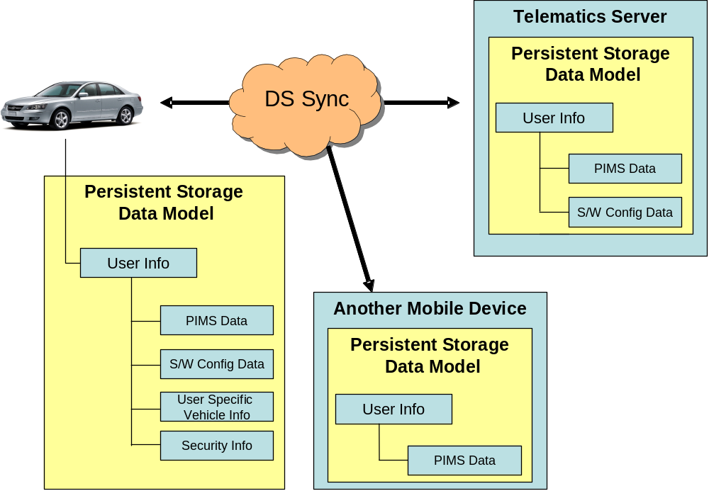

Figure 1. Data model architecture for persistent storage management

The Figure 1 presents the Persistent Storage Management Tree in a vehicle. Parts of this tree will be synchronized with the Telematics Server.
As several Users may use the same Telematics Terminal, there is a need for managing the storage that contains each User’s PIMS Data, S/W specific configuration data,, security information, etc.

The persistent storage management system will be related to RFC 9: Preferences dealing with managing user preference data. It will be also related to RFC 10: User Admin when it requires user specific persistent storage.

Terminology

Telematics Terminal
The Telematics Terminal is a terminal device in vehicle which is used to the telematics service.
It can be also a mobile phone or PDA, etc.
Telematics Server
The Telematics Server is a Telematics Server system which provides various telematics services.
User
The User is a driver or a fellow passenger in vehicle who uses the telematics service.
Administrator
The Administrator is a telematics system Administrator in the Telematics Server side.
PIMS Data
Personal Information Management Systems Data. e.g. address book, schedule, preference destination, etc.

Problem Description
Typically several users will use, personalized, telematics service in a vehicle. In this case, the information of each user(S/W specific configuration data) should be handled correctly: a user should only be able to access the data he is authorized for. Also many applications may use the type of data of a User. If these applications manage the data separately, it is inefficient. Therefore a standardized interface is needed to access S/W specific and user specific data.
The User Admin service provides APIs to manage users, and the Preference service provides APIs to maintain the user preference data. These two services or other services may need overall persistent storage management service when getting available persistent storage space for example.

Use Cases

User Storage Management

Description
Manage the user’s storage space.

Flow of events

- The User or the Administrator wants to add a new user, update or delete an existing user.
- This request is sent to the user management system (defined as User Admin service).
- The User Admin service adds or removes this user and then passes the request to the persistent storage management system.
- Subsequently the persistent storage management system either makes new storage for new user or deletes user’s storage.

Notes
None

4.1.4 Exception

The User has no right to add, adjust, or delete Users.

Configuration Management per Each User

Description
Manage the user specific configuration data.

Flow of events

- The User or the Administrator wants to retrieve or update the user configuration data. (e.g. authentication, personal profile, etc)
- The request is sent to the User Admin service.
- The User Admin Service passes the request to persistent storage management system.
- After the processing the request, the persistent storage management system sends a completion notice to the User.

Notes
None

PIMS Data Management

Description
Manage the user’s PIMS data.

Flow of events

- The User wants to retrieve or update the PIMS data. (e.g. address book, schedule, preference destination, etc.).
- The request is sent to the User Admin service and the User Admin Service passes it to the persistent storage management system.

Notes
The each user’s directory which includes the PIMS data is managed independently according to the User id.

Personal S/W specific configuration data Management

Description
Manage the user’s PIMS data.

Flow of events

- The user application needs to retrieve or update its specific configuration data. (e.g. Bookmark on browser, preference destination on navigation).
- The user application sends the request to the User Admin service and the User Admin service passes it to the persistent storage management system. If sufficient access right are available, the data will be returned to the user application
- During the processing, the each User’s directory which includes the S/W specific configuration data is managed individually according to User id like the PIMS data.

Notes
The each user’s directory which includes the S/W specific configuration data is managed independently according to the User id like the PIMS data.

Data Synchronization

Description
Manage the user’s PIMS data.

Flow of events

- The User wants to synchronize the data as mentioned in section 4.3 and 4.4 between Telematics Terminal and other mobile devices. (e.g. mobile phone, PDA, etc.)
- The User requests to synchronize between Telematics Terminal and Telematics Server.
- The User requests to synchronize between Telematics Server and the mobile devices or the other vehicle.

Notes
The synchronization is performed using SyncML DS of OMA.

Requirements

High Level Functional Requirements

Security
- The User must be authenticated to use his persistent storage.
- The User must be authorized to manage another User’s persistent storage.
- All data communications between the Telematics Terminal and the Telematics Server must be secure.

User Specific Data Management
- The persistent management system may provide independent storage space in the Telematics Terminal for each User.
- It must be possible to store and retrieve PIMS data per User.
- It must be possible to store and retrieve S/W specific configuration data per User.
- It must be possible to store and retrieve user configuration data per User.
- It must be possible to store and retrieve security data per User.

User Storage Management
- It must be possible to create a limited amount of storage space, or change this limited amount of storage space per User.
- It must be possible to know the available amount of persistent storage space.
- It must be possible to know the amount of space used by the User.

Synchronization Related
- The User specific data should be able to be synchronized with a Telematics Server or other mobile devices, e.g. mobile phone, PDA.

Overall System Requirements
- The persistent storage management system should be able to support a multi-user environment in the Telematics Terminal.

System Elements

Telematics Terminal
- Independent storage may be needed for each User( e.g. family members)
- Each User should be authenticated to use the vehicle device by using convenient methods such as IC cards.
- A standardized interface that accesses current driver’s storage is required for the personalized applications which use PIMS data
- (The PIMS data in the terminal can be synchronized directly with other mobile devices, e.g. mobile phone, PDA.)

Telematics Server
- The PIMS data in the Telematics Server may be synchronized with the telematics terminal but also with the other devices, e.g. mobile phone, PDA, home server.

Data model
The persistent storage management system can have a data model as follows.
    - PIMS Data
  - Address book : refer the OMA vCard
  - Schedule : refer the OMA vCalendar
  - Destination preference: One of the specialized information in telematics that is used for the route guidance and navigation. In this case, new object type may be defined which is not in the OMA vObject. For example, it can be called ‘vDestination’.

- User specific vehicle Information
  - Preferred FM band information
  - Seat position information for the individual User

- S/W specific configuration Data
- Preference URL : be used on browser application and refer the OMA vBookmark
- Each of applications can have information specialized on person

- Security Information
- Information used only for Telematics Terminal and does not have to be synchronized with the Telematics Server, (e.g. credential data)

Document Support

References
- Bradner, S., Key words for use in RFCs to Indicate Requirement Levels, RFC2119, March 1997.
- Software Requirements & Specifications. Michael Jackson. ISBN 0-201-87712-0
- vObject Minimum Interoperability Profile, OMA BAC
- RFC 9 - Preferences, OSGi Alliance
- RFC 10 - User Admin, OSGi Alliance

Author’s Address

Name | Kyong-Ho Kim
Company | ETRI, TelematicsUSN Research Division
Address | 161 Gajung-dong, Yusong-gu, Daejon, Korea
Voice | +82-42-869-1634
e-mail | kkh@etri.re.kr

Acronyms and Abbreviations

OSGi – Open Services Gateway Initiative
TSP – Telematics Service Provider
DS – Data Synchronization
PIMS – Personal Information Management System
OMA – Open Mobile Alliance
URL – Uniform Resource Locators

End of Document

