
RFP 000 Enterprise Declarative Services
Confidential, Draft
16 Pages
Abstract
An integration between Dependency Management and Configuration Management is required which can be used in an Enterprise Environment.

Document Information

Table of Contents
0 Document Information 2
0.1 Table of Contents 2
0.2 Terminology and Document Conventions 3
0.3 Revision History 3
1 Introduction 3
2 Problem Description 4
2.1 Approach 4
2.2 Entities used in the following chapters 4
2.3 CAS and DS with ComponentFactory 5
2.4 CAS and DS with ManagedServiceFactory 6
2.5 CAS and DS with ComponentFactory and ManagedServiceFactory and Whiteboard Pattern 8
3 Use Cases 9
3.1 General Use Cases 9
3.1.1 Initial startup of a component 9
3.1.2 Late injection of optional dependencies 9
3.1.3 Update of Configuration Data 10
3.1.4 Required dependency went down 10
3.1.5 Disable component configuration 10
3.2 Developer Use Cases 10
3.2.1 Ease of Use 10
4 Requirements 11
4.1 General Requirements 11
4.2 Non-functional Requirements 11
5 Solution Proposal 12
6 Document Support 14
6.1 References 14
6.2 Author’s Address 14
6.3 Acronyms and Abbreviations 14
6.4 End of Document 14

Terminology and Document Conventions
The key words "MUST", "MUST NOT", "REQUIRED", "SHALL", "SHALL NOT", "SHOULD", "SHOULD NOT", "RECOMMENDED", "NOT RECOMMENDED", "MAY" and "OPTIONAL" in this document are to be interpreted as described in [1].
Source code is shown in this typeface.

Revision History
The last named individual in this history is currently responsible for this document.

Revision | Date | Comments
Initial | 23 October 2006 | First Draft  Nicole Wengatz, Siemens AG
2nd Draft | 30 October 2006 | Changes and corrections after internal review at Siemens AG and Siemens Enterprise Communications GmbH & Co. KG  Nicole Wengatz, Robert Jasny, Siemens AG

Introduction
The Declarative Services Specification (DS) and the Configuration Admin Service Specification (CAS) are part of the OSGi R4 Service Compendium.

The Siemens Enterprise Networks HiPath product line architecture prescribes development of product specific elements as well as for common SW assets. These elements are hosted by a lightweight (server side) service execution environment. The OSGi Service Platform is used at the very core.

One of the main differences between the embedded and the enterprise market is that in the enterprise market services often hold a state (e.g. call graphs) and need long startup times (e.g. connecting to a realtime communication system like a telephony switch). Also service availability plays a very important role (e.g. in a call center application). Combining both, certain requirements can be derived, for example such an enterprise service cannot be disposed and recreated frequently.

Our goal was to use the DS in combination with the CAS for the service execution environment. DS seemed to be a potential solution for dependency management. This RFP outlines the changes to the existing DS specification as well as enterprise related enhancements that we identified.

Problem Description

Approach
During the inception phase we investigated different approaches to combine the CAS and the DS. The following chapters describe the most important combinations and explain why we decided not to go this way.
Chapter 2.3 and 2.4 describe not complete combinations of CAS and DS. Chapter 2.5 describe a from our point of view reasonable way of combining both services. But even with this combination, our requirements can not be fulfilled.
Our main findings are:
- The integration of CAS and DS has to be improved, it is not straightforward.
- Component configuration (component.xml) and configuration in CAS overlaps.
- A stateful OSGi service must not be disposed if a required dependency goes down.
- The DS functionality should be extended, e.g.:
  - Injection of object (not only OSGi service) references.
  - Late injection of optional dependencies has to be supported.
  - Configuration of interceptors (e.g. registration of intercepted OSGi services) has to be supported.

Entities used in the following chapters
DS | Declarative Services
Instance Creator | Responsible for creating instances.
ManagedServiceFactory | CAS interface
Component Factory Listener | POJO using the ServiceTracker to get informed about ComponentFactory registrations.
Component Manager | POJO implementing the ManagedServiceFactory or ManagedService interface, responsible for creating instances.

CAS and DS with ComponentFactory

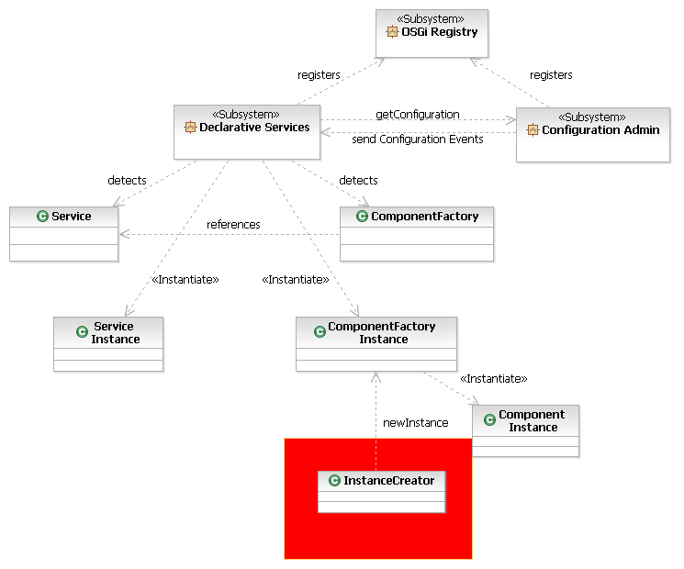
In this prototype we configure a reference between a ComponentFactory and a Service. The Declarative Services (DS) detects both components, creates an instance of the service and an instance of the ComponentFactory (because the reference to the service could be resolved).

The DS is connected to the Configuration Admin Service, which has Component Configurations for the ComponentFactory. The CAS sends updated configuration to the DS but the DS does not create any instances (e.g. does not call the newInstance() on the ComponentFactory). Therefore it is necessary to implement our own InstanceCreator class which is responsible to create new instances. The spec does not specify who will create the instances. This seems to be an inconsistency in the spec as it is not clear how the instance creator is invoked.
So, this is what we get from OSGi – on the first shot it’s not complete from our perspective. In chapter 2.4 and 2.5 we describe a stepwise approach how to do this with OSGi means.

CAS and DS with ManagedServiceFactory
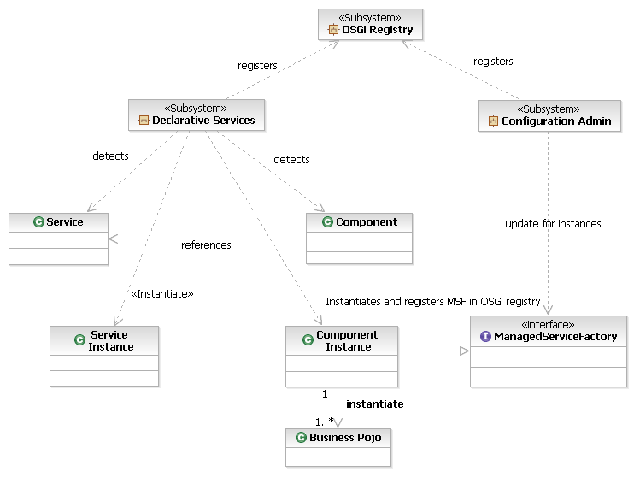

In this prototype we configure a reference between a Component (which is not a DS ComponentFactory) and a Service. The Declarative Services (DS) detects both components, creates an instance of the service and an instance of the Component (because the reference to the service could be resolved). The component instance implements the ManagedServiceFactory interface and is able to receive the update requests from CAS. When the component instance receives a configuration update event from the CAS it creates an instance of our business component.

component.xml:

<?xml version="1.0" encoding="UTF-8"?>
<component name="Component" immediate="true">
<implementation class="Component"/>

<reference name="Reference" interface="ServiceIF"
bind="setRef"
unbind="unsetRef"
cardinality="1..1"
policy="static"
/>

<service>
<provide interface="ManagedServiceFactory"/>
</service>
</component>

The problem with this approach is that only the component instance is managed by the DS but not the created business instances. The component instance acts as a helper to create business components for each configuration in CAS.

CAS and DS with ComponentFactory and ManagedServiceFactory and Whiteboard Pattern
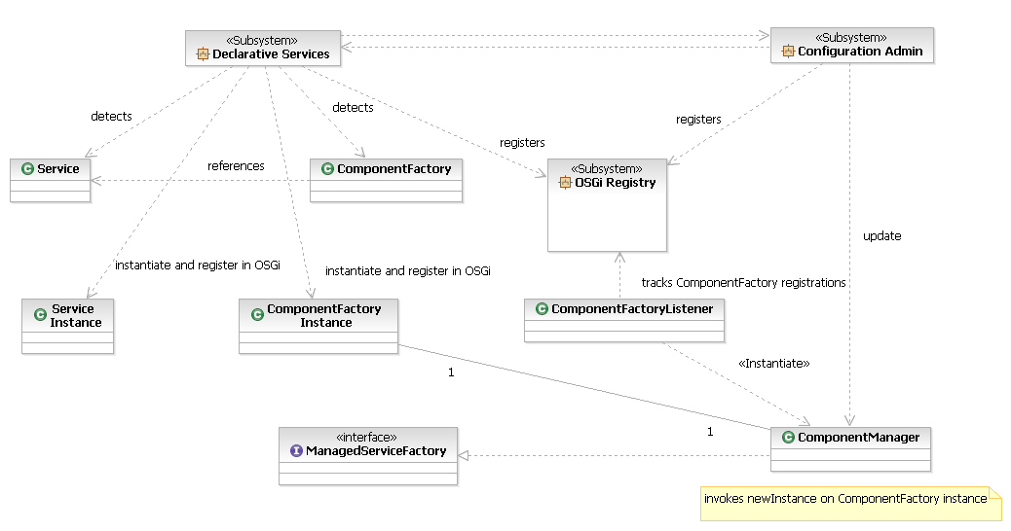
In this prototype we configure a reference between a ComponentFactory and a Service. The Declarative Services (DS) detects both components, creates an instance of the service and an instance of the ComponentFactory (because the reference to the service could be resolved) and registers them in OSGi. The PID is taken from the component.xml file.

The ComponentFactoryListener uses the ServiceTracker to get informed about ComponentFactory registrations. For every component factory a ComponentManager will be created. The ComponentManager implements the ManagedServiceFactory interface. It registers in OSGi with a FPID which is the PID used by the DS for the ComponentFactory registration.
CAS detects the ManagedServiceFactory and invokes update for all configurations belonging to the FPID. The ComponentManager creates instances (by invoking newInstance on the ComponentFactory instance) which will be managed by the DS.

From our point of view this combination of CAS and DS is reasonable. We see the following drawbacks to fulfill our requirements for ‘enterprise services’:
- Component instances must never be reused. Each time a component configuration is activated, SCR must create a new component instance to use with the activated component configuration.
  - This behaviour causes problems in case of stateful components or components which have a long startup time.
- The DS is responsible for the injection of required or optional references to other OSGi services. In addition we require the possibility to get simple objects (not only OSGi service references) like in Spring injected.
- The DS registers the components in OSGi. But there is no way to add functionality before registration, e.g. we would like to register intercepted instances.
- Late injection for optional references is not supported.

Use Cases

General Use Cases

Initial startup of a component
An application bundle containing several components is started. The configuration data is defined in CAS. For every component configuration belonging to a contained component the following steps have to be executed:
- An instance has to be created.
- The configuration properties have to be injected.
- For every configured object reference an object has to be created and injected. The object itself has no lifecycle beneath that of the using instance. An example for such objects could be Business Delegates (in case of remotely accessible services) or Hibernate Configuration Files.
  - Example (part of component.xml):
<objectReference interface="POJI" factory="POJOFactory">
<argument>Have</argument>
<argument>Fun</argument>
</objectReference>
- References (required and optional, single and multiple) to OSGi services have to be resolved and injected. Only if all required references are resolved the component will be activated.
- Activation is a two step process, invoking of an activation method to inform the component that it will be registered soon and registering the component in OSGi.
- If an interceptor chain is configured for the component, the interceptor chain (the component itself is the last element in the chain) will be registered instead of the component itself.
- The component will be registered with the properties.
Singleton components have to be supported.
Requirements: [1],[2],[3],[4],[5],[6],[7],[8],[9],[10],[11]

Late injection of optional dependencies
An optional reference (which could not be resolved at startup time) comes up. It has to be injected into the component. Optional dependencies can come and go without the need to de/activate or restart the component
Requirements: [13]

Update of Configuration Data
Configuration data got updated. The component registration has to be updated. Updated properties have to be re-injected into the component.
Requirements: [12]

Required dependency went down
A required component went down. If another suited component is available it will be injected without deactivating the component. If no suitable component is available, the component will be deactivated. Deactivation is a two step process; unregister the component and invoking of a deactivation method to inform the component that it is unregistered. The component will not be disposed.
As soon as a suited component gets available, it will be injected and the using component will be activated.
Requirements: [14]

Disable component configuration
A component configuration will be disabled in CAS (e.g. by setting an enabled flag to false). The component instance will be disposed, but the configuration data remains available in CAS. As soon the component configuration is enabled again a new component instance will be created. This is an option; of course it still must be possible to remove an instance permanently by deleting the configuration in CAS.
Requirements: [15]

Developer Use Cases

Ease of Use
The developer has to know that he is implementing an OSGi service. But he should not be responsible for infrastructure tasks like registering his service as ManagedServiceFactory or implementing update methods to create instances. These tasks have to be taken over by the OSGi framework.
Requirements: [17]

Requirements

General Requirements
- MUST allow multiple instances of a component.
- MUST allow singleton components.
- MUST support registration properties for components.
- MUST support declarative configuration of component.
- MUST support filters for dependency resolution. Component Dependencies can be attributed additionally by a RFC 1966 filter. The container must use the given filter to find a matching dependency.
- MUST support object references. Object references must be declarative configurable in the component.xml (similar to component references). The container creates these objects with the configured arguments and injects them into the component. The injected object itself has no lifecycle beneath that of the referencing instance. The container is also responsible for disposing the objects.
- MUST support optional and required references, single and multiple cardinality.
- MUST support runtime interception.
- MUST support delivery of interceptors independent from the intercepted component.
- MUST support chaining of interceptors.
- MUST support interface specific interceptor
- MUST not deactivate or restart service when changing configuration data. Registration properties have to be updated without influencing the life cycle state of a component.
- MUST allow dynamic adding and removing optional dependencies (late injection). Such dependencies can come and go without the need to de/activate or restart the component.
- MUST allow a substitute when a required dependency has broken.
- MUST be possible to dispose a component instance without removing the configuration data in the CAS.

Non-functional Requirements
- SHOULD use as much functionality and capabilities of OSGi R4 as appropriate.
- MUST provide ‘Ease of use’ for the application developer. The OSGi framework has to provide services which take over infrastructural tasks like Dependency Management, Activation of Services, Creation of component instances. It is not appropriate that an application developer has to take care.

Solution Proposal
This chapter describes a rough upfront design for a possible solution. We would like to propose to split the described and required functionality in two parts:
- Configuration and Connection to CAS
- Lifecycle Management and Dependency Management
The first part could be implemented by a Component Manager (blue part), the second part by an Enterprise Declarative Services (yellow part), see following picture.
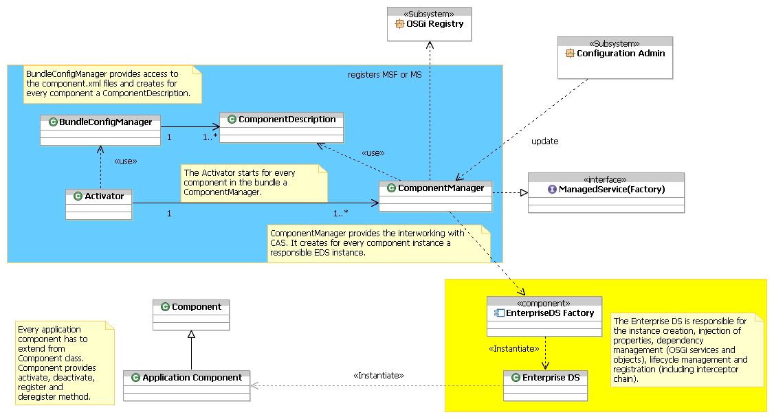

The Activator starts a BundleConfigManager which provides access to the component.xml files. For every component in the bundle a ComponentManager will be created. It implements the ManagedServiceFactory interface and will be registered in OSGi. For Singletons a ManagedService could be registered instead of a factory.
Component instances will be configured via CAS. The ComponentManager creates for every Component instance an Enterprise DS instance.

The Enterprise DS is responsible for:
- Component instance creation
- Injection of properties
- Creation and Injection of objects
- Dependency Management and Injection of OSGi services
- Lifecycle Management, e.g. activation and registration of components
- Creation of Interceptor chain

In chapter 2 we described why we could not use the existing DS and CAS for our project. In addition we had a look to the Spring OSGi work, see http://www.springframework.org/osgi/specification.
We find it very interesting and believe that our proposal could be implemented on top of Spring OSGi. But definitely we require some functionality on top. Out of the box we cannot use the Spring OSGi, because we see a similar gap in the integration with CAS like in 2.4.

Document Support

References
- Bradner, S., Key words for use in RFCs to Indicate Requirement Levels, RFC2119, March 1997.
- R4 Service Compendium Specification V4.0.1. http://membercvs.osgi.org/sp-r4/final/r4.cmpn.pdf Software Requirements & Specifications. Michael Jackson. ISBN 0-201-87712-0

Author’s Address

Name | Nicole Wengatz, Robert Jasny, Tim Diekmann, Dr. Manfred Hutt
Company | Siemens AG
Address | Siemens AG, Otto-Hahn-Ring 6, 81739 Munich, Germany
Voice | +49 (89) 636-50571
e-mail | Nicole.Wengatz@siemens.com, Robert.Jasny@siemens.com, Tim.Diekmann@siemens.com, Manfred.Hutt@siemens.com

Acronyms and Abbreviations

End of Document

