
OSGi and Integration of the Service Component Architecture
Open Distribution, Draft
10 Pages
Abstract
The OSGi platform provides an attractive foundation for supporting the Service Component Architecture. This RFP describes the various ways the Service Component Architecture and the OSGi platform can integrate. Various levels of integration are provided ranging from the use of OSGi as an isolation mechanism hosting single components, to a full fledged runtime container for an SCA runtime to the transparent integration of SCA components and SCA composites into the OSGi runtime so that they can seamlessly interoperate with existing OSGi component models such as Declarative Systems and Spring/OSGi.

Document Information

Table of Contents
0 Document Information 2
0.1 Table of Contents 2
0.2 Terminology and Document Conventions 2
0.3 Revision History 3
1 Introduction 3
2 Application Domain 4
2.1 Terminology + Abbreviations 4
2.2 Comparison between the SCA and OSGi models 5
3 Problem Description 8
4 Use Cases 8
4.1 OSGi as a packaging and runtime model for individual SCA components 9
4.2 OSGi as a packaging and runtime model for multiple SCA components 9
4.3 OSGi as an SCA runtime 9
4.4 SCA as a peer OSGi component model 9
5 Requirements 9
6 Document Support 10
6.1 References 10
6.2 Author’s Address 10
6.3 End of Document 10

Terminology and Document Conventions
The key words "MUST", "MUST NOT", "REQUIRED", "SHALL", "SHALL NOT", "SHOULD", "SHOULD NOT", "RECOMMENDED", "NOT RECOMMENDED", "MAY" and "OPTIONAL" in this document are to be interpreted as described in [1].
Source code is shown in this typeface.

Revision History
The last named individual in this history is currently responsible for this document.

Revision | Date | Comments
Initial | Apr 27, 2007 | Initial draft created.  Hal Hildebrand, Oracle hal.hildebrand@oracle.com

Introduction
Service Component Architecture (SCA) provides a programming model for building applications and systems based on the Service Oriented Architecture. It is based on the idea that business function is provided as a series of services, which are assembled together to create solutions that serve a particular business need. These composite applications can contain both new services created specifically for the application and also business function from existing systems and applications, reused as part of the composition. SCA provides a model both for the composition of services and for the creation of service components, including the reuse of existing application function within SCA compositions. This architecture has a surprising level of congruence with concepts already in the OSGi platform. OSGi not only provides a convenient packaging and module format for SCA, but the service oriented nature of the platform as well as a full featured class resolution and lifecycle model make it an ideal container to host an SCA runtime.
At the top level, there are two different paths of integration of OSGi and SCA. One path embeds the OSGi container in a encompassing container environment, similar to the proposals for running OSGi containers in a J2EE application server. In this path, OSGi is merely used as existing infrastructure to solve some interesting issues for an SCA container – i.e. lifecycle, class resolution, and packaging. Another path is one that embeds the SCA components in an OSGi environment, where the SCA components operate as peers and cooperate with other services according to the SCA. In this path, SCA integration services are indistinguishable from other OSGi services and seamlessly interoperates with existing OSGi frameworks such as Declarative Services, the new Spring/OSGi component framework and, of course, the existing OSGi infrastructure.

Application Domain
The domain addressed by this RFP is twofold:
- Application of OSGi in SCA controlled environments
- Integration of SCA as an OSGi component model
The differences between these two integration strategies are significant. In the first domain, OSGi is used simply as a convenient infrastructure definition that provides a modular mechanism for packaging SCA components and assemblies. The infrastructure is used for class resolution and as a skeleton to hang the lifecycle of the SCA artifacts on. In this model, existing applications that are built on the OSGi platform are not expected to interoperate with the SCA components without (potentially) significant changes to these existing applications. The OSGi environment is considered to be a private sandbox that is entirely controlled and populated by the enclosing SCA runtime environment. Here, the interesting issues are how the enclosing environment bridges to the class loaders in the enclosed OSGi container, the integration of the lifecycle with the enclosing container and how the OSGi container itself maps to the SCA concepts – i.e. what levels of granularity within the SCA model does the OSGi container make sense in mapping.
The second domain is one where SCA is considered to be one component model among many peer component models. In this domain, SCA components and assemblies are integrated into the OSGi service model and are accessed and used by other components without requiring any new OSGi support mechanisms. OSGi bundles map surprisingly well to SCA component models where the exported services of the OSGi bundle provide essentially identical functionality of the SCA component inbound services. Likewise, the imported services that the OSGi bundle uses are essentially identical to the functionality of the SCA component outbound references. If SCA components embedded in the OSGi environment map one to one with OSGi bundles, and these components expose their services as OSGi services and their references to other services are simply OSGi services, there SCA components can operate transparently in existing OSGi applications and seamlessly interoperate with other OSGi component models.

Terminology + Abbreviations
- SCA: Service Component Architecture
- SCA Component: Components are the basic elements of business function in an SCA assembly, which are combined into complete business solutions by SCA composites. Components are configured instances of implementations. Components provide and consume services. More than one component can use and configure the same implementation, where each component configures the implementation differently.
- SCA Services: SCA services are used to declare the externally accessible services of an implementation. For a composite, a service is typically provided by a service of a component within the composite, or by a reference defined by the composite. The latter case allows the republication of a service with a new address and/or new bindings. The service can be thought of as a point at which messages from external clients enter a composite or implementation. A service represents an addressable set of operations of an implementation that are designed to be exposed for use by other implementations or exposed publicly for use elsewhere (e.g. public Web services for use by other organizations). The operations provided by a service are specified by an Interface, as are the operations required by the service client (if there is one). An implementation may contain multiple services, when it is possible to address the services of the implementation separately.
- SCA Component Implementation: Component implementations are concrete implementations of business function that provides services and/or which make references to services provided elsewhere. In addition, an implementation may have some settable property values.
- SCA Composite: An SCA composite is used to assemble SCA elements in logical groupings. It is the basic unit of composition within an SCA Domain. An SCA composite contains a set of components, services, references and the wires that interconnect them, plus a set of properties which can be used to configure components. Composites may form component implementations in higher-level composites – in other words the higher-level composites can have components that are implemented by composites. A composite can be used as a unit of deployment. When used in this way, composites contribute elements to an SCA domain.
- SCA Domain: An SCA Domain represents a complete runtime configuration, potentially distributed over a series of interconnected runtime nodes. A single SCA domain defines the boundary of visibility for all SCA mechanisms.

Comparison between the SCA and OSGi models
This section provides a brief, visual overview highlighting the similarities between SCA and existing OSGi models and specifications.
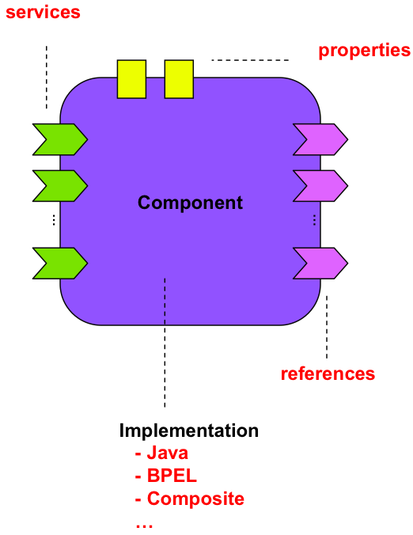
Figure 1 SCA Component Model
Figure 1 illustrates the canonical representation of an SCA component. On the left are the exposed services of the SCA component, with the service references of the component shown on the left. References from one component “plug into” the exposed services of another component, as suggested by the graphic representation above. Properties are injected into the component that provide the component implementation with any parameters required by the implementation.
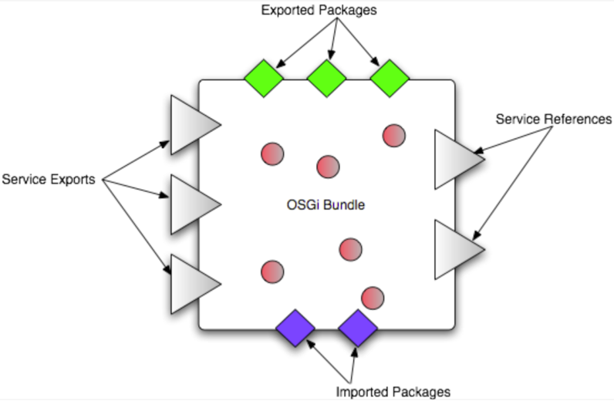
Figure 2 OSGi Bundle Model
Figure 2 provides a similar model for the OSGi bundle. As one can see by this comparison, the OSGi bundle actually provides a superset of the SCA component model by defining a class import and export mechanism in addition to a well-defined lifecycle for the bundle and the services it defines, as shown in Figure 3 below.
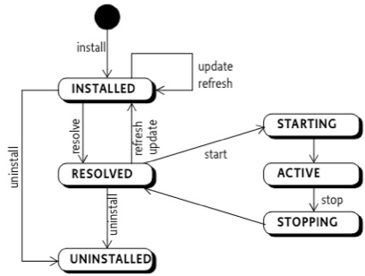
Figure 3 OSGi Bundle Lifecycle
SCA components can be assembled into composites, which define the “wiring” which introduces and connects services exported by a component to the references from another component that use these services. This is shown in Figure 4 below.
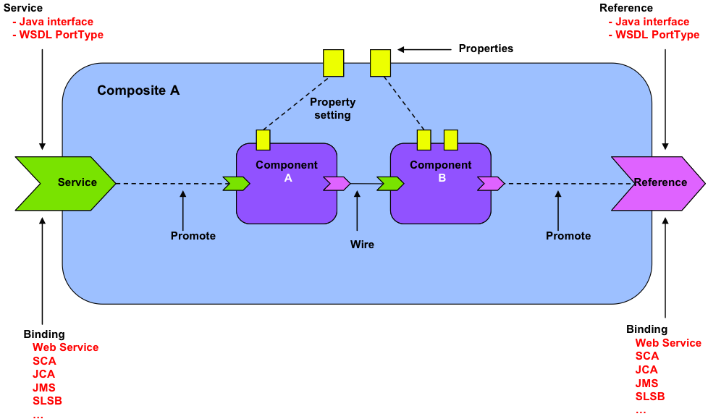
Figure 4 SCA Composite Model
Again, what is striking about the SCA composite model is how similar it is to models produced by OSGi wiring Administration specification, shown below in Figure 5.
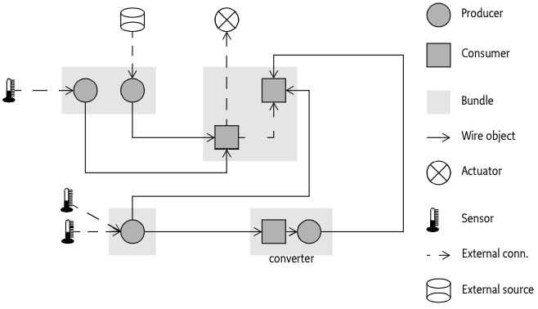
Figure 5 Wiring Admin Model
In this figure, we can see that the wiring model of SCA closely maps to the Wiring Admin specification in OSGi. Producers and consumers map to SCA services and references. Wires provide the connection between the two an allow interposition and interceptor models which provide the same kind of functionality as the policy enforcement points do in SCA.

Problem Description
SCA was developed independently of the OSGi architecture and many have noticed the similarity of SCA concepts and OSGi concepts. In addition, many recognize the advantages of using OSGi to provide essential pieces of an SCA runtime environment for Java. Many groups have also expressed the desire to integrate SCA and OSGi at a more fundamental level in which SCA components and composites interoperate with existing OSGi component models.
- Define how the OSGi lifecycle is used by SCA
- Mapping of the SCA deployment model to OSGi bundles
  - OSGi metadata
  - SCA metadata
  - Bundle lifecycle
- Exposing SCA services as OSGi services
- Consumption of OSGi services as SCA references
- Wiring of SCA components within an OSGi environment
- Integration of existing OSGi services into the SCA model
  - Configuration Admin service for managing properties
  - Wiring Admin service for composite assembly
- Defining how SCA components interact with the dynamic nature of OSGi services
Providing these mappings and definitions will facilitate the adoption of OSGi within SCA and allow SCA to interoperate as a component model within the OSGi environment.

Use Cases
This is not an exhaustive list of use cases that should be supported by any RFC in response to this proposal, but should instead be treated as representative of typical scenarios.

OSGi as a packaging and runtime model for individual SCA components
An SCA runtime environment uses OSGi as the infrastructure that manages the class loading and lifecycle of an SCA component. In this use case, the SCA runtime maps the component to an OSGi bundle, and this component is isolated within a single OSGi container runtime. This OSGi runtime container hosts the SCA component and any bundles which contain the classes necessary for the SCA component implementation to operate.

OSGi as a packaging and runtime model for multiple SCA components
An SCA runtime environment uses OSGi as the infrastructure that manages the class loading and lifecycle of multiple SCA components. SCA components map to individual OSGi bundles and multiple of these components and any bundles which contain the classes necessary for these component’s implementation are hosted within a single OSGi container runtime.

OSGi as an SCA runtime
The OSGi container is used by the SCA runtime to implement the entire container semantics. The runtime interprets the SCA metadata to wire up the defined SCA composites. The SCA container uses OSGi bundles not only for the SCA components, but also as a mapping of SCA composites and the communication endpoints (bindings) that connect the components to the outside world. The runtime makes maximal use of existing OSGi services such as the configuration administration service for managing the properties of the composites, components and communication endpoints. The wiring admin service is used to provide the concrete implementation of the SCA wiring represented by the SCA metadata.

SCA as a peer OSGi component model
SCA components are hosted in an OSGi container and participate fully and interoperate with other OSGi services in a seamless fashion. As bundles containing SCA metadata are loaded into the system, the environment orthogonally configures the bundles and transparently integrates them into the OSGi service registry. OSGi services integrate with SCA components through exposed services in the OSGi service registry through standard mechanisms. Likewise, SCA components integrate through references to services that are obtained through the OSGi registry. SCA bindings (endpoints) are also seamlessly exposed and transparently integrated into the OSGi infrastructure.

Requirements

- The solution MUST allow SCA runtimes to make use of the OSGi infrastructure, such as packaging, lifecycle and class loading and resolution
- The solution SHOULD provide a roadmap for integrating existing OSGi services into an SCA runtime.
- The solution MUST be compatible with existing SCA metadata and packaging specifications.
- The solution MUST provide a mechanism for integrating SCA components seamlessly into the OSGi environment.
- The solution SHOULD be configurable and understand policy expressions for the provisioning of the SCA solutions, especially including the quality of service features and policy.
- The solution MAY be deployable into other containers (such as JEE or Spring).

Document Support

References
- Bradner, S., Key words for use in RFCs to Indicate Requirement Levels, RFC2119, March 1997.
- Software Requirements & Specifications. Michael Jackson. ISBN 0-201-87712-0
- Service Component Architecture Specifications, http://tinyurl.com/2ed9w6

Author’s Address

Name | Hal Hildebrand
Company | Oracle
Address | 500 Oracle Parkway, Redwood City, 94038 USA
Voice | +1 650 506 2055
e-mail | hal.hildebrand@oracle.com

End of Document

