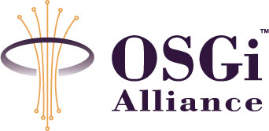
RFP 88 Externalize OSGi Services
Open Distribution, Draft
15 Pages
Abstract
The OSGi platform provides an attractive foundation for building enterprise applications. However it lacks a rich component model for declaring components within a bundle and for instantiating, configuring, assembling and decorating such components when a bundle is started. This RFP describes a set of core features required in an enterprise programming model and that are widely used outside of OSGi today when building enterprise (Java) applications. These features need to be provided on the OSGi platform for it to become a viable solution for the deployment of enterprise applications.

Document Information

Table of Contents
0 Document Information 2
0.1 Table of Contents 2
0.2 Terminology and Document Conventions 3
0.3 Revision History 3
1 Introduction 3
2 Application Domain 4
2.1 Terminology + Abbreviations 5
3 Problem Description 5
3.1 Scenario diagrams 6
3.1.1 A non-OSGi distributed client using an OSGi service, 6
3.1.2 An OSGi client using a remote non-OSGi Service 7
3.1.3 A OSGi client using an OSGi service in another OSGi container 7
3.2 Levels of transparency 8
3.2.1 Asynchronous remote communication 8
3.2.2 Data fencing 9
4 Use Cases 9
4.1 Assemble OSGi components into existing integration scenarios 9
4.2 Provide seamless customer experience following acquisition 9
4.3 Manufacturing capacity planning 10
4.4 Existing Enterprise Application Partially Ported to OSGi 10
5 Requirements 10
6 Document Support 12
6.1 References 12
6.2 Author’s Address 12
6.3 End of Document 12

Terminology and Document Conventions
The key words "MUST", "MUST NOT", "REQUIRED", "SHALL", "SHALL NOT", "SHOULD", "SHOULD NOT", "RECOMMENDED", "NOT RECOMMENDED", "MAY" and "OPTIONAL" in this document are to be interpreted as described in [1].
Source code is shown in this typeface.

Revision History
The last named individual in this history is currently responsible for this document.

Revision | Date | Comments
Initial | Feb 21 2007 | Initial draft created.  Eric Newcomer, IONA eric.newcomer@iona.com
Update | May 8, 2007 | Eric Newcomer, IONA – comments from Tim Diekmann and David Bosschaert incorporated
Update  Update | May 16, 2007  May 24, 2007 | David Bosschaert (davidb@iona.com), Eric Newcomer, IONA – feedback from the F2F May 14-15 in Redwood City, CA  Add text changes to section 5 per email discussion with Hal Hildebrand to help clarify that no specific implementation is implied.
Update | June 8, 2007 | Eric Newcomer, David Bosschaert – update drawings for consistency with OSGi conventions, incorporate additional comments.
Update | July 6, 2007 | David Bosschaert – updated drawings and added 2 new drawings to clarify potential optimizations that certain implementations could make, as requested at the EEG F2F meeting in Munich.

Introduction
Among the requirements for enterprise use of OSGi is the ability to access applications external to OSGi, and to externalize OSGi services for remote access. Many existing technologies are already deployed in the typical enterprise IT environment. OSGi based services will need to interact with those existing technologies and existing technologies will need a way to invoke OSGi based services.
One way to look at this is as the ability for OSGi services to interact with legacy applications. Another way is to think about this requirement is that it would allow OSGi based services to participate in a heterogeneous SOA
In any case, whatever the perspective, OSGi deployments in an enterprise environment will need to coexist and work together well with multiple external technologies. This does not include containers into which OSGi is mapped, or that are deployed onto OSGi (either in part of whole). This does include programs written using languages other than Java (C++, C#, VB, Python, Ruby, etc.) and established enterprise software systems such as object request brokers, message oriented middleware, application servers, database management systems, and packaged applications such as ERP and CRM systems.
Because OSGi bundles are going to be deployed into heterogeneous enterprise IT environments, an RFP needs to be created to define the requirements on OSGi in order to allow such deployments.
One very good related question is whether distributed OSGi needs to be 100% the same (at least to the developer) as non-distributed OSGi. If there’s a requirement for transparent distribution, but it cannot be met, this argues in favor of explicitly drawing a line somewhere and ensuring the developers are aware of the differences and design and code to them.

Application Domain
The primary domain addressed by this RFP is the heterogeneous enterprise IT environment that includes existing and new non-OSGi based applications that need to communicate with OSGi based applications, and with which OSGi based applications need to communicate. Examples of such applications include internet banking applications connected to mainframe databases, travel applications with multiple providers of travel item reservations that all use different technologies, telecommunications industry services for broadband telephony and television that rely on legacy billing applications, and so on. Standalone or single technology applications (i.e. OSGi only) are not in scope.
Some core features of heterogeneous enterprises:
- “Stove-piped” applications written using different languages and software systems, including but not limited to .NET, JEE, C++, CORBA, message oriented middleware, TP monitors, data base management systems, packaged applications, EDI, and Web technologies
- Applications built and maintained by separate departments and business divisions that were not designed or built using any consistent principles, and may or may not have integration points exposed.
- Multiple communication protocols and paradigms (i.e. synch and asynch) for interacting with different applications
- Multiple data formats for the same, or similar data items that need to be accessed consistently or reconciled for both read and update operations.
- Quality of service requirements inherent in existing applications, including security, transactionality, reliability, and performance service levels of agreement that need to be met, sometimes expressed in machine readable policies and configuration files

Terminology + Abbreviations
- Communications protocol: a mechanism for remote interaction across two or more machine address spaces, typically spanning multiple network addresses. Communications protocols are typically either synchronous (e.g. RPC) or asynchronous (e.g. MOM), and existing enterprise applications are divided in somewhat equal measure between those better served by one or the other.
- Data format: usually a serialization mechanism for packing and unpacking typed data into and out of messages exchanged between programs in different address spaces. Often associated with a communications protocol (e.g. CDR with IIOP, XML with SOAP). Intended to help resolve the issue of multiple data types in various programming languages.
- Qualities of service: sometimes also called “nonfunctional” requirements associated with application functions, and sometimes also defined and managed separately using policy and configuration metadata. Examples include security, transactions, and reliability requirements that may be applied to application programs in order to meet operational business requirements.
- Operational environment: associated with management and governance capabilities for applications, the operational environment represents requirements for deploying, updating, and tracking the execution of application programs. Sometimes these requirements will span OSGi and non-OSGi based components when deployed in combination.

Problem Description
Enterprise application developers working with OSGi will need to interact with existing applications, and often existing applications will need to be modified to interact with newer, OSGi based applications. Sometimes the objective of the interaction will be to perform retrieval and update operations directly on existing data resources. Other times the objective of the interaction will be to use an existing or new program to serve as a proxy or intermediary for another program’s data operations. Other times the objective of an interaction will be to request the execution of some business logic, or to evaluate some data, or perform a complex calculation and return the results.
The current OSGi specifications are lacking in the following areas with respect to this requirement:
- No mechanism defined for plugging in or binding to different communications protocols
- No mechanism defined for plugging in or binding to different data formats – the requirement here in both cases can also be stated as how to bind an OSGi service to a transport layer and data format layer
- No definition on how to mix ‘n’ match communications protocols and data formats (e.g.. allow SOAP over JMS or binary over HTTP)
- No ability to configure or plug in quality of service capabilities
- No ability to discover and download a remote service
- No ability to interact with external (i.e. remote) data resources
- No ability to transform OSGi invocations into external invocations that use existing communications protocols, data formats, and quality of service capabilities found in existing heterogeneous IT environments
- No ability for OSGi components to receive and understand messages from existing applications that use distributed communications protocols, data formats, and qualities of service
Providing these capabilities on the OSGi platform – either directly or indirectly - will facilitate the adoption of OSGi into existing heterogeneous IT environments.
While OSGi has some of the capabilities in place for interaction with external systems, the requirements of interacting with heterogeneous IT environments is often dictated by the requirements of the existing applications, since they represent communications protocols, data formats, programming languages, software systems, and qualities of service agreements already in place for the business.
Another requirement centers around interoperability:
1. A service remoted through OSGi implementation A should be accessible from another Service that runs in OSGi implementation B.
2. Implementations A and B could be based on entirely different OSGi runtimes.
3. For a user of the OSGi runtime, is should be easy to identify that a certain OSGi runtime can interop with another OSGi runtime. So let's say the user already has an OSGi runtime that exposes its services using a certain wire protocol, e.g. SOAP/HTTP. If the user starts using another OSGi runtime that says that it supports SOAP/HTTP they should interoperate. So the way they use that particular protocol should be the same.

Whether or not an IDL or some other formalism like special use of Java Interfaces would be needed to satisfy this is certainly a valid discussion point, but it would be good to try and solve it within the boundaries of Java Interfaces, simply because this concept is already used in OSGi.

Scenario diagrams
Schematically, the problem domain centers around the following scenarios. Note that the non-OSGi clients and servers mentioned represent legacy applications that typically can’t be modified.

A non-OSGi distributed client using an OSGi service,
A legacy client needs to invoke a service that is provided by an OSGi service. The client is written in a programming language such as C++ and uses a certain distributed protocol, such as SOAP/HTTP(S), CORBA/IIOP or RMI to access this service.
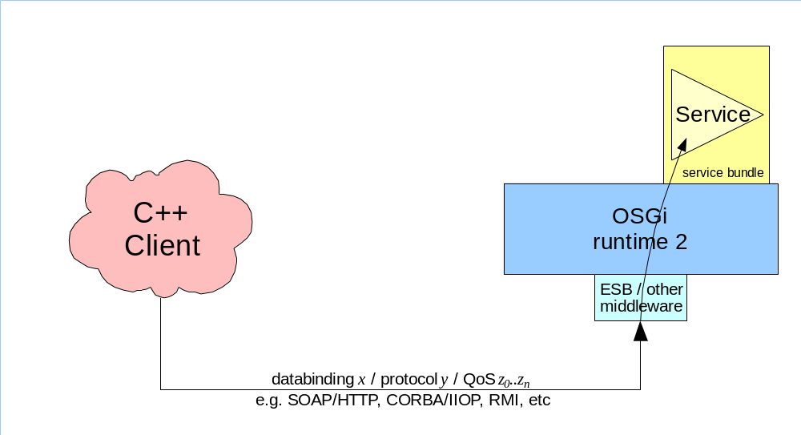
Figure 1
Error: Reference source not found focuses on the OSGi runtime part of this scenario. While certain services could be distributed, it is also possible for other services to exist in the same OSGi container runtime that aren’t distributed. A co-located client would be capable of making a direct invocation on services that are in the same OSGi container regardless of their distribution status.
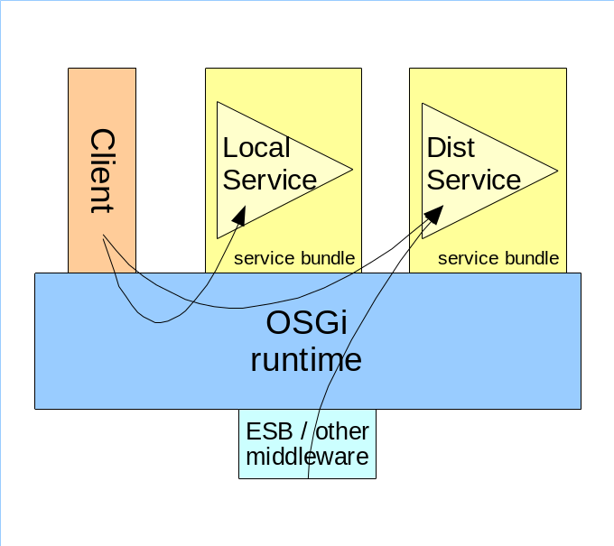
Figure 2

An OSGi client using a remote non-OSGi Service
An OSGi client needs to invoke a legacy SOA service. The service is exposed using a particular type of middleware, e.g. SOAP/HTTP, CORBA/IIOP, RMI, etc.
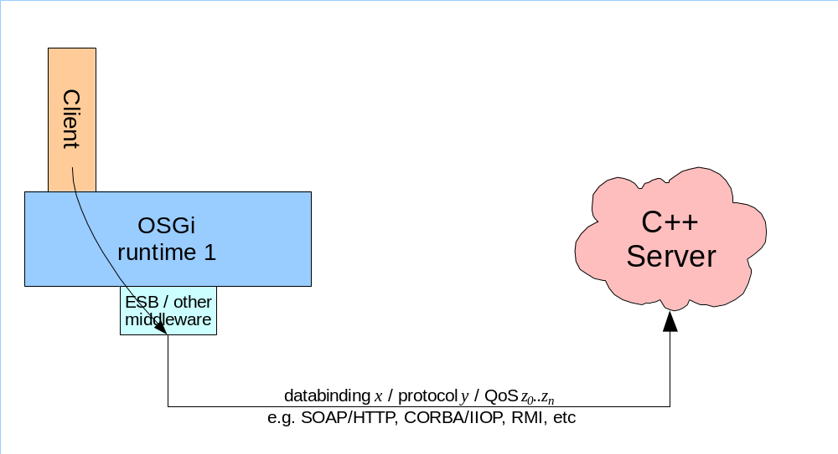
Figure 3

A potential implementation of the OSGi side of this scenario could be realized as illustrated in the figure below. The client would look up the distributed service using the regular OSGi mechanisms and invoke on it normally. The distributed service could be represented locally through a proxy that might have been created by the distribution technology to represent the remote service. The actual remote invocation would be done by the proxy in this case.
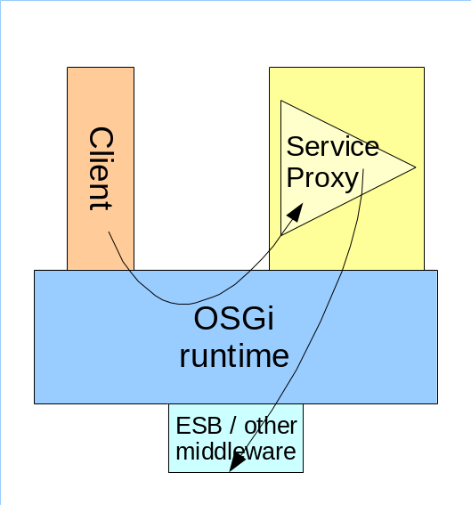
Figure 4

A OSGi client using an OSGi service in another OSGi container
This scenario focuses on a client in one OSGi container that needs to invoke on a Service that lives in another OSGi container. Both client and server might initially not be written to be distributed. However, in there may in certain cases be a possibility to tweak the client and/or service code to make them behave better in this distributed scenario.
Note that in this case an implementation might choose to use an optimized protocol to communicate between the OSGi runtimes.
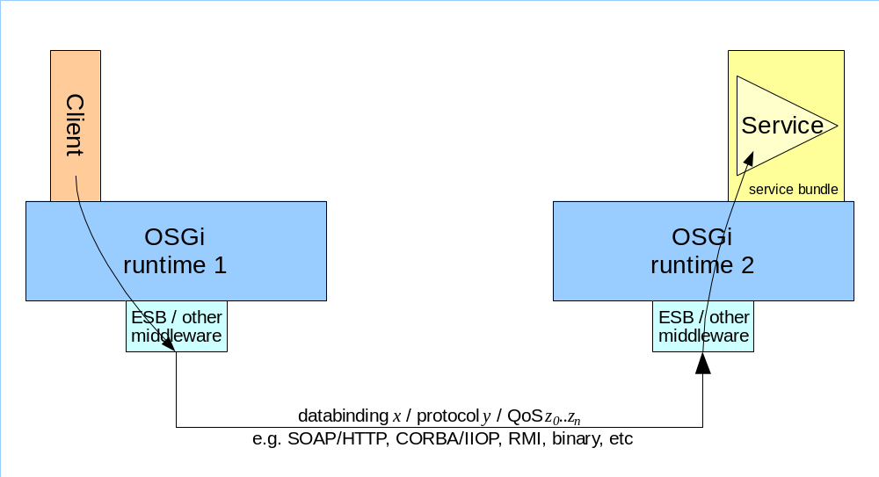
Figure 5

Levels of transparency
While it would nice to be able to turn an existing OSGi Service & Client into a distributed OSGi system without making code changes, it cannot be required that distributed OSGi is entirely transparent. The distributed nature of the system will introduce new scenario’s (e.g. new failure scenarios) that were not relevant to non-distributed OSGi. If the program wishes to, it should be allowed to interact with the distributed nature of the system. Therefore, the following levels of transparency should be supported:
- Completely transparent to the developer. No code changes needed in either Client and Service. Metadata changes will probably be necessary at this level.
- The programmer should be able to influence the lookup of the Service in the Client based on properties provided in the metadata (e.g. transport, QoS, etc).
- For any given distributed service it must be possible to find out what the communication provider is and obtain additional metadata that describes the data binding, protocol and QoS.
- It must be possible to handle exceptions caused by the communications mechanism in a generic, non-communication provider specific, way. These exceptions should also provide detailed information on what caused it, the cause may be transport specific.

Asynchronous remote communication
Many enterprise applications are built using asynchronous communication metaphors such as message queues, publish and subscribe mechanisms. Since programming languages typically follow a synchronous model for execution, explicit developer action is generally required to work with such communication protocols. A program must normally be aware of the asynchronous communication to work properly in these cases.
The solution should not prevent the developer from developing it application in such a way that it suits the asynchronous (one-way) semantics exposed by such protocols. The metadata associated with the distributed nature of the service could be used identify whether a service is async or not.

Data fencing
When exposing a service over a remote protocol, typically a binding/transport-specific interface definition is used to advertise the interface of the service. Such interfaces generally don’t allow applications internals to be exposed, but rather need a clear and finite definition. Therefore it will probably be necessary to put some constraints on the possible usage of datatypes in service interfaces in order to be able to expose them over remote interfaces. As an example, an interface that has a java.lang.Object as an argument will probably not be allowed. The extract boundaries of the data fencing will need to be defined and it would be nice if a tool could or clear methodology could be defined that would allow the developer to test whether the interfaces at hand satisfy this requirement.

Use Cases
This is not an exhaustive list of use cases that should be supported by any RFC in response to this proposal, but should instead be treated as representative of typical scenarios.

Assemble OSGi components into existing integration scenarios

A telecommunications company wishes to bring a new service to market, such as broadband TV or phone, and needs to develop new application capability using OSGi specific to the new service while using existing application capability to provide billing and customer care for the new service. The new service would be deployed and delivered using the OSGi developed application but the new application would need to feed data about the customers and the usage of the new service into the existing applications. The telecommunications company wants to get the new service to market as quickly as possible, and therefore wishes to minimize the amount of new code it has to develop, and maximize the use of existing application functionality. The existing applications include very heavy security to prevent fraud and have stringent requirements for message delivery to avoid duplicating any billing information or customer information in the existing applications. Furthermore the existing applications in some cases require multiple updates to existing data resources to be treated as a transactional unit (which may extend into the OSGi based application component since it will also be persisting data and using asynchronous communication protocols for store and forward reliability of processing the billing data).

Provide seamless customer experience following acquisition

A large bank acquires a smaller bank and wishes to consolidate the customer and account databases and applications from the two companies. The smaller bank has developed applications using OSGi while the larger bank has developed applications using a variety of technologies and languages deployed on mainframes, UNIX, and Windows operating systems. The larger bank connects applications together using an SOA based on CORBA interfaces and MOM and CORBA communication protocols. The smaller bank’s applications need to be refactored into reusable services that interact with the services in the larger bank. Furthermore the smaller bank’s applications need to be able to support the security requirements and reliability requirements of the larger bank’s services. The result will be services hosted by the smaller bank’s OSGi based environment that allow services hosted by the larger bank’s heterogeneous environment to access the smaller bank’s customer and account information and vice versa. Customer service agents in both the smaller and larger bank need to be able to provide a seamless experience for customers interested in any new accounts or banking services, whether originally provided by the smaller or the larger bank.

Manufacturing capacity planning

A large manufacturing company needs to interact with multiple suppliers and buyers to estimate production capacity for the next season’s ski boot market. The suppliers and buyers all have different IT environments while the manufacturer has recently converted its systems to OSGi. The manufacturer wants to on the one hand obtain reliable information from buyers forecasting demand for the next season and on the other hand distribute the risk to their parts suppliers. Information from the buyers needs to flow through the manufacturer to the suppliers seamlessly, reliably, and accurately. The suppliers are using a variety of communication protocols and data formats, such as RMI, IIOP, SOAP/HTTP, tag/value pairs, etc., which all need to be understood and interacted with from the new OSGi based application.

Existing Enterprise Application Partially Ported to OSGi
An enterprise is adopting OSGi incrementally and starts by porting its order entry system to OSGi based software. However, the inventory management, customer management, and billing and accounting systems remain on the older platform. The new OSGi based system needs to seamlessly interact with all the other applications that the former order entry system interacted with, and allow the other applications to seamlessly interact with the new order entry application.

Requirements
1. The solution MUST enable interoperability between OSGi developed services (or components) and services (or components) developed using non OSGi environments.
The interoperability would typically be provided through the use of existing distributed data bindings and protocols such, e.g. SOAP/HTTP, CORBA/IIOP, JMS, RMI etc. Not all possible integrations need to be delivered, what is needed is an extensible framework that can hold these. The Reference Implementation should come with at least 2 implementations to prove the scenario and pluggability.
2. The solution SHOULD abstract protocols, data formats, and quality of service features in order to be easily adaptable to communication protocols, data formats, and qualities of service found in existing enterprise applications and software systems.
This means that the user code should not be required to be written against a particular type of protocol. This should be abstracted.
3. The solution SHOULD be compatible with multiple external programming languages and operating systems.
So it should allow interoperability with systems written in a variety of programming languages (e.g. C/C++, .NET, Cobol, scripting languages) running on a number of operating systems such as Windows, UNIX, Mainframes. Note that these external systems do not need to be running an OSGi container. Interoperability would be provided through the distributed databinding & protocol used.
4. The solution SHOULD be extensible for custom developed interoperability solutions (i.e. users can add their own protocols, data formats, and quality of service extensions).
5. The solution SHOULD be configurable and understand policy expressions for the provisioning of the interoperability solutions, especially including the quality of service features.
The policy information could be for example expressed as WS-Policy expressions which should give the administrator the ability to define the distribution-related metadata in a declarative way.
6. The solution SHOULD support high availability and performance requirements typical of existing enterprise systems.
7. The solution SHOULD bridge the OSGi context sharing mechanism with external context sharing mechanisms (to support stateful failover, shared stateful sessions, etc.).
8. The solution SHOULD NOT introduce language specific, protocol specific, or quality of service specific dependencies.
9. The solution for external access SHOULD be as consistent as possible with the solution for accessing internal OSGi services, to minimize the amount of effort in moving from one to the other.
10. The solution SHOULD provide a consistent mechanism for simultaneously incorporating multiple protocols and data formats.
11. The solution SHOULD provide a consistent mechanism for quality of service enhancements. .
12. The solution MUST make it possible, but not necessary, for developers to interact with the distributed attributes of the system, such as distributed error conditions, and information around the databinding, transport and QoS.
To give application developers the option to find out the distributed properties of the Service and also be capable of detecting remoting-related specific error conditions if they wish to do so.
13. The solution MUST NOT prevent the use of asynchronous programming models if these are provided by the transport used.
In other words, if the transport provides an asynchronous protocol such as JMS, CORBA one-ways or other message queue or publish-and-subscribe model, it must be possible for the application programmer to take advantage of this asynchronous nature.
14. The solution SHOULD support the capability for a developer to declaratively specify the configuration requirements for a protocol layer.
15. The solution SHOULD allow a deployer to define wiring and configuration information for bundles and create distributed solutions with minimal or no code changes.

Document Support

References
- Bradner, S., Key words for use in RFCs to Indicate Requirement Levels, RFC2119, March 1997.
- Software Requirements & Specifications. Michael Jackson. ISBN 0-201-87712-0

Author’s Address

Name | Eric Newcomer
Company | IONA Technologies
Address | 200 West Street, Waltham, MA 02451 USA
Voice | +1 781 902 8366
e-mail | eric.newcomer@iona.com

Name | David Bosschaert
Company | IONA Technologies
Address | The IONA Building, Shelbourne Road, Ballsbridge, Dublin 4, Ireland
Voice | +1 353 637 2371
e-mail | davidb@iona.com

End of Document

