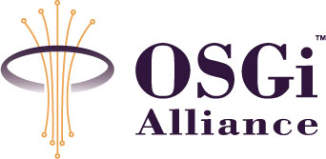
Remote Management Architecture for Multiple Service Provider Environment
Confidential, Draft
8 Pages

Abstract
This document formalizes the use cases and requirements needed to define the reference architecture for Multiple Service Provider environment.

Document Information

Table of Contents
0 Document Information 2
0.1 Table of Contents 2
0.2 Terminology and Document Conventions 2
0.3 Revision History 2
1 Introduction 2
2 Application Domain 3
2.1 Terminology + Abbreviations 4
3 Problem Description 5
4 Use Cases 5
4.1 Service Provider registers a Service Application 5
4.2 Registering a conflicting Service Application 5
4.3 Runtime detection of conflict 6
4.4 Finding conflict by runtime statistics 6
4.5 Independence of management 6
5 Requirements 6
5.1 References 6
5.2 Author’s Address 7
5.3 End of Document 7

Terminology and Document Conventions
The key words "MUST", "MUST NOT", "REQUIRED", "SHALL", "SHALL NOT", "SHOULD", "SHOULD NOT", "RECOMMENDED", "NOT RECOMMENDED", "MAY" and "OPTIONAL" in this document are to be interpreted as described in [1].
Source code is shown in this typeface.

Revision History
The last named individual in this history is currently responsible for this document.

Revision | Date | Comments
Initial | June 28 2007 | Initial draft created.  Hiroyuki Maeomichi NTT maeomichi.hiroyuki@lab.ntt.co.jp
 | July 25 2007 | Fixed grammatical errors

Introduction
The “multiple service provider” model is one of the business models known for the OSGi service platform. In the model, multiple service providers offer their services on a single OSGi service platform in the end user’s premises. This document discusses the reference architecture that embodies the model.

Application Domain
In the “Multiple Service Provider” model, three entities play key roles: (1) service provider, (2) end user, and (3) service aggregator. A service provider provides one or more service applications to the end user by delivering them as a bundle on the OSGi service platform in the end user’s premises. The end user can subscribe to many service applications provided simultaneously by multiple service providers. The service aggregator has the most important role since it offers the following three functions.
(1) Remote management of equipment that realizes the OSGi service platform.
(2) Delivery of bundles provided by service providers.
(3) Resolution of conflicts between service applications. This is to prevent improper interaction between service applications, and to keep service applications running correctly and safely.
Figure 1 shows an overall picture of remote management. An OSGi FW is managed by a single Management System. Service Aggregator operates the Management System. Multiple Service Providers provide their Service Applications through the Management System.
IF1 enables Service Providers to (1)register bundles with the Management system, (2)update/delete Bundles on the Management System, (3) associate an End User with a Service Application, (4)monitor OSGi FW, (5) get statistics and conditions of OSGi FWs, (6) exchange events and messages and (7) control lifecycle and configuration of bundles provided by the SP itself.

The management system uses IF2 to execute both bundle level management and equipment level management. Bundle Level management includes message and event delivery, bundle delivery, bundle life cycle control, and configuration management. Equipment level management includes monitoring and authentication.

IF3 enables an SP bundle to delegate operations that only the management agent is authorized to do, e.g., sending events and messages, accessing repositories, and executing privileged operations. It also enables the management agent to manage bundles. (This kind of operation may be executed only through BundleContext. In that case, this direction can be omitted.)
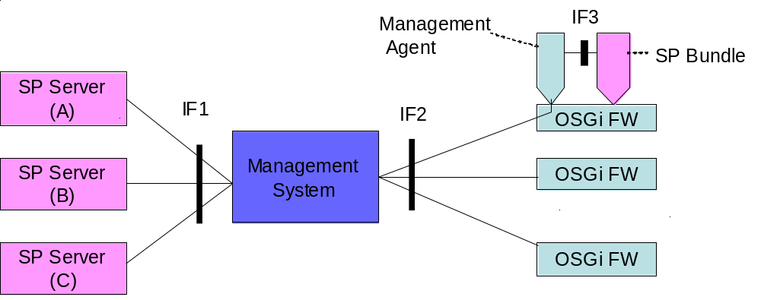
Figure 1: Roles, entities, and interfaces

Terminology + Abbreviations
•Service Application (SA): A set of bundles, which runs on OSGi FW. The granularity of the set is an application at the business level. It is usually a unit of subscription for the end user.
•Service Provider (SP): The entity that provides Service Application.
•Service Provider Bundle (SP Bundle): OSGi Bundles provided by SP
•Service Provider Server: a Server provided by the Service Provider. It may accommodate the server-side application that communicates with the Service Application.
•Dependency of SA: The condition in which an SA requires other specific SAs in order to run properly
•Dependency Management: To resolve the dependency between Service Applications. A Service Application may depend on other Service Applications.
• Conflict of SA: The SA does not run properly with other SAs because of the interaction between them.
•Conflict Management: Resolves conflicts between Service Applications. Some service applications may conflict with other Service Applications.
•Service Application Aggregation: Consolidating Service Applications, which are provided by multiple service providers, while simultaneously fulfilling “Dependency Management” and “Conflict Management”.
•Service Aggregator: A Service Aggregator is a Service Provider that consolidates Service Applications provided by other Service Providers into one distinct offering and resolves dependencies and conflicts between different Service Applications.
•Separation: Prevents SAs provided by different SPs from improperly interacting, and keeps each SA running properly and safely.
•Segment: Separated area created by “Separation”. Each segment is dedicated to a managing entity, typically a service provider.
•Management System: The entity that manages OSGi framework (FW).
•Management Agent: A bundle that is responsible for managing a Service Platform under control of a Management System.
•End User: The owner of an OSGi FW, who typically derives some benefit from running Service Applications on it.

Problem Description
“OSGi Service Platform R3” defines “Reference Architecture” and “Remote Management Reference Architecture”, but there are the following problems.
•The sections have been removed from the latest specification.
•The sections don’t describe what sort of task is included in conflict management and how service aggregator resolves conflicts. With no reference model, service aggregator may use its own restrictions on bundles and bundles may be strongly dependent on Service Aggregator.
•The sections don’t include an explicit model of multiple service providers providing services. The existing SGW model permits the existence of Service Aggregator, because it is defined as a special Service Provider. With the existing models, it is hard to elucidate issues raised by the multiple service providers. It is also hard to derive a remote management protocol that can handle multiple service providers’ issues, from any existing model.

Use Cases
This is not an exhaustive list of the use cases that should be supported by any RFC in response to this proposal, and should, instead, be treated as representative of typical scenarios.

Service Provider registers a Service Application
SP A registers application A1. Service Aggregator checks if the application complies with regulations. After passing the check, Service Aggregator put it on to management system.
In the next step, end user subscribes to A1.The subscription triggers download and installation of an application bundle on to the SGW.

Registering a conflicting Service Application
SP B registers application B1. Service Aggregator confirms the conformance of the application, but detects a conflict between A1 and B1. Aggregator registers B1 with the restriction in that a user can not subscribe to A1 and B1 in the same time.
After that, end user tries to subscribe to B1, but fails due to the conflict.

Examples of conflict:
- Both A1 and B1 export same packages (same name, version and property) that have different implementation.
- Both A1 and B1 use same network port number.
- Both A1 and B1 use same “unsharable” device.
- B1 uses A1’s service without agreement.

Runtime detection of conflict
An end user is subscribing to A1 and C1. Both applications run on the SGW. During runtime, the management agent detects a conflict between A1 and C1. Management agent sends an event to the service aggregator. After confirming the situation, the aggregator records conflict between A1 and C1. After that, no end user is permitted to subscribe to A1 and C1 in the same time.
Examples of conflict:
- CPU load is constantly high for only the SGWs in which both A1 and D1 are subscribed.
- A bundle in A1 tried to stop a bundle C1.

Finding conflict by runtime statistics
The Service Aggregator checks statistics for SGWs and finds the tendency that SGWs that run A1 and D1 tend to malfunction. The Service Aggregator starts to investigate the cause with related SPs; SP A and SP D. The service Aggregator registers a conflict depending on the severity of the malfunction.

Independence of management
SP controls the lifecycle and configuration of the bundles provided by the SP itself. In the other hand, SP can not control the lifecycle or configuration of the bundles provided by other SP.
Management protocol such as events and messages should be delivered properly; Management protocol related to SP A is never delivered to SP B.

Requirements
- The solution MUST specify Reference Architecture that defines roles, entities, and Interfaces among them.
- The solution MUST define the “Multiple Service Provider” model.
- The solution MUST define a terminology for conflict management.
- The solution SHOULD describe typical operations for conflict management and their limitations.
- Management protocol such as events and messages SHOULD be delivered properly.
- Event, message, and command on interface IF 2 SHOULD have the property that specifies SP.
- Conflict management SHOULD be possible by remote management.
- Management protocol SHOULD take conflict management into account.

References
- Bradner, S., Key words for use in RFCs to Indicate Requirement Levels, RFC2119, March 1997.
- Software Requirements & Specifications. Michael Jackson. ISBN 0-201-87712-0

Author’s Address

Name | Hiroyuki Maeomichi
Company | NTT Corporation
Address | Y320C, 1-1 Hikari-no-oka, Yokosuka, Kanagawa, Japan
E-mail | maeomichi.hiroyuki@lab.ntt.co.jp

End of Document

