
VEG - HMI API High Level Requirements
Confidential, Draft
21 Pages
Text in Red is here to help you. Delete it when you have followed the instructions.
The <Document Title> and <Company Name> can be set from the File=>Properties menu. To update it onscreen, press F9. To update all of the fields in the document Select All (CTRL-A), then hit F9. Set the confidentiality and release level by selecting one from each list; Confidential, Members Only or Open Distribution and Draft, Final Draft, Release. The date is set automagically when the document is saved. Note that FINAL DRAFT and RELEASE documents should only be released as PDF, NOT AS WORD DOCUMENTS
Abstract
10 point Arial Centered.
Put information about the purpose of the document and the information that it contains here. This text should not extend beyond this front page. If it does, revise the abstract.
This RFC provide proposed solutions and requirements for an OSGi HMI API. Its aim is not to standardize UI technologies or communications between UI technologies and server techniques, but to create a specification for an HMI API for OSGi to support UI abstraction with all benefits of OSGi technology (such as dynamic loading of user interfaces and styles).

Document Information

Table of Contents
0 Document Information 2
0.1 Table of Contents 2
0.2 Terminology and Document Conventions 2
0.3 Revision History 3
1 Introduction 3
2 Application Domain 4
2.1 Terminology + Abbreviations 5
3 Problem Description 6
3.1 Proposed Solutions 8
3.1.1 Proposed process 8
3.1.2 Proposed Solution Architecture with UI anatomy 9
3.1.3 Proposed Solution based on MIF 10
3.1.4 Proposed Solution Architecture with Context Aware Adaptive UI generation 13
3.2 Communication between UI’s and server. 13
4 Use Cases 14
5 Requirements 15
5.1 Template 15
5.1.1 API High level requirements 15
5.2 Context aware requirements 18
5.3 Interaction data Requirements 19
6 Document Support 20
6.1 References 20
6.2 Author’s Address 20
6.3 End of Document 20

Terminology and Document Conventions
The key words "MUST", "MUST NOT", "REQUIRED", "SHALL", "SHALL NOT", "SHOULD", "SHOULD NOT", "RECOMMENDED", "NOT RECOMMENDED", "MAY" and "OPTIONAL" in this document are to be interpreted as described in [1].
Source code is shown in this typeface.

Revision History
The last named individual in this history is currently responsible for this document.

Revision | Date | Comments
Initial | 04 18 2007 | Initial version  Bart den Haak, LogicaCMG, bart.den.haak@logicacmg.com

Introduction
Describe the state of the RFP and explain how the RFP came into existence.
The goal of the Vehicle Expert Group (VEG) is to tailor and extend the OSGi specification in order to meet vehicle-specific requirements. To achieve this, the VEG will define a list of topics that cover vehicle-specific issues.

During the last VEG requirements meeting in Eindhoven (2007/03/22) attendants voted for OSGi VEG specification requirements. Providing an API for Human Machine Interface (HMI) was one of the top 8. This document will describe the high level requirements necessary for an API for HMI in OSGi.

Discuss any other issues that are not addressed in the following chapters.

This document will NOT specify:
- Technical Requirements;
- Customization of the User Interface;
- Specification of Interaction between the machine and end user;
- Implementation solutions;
- Non functional requirements

Application Domain
This is a description of the real world, unrelated to computer solutions. E.g. if you must make a text editor, you describe how the authors input text, do review cycles with peers and publish.
Vehicle drivers often use various user interfaces to interact with the vehicle itself or additional instruments/components. E.g. to operate a navigation system, audio/video, telephone or vehicle personalization.

OSGi developers need an abstract layer to communicate with user interfaces, so they don’t need the specific user interface technology knowledge to develop UI’s and can concentrate on the business logic.
UI designer could design themes and styles for each UI technique separate from the business logic in the form of templates which could be bundled in an OSGi service/bundle.
This section should define the terminology that is used in later sections and paint a clear picture about issues and facts of the problem domain.
Terminology is defined in section 2.1.
Do not discuss solutions or problems that are solved, focus on a description of the context of the problem. This should answer questions like: What actors/entities take part in the problem domain? What is their role?
Actors: End users (use the user interface), OSGi developers (develop business logic), UI designers (design UI templates specific for a user interface technique).
It should describe the world as it is now, not when the solution is applied. This is a real world description, not of a computer system solving the real world problem!
This section should also list assumptions that the RFC may make about the problem context. E.g. the number of users of a gateway shall not exceed 100.
This RFC provide proposed solutions and requirements. Its aim is not to standardize UI technologies or communications between UI technologies and server techniques. Its aim is to create a specification for an HMI API for OSGi to support UI abstraction with all benefits of OSGi technology (such as dynamic loading of user interfaces and styles).
The difficult part is to not describe the solution, or the problem. This section should strictly limit itself to the context of the problem and the solution.
Also, you should list existing products that exist in the problem context. E.g. for the Communications architecture there are Java Phone API, Java Messaging Service and javax.microedition.io that operate in this scope. It is not required to evaluate them, just list them.

- Model View Controller Pattern (MVC)
- W3C Multimodal Interaction Framework
- Context Aware and adaptive user interface generation
  - Java Context Aware Framework
  - Context Toolkit
  - Context Information service
  - Context service
  - Activity based computing
  - Task based computing
- User Interface Description Languages (UIDL):
  - UIML
  - XIML
  - AUIML
  - USIXML
  - AUIT
  - AAIML
  - XUL
  - GITK/GIML
  - XAML

Terminology + Abbreviations
API – Application Programming Interface
HMI – Human Machine Interface

Human user: A user who enters input into the system and observes and hears information presented by the system. In this document, we will use the term "user" to refer to a human user. However, an automated user may replace the human user for testing purposes. For example, an automated "testing harness" may replace human users for regression testing to verify that changes to one component do not affect the user interface negatively

Input - allowing the users to manipulate a system

Output - allowing the system to produce the effects of the users' manipulation

Smart clients are "easily deployed and managed client applications that provide an adaptive, responsive and rich interactive experience by leveraging local resources and intelligently connecting to distributed data sources” [MSDN06].

A thin client is a minimal client. Thin clients utilize as few resources on the host computer as possible. A thin client's job is generally just to (graphically) display information provided by an application server, which performs the bulk of any required data processing [Wikipedia06].

A thick client (also known as a fat client or rich client) is a client that performs the bulk of any data processing operations itself and relies on the server it is associated with primarily for data storage. Although the term usually refers to software, it can also apply to a network computer that has relatively strong processing abilities [Wikipedia06].

User Interface: The aspects of a computer system or program which can be seen (or heard or otherwise perceived) by the human user, and the commands and mechanisms the user uses to control its operation and input data [DieNet06].

User Interface Type - A category of a user interface.

User interface Technique – The process to develop a certain user interface type.

Problem Description
Detailed description of what problem is actually being solved. This section should answer questions like: What problem is being addressed?
With increasing number of variety of devices (in vehicles) and their use in ubiquitous environments by various types of users, adaptation of user interfaces has become a necessity rather than a facility. Existing systems lack the ability to satisfy the heterogeneous needs of many users. These needs also vary according to the context, where context comprises of environmental conditions, the characteristics of device used to interact with the application, and the user characteristics.
There is a need for techniques that can help the UI designer and developer to deal with myriad of contextual situations. Also, user should be provided with the facility to have an adaptive interface that adapts to changing needs of the user.

The user interface facets including content, structure, navigation, presentation and style have to be modified based on the context. Technological support is necessary for design, development and generation of user interface to each computing platform, each type of user and each type of environment encapsulated in a Human Machine Interface API suitable for OSGi technology.

Problem 2: Where is the edge between thin and thick client? (client server paradigm)
To provide an HMI API we must define the edge between thin and thick client, otherwise we couldn’t abstract user interface properly. Below we explain why this is necessary.
Nowadays, there are myriad user interface techniques and types for different application domains. Some techniques are stateless, such as HTML for providing information to the end user.
Stateless user interfaces are generated by a server (e.g. a web server for HTML) and are not context aware. Business logic is processed on the server side. This is also known as ‘thin’ client.
State full user interface types, such as Java Swing, can process business logic by themselves and use the server only to provide raw information (e.g. an SQL server). They are also aware of the user’s context. These techniques are also known as thick or fat clients.
The difficulty comes when we combine stateless and state full techniques or adding dynamics to stateless user interface types (e.g. adding JavaScript to HTML result into DHTML or AJAX). This is also known as smart clients.

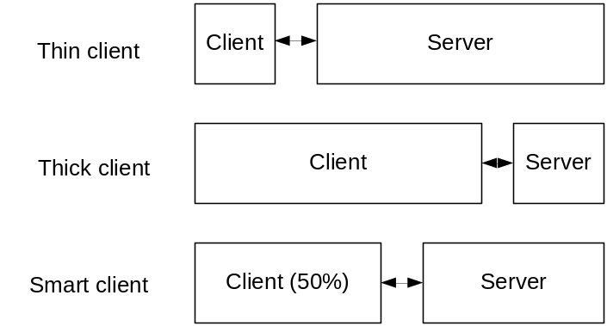

Figure 1, Client server paradigm

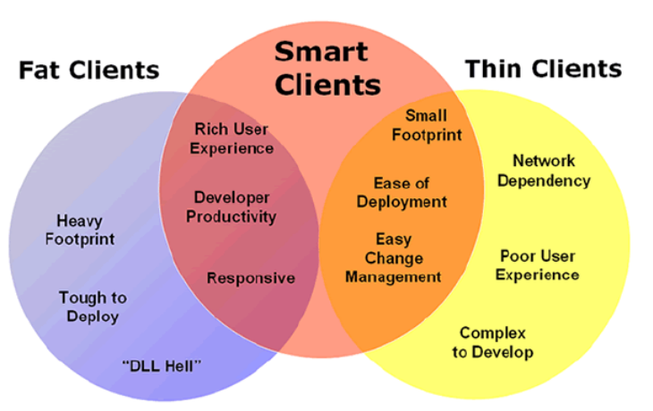
Figure 2, Smart clients, a mix of both thin and FAT (adopted from MSDN)

To support both thin clients, an API HMI must provide ‘servers’ or ‘generators’ as an UI proxy in order to treat thin clients as thick clients. Figure 3 explains this in more detail. A thin client is treated by the HMI API in the same way, but depends on a (external) proxy.

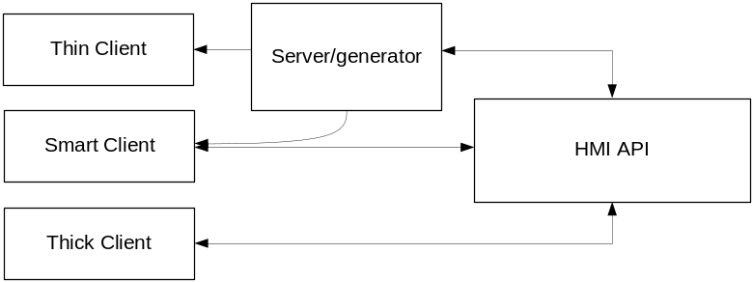
Figure 3, a possible HMI API which treat thin clients as thick clients

Proposed Solutions

Many research on abstract user interface API’s was done by both the academic and the industrial world. There are two topics on abstract user interfaces: User Interface Description Languages (UIDL) and User interface generation. We could learn lessons from both topics and combine them to create an HMI API for OSGi. Because and HMI API focus on abstraction of user interfaces, this is not VEG specific, but could be adopted by other expert groups.

This document proposes 3 solutions:
- HMI API Architecture with UI anatomy
- HMI API based on MIF
- HMI API Context Aware Adaptive UI generation

Proposed process
The following process could result into a HMI API.
- HMI API definition
- Create an user interface anatomy
- Collect user interface types (at the moment only for vehicles software) to support
- Create HMI API requirements
- Create an HMI API architecture
- Define abstract user interface events
- Define user interface services or bundles

HMI API definition
An HMI API can handle stateless and state full user interface clients in a same way and is aware of their user’s context.
NOTE: Styles (included in the context) can be separate in the form of resources for UI designers

Proposed User interface Anatomy

With a user interface anatomy we could define the requirements for a UI service or bundle if the chosen solution architecture support this.
User interface anatomy adopted from UIML [6]:
- Description
- Structure
- Data (content)
- Style(=optional)
- Events
NOTE: we could treat the UI anatomy as a ‘User Interface Context’.

Link: http://www8.org/w8-papers/5b-hypertext-media/uiml/uiml.html

User interface types

- Graphical user interfaces (GUI) accept input via devices such as computer keyboard and mouse and provide articulated graphical output on the computer monitor. There are at least two different principles widely used in GUI design: object-oriented interfaces (OOUI) and application oriented interfaces[verification needed].
- Tactile interfaces supplement or replace other forms of output with haptic feedback methods. Used in computerized simulators etc.
- Touch interfaces are graphical user interfaces using a touchscreen display as a combined input and output device. Used in many types of industrial processes and machines, self-service machines etc.
- Voice/Sound user interfaces

- Attentive user interfaces manage the user attention deciding when to interrupt the user, the kind of warnings, and the level of detail of the messages presented to the user.
- Batch interfaces are non-interactive user interfaces, where the user specifies all the details of the batch job in advance to batch processing, and receives the output when all the processing is done. The computer does not prompt for further input after the processing has started.
- Conversational Interface Agents attempt to personify the computer interface in the form of an animated person, robot, or other character (such as Microsoft's Clippy the paperclip), and present interactions in a conversational form.
- Zero-Input interfaces grab inputs from a set of sensors instead of querying the user with input dialogs.
- Tangible user interfaces, which place a greater emphasis on touch and physical environment or its element.

Proposed Solution Architecture with UI anatomy

Context of use of an interactive system contains the people who use the system, the platform used to interact with the system and the physical environment where the interaction takes place.

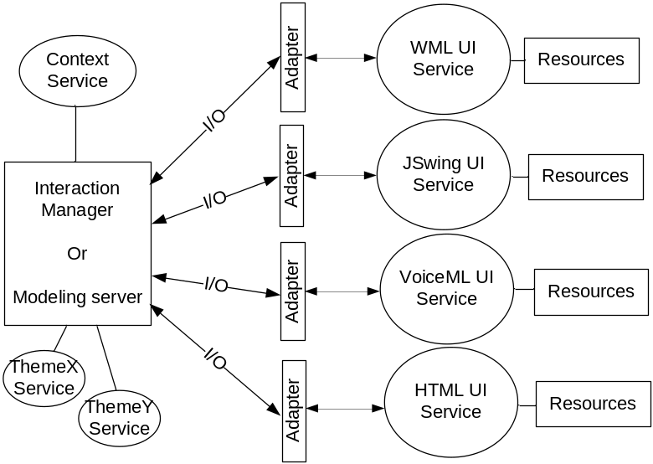
Figure 4, a possible OSGi solution with UI services and theme service when using an UI anatomy

The UI services are OSGi bundles and all implement the UI anatomy and could use internal or external style resources. The UI service/bundle implements abstract interfaces. (E.g. Swing, HTML, WML, VoiceML bundles). Look and feel is defined outside the bundle or bundled and deployed as a theme bundle.

The adapters in this architecture are abstract, which means they also could represent a thin client proxy.
The Interaction or modeling server creates abstraction for all services that use user interfaces.
The theme services are OSGi bundles
The context services are OSGi bundles who manage the UI contexts.

Proposed Solution based on MIF

Definition:
Multi model interactive User interfaces: The User interfaces that provide support for multiple ways to interact are called multi model user interfaces. A user interface is said to implement multimodel user interactions when it has the ability to adapt the interactions based on input and output capabilities of the devices. For example, limited display size may demand for speech recognition and speech synthesis technologies.

Multimodal Interaction Framework
The purpose of the W3C multimodal interaction framework [5] is to identify and relate markup languages for multimodal interaction systems. The framework identifies the major components for every multimodal system. Each component represents a set of related functions. The framework identifies the markup languages used to describe information required by components and for data flowing among components.

The W3C Multimodal Interaction Framework describes input and output modes widely used today and can be extended to include additional modes of user input and output as they become available.

The multimodal interaction framework is not an architecture. The multimodal interaction framework is a level of abstraction above an architecture. An architecture indicates how components are allocated to hardware devices and the communication system enabling the hardware devices to communicate with each other. The W3C Multimodal Interaction Framework does not describe either how components are allocated to hardware devices or how the communication system enables the hardware devices to communicate.

The W3C Multimodal Interaction Framework (MIF) has much overlap with the MVC pattern. Since this framework is supported by W3C, we recommend the adaptation of (at least most) the requirements of this framework.

A concrete interface specification based on (a subset of) the requirements of the W3C Multimodal Interaction Framework [5] could result into a generic HMI API specification. The interface specification could also be reused by other OSGi work groups.

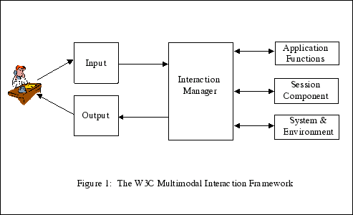

Input — An interactive multimodal implementation will use multiple input modes such as audio, speech, handwriting, and keyboarding, and other input modes.
Output — An interactive multimodal implementation will use one or more modes of output, such as speech, text, graphics, audio files, and animation.
Interaction manager — The interaction manager is the logical component that coordinates data and manages execution flow from various input and output modality component interface objects.
The interaction manager maintains the interaction state and context of the application and responds to inputs from component interface objects and changes in the system and environment. The interaction manager then manages these changes and coordinates input and output across component interface objects.
In some architectures the interaction manager may be implemented as one single component. In other architectures the interaction manager may be treated as a composition of lesser components. Composition may be distributed across process and device boundaries.
Session component — The Session component provides an interface to the interaction manager to support state management, and temporary and persistent sessions for multimodal applications. This will be useful in the following scenarios but is not limited to these:
- A user is interacting with an application which runs on multiple devices.
- The application is session based e.g. multiplayer game, multimodal chat, meeting room etc.
- The application provides multiple modes of providing input and receiving output.
- The application runs on a single device and needs to experience multimodality by switching modes.
System and Environment component — This component enables the interaction manager to find out about and respond to changes in device capabilities, user preferences and environmental conditions. For example, which of the available modes, the user wishes to use — has the user muted audio input? The interaction manager may be interested in the width and height of the display, whether it supports color, and other capability and configuration information.

Application functions (= application logic)

  - OSGi ‘Theme services’

User interface components make their functionality available to interaction managers through a set of interfaces, and can be considered as receiving values from and returning values to the host environment. Here, values can be simple or complex types, and components can specify the location for binding the received data, perhaps using XPath, which is W3C's language for addressing parts of an XML document, and was originally designed to be used by both XSLT and XPointer. The set of interfaces will be built on DOM, and thereby provide an object model for realizing the functionality of a given modality.
The functionality of a user interface component can therefore usefully be encapsulated in a programming-language-independent manner into an object exposing the following kinds of features:
- a set of properties (e.g. presentation parameters or input constraints);
- a set of methods (e.g. begin playback or recognition); and
- a set of events raised by the component (e.g. mouse clicks, speech events).
The DOM defines a platform-neutral and programming-language-neutral interface to documents, their structure and their content. The user interface objects extend this model by adding modality-specific interfaces. In this way, user interface objects can define abstract interfaces which are usable across different host environments.

Additional recommendations:
Input channels or communication channels could be adopted by the HMI API when using this framework. Channels from the user interface to the application (e.g. COM, USB, WLAN, WAN/LAN, Bluetooth etc.)

Assumption and request for adoption
When we look at user interfaces at a higher level we could assume every interaction with an end user is provided by multiple modals. If the OSGi alliance agree on this assumption, a close look at the W3C Multimodal Interaction Framework (MIF) is useful. This framework provides requirements to create an HMI API. This document adopted the use case and some requirements from this specification. Because MIF’s purpose is creating a framework for the internet, some requirements are not useable. Looking at the communication between server and client, DOM seems the proper solution, but for small embedded devices (as in vehicles) with no DOM support other techniques must be considered.

Links:
http://www.w3.org/TR/mmi-framework/

http://builder.com.com/5100-6371-5090322.html

Proposed Solution Architecture with Context Aware Adaptive UI generation

Context of use of an interactive system contains the people who use the system, the platform used to interact with the system and the physical environment where the interaction takes place.

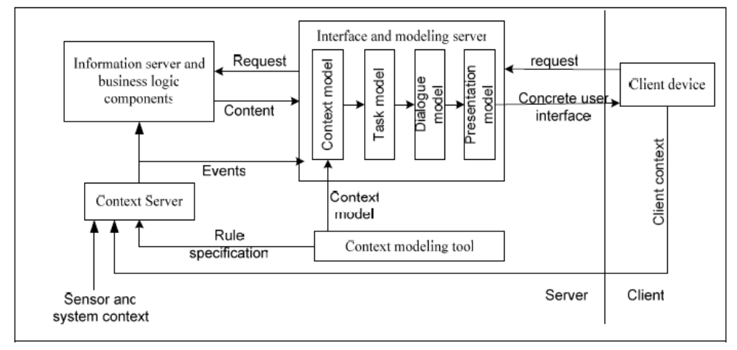

See [3] for the whole description.

Communication between UI’s and server.

OSGi must support a communication protocol (or interface) in order to exchange interaction/context data. The communication protocol could be based upon DOM (DOM defines interfaces whereby programs and scripts can dynamically access and update the content, structure and style of documents), like EMMA[5] or XIML [4].

For those devices without DOM support an alternative universal solution with a small footprint must be supported by OSGi. Maybe the Aterms (http://www.cwi.nl/htbin/sen1/twiki/bin/view/Meta-Environment/ATerms ) invented by prof. P. Klint (University of Amsterdam) could be used.

Who will benefit from the proposed solution?
With an HMI API which separate application logic and user interface logic, OSGi developers can concentrate and develop application bundles without having knowledge about the user interface styling. User interface styling could be done separate from the application development process.
Why does the OSGi need this RFC?
To enable user interface and style independent OSGi bundle development a HMI API must be provided.

Use Cases
List one or more use case models that describe system functionality.

Use case is adopted from [5]:

In this example, the user wants to go to a specific address from his current location and while driving wants to take a detour to a local restaurant (The user does not know the restaurant address nor the name). The user initiates service via a button on his steering wheel and interacts with the system via the touch screen and speech.

Property 1. The driving architecture contains the components illustrated in Figure 4: a graphical display, map database, voice and touch input, speech output, local ASR, TTS Processing and GPS.

Property 2. No components are partitioned or combined with the possible exception of the integration and interaction manager components, and the generation and interaction components. There are two possible configurations, depending upon whether the integration component is stand alone or combined with the interaction manager component:

- Information entered by the user may be encoded into EMMA (Extensible MultiModal Annotation Markup Language, formerly known as the Natural Language Semantic Markup Language) and combined by an integration component (shown within the dotted rectangle in Figure 4) which is separate from the interaction manager.
- Information entered by the user may be recognized and interpreted and then routed directly to the interaction manager, which performs its own integration of user information

There are two possible configurations, depending upon whether the generation component is stand alone or combined with the interaction manager component:
- Information from the interaction manager may be routed to the generation component, where multiple modes of output are generated and the appropriate synchronization control created.
- Information may be routed directly to the styling components and then on to the rendering components. In this case, the interaction manager does its own generation and synchronization.

Property 3. All components are allocated to a single client side hardware device onboard the car. In Figure 4, the client is illustrated by a pink box containing all of the components.

Property 4. No communication system is required in this centralized architecture.

Property 5. Dialog Model: The user wants to go to a specific address from his current location and while driving wants to take a detour to a local restaurant. (The user does not know the restaurant name or address.) The user initiates service via a button on his steering wheel and interacts with the system via the touch screen and speech

Requirements

Template

Each requirement will use the following template:
ID | Requirement | Priority
Description: |  | Reference
Criteria: |  | Reference
Source:

API High level requirements

HMI-01 | The MPI API should support stateless and state full user interfaces | Normal
Description: |  | N/A
Criteria: |  | N/A
Source:

HMI-10 | The MPI API should support device independent user interfaces | Normal
Description: |  | N/A
Criteria: |  | N/A
Source:

HMI-20 | The MPI API should support dynamic updates of user interface (parts) and UI styles during application runtime. | Normal
Description: |  | N/A
Criteria: | Only for state full user interfaces | N/A
Source:

HMI-30 | The MPI API should provide the possibility of adding different user interface types at application runtime. | Normal
Description: |  | N/A
Criteria: |  | N/A
Source:

HMI-40 | The MPI API should support bindings for the following input UI technologies:  - Didactic Interfaces  - Speech interfaces  - Hand writing interfaces  - Pointing device interfaces | Normal
Description: |  | N/A
Criteria: |  | N/A
Source:

HMI-50 | The MPI API should support bindings for the following output UI technologies:  - Didactic Interfaces (vibrating)  - Voice interfaces  - Audio interfaces  - Graphics interfaces (display) | Normal
Description: |  | N/A
Criteria: | Concrete output technologies:  Web (XHTML, WML, FLASH)  Desktop: Swing, AWT  Voice: VoiceML  Car: ? | N/A
Source:

HMI-60 | The MPI API should provide an abstraction layer for UI events/ event handling | Normal
Description: |  | N/A
Criteria: |  | N/A
Source:

HMI-70 | The MPI API bundles should provide UI themes in the form of ‘Theme bundles’ | Normal
Description: |  | N/A
Criteria: | Implementation of an universal theme interface | N/A
Source:

HMI-80 | The MPI API should support generic personalization for all types of users interface | Normal
Description: |  | N/A
Criteria: |  | N/A
Source:

HMI-90 | The HMI API should separate the User interface logic and the application logic.  - UI logic def:  - Application logic def: | Normal
Description: |  | N/A
Criteria: |  | N/A
Source:

HMI-100 | The HMI API should provide a central service for UI input and output. | Normal
Description: |  | N/A
Criteria: |  | N/A
Source:

HMI-110 | The HMI API should provide support UI developers/designers | Normal
Description: |  | N/A
Criteria: |  | N/A
Source:

HMI-120 | The HMI API should provide support UI design tools | Normal
Description: |  | N/A
Criteria: |  | N/A
Source:

HMI-130 | The HMI API should support smart, thick and thin clients and treat them in the same way. | Normal
Description: |  | N/A
Criteria: |  | N/A
Source:

HMI-130 | The HMI API should provide proxies for thin clients. | Normal
Description: |  | N/A
Criteria: |  | N/A
Source:

Context aware requirements

HMI-C-10 | Sensor technology to capture the contextual information: Acquire raw contextual information | Normal
Description: |  | N/A
Criteria: |  | N/A
Source:

HMI-C-20 | Support for event based programming model so as to have the ability to trigger events when certain context change is observed. | Normal
Description: |  | N/A
Criteria: |  | N/A
Source:

HMI-C-20 | A way to communicate the sensed contextual data to other elements in the environment and a way to interpret the collected data: provide interpreted context to application. | Normal
Description: |  | N/A
Criteria: |  | N/A
Source:

Interaction data Requirements

HMI-ID-01 | Central repository of data. | Normal
Description: | The API must enable a comprehensive, structured storage mechanism for interaction data. | N/A
Criteria: |  | N/A
Source:

HMI-ID-10 | Comprehensive lifecycle support. | Normal
Description: | The API must enable support functionality throughout the complete lifecycle of a user interface. | N/A
Criteria: |  | N/A
Source:

HMI-ID-20 | Abstract and concrete elements. | Normal
Description: | The HMI API must be able to represent the abstract aspects of a user interface, such as the context in which interaction takes place, and the concrete aspects, such as the specific widgets that are to be displayed on a screen. | N/A
Criteria: |  | N/A
Source:

HMI-ID-30 | Relational support. | Normal
Description: | The HMI API must be able to effectively relate the various elements captured within the scope of its representation. | N/A
Criteria: |  | N/A
Source:

HMI-ID-40 | Underlying technology. | Normal
Description: | In order to be useful within an industry-based new computing model, the HMI API must adhere to at least two implementation requirements:  First is the use of an underlying technology that is compatible with that computing model.  Second, the HMI API must not impose any particular methodologies or tools on the design, operation, and evaluation of user interfaces. | N/A
Criteria: |  | N/A
Source:

Document Support

References
- Bradner, S., Key words for use in RFCs to Indicate Requirement Levels, RFC2119, March 1997.
- Software Requirements & Specifications. Michael Jackson. ISBN 0-201-87712-0
- Hanumansetty, G.H, Model Based Approach for Context Aware and Adaptive User Interface Generation, 2004
- Puerta A, XIML - A Universal Language for User Interfaces, IEEE 2003
- W3C Multimodal Interaction Framework, http://www.w3.org/TR/mmi-framework/ last visited: 2007, April 19
- Constantinos Phanouriou et al., UIML: A Device-Independent User Interface Markup Language, Apr 2001, DAI-B 61/10, p. 5412 / ACM, ISBN:0-599-98462-7
Add references simply by adding new items. You can then cross-refer to them by chosing <Insert><Cross Reference><Numbered Item> and then selecting the paragraph. STATIC REFERENCES (I.E. BODGED) ARE NOT ACCEPTABLE, SOMEONE WILL HAVE TO UPDATE THEM LATER, SO DO IT PROPERLY NOW.

Author’s Address

Name | Bart den Haak MSc
Company | LogicaCMG
Address | Laan van Zuid Hoorn, Rijswijk, Netherlands
Voice | +31 (0) 641 28 50 60
e-mail | bart.den.haak@hotmail.com

End of Document

