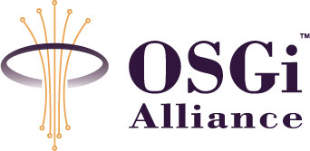
RFP-0095 Multiple Service Provider Separation
Confidential, Draft
10 Pages

Abstract
This document formalizes the use cases and requirements needed to define the multiple service provider separation. The “multiple service providers” model is one of the business models known for the OSGi service platform. In the model, multiple service providers offer their services on a single OSGi service platform in the end user’s premises. This document discusses the concept of “separation”, which simplifies the management of “multiple service providers” model.

Document Information

Table of Contents
0 Document Information 2
0.1 Table of Contents 2
0.2 Terminology and Document Conventions 2
0.3 Revision History 3
1 Introduction 3
2 Application Domain 3
2.1 Terminology + Abbreviations 4
3 Problem Description 5
4 Use Cases 6
4.1 Package and service used inside a single application 6
4.2 Package and service separation between different applications 7
4.3 Package and service sharing between different applications 7
4.4 Common resource used by applications 7
4.5 Common resource conflict between different applications 7
4.6 Permission management according to application lifecycle 8
4.7 Permission management for application composition changes 8
4.8 System bundle sharing between different applications 8
5 Requirements 9
5.1 Requirements for separation 9
5.2 Requirements for the permission management 9
5.3 Limitation for the solutions 9
6 Document Support 9
6.1 References 9
6.2 Author’s Address 9
6.3 End of Document 10

Terminology and Document Conventions
The key words "MUST", "MUST NOT", "REQUIRED", "SHALL", "SHALL NOT", "SHOULD", "SHOULD NOT", "RECOMMENDED", "NOT RECOMMENDED", "MAY" and "OPTIONAL" in this document are to be interpreted as described in [1].
Source code is shown in this typeface.

Revision History
The last named individual in this history is currently responsible for this document.

Revision | Date | Comments
Initial | June 19 2007 | Initial draft created.  Koya Mori NTT mori.kouya@lab.ntt.co.jp  Hiroyuki Maeomichi NTT maeomichi.hiroyuki@lab.ntt.co.jp

Introduction
The “multiple service providers” model is one of the business models known for the OSGi service platform. In the model, multiple service providers offer their services on a single OSGi service platform in the end user’s premises. This document discusses the concept of “separation”, which simplifies the management of “multiple service providers” model.

Application Domain
In the “Multiple Service Providers” model, three entities play key roles: (1) service provider, (2) end user, and (3) service aggregator. A service provider provides one or more service applications to the end user by delivering them as a bundle on the OSGi service platform in the end user’s premises (Fig. 1). The end user can subscribe to many service applications provided simultaneously by multiple service providers. The service aggregator has the most important role since it offers the following three functions.
(1) Remote management of equipment that realizes OSGi service platform.
(2) Delivery of bundles provided by service providers.
(3) Resolution of conflicts between service applications. This is to prevent improper interaction between service applications, and to keep service applications running correctly and safely.
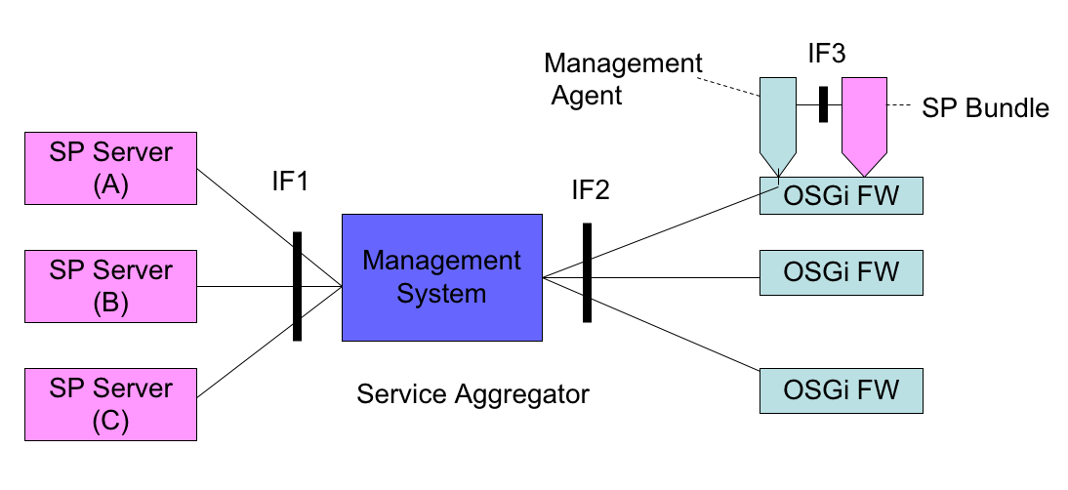
Fig.1 Remote Management Reference Architecture
Several kinds of activities are needed to implement conflict management. Some of them can be greatly simplified by introducing the concept of “separation”. In the concept, there are several areas, each of which is dedicated to one unit, mainly a service provider. Interactions between different areas are restricted, while interactions within the same area are freely accessible.
For example, multiple Service Providers provide Service Applications that consist of bundles and resources through the Service Aggregator. These Service Applications are concurrently deployed on a single OSGi Framework. The Service Aggregator should separate the accesses of the Service Applications to ensure the service operation desired by the Service Providers. Basically, the Service Aggregator should avoid giving permissions across different Service Applications.

Terminology + Abbreviations
•Service Application (SA): A set of bundles, which runs on OSGi FW. The granularity of the set is an application at the business level. It is usually a unit of subscription for the end user.
•Service Provider (SP): The entity that provides Service Application.
•Conflict Management: Resolves conflicts between Service Applications. Some service applications may conflict with other Service Applications.
•Service Aggregator: A Service Aggregator is a Service Provider that consolidates Service Applications provided by other Service Providers into one distinct offering and resolves dependencies and conflicts between different Service Applications.
•Separation: Prevents SAs provided by different SPs from improperly interaction.
•Common resource: Resources commonly shared between Service Applications, such as sockets, files, and system properties.

Problem Description
Multiple Service Applications must be operated on a single OSGi framework to aggregate different Service Providers in remote management architecture. These Service Applications’ bundles are able to utilize not only packages and services provided by the same Service Application, but also other resources, as shown below.
- Packages and services provided by other Service Applications’ bundles.
- Resources such as files, sockets, and system properties, which can be shared between Service Applications.
- The system bundles and framework, which are defined in OSGi specifications.
Access to the resources can be controlled by setting permissions for each Service Application’s bundle. However, if Multiple Service Providers are present, the management of permissions faces the risks below.
  - The risk associated with the exporting packages to other Service Providers unexpectedly
  - The risk associated with the giving services to other Service Providers unexpectedly
  - The risk of information leak and loss from file accesses from another Service Provider’s bundle.
- The risk of conflict in the operation of a single device, which is controlled via networks by Multiple Service Providers
- The risk of conflict in the utilization of system bundles that are called by Multiple Service Providers
Introducing “Separation” efficiently reduces these risks. Separation prevents improper interactions between Service Applications provided by different Service Providers, and ensures that each Service Application operates properly and safely by isolating the resources, such as bundles, files, sockets, and system property, that are utilized by the Service Applications. Separation should be implemented by Service Aggregator.
Separation has advantages for the three roles of remote management architecture: Service Provider, End User, and Service Aggregator.
- Service Provider
The Service Provider is assured that each Service Application will run properly on any OSGi equipment. Moreover, Service Application’s bundles can be developed in a safe manner because the accessible resources have been clarified.
- End User
The End User does not need to worry about the Conflict Management for Multiple Service Applications to which he or she has subscribed, because they can delegates it to the Service Aggregator.
- Service Aggregator
The Service Aggregator simplifies the permission management to ensure the proper operation of the Service Applications because it does not need to check all permissions to avoid improper interactions between Service Applications; only permissions that cross Service Applications need be checked. The permission management is a tangled operation, so simplification of management is important for Service Aggregator.
As one approach to implementing Separation, Permission Admin or Conditional Permission Admin can be utilized. The Service Aggregator can ensure Separation by configuring the permissions via Permission Admin or Conditional Permission Admin. Specifically, by using Conditional Permission Admin, the Service Aggregator can group the bundles when assigning permission, so that permission management becomes simpler.
However, problems remain only if Permission Admin or Conditional Permission Admin are used for permission management. The most important function in Separation is detecting permissions that induce improper interactions and determining the appropriate permissions for each Service Application; reducing the number of permissions managed is not the only key goal.
- Permission Admin and Conditional Permission Admin can’t support the determination of permission by continuously ensuring the separation of resources among Service Applications. Therefore, to avoid setting permissions across other Service Applications, or to share resources, such as files, sockets, and system bundles with Service Aggregator’s policy, Service Aggregator should check the tangled permissions for each Service Application.
- Permission Admin and Conditional Permission Admin have no interface for acquiring the current interaction states among Service Applications
- Permission Admin and Conditional Permission Admin can’t detect the permissions that allow improper interactions among Service Applications

Use Cases
This is not an exhaustive list of the use cases that should be supported by all RFCs responding to this proposal, and should, instead, be treated as representative of typical scenarios.

Package and service used inside a single application
SP-A’s application is deployed on an OSGi Framework. SP-A’s application provides a gas-meter checker application and consists of several bundles. One of the bundles registers a gas-meter driver service that provides an interface to operate the gas-meter. The other bundle obtains the gas-meter value by using the gas-meter driver service and sends the value to the center server for billing.
At the initialization of SP-A’s application, permissions, which allow accesses inside SP-A’s application such as ServicePermission to get and PackagePermission to import for gas-meter driver service, are automatically given by the separation mechanism.
In this case, permissions, which are needed to access services and packages provided by a bundle belonging to the same application, are given automatically. Therefore, the permission management can be simplified.

Package and service separation between different applications
SP-A’s and SP-B’s applications are deployed on a single OSGi Framework. SP-A’s application provides a gas-meter checker application and registers a gas-meter driver service to operate the gas-meter. SP-B’s application provides a home security application and handles available devices in the home network.
At the initialization of SP-B’s application, the separation mechanism detects the requirement of ServicePermission{get} to the gas-meter driver service from the home security application, which is across the different SPs’ applications. Then, the separation mechanism does not give the ServicePermission to the home security application because the agreement to give the ServicePermission is not granted by Service Aggregator.
In this case, permissions, which are across the different applications, are not given without Service Aggregator’s agreement. Therefore, the separation of the applications is ensured, and improper interactions from different applications are avoided by the separation mechanism.

Package and service sharing between different applications
SP-C’s and SP-B’s applications are deployed on a single OSGi Framework. SP-C’s application provides a web camera application and registers a web camera driver service to operate the web camera. SP-B’s application provides a home security application and handles available devices in the home network.
At the initialization of SP-B’s application, the separation mechanism detects the requirements of ServicePermission{get} and PackagePermission{import} to the web camera driver service from the home security application, which are across the different SPs’ applications. Then, the separation mechanism notifies the Service Aggregator to get agreement to grant the permissions. The Service Aggregator grants these permissions based on the policy determined preliminarily with the agreement of the SP-C that owns the web camera driver service.
In this case, the permissions across the different applications should be decided by Service Aggregator. Since the Service Aggregator decides the permissions across the different applications, the applications are protected from the improper interaction by unacquainted applications.

Common resource used by applications
SP-A’s application is deployed on an OSGi Framework. SP-A’s application provides a gas-meter checker application and registers a gas-meter driver service to operate the gas-meter via network.
At the initialization of SP-A’s application, the separation mechanism detects the requirements of SocketPermission from the gas-meter checker application to the gas-meter, which accesses the common resources such as sockets. Then, the separation mechanism notifies the Service Aggregator to get allowance for granting the permissions. The Service Aggregator grants the permission based on the policy determined preliminarily.
In this case, Service Aggregator should decide the permissions that access the common resources, such as sockets, files, and properties. Since the Service Aggregator should decide only the permissions for accessing the common resources, the separation mechanism clarifies relationships that involve resources sharing and simplifies permission management for separating common resources.

Common resource conflict between different applications
SP-C’s and SP-D’s applications are deployed on a single OSGi Framework. SP-C’s application provides a web camera application and records the data to a directory of /data. SP-D’s application provides a sensor data recording application and records the sensor data to a directory of /data.
First, SP-C’s application is deployed on an OSGi Framework and gets the FilePermission to write data in the directory /data with the agreement of Service Aggregator. Second, SP-D’s application is deployed on the same OSGi Framework, and tries to get FilePermission to write. However, the separation mechanism detects a situation in which the overlapped FilePermission is required. So the Service Aggregator decides to reject the request of the FilePermission to SP-D’s application because the required directory overlaps with the SP-C’s application. Then, the Service Aggregator proposes the other directory to SP-D, which is available for SP-D’s application. The SP-D’s application changes the required directory and is able to get the FilePermission to the new directory.
In this case, the permission for unsharable resources inducing improper interactions between different applications is detected by the separation mechanism, and the Service Aggregator is able to provide the appropriate decision to solve the conflict.

Permission management according to application lifecycle
SP-A’s applications are deployed on an OSGi Framework. SP-A’s application provides a gas-meter checker application and uses a socket to operate the gas-meter via the network.
First, SP-A’s application is deployed on an OSGi Framework. Then, the separation mechanism gives appropriate permissions to the gas-meter checker application with the agreement of Service Aggregator. Second, SP-A’s application is deleted from the OSGi Framework, and the separation mechanism deletes the permissions for SP-A’s application.
In this case, the permissions for applications are managed automatically by the separation mechanism. So the Service Aggregator simplifies permission management when the application’s lifecycle changes.

Permission management for application composition changes
SP-E’s application is deployed on an OSGi Framework. The SP-E’s application provides an advertisement delivery application and has two types of graphical user interface; AWT and servlet.
At the initialization of SP-E’s application, one bundle provides an AWT graphical user interface on an OSGi Framework. Next, the application changes the AWT interface to a web interface, so the SP-E’s application installs the new bundle providing servlet interface. Then, the separation mechanism sets the appropriate permissions for the servlet bundle. On the other hand, the bundle providing AWT interface is uninstalled from the OSGi Framework, and the separation mechanism deletes the permissions automatically, which are set to the AWT bundle.
In this case, the permission is automatically set by a separation mechanism without a Service Aggregator’s operation when a conposition of an application changes, so that the unnecessary permissions are deleted to run applications with the few permission as possible.

System bundle sharing between different applications
SP-B’s application is deployed on an OSGi Framework. SP-B’s application provides a home security application, which uses an HTTP service to register servlet.
The Service Aggregator’s policy is set preliminary in order to the separation mechanism automatically gives the ServicePermission for HTTP service. Therefore, at the initialization of SP-B’s application, the bundle is automatically given ServicePermission for HTTP service, which is one of the system bundles.
In this case, permissions, which are needed to access system bundles, are given automatically by the preliminarily settings of permission policy. So the Service Aggregator does not need to check the permission relating the system bundles when applications’ states change.

Requirements

Requirements for separation
- The solution MUST specify the model needed to manage the separation conditions that are decided by the Service Aggregator.
- The solution MUST separate the resources for each Service Application to control the accesses to bundles provided by independent Service Providers.
- The solution MUST control the separation conditions by the Service Aggregator alone.
- The solution MUST control the separation conditions remotely.
- The solution MUST store the separation conditions persistently.
- The solution MUST provide a function to confirm the separation conditions on each OSGi Framework.
- The solution MUST provide a function to detect the violation of separation conditions.
- The solution MUST provide a function to resolve the conflict of common resources.

Requirements for the permission management
- The solution SHOULD utilize the (Conditional) Permission Admin to configure separation conditions.
- The solution SHOULD cover the existing permissions in the OSGi R4 and Java2 security model.
- The solution SHOULD prepare the mechanisms to accommodate the new types of permissions.

Limitation for the solutions
- The system resources such as CPU load, memory use and file system use, are beyond the scope of the requirements.
- The security issues such as denial of service attacks, authentication between applications, and prevention of runaway programs, are beyond the scope of the requirements.

Document Support

References
- Bradner, S., Key words for use in RFCs to Indicate Requirement Levels, RFC2119, March 1997.
- Software Requirements & Specifications. Michael Jackson. ISBN 0-201-87712-0

Author’s Address

Name | Koya Mori, Hiroyuki Maeomichi
Company | NTT Corporation
Address | Y320C, 1-1 Hikari-no-oka, Yokosuka, Kanagawa, Japan
E-mail | mori.kouya@lab.ntt.co.jp, maeomichi.hiroyuki@lab.ntt.co.jp

End of Document

