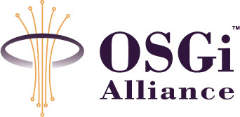
RFC 99 Command Provider
Confidential, Draft
12 Pages
Abstract
All open source implementations of the OSGi Specifications provide a shell interface that is extendible. Unfortunately, they all do this in a different, incompatible way. This RFP investigates the requirements around a facility to standardize shell extensions across all OSGi implementations.

Document Information

Table of Contents
0 Document Information 2
0.1 Table of Contents 2
0.2 Terminology and Document Conventions 3
0.3 Revision History 3
1 Introduction 3
2 Application Domain 4
2.1 OSGi Console 5
2.1.1 Interface Command Interpreter 5
2.1.2 Interface Command Provider 5
2.2 Eclipse Console 6
2.2.1 Command Interpreter 6
2.2.2 Interface Command Provider 6
2.3 Apache Felix Shell 6
2.3.1 Interface Shell Service 7
2.3.2 Interface Command 7
2.4 Knopflerfish Shell 7
2.4.1 Interface Console Service 8
2.4.2 Interface CommandGroup 8
2.4.3 Interface Session 8
2.4.4 Interface Session Listener 8
2.5 Terminology + Abbreviations 9
3 Problem Description 9
4 Use Cases 9
4.1 Configuration of HTTP over Telnet 9
4.2 An Advanced Scripted Shell 10
4.3 Providing a Serial Port Shell 10
5 Requirements 10
5.1 Non Functional 10
5.2 Command Names 10
5.3 Shell 10
5.4 Shell Commands 11
5.5 Source Providers 11
6 Document Support 12
6.1 References 12
6.2 Author’s Address 12
6.3 End of Document 12

Terminology and Document Conventions
The key words "MUST", "MUST NOT", "REQUIRED", "SHALL", "SHALL NOT", "SHOULD", "SHOULD NOT", "RECOMMENDED", "NOT RECOMMENDED", "MAY" and "OPTIONAL" in this document are to be interpreted as described in [1].
Source code is shown in this typeface.

Revision History
The last named individual in this history is currently responsible for this document.

Revision | Date | Comments
Initial | AUG 01 2007 | Initial version

Introduction
In the past few years, the open source implementations of the OSGi Framework have implemented command line shells like bash or csh that interact with commands provided by bundles. Unfortunately, this binding between shell and command provider has not been standardized and the different open source implementations have chosen their own binding models that are not compatible.
This RFP analyzes the existing bindings, defines the problem, and defines the requirements. The work in this RFP is based on the work done in the OSGi Reference Implementation, Eclipse, Apache Felix (formerly Oscar), and Knopflerfish.

Application Domain
A shell is a facility to interact in the system via a command line interface. A command line is usually typed by a user over a telnet connection or via the system console. The shell parses this command line and finds the name of the requested command by looking at the first arguments. It can then parse the parameters, optionally performing substation or aliasing. Advanced shells could provide conditionals, looping, and other programming constructs.

Often shells have built in commands that are directly executed. However, normally a shell provides an extension mechanism so that other bundles can provide other command implementations. The shell can call these extensible commands with a raw line or it can parse the arguments and potentially perform parameter substitution. A shell must link a command to a name. The name (and help information) can be found through a service or via an extender model.

The command lines should come from somewhere, this is called the source. They can come from a graphic user interface, via a telnet session, or direct from the console. It is possible that the shell implements a specific source (console, telnet, etc) or that it provides a service that allows other bundles to create a session related to the input and output stream of a source.

The shell provides command line editing when there is an interactive interface like telnet or the console because users make mistakes. This is supposed to be left cursors, right cursor, delete, backspace, home, end. Both telnet and the Java Console have their peculiarities that are not trivial. Shells can also provide aliasing of commands, history of commands, etc.

Because commands are extendable, it is possible to run into name conflicts. Some shells ignore this problem and always let one command provider win. Others have a name conflict facility.

Commands that run must return their output to the user. In certain cases, this can be a lot of output. Some commands also require input from the user or other programs. The latter is called piping; this happens when the output of one program is the input of the next program.

Commands can block the UI or they can be executed in the background. In that case, multiple commands can run simultaneously.

A shell provides access to basic functionality of the system through a remote interface. There is an obvious security risk. It is therefore necessary to authenticate the user before any commands are processed.

There are 4 known shells in the OSGi world:

- The OSGi console org.osgi.tools..console
- Eclipse console, build into the Equinox Framework
- Apache Felix shell
- Knopflerfish shell

OSGi Console
The OSGi shell always uses telnet to be accessed. It provides a simplistic command line interpreter to parse the arguments. The shell supports parameter substitution from variables.
Commands are implemented as CommandProvider services. The implementation can register functions by implementing methods on the implementation. The name of the method must start with a “_”. Each command returns Object and accepts a CommandInterpreter object as argument. For example, implementing the method Object _ls(CommandInterpeter intp) throws Exception { … } will provide an ls command.
The Command Interpreter provides access to the arguments, variables, and can be used to send errors. The return value is printed. Each Command Provider must implement a toString(Object) method that is used to convert domain objects to strings. Commands can not grab the input stream nor can they directly control the output stream. Each provider should implement a getHelp method that describes the commands.
The shell is implemented as a bundle that runs on any framework. The shell includes a set of basic commands for seeing the bundles, services, exported packages, etc.
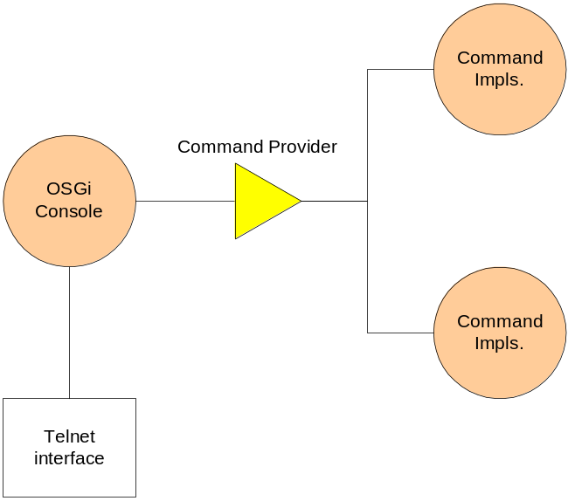

Interface Command Interpreter
error(String)
execute(String)
getUser()
getVariable(String)
nextArgument()
setVariable(String, Object)

Interface Command Provider
getHelp()
toString(Object)

Eclipse Console
The Eclipse Console is a derivative of the OSGi Console, it actually uses the same names for the interfaces and the command discovery (reflection of _ methods) but the Command Interpreter is very different. It does not implement variables and has several methods to directly print to the console instead of using the printing of domain object by the Command Providers. The Command Interpreter does not provide direct access to the input or output stream.
The shell is an intrinsic part of the Equinox Framework, it can not be used as a separate bundle on other frameworks.
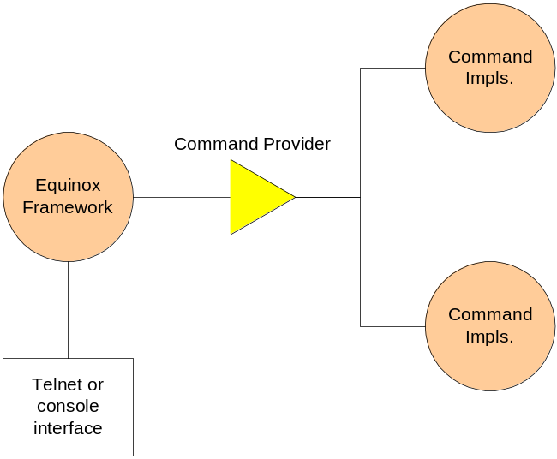

Command Interpreter
execute(String)
nextArgument()
print(Object)
printBundleResource(Bundle,String)
printDictionary(Dictionary,String)
println()
println(Object)
printStackTrace(Throwable)

Interface Command Provider
getHelp()

Apache Felix Shell
The Apache Felix Shell adds a generic shell service so that other bundle can execute commands through a command line interface. This could be a bundle implementing the telnet interface to a user or some other program that wants to use the facilities of the shell in another way.

The Shell Service does not parse the commandline into arguments, this is left to the command implementation. Command implementations are Command services, each command has its own service. Normally, commands are implemented with sub commands. For example, obr install …

A Command service must provide the name, the usage, and a description. The shell service will call the execute method for command execution. Commands can print to the out and err, but they can not get the input stream.
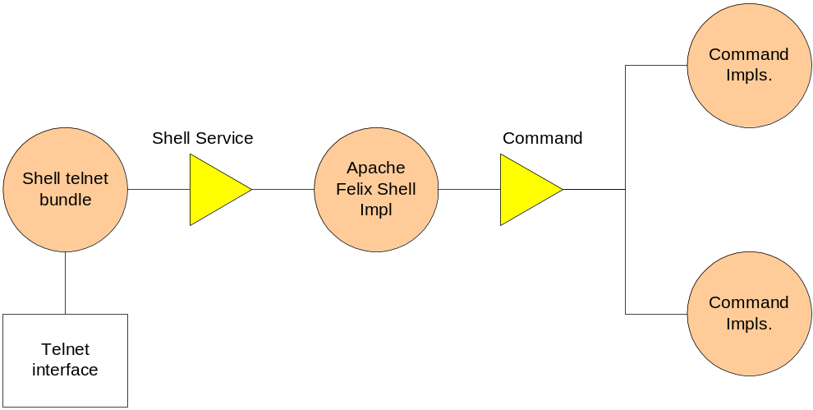

Interface Shell Service

String[] getCommands();
String getCommandUsage(String);
String getCommandDescription(String);
ServiceReference getCommandReference(String);
void executeCommand(String, PrintStream, PrintStream) throws Exception;

Interface Command
String getName();
String getUsage();
String getShortDescription();
void execute(String, PrintStream, PrintStream);

Knopflerfish Shell
The Knopflerfish shell follows a similar pattern as the Apache Felix shell. There is a Console Service that allows any bundle to execute a command directly, or start a parsing session. This session can be controlled by a party, for example a bundle that creates a TCP session. The session can be aborted, interrupted, or closed.
To extend the Knopflerfish shell, one has to implement a CommandGroup interface. This interface defines an execute method that gets the parsed arguments, a Reader, a PrintWriter, and for some reason a Session object. There are helper methods for the help and name. The groupname is registered as a property but the object is expected to parse the command line into sub commands.
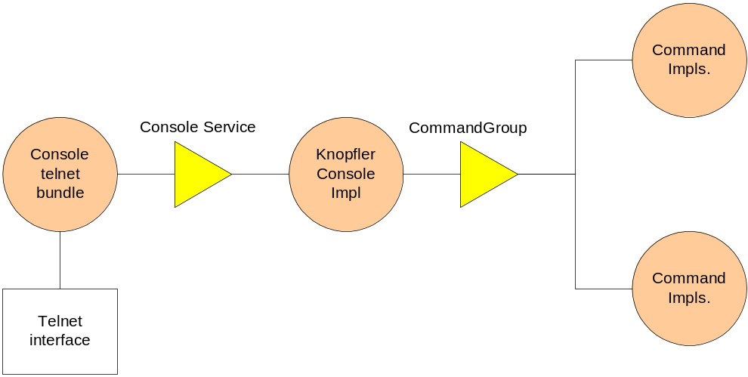

Interface Console Service
String runCommand(String)
Session runSession(String, Reader, PrintWriter)
String[] setAlias(String, String[])

Interface CommandGroup
int execute(java.lang.String[],Reader,PrintWriter,Session)
String getGroupName()
String getLongHelp()
String getShortHelp()

Interface Session
void abortCommand()
void addSessionListener(SessionListener)
void close()
char getEscapeChar()
String getInterruptString()
String getName()
Dictionary getProperties()
void removeSessionListener(SessionListener)
void setEscapeChar(char)
void setInterruptString(String)

Interface Session Listener
void sessionEnd(Session session)

Terminology + Abbreviations

Problem Description
There is a need for a service that allows human users as well as well as programs to interact with on OSGi based system with a line based interface: a shell. This shell should allow interactive and string based programmatic access to the core features of the framework as well as provide access to functionality that resides in bundles.

Shells can be used from many different sources it is therefore necessary to have a flexible scheme that allows bundles to provide shells based on telnet, the Java 6 Console class, plain Java console, serial ports, files, etc.

Supporting commands from bundles should be made very lightweight and simple as to promote supporting the shell in any bundle. Commands need access to the input and output streams. Commands sometimes need to store state between invocations in the same session.

There is a need for a very basic shell functionality in small embedded devices, however, the design should permit complex shells that support background processing, piping, full command line editing, and scripting. It is possible that a single framework holds multiple shells.

The shell must provide a means to authenticate the user and the commands must be able to investigate the current user and its authorizations, preferably through standardized security mechanisms. To minimize footprint, it must also be possible to implement a shell without security.

Use Cases

Configuration of HTTP over Telnet
An implementation of the Http Service wants to provide a configuration interface through a shell. It implements httpconfig command registers this command with the shell as described by the OSGi specification. The new Knopflerfish shell picks up the command. A user logs into a telnet bundle that binds to the local Knopflerfish shell service by creating a session. The user configures the Http Service but tries to shutdown the Http Service. The shell security does not allow this command to be executed by this user. When the user is finished, he quits. The session is destroyed and the telnet socket is closed.

An Advanced Scripted Shell
The explosive growth of OSGi devices has triggered the interest of ACME Inc. They see a clear market for an advanced shell that provides scripting, aliasing, full history, user properties, and a graphic user interface. The look at the OSGi specifications and develop their advanced shell. They do not have to interface to sources like telnet, nor do they have to implement the commands. They fit right in as a plugin replacement for the existing shells.

Providing a Serial Port Shell
ACME is highly successful selling their advanced Scripted Shell. So successful that they get a significant request to support their shell over a serial port. After their marketing group looks at the staggering sales figures they decide support a project for this. The development group develops the serial port interface in a matter of days because they only had to implement a small bundle that handled the interaction with the serial ports and the line editing.

Requirements

Non Functional
- Lightweight to allow shells for low footprint devices
- Allow shells with piping, background, scripting, etc.
- Make commands trivial to implement
- Make it easy to connect the shell to different sources.
- Provide an optional security framework based on existing security facilities
- Minimize the cost of a command (e.g. do not require eager loads of objects implementing commands)
- Support use of existing code by making a design that closely follows practices for command line applications in Java.

Command Names
- Provide a list of basic command signatures to manage the framework so they are consistent among implementations.

Shell
- Provide interface to execute a string as command
- Allow other bundles to implement commands
- Allow other bundles to provide a connection to: telnet, console, serial port, etc.
- Provide help for each command
- Provide a means to disambiguate commands with the same name
- Provide a means to disambiguate when there are multiple shells
- Authenticate the user
- Provide programmatic access to the shell, that is, a program generates the commands.

Shell Commands
- Read input from user or previous command
- Write output to user or next command
- Save and access state per session
- Provide usage information of the command
- Allow commands to be protected with permissions
- Provide access to he authenticated user via User Admin (though User Admin may not be present)
- Optional: Allow computer readable meta information about the commands to support forms
- Optional: Provide formatting rules + library to standardize look and feel for output. This could consist of routines to show tables in a consistent form.
- Commands should not have to do low level parsing of command line arguments.

Source Providers
- Provide an easy way to allow bundles to connect the shell to sources like telnet, serial ports, etc.

Document Support

References
- Bradner, S., Key words for use in RFCs to Indicate Requirement Levels, RFC2119, March 1997.
- Software Requirements & Specifications. Michael Jackson. ISBN 0-201-87712-0

Author’s Address

Name | Peter Kriens
Company | aQute
Address | 9c, Avenue St. Drezery
Voice | +33467542167
e-mail | Peter.Kriens@aQute.biz

End of Document

