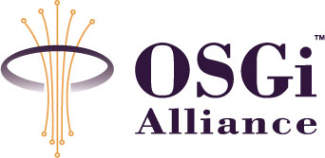
RFP 107 – Generic Remote Device Management Model
Draft
8 Pages

Abstract
This RFP defines the need for unified data model and API for describing and manipulating of management information of various types of devices. This data model and API is intended for building of generic centralized remote management applications and tools, hiding the specific management interfaces supported by the different device types under a common universal interface.

Document Information

Table of Contents
0 Document Information 2
0.1 Table of Contents 2
0.2 Terminology and Document Conventions 2
0.3 Revision History 2
1 Introduction 3
2 Application Domain 3
2.1 Terminology + Abbreviations 4
3 Problem Description 4
3.1 Position of the Generic Remote Device Management Abstraction 5
3.1.1 Backend Management Server 5
3.1.2 Device/OSGi Framework Side 5
3.2 Generic Device Management Data Model 6
3.2.1 Manageable Object 7
3.2.2 Manageable Objects Hierarchy 7
3.2.3 Manageable Object Meta-Data 7
4 Use Cases 7
5 Requirements 8
6 Document Support 8
6.1 References 8
6.2 Author’s Address 8
6.3 End of Document 8

Terminology and Document Conventions
The key words "MUST", "MUST NOT", "REQUIRED", "SHALL", "SHALL NOT", "SHOULD", "SHOULD NOT", "RECOMMENDED", "NOT RECOMMENDED", "MAY" and "OPTIONAL" in this document are to be interpreted as described in [1].
Source code is shown in this typeface.

Revision History
The last named individual in this history is currently responsible for this document.

Revision | Date | Comments
Initial | MMM DD YYYY | Put information relating to the changes you have made here.  <name>, <company> <e-mail>

Introduction
Describe the state of the RFP and explain how the RFP came into existence. Discuss any other issues that are not addressed in the following chapters.

Application Domain

This is a description of the real world, unrelated to computer solutions. E.g. if you must make a text editor, you describe how the authors input text, do review cycles with peers and publish. This section should define the terminology that is used in later sections and paint a clear picture about issues and facts of the problem domain. Do not discuss solutions or problems that are solved, focus on a description of the context of the problem. This should answer questions like: What actors/entities take part in the problem domain? What is their role?
It should describe the world as it is now, not when the solution is applied. This is a real world description, not of a computer system solving the real world problem!
This section should also list assumptions that the RFC may make about the problem context. E.g. the number of users of a gateway shall not exceed 100.
The difficult part is to not describe the solution, or the problem. This section should strictly limit itself to the context of the problem and the solution.
Also, you should list existing products that exist in the problem context. E.g. for the Communications architecture there are Java Phone API, Java Messaging Service and javax.microedition.io that operate in this scope. It is not required to evaluate them, just list them.

Terminology + Abbreviations

Problem Description
There are number of standards currently existing concerning remote management of devices - each of them targeted to a concrete vertical market. Some of the most popular examples of such standards are OMA Device Management (OMA DM) protocol - defined by Open Mobile Alliance for remote management of mobile devices and CPE Wan Management Protocol (CWMP, widely known as TR-069) - defined by DSL Forum for remote configuration and monitoring of home DSL equipment. In addition to these standards there a lot of devices which provide some other vendor specific mechanism for remote management and monitoring. This diversity of management protocols and mechanisms also applies to the field of OSGi compliant devices – there are various existing OSGi products and solutions offering remote management interfaces over different technologies – OMA DM, JMX, TR-069 or proprietary vendor/solution-specific protocols.
Respectively, each of the remote management mechanisms imposes usage of the corresponding remote management systems, applications and tools - depending of the concrete management standard or even specific for a concrete device model. However with the recent spreading of the “smart” network-connected devices (fixed-line and mobile), it is not uncommon case, when a single service provider or enterprise need to remotely maintain different devices belonging to different technology domains. Usage of different remote management tools for managing of such heterogeneous network of devices makes the administration process more difficult and costly. The problem can be further illustrated if we have to manage devices belonging to different domains - for example mobile devices, residential gateways and set-top boxes, which however are based on a common horizontal technology - such as OSGi. In that case, all these devices have a common sub-set of identical manageable elements – OSGi bundles, bundle configurations, bundle permissions, etc., provided by the OSGi framework. But each of these device types normally provides different remote management interface, e.g. OMA DM - for mobile devices, TR-069 – for residential gateways and set-top boxes. Hence, despite that they share common characteristics, which are managed in similar way, we have to use different management systems and tools for OMA DM and for TR-069 based devices.
That motivates the need for defining a common abstraction for representing manageable elements of different class of devices, regardless of the remote management standards they support, and the corresponding API for building of universal remote management applications and GUI tools.

Position of the Generic Remote Device Management Abstraction

Backend Management Server
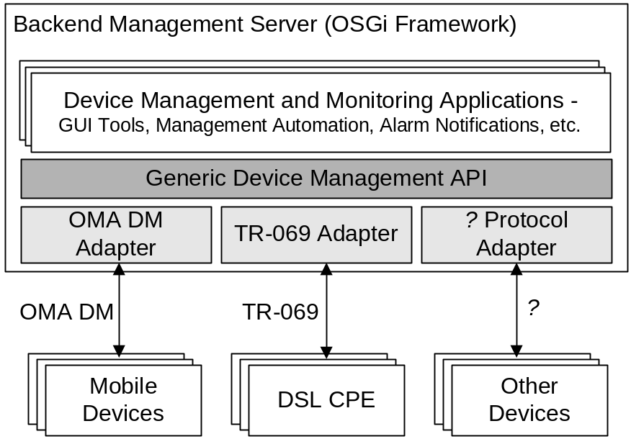
Fig. 1 – Position of the Generic Device Management API on the RMS Side
The Generic Device Management API is intended for server-side applications. Examples of such applications include:
- Generic GUI administration consoles
- Scripting interpreters
- Rule-based management automation applications
These applications may use this API without need to know in advance the exact device types, their manageable elements and the management interfaces/protocols supported by the devices.
The exact interface with different classed of devices are handled by a set of adapter components, which translates the device-specific data model to the common data model supported by the Generic Device Management API.
Such architecture allows extending the system to support other class of devices by adding the corresponding adapter, while still leveraging the same generic device management applications and tools.

Device/OSGi Framework Side
Although the focus of this RFP is mainly the remote device management and generic device management interface for the server-side, this section shows how such idea can be extended on the device-side as well.
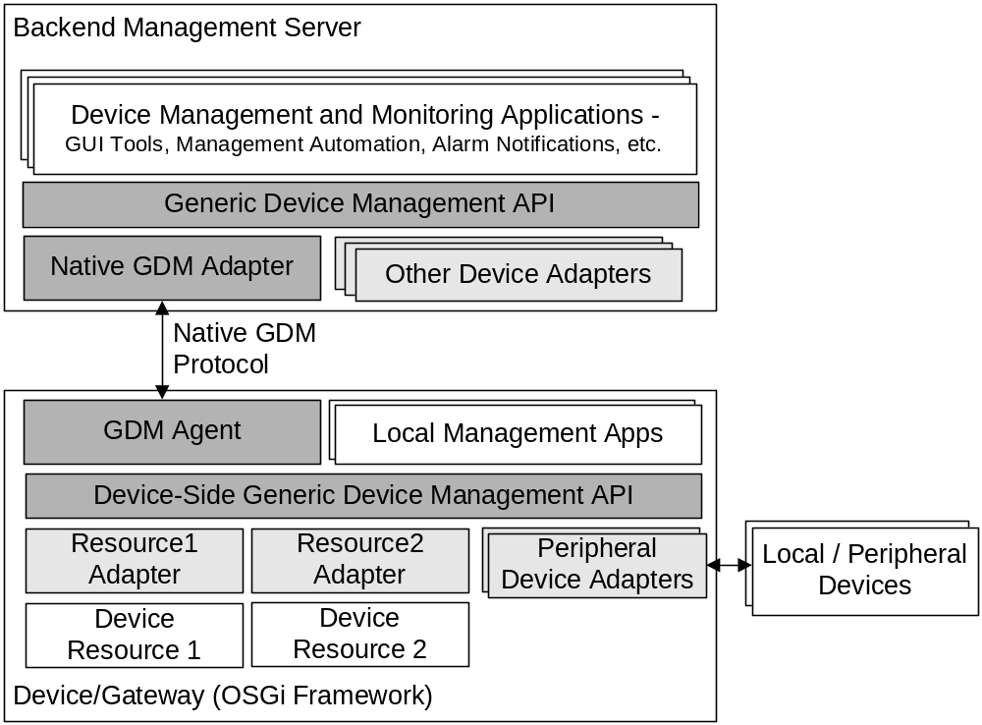
Fig. 2 – Generic Device Management API on the Device-Side
Figure 2 depicts a possible architecture of a device, which directly supports the same generic device management model as the backend system does. In this case, the adapter(s) which translate device-specific manageable resources are located on the device itself and are made available to the remote management server via a universal device-side agent and server-side adapter, which communicate over a protocol especially designed for the generic device management data model.
This model is especially useful for devices with dynamic application frameworks, such as the OSGi framework, since each dynamically deployed application or device driver may expose some manageable elements to the RMS by plugging suitable adapter.
Having devices, which directly supports the Generic Device Management interface does not contradict with the model described in 3.1.1, i.e. single RMS can support simultaneously devices, which provide natively the Generic Device Management model, as well such, which provide other management interfaces.

Generic Device Management Data Model
An important part of each device management model takes the data model for describing of the manageable elements of the device. Examples of such data models are the Device Management Tree (DMT) in the OMA DM protocol and the Parameters tree in the TR-069 protocol. This data models aims to represent the devices with different characteristics into a set of data objects with relatively simple data structure, which can be handled in a uniform way by the management server. Although different protocols provide different data models in terms of terminology and syntax – all these data models are essentially similar in semantics and can be converted to a common device abstraction.
The following paragraphs outlines the main characteristics of a generic data model for device management.

Manageable Object
In order to represent the device into a manageable data structure, it has to be decomposed into a set of simple elements, with common structure. We well call these elements Manageable Objects (MO) in the scope of this RFP.
Each Manageable Objects represents one relatively self-contained resource on the target device, which may be subject of management and monitoring. Such resource can be one software component or application deployed on the device or it can represent some peripheral device connected to the target device, like camera or microphone.
Each manageable object can be represented as a set of attributes, which exposes static and dynamic characteristics of the manageable objects and a set of actions, which can be executed by the management system/tools over this manageable object.
For example attributes of a MO representing an application can be the name of the application, its version, vendor and run-time state (started, installed), while its actions can be start, stop, uninstall.
The value of the attributes and the arguments of the actions have to be constrained in terms of the possible data types to a defined set of simple types, e.g. Java primitive types and possibly arrays of primitive types. In that way applications may handle them in a generic way – displaying in GUI, storing them persistently or transferring them over the network.

Manageable Objects Hierarchy
Since each Manageable Object has to be relatively simple data structure, the generic data management model should allow composing of multiple Management Objects in order to represent more complex resources in the system. A possible way for achieving this defining a hierarchy relations between manageable objects, i.e. one MO may have multiple additional sub (or child) Management Objects, thus more complex resources may be decomposed into an hierarchy of sub-components achieving arbitrary level of granularity.

Manageable Object Meta-Data
A powerful meta-data model should be an essential element of the generic device management model. The meta-data must provide information about:
- supported attributes by each MO, along with the data type of their values and value constraints;
- supported actions and their parameters;
- possible hierarchy relations between manageable objects
The meta information has to provide enough user-oriented information – like user friendly labels of the manageable objects, their attributes and actions, descriptions, etc. Using this meta-data the GUI tools (like management consoles) can present convenient interface to the user for management and monitoring of the device, without having to know in advance its type and structure.

Use Cases
List one or more use case models that describe system functionality.

Requirements
List the detailed requirements that should hold for the solution. This should be described as statements that can be tested in some way.

Document Support

References
- Bradner, S., Key words for use in RFCs to Indicate Requirement Levels, RFC2119, March 1997.
- Software Requirements & Specifications. Michael Jackson. ISBN 0-201-87712-0

Add references simply by adding new items. You can then cross-refer to them by chosing <Insert><Cross Reference><Numbered Item> and then selecting the paragraph. STATIC REFERENCES (I.E. BODGED) ARE NOT ACCEPTABLE, SOMEONE WILL HAVE TO UPDATE THEM LATER, SO DO IT PROPERLY NOW.

Author’s Address

Name | Jordan Simeonov
Company | ProSyst Software GmbH
Address | Dürener Str. 405, 50858 Köln, Germany
Voice | +359 2 9523581
e-mail | J_simeonov@prosyst.bg

End of Document

