

Draft
11 Pages
Abstract
This document proposes updating the OSGi API to use of Java 5 Generics.

Document Information

Table of Contents
0 Document Information 2
0.1 Table of Contents 2
0.2 Terminology and Document Conventions 2
0.3 Revision History 3
1 Introduction 3
2 Application Domain 3
2.1 Benefits of Generics 4
2.2 Terminology + Abbreviations 4
3 Problem Description 4
4 Use Cases 5
4.1 Modernize the OSGi API 5
4.1.1 Automatic Type Conversion 5
4.2 Automatic Generation of try/catch blocks 6
4.3 API Modernization 8
5 Requirements 9
6 Document Support 10
6.1 References 10
6.2 Author’s Address 10
6.3 End of Document 10

Terminology and Document Conventions
The key words "MUST", "MUST NOT", "REQUIRED", "SHALL", "SHALL NOT", "SHOULD", "SHOULD NOT", "RECOMMENDED", "NOT RECOMMENDED", "MAY" and "OPTIONAL" in this document are to be interpreted as described in 6.1.
Source code is shown in this typeface.

Revision History
The last named individual in this history is currently responsible for this document.

Revision | Date | Comments
Initial | APR 29 2008 | Initial Draft  John Wells, Oracle jwells@bea.com
0.1 | MAY 15 2008 | Change SHOULD to MUST
0.2 | 19 May 2008 | Updated to add additional requirements.  BJ Hargrave, IBM
0.3 | 21 May 2008 | Add requirements for using more modern Java API such as Map and List  John Wells, Oracle

Introduction
The OSGi API could use some modernizing touches, such as the use of Java 5 Generics. Many modern IDE tools can generate code and perform other syntactic checks when these modern Java features are specified. Hence, wherever possible OSGi should consider using modern language features.

Application Domain
Modern Integrated Development Environments such as Eclipse and IntelliJ use modern features of the Java language to enhance the developer experience. Today's OSGi developers can not use many of the features of these IDEs when interacting with OSGi Java API due to the fact that the current OSGi API do not use these modern features of the Java language.
OSGi has some reasonable constraints concerning backward compatibility and JVM platform, so it is possible that not all modern features of Java can be properly used in the OSGi API (e.g. annotations). However the Java Generics feature, introduced in Java 5, was designed to be able to be used in a backwards compatible manner. This document proposes that the OSGi API be modernized to use Java 5 generics. It will also propose a small modification of present API style that would be useful to users of Java Integrated Development Environments.
Java 5 was released in 2004. Since then the entire J2SE set of libraries have been modernized to use generics. It is about time OSGi did the same!

Benefits of Generics
A nice introduction to Java 5 generics can be found at this link: http://www.angelikalanger.com/Articles/JavaPro/01.JavaGenericsIntroduction/JavaGenerics.html.
The following is a list of benefits that can be had by using Generics in Java code:
- For-While loops
- Auto Boxing and Auto Unboxing
- Compile time type checking of Collections
- Erasure (Generics do not affect the byte code of compiled java classes)

Terminology + Abbreviations
- Java IDE: An integrated development environment designed to ease the development of Java applications.
- Generics: A feature added to Java 5 which allows parameterizing types on classes such as collections

Problem Description
Developers use Java IDEs such as Eclipse and IntelliJ in order to develop their applications. All of the popular IDE have good support for Java Generics. However, when using these IDEs with OSGi (an increasingly popular activity) the OSGi API can not use these features of the IDE.
Worse, it is often the case that the OSGi API are flagged as “errors” or “warnings” due to the fact that they do not contain generic types where they should. This leads developers to think of OSGi as “old” or “legacy”. The fact that OSGi API often show up as having “errors” or “warnings” might cause developers to have negative associations with the OSGi API. While these things can often be modified to not be warnings or errors in the development environment it is still something that might become a barrier to adoption in some IT shops.

Use Cases
All of the below use cases are from the point of view of a group of developers writing an application using the OSGi API in an Java Integrated Development Environment such as Eclipse or IntelliJ.

Modernize the OSGi API

Automatic Type Conversion
Some developers are attempting to write a bundle that monitors other bundles for a particular set of resources. In order to do so, they are using the Bundle.findEntries() method. Since the OSGi API returns a non-qualified Enumeration, they must convert the elements in the Enumeration to a URL like this:
Enumeration foo = bundle.findEntries();
while (foo.hasMoreElements()) {
URL fooURL = (URL) foo.nextElement();
}
While this is certainly fine Java code, the following Java code is slightly more compact:
Enumeration<URL> foo = bundle.findEntries();
while (foo.hasMoreElements()) {
URL fooURL = foo.nextElement();
}
Notice that the URL only needed to be declared on the definition of foo, and does not need to be used elsewhere.
The following screen shot is an example of what the developers see as they are using the OSGi API from within Eclipse:
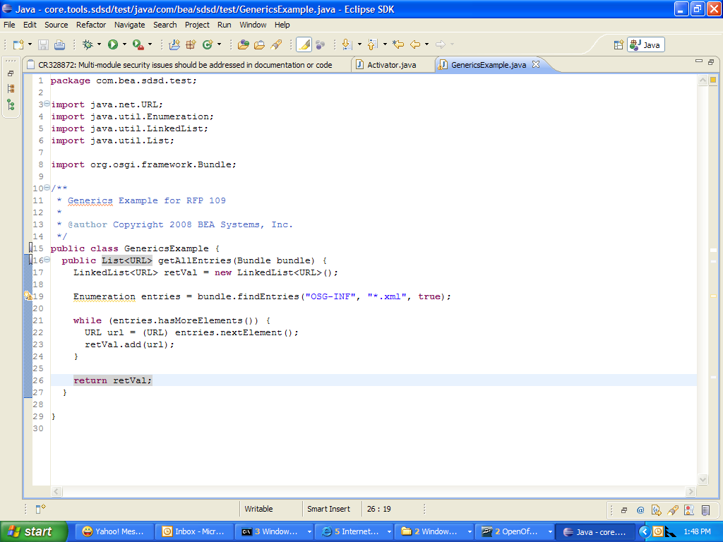
Notice that the “Enumeration” for entries comes up with a jagged yellow line and a little yellow light bulb on the left-hand side. Experienced Eclipse users (do we have any in this consortium) know that this is a “warning”, and often developers spend a lot of time trying to remove the warnings from their code. However, since the OSGi API has the older style (without the use of the Generics) this warning can only be removed by modifying the default policies of Eclipse or by adding an annotation to this method that tells the IDE to not flag this line as a warning.
Another example of how Generics can help OSGi code can be found in this example:
public interface ServiceReference<T> {
...
}
public interface ServiceRegistration<T> {
...
}
public interface BundleContext {
<T> ServiceReference<T> getServiceReference(String clazz);
<T> T getService(ServiceReference<T> ref);
}

This allows code like:
ServiceReference<LogService> log
= context.getServiceReference(LogService.class.getName);

Obviously, the BundleTracker can use the same boost:
class BundleTracker<T> {
BundleTracker(BundleContext context, String clazz,
BundleContextCustomizer<T> customizer ) {
...
}
T getService() {...}
T waitForService(long timeout) { ... }
// etc.

How sweet is that?!? OSGi developers need this stuff... bad!

Automatic Generation of try/catch blocks
OSGi has made a stylistic choice to document in javadoc runtime exceptions that are known to be throwable from certain API but to not declare those exceptions on the method. Since these runtime exceptions were considered important enough to document in the javadoc, it also seems reasonable that developers should be explicitly handling these exceptions in many cases.
Modern IDE's such as Eclipse have the ability to automatically generate try/catch blocks around highlighted code. The usual operation of such a facility is to find all the declared exceptions (checked or unchecked) and to properly indent the code and add the try-catch block as requested. However, due to the existing OSGi style, the special Runtime exceptions will not be seen by the IDE and hence will not be included in the list of catch clauses surrounding the developer code in question.
A group of developers is attempting to use the Conditional Permission Admin service in order to write a GUI that presents the condition table to the user. They want to be sure they catch all reasonable exceptions so they can present the exception back to the user. So they use the automatic try catch feature of Eclipse and end up with the following screen shot:
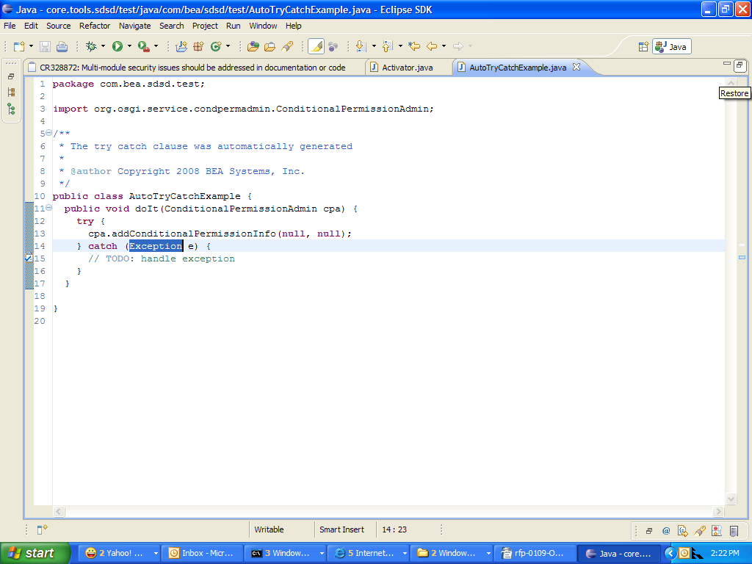

Notice that since there were no declared exceptions on the “addConditionalPermissionInfo” Eclipse did not know what to do and so just caught “Exception”. However, this was not what the developers intended, they only wanted to catch likely and documented Exceptions, not all possible exceptions. As it turns out, this API is documented to throw SecurityException. However, since the SecurityException is not a declared exception Eclipse did not do the correct thing in this case.
After modifying the OSGi code to explicitly throw SecurityException, this is the screen shot from the same operation:

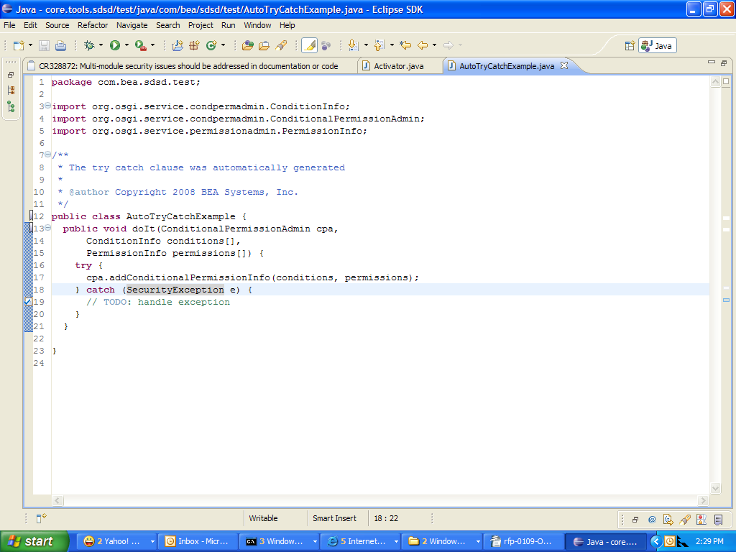
Notice that in this screen shot Eclipse was able to divine that the method might throw SecurityException and correctly generated the appropriate try catch block.

4.3 API Modernization
Java developers of today expect to use certain Java API in place of earlier Java API that is less functional. For example, the use of the “java.util.Dictionary” class has generally been replaced by use of the “java.util.Map” interface and its concrete classes. “java.util.Enumeration” has been replaced with “java.util.List”. The latter Java API are generally more functional or are in some sense safer to use for example in threaded applications.
For example, take the same example code from above:
Enumeration foo = bundle.findEntries();
while (foo.hasMoreElements()) {
URL fooURL = (URL) foo.nextElement();
}
A more modern version of the “Enumeration findEntries()” API would be “List<URL> findEntriesAsList()”. The “findEntriesAsList” API would never return null, but would instead return an empty List if there were no entries found. Here is how modern code would look when using the modern API:
for (URL entry : bundle.findEntriesAsList()) {
}
This use of a the modern API shows the use of “java.util.List” inside a for-while loop. Notice that because the list is Genericised that there is no need to do any sort of cast when filling in the “entry” variable. There are other benefits to using a List rather than an enumeration as well.
OSGi API should be modernized to use genericised Lists in place of Enumerations, and Maps in place of Dictionaries wherever possible. The API that remains which uses the older Java style should be deprecated and removed in accordance to the OSGi policy on removal of deprecated functionality.

Requirements
- The solution MUST ensure backward compatibility with existing OSGi code.
- The solution MUST allow for use of Java 5 syntactic features such as for-while loops, auto-boxing and automatic type conversion. Note: use of these Java 5 language features by bundle developers will prevent their bundle from running on pre-Java 5 environments as these language features cause the compiler to automatically generate code which relies upon new API added in Java 5.
- The solution MUST allow for use of modern IDE facilities such as automatic generation of try catch blocks.
- The solution MUST NOT require using a Java 5 virtual machine or class libraries at runtime. That is, the solution MUST allow class files with major version not greater than 48 and the solution MUST allow class files which do not contain class or member references automatically generated by the compiler beyond the OSGi Minimum Execution Environment 1.1.
- The solution MUST allow bundles compiled against the “modern” OSGi API proposed by the RFP and bundles compiled against the “non-modern” API to be able to execute together and interoperate in the same framework instance.
- The solution MUST NOT require bundle developers to “retroweave” their bundle if they do not care to to use the “modern” OSGi API proposed by the RFP. That is, bundle developers must be able to compile and run in pre-Java 5 environments. Note: retroweaver[3] can weave in references to a retroweaver runtime API (retroweaver-rt-<version>.jar).
- The solution MUST provide OSGi API source code in both “modern” and “non-modern” forms. This is necessary since the implementation of certain OSGi API classes must be modified by a specification implementation. For example, AdminPermission. The solution MUST not require the implementor to use Java 5 or retroweaving to run in a pre-Java 5 environment.
- The solution MUST replace the use of java.util.Enumeration with java.util.List (properly Genericised) where appropriate by adding equivalent methods that use List and by deprecating the use of the API with the Enumeration.
- The solution MUST replace the use of java.util.Dictionary with java.util.Map (properly Genericised) where appropriate by adding equivalent methods that use Map and by deprecating the use of the API with the Dictionary.

Document Support

References
- Bradner, S., Key words for use in RFCs to Indicate Requirement Levels, RFC2119, March 1997.
- Software Requirements & Specifications. Michael Jackson. ISBN 0-201-87712-0
- Retroweaver, http://retroweaver.sourceforge.net/
- JbossRetro, http://wiki.jboss.org/wiki/Wiki.jsp?page=JBossRetro
- Retrotranslator, http://retrotranslator.sourceforge.net/

Author’s Address

Name | John Wells
Company | Oracle
Address | 150 Allen Road, Liberty Corner, NJ 07938
Voice | +1 908-580-3127
e-mail | jwells@bea.com

End of Document

