**Qiskit Installation:**

<https://docs.quantum.ibm.com/guides/install-qiskit>

Young’s Experiment

<https://www.youtube.com/watch?v=Iuv6hY6zsd0&t=10s>

[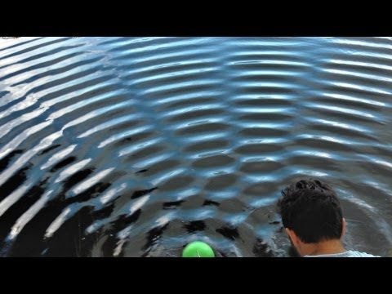](https://www.youtube.com/watch?v=Iuv6hY6zsd0&t=10s)