# **TECHNICAL BACKGROUND INFORMATION**

**Using EffectiveUserName =**

<https://www.qumio.com/Blog/Lists/Posts/Post.aspx?ID=49>

**Using Roles=**

<https://docs.microsoft.com/en-us/sql/analysis-services/instances/connection-string-properties-analysis-services?view=sql-server-2014>

**Using CustomData=**

<https://www.kasperonbi.com/using-customdata-and-ssas-with-power-bi-embedded/>

**Using RunAs**runas /user:cklenovo\SSAS_USER01 "C:\Program Files (x86)\Microsoft SQL Server\140\Tools\Binn\ManagementStudio\Ssms.exe"

# **Dynamic Role**

I added the code to each of the dimensions at the cube level. The code give priority to CustomData specified in the ConnectionString.

{StrToMember("[Provider - Inpatient - Hospital Admission].[Provider - UserID].&amp;[" + iif(isempty(customdata()) = True, username(), customdata()) + "]")}

# **ROLES**

Adding filters on multiple role-playing dimensions act as "INTERSECTION" aka "AND".

A possible workaround would be create several roles without members and with the minimum number of dimension filters. Then use the connection string to specify the appropriate role.

Example:

One report requires filtering permissions on [Department  - Medication Administration] and [Provider - Patient - PCP] to the current user.

* A specific role is created without any memberships called SpecialRole.role.
* SpecialRole.role filters [Department  - Medication Administration] and [Provider - Patient - PCP] to the current user.
* The report then uses a special connection string to apply this role to the query: Data Source=myServerAddress;Catalog=myDataBase;**Roles=SpecialRole**

See this article for the connection string syntax:

<https://docs.microsoft.com/en-us/sql/analysis-services/instances/connection-string-properties-analysis-services?view=sql-server-2014>

# **HOW TO USE CONNECTION STRINGS IN SSMS**

Open an MDX query to the SSAS database

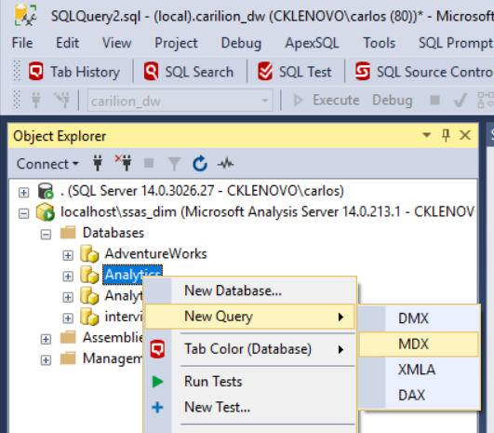

Change the connection. This will allow customization of the connection string.

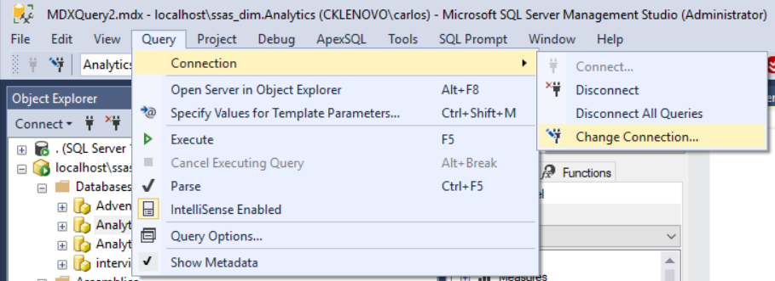

Click the “Options” button

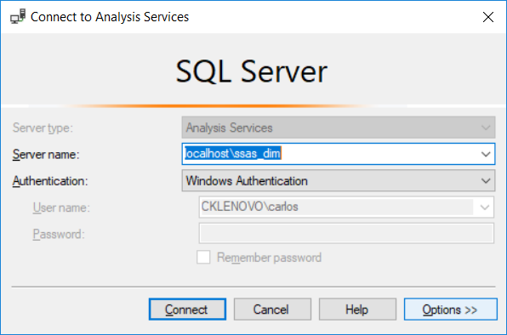

The dialog box will change to this:

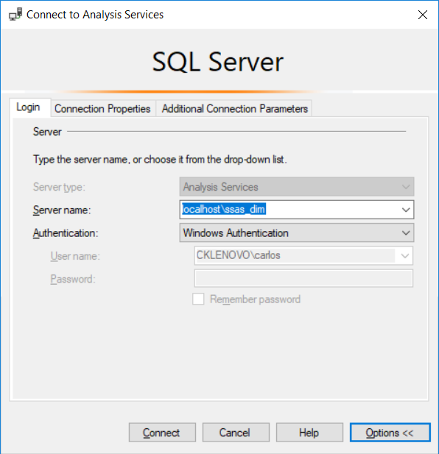

Ignore the “Connection Properties” tab

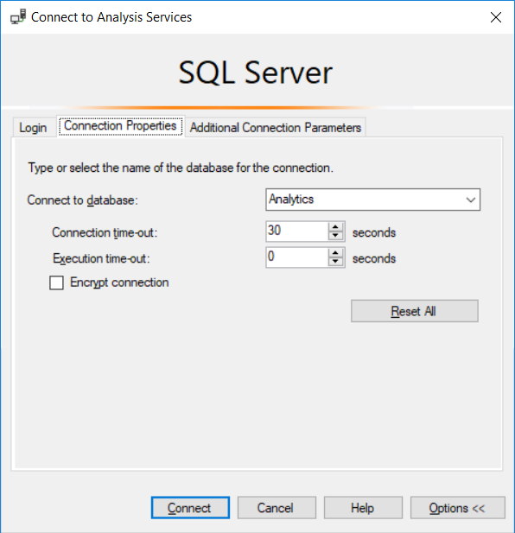

In the “Additional Connection Parameters” you will specify the EffectiveUserName, Roles, and/or CustomData.

EffectiveUserName=cklenovo\SSAS_USER01

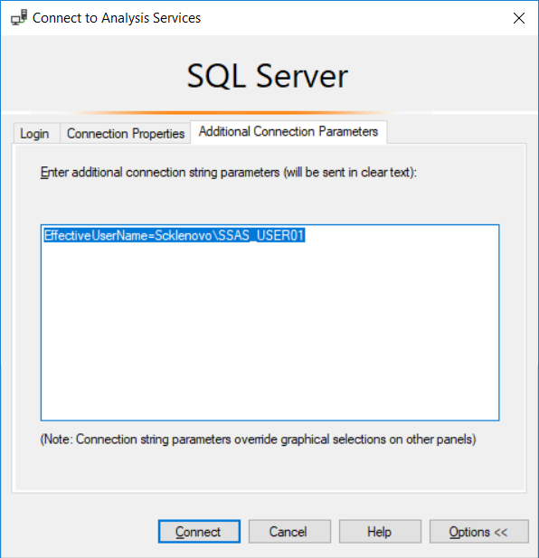

CustomData=cklenovo\SSAS_USER01

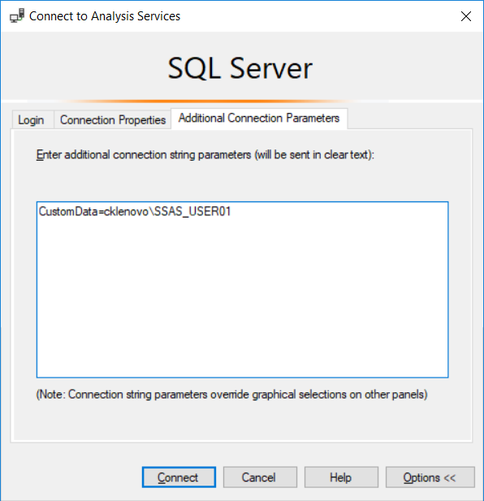

select

{ [Measures].[Lab Order - Count] } on 0,

{StrToMember("[User - Lab Order - Collecting].[User - UserID].&[" + iif(isempty(customdata()) = True, username(), customdata()) + "]")} on 1

from

[Analytics]

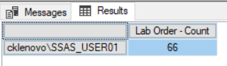

Find the role you want to specify in Visual Studio solution

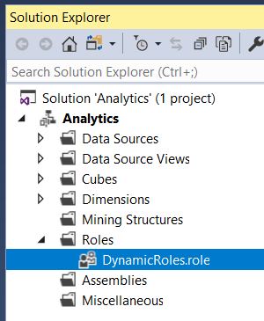

Roles=DynamicRoles

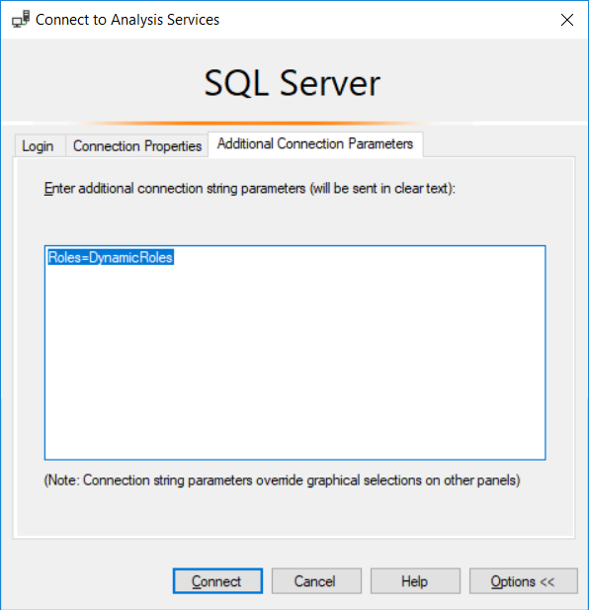

select

{ [Measures].[Lab Order - Count] } on 0,

{[Provider - Patient - PCP].[Provider - UserID].members} on 1

from

[Analytics]

