CYBER SECURITY PORTFOLIO

Python Security Automation
Development of an Active Network Scanner & automated Log Parser

Prepared By: Osandi Amurthanjali
Project Type: Independent Self-Study Portfolio Project
Focus Area: Defensive Security Operations & Automation
Date: June 2026

1. Executive Summary
In modern Security Operations Centers (SOC), automation plays a vital role in reducing response times and handling repetitive tasks efficiently. This portfolio project demonstrates how Python can be utilized to build custom defensive security automation utilities from scratch.
The project is divided into two operational modules: an active Network Scanner that discovers active infrastructure hosts and records hardware addresses, and an automated Log Parser designed to process web server access logs. Together, these tools provide foundational capabilities required for asset discovery and signature-based threat detection.

2. Project Objectives
- Network Reconnaissance: Automate the identification of live hosts within a local area network (LAN) using low-level protocol requests.
- Threat Identification: Develop an analytics script to parse server raw logs using pattern matching to identify indicators of compromise (IoCs).
- Signature Detection: Establish baseline thresholds to detect automated malicious activities, such as web directories scouting and password brute-forcing.
- Error Resolution and Troubleshooting: Document pipeline bugs, script deployment obstacles, and local platform path corrections encountered during standalone development.

3. Technical Stack & Environment
The solution was built using core Python components alongside dedicated third-party networking modules, avoiding full commercial frameworks to ensure granular structural control.
Component /  Layer | Technology / Module | Purpose & Application
Programming  Engine | Python 3.14 | Core automation logic, file operations, and execution container.
Packet Crafting | Scapy (v2.7.0) | Constructing custom Ether/ARP layer-2 frames and processing interface replies.
Pattern Matching | Regular Expressions (re) | Extracting textual string metadata (IP addresses, HTTP verbs, response status codes).
Data Aggregation | collections.Counter
Component /  Layer | Technology / Module | Purpose & Application
 |  | Tabulating security event frequencies to map brute force triggers.
Host  Configuration | Windows Environment  Variables | Configuring system executable PATHs for binary isolation control.

4. Module 1: Active Network Scanner

4.1 Architectural Design
The scanner leverages Address Resolution Protocol (ARP) requests to discover active hosts. Instead of standard high-overhead ICMP pings (which are frequently blocked by local firewalls), a Layer 2 broadcast frame is assembled.
An Ethernet frame with a broadcast destination address (ff:ff:ff:ff:ff:ff) is coupled with an ARP packet mapping the specified network range. The module transmits these packets using the srp() function, capturing responses within a 3-second timeout window. Valid responses are extracted into an array containing corresponding IP and MAC address pairs.
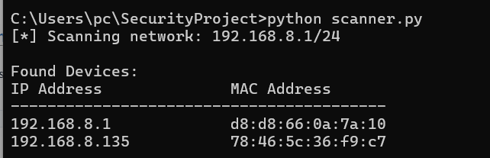
5. Module 2: Automated Log Parser
5.1 Analytical Logic & Signature Matching
The log parser processes standard access text fields sequentially using regular expressions. It maps a signature extraction pattern isolating the target IP address and trailing server status code:
(?P<ip>\d{1,3}\.\d{1,3}\.\d{1,3}\.\d{1,3}).*?"\s(?P<status>\d{3})
Extracted data fields are aggregated based on target HTTP status counters:
- Status 401 (Unauthorized Logins): If a singular IP generates 3 or more consecutive unauthorized tracking attempts, the algorithm flags it under an [ALERT] Potential Brute Force Attack
classification.
- Status 404 (Not Found Errors): Frequent non-existent requests from a host are cataloged under an
[INFO] Suspicious Scanning Activity alert indicator, signaling a directory exposure scouting routine.
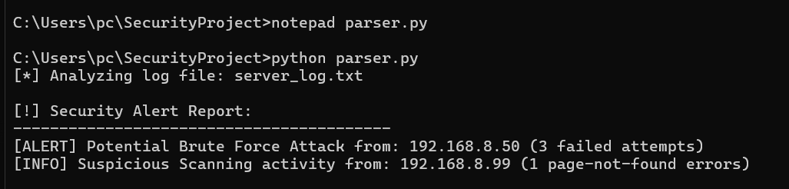
6. Challenges & Solutions Encountered
During independent deployment, several low-level environmental and architectural errors were encountered and resolved systematically:
- Challenge: Environment PATH Disconnection
Problem: Pip execution returned a critical warning indicating scapy.exe is installed in a directory not on PATH, blocking direct command invocation.
Resolution: Manually configured the Windows System Environment Variables, introducing the local roaming user subfolder path to allow direct system-wide accessibility.
- Challenge: Scope Discrepancy & Indentation Validation
Problem: Python interpreter thrown an IndentationError preventing core compilation due to unaligned spacing within conditional blocks.
Resolution: Realigned the target conditional blocks using strict block tabulations, matching scope indicators smoothly.
- Challenge: Invalid Literal Syntax
Problem: The execution failed with a SyntaxError: invalid decimal literal due to a variable declaration beginning with a numeric value (e.g., 404_counts).
Resolution: refactored variable naming architecture to follow pep-8 standards, converting labels to compliance scripts (e.g., four_o_four_counts).
- Challenge: Interface Gateway Mismatch
Problem: Network scanner script executed successfully but generated blank response lists due to using an incompatible default subnet range (192.168.1.1/24).
Resolution: Utilized ipconfig diagnostics to identify the active wireless link gateway (192.168.8.1) and refactored the structural target netmask accordingly.

7. Conclusion & Future Scope
This self-study automation project establishes how open-source scripting can perform network inventory assessment and parse data structures for immediate hazard detection. By scaling these core modules, an engineer can construct comprehensive, low-cost asset management and intrusion alert structures.
Future extensions planned for this pipeline include:
- Integrating an active Port Scanner module leveraging standard Python socket interfaces.
- Adding automated SMTP email notifying logic using the smtplib library to forward alert lines instantly to security operations staff.
- Developing a centralized Command Line Interface (CLI) dashboard control menu structure.

