Experiment Number: 3
MATLAB Analysis of Spectrum Bands, Propagation Loss and Cellular Interference
Aim
To compare a simplified free-space path-loss estimate across representative sub-1 GHz, mid-
band and mm Wave frequencies, and examine how distance and frequency reuse affect
received signal and a simple interference measure.
Objectives
By the end of the experiment, students should be able to:
1. Calculate or simulate path loss at representative sub-1 GHz, mid-band and mmWave
frequencies.
2. Compare estimated received signal strength as frequency and distance change.
3. Examine how cell separation or frequency reuse changes a simplified interference ratio.
4. Relate the results to coverage and spectrum-use considerations across mobile generations,
while stating model limitations.
Requirements
• Computer with MATLAB R2019b or later.
• No RF hardware is required.
Theoretical Background
- The free-space path-loss equation in decibels is FSPL = 32.44 + 20log10(f_MHz) +20log10(d_km), where f is carrier frequency and d is separation.
- With fixed transmit powerand antenna gains, estimated received power is P_r = P_t + G_t + G_r − FSPL.
- In thisidealized equation, doubling distance adds about 6 dB of loss and doubling frequency addsabout 6 dB of loss at the same distance.
- For a simple reuse illustration, let the desired transmitter be at distance R and six equal-powerco-channel interferers be at distance D = √(3N)R, where N is a reuse-cluster size.
- Under a power-law path-loss exponent n, approximate SIR = (D/R)^n / 6. This idealized first-tier model omits shadowing, fading, sector antennas, unequal loads, terrain, adjacent-channel leakage and real frequency-planning constraints. Because desired and interfering links use the same frequency, frequency-dependent free-space loss cancels in this simplified SIR ratio.
Parameters and Assumptions
1. Carrier Bands: 0.7 GHz, 3.5 GHz, and 28 GHz — Representative sub-1 GHz, mid-band, and millimetre-wave frequency points.
2. Transmit Power: 30 dBm — Illustrative conducted transmit power, with antenna gains assumed to be 0 dBi.
3. Distance Range: 0.1 km to 2 km — The range used for free-space propagation comparisons.
4. Path-Loss Exponent for Reuse Model: 3.5 — An illustrative non-free-space distance exponent used in the frequency-reuse model.
5. Reuse Cluster Sizes (N): 1, 3, 7, and 12 — Different cluster sizes used to compare frequency reuse; larger \(N\) implies greater idealized co-channel separation.
Procedure
1. Run the script and inspect the path-loss and received-power plots.
2. Record the estimated received power at 0.5 km for each frequency.
3. Inspect the reuse-SIR plot and compare the baseline N values.
4. Change transmit power, distance range, path-loss exponent or reuse sizes; rerun and
record the effect.
5. Explain why frequency reuse changes the simplified co-channel SIR and why the free-
space link budget is not a complete coverage prediction.
MATLAB Program — Path Loss, Received Power and Reuse Interference
% Experiment 3: illustrative propagation and frequency reuse
clear; clc; close all;
% Representative bands and link-budget assumptions
freqGHz = [0.7 3.5 28];
freqMHz = freqGHz * 1000;
bandName = ["Sub-1 GHz"; "Mid-band"; "mmWave"];
txPowerdBm = 30;
gtDbi = 0; grDbi = 0;
distanceKm = logspace(log10(0.1),log10(2),200);
distanceAtPointKm = 0.5;
% Free-space path loss (d in km, f in MHz)
fspl = @(fMHz,dKm) 32.44 + 20*log10(fMHz) + 20*log10(dKm);
lossAtPoint = fspl(freqMHz,distanceAtPointKm);
rxAtPoint = txPowerdBm + gtDbi + grDbi - lossAtPoint;
linkTable = table(bandName,freqGHz(:),lossAtPoint(:),rxAtPoint(:), ...
'VariableNames',{'Band','Frequency_GHz','FSPL_dB','EstimatedRx_dBm'});
disp(linkTable);
% Path loss and received power over distance
figure; tiledlayout(1,2);
nexttile; hold on; grid on;
for k=1:numel(freqMHz)
plot(distanceKm,fspl(freqMHz(k),distanceKm),'LineWidth',1.5);
end
set(gca,'XScale','log'); xlabel('Distance (km)'); ylabel('Path loss (dB)');
legend(bandName,'Location','northwest'); title('Free-Space Path Loss');
nexttile; hold on; grid on;
for k=1:numel(freqMHz)
rx = txPowerdBm + gtDbi + grDbi - fspl(freqMHz(k),distanceKm);
plot(distanceKm,rx,'LineWidth',1.5);
end
set(gca,'XScale','log'); xlabel('Distance (km)'); ylabel('Estimated received power (dBm)');
legend(bandName,'Location','southwest'); title('Illustrative Received Power');
% Simple first-tier co-channel reuse estimate
cellRadiusKm = 0.5;
reuseN = [1 3 7 12];
pathLossExponent = 3.5;
reuseDistance = sqrt(3*reuseN) * cellRadiusKm;
sirLinear = (reuseDistance/cellRadiusKm).^pathLossExponent / 6;
sirDb = 10*log10(sirLinear);
reuseTable = table(reuseN(:),reuseDistance(:),sirDb(:), ...
'VariableNames',{'ReuseClusterN','ApproxInterfererDistance_km','ApproxSIR_dB'});
disp(reuseTable);
figure; plot(reuseN,sirDb,'o-','LineWidth',1.5); grid on;
xlabel('Reuse cluster size N'); ylabel('Approximate SIR (dB)');
title('Simplified Co-Channel SIR versus Reuse Cluster Size');
fprintf('At %.2f km, estimated received powers are:\n',distanceAtPointKm);
disp(table(bandName,rxAtPoint(:),'VariableNames',{'Band','Rx_dBm'}));

Result
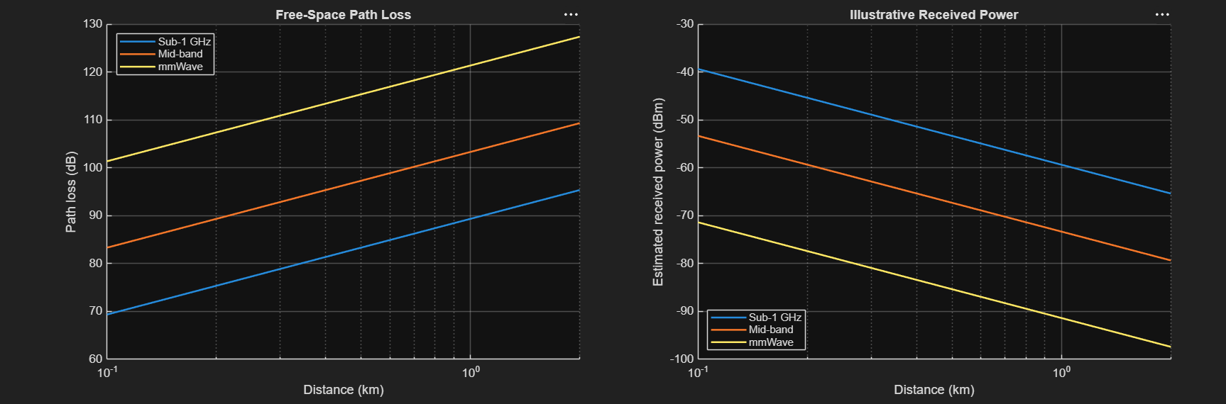
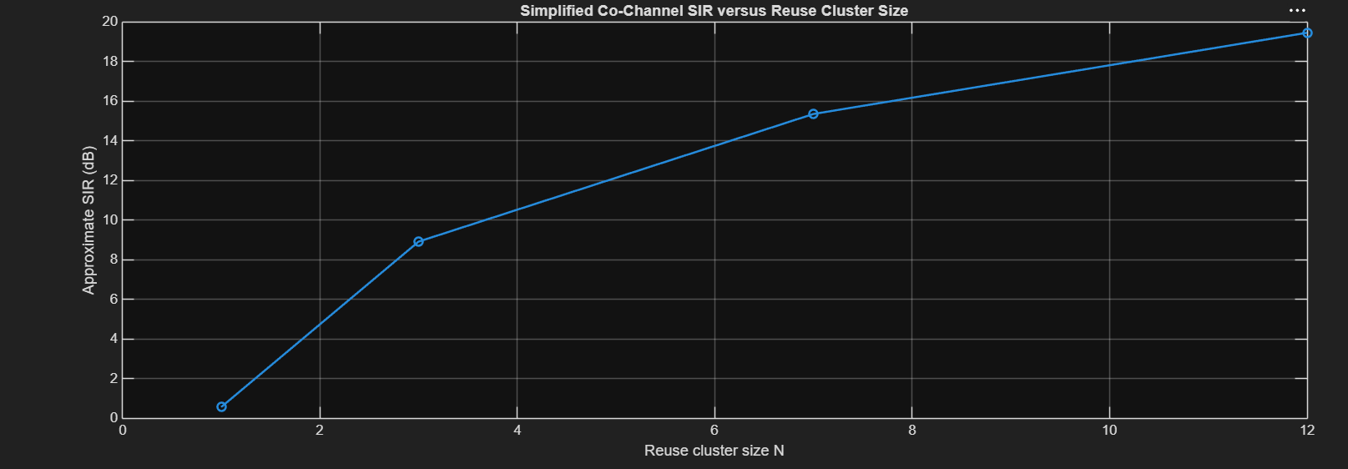
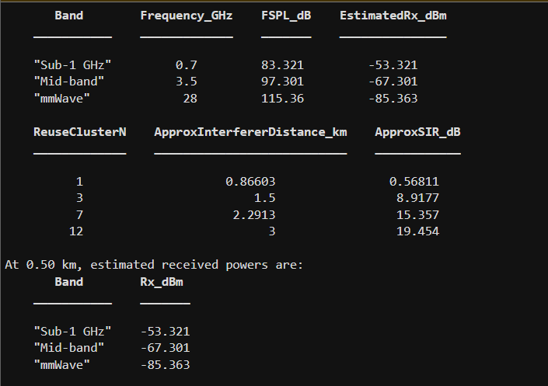
Conclusion
Summarize the frequency and distance trends from the simulation and the effect of reuse separation on the illustrative SIR. Identify the free-space assumption, fixed transmit power and idealized six-interferer geometry as limitations. Note that practical coverage depends on antenna characteristics, environment, bandwidth, receiver sensitivity, interference, regulatory constraints.

