Experiment: 7
Analysis of 5G NR Frame Structure and Subcarrier Spacing

Aim
To analyze the 5G NR frame structure by studying subcarrier spacing, slot duration, OFDM
symbols and simplified downlink/uplink resource assignments using MATLAB, and to relate
the radio resources to gNodeB functions and RRC operation.
Objectives
• To generate or inspect a simplified 5G NR resource grid.
• To compare selected subcarrier spacings and their effect on symbol or slot duration.
• To identify basic downlink and uplink resource assignments in the model.
• To relate the radio resources to gNodeB functions, RAN organization and RRC’s role.
Software Required
• MATLAB
Theory
5G NR uses flexible numerology. For the standard subcarrier-spacing sequence used in the
master record, 15, 30, 60, 120 and 240 kHz correspond to numerology indices 0 through 4.
With a normal cyclic prefix, a slot contains 14 OFDM symbols. Increasing subcarrier spacing
reduces slot duration, enabling flexible latency characteristics. The gNodeB is responsible for
radio access functions and scheduling, while RRC performs control and configuration
functions such as radio-resource configuration and connection management.
Objective – 1: Generate / Inspect a Simplified 5G NR Resource Grid
Procedure
1. Define the number of subcarriers and OFDM symbols.
2. Create a simplified matrix representing the resource grid.
3. Assign sample downlink and uplink resources.
4. Display the resource allocation using an image representation.
5. Interpret the time-frequency organization.

Program:
clc; clear; close all;
Nsc = 24; % Simplified number of subcarriers
Nsym = 14; % OFDM symbols per slot
grid = zeros(Nsym,Nsc);
% Simplified DL assignment: symbols 1-10
grid(1:10,:) = 1;
% Simplified UL assignment: symbols 11-14
grid(11:14,:) = 2;
figure
imagesc(grid)
grid on
xlabel('Subcarrier Index')
ylabel('OFDM Symbol Index')
title('Simplified 5G NR Time-Frequency Resource Grid')
colorbar
Expected Output: A time-frequency grid representing simplified downlink and uplink
resource assignments.
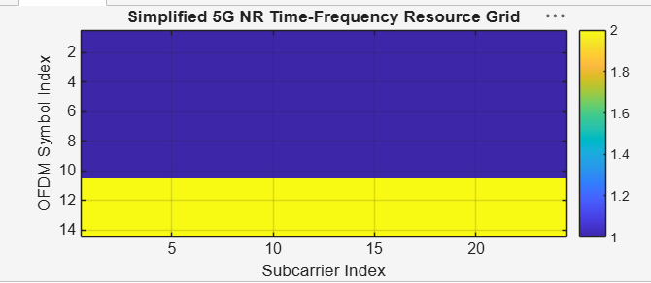
Figure 7.1: Simplified 5G NR Time-Frequency Resource Grid

Objective – 2: Compare SCS and Slot Duration
Procedure
1. Define 15, 30, 60, 120 and 240 kHz SCS values.
2. Associate the corresponding slot durations.
3. Plot SCS against slot duration.
4. Observe the inverse relationship.
5. Explain the latency implication.
Program:
clc; clear; close all;
scs = [15 30 60 120 240]; % kHz
mu = 0:4;
slot = [1 0.5 0.25 0.125 0.0625]; % ms
figure
plot(scs,slot,'o-','LineWidth',2)
grid on
xlabel('Subcarrier Spacing (kHz)')
ylabel('Slot Duration (ms)')
title('5G NR Slot Duration for Different Subcarrier Spacing')
figure
bar(scs)
grid on
set(gca,'XTickLabel',mu)
xlabel('Numerology Index (\mu)')
ylabel('Subcarrier Spacing (kHz)')
title('5G NR Subcarrier Spacing for Different Numerologies')
Expected Output: Slot duration decreases as SCS increases. The SCS graph shows 15, 30, 60,
120 and 240 kHz.

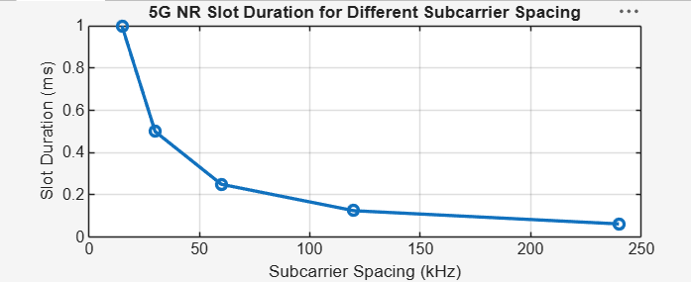Figure 7.2: 5G NR Slot Duration for Different Subcarrier Spacing
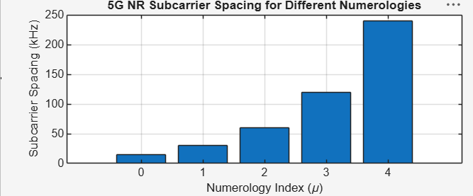
Objective – 3: Identify Basic DL and UL Resource Assignments
Procedure
1. Define a simplified slot with 14 OFDM symbols.
2. Assign selected symbols/resources to downlink and uplink.
3. Plot the allocation.
4. Identify which resources are used for downlink and uplink in the model.
5. Discuss that actual NR resource allocation is more detailed and scheduler-dependent.
Program:
clc; clear; close all;
symbols = 1:14;
DL = [1 1 1 1 1 1 1 1 1 1 0 0 0 0];
UL = [0 0 0 0 0 0 0 0 0 0 1 1 1 1];
figure
plot(symbols,DL,'o-','LineWidth',2); hold on
plot(symbols,UL,'s-','LineWidth',2)
grid on
xlabel('OFDM Symbol Index')
ylabel('Allocation Status')
title('Simplified Downlink and Uplink Assignment')
legend('Downlink','Uplink')
Expected Output: A plot identifying simplified DL and UL resource assignments across the
OFDM symbols.
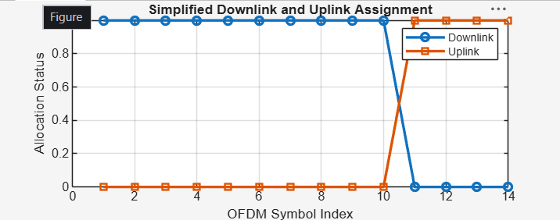
Figure 7.3: Simplified Downlink and Uplink Assignment
Objective – 4: Relate Resources to gNodeB, RAN and RRC
The gNodeB is the principal 5G NR radio access node. It participates in radio-resource
management and scheduling and provides the radio interface between the UE and the 5G
core. RRC is a control-plane protocol responsible for radio-resource configuration and
connection-related control. The simplified grid therefore represents the radio resources that
are scheduled and configured within the RAN; the exact allocation in a live network depends
on traffic, channel conditions, QoS and scheduling decisions.
Result
1. A simplified 5G NR resource grid was generated and inspected.
2. The effect of different SCS values on slot duration was analyzed.
3. Basic downlink and uplink resource assignments were represented.
4. The relationship among NR radio resources, gNodeB operation, RAN organization and
RRC was explained.

