Experiment: 5
Simulation and Throughput Analysis of LTE-Advanced Carrier Aggregation
Aim
To simulate an LTE-Advanced wireless link using carrier aggregation and analyze the effect
of aggregating multiple component carriers on available transmission bandwidth and
estimated throughput using MATLAB.
Objectives
• To model an LTE-Advanced link using one component carrier.
• To extend the model to use multiple aggregated component carriers.
• To compare estimated throughput for different carrier bandwidths.
• To explain how carrier aggregation increases available transmission bandwidth.
Software Required
• MATLAB
Theory
Carrier aggregation is an LTE-Advanced technique in which multiple component carriers are
combined so that a user can access a larger effective transmission bandwidth. A single
component carrier provides a limited bandwidth, whereas aggregation of two or more carriers
increases the total usable bandwidth. In a simplified throughput model, estimated throughput
can be related to aggregated bandwidth and spectral efficiency. The experiment therefore
demonstrates the principle of bandwidth aggregation and its impact on achievable data rate.
Expected Outputs
• Plot/table showing throughput for a single component carrier.
• Comparison of one, two and three aggregated component carriers.
• Throughput versus aggregated bandwidth graph.
• Observation that aggregated bandwidth increases the estimated throughput under the same
spectral-efficiency assumption.

Objective – 1: Model One Component Carrier
Define a single LTE-Advanced component carrier and estimate its throughput for a selected
bandwidth and spectral efficiency.
Procedure
1. Open MATLAB and create a new script.
2. Define the component-carrier bandwidth, spectral efficiency and number of component
carriers.
3. Calculate the single-carrier throughput using bandwidth × spectral efficiency.
4. Display the bandwidth and estimated throughput.
5. Plot the single-carrier result.
MATLAB Program
clc; clear; close all;
BW1 = 20; % Component carrier bandwidth (MHz)
SE = 4; % Spectral efficiency (bits/s/Hz)
Ncc = 1; % Number of component carriers
BWagg = BW1*Ncc;
Throughput = BWagg*SE; % Mbps for MHz × bits/s/Hz
disp('Single Component Carrier')
disp(['Bandwidth = ',num2str(BWagg),' MHz'])
disp(['Estimated Throughput = ',num2str(Throughput),' Mbps'])
figure
bar(Ncc,Throughput)
grid on
xlabel('Number of Component Carriers')
ylabel('Estimated Throughput (Mbps)')
title('LTE-Advanced Single Carrier Throughput')
Expected Output: A graph showing the estimated throughput for one 20 MHz component
carrier. With the selected 4 bits/s/Hz simplified assumption, the estimated throughput is 80
Mbps.

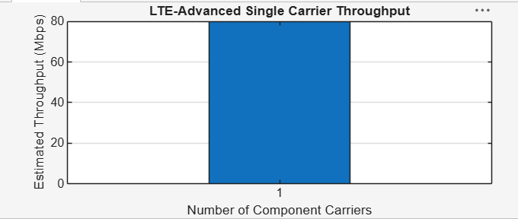
Single Component Carrier
Bandwidth = 20 MHz
Estimated Throughput = 80 Mbps

Objective – 2: Extend to Multiple Aggregated Component Carriers
Aggregate multiple component carriers and determine the resulting total bandwidth and
estimated throughput.
Procedure
6. Define one, two and three component-carrier configurations.
7. Calculate total aggregated bandwidth for each configuration.
8. Estimate throughput using the same spectral-efficiency value.
9. Plot throughput for the different aggregation configurations.
10. Compare the results and explain the increase.
MATLAB Program
clc; clear; close all;
BWcc = 20; % MHz per component carrier
SE = 4; % bits/s/Hz
CC = [1 2 3]; % Number of component carriers
AggBW = BWcc .* CC; % MHz
Throughput = AggBW .* SE; % Mbps
disp('CC Aggregated BW (MHz) Estimated Throughput (Mbps)')
disp([CC' AggBW' Throughput'])
figure
bar(CC,Throughput)
grid on
xlabel('Number of Aggregated Component Carriers')
ylabel('Estimated Throughput (Mbps)')
title('LTE-Advanced Carrier Aggregation Throughput')
Expected Output: The graph increases with the number of aggregated component carriers. For
the selected parameters, 1, 2 and 3 carriers provide 80, 160 and 240 Mbps respectively.
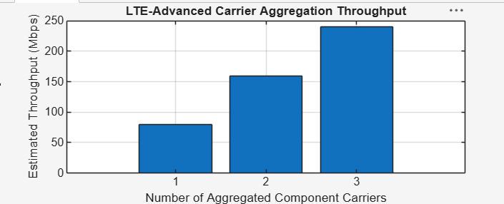
CC Aggregated BW (MHz) Estimated Throughput (Mbps)
1 20 80
2 40 160
3 60 240

Objective – 3: Compare Estimated Throughput for Different Carrier Bandwidths
Procedure
1. Define several component-carrier bandwidths.
2. Calculate throughput for each bandwidth using the selected spectral efficiency.
3. Compare the throughput values.
4. Plot bandwidth against estimated throughput.
5. Identify the bandwidth configuration that provides the highest estimated throughput.
MATLAB Program
clc; clear; close all;
BW = [5 10 15 20]; % Carrier bandwidths (MHz)
SE = 4; % bits/s/Hz
TP = BW .* SE; % Estimated throughput (Mbps)
disp('Bandwidth (MHz) Throughput (Mbps)')
disp([BW' TP'])
figure
plot(BW,TP,'o-','LineWidth',2)
grid on
xlabel('Carrier Bandwidth (MHz)')
ylabel('Estimated Throughput (Mbps)')
title('Throughput vs Component Carrier Bandwidth')
Expected Output: Throughput increases as the component-carrier bandwidth increases.
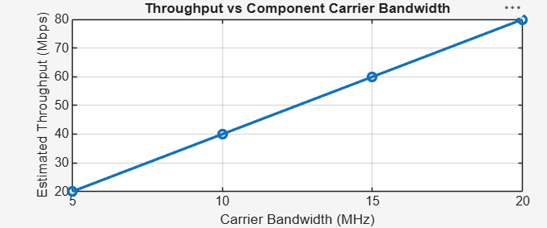
Objective – 4: Explain the Effect of Carrier Aggregation
The total available bandwidth is obtained by combining the component carriers. Under the
simplified constant spectral-efficiency model, throughput increases approximately in
proportion to the aggregated bandwidth.
Result
1. The LTE-Advanced link was successfully modeled using a single component carrier.
2. Multiple component carriers were aggregated and the resulting bandwidth and estimated
throughput was calculated.
3. Throughput was compared for different carrier bandwidths.
4. The simulation demonstrated that carrier aggregation increases available transmission
bandwidth and can increase achievable throughput.

