9. Simulation and Performance Evaluation of OFDMA Resource-Block Allocation for Multi-User Communication.
Objectives of This Experiment
1. To represent a set of orthogonal OFDMA resource blocks and multiple users in MATLAB.
2. To allocate resource blocks using traffic-demand and channel-quality-based allocation rules.
3. To compare user throughput, resource utilization and fairness under different allocation
strategies.
4. To explain how orthogonal resource allocation limits inter-user interference in multi-user
communication.
Software Required
MATLAB (with Communications and Signal Processing Toolboxes if
needed).
Objective Linkage
The experiment links the simulation of OFDMA resource allocation with
the practical understanding of multi-user communication, radio resource management, system
performance evaluation, throughput optimization, and efficient utilization of wireless resources.
Experimental Procedure:
A. OFDMA System Modelling
Consider a downlink OFDMA system with 4 users and 24 resource blocks (RBs). Each resource
block has a bandwidth of 180 kHz, and the scheduling interval is 1 ms. The maximum achievable
spectral efficiency is limited to 6-bit/s/Hz. The traffic demands of the four users are [8, 12, 5, 10]
Mbit/s. Generate an SNR value. Value for every user-resource-block pair. Convert SNR to achieve
spectral efficiency using a capped Shannon capacity formula, and determine the achievable data rB.

Implement and simulate the following three baseline OFDMA resource-block allocation
strategies:
• Round-Robin Allocation:
Allocate the 24 resource blocks successively and cyclically among the 4 users, without
considering their instantaneous channel conditions.
• Maximum-CQI Allocation:
For each resource block, identify the user having the highest instantaneous SNR/channel
quality and allocate that resource block exclusively to that user.
• Traffic-Aware Allocation:
Allocate each resource block by jointly considering the user's instantaneous channel quality
and its remaining unsatisfied traffic demand.
MATLAB Program Script
clc;
clear;
close all;
%% Input parameters
rng(7); % Repeatable random results
K = 4; % Number of users
NRB = 24; % Number of resource blocks
BRB = 180e3; % Bandwidth per RB in Hz
Tslot = 1e-3; % Scheduling interval in seconds
etaMax = 6; % Maximum spectral efficiency, bit/s/Hz
avgSNRdB = [5 10 15 8]; % Average user SNR in dB
trafficMbps = [8 12 5 10]; % Offered traffic in Mbit/s
% Bits requested during one scheduling interval
demandBits = trafficMbps * 1e6 * Tslot;
%% Generate channel quality for each user and RB
% Independent SNR variation around each user's average SNR
snrVariation = 4 * randn(K, NRB);
snrDB = avgSNRdB(:) + snrVariation;
snrLinear = 10.^(snrDB / 10);
% Shannon-based spectral efficiency with an upper limit
spectralEfficiency = min(log2(1 + snrLinear), etaMax);
% Achievable bits on each RB during one scheduling interval
rateBps = BRB * spectralEfficiency;
bitsPerRB = rateBps * Tslot;
strategyNames = {'Round Robin', 'Maximum CQI', 'Traffic Aware'};
allocations = zeros(K, NRB, 3);
%% Strategy 1: Round-robin allocation
for n = 1:NRB
user = mod(n - 1, K) + 1;
allocations(user, n, 1) = 1;
end
%% Strategy 2: Maximum-CQI allocation
for n = 1:NRB
[~, user] = max(snrDB(:, n));
allocations(user, n, 2) = 1;
end
%% Strategy 3: Traffic-aware channel-quality allocation
servedBits = zeros(K, 1);
for n = 1:NRB
remainingBits = max(demandBits(:) - servedBits, 0);
if all(remainingBits <= 0)
break;
end
normalizedDemand = remainingBits ./ max(demandBits(:), eps);
metric = bitsPerRB(:, n) .* normalizedDemand;
% Prevent allocation to a user whose demand has been satisfied
metric(remainingBits <= 0) = -inf;
[~, user] = max(metric);
allocations(user, n, 3) = 1;
deliveredBits = min(bitsPerRB(user, n), remainingBits(user));
servedBits(user) = servedBits(user) + deliveredBits;
end
%% Performance calculations
userThroughputMbps = zeros(K, 3);
totalThroughputMbps = zeros(1, 3);
jainFairness = zeros(1, 3);
utilization = zeros(1, 3);
unservedTrafficMbps = zeros(K, 3);
rbPerUser = zeros(K, 3);
for s = 1:3
allocation = allocations(:, :, s);
deliveredBits = sum(allocation .* bitsPerRB, 2);
% Throughput is restricted to requested traffic
usefulBits = min(deliveredBits, demandBits(:));
userThroughputMbps(:, s) = usefulBits / Tslot / 1e6;
totalThroughputMbps(s) = sum(userThroughputMbps(:, s));
throughput = userThroughputMbps(:, s);
jainFairness(s) = sum(throughput)^2 / (K * sum(throughput.^2) + eps);
allocatedRBs = sum(allocation(:));
utilization(s) = allocatedRBs / NRB * 100;
unservedTrafficMbps(:, s) = max(trafficMbps(:) - throughput, 0);
rbPerUser(:, s) = sum(allocation, 2);
end
%% Display results
fprintf('\nOFDMA RESOURCE-BLOCK ALLOCATION RESULTS\n');
fprintf('=======================================\n');
for s = 1:3
fprintf('\n%s\n', strategyNames{s});
fprintf('User\tRBs\tThroughput (Mbit/s)\tUnserved (Mbit/s)\n');
for k = 1:K
fprintf('%d\t%d\t%8.3f\t\t%8.3f\n', ...
k, rbPerUser(k, s), userThroughputMbps(k, s), unservedTrafficMbps(k, s));
end
fprintf('Total throughput: %.3f Mbit/s\n', totalThroughputMbps(s));
fprintf('Jain fairness : %.4f\n', jainFairness(s));
fprintf('RB utilization : %.2f %%%\n', utilization(s));
end
%% Allocation maps plotting
figure('Name', 'OFDMA Resource-Block Allocation');
for s = 1:3
subplot(3, 1, s);
[userIndex, rbIndex] = find(allocations(:, :, s));
stem(rbIndex, userIndex, 'filled', 'LineWidth', 1.1);
grid on;
xlim([1 NRB]); ylim([0.5 K + 0.5]); yticks(1:K);
xlabel('Resource-block index'); ylabel('Allocated user');
title(strategyNames{s});
end
%% Throughput comparison plotting
figure('Name', 'User Throughput Comparison');
bar(userThroughputMbps);
xlabel('User'); ylabel('Throughput (Mbit/s)');
title('User Throughput Under Different Allocation Strategies');
legend(strategyNames, 'Location', 'best');

Results
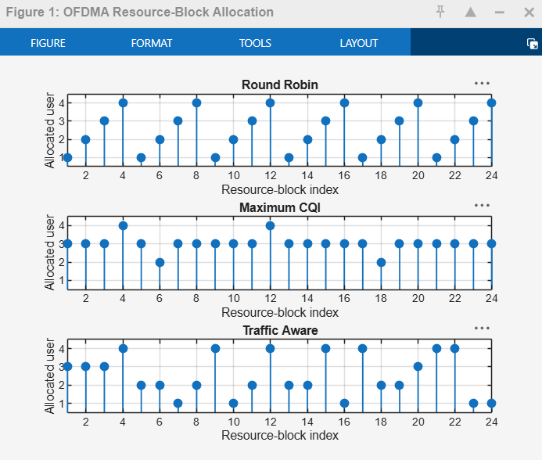
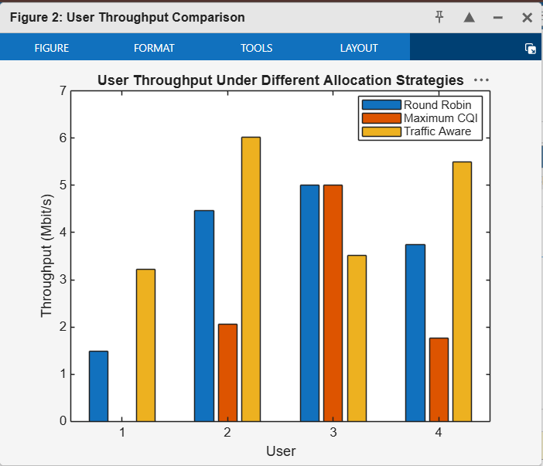

OFDMA RESOURCE-BLOCK ALLOCATION RESULTS
=======================================
Round Robin
User RBs Throughput (Mbit/s) Unserved (Mbit/s)
1 6 1.479 6.521
2 6 4.464 7.536
3 6 5.000 0.000
4 6 3.740 6.260
Total throughput: 14.683 Mbit/s
Jain fairness : 0.8821
RB utilization : 100.00 %
Maximum CQI
User RBs Throughput (Mbit/s) Unserved (Mbit/s)
1 0 0.000 8.000
2 2 2.055 9.945
3 20 5.000 0.000
4 2 1.764 8.236
Total throughput: 8.820 Mbit/s
Jain fairness : 0.6014
RB utilization : 100.00 %
Traffic Aware
User RBs Throughput (Mbit/s) Unserved (Mbit/s)
1 5 3.219 4.781
2 8 6.023 5.977
3 4 3.513 1.487
4 7 5.496 4.504
Total throughput: 18.251 Mbit/s
Jain fairness : 0.9337
RB utilization : 100.00 %>>

