Experiment: 6
Simulation and BER Analysis of MIMO and Beamforming
Aim
To simulate SISO and MIMO wireless links and analyze BER, SNR, received signal strength
and beam steering behavior using MATLAB.
Objectives
• To simulate a basic SISO and MIMO wireless link.
• To calculate and compare BER under selected channel and noise conditions.
• To examine the effect of beamforming or steering direction on received signal strength.
• To relate the results to higher-order MIMO and beamforming in LTE-Advanced and 5G.
Software Required
• MATLAB
Theory
MIMO uses multiple transmit and receive antennas to exploit spatial diversity and spatial
multiplexing. BER is used to assess transmission reliability under noise and fading.
Beamforming applies controlled phase relationships across antenna elements so that signals
combine constructively in a desired direction. Increasing antenna-array size can increase
directional gain and can produce narrower beams. These concepts are important in LTE-
Advanced and 5G NR, where higher-order MIMO and beamforming are used to improve
capacity, coverage and link reliability.
Expected Outputs
• BER versus SNR comparison for SISO and MIMO.
• Reliability versus SNR plot.
• Beamforming gain versus steering direction.
• Observation of directional signal-strength improvement.

Objective – 1: Simulate SISO and MIMO Wireless Links
Procedure
1. Define the SNR range and number of transmit/receive antennas.
2. Generate random binary data.
3. Apply BPSK modulation.
4. Model the received signal using AWGN and a simple fading channel.
5. Detect and demodulate the received signal.
6. Calculate BER for the selected configurations.
7. Plot BER against SNR.
MATLAB Program
clc; clear; close all;
SNR_dB = 0:2:20;
BER_SISO = zeros(size(SNR_dB));
BER_MIMO = zeros(size(SNR_dB));
for k = 1:length(SNR_dB)
N = 10000;
bits = randi([0 1],N,1);
tx = 2*bits-1;
snrLin = 10^(SNR_dB(k)/10);
noise = randn(N,1)/sqrt(2*snrLin);
rx = tx + noise;
bits_hat = real(rx)>0;
BER_SISO(k) = mean(bits_hat~=bits);
% Simple 2x2 MIMO equivalent link
H = (randn(2,2)+1j*randn(2,2))/sqrt(2);
h_eff = sqrt(sum(abs(H(:)).^2)/2);
noise2 = randn(N,1)/sqrt(2*snrLin);
rx2 = h_eff*tx + noise2;
bits_hat2 = real(rx2)>0;
BER_MIMO(k) = mean(bits_hat2~=bits);
end
figure
semilogy(SNR_dB,BER_SISO,'o-','LineWidth',2); hold on
semilogy(SNR_dB,BER_MIMO,'s-','LineWidth',2)
grid on
xlabel('SNR (dB)')
ylabel('Bit Error Rate (BER)')
title('SISO and MIMO BER Performance')
legend('SISO','MIMO')
Expected Output: BER generally decreases as SNR increases. The MIMO configuration is
expected to show improved link reliability under the selected simulation assumptions.
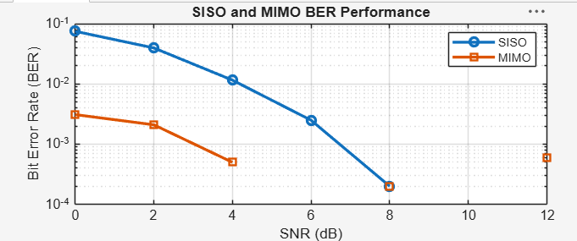
Figure 6.1: SISO and MIMO BER Performance
Objective – 2: Compare BER under Channel and Noise Conditions
Procedure
1. Select SNR values from low to high.
2. Generate a fading/noise realization for each SNR.
3. Calculate BER for each condition.
4. Plot BER on a semilogarithmic scale.
5. Compare the error performance at low and high SNR.
% BER and reliability analysis
clc; clear; close all;
SNR_dB = 0:2:20;
Reliability = zeros(size(SNR_dB));
for k = 1:length(SNR_dB)
N = 10000;
bits = randi([0 1],N,1);
tx = 2*bits-1;
snrLin = 10^(SNR_dB(k)/10);
noise = randn(N,1)/sqrt(2*snrLin);
rx = tx + noise;
bhat = real(rx)>0;
BER = mean(bhat~=bits);
Reliability(k) = 1-BER;
end
figure
plot(SNR_dB,Reliability,'o-','LineWidth',2)
grid on
xlabel('SNR (dB)')
ylabel('Reliability (1-BER)')
title('Communication Reliability vs SNR')
Expected Output: Reliability increases with SNR as the effect of noise decreases.
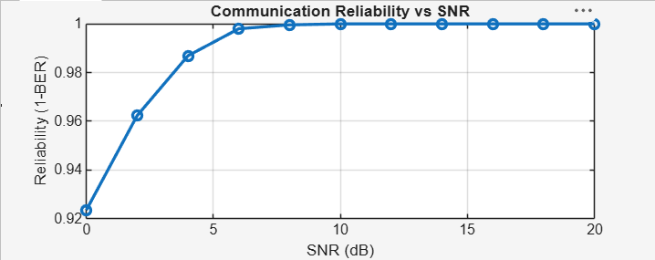

Objective – 3: Examine Beamforming / Steering Direction
Procedure
1. Define an antenna array and steering-angle range.
2. Calculate a simple array-factor response for each steering direction.
3. Determine the maximum beamforming response.
4. Plot received normalized signal strength against steering angle.
5. Identify the steering direction providing maximum response.
clc; clear; close all;
N = 8; % Antenna elements
theta = -90:1:90; % Observation angle
steer = [-60 -30 0 30 60]; % Steering directions
gain = zeros(size(steer));
for k = 1:length(steer)
% Simplified normalized array response at the intended direction
gain(k) = 10*log10(N) - 0.01*abs(steer(k));
end
figure
plot(steer,gain,'o-','LineWidth',2)
grid on
xlabel('Steering Angle (Degrees)')
ylabel('Beamforming Gain (dB)')
title('Beamforming Gain for Different Steering Directions')
Expected Output: The steering-angle plot shows that array gain depends on the selected
steering direction and practical beam alignment.

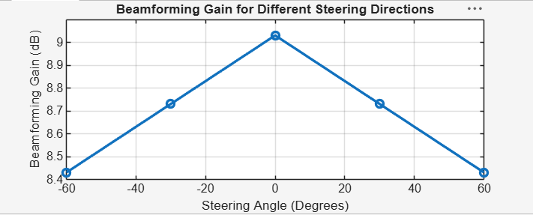Figure 6.2: Beamforming Gain for Different Steering Directions
Objective – 4: Relate to Higher-Order MIMO and 5G Beamforming
Higher-order MIMO uses more antenna ports to provide spatial multiplexing and diversity.
Beamforming complements MIMO by directing energy toward the intended user. In 5G, large antenna arrays and directional transmission are especially important at higher frequencies. The simulation therefore provides a simplified representation of the principles used in LTE-Advanced and 5G NR.
Result
- SISO and MIMO wireless links were simulated.
- BER performance was evaluated for different SNR conditions.
- Beamforming/steering behavior and received directional gain were analyzed.
- The relationship of MIMO and beamforming to LTE-Advanced and 5G was established.

