11. Simulation and Performance Evaluation of OFDM and FBMC Wireless Waveforms
Objectives of This Experiment
1. To generate a basic Orthogonal Frequency Division Multiplexing (OFDM) signal and a Filter
Bank Multicarrier (FBMC) signal in MATLAB.
2. To compare their spectral characteristics by plotting and analyzing their power spectral
density (PSD).
3. To examine and compare the Peak-to-Average Power Ratio (PAPR) of both waveforms
under identical modulation conditions.
4. To relate the empirical results to next-generation multi-carrier waveform design constraints
(GFDM, FBMC, UFMC) defined in the wireless syllabus.
Software Required
MATLAB (with Communications Toolbox).
Objective Linkage
The experiment links the simulation of multicarrier wireless waveforms
with the practical understanding of spectral confinement, out-of-band emissions, power amplifier
efficiency, and the design space of next-generation physical layers (5G/6G).
Experimental Procedure
A. Waveform System Modelling
Model a multicarrier transmission link using a total of N = 64 subcarriers, out of which only M =
12 are active (centered) to clearly visualize out-of-band emissions. The modulation scheme is 4-
QAM (QPSK). Generate random binary data, perform constellation mapping, and execute the
respective multicarrier modulation steps to produce the time-domain waveforms.
• OFDM Path: Map the modulated symbols onto active subcarriers, apply an Inverse Fast
Fourier Transform (IFFT) scaled by √N, and append a Cyclic Prefix (CP) of length Ncp = 16
to combat multi-path distortions.
• FBMC Path: Implement Offset QAM (OQAM) by splitting complex symbols into real and
imaginary components staggered by N/2 samples. Pass these components through a synthesis
filter bank using the PHYDYAS prototype filter with an overlapping factor of Kfbmc = 4 to
construct continuous overlapping arrays.
B. Spectral & Metric Calculations
• Power Spectrum Estimation: Pass the time-domain signals through a periodogram-based
spectral estimator to extract the normalized PSD in dB. Compute the peak out-of-band
sidelobe power level relative to the main lobe.
• PAPR Analysis: Extract the peak instantaneous power over the average power for each block
of symbols to establish an accurate comparison metric under varying statistical inputs.
MATLAB Program Script
clc; clear; close all;
%% 1. Input Parameters Setup
N = 64; % Total subcarriers
M = 12; % Active subcarriers (centered)
N_cp = 16; % Cyclic prefix for OFDM
K_fbmc = 4; % Overlapping factor for FBMC
N_sym = 100; % Number of symbols to simulate
rng(42); % Set seed for reproducible results
% Active subcarrier index allocation
active_idx = (N/2 - M/2 + 1) : (N/2 + M/2);
%% 2. Data Generation and QAM Mapping
num_bits_per_sym = M * 2; % 4-QAM = 2 bits/symbol
data_bits = randi([0 1], num_bits_per_sym, N_sym);
% Modulate bits to QAM symbols
qam_mod = zeros(M, N_sym);
for s = 1:N_sym
bits = data_bits(:, s);
for m = 1:M
b_idx = (m-1)*2 + 1;
% Simple QAM Gray Mapping
real_part = 1 - 2*bits(b_idx);
imag_part = 1 - 2*bits(b_idx+1);
qam_mod(m, s) = (real_part + 1i*imag_part)/sqrt(2);
end
end
%% 3. OFDM Waveform Generation
ofdm_tx_sig = [];
for s = 1:N_sym
ifft_in = zeros(N, 1);
ifft_in(active_idx) = qam_mod(:, s);
time_sym = ifft(ifft_in) * sqrt(N);
% Append Cyclic Prefix
cp_part = time_sym(end - N_cp + 1:end);
ofdm_tx_sig = [ofdm_tx_sig; cp_part; time_sym];
end
%% 4. FBMC Waveform Generation (OQAM Processing)
% PHYDYAS Prototype Filter Coefficients for K=4
H1 = 0.97195983; H2 = 0.70710678; H3 = 0.23514752;
g = zeros(1, 4*N);
for t = 0:(4*N-1)
g(t+1) = 1 - 2*H1*cos(2*pi*t/(4*N)) + 2*H2*cos(4*pi*t/(4*N)) - 2*H3*cos(6*pi*t/(4*N));
end
g = g / sqrt(sum(g.^2)); % Normalize filter energy
fbmc_tx_sig = zeros(N*N_sym + 4*N, 1);
% OQAM Implementation via synthesis equation scaling
for s = 1:N_sym
for m = 1:M
k = active_idx(m);
sym_data = qam_mod(m, s);
% Split into In-phase (Real) and Quadrature (Imag) components
r_data = real(sym_data);
i_data = imag(sym_data);
% Phase tracking offsets for orthogonality constraint
phase_r = exp(1i * pi * (k-1) * (0 - (4-1)/2));
phase_i = exp(1i * pi * (k-1) * (N/2 - (4-1)/2)) * 1i;
% Time domain modulation & windowing arrays
t_arr = 0:(4*N-1);
carrier_r = exp(1i * 2 * pi * (k-1) * t_arr / N) * phase_r;
carrier_i = exp(1i * 2 * pi * (k-1) * t_arr / N) * phase_i;
shift_r = (s-1)*N + 1;
shift_i = (s-1)*N + N/2 + 1;
fbmc_tx_sig(shift_r : shift_r + 4*N - 1) = fbmc_tx_sig(shift_r : shift_r + 4*N - 1) +
(r_data * g .* carrier_r).';
fbmc_tx_sig(shift_i : shift_i + 4*N - 1) = fbmc_tx_sig(shift_i : shift_i + 4*N - 1) +
(i_data * g .* carrier_i).';
end
end
%% 5. Metric Calculations (PAPR)
window_len_ofdm = N + N_cp;
ofdm_papr_vals = zeros(N_sym, 1);
for s = 1:N_sym
seg = ofdm_tx_sig((s-1)*window_len_ofdm + 1 : s*window_len_ofdm);
ofdm_papr_vals(s) = max(abs(seg).^2) / mean(abs(seg).^2);
end
max_ofdm_papr = 10 * log10(max(ofdm_papr_vals));
fbmc_papr_vals = zeros(N_sym, 1);
for s = 1:N_sym
seg = fbmc_tx_sig((s-1)*N + 1 : (s-1)*N + N);
if mean(abs(seg).^2) > 0
fbmc_papr_vals(s) = max(abs(seg).^2) / mean(abs(seg).^2);
end
end
max_fbmc_papr = 10 * log10(max(fbmc_papr_vals));
%% 6. Display Performance Metrics
fprintf('\nWAVEFORM COMPARISON SIMULATION RESULTS\n');
fprintf('=======================================\n');
fprintf('OFDM Max Inst. PAPR : %.3f dB\n', max_ofdm_papr);
fprintf('FBMC Max Inst. PAPR : %.3f dB\n', max_fbmc_papr);
%% 7. Plotting Power Spectral Density (PSD)
[psd_ofdm, f_ofdm] = periodogram(ofdm_tx_sig, [], 2048, 1, 'centered');
[psd_fbmc, f_fbmc] = periodogram(fbmc_tx_sig, [], 2048, 1, 'centered');
figure('Name', 'Waveform Spectral Evaluation');
plot(f_ofdm, 10*log10(psd_ofdm/max(psd_ofdm)), 'r-', 'LineWidth', 1.2); hold on;
plot(f_fbmc, 10*log10(psd_fbmc/max(psd_fbmc)), 'b-', 'LineWidth', 1.2); grid on;
xlabel('Normalized Frequency (\times \pi rad/sample)');
ylabel('Relative Power Density (dB)');
title('PSD Comparison: OFDM vs. FBMC');
legend('OFDM (Rectangular Window)', 'FBMC (PHYDYAS Prototype Filter)', 'Location',
'southoutside');
ylim([-80 5]);

Result
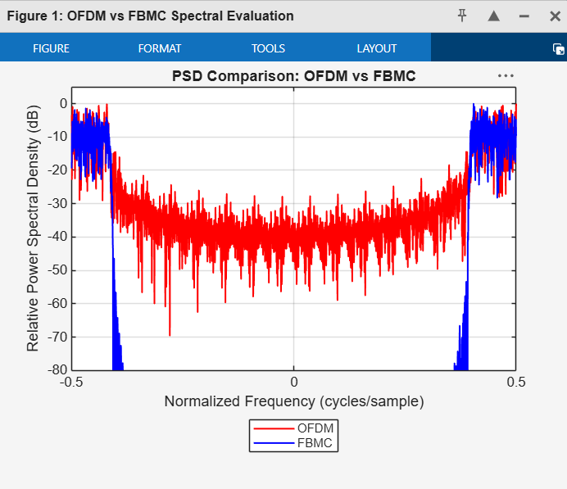
WAVEFORM COMPARISON RESULTS
===========================
OFDM Maximum PAPR: 9.690 dB
FBMC Maximum PAPR: 8.647 dB

