EXP NO: 9
ULTRASONIC SENSOR IN PROTEUS USING ARDUINO
AIM:
To write an Embedded C program for interfacing Ultrasonic Sensor using Arduino Uno
and Proteus
SOFTWARE REQUIRED:
• Proteus 8 software.
• Arduino IDE software
PROGRAM
// Program Sketch
int trig = 10;
int echo = 9;
long duration;
int cm;
void setup() {
// put your setup code here, to run once:
pinMode(trig, OUTPUT);
pinMode(echo,INPUT);
Serial.begin(9600);
}
void loop() { // Sketch to calculate ultrasonic distance
digitalWrite(trig, LOW);
delayMicroseconds(10);
digitalWrite(trig, HIGH);
delayMicroseconds(10);
digitalWrite(trig, LOW);
delayMicroseconds(10);
duration = pulseIn(echo, HIGH);
cm = (duration/2) * 0.034;
// Print Value on Serial Monitor
Serial.print(" Distance = ");
Serial.print(cm);
Serial.println(" cm");
}
OUTPUT:
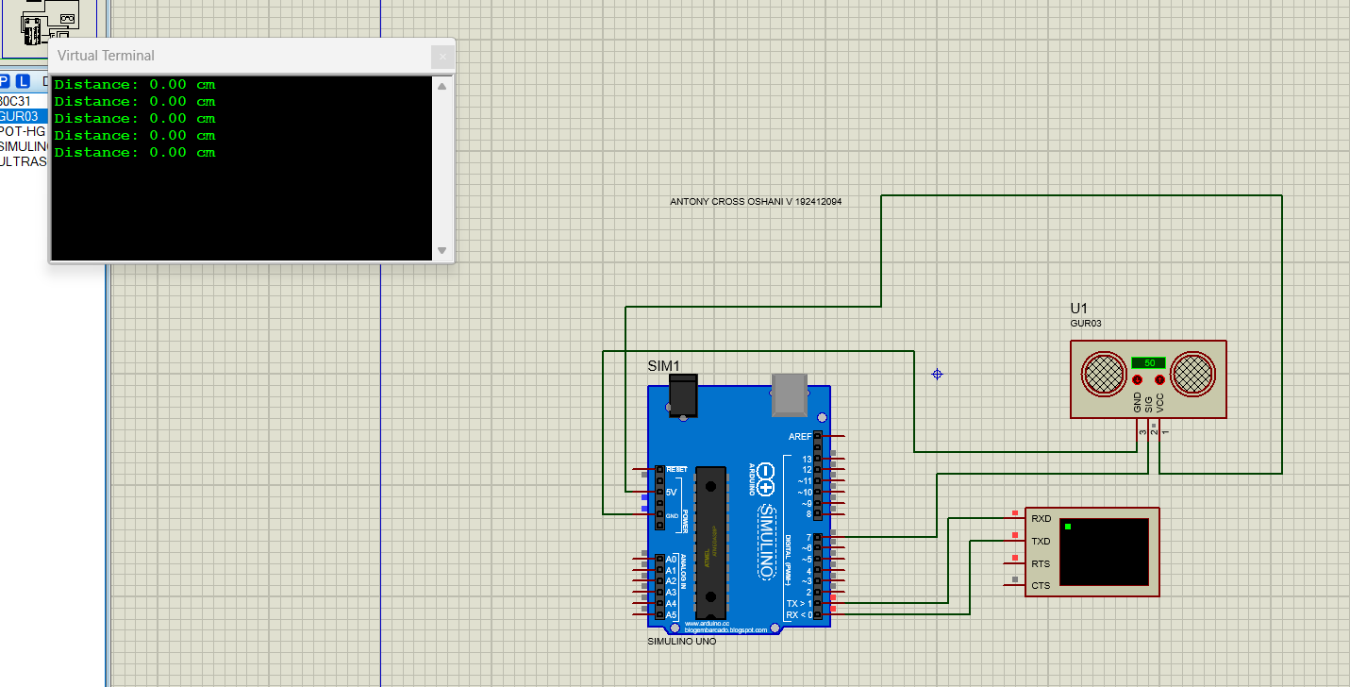
RESULT:
Thus the program has been successfully verified and executed.

