EXP NO: 11
STUDY OF GPIO & BIT ADDRESSING IN AT89C51
AIM:
To study GPIO control and bit-addressable SFR using Embedded C.
SOFTWARE REQUIRED:
Keil
THEORY
8051 ports are byte and bit addressable. Using sbit, individual bits of a port can be accessed
directly. Ports default to logic HIGH due to internal pull-ups.
PROGRAM
#include <reg51.h>
sbit LED1 = P1^0;
sbit LED2 = P1^1;
void delay()
{
unsigned int i,j;
for(i=0;i<200;i++)
for(j=0;j<1000;j++);
}
void main()
{
while(1)
{
LED1 = 1;
LED2 = 0;
delay();
LED1 = 0;
LED2 = 1;
delay();
}
}

OUTPUT:
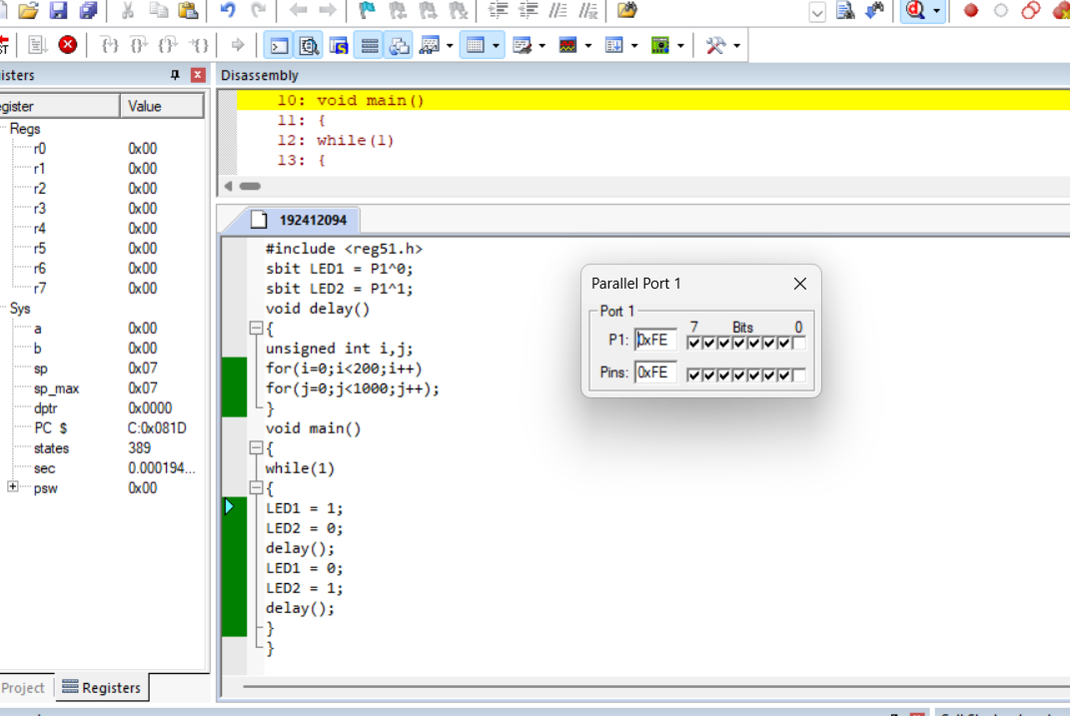
OBERVATION:
Register Value
P1 0x01
P1 0x02
RESULT:
Thus GPIO and bit addressing was studied and in Port1 the pins P1.0 and P1.1 toggled
alternately.

