EXP NO: 7
SERIAL COMMUNICATION USING ARDUINO WITH PROTEUS
AIM:
To write an Embedded C program for serial communication using Arduino Uno and
Proteus
SOFTWARE REQUIRED:
• Proteus 8 software.
• Arduino IDE software
PROGRAM
void setup()
{
Serial.begin(9600); // send and receive at 9600 baud
}
int number = 0;
void loop()
{
Serial.print("Number is ");
Serial.println(number); // print the number
delay(500); // delay half second between numbers
number++; // to the next number
}
OUTPUT:
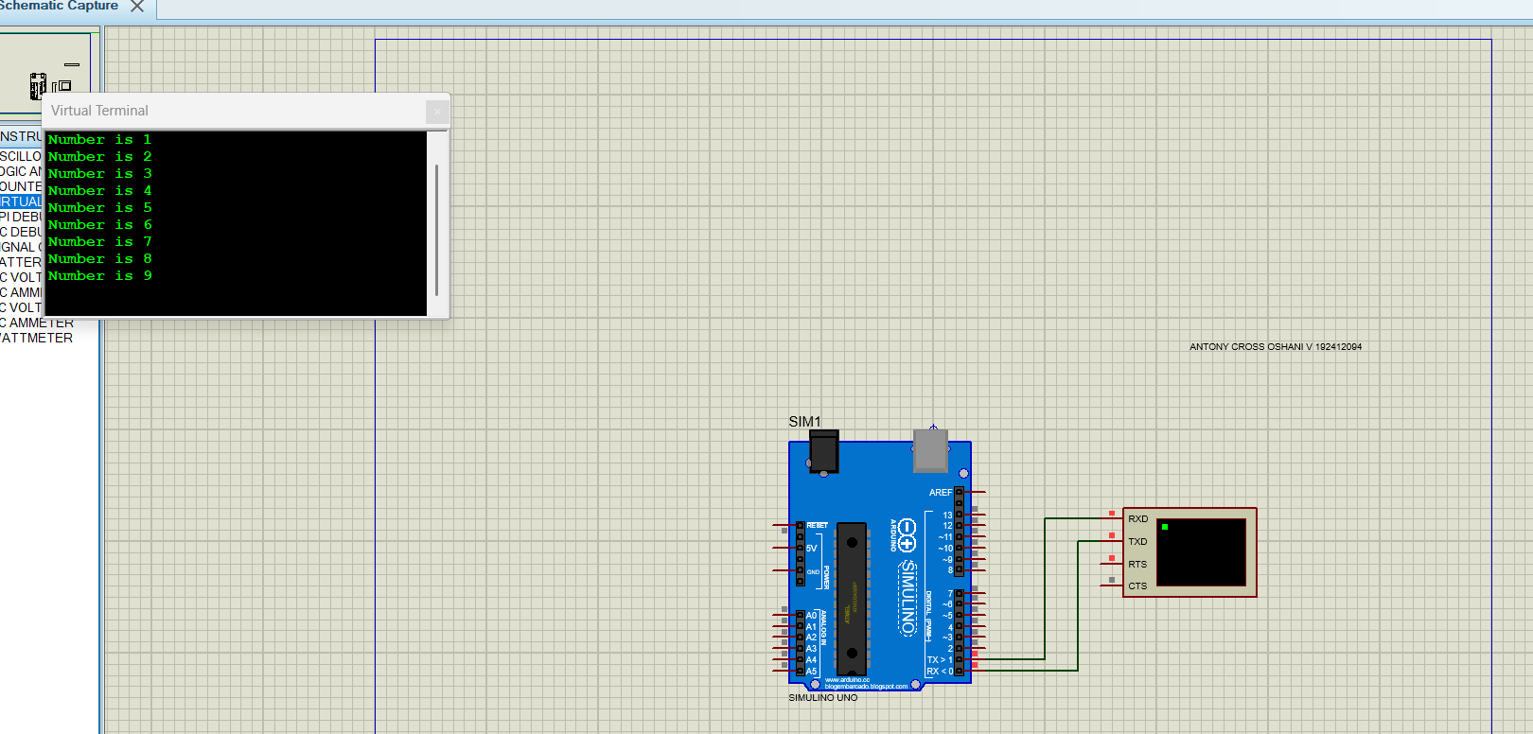
RESULT:
Thus the program has been successfully verified and executed.

