EXP NO: 13
EMBEDDED C PROGRAM TO ADD AN ARRAY OF 16-BIT NUMBERS AND
STORE THE 32-BIT RESULT IN INTERNAL RAM
AIM:
To write an Embedded C program to add an array of 16-bit numbers and store the results in
internal RAM using Keil software.
SOFTWARE REQUIRED:
Keil
PROGRAM
#include <reg51.h>
void main(void)
{
unsigned int i;
array[00x00 unsigned int array[5] = {0x1111, 0x2222, 0x8888, 0x4444, 0xABCD};
unsigned long sum = 0;
for (i = 0; i < 5; i++)
{
sum = sum + array[i];
}
P0 = (unsigned char)(sum & 0xFF); // Lower 8 bits
P1 = (unsigned char)((sum >> 8) & 0xFF); // Next 8 bits
P2 = (unsigned char)((sum >> 16) & 0xFF); // Upper 8 bits
while(1); // keep output stable
}
OUTPUT:
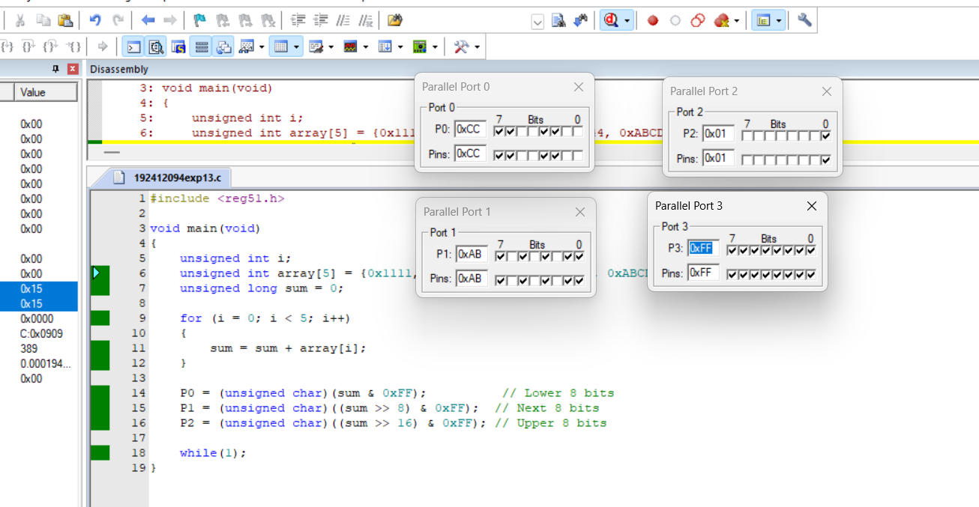
RESULT:
Thus the program has been successfully verified and executed.

