EXP NO: 3
STEPPER MOTOR USING AT89C51 USING PROTEUS
AIM:
To write an assembly language program for Stepper Motor Using AT89C51 using Keil and
Proteus
SOFTWARE REQUIRED:
Proteus 8 software.
PROGRAM
ORG 0000H
UP: MOV P2,#09H
ACALL DELAY
MOV P2,#0CH
ACALL DELAY
MOV P2,#06H
ACALL DELAY
MOV P2,#03H
ACALL DELAY
SJMP UP
DELAY:MOV R4,#18
H1:MOV R3,#255
H2:DJNZ R3,H2
DJNZ R4,H1
RET
END

OUTPUT:
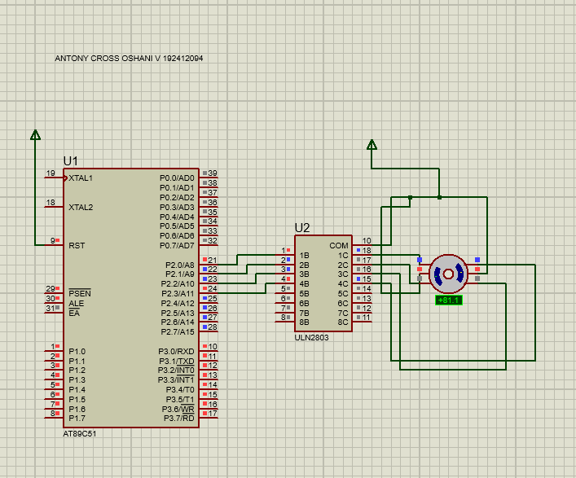
RESULT:
Thus the program has been successfully verified and executed.

